INSTRUCTIONS

Read the following carefully before answering the questions:

1.  2.  3.  4.  5.  6.  7.  8. | Answer ALL the questions.  Write ALL the answers in the ANSWER BOOK.  Number the answers exactly as the questions are numbered.  Start the answer to each question at the top of a new page.  All drawings should be done in pencil and labelled in ink.  Calculators may be used.  Write neatly and legibly.  The diagrams in the question paper may not necessarily be drawn to scale.

SECTION A

QUESTION 1

1.1 | Various possible answers are provided for each question. Indicate the correct  answer by writing only the letter next to the relevant question number.

 | 1.1.1 | A substance that acts as a transport medium as well as a reagent during human nutrition is …

 | A  B  C  D | an enzyme.  water.  glucose.  blood.

 | 1.1.2 | The end products of protein digestion are …

 | A  B  C  D | glucose molecules.  glucose and water.  glycerol and fatty acids.  amino acids.

 | 1.1.3 | Which of the following is normally in a higher concentration in the hepatic portal vein than in most other veins in the human body?

 | A  B  C  D | Glucose  Urea  Oxygen  Carbon dioxide

1.1.4 Study the diagram below of a schematic representation of some
population dynamic parameters and answer the question which
follows.

X

immigration

population
size

Which parameter does the letter X on the diagram represent?

 | A  B  C  D | Natality  Migration  Mortality  Emigration

 | 1.1.5 | The function of the hairs in the nasal cavity is to …

 |  | (i)  (ii)  (iii)  (iv) | warm the air.  filter the air.  remove the carbon dioxide from the atmospheric air.  slow down air movement.

Which of the above is/are correct?

 | A  B  C  D | Only (ii)  Only (iv)  (ii) and (iv)  (i), (ii), (iii) and (iv)

 | 1.1.6 | The following substances are involved in metabolic processes in the human body:

 |  | (i)  (ii)  (iii)  (iv)  (v) | Oxygen  Amino acids  Carbon dioxide  Water  Glucose

The combination of substances used in animal cells is …

 | A  B  C  D | (i) and (ii) only.  (ii), (iii) and (iv).  (i), (ii), (iii), (iv) and (v).  (i), (ii), (iv) and (v).

 | 1.1.7 | Normally, when they are sitting still, the blood of people living at a high altitude …  (i) flows faster than the blood of those living at sea-level.  (ii) flows slower than the blood of those living at sea-level.  (iii) has a smaller volume than the blood of those living at sea-level.  (iv) has a larger volume than the blood of those living at sea-level.  (v) has a higher erythrocyte (red blood corpuscle) count than those  living at sea-level.  Which of the above statements is/are correct?  A (i), (ii) and (v)  B (i), (iv) and (v)  C (i) and (iv)  D (v) only

 |  |  | (7 × 2) |  | (14)

1.2 | Give the correct biological term for each of the following descriptions. Write only the correct term next to the relevant question number.

 | 1.2.1  1.2.2  1.2.3  1.2.4  1.2.5  1.2.6  1.2.7  1.2.8  1.2.9  1.2.10 | The structure in a leaf through which gaseous exchange takes place  All the biochemical processes taking place in living cells  The process during which energy is gradually released from a fuel molecule inside a living cell  The mechanical process whereby food is moved along in the intestinal canal of humans  Membranes lining the thoracic cavity and covering the lungs  The structure which prevents food from entering the trachea during swallowing  Organisms that damage or disturb the health of crops and farm animals  The determination of the size of a population by counting all its  members  The phenomenon where one animal hunts, kills and eats another animal  The process by which food is chewed into a fine pulp and mixed with saliva |  | (10)

1.3 | Match the items in COLUMN I with the descriptions in COLUMN II. Write only the letter of your choice next to the relevant question number.

 |  | COLUMN I |  | COLUMN II

 | 1.3.1  1.3.2  1.3.3  1.3.4  1.3.5  1.3.6 | Goitre  Bile  Sodium hydroxide  Alcohol  Intercostal muscles  Lactic acid | A  B  C  D  E  F  G  H  I | Chemical used to extract chlorophyll from  leaves  Deficiency of iron in the diet  A product of anaerobic respiration in muscle cells  Chemical used to absorb carbon dioxide  from atmospheric air  A high concentration in the blood will increase the rate of breathing  Digestive juice which does not contain enzymes  Movement of air into and out of the lungs  Deficiency of iodine in the diet  Chemical used to supplement carbon  dioxide in water  (6 × 2) |  | (12)

1.4 | The following apparatus can be used to show how certain human body parts  function. Study the diagram and answer the questions that follow.

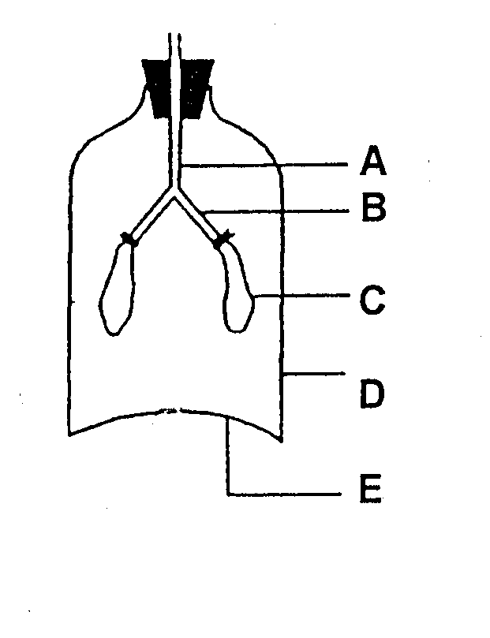

F

 | 1.4.1 | Name the process that can be demonstrated using the above apparatus. |  | (1)

 | 1.4.2 | Write the letter of the part of the apparatus which represents the following parts in the human body:

 |  | (i)  (ii)  (iii) | Bronchus  Trachea  Rib cage |  | (1)  (1)  (1)

 | 1.4.3 | Give TWO reasons why part D is a poor representation of the structure in the human body. |  | (2)

 | 1.4.4 | What happens to each of the following parts when part E is pulled downwards:

 | (i)  (ii) | Volume of F  Pressure in F |  | (1)  (1)  (8)

1.5 | Each of the following diagrams has one incorrect label. Write the incorrect  label and next to it the correct label.

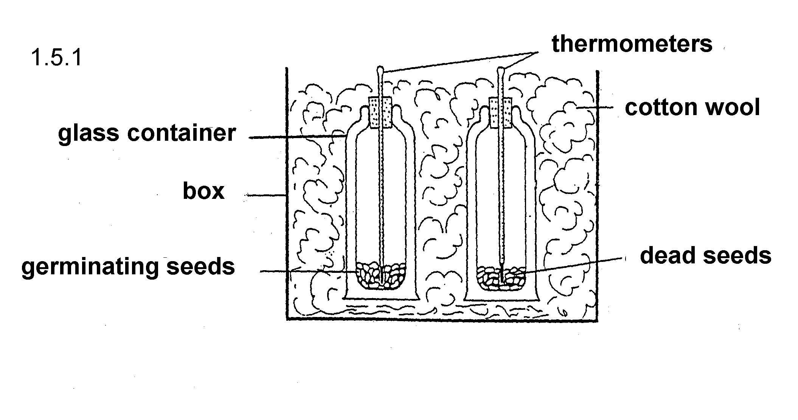

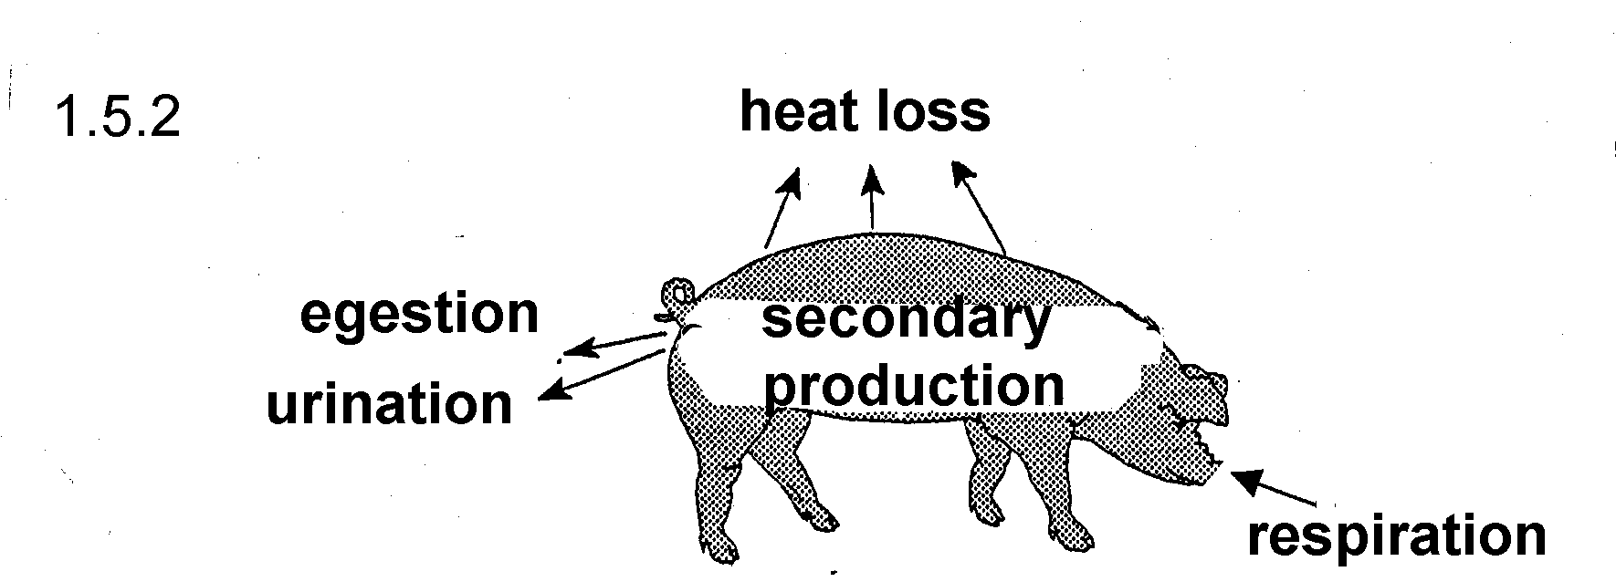

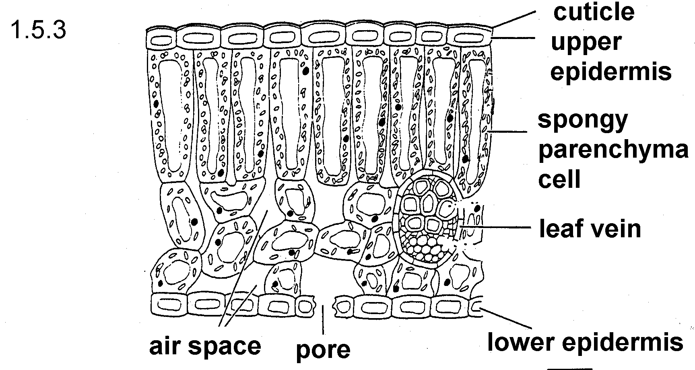

TOTAL SECTION A: | (3 x 2) | (6)  50

SECTION B

QUESTION 2

2.1 | Study the following diagram which shows part of the human digestive system and then answer the questions that follow.

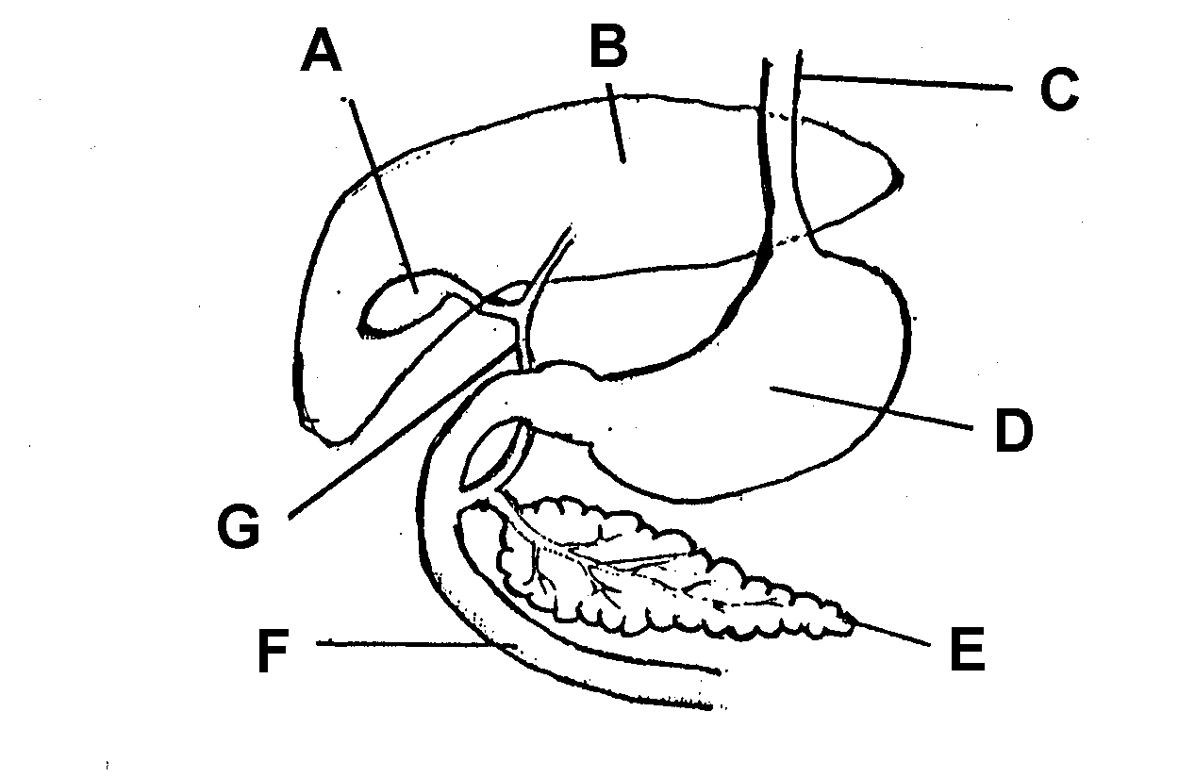

 | 2.1.1 | Identify parts A, B, C, D, F and G. |  | (6)

 | 2.1.2 | Give the letter of the part where the content is acidic. |  | (1)

 | 2.1.3 | Name the chemical substance that is responsible for the acidity  of the content of the part named in Question 2.1.2. |  | (1)

 | 2.1.4 | Name ONE function other than creating an acidic medium of the  substance named in Question 2.1.3. |  | (1)

 | 2.1.5 | Identify part E. |  | (1)

 | 2.1.6 | Describe how part E plays a role in decreasing the blood sugar  level. |  | (4)

 | 2.1.7 | Give FOUR functions of part B with regard to nutrition. |  | (4)

2.2 | Draw a labelled diagram of a single villus. |  | (7)  (25)

QUESTION 3

3.1 | Study the following diagram representing a section through an alveolus and a surrounding blood capillary in the human body and answer the questions that follow.

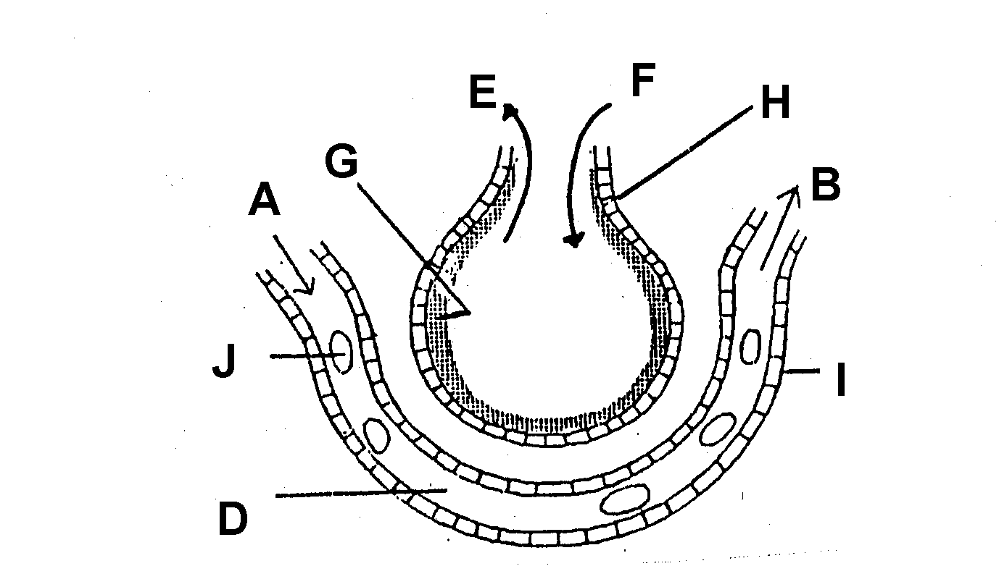

C

 | 3.1.1 | Name the organ in which an alveolus is found. |  | (1)

 | 3.1.2 | Name the gas indicated by arrow E. |  | (1)

 | 3.1.3 | Identify the type of tissue numbered I. |  | (1)

 | 3.1.4 | Would you find a higher concentration of oxygen at A or B? |  | (1)

 | 3.1.5 | What is the function of G? |  | (1)

 | 3.1.6 | What physical process allows gaseous exchange to take place  between the air in C and the blood in D? |  | (1)

 | 3.1.7 | Name TWO forms in which the gas F is transported in the blood. |  | (2)

3.2 | Study the following population growth curve of organisms in a closed  environment and answer the questions that follow.

Number of individuals (x100)
A B

5--
Y
4--

3--

2--

1--

0 2 4 6 8 10

Time (weeks)

 | 3.2.1 | Which growth form is illustrated by the graph? |  | (1)

 | 3.2.2 | Give TWO possible reasons for the slow increase in the population size at phase A. . |  | (2)

 | 3.2.3 | List TWO density-dependent factors that may be responsible for the growth form indicated at phase B of the graph. |  | (2)

 | 3.2.4 | Use the graph to determine the following:  (i) The number of animals in the second week  (ii) The maximum number of individuals that can be sustained by  the habitat under the prevailing conditions |  | (2)  (2)

 | 3.2.5 | During which week was the population size 200 individuals? |  | (2)

 | 3.2.6 | Suggest a possible reason for the sudden decrease in population size at Y. |  | (2)

3.3 | The population size of mice in a wheat-field was estimated by using the mark-recapture method.

 | 3.3.1 | Is this a direct or indirect method of determining population size? |  | (1)

 | 3.3.2 | Name THREE precautionary measures you would take when you use the mark-recapture method to estimate the population size of the mice in the wheat-field. |  | (3)
 |  |  |  | (25)

QUESTION 4

4.1 | Study the diagram below that illustrates a process taking place in plant cells and answer the questions that follow.
CO₂
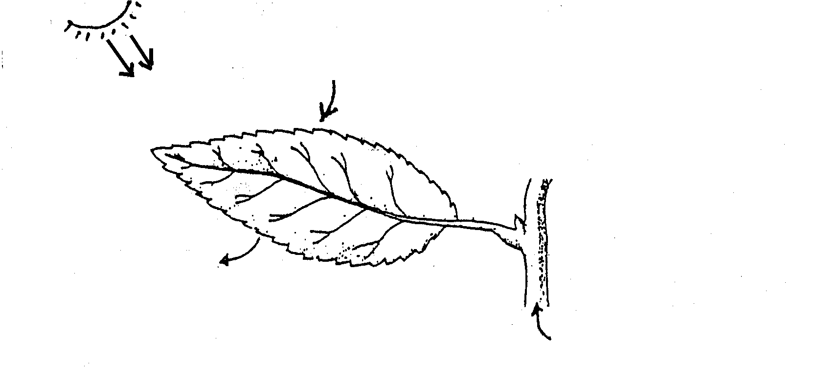
CO₂
D = final product
D
liquid B
gas A

 | 4.1.1 | Name the process illustrated by the diagram. |  | (1)

 | 4.1.2 | Identify the following:  (i) Gas A  (ii) Liquid B  (iii) Final product D |  | (1)  (1)  (1)

 | 4.1.3 | Give TWO reasons why the process named in Question 4.1.1 above is regarded as biologically important. |  | (2)

 | 4.1.4 | A learner covered a section of the leaf with a piece of aluminium foil for six hours and then tested the leaf for the presence of starch.

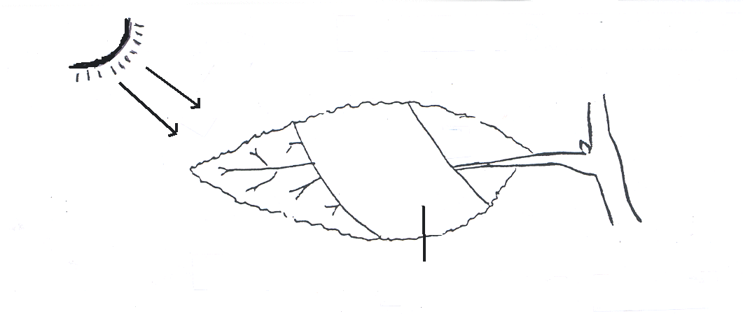
aluminium foil

 | (i)  (ii) | What is the aim of this investigation?  Describe the result of this investigation. |  | (2)  (4)

4.2 | Study the diagrams below and answer the questions that follow.

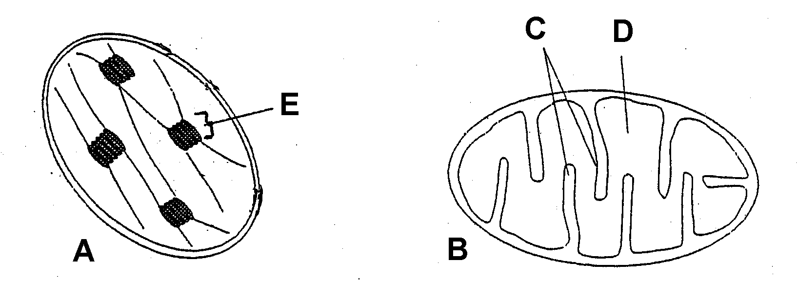

 | 4.2.1 | Which organelle, A or B, is present in all living cells? | (1)

 | 4.2.2 | Identify parts C, D and E. |  | (3)

4.3 | The following diagram illustrates the apparatus that is used in an experiment  to investigate a certain aspect of cellular respiration. Study the diagram and  answer the questions that follow.

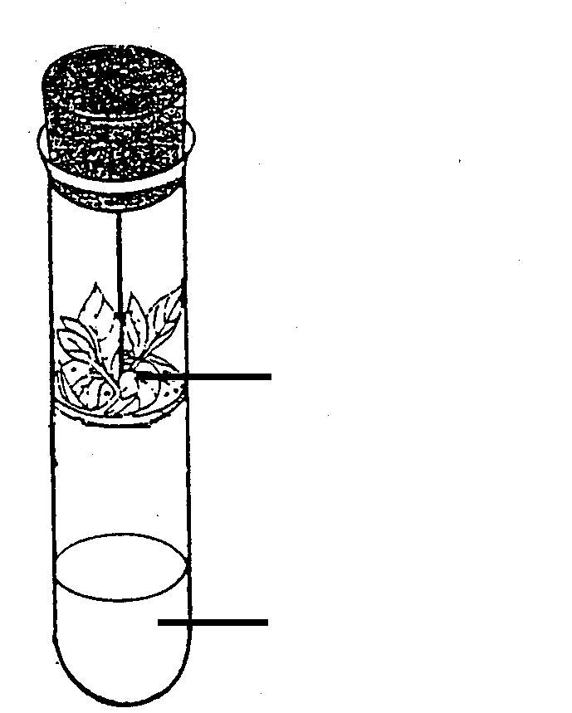
plant material
clear lime water

 | 4.3.1 | What is the aim of this investigation? |  | (2)

 | 4.3.2 | What is the function of the clear lime water? |  | (1)

 | 4.3.3  4.3.4 | Give ONE precaution that should be taken when conducting this investigation and give a reason for the precaution mentioned.  Briefly describe what happens during the process of respiration. |  | (2)  (4)  (25)

QUESTION 5

5.1 | Study the table below which shows the composition per 100 g of certain food  types in the human diet.

Food type | Energy  (kJ) | Proteins  (g) | Fats  (g) | Carbohydrates  (g)
Bacon | 1 983 | 12 | 48 | 0
Beans | 376 | 5 | 0,4 | 18
Bread | 1 061 | 8,2 | 1,6 | 55,1
Butter | 3 121 | 0,3 | 82,4 | 0
Milk | 274 | 3,2 | 3,9 | 4,7

Use the information in the table to answer the following questions:

 | 5.1.1 | Name TWO food types which are the best in terms of supplying  the nutritional needs of the body. |  | (2)

 | 5.1.2 | Calculate the amount of energy provided by 150 g of beans. |  | (2)

 | 5.1.3 | List TWO functions of fats in the human body. |  | (2)
 | 5.1.4 | Name, giving a reason, the food type which you consider to be the most efficient in the prevention of kwashiorkor. |  | (2)

5.2 | Use the table below to answer the questions that follow:

Food type | Calcium  (mg) | Iron  (mg) | Vit. A  (ug) | Vit B₁  (ug)
Bacon | 10 | 0 | 0 | 0
Beans | 63 | 2,2 | 301 | 0
Bread | 99 | 1,9 | 0 | 0
Butter | 1,4 | 0 | 2 010 | 1
Milk | 119 | 0,1 | 83 | 0,05

Refer to the table and name, giving a reason, the food type which you consider to be the most efficient for the following:

 | 5.2.1  5.2.2  5.2.3  5.2.4 | Normal night vision  Preventing anaemia  Preventing rickets  Preventing beri-beri |  | (2)  (2)  (2)  (2)

5.3 | 5.3.1 | Which chemical reagent would you use when you test for the  following:

 | (i)  (ii) | Starch in bread  Fats in butter |  | (1)  (1)

 | 5.3.2 | Give the result that will show the following:

 | (i)  (ii) | Bread contains starch  Butter contains fats |  | (1)  (1)

 | 5.3.3 | Describe a test you would perform to show that beans contain protein.  TOTAL SECTION B:  GRAND TOTAL: |  | (5)  (25)  100  150

