INSTRUCTIONS AND INFORMATION TO CANDIDATES

Read the following carefully before answering the questions:

1.  2.  3.  4.  5.  6.  7.  8. | Answer ALL the questions.  Write ALL the answers in the ANSWER BOOK.  Number the answers exactly as the questions are numbered.  Begin the answer to each question at the top of a new page.  All drawings should be done in pencil and labelled in ink.  Calculators may be used.  Write neatly and legibly.  The diagrams may not necessarily be drawn to scale.

SECTION A

QUESTION 1

1.1 | Various possible answers are provided for each question. Indicate the correct answer by writing down only the letter next to the question number.

 | 1.1.1 | A motor neuron conducts nerve impulses from ...

 |  | A  B  C  D | an effector to the central nervous system.  the central nervous system to a receptor.  a receptor to the central nervous system.  the central nervous system to an effector.

 | 1.1.2 | The removal of metabolic waste products from the body is called....

 |  | A  B  C  D | osmosis.  secretion.  plasmolysis.  excretion.

Questions 1.1.3 to 1.1.7 refer to the diagram below:

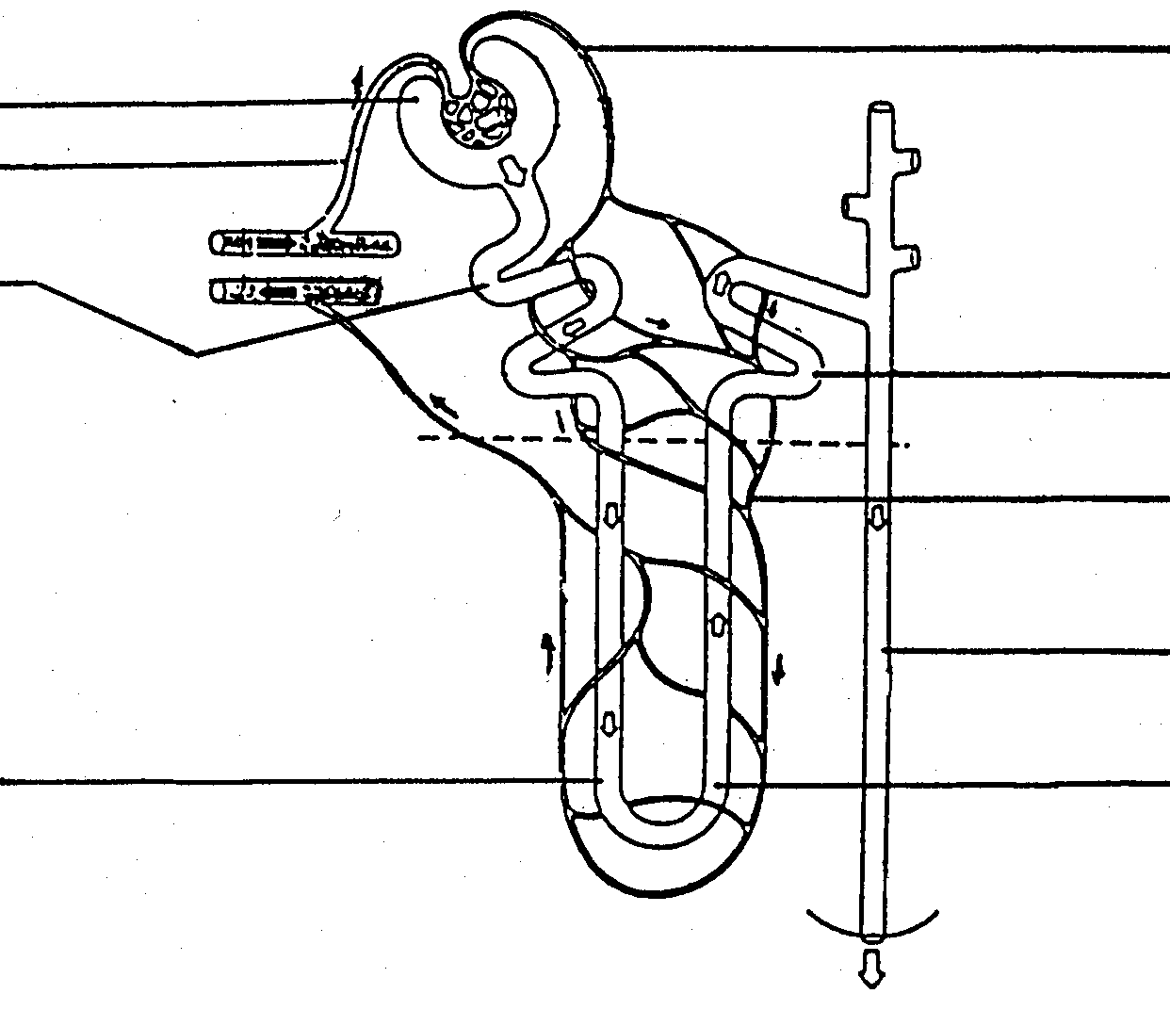
2

7

8

9

6
3
1

4

5

 | 1.1.3 | The diagram represents a(n) ...

 |  | A  B  C  D | villus.  alveolus.  neuron.  nephron.

 | 1.1.4 | Passive reabsorption occurs mainly in number ...

 |  | A  B  C  D | 3.  4.  5.  9.

 | 1.1.5 | In which numbered part would urine be found?

 |  | A  B  C  D | 1  3  8  9

 | 1.1.6 | Which part on the diagram indicates a part of the renal tubule?

 |  | A  B  C  D | 1  2  4  8

 | 1.1.7 | The hormone which plays a significant role in the reabsorption of water is...

 |  | A  B  C  D | thyroxin.  adrenalin.  insulin.  ADH.

Questions 1.1.8 and 1.1.9 refer to the diagram below:

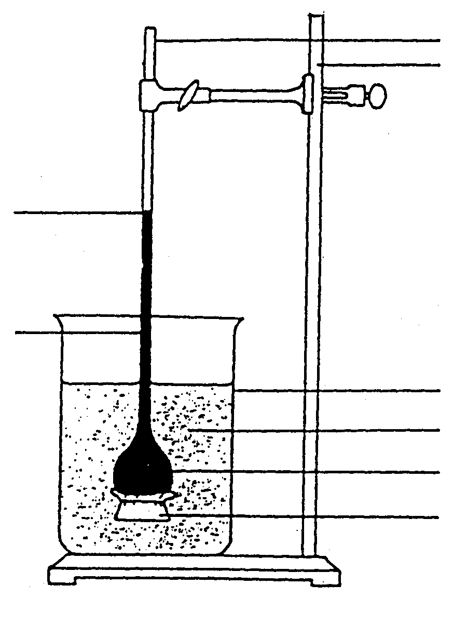

thistle funnel

retort stand

glass beaker

distilled water

20% salt solution

dialysis tubing

level at the end of experiment

level at the beginning of the experiment

 | 1.1.8 | The apparatus illustrates ...

 |  | A  B  C  D | diffusion.  plasmolysis.  guttation.  osmosis.

 | 1.1.9 | Why did the level of the solution in the thistle funnel rise? Because there was...

 |  | A  B  C  D | a lower water potential in the thistle funnel than in the beaker.  a lower water potential in the beaker than in the thistle funnel.  a higher water potential in the thistle funnel than in the beaker.  the same water potential in the thistle funnel as in the beaker.

 | 1.1.10 | Which ONE of the following is responsible for the phenomenon illustrated in the diagrams below?

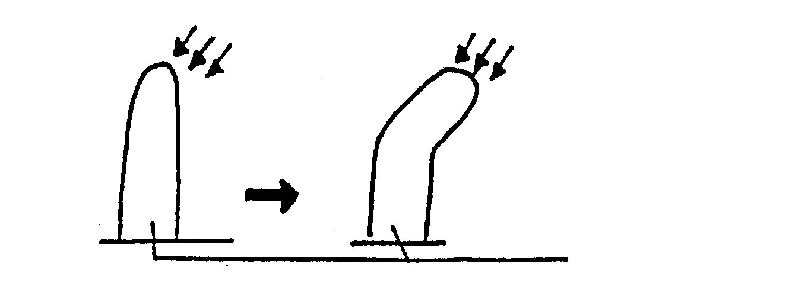
light
light
young stem

 |  | A  B  C  D | Chlorophyll  Gibberellins  Auxins  Cytokinins (10x2) |  | (20)

1.2 | Give the correct biological term for each of the following descriptions. Write only the term next to the relevant question number.

 | 1.2.1  1.2.2  1.2.3  1.2.4  1.2.5  1.2.6  1.2.7 | A group of plants adapted to survive in dry, arid regions  Small pores on leaf edges through which drops of water are released  The ability of water molecules to do work through osmosis  The waxy waterproof layer which covers the aerial parts of a plant  Extracellular fluid surrounding the cells of living animals  The pressure build up in the xylem tissue as a result of absorption of water  The part of the eye where most refraction occurs

 | 1.2.8  1.2.9  1.2.10 | The hormone, which is secreted when the blood sugar level is low  A group of animals able to regulate their internal temperature  A state of animal inactivity during cold winter months |  | (10)

1.3 | Match the word/term in COLUMN I with the concept/information in  COLUMN II by writing only the correct letter next to the relevant question number .

 | 1.3.1  1.3.2  1.3.3  1.3.4  1.3.5 | COLUMN I  Iris  Eustachian tube  Eardrum/Tympanum  Retina  Middle ear | A  B  C  D  E  F  G | COLUMN II  The part of the eye that detects light stimuli  The soft jelly-like transparent material located behind the eye lens  The part of the ear containing the ossicles  The structure that regulates the amount of light entering the eye  The membrane separating the outer ear and middle ear  The layer of the eye containing no blood vessels  It connects the middle ear with the  pharynx
 |  |  |  | (5 x 2) |  | (10)

1.4 | The graphs A, B and C below indicate the results of different environmental factors on the rate of transpiration. Study the graphs and answer the questions that follow.

A B C
Transpiration rate
Transpiration rate
Transpiration rate
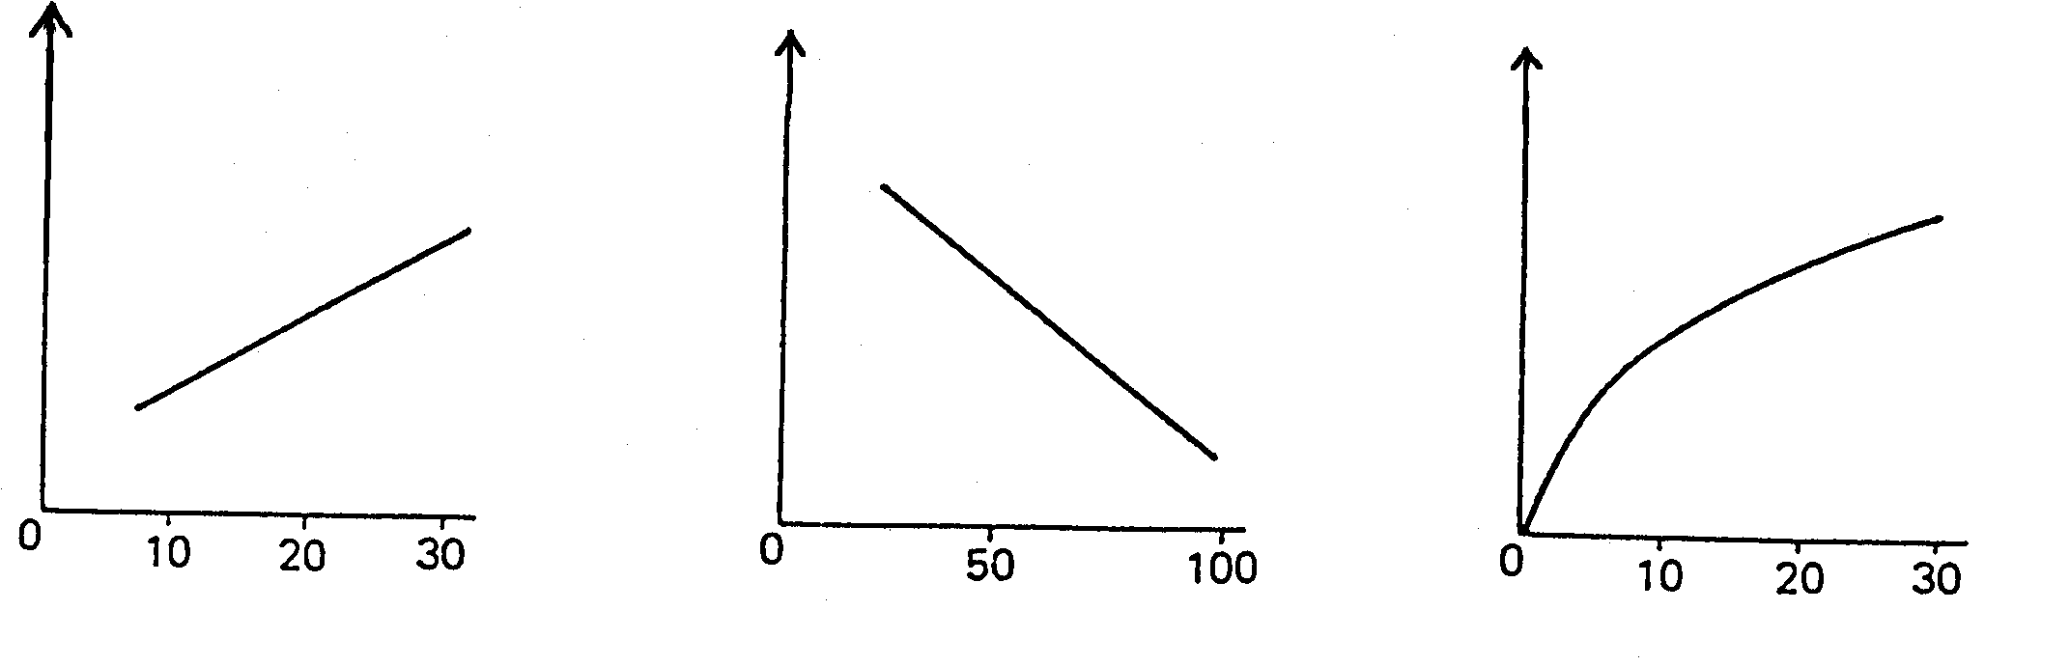
Temperature (°C ) Relative humidity (%) Wind speed (km/h)

 | 1.4.1  1.4.2  1.4.3 | Briefly explain graphs A, B and C.  Name the apparatus used to determine the rate of transpiration.  Give ONE precaution which should be taken in setting up the apparatus referred to in QUESTION 1.4.2. Give a reason for the answer.  TOTAL SECTION A |  | (6)  (2)  (2)  (10)  [50]

SECTION B

QUESTION 2

2.1 Study the diagram below and answer the questions that follow.

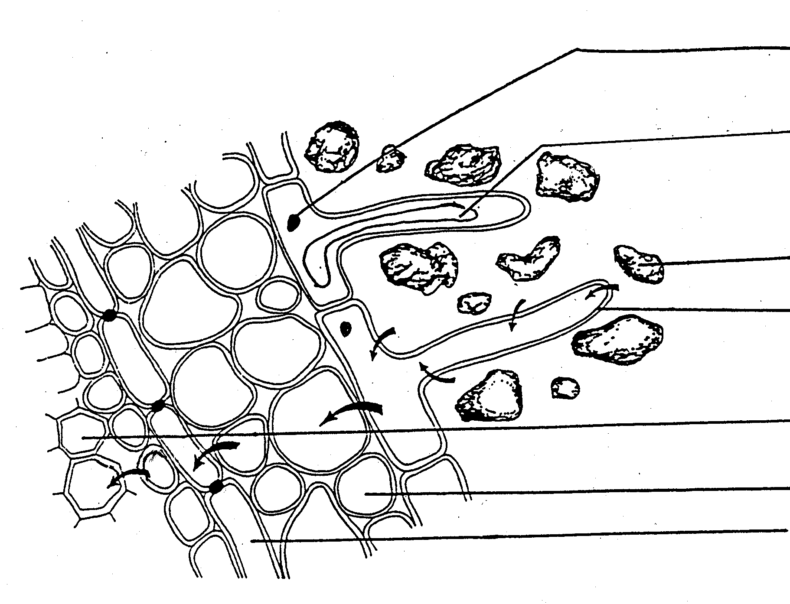

1

2

3

4

5

6
7

 | 2.1.1  2.1.2  2.1.3  2.1.4  2.1.5  2.1.6 | Label parts 1 to 6.  Explain the process of water absorption by the root hair.  Give THREE ways in which root hairs are structurally adapted for water absorption.  Name the cell indicated by 7.  In what way must the water potential of the root hair be different from that of soil water for water to enter the root hair?  Give THREE functional adaptations of xylem. |  | (6)  (5)  (3)  (1)  (2)  (3)

2.2 | The diagrams represent two plant cells A and B. One of these cells was  placed in a concentrated sugar solution and the other one in distilled water.

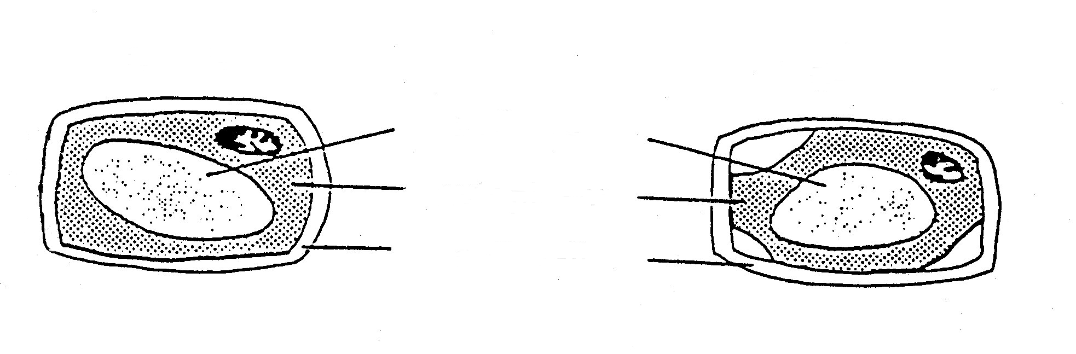
cell sap

cytoplasm
cell wall
Cell A
Cell B

 | 2.2.1  2.2.2  2.2.3 | Which cell, A or B, underwent plasmolysis?  Which cell was placed in the concentrated sugar solution?  Explain the structural changes that take place in a plant cell due to plasmolysis. |  | (1)  (1)  (3)  (25)

QUESTION 3

3.1 | Study the diagram of the human skin below and answer the questions that follow:

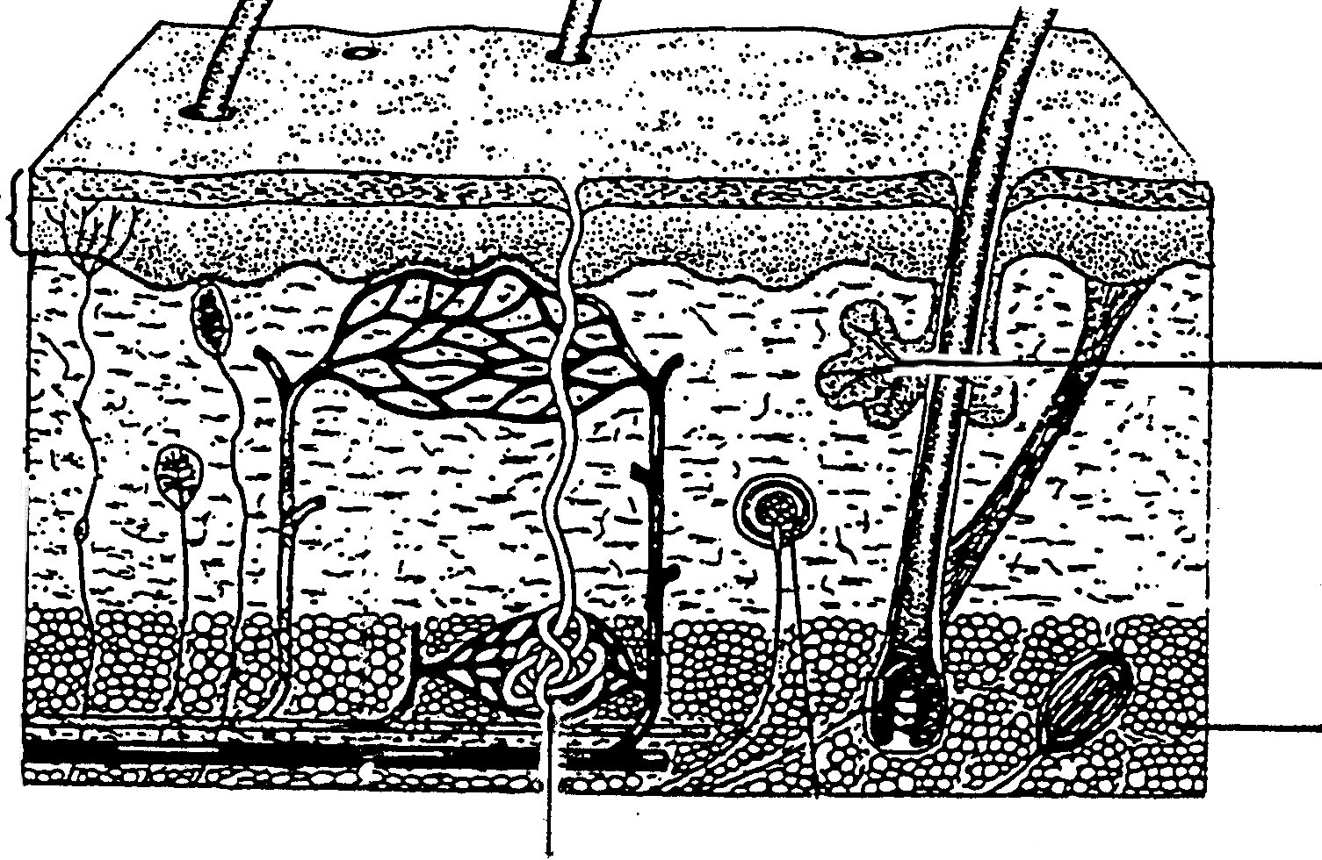
4
2
3
1

 | 3.1.1  3.1.2  3.1.3 | Label the parts numbered 1, 2 and 3.  Explain how any THREE structures visible in the diagram maintain a constant body temperature.  Name TWO physiological processes associated with part 4. |  | (3)  (6)  (2)

3.2 | Study the diagram below and answer the questions that follow.

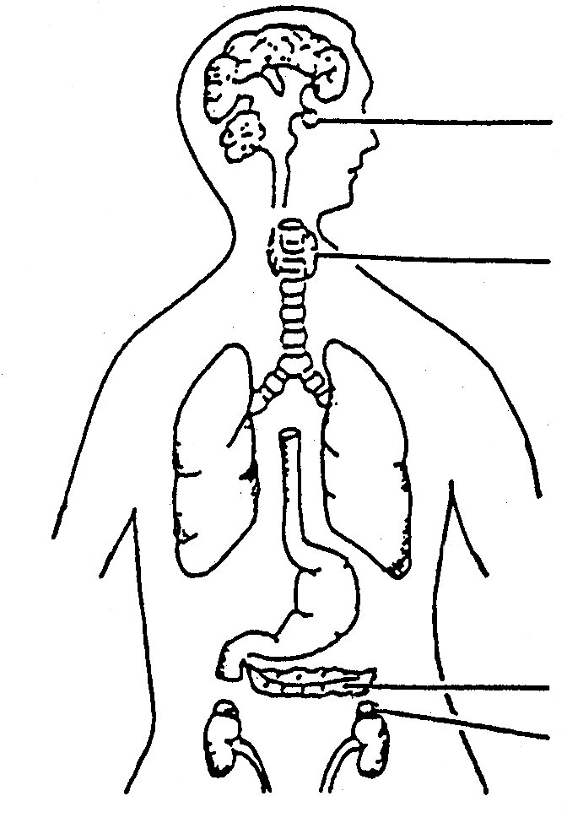

1

2

3
4

 | 3.2.1  3.2.2  3.2.3  3.2.4 | Identify the endocrine glands 1, 2 and 4.  Name ONE hormone secreted by 3 and 4 respectively.  List any TWO functions of the hormones secreted by 2 and 4 respectively.  Briefly describe the feedback mechanism between 1 and 2. |  | (3)  (2)  (4)  (5)  (25)

\QUESTION 4

4.1 | Study the diagram below and answer the questions that follow:

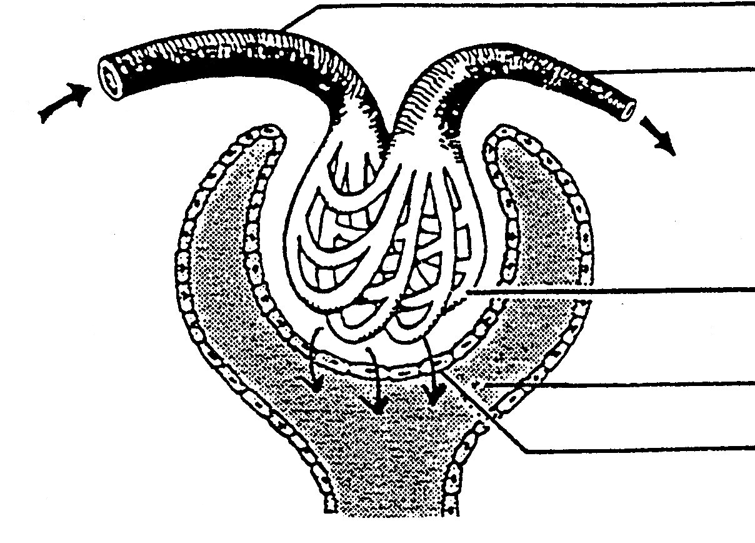
1

2

3

4

5
6

 | 4.1.1  4.1.2  4.1.3  4.1.4  4.1.5 | Identify the parts 1 to 6.  How is this structure adapted for its function?  Name the process which occurs in 6.  Name THREE substances which will move from 3 to 4 as indicated  by the arrows.  Name THREE substances which will be reabsorbed into the blood from the filtrate in 4, at a later stage. |  | (6)  (4)  (1)  (3)  (3)

4.2 | Discuss the homeostatic role of the kidneys after a large quantity of salt has been taken in. |  | (5)

4.3 | Give THREE functions of the kidney. |  | (3)  (25)

QUESTION 5

5.1 | Study the diagram below and answer the questions that follow:

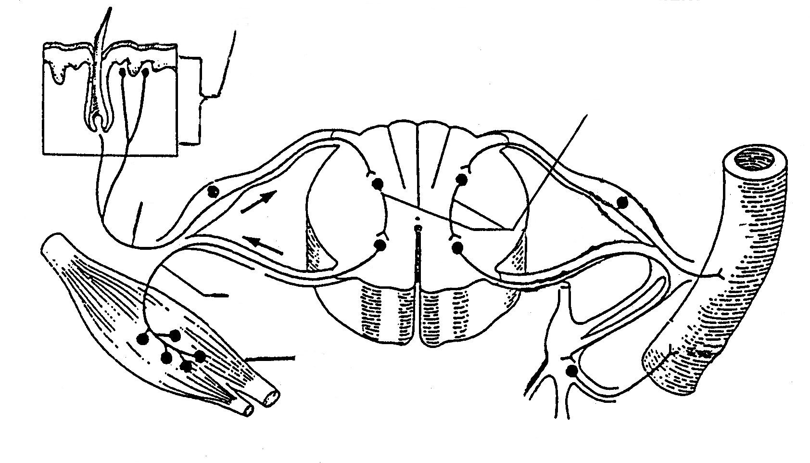
3
5
4
2
1

 | 5.1.1  5.1.2 | Label parts 1 to 5.  By using ONLY diagram numbers and arrows indicate the pathway of a nervous impulse during a reflex action. |  | (5)  (5)

5.2. | Make a neat, labelled drawing of a motor neuron. |  | (6)

5.3 | Study the diagram below showing a side view of the human brain and answer the questions that follow:
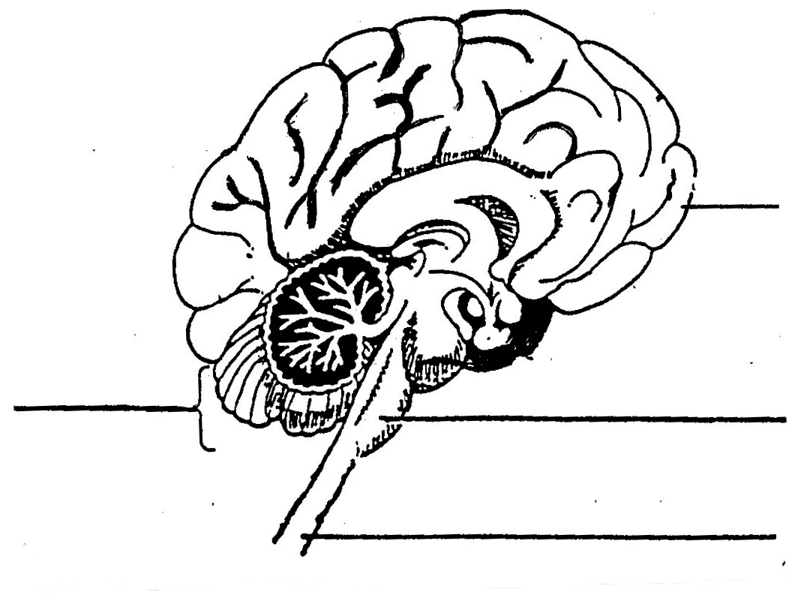

1

2

3
4

 | 5.3.1  5.3.2  5.3.3 | Label parts 1 to 4.  State FOUR functions of the brain.  Give ONE way in which the brain is protected from injury. |  | (4)  (4)  (1)  (25)

TOTAL SECTION B  GRAND TOTAL |  | [100]  150

