INSTRUCTIONS AND INFORMATION TO CANDIDATES

Read the following carefully before answering the questions:

1.  2.  3.  4.  5.  6.  7.  8. | Answer ALL the questions.  Write ALL the answers in the ANSWER BOOK.  Number the answers exactly as the questions are numbered.  Start the answer to each question at the top of a new page.  All drawings should be done in pencil and labelled in ink.  Write neatly and legibly.  Calculators may be used.  The diagrams in the question paper may not necessarily be drawn to scale.

SECTION A

QUESTION 1

1.1 Various possible answers are provided for each question.
Indicate the correct answer by writing only the letter next to the question number.

1.1.1 Which ONE of the following is organic?

A Sodium chloride
B Glucose
C Magnesium
D Water

    - Which element is found free in the air, and is essential to life, but is
not obtained directly from the air by plants?

A Nitrogen
B Oxygen
C Carbon dioxide
D Magnesium

Questions 1.1.3 to 1.1.5 are based on the following diagram.

1.1.3 Which vitamin is synthesised according to the diagram?

A Vitamin B
B Vitamin E
C Vitamin D sun
D Vitamin C

skin

vitamin liver

    - Which disease could develop if a growing child does not have
enough of this vitamin?

A Scurvy
B Anaemia
C Beri-beri
D Rickets

 | - Which food is most likely to prevent the condition mentioned in  Question 1.1.4?  A Citrus  B Egg-yolk  C Grains  D Yeast  (5 x 2) |  | (10)

1.2 | Give the correct biological term for each of the following descriptions.  Write down only the correct term next to the question number.

 | 1.2.1  1.2.2  1.2.3  1.2.4  1.2.5  1.2.6  1.2.7  1.2.8  1.2.9  1.2.10 | The type of nutrition found in green plants which involves the making of organic compounds  The organelles in which cellular respiration takes place  The type of energy absorbed by chlorophyll molecules  The energy-carrier molecule found in living cells  A result of over- nutrition causing an increase in the fat content of the body  The type of anaerobic respiration occurring in yeast cells  The removal of undigested wastes from the body  The harmful effects of eating too little food from all the food types  The chemical substance in the stomach which has an antiseptic function  The hormone which changes excess glucose to glycogen |  | (10)

1.3 | The following is a list of characteristics related to organic compounds:  A - form antibodies  B - structural component of cell walls  C - energy source  D - denatured by excessive heat  E - insulation material  F - forms part of cell membranes  Indicate only the letter of the characteristic(s) which correspond(s) to each of the following items:

 | 1.3.1  1.3.2  1.3.3  1.3.4 | TWO characteristics related to lipids  TWO characteristics related to proteins  ONE characteristic related to carbohydrates  ONE characteristic related to carbohydrates, proteins and lipids |  | (2)  (2)  (1)  (1)  (6)

1.4 | State whether for each of the statements in COLUMN I, it applies to A only, B only, both A and B or none of the items in COLUMN II.  Write down A only, B only, A and B, or none next to the question number.

COLUMN I |  | COLUMN II
1.4.1 | Population parameters | A  B | Natality  Mortality
1.4.2 | Parental care absent | A  B | Mammals  Humans
1.4.3 | The one-way movement of individuals out of a population | A  B | Emigration  Migration
1.4.4 | Density dependent factors | A  B | Earthquakes  Food availability
1.4.5 | Two or more species compete for the  same resources | A  B | Inter-specific competition  Intra-specific competition
1.4.6 | Indirect method of estimating  population size | A  B | Mark-recapture/Petersen index  Census
1.4.7 | Population growth curve which starts  slow, then increases and levels off | A  B | Logarithmic growth curve  Geometric growth curve

(7x 2) |  | (14)

1.5 | The following diagram illustrates a section through a leaf. Arrows A to E indicate the pathways of substances needed for photosynthesis or, of  substances formed during photosynthesis.

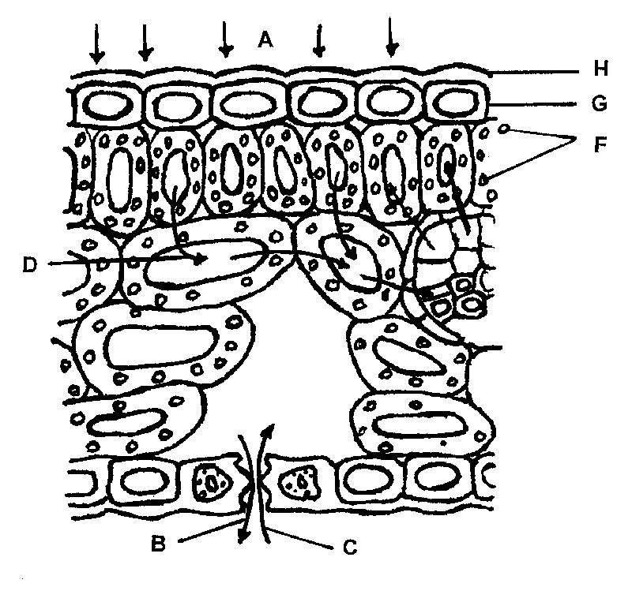
KEY:

The arrows indicate the direction in which A, B, C, D and E move
A

H
G
F

D

E

C
B

 | 1.5.1  1.5.2  1.5.3  1.5.4  1.5.5  1.5.6  1.5.7 | Name the required substances A, C and E respectively.  Name the products/by-products B and D respectively.  Name ONE type of cell in the leaf where these factors or products  will be used or formed in the presence of chloroplasts.  Identify organelle F.  Identify cell G.  Give ONE function of part H.  Identify the opening through which substances B and C move.  TOTAL SECTION A |  | (3)  (2)  (1)  (1)  (1)  (1)  (1)  (10)  [50]

SECTION B

QUESTION 2

2.1 | Study the accompanying diagram of a villus and answer the questions that follow.

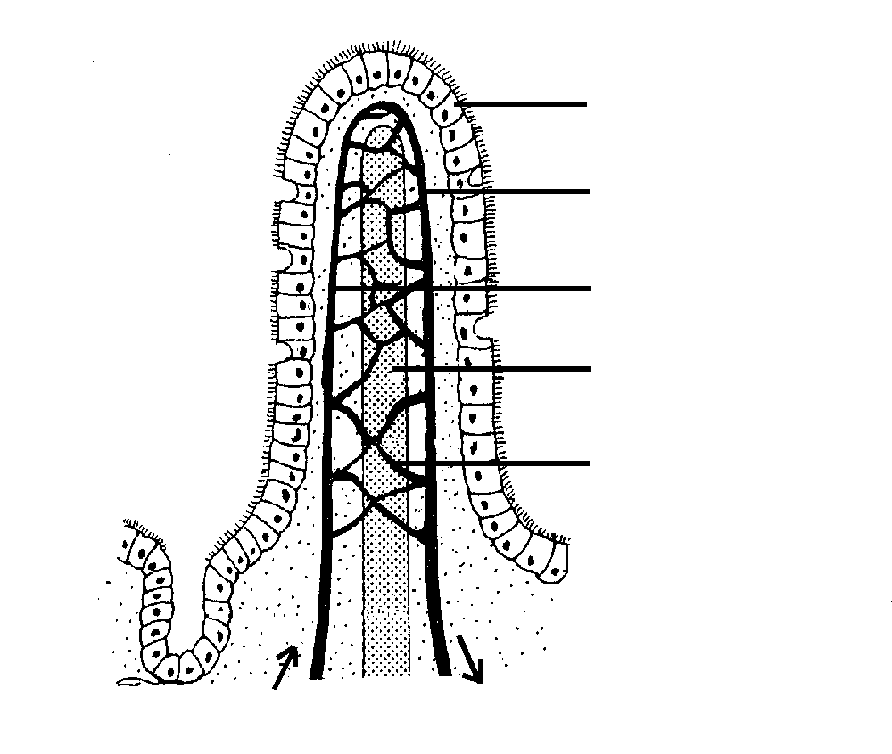
A
B
C
D
E

 | 2.1.1  2.1.2  2.1.3  2.1.4  2.1.5  2.1.6  2.1.7 | In what part of the digestive system are the most villi found?  Why are they located in the region mentioned in Question 2.1.1?  Explain THREE ways in which the villi are adapted to perform  their function.  Identify E.  Name TWO digestive products carried by structure B.  Give ONE difference between the contents of structures B and C.  Write the letter of the part responsible for the absorption of the end products of fat/lipid digestion. |  | (1)  (1)  (6)  (1)  (2)  (2)  (1)

2.2 | The following questions are based on the undermentioned data. Study the graph and then answer the questions which follow.

KEY: Roughage Carbohydrates

Proteins Fats Water

 | 2.2.1  2.2.2  2.2.3  2.2.4  2.2.5  2.2.6 | Which food type will spend more time being digested in the stomach, compared to the other food types?  Which one of the food types contains the highest percentage of  roughage?  Give ONE function of roughage in the human body.  Which food plays the most important role in the prevention of  kwashiorkor?  Which ONE of the foods would release the most energy per  molecule?  Which food contains the least amount of carbohydrates? |  | (2)  (2)  (1)  (2)  (2)  (2)  (25)

QUESTION 3

3.1 | A learner was given FIVE powders A, B, C, D and E. Each powder was tested for the presence of the following:  glucose - using Benedict’s test or Fehling’s solutions  starch - using the iodine test  protein - using the Biuret test or Millon’s test  The table of results below shows the final colour observed at the end of the tests.

 | Powder A | Powder B | Powder C | Powder D | Powder E
Benedict’s/ Fehling's test | Orange | Blue | Blue | Orange | Blue
Iodine test | Blue-black | Blue-black | Yellow/Brown | Blue-black | Yellow/ Brown
Biuret /  Millon’s test | Blue/  White | Blue/  White | Purple/  Brick red | Purple/  Brick red | Blue/  White

Which powder contained…

 | 3.1.1  3.1.2  3.1.3  3.1.4  3.1.5 | protein only?  starch only?  starch and glucose only?  glucose, starch and protein?  no glucose, protein or starch? |  | (5)

3.2 | The following apparatus was set up to demonstrate the action of saliva on starch.

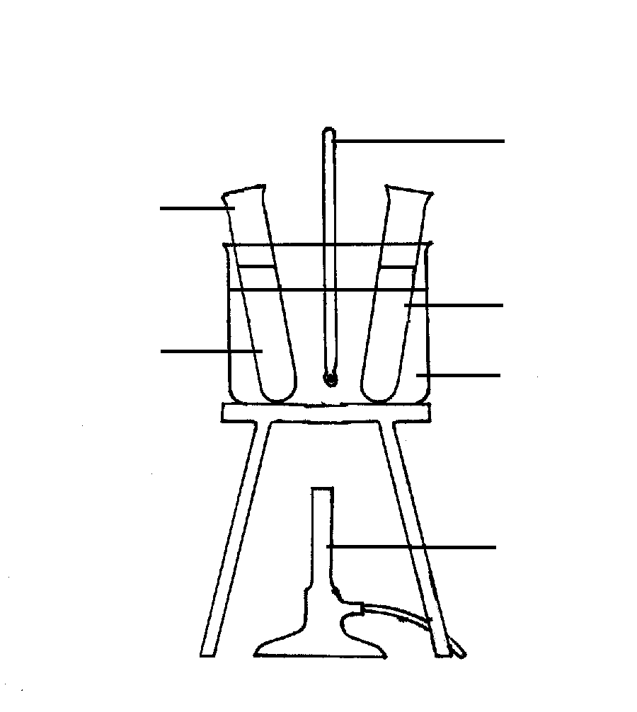
A
starch solution and saliva
thermometer
starch solution
water bath
Bunsen-burner

 | 3.2.1  3.2.2  3.2.3  3.2.4  3.2.5  3.2.6  3.2.7  3.2.8 | Name the active substance in the solution which breaks down starch.  Does this substance mentioned in Question 3.2.1 work in an alkaline, acidic or neutral medium?  Name the product present in test tube A after the starch has been  broken down.  What is the process by which starch is broken down in test tube A called?  At what temperature should the water in the water bath be kept?  Explain your answer to Question 3.2.5 above.  To which group of organic compounds do enzymes belong?  How would a temperature of 100ºC affect the experiment? |  | (1)  (1)  (1)  (2)  (1)  (1)  (1)  (2)
3.3 | The following diagrams show the apparatus of an investigation that was  carried out to determine the influence of carbon dioxide on photosynthesis.
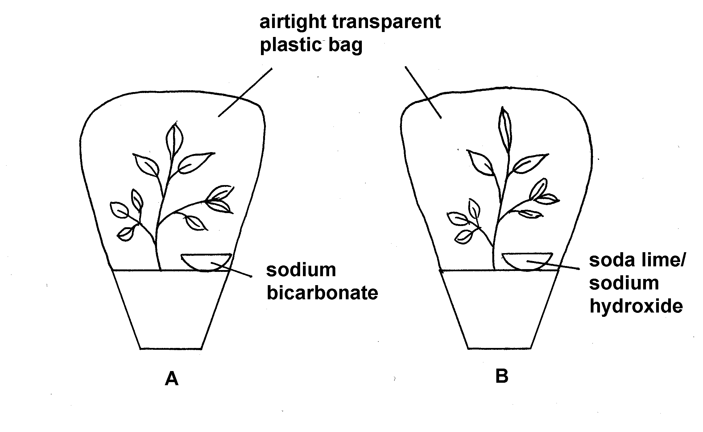

saturated sodium bicarbonate

 | 3.3.1  3.3.2  3.3.3  3.3.4 | Which apparatus, A or B, will contain a greater quantity of carbon dioxide?  In which diagram will you find a positive result for the starch test after a few hours?  What is the function of the soda lime/sodium hydroxide?  Another test was conducted to determine the exact amount of product formed in leaf samples from both sets of apparatus as illustrated in the above diagram. The table below gives the results obtained. All other factors were kept constant. |  | (2)  (2)  (1)

 | Mass of leaf sample at the start of investigation | After 10 minutes | After 60 minutes | After 90 minutes
Apparatus A | 10 mg | 12 mg | 14 mg | 16 mg
Apparatus B | 10 mg | 9 mg | 7 mg | 4 mg

 | (i)  (ii) | Explain why there is a difference between the results obtained in the leaves of plant A and plant B.  Which other factor apart from carbon dioxide is necessary for  photosynthesis? |  | (4)  (1)  (25)

QUESTION 4

4.1 | The diagrams below illustrate some parts of the human respiratory system.

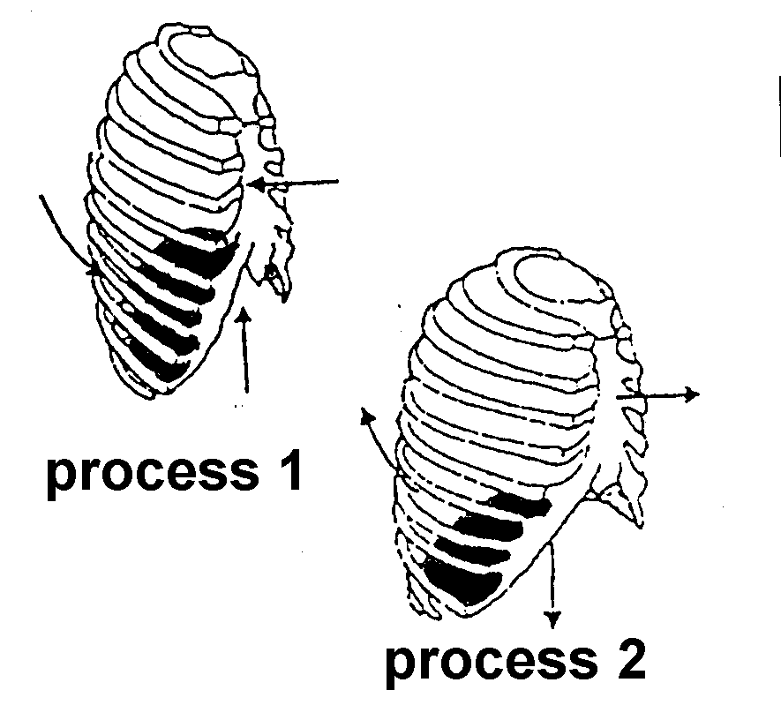
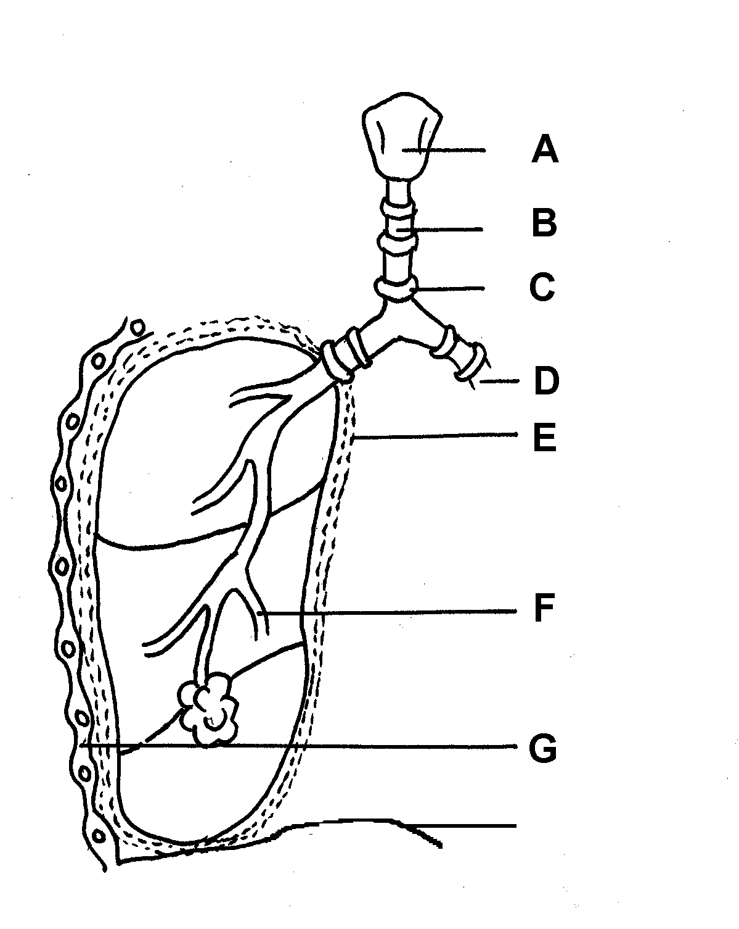
H

 | 4.1.1  4.1.2  4.1.3  4.1.4 | Identify the parts A, B, C, D, E and H.  What are the functions of the structures C, E and H?  State TWO functions of the mucus which lines the air passages.  Study processes 1 and 2 in the diagram. Describe the changes that  take place from process 1 to process 2. |  | (6)  (3)  (2)  (5)

4.2 | Study the following diagram which illustrates part of the human  respiratory system and answer the questions which follow:
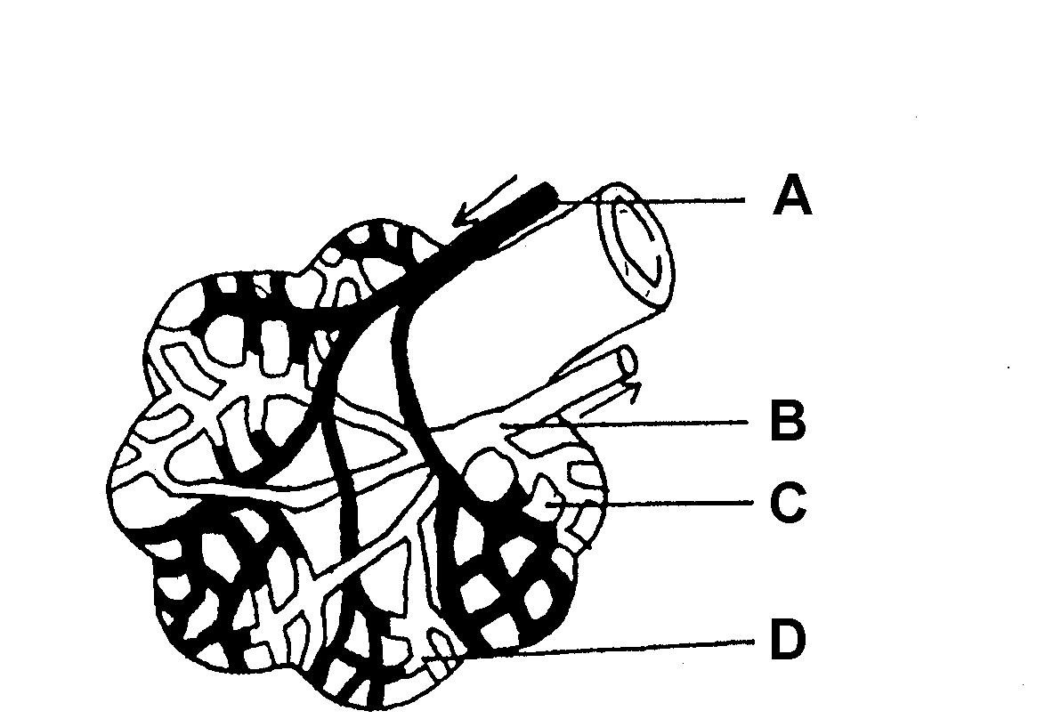

A

B

C

D

 | 4.2.1  4.2.2  4.2.3  4.2.4 | Identify the parts labelled A, B, C and D.  Which gas is at a higher concentration immediately after inhalation at points…  (i) A?  (ii) B?  State TWO ways in which the gas mentioned in Question 4.2.2 (i)  above is transported.  State how the gas mentioned in Question 4.2.2 (ii) is transported. |  | (4)  (2)  (2)  (1)  (25)

QUESTION 5

5.1 | The following diagram illustrates an actively respiring muscle cell.  A B  ENERGY  RELEASED  C D

 | 5.1.1  5.1.2  5.1.3 | Name the required substances, A and B, which enter the cell for  respiration.  Name the by-products C and D.  If this cell had respired anaerobically, which substance would  have ...  (i) entered the cell in insufficient quantities?  (ii) accumulated in the cell? |  | (2)  (2)  (2)  (2)

5.2 | Three thermos flasks A, B and C were set up as shown in the diagram.  Temperatures were measured at daily intervals over a period of five days.

thermos flasks

dead
germinating
seeds seeds

cotton cotton
wool wool

thermometer thermometer

A B C

NB: Seeds in flasks A and B were sterilised.

The results after five days were as follows:

Flask A :  Flask B :  Flask C : | Temperature increased from 18ºC to 21,3ºC on day 5  Temperature remained the same at 18ºC  Temperature increased from 18ºC to 19,6ºC on day 5

 | 5.2.1  5.2.2  5.2.3  5.2.4 | Name the process responsible for the increase in the temperature in flask A.  Why were thermos flasks used instead of plastic/glass bottles?  Why were the seeds soaked in formalin in flask B?  Explain why the temperature increased in flask C. |  | (2)  (2)  (2)  (2)

5.3 | The owner of a nursery (place where plants are sold) has a large number of plants in his garden. He suddenly experienced trouble with plant lice on his plants and decided to try and control this pest with the aid of ladybird beetles instead of insecticides. The results are given in the graph below. Study it and answer the questions.

KEY:

 | 5.3.1  5.3.2  5.3.3  5.3.4  5.3.5 | Use the graph to determine which animal is:  (i) The predator  (ii) The prey  Give a reason for your choices in Question 5.3.1.  What was the maximum number of plant lice per plant during the period of investigation?  After approximately six weeks the number of plant lice started decreasing. Give TWO possible reasons for this decrease.  Give ONE possible reason why the number of plant lice started increasing again after about 12 weeks. . |  | (2)  (2)  (2)  (2)  (1)  (25)

TOTAL SECTION B  GRAND TOTAL |  | [100]  150

