INSTRUCTIONS AND INFORMATION TO CANDIDATES

Read the following carefully before answering the questions:

1.  2.  3.  4.  5.  6.  7.  8. | Answer ALL the questions.  Write ALL the answers in the ANSWER BOOK.  Number the answers exactly as the questions are numbered.  Start the answer to each question at the top of a new page.  All drawings should be made in pencil and labelled in ink.  Calculators may be used.  Write neatly and legibly.  The diagrams in the question paper may not necessarily be drawn to scale.

SECTION A

QUESTION 1

1.1 | Various possible answers are provided for each question. Indicate the correct answer by writing only the letter next to the question number.

 | 1.1.1 | Which one of the following is involved in the sensation of smell?

 |  | A  B  C  D | Proprioceptors  Olfactory receptors  Photoreceptors  Thermoreceptors

 | 1.1.2 | Far-sightedness, in old age, is due to...

 |  | A  B  C  D | the eye lens becoming opaque.  enlargement of the eyeballs.  shortening of the eyeball.  reduced elasticity of the lens.

 | 1.1.3 | Otoliths are...

 |  | A  B  C  D | bones in the middle ear.  concerned with hearing.  parts of the olfactory cells.  involved in maintaining the equilibrium of the body.

 | 1.1.4 | Which ONE of the following statements is correct?

 |  | A  B  C  D | Stimuli are changes in the internal and external environment.  Sensory organs react directly to nerve impulses.  Effectors are sensory cells that receive stimuli.  Receptors are muscles and glands which respond to stimuli.

 | 1.1.5 | Which ONE of the following is a function of the cerebrospinal fluid? It ...

 |  | A  B  C  D | conducts impulses to and from the brain.  protects the delicate structures of the brain and spinal cord.  separates the brain and spinal cord.  ensures a constant pressure only around the brain.

Questions 1.1.6 and 1.1.7 refer to the graph below. The graph shows the relationship between body temperature and air temperature in an endotherm and an ectotherm over a period of 24 hours.

39

37

35

33

31

29

27

25

23

21

19

17

15

13

11
07:00 11:00 15:00 19:00 23:00 03:00 07:00
Temperature (ºC)
air temperature
Time (hours)

 | 1.1.6 | To reach the indicated body temperature on the graph at 15:00 the behaviour of a reptile will be as follows:

 |  | A  B  C  D | Hiding under rocks  Basking in the sun  Burrow in the soil  Panting severely

 | 1.1.7 | The body temperature of the endothermic animal at 03:00 will be ...

 |  | A  B  C  D | 14°C  17°C  33°C  37°C

 | 1.1.8 | Under normal circumstances the kidneys play an important role in maintaining homeostasis with respect to...

 |  | A  B  C  D | osmoregulation.  blood supply.  glucose concentration.  deamination.

 | 1.1.9 | Which organ produces endocrine and exocrine secretions?

 |  | A  B  C  D | Adrenal glands  Pancreas  Thyroid  Liver

 | 1.1.10 | An excess of hydrogen ions (H⁺) in the kidney will give blood a ... pH.

 |  | A  B  C  D | very alkaline  slightly alkaline  slightly acidic  neutral (10 x 2) |  | (20)

1.2 | Give the correct biological term for each of the following descriptions.  Write only the term next to the relevant question number.

 | 1.2.1  1.2.2  1.2.3  1.2.4  1.2.5  1.2.6  1.2.7  1.2.8  1.2.9  1.2.10 | The part of the brain which controls cardiovascular activities  The hormone which regulates the metabolic rate  A fatty structure which insulates an axon  The process which takes place at night in some leaves under conditions of relatively high and increased root pressure  The pressure which arises in a plant cell vacuole as a result of endosmosis  The ability of a solution to absorb water through a differentially permeable membrane  The fluid which drains into blood from blind-ended vessels in humans  The state of inactivity of animals during long periods of cold temperatures  A crystalised organic compound derived from amino acids and which sometimes accumulates as kidney stones  A tough membrane of connective tissue protecting the kidney |  | (10)

1.3 | Match the information in COLUMN II with the word/term in COLUMN I by writing the correct letter next to the corresponding question number.

 | 1.3.1  1.3.2  1.3.3  1.3.4  1.3.5 | COLUMN I  Epidermis  Dendrite  Xylem  Glucose  Pia mater | A  B  C  D  E  F  G  H  I  J | COLUMN II  Delicate membrane with densely packed blood vessels  The layer in the skin which contains the sweat glands  Passively reabsorbed by the kidneys  Tissue responsible for transporting glucose  Outgrowth which conducts impulses to the cell body of a neuron  Actively secreted by a nephron  The layer in the skin from which hair develops  Long extensions of the cell body of a neuron  Tissue without living contents  Outer thick membrane surrounding the brain

 | (5 x 2) |  | (10)

1.4 | State whether for each of the phrases in COLUMN II, it applies to A only, B only, both A and B or none in COLUMN I. Write A only, B only, A and B or none next to the appropriate question number.

 | COLUMN I | COLUMN II
1.4.1 | A - Cranial nerves  B - Spinal nerves | Peripheral nervous system
1.4.2 | A - Cerebellum  B - Cerebrum | Playing soccer
1.4.3 | A - Spinal cord  B - Cerebellum | Respiratory centre

 | (3 x 2) |  | (6)

1.5 | Study the diagram below and complete the passage by filling in the missing words. Write the answer next to the question number.

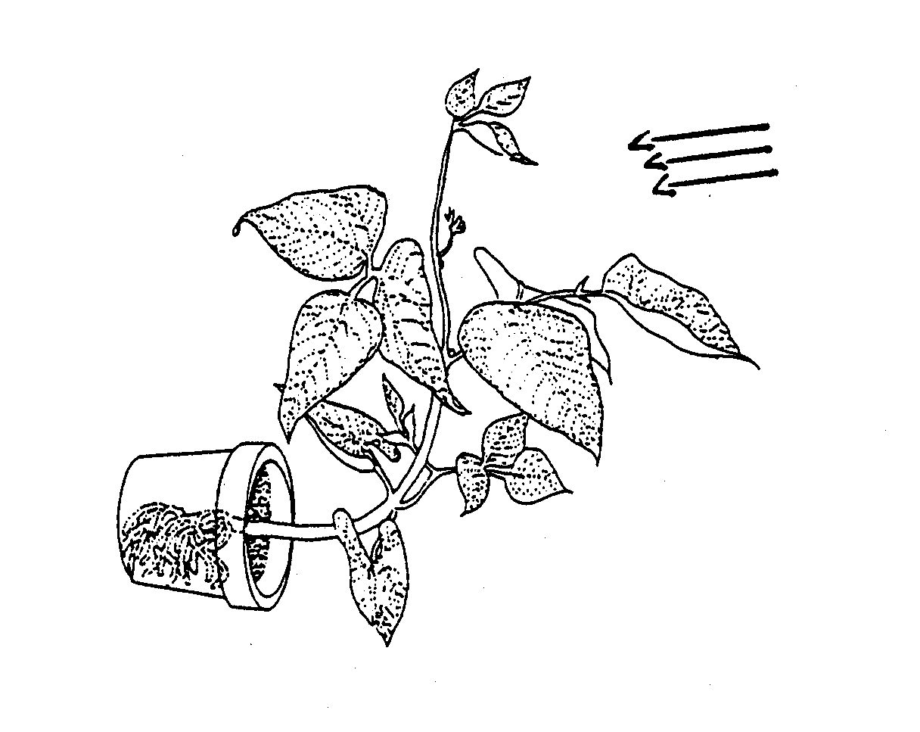
light source

 | When the above plant receives light from only one direction the hormone, 1.5.1, will move to the 1.5.2 side. The higher concentration of this hormone causes cell 1.5.3, while on the opposite side growth is 1.5.4. The effect of this unequal growth causes a 1.5.5 of the stem towards the source of light. This phenomenon is known as positive 1.5.6. 1.5.7 is a growth movement of a plant organ in response to a stimulus of gravity. In roots the hormone is produced in the apical 1.5.8 of a root tip. |  | (8)

1.6 | Each of the diagrams below shows the results of experiments. One part in each diagram is either drawn or labelled incorrectly. Write the number of the incorrect label / part and indicate the correct label or explain how it may be corrected.

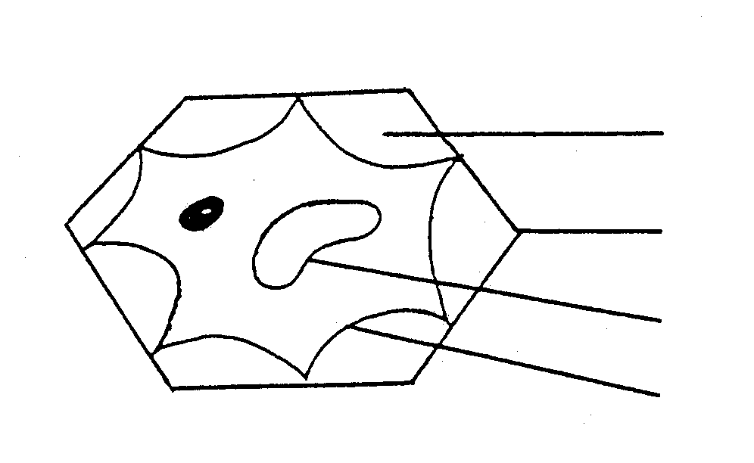
1.6.1

1 cytoplasm

2 cell wall

3 tonoplast

4 cell membrane
5 A partially plasmolysed plant cell

 | 1.6.2 | 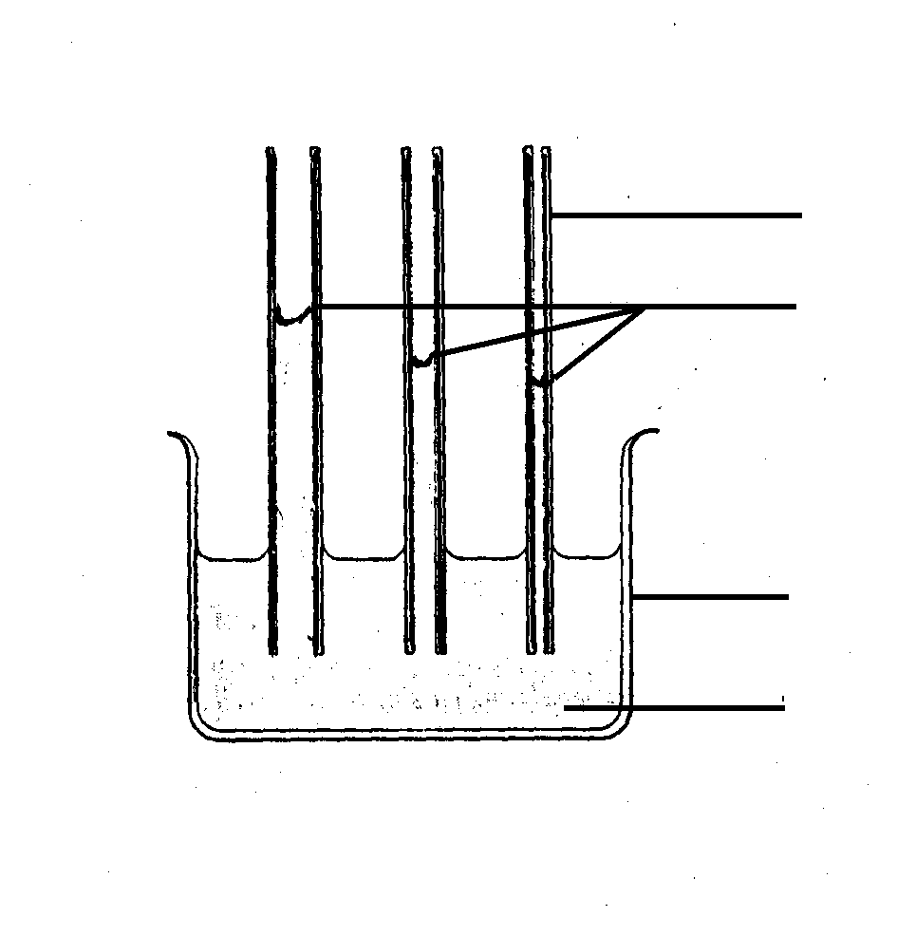  1 glass tube  2 levels of water  3 glass beaker  4 water  5 Experiment to illustrate capillarity

1.6.3
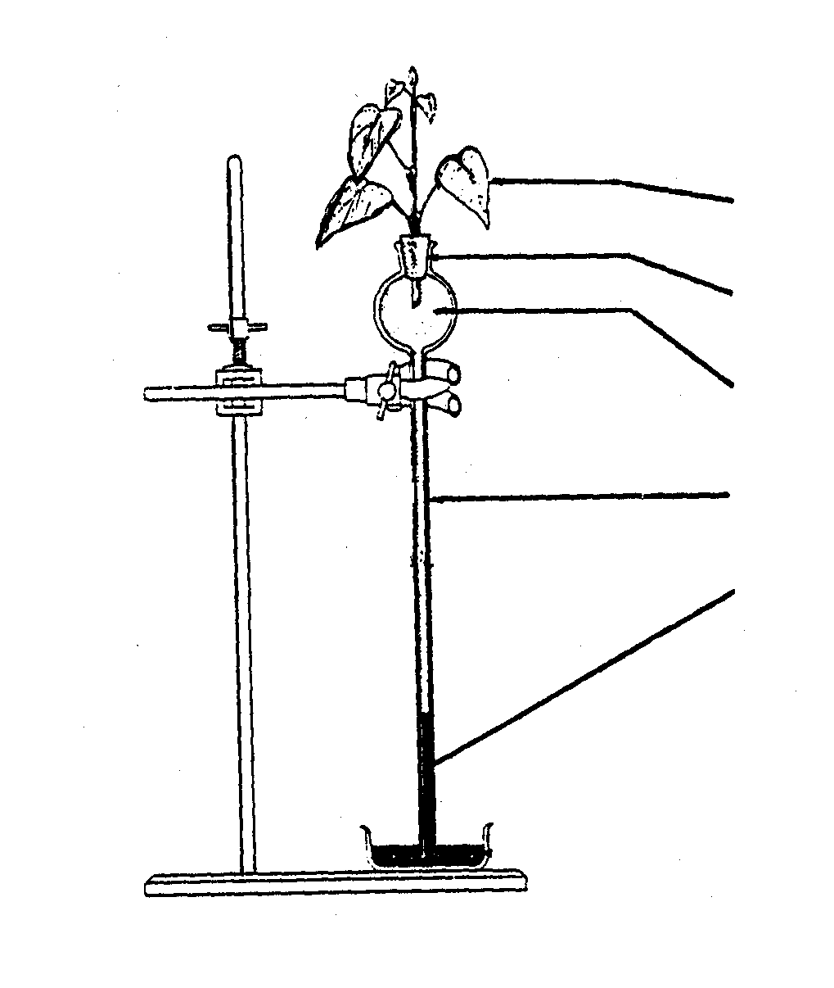

1 twig with leaves
2 rubber stopper

3 glycerine

4 thistle funnel

5 mercury
6 Experiment to illustrate transpiration pull

 |  | (3 x 2) |  | (6)

TOTAL SECTION A |  | [60]

SECTION B

QUESTION 2

2.1 | Study the diagram below and answer the questions that follow:
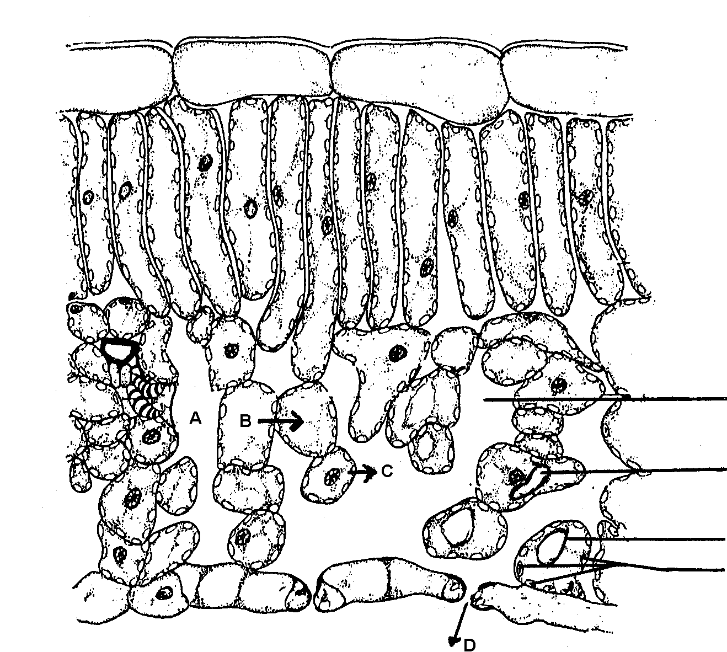

1

2

3
4

2.1.1  2.1.2  2.1.3 | Label parts 1 to 4.  Name the main process responsible for the movement of water from the roots to A.  Name processes B, C and D respectively. |  | (4)  (2)  (3)

2.1.4 | (i)  (ii) | Name the apparatus with which the rate of process D can be measured in the laboratory.  How is the rate determined with this apparatus mentioned in QUESTION 2.1.4 (i)? |  | (1)  (3)

2.1.5  2.1.6  2.1.7  2.1.8 | Draw a labelled diagram of apparatus which can be used to illustrate process B experimentally.  Explain the result of the experiment in QUESTION 2.1.5 in terms of water potential.  Tabulate four differences in the structure of the organ illustrated in the diagram above, in mesophytes and in xerophytes. (4 x 2)  Explain how process C will be affected in rainy conditions. |  | (7)  (4)  (8)  (3)  (35)

QUESTION 3

3.1 | Study the table below, which illustrates the rate of water absorption by roots and the rate of transpiration by leaves:

TIME | A  Rate of water absorption (m per hour) | B  Rate of transpiration  (m per hour)
06:00  08:00  10:00  12:00  14:00  16:00  18:00 | 1,5  1,5  3,2  4,5  5,7  7,6  8,0 | 0,5  2,0  4,5  6,0  7,4  9,3  5,5

 | 3.1.1  3.1.2  3.1.3  3.1.4  3.1.5 | Draw line graphs on the same system of axis to illustrate these results. Label them A and B.  Add a new line on the graph to represent the transpiration rate you might expect if wind is blowing over the experiment.  Using information on the table, indicate the time during which the sun rises. Give a reason for the answer.  When does maximum transpiration occur?  Is there a nett loss or a nett gain of water by the plant between 06:00 – 18:00? Show calculations. |  | (6)  (2)  (2)  (1)  (4)

3.2 | The diagram below shows a kidney and associated structures. The tables, A and B, list the percentages of certain components found in certain structures of the kidney.

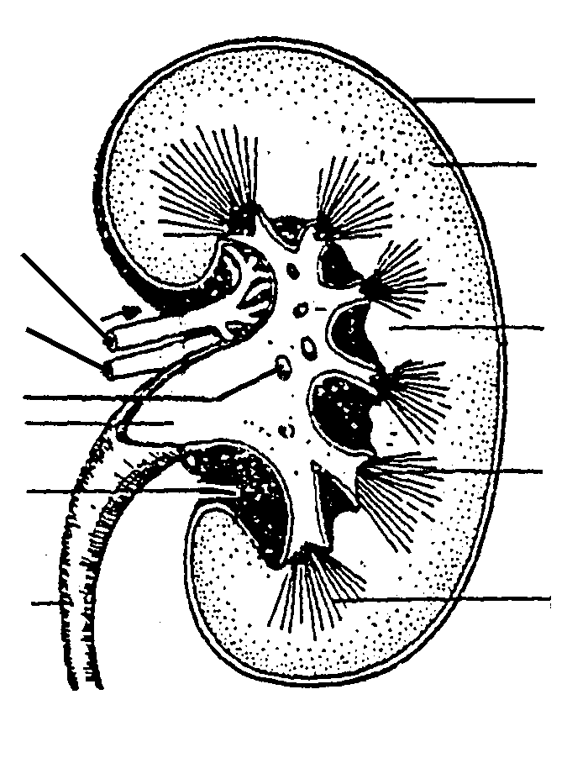
A

11

10
9
8

7

6
1

2

3

4

5
Component | Concentration %
urea | 0,03
glucose | 0,10
amino acids | 0,05
salts | 0,72
proteins | 8,00

B
Component | Concentration %
urea | 2,00
glucose | 0,00
amino acids | 0,00
salts | 1,50
proteins | 0,00

 | 3.2.1  3.2.2  3.2.3  3.2.4 | Identify parts 4, 5 and 8.  Name ONE place where the contents of B might be found.  Explain the answer.  Which structures, shown in the diagram, may be associated with table A? Give reasons for the answer.  In which numbers of the diagram are the following found: |  | (3)  (4)  (4)

 |  | (i)  (ii)  (iii) | Ducts of Bellini  Malpighian bodies  Loop of Henlé |  | (1)  (1)  (1)

 | 3.2.5 | Explain how the kidneys ensure that a person does not dehydrate on a hot day. |  | (6)  (35)

QUESTION 4

4.1 | When a person's kidneys do not function as a result of a disease or injury, the blood must be cleansed artificially by dialysis. One method of dialysis is the usage of an artificial kidney machine indicated by the diagram below:

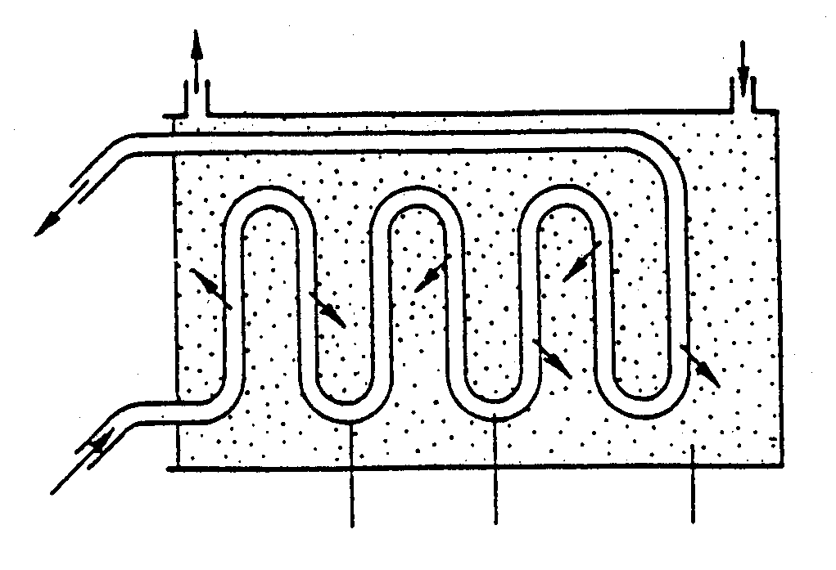
bathing fluid
bathing fluid
blood to patient
blood from patient
tube A blood bathing fluid

 | 4.1.1  4.1.2  4.1.3  4.1.4  4.1.5 | What particular property must the wall of tube A have?  Suggest why tube A is coiled rather than straight.  Name ONE constituent of the blood plasma that does not pass into the bathing fluid.  Name TWO substances, other than salts, which pass into the bathing fluid.  Explain why the bathing fluid must already contain essential salts before it enters the machine. |  | (1)  (2)  (1)  (2)  (2)

4.2 | Draw a labelled diagram of a Malpighian body. |  | (8)

4.3 | Study the graph below, illustrating O₂ consumption at different environmental temperatures, and answer the questions that follow:

Environmental temperature ( □C)
Oxygen consumption
(arbitrary units)
endotherm
ectotherm

 | 4.3.1  4.3.2  4.3.3  4.3.4 | Explain why ectothermic animals use less oxygen at low environmental temperatures.  Which ONE of the groups of organisms on the graph uses more of its own energy to regulate its body temperature?  Explain your answer in QUESTION 4.3.2.  At which environmental temperatures do endothermic organisms use the least energy for thermoregulation? Give a reason for the answer. |  | (3)  (1)  (3)  (3)

4.4 | Structures in the ear respond to sudden changes in body position. Name TWO structures in the ear and explain ONE way in which each structure named responds to such changes. |  | (4)

4.5 | Explain the consequences of the following abnormalities in the human body:

 | 4.5.1 | Blockage of Eustachian tubes |  | (3)

 | 4.5.2 | Fused bony ossicles |  | (2)  (35)

TOTAL SECTION B |  | [105]

SECTION C

QUESTION 5

5.1 | The diagram below illustrates two boys playing cricket just after sunset:

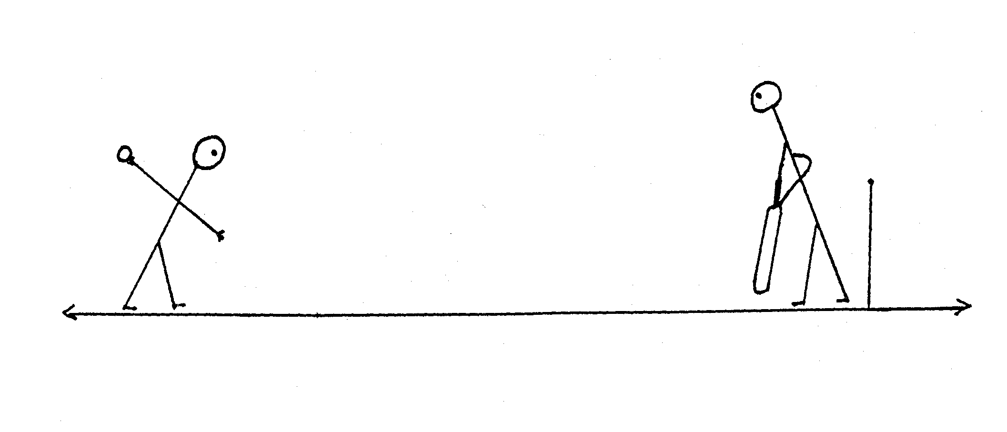
bowler22 mbatsman

 | 5.1.1 | How does the batsman manage to keep his eyes focused from the time the ball leaves the bowler's hand, until he hits the ball? |  | (8)

 | 5.1.2 | The table below indicates the appearance of the boys' pupils:

Time of day | Diameter of pupil (mm)
15:00  17:00  19:00 | 2,0  2,4  3,8

 |  | (i) | Give the diameter of the pupils of the batsman at 19:00. |  | (2)

 |  | (ii) | Explain how the changes in the pupils of the batsman are brought about. |  | (5)

 |  | (iii) | Why are the changes referred to in QUESTION 5.1.2 (ii) regarded as a reflex action? |  | (2)

5.2 | Explain how a person who is running and is suddenly frightened by the sound of a hissing snake, responds.  Content : 15  Synthesis: 3 |  | (18)

TOTAL SECTION C  GRAND TOTAL |  | [35]  200

