INSTRUCTIONS AND INFORMATION TO CANDIDATES

Read the following carefully before answering the questions:

1.  2.  3.  4.  5.  6.  7.  8. | Answer ALL the questions.  Write ALL the answers in the ANSWER BOOK.  Number the answers exactly as the questions are numbered.  Start the answer to each question at the top of a new page.  All drawings should be done in pencil and labelled in ink.  Write neatly and legibly.  Calculators may be used.  The diagrams in the question paper are not necessarily drawn to scale.

SECTION A

QUESTION 1

1.1 | Various possible answers are provided for each question. Indicate the correct answer by writing only the letter next to the question number.

 | 1.1.1 | The oxygen in the air we breathe …

 | A  B  C  D | functions as the final electron acceptor during oxidative phosphorylation.  is released during the Krebs cycle.  combines with carbon to form carbon dioxide.  combines with carbon to form glucose.

 | 1.1.2 | Which ONE of the following is the correct function of the cilia in the nasal passage of humans?

 | A  B  C  D | Secretes mucus which traps dust particles  Moistens the incoming air  Beating causes the incoming air to be warmed  Beating carries trapped dust particles to the back of the mouth cavity

 | 1.1.3 | Which ONE of the following statements about hepatic portal blood is true?

 | A  B  C  D | It contains absorbed fats.  It contains ingested proteins.  It is mixed with bile in the liver.  It is mixed with blood from the hepatic artery in the liver.

 | 1.1.4 | The carbohydrates synthesised by green plants may be converted into the structure of new cells in the form of….

 | A  B  C  D | glucose.  sucrose.  cellulose.  starch.

 | 1.1.5  1.1.6  1.1.7 | Which of the following combination of conditions must be satisfied for the mark-recapture technique to be reliable?  (i) The mark must last for the entire period of the investigation  (ii) The mark must affect the movement of the animals  (iii) The marked animals must be allowed to mix freely and  randomly with the entire population  (iv) The population should change during the period of the  investigation  A (i); (ii) and (iii)  B (i) and (iii)  C (ii) and (iv)  D (ii); (iii) and (iv)  Which ONE of the following is released during the light phase of  photosynthesis and combines with carbon dioxide during the dark phase?  A Oxygen atoms  B Hydrogen atoms  C ATP  D Water  Where exactly, in the chloroplast, does the light phase of  photosynthesis occur?  A Stroma  B Cristae  C Grana  D Ribosomes  (7 x 2) |  | (14)

1.2 | Give the correct biological term for each of the following descriptions. Write only the correct term next to the appropriate question number.

 | 1.2.1  1.2.2  1.2.3  1.2.4  1.2.5  1.2.6  1.2.7  1.2.8  1.2.9  1.2.10 | A nutrient that prevents abnormal enlargement of the thyroid gland  A disorder caused by the lack of vitamin B₃ (Niacin/Nicotinic acid/  Vitamin pp)  The chemical reagent used to test for the presence of starch  Organic co-factors which serve as hydrogen carriers in biochemical reactions  The region in the chloroplast where the dark phase of  photosynthesis occurs  The stage of respiration when carbon dioxide is released  The end product of protein digestion  A psychological disease characterised by a refusal to eat, resulting in great loss in mass  The bones of the nasal cavity, which slow down the movement of the incoming air  A type of population dispersal involving the mass movement of the  entire population from one place into another and back again |  | (10)

1.3 | Match the items in COLUMN I with the information in COLUMN II.  Write only the letter of your choice next to the associated question number.

 | (5 x 2) | (10)
  COLUMN I | COLUMN II
  1.3.1 Vitamin B₁  1.3.2 Vitamin K  1.3.3 Nitrogen  1.3.4 Iron  1.3.5 Phosphorus | A  B  C  D  E  F  G  H  I | Synthesised by bacteria in the human intestine  Required for the synthesis of  proteins  Deficiency leads to beri-beri  Required for the formation of  bones and teeth  Necessary for the secretion of  hydrochloric acid  Prevents bleeding of gums  Obtained from tea, nuts and  spices  Involved in the metabolism of  glucose  A component of haemoglobin

1.4 | Study the diagram below and then answer the questions that follow.
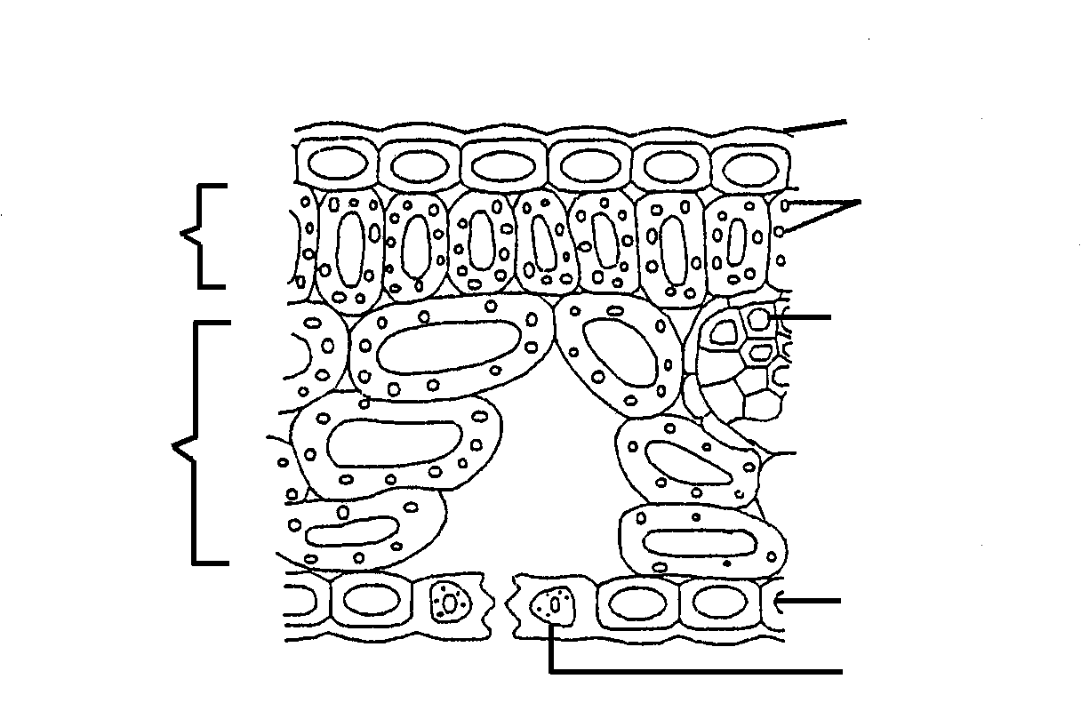

A

B
D

C

E

X

Y

For each of the statements below, indicate the LETTER in the diagram above
which corresponds with it.

 | 1.4.1 | Prevents the loss of excess moisture. |  | (2)

 | 1.4.2 | Specialised epidermal cell with chloroplasts. |  | (2)

 | 1.4.3  1.4.4 | The main photosynthetic cells in the leaf.  Cells with thick, lignified walls. |  | (2)  (2)  (8)

1.5 | The following is a list of some food sources of nutrients.  grapes; egg-yolk; whole-wheat bread; carrots;  cane sugar; oranges; guavas; spinach  Select from the list:

 | 1.5.1  1.5.2  1.5.3  1.5.4  1.5.5 | TWO that are rich in vitamin C  ONE that would prevent rickets  ONE that would probably assist in fat absorption and cellular  respiration  TWO that will show a positive result for glucose when treated with HC and then with either Benedict’s or Fehling’s A and B solutions  TWO that are rich in vitamin A |  | (2)  (1)  (1)  (2)  (2)  (8)

1.6 | An investigation of the action of enzymes was conducted by a group of learners as indicated in the diagram below. The glass cylinders P, Q, R, and S were left in a water bath at 37ºC for 30 minutes. Assume that the total volume does not affect the result.

- 1 m pepsin solution  - 1 m water | - 1 m pepsin  solution  - 1 m  hydrochloric acid  - 1 m water | - 1 m pepsin  solution  - 1 m sodium  hydroxide  - 1 m water | - 1 m water

glass
P cylinder Q R S

5 m albumin 5 m albumin 5 m albumin

Results of the above investigation:

Glass cylinders | Appearance of contents of glass cylinders at beginning of investigation | Appearance of contents of glass cylinders after 30 minutes
P | Whitish | Whitish
Q | Whitish | Clear
R | Whitish | Whitish
S | Whitish | Whitish

 | 1.6.1 | State ONE aim of the investigation. |  | (2)

 | 1.6.2 | Why was the temperature of the water bath maintained at 37ºC? |  | (1)

 | 1.6.3 | State ONE difference between the results of Q and S. |  | (1)

 | 1.6.4 | What is the purpose of…

 | (i)  (ii) | glass cylinder S?  the sodium hydroxide? |  | (1)  (1)

 | 1.6.5 | Where is pepsin secreted in the human alimentary canal? |  | (1)

 | 1.6.6 | Which glass cylinder has conditions similar to that of the part  named in Question 1.6.5? |  | (1)

 | 1.6.7 | If hydrochloric acid is added to glass cylinder P after 30 minutes and the glass cylinder is left in the water bath for a further 30 minutes, what would the contents of this glass cylinder look like?  TOTAL SECTION A |  | (2)  (10)  [60]

SECTION B

QUESTION 2

2.1 | Study the diagram below and answer the questions that follow.  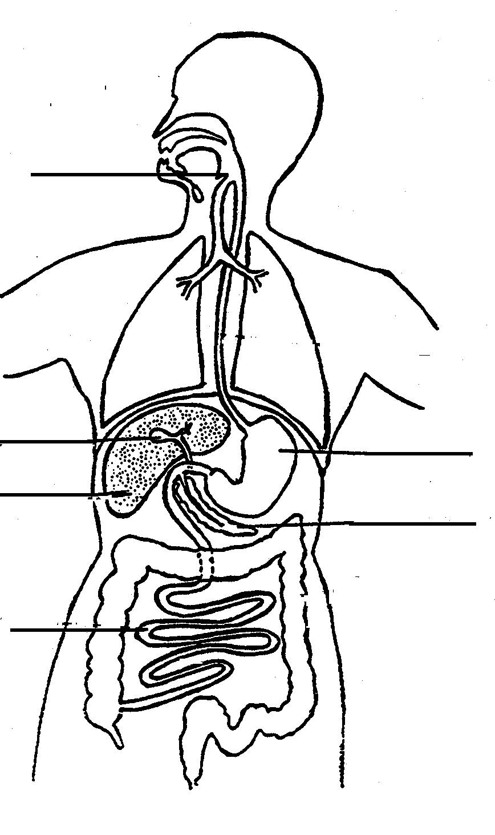  epiglottis  A  F  E  B  C  D

 | 2.1.1 | State ONE function of the epiglottis. |  | (1)

 | 2.1.2 | Waves of muscular contractions move across part A after food has arrived there.

 | (i)  (ii)  (iii) | What term is used to describe these wave-like movements?  Give ONE function of this movement.  How is the internal lining of part A protected against  digestion by enzymes? |  | (1)  (1)  (1)

 | 2.1.3 | State the LETTER of the part which secretes pancreatic juice. |  | (1)

 | 2.1.4 | Name the main part of the alimentary canal where pancreatic juice is active. |  | (1)

 | 2.1.5 | What is the role of the mucus that is secreted in the oesophagus? |  | (2)

2.2 | The villi in the small intestine of mammals are structurally suited for efficient absorption of nutrients.

 | 2.2.1 | Explain THREE ways to show that the above statement is true. |  | (6)

 | 2.2.2 | Name the main end products of the digestion of potatoes and  describe how they are absorbed by the body. |  | (6)

2.3 | The graphs below show the average variation in the levels of blood glucose and insulin over a six-hour period for ten people with normal glucose levels. (A normal glucose level is 100 mg per 100 cm³ .)  Two meals were eaten and a period of exercise occurred at the times shown.

First meal eaten
Period of exercise
Second meal eaten

glucose
insulin

insulin

 | 2.3.1 | What effect do the following have on the blood glucose level?

 | (i)  (ii) | A meal  A period of exercise |  | (1)  (1)

 | 2.3.2 | Describe the effect of insulin on the blood glucose level. |  | (3)

 | 2.3.3 | Give a reason for each of the following experimental procedures:

 | (i)  (ii) | taking the average level for a group of people rather than for  a single person.  using only people with normal glucose levels. |  | (2)  (2)

 | 2.3.4 | How long after the first meal does it take for the blood glucose level  to return to normal? |  | (2)

 | 2.3.5 | Give the 'normal' insulin concentration in the blood when the  blood glucose returned to normal after the first meal. |  | (1)

 | 2.3.6 | Explain the increase in the blood glucose level during the period of  exercise. |  | (3)  (35)

QUESTION 3

3.1 | The diagrams below represent age distribution for the human population of a developed country and a developing country in one year at a certain time.

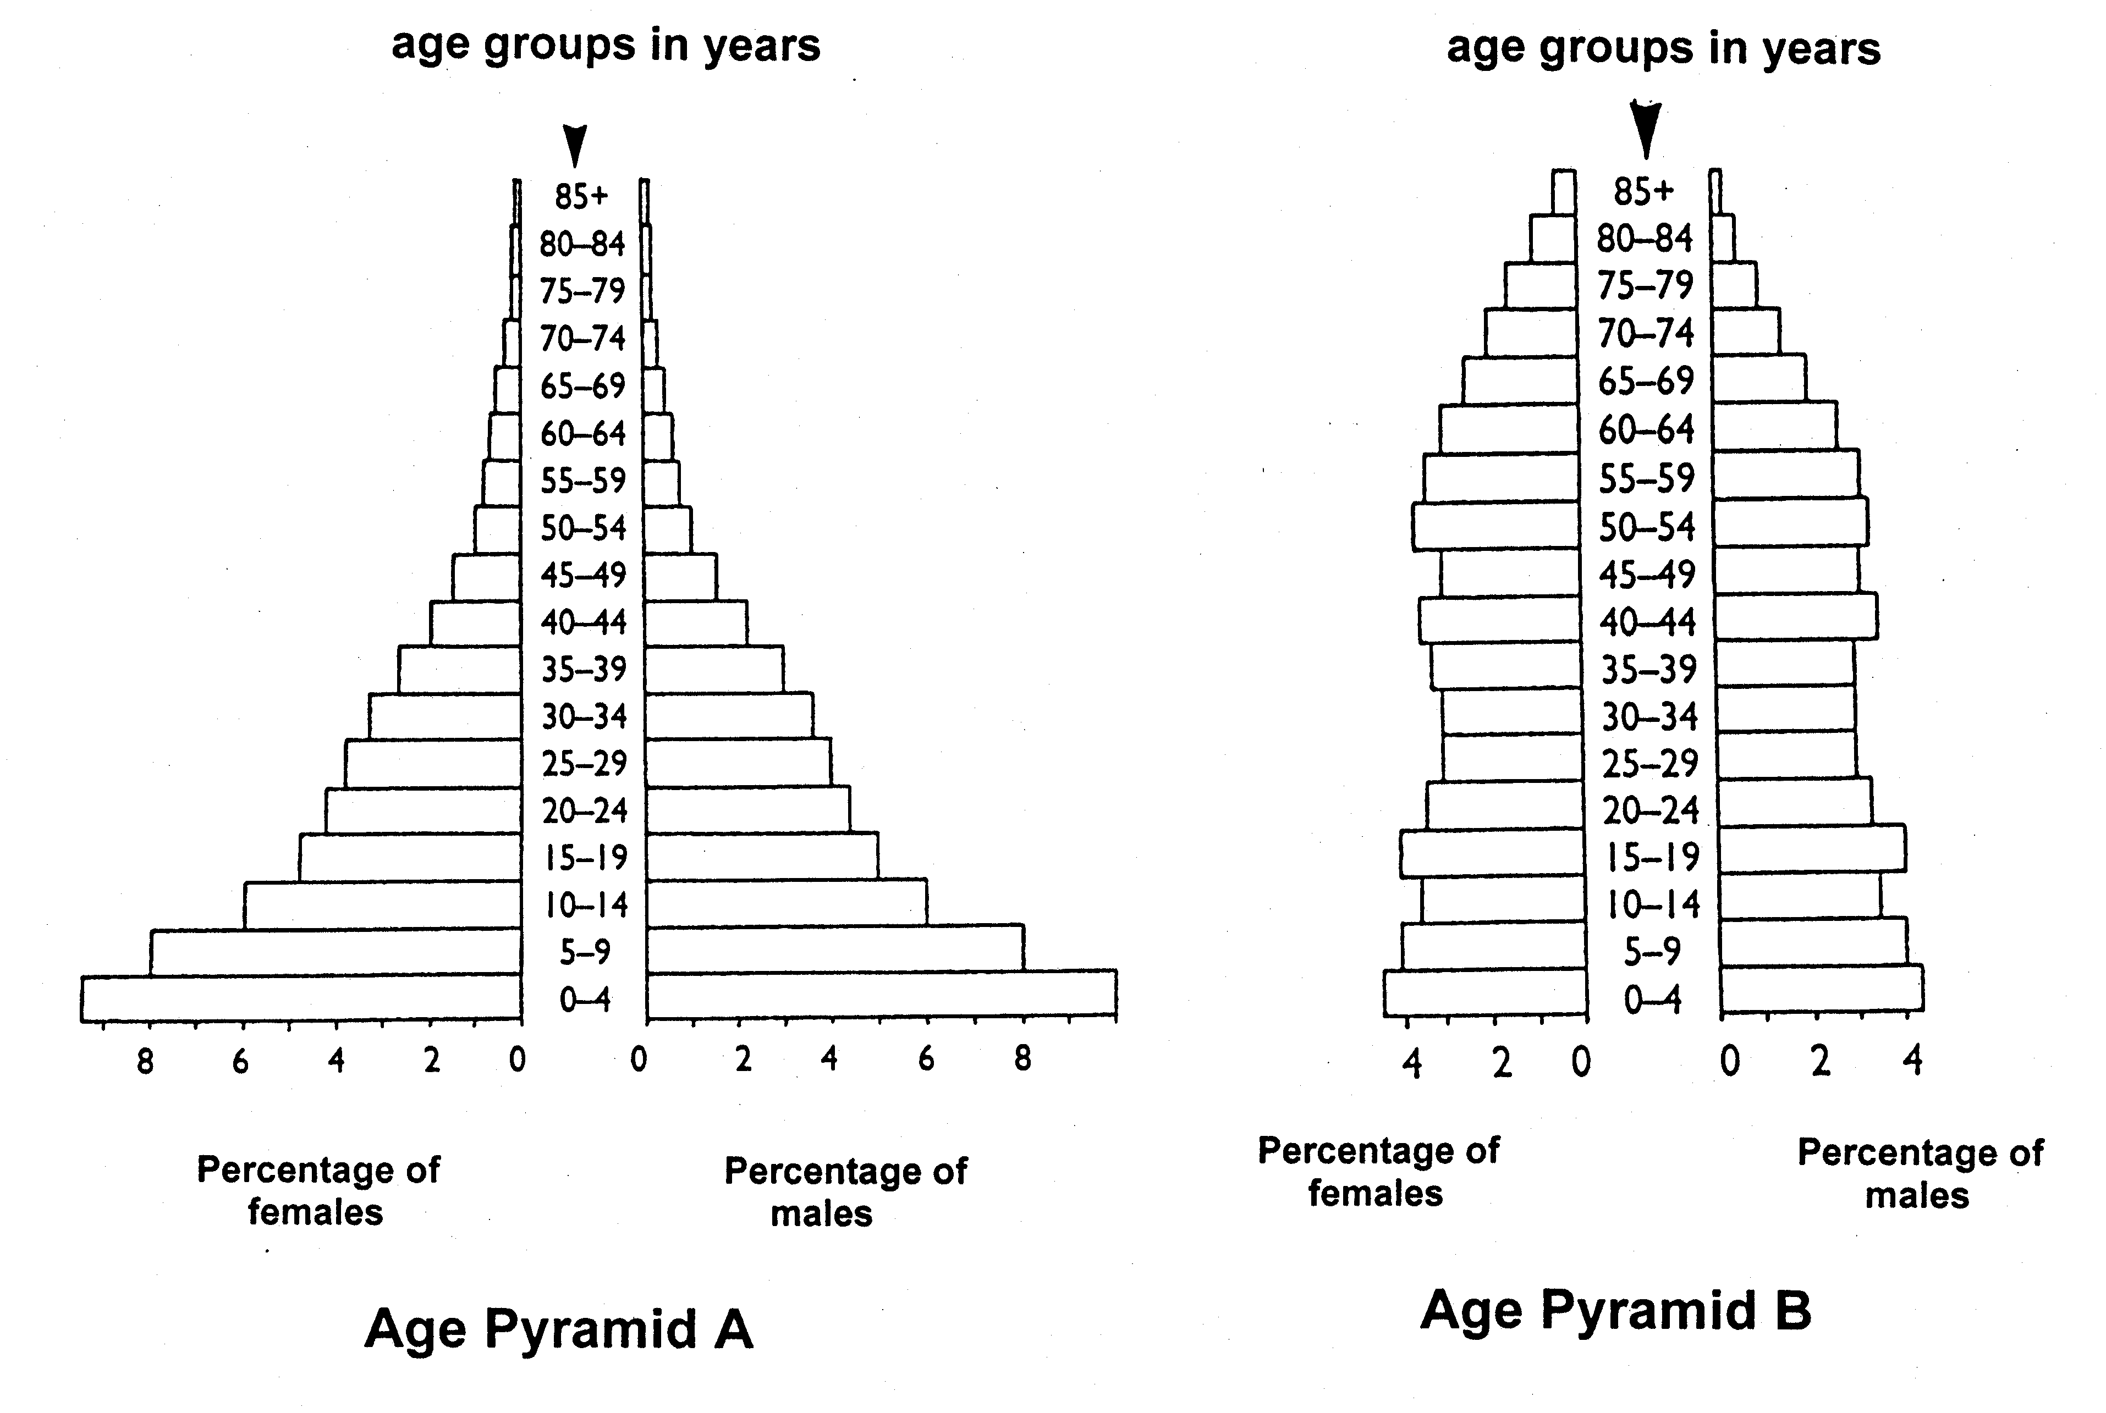

 | 3.1.1 | What percentage of the female population is aged between 5 and 9 years in Pyramid A? |  | (2)

 | 3.1.2 | Which age group makes up exactly 6 percent of the male  population in Pyramid A? |  | (2)

 | 3.1.3 | What percentage of the female population are aged 65 to 69 years in Pyramid B? |  | (1)

 | 3.1.4 | Which group, male or female, has the larger percentage reaching old age in Pyramid B? |  | (1)

 | 3.1.5 | Which pyramid represents the population distribution of a  developed country? |  | (1)

 | 3.1.6 | Give TWO reasons for the answer in Question 3.1.5. |  | (2)

3.2 | Differentiate between the following pairs of terms:

 | 3.2.1  3.2.2  3 3.2.3 | Intraspecific competition and interspecific competition  Density–dependent factors and density–independent factors  Predator and prey |  | (2)  (2)  (2)

3.3 | The table below shows changes in the number of bacteria growing in a special nutrient medium. The temperature was kept constant at an optimum level over a period of 30 hours.

Time (hours) | 0 | 5 | 10 | 15 | 20 | 25 | 30
Number of  bacteria | 1 | 300 | 1 000 | 4 400 | 5 000 | 4 900 | 4 000

 | 3.3.1 | Plot a line graph of the above results.  Use an appropriate scale and labels for the axes. |  | (10)
 | 3.3.2 | Identify the type of growth form from the graph. |  | (1)

 | 3.3.3 | Determine the number of bacteria at 22 hours. |  | (2)

 | 3.3.4 | After 5 hours the bacteria population was 300. How many more  hours passed before the population doubled in number? |  | (2)

 | 3.3.5 | Give a reason for the shape of the curve between 10 and 15 hours. |  | (3)

 | 3.3.6 | Give TWO possible reasons for the decrease in the number of bacteria after about 23 hours. |  | (2)  (35)

QUESTION 4

4.1 | The sets of apparatus below were used to demonstrate a biochemical  process. Answer the questions which follow.

AT THE BEGINNING
A (in a water bath B (in a water bath
at 20ºC) at 30ºC)

cm³ cm³
-100 measuring -100
-90 cylinders -90
-80 -80
-70 -70
-60 -60
-50 -50
-40 -40
-30 -30
-20 -20
-10 dough containing -10
flour, yeast and
glucose

AFTER ONE HOUR
A B

cm³ cm³
-100 -100
-90 -90
-80 -80
-70 -70
-60 -60 -50 -50
-40 -40 -30 -30
-20 dough -20 -10 -10

NOTE: A dough is the raw mixture from which bread is made.

 | 4.1.1 | Name the biochemical process that is being demonstrated. |  | (2)
 | 4.1.2 | What is the approximate volume of the dough after one hour in the  following cylinders:

 | (i)  (ii) | A  B |  | (1)  (1)

 | 4.1.3 | What product of the biochemical process has caused the swelling of the dough? |  | (1)

 | 4.1.4 | Suggest a reason for the difference in the volume of the dough in each measuring cylinder after one hour. |  | (2)

 | 4.1.5 | Which substance in the dough provided the raw material for the biochemical process? |  | (1)

 | 4.1.6 | Tabulate TWO differences between glycolysis and oxidative  phosphorylation. |  | (4)

4.2 | The diagram below represents an apparatus used in an investigation. The  number of gas bubbles rising from the plant was counted each minute. The  results of the investigation are recorded in the table below.

bubbles of gas
0 0
water 00 0 0 lamp
water
plant

Number of bubbles Distance between lamp and plant
per minute (cm)

98 10
56 15
29 20
20 25
8 30
3 35
1 40

 | 4.2.1 | State ONE aim for this investigation. |  | (2)

 | 4.2.2 | Name the gas that is produced by the plant. |  | (1)

 | 4.2.3 | The water plant does not have stomata. Suggest how gaseous  exchange takes place in this plant. |  | (2)
 | 4.2.4 | Sometimes a chemical in the form of potassium bicarbonate  (KHCO₃) is added to the water. How will this chemical affect the  investigation? |  | (3)

 | 4.2.5 | State ONE conclusion about this investigation from the results. |  | (4)

4.3 | The graph below shows the concentration of carbon dioxide in a crop of plants in a garden.

Normal concentration of carbon dioxide
NOTE: The top of the vegetation is at approximately 100 cm.

 | 4.3.1 | According to the graph, what is the normal carbon dioxide concentration in the air? |  | (2)

 | 4.3.2 | At what height above the ground is there the lowest concentration of carbon dioxide? |  | (2)

 | 4.3.3 | Suggest a reason for the concentration of carbon dioxide being the lowest at the height mentioned in Question 4.3.2. |  | (3)

 | 4.3.4 | Why is the concentration of carbon dioxide at ground level greater than that normally found in the air?  TOTAL SECTION B |  | (4)  (35)  [105]

SECTION C

QUESTION 5

5.1 | Study the diagram and the table below and then answer the questions which follow.  The diagram shows a blood capillary in close contact with structure X. The relative concentrations of CO₂ and O₂ (in arbitrary units) are given at three different sites X, P and Q.  The table shows the rate of blood flow in cubic centimetres per minute through different parts of the body as increasingly strenuous exercise is carried out.

100 units O₂
X
40 units CO₂ blood capillary

40 units O₂ 95 units O₂
P Q
46 units CO₂ 40 units CO₂

Part of body Blood flow in cm³ per minute

At Rest Light Strenuous Maximum
Exercise Exercise Exercise

Brain 750 750 750 750
Skin 500 1 500 1 900 600
Heart Muscle 250 350 750 1 000
Skeletal Muscle 1 200 4 500 12 500 22 000
Kidneys 1 100 900 600 250
Small Intestine 1 400 1 100 600 300
Other 600 400 400 100

 | 5.1.1 | Which one of the following statements is TRUE with regard to the  diagram above?

Statement  Statement  Statement  Statement | A:  B:  C:  D: | X is an alveolus and blood flow is from P to Q.  X is an alveolus and blood flow is from Q to P.  X is a muscle and blood flow is from P to Q.  X is a muscle and blood flow is from Q to P. |  | (2)

 | 5.1.2 | State ONE generalisation that can be made from the information in the table. |  | (2)

 | 5.1.3 | How much blood passes through the heart muscle during…

 | (i)  (ii)  (iii) | rest?  exercise?  maximum exercise? |  | (1)  (1)  (1)

 | 5.1.4 | Which part of the body has the greatest increase in blood flow  during maximum exercise compared to the body at rest? |  | (2)

 | 5.1.5 | Explain why it is unwise to carry out strenuous exercise after eating a large meal. |  | (2)

 | 5.1.6 | Calculate the blood flow through all parts of the body during strenuous exercise. (Show all calculations.) |  | (2)

 | 5.1.7 | As exercise increases in the skeletal muscles, what happens to the…

 | (i)  (ii) | pyruvic acid?  pH of the blood? |  | (2)  (2)  (17)

5.2 | Discuss the breathing pattern of an athlete at rest, how this changes during a race and immediately after the race (the recovery period) as illustrated in the sketches below.

At rest During the race Recovery period

Content: 15  Synthesis: 3  TOTAL SECTION C  GRAND TOTAL |  | (18)  [35]  200

