GAUTENG DEPARTMENT OF EDUCATION

SENIOR CERTIFICATE EXAMINATION

BIOLOGY SG

TIME : 3 hours

MARKS : 300

INSTRUCTIONS:

- Answer ALL the questions in your answer book.

- Number ALL the questions clearly and accurately using the question numbers provided.

SECTION A

Answer QUESTION 1A on the multiple choice answer sheet on the inside cover of your answer book.

QUESTION 1A

Four possibilities are suggested as answers to the following questions, of which only one is correct in each case. Indicate the correct answer by making a cross (X) over the appropriate letter next to the corresponding number on the answer sheet.

EXAMPLE: Saliva is secreted in the

- mouth.
- oesophagus (food pipe).
- stomach.
- duodenum (small intestine).

ANSWER: A B C D

1.1 Which of the following is an inorganic compound?
 | A. | Glucose
 | B. | Amino acid
 | C. | Cellulose
 | D. | Water

1.2 Which one of the following macro-elements is an important part of the energy carrier molecule used during photosynthesis and respiration?
 | A. | Phosphorus
 | B. | Iodine
 | C. | Magnesium
 | D. | Sodium

1.3 Micronutrients are also known as
 | A. | Proteins
 | B. | Hormones
 | C. | Enzymes
 | D. | Trace elements

Questions 1.4 to 1.6 are based on the accompanying diagram, showing the synthesis of a certain vitamin in the human body.
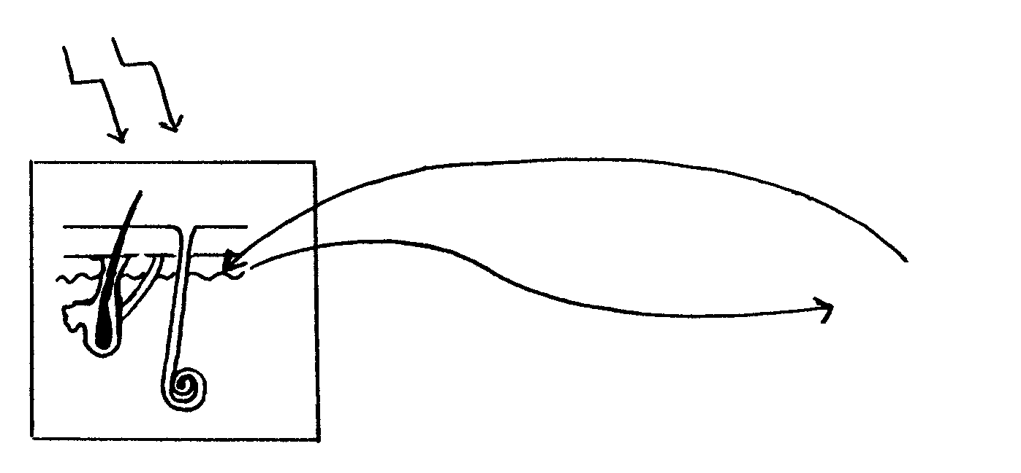
Sunlight
liver
skin

sweat gland
Vitamin X

1.4 The vitamin X being synthesised is
 | A. | Vitamin D.
 | B. | Vitamin C.
 | C. | Vitamin B.
 | D. | Vitamin A.

1.5 If a growing child does not have enough of the vitamin mentioned in Question 1.4, the child is most likely to develop one of the following:
 | A. | Beri-beri
 | B. | Anaemia
 | C. | Rickets
 | D. | Scurvy

1.6 Which food is most likely to prevent the condition mentioned in Question 1.5?
 | A. | Yeast
 | B. | Egg yolk
 | C. | Citrus
 | D. | Grains
  - An athlete plans to run the Comrades Marathon and is advised to follow a carbohydrate-rich diet. Which one of the following food type combinations would probably be included in the diet?
- Milk, meat, eggs
- Macaroni, bananas, bread
- Oranges, vegetables, dried beans
- Carrot salad, nuts, cheese

  - In what form are the carbohydrates stored in the athlete’s body?
A. | Glycerol
B. | Glycogen
C. | Fats
D. | Starch

1.9 In what form are the carbohydrates absorbed into the athlete’s body?
 | A. | Amino acids
 | B. | Fatty acids
 | C. | Glycerol
 | D. | Glucose

1.10 Which one of the following is used to test for proteins?
 | A. | Fehling’s A and B solution / Benedict’s solution
 | B. | Millon’s reagent / Biuret test / xantho-protein test
 | C. | Schultz’s solution
 | D. | Iodine solution

  - The building units of fats are

x

A

B

C
- glucose and fatty acids.
- fatty acids and amino acids.
- glycerol and amino acids.
- glycerol and fatty acids.

Questions 1.12 to 1.16 are based on the following diagram:

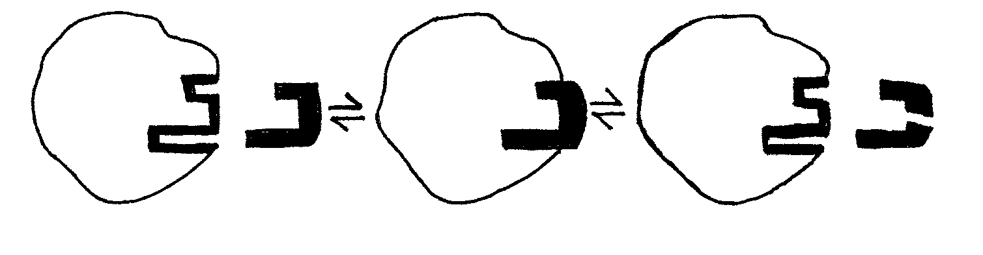

1.12 The process where C is the end product as shown in the diagram, is known as
 | A. | anabolism.
 | B. | catabolism.
 | C. | denaturation.
 | D. | saturation.

1.13 The part X represents the
 | A. | enzyme.
 | B. | apo-enzyme.
 | C. | active site.
 | D. | holo-enzyme.

1.14 The structure formed at B is called the
 | A. | enzyme molecule.
 | B. | substrate molecule.
 | C. | enzyme-substrate complex.
 | D. | end product molecule.

1.15 The reaction of enzymes as shown in the diagram is
 | A. | diffusion.
 | B. | the lock-and-key theory.
 | C. | osmosis.
 | D. | denaturation.

  - Which property of enzymes is illustrated by the diagram? Enzymes
- act only on a specific substrate.
- are sensitive to temperature.
- are sensitive to pH changes.
- are components of proteins.

  - A co-enzyme
- is a protein regulating enzyme actions.
- assists an enzyme during reactions.
- controls the direction of an enzyme action.
- uses energy for a reaction to be carried out.

  - Which of the following environmental conditions will increase the rate of transpiration the most?
- Low temperature; low humidity
- High temperature; low humidity
- High temperature; still air
- High humidity; wind

  - A plant cell placed in a concentrated salt solution becomes
 | A. | turgid.
 | B. | etiolated.
 | C. | dehydrated.
 | D. | plasmolysed.

  - The pressure which results within a plant cell due to absorption of water is
- turgor.
- plasmolysis.
- osmosis.
- diffusion.

1.21 Which ONE of the following is a plant growth substance?
 | A. | Auxin
 | B. | Thyroxin
 | C. | Adrenalin
 | D. | Enzymes

1.22 If the shoot of a plant is exposed to a unilateral light stimulus, then the auxin concentration on the darker side
 | A. | remains constant.
 | B. | fluctuates rapidly.
 | C. | increases.
 | D. | decreases.

1.23 The reaction of stem growth to the stimulus of gravity can be seen as
 | A. | positively phototropic.
 | B. | negatively phototropic.
 | C. | positively geotropic.
 | D. | negatively geotropic.

Questions 1.24 to 1.28 refer to an experiment which demonstrates that carbon dioxide is essential for photosynthesis.
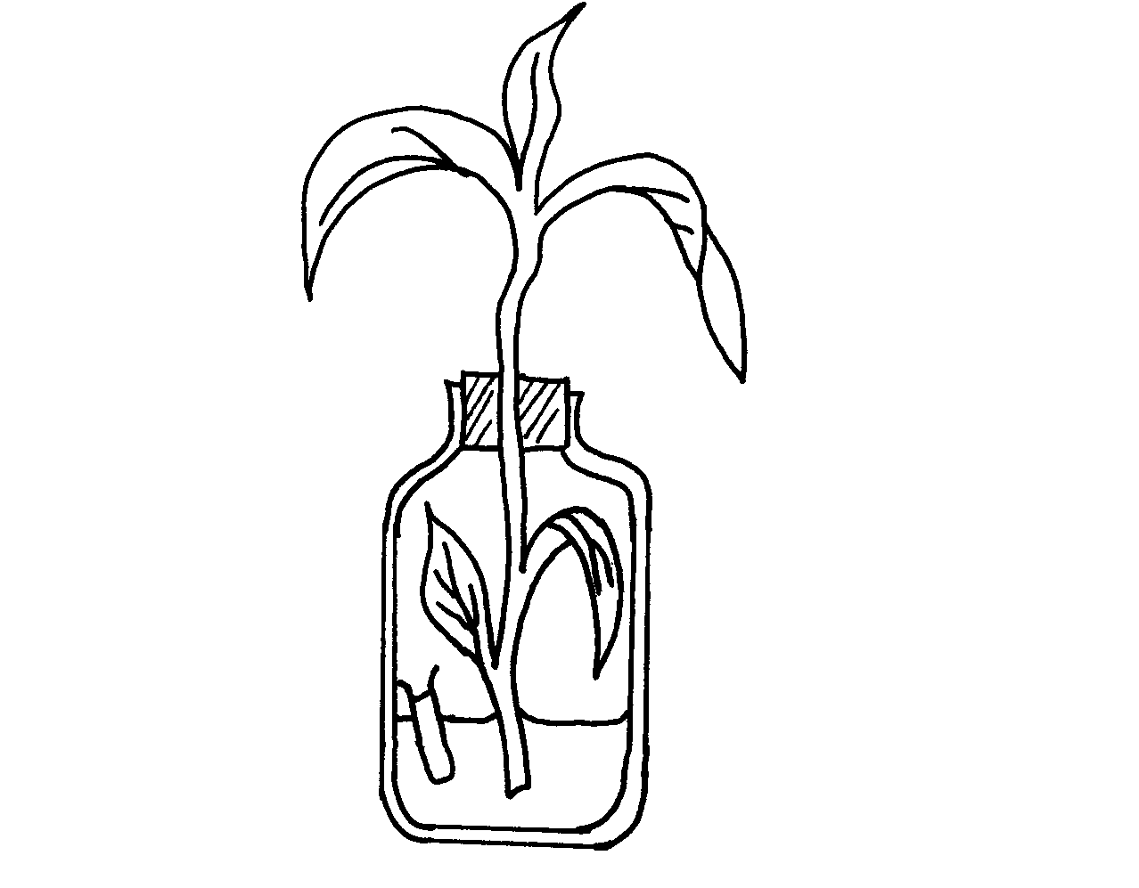
Leaf Y
Leaf X
water
Liquid R

  - Before setting up the experiment, the plant shoot should be
- boiled in water.
- boiled in alcohol.
- kept in the dark for several hours.
- kept in the light for several hours.

1.25 The liquid R is
 | A. | mercury.
 | B. | lime water.
 | C. | cobalt chloride solution.
 | D. | sodium hydroxide solution.

1.26 The purpose of liquid R is to
 | A. | absorb carbon dioxide.
 | B. | supply carbon dioxide.
 | C. | absorb oxygen.
 | D. | supply oxygen.

  - After the experiment had been set up for eight hours of daylight, which ONE of the following observations are likely to be true?
- Both leaves (X and Y) contain starch.
- Leaf X is green; leaf Y is yellow.
- Leaf X contains starch; leaf Y does not contain starch.
- Leaf X does not contain starch; leaf Y contains starch.

  - When using iodine solution, the colour change observed in the leaf containing starch will be the following
 | A. | brown
 | B. | blue black
 | C. | green
 | D. | yellow

  - Which of the following substance will increase in muscles during strenuous exercise?
- Lactic acid
- Oxygen
- ATP
- Carbon dioxide

A. | (ii) only
B. | (iii) only
C. | (i) only
D. | (iv) only

1.30 Cellular respiration in plants takes place
 | A. | during the day.
 | B. | during the night.
 | C. | day and night.
 | D. | periodically.
1.31 Cellular respiration is a catabolic process because
- water is released during the process.
- it uses radiant energy.
- glucose is broken down to release energy.
- it releases carbon dioxide.

1.32 Vegetables and fruit are important because they contain roughage which
 | A. | provides energy.
 | B. | builds muscle tissue.
 | C. | stimulates peristalsis.
 | D. | provides certain vitamins.

1.33 Children fed on a diet rich in carbohydrates, but with insufficient proteins, could suffer from
 | A. | scurvy.
 | B. | marasmus.
 | C. | kwashiorkor.
 | D. | anorexia.

Questions 1.34 and 1.35 refer to the diagrammatic representation of the air passages present in the respiratory system of the human.

PARTS OF THE HUMAN BREATHING SYSTEM
larynx bronchioli pharynx trachea bronchi nasal cavity
(voice box) (air pipe) (lung pipe)
1 2 3 4 5 6

1.34 Which labelled part (s) of the system is (are) common to the passage of both food and air?
 | A. | 1, 3 and 4
 | B. | 3 only
 | C. | 4 only
 | D. | 2 and 3

1.35 Which labelled part(s) of the system is composed of circular-shaped cartilage rings?
 | A. | 2 and 5
 | B. | 2 and 4
 | C. | 2 and 3
 | D. | 1 and 2

1.36 The transport of nitrogenous waste to the kidney occurs mainly through the
 | A. | renal vein.
 | b. | renal artery.
 | c. | pulmonary vein.
 | D. | pulmonary artery.

1.37 This hormone lowers the blood glucose level when its concentration rises above the normal level.
 | A. | Glucagon
 | B. | Insulin
 | C. | Thyroxin
 | D. | Adrenalin

  - During energy flow through an ecosystem
- energy is lost through anaerobic respiration.
- energy is lost mainly through digestion.
- some energy is used for metabolic processes at each trophic level.
- the same amount of energy is available at each trophic level.

1.39 The receptor in the human body that is sensitive to an external environmental temperature of 10ºC, is
 | A. | Pacinian corpuscle
 | B. | Ruffini’s corpuscle
 | C. | Meissner’s corpuscle
 | D. | Krause’s end bulb

1.40 A density-independent factor that regulates population growth is
 | A. | lack of food.
 | B. | predation.
 | C. | disease.
 | D. | drought.
40x2 = [80]
QUESTION 1B  hearing region  turbinate bones  DIAGRAM A  iris  tear gland  DIAGRAM B  pancreas  duodenum  stomach  DIAGRAM C  nephron  nephridiopore  DIAGRAM D  glass tube  thermos  flask  sugar and yeast solution  sugar solution  DIAGRAM E  In each of the following diagrams (A-E) there is one incorrect label. For each diagram write down the incorrect label and then the correct label in your answer book. |  | [10]
QUESTION 1C  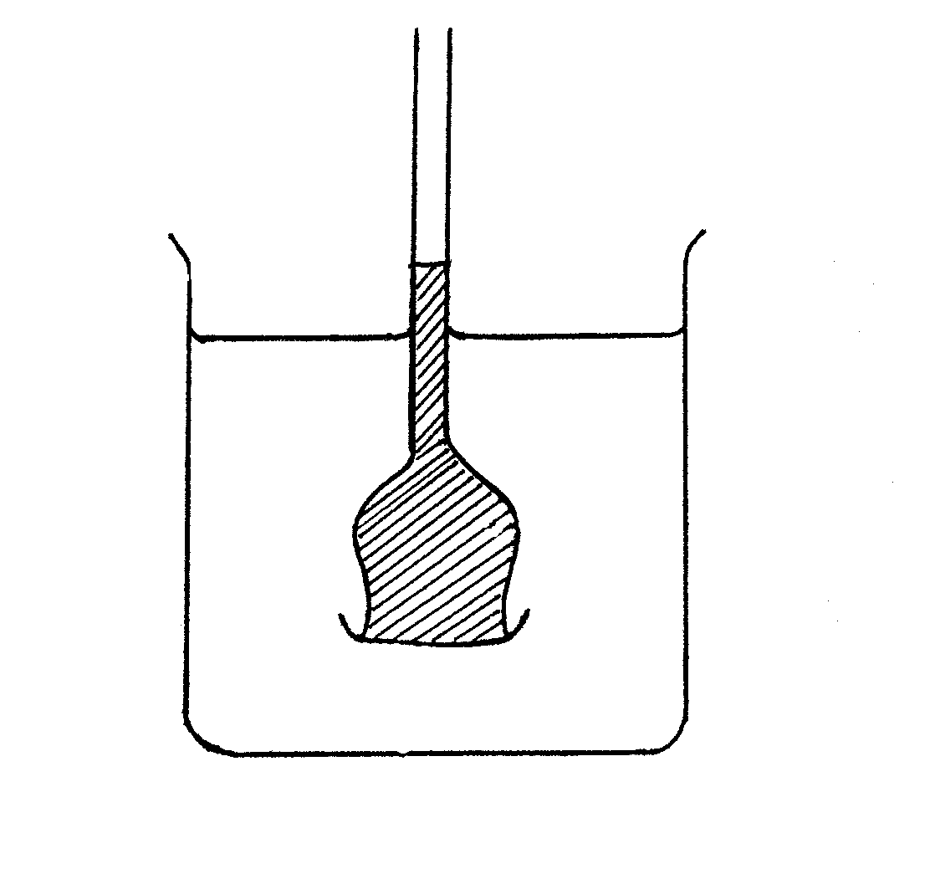  A  B  C  differentially permeable membrane  The apparatus drawn below was used to demonstrate the movement of water through a partially permeable membrane. At the start of the experiment the levels of liquid in the beaker and in the thistle funnel were the same.  Point A indicates the height to which the liquid in the funnel rose after an hour.  - Is water or a sucrose solution placed in C?  - Name the process occurring during this experiment.  - Does water move from B to C or from C to B? Explain the reason for this movement.  - Why does the level of the liquid in the thistle funnel stop rising after a few hours?  - Explain why pure water has a higher water potential than a sucrose solution.  TOTAL FOR SECTION A: | (2)  (1)  (3)  (2)  (2)  [10]  [100]

SECTION B  1  2  3  5  6  7  4  3  1  2  QUESTION 2  - Study the structure of a human organ and answer the questions that follow.  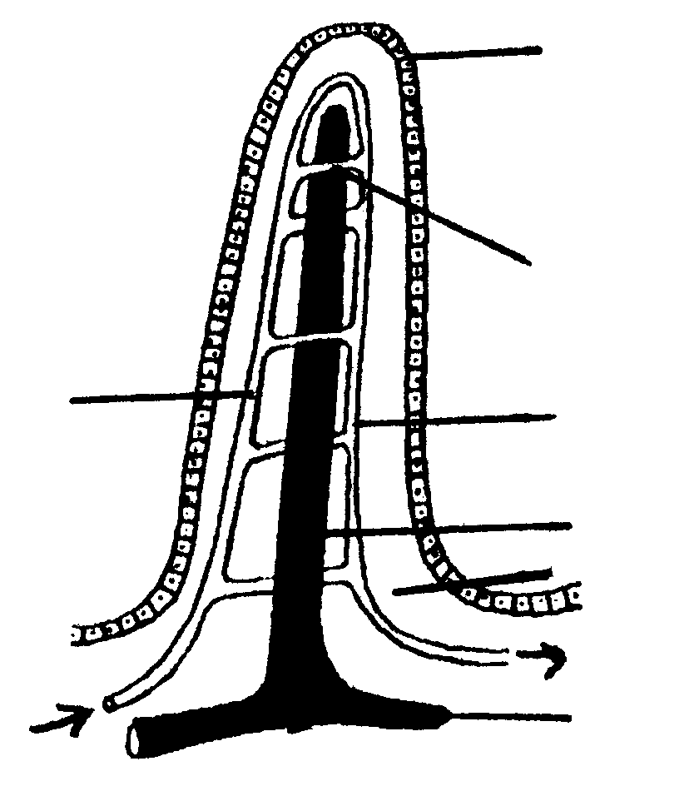  - Identify this structure.  - In which part of the digestive system of the human do we find this structure?  - State ONE function of this structure.  - State THREE structural characteristics of this structure which allows it to perform effectively.  - Identify the parts numbered 1 to 7.  - Through which physical process do substances move into this structure.  - Name the tiny fold-like structures found on the surface of part number 1.  - Name TWO digestive products absorbed by the structure numbered 2.  - Name ONE substance absorbed by the structure numbered 5.  - Study the diagram below and answer the questions that follow.  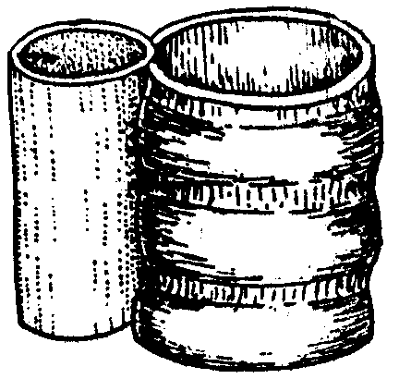  - Identify the parts numbered 1 and 3.  - What is the function of part number 2?  - What is meant by the term gaseous exchange?  - What muscular action occurs in structure number 1?  - Name the two systems to which structure 1 and 3 is part of. | (1)  (1)  (2)  (6)  (7)  (2)  (1)  (2)  (1)  (4)  (2)  (4)  (1)  (2)

The diagram below represents a human nephron.  7  6  5  4  3  z  x  y  1  2  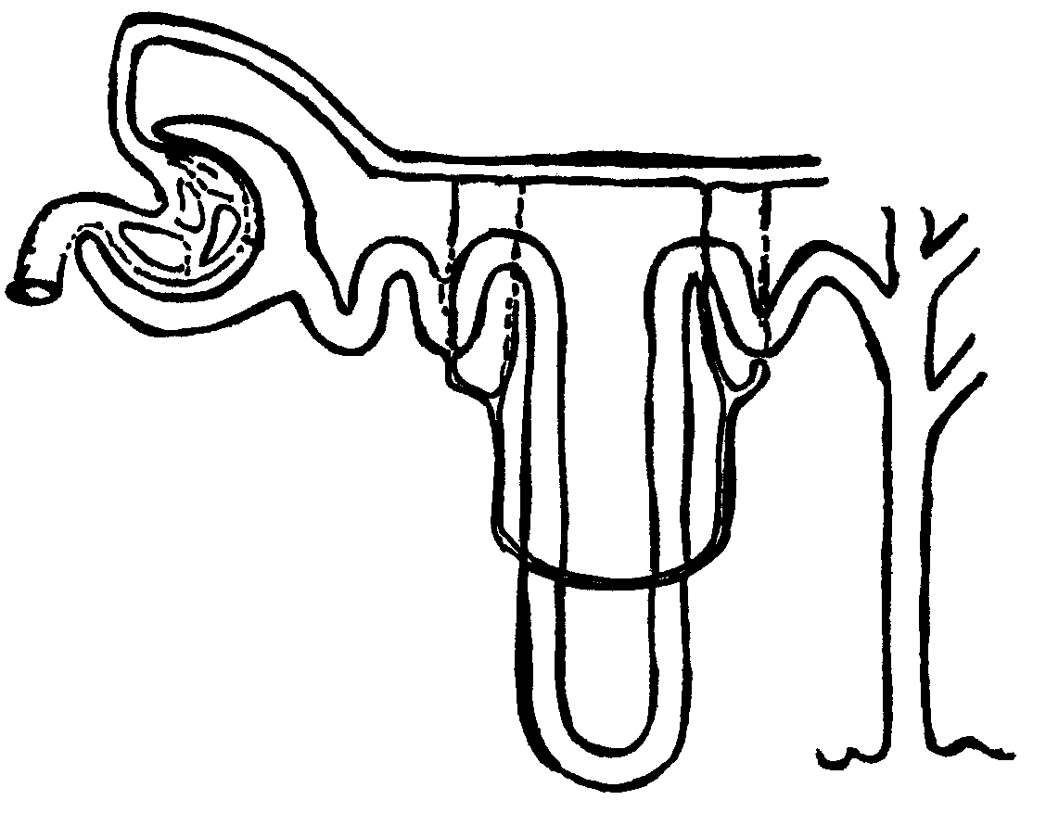  - Name the blood vessel number 6 which brings blood to the nephron.  - Identify the cup-shaped structure numbered 5.  - Explain why blood vessel number 6 has a larger diameter than blood vessel number 7.  - Name the processes occurring at X, Y and Z.  - Name TWO nitrogenous substances that pass from the blood into structure number 5.  - List TWO constituents of blood that do not pass into structure number 5.  - Name TWO organic substances that pass from the tubule into the blood at part number 4.  - Name the liquid passing through part number 3. | (1)  (1)  (2)  (3)  (2)  (2)  (2)  (1)  [50]

QUESTION 3

3.1 Supply the missing word(s) for the letters a to j which complete(s) the table on the endocrine system below. Write down the letter and its associated answer.

GLAND | HORMONE SECRETION | FUNCTION IN THE BODY
a | ADH | b
Thyroid | c | d + e
f | g | controls glucose level in blood
Adrenal | h | cope with emergency situations
i | TSH | j
(10)

The drawings below ARE NOT drawn to scale and show the following:
C

B
A
- a dolphin (100 kg)
- a small mouse (0,5 kg)
- a large lizard (0,9 kg) and

D. an elephant (300 kg)

D  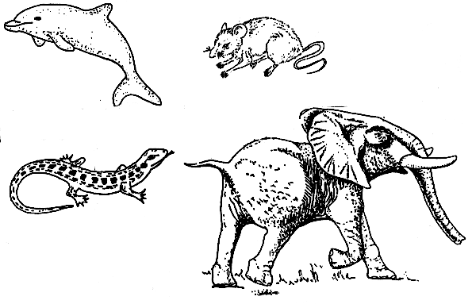  - What do you understand by the terms homoiothermic (endothermic) and poikilothermic (ectothermic)?  - Name ONE (a) homoiothermic (endothermic) and ONE (b) poikilothermic (ectothermic) animal from the drawings above.  - Using the letters A, B, C or D state which animal  - loses most heat per unit area of surface.  - uses heat exchangers to retain body heat.  - uses body orientation to control body temperature.  - has the smallest surface area to volume ratio. | (4)  (2)  (2)  (2)  (2)  (2)

3.3 Study the diagram of a neuron below.
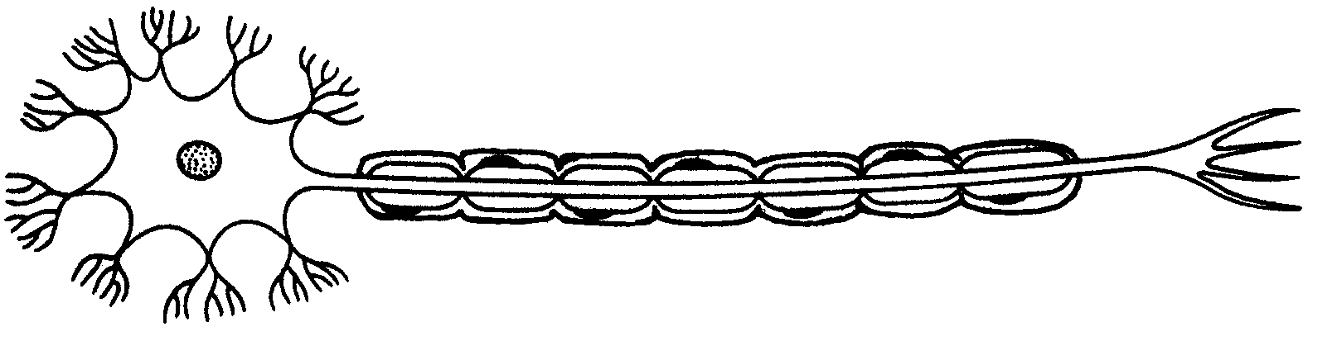
5 4
1
2
3

- Identify the parts numbered 1 to 5.  3.3.2 What is the function of the part numbered 1?  3.3.3 Name the type of neuron shown in the diagram.  3.3.4 What is the purpose of this type of neuron in the human body? | (5)  (2)  (2)  (2)

3.4 Study the diagram below.
from the heart
blood

D
cell

C

B

A

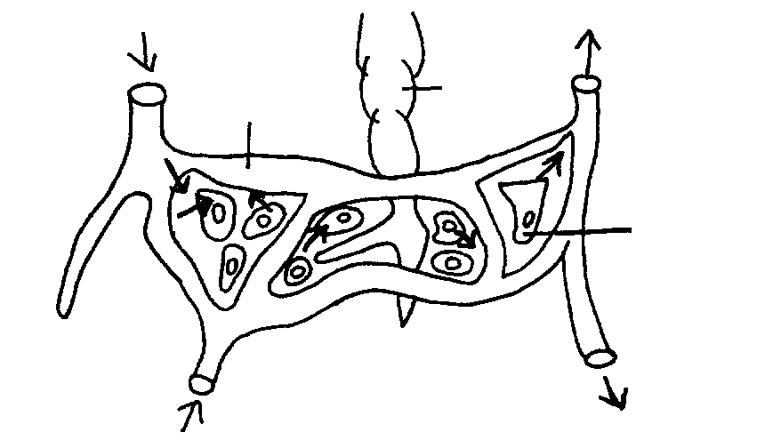

3.4.1 Name the fluid found between the cells in the human body.  3.4.2 Identify the gases that are shown by A and C.  3.4.3 What process is the diagram showing?  3.4.4 Name the fluid that enters D. | (2)  (2)  (2)  (1)

The following diagram shows the human brain.
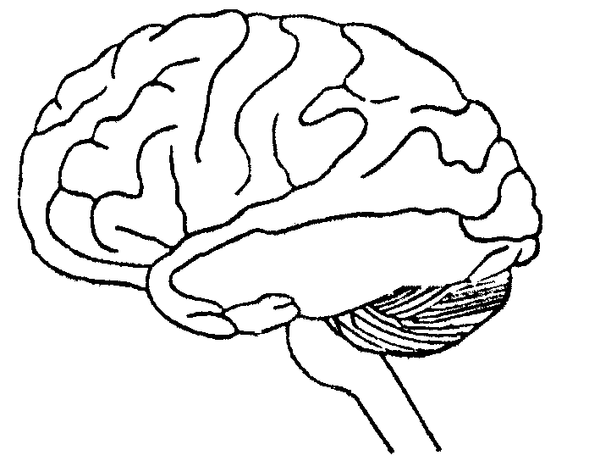
1
2
3

- Give the number and name of the part that concentrates on voluntary actions.  - Name part number 2 which has a modifying influence on muscle movement.  - State ONE function of part number 3.  - Draw a labelled diagram of the tongue showing the different taste areas.  QUESTION 4  4.1 Yeast cells are cultivated in 2 ml of a culture-medium containing glucose. Every day a sample of the yeast population is taken and counted with the help of a microscope. The table below shows the number of yeast cells in the sample per microscope field. | (2)  (1)  (1)  (4)  [50]

DAY | NUMBER OF YEAST CELLS  PER MICROSCOPE FIELD
1 | 200
2 | 650
3 | 1200
4 | 2500
5 | 2500

Show graphically the results given in the table.  (x-axis : DAY, y-axis : NUMBER OF YEAST CELLS)  - Indicate on the graph the different phases of growth.  - What is the carrying capacity of this particular culture?  - What kind of growth form is shown by the graph?  - Why did the number of yeast cells double from day 3 to day 4? | (5)  (3)  (2)  (1)  (3)

Study the histogram below on the growth pattern of AIDS in Gauteng and answer the questions that follow.
Number of HIV individuals (in %)
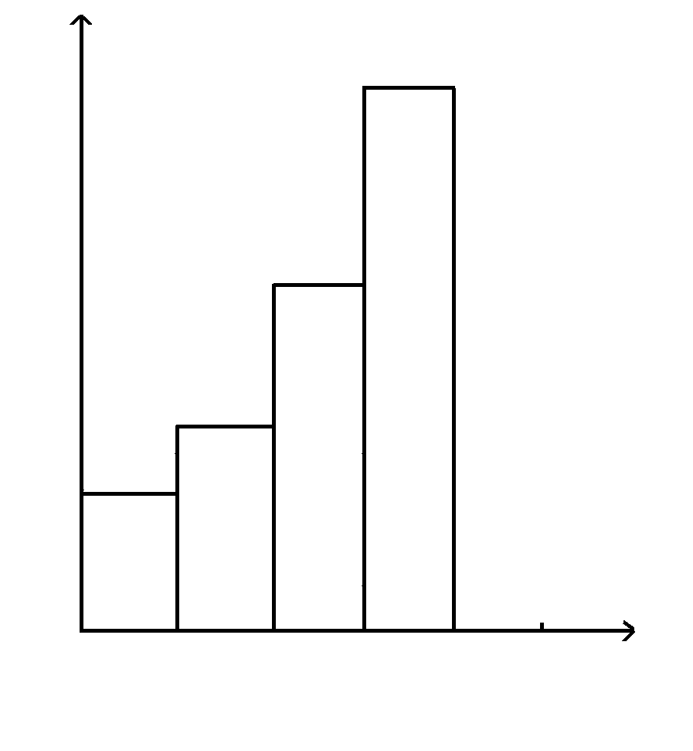
1997 1998 1999 2000
Time (years)

20

15

10

5

What is meant by the word AIDS?  - What was the percentage population of HIV / AIDS individuals in 1997?  - What is the increase of HIV individuals between the years 1999 and 2000?  Direct and indirect techniques are used to determine population size. What method is used to determine the population of HIV individuals? | (2)  (2)  (4)  (1)

- Study the following diagrams showing the apparatus used in an investigation.  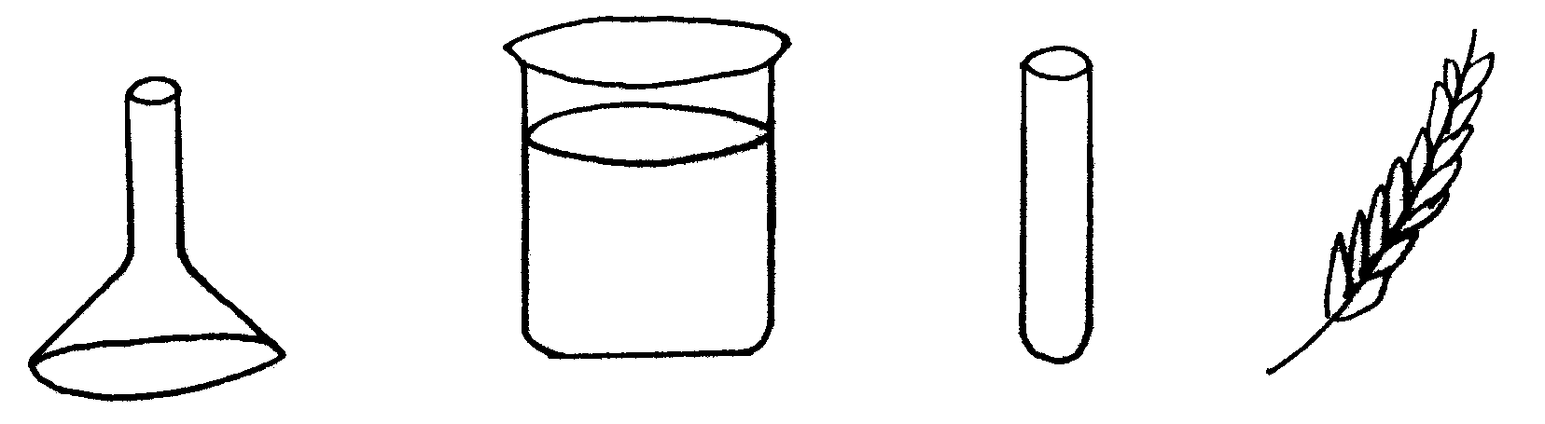  funnel  beaker  test-tube  water plant /  e.g Elodea sp.  water  The above apparatus was placed in sunlight and gas bubbles were observed.  - Draw the arrangement of the above apparatus showing the gas bubbles being released.  - Name the process the apparatus illustrates.  - What are the gas bubbles made of?  - Does the diagram illustrate the experiment or the control? | (7)  (2)  (2)  (1)

The diagram below shows the structure of the human ear.  1  2  4  5  6  7  8  11 10 9  3  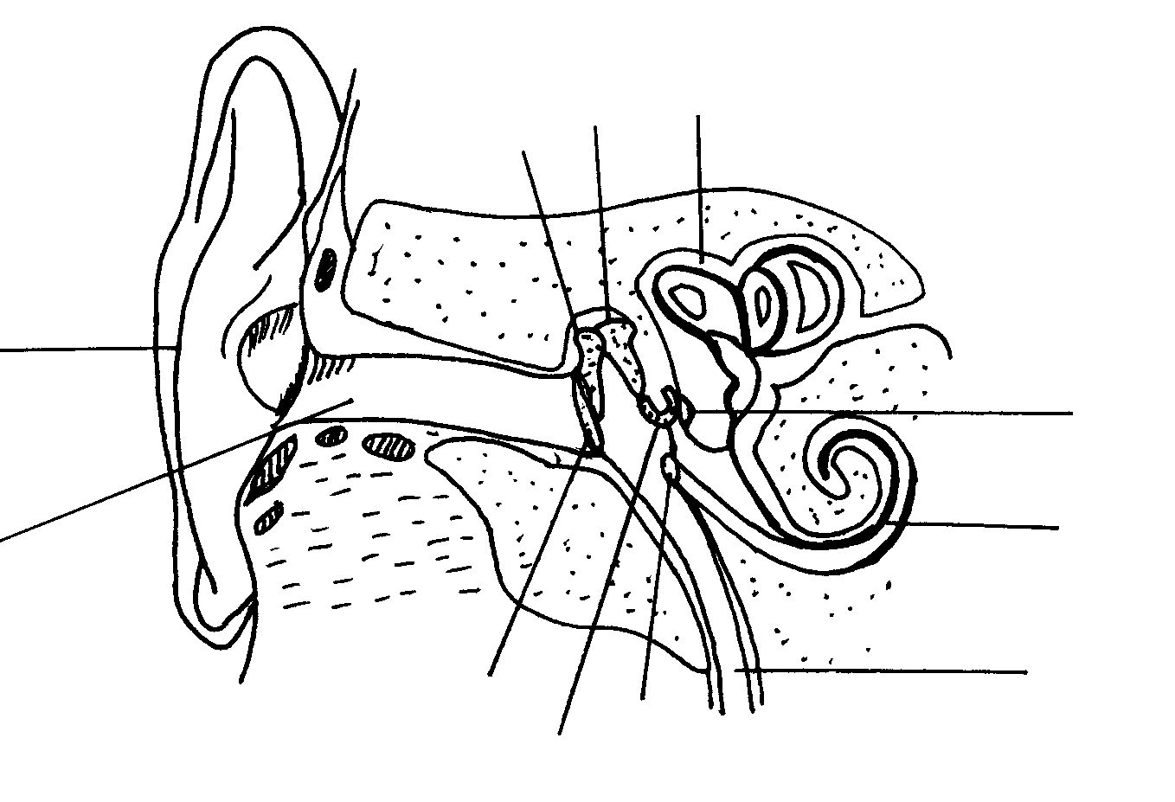  - Identify the parts numbered 2, 3, 6, 7, 9 and 11.  - Give the NUMBER/S of the part /s which  - direct sound waves into the auditory canal.  - balance air pressure between the outer and the middle ear.  - are ear ossicles.  - contain the organ of hearing.  - are windows covered by membranes  - help in maintaining balance. | (6)  (9)  [50]

QUESTION 5
B
A
1
2
3
4
5
6
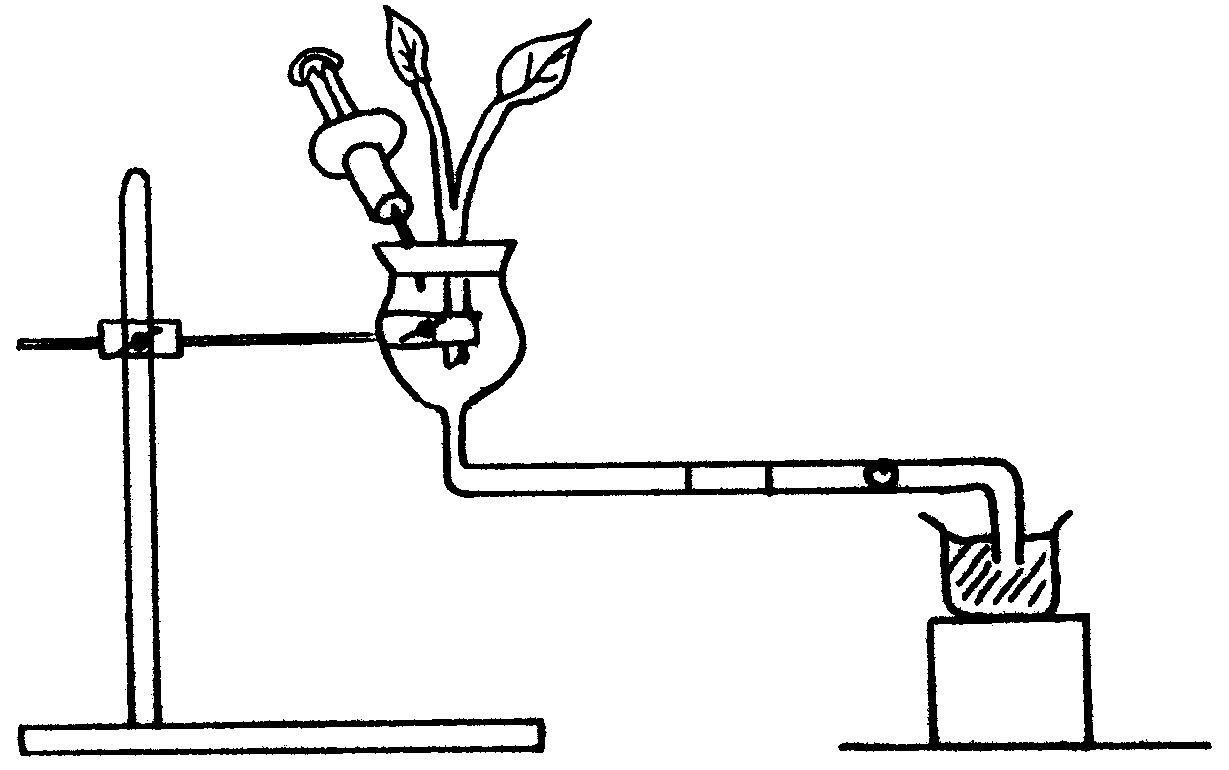
retort
stand
wooden block
beaker with
water

C B

A

The apparatus drawn below is used for a particular investigation. Study the apparatus and answer the questions that follow.

- Name the apparatus drawn.  1  2  3  4  5  6  A  B  - What is the aim of this experiment?  - List TWO precautions you would take in setting up the apparatus.  - Why is the air bubble indicated by letter A introduced into the capillary tube?  - If the twig is covered with a plastic bag, what effect will this have on the movement of the air bubble? Explain your answer briefly.  - Name other factors in the environment that could have affected the results.  - The diagram shows two stages in the changing of the lens when a human eye is focussed on an object.  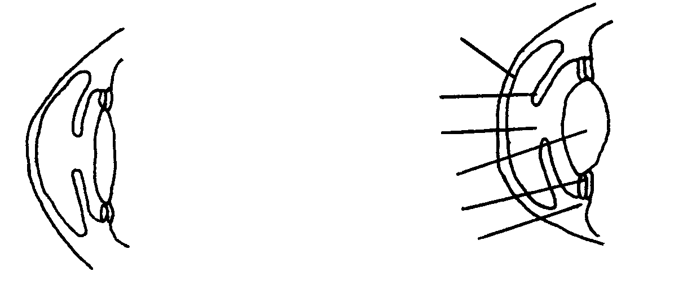  Identify the parts numbered 1,4,5 and 6.  - Which lens (A or B) is adapted to distant vision?  - What is the process called whereby the eye has the ability to focus on near  or distant objects?  5.2.4 Give the NUMBER of the part that  - regulates the amount of light entering the eye.  (b) is responsible for the colour of the eye. | (1)  (2)  (4)  (1)  (3)  (3)  (4)  (1)  (2)  (2)  (2)

5.3 The diagram below shows structures concerned with homeostasis.
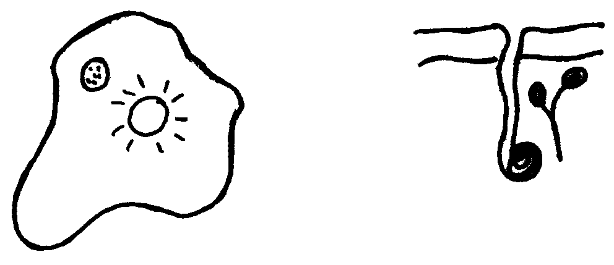
1
2
3
4

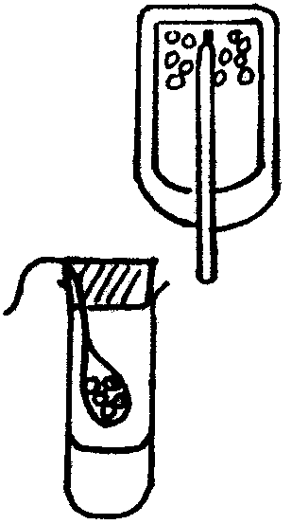  - Identify the structure numbered 1.  1  germinating seeds  thermometer  germinating seeds  Y  athlete  product C  product B  A  (gas)  X  - Name the organism to which structure number 1 belongs.  - What is the function/s of structure number 1?  - Parts numbered 2, 3 and 4 are found in a human skin. Identify each part.  - During what environmental conditions would parts numbered 2, 3 and 4 become active.  - Explain the activity of parts numbered 2, 3 and 4 as mentioned in  Question 5.3.5.  - Study the diagrammatic representation that illustrates the requirements and products of cellular respiration.  - Identify the gas A.  - With reference to B and C, name the products formed.  - Supply an aim for each experiment X and Y.  - Name the part number 1.  - Give ONE reason why part number 1 is inverted in experiment X?  - Give the results obtained for each experiment X and Y.  TOTAL: | (1)  (1)  (2)  (3)  (1)  (2)  (2)  (2)  (4)  (4)  (2)  (4)  [50]  300

