GAUTENG DEPARTMENT OF EDUCATION

SENIOR CERTIFICATE EXAMINATION

BIOLOGY SG

TIME : 3 hours

MARKS : 300

INSTRUCTIONS:

- Answer ALL the questions in your answer book.

- Number ALL the questions clearly and accurately using the question numbers provided.

SECTION A

Answer QUESTION 1A on the answer sheet on the inside cover of your answer book.

QUESTION 1A

Four possibilities are suggested as answers to the following questions, of which only one is correct. Indicate the correct answer by making a cross (X) over the appropriate letter next to the corresponding number on the answer sheet.

EXAMPLE: Saliva is secreted in the

- mouth.
- oesophagus (food pipe).
- stomach.
- duodenum (small intestine).

ANSWER: A B C D

Questions 1.1 to 1.4 are based to the following diagram which deals with digestion.

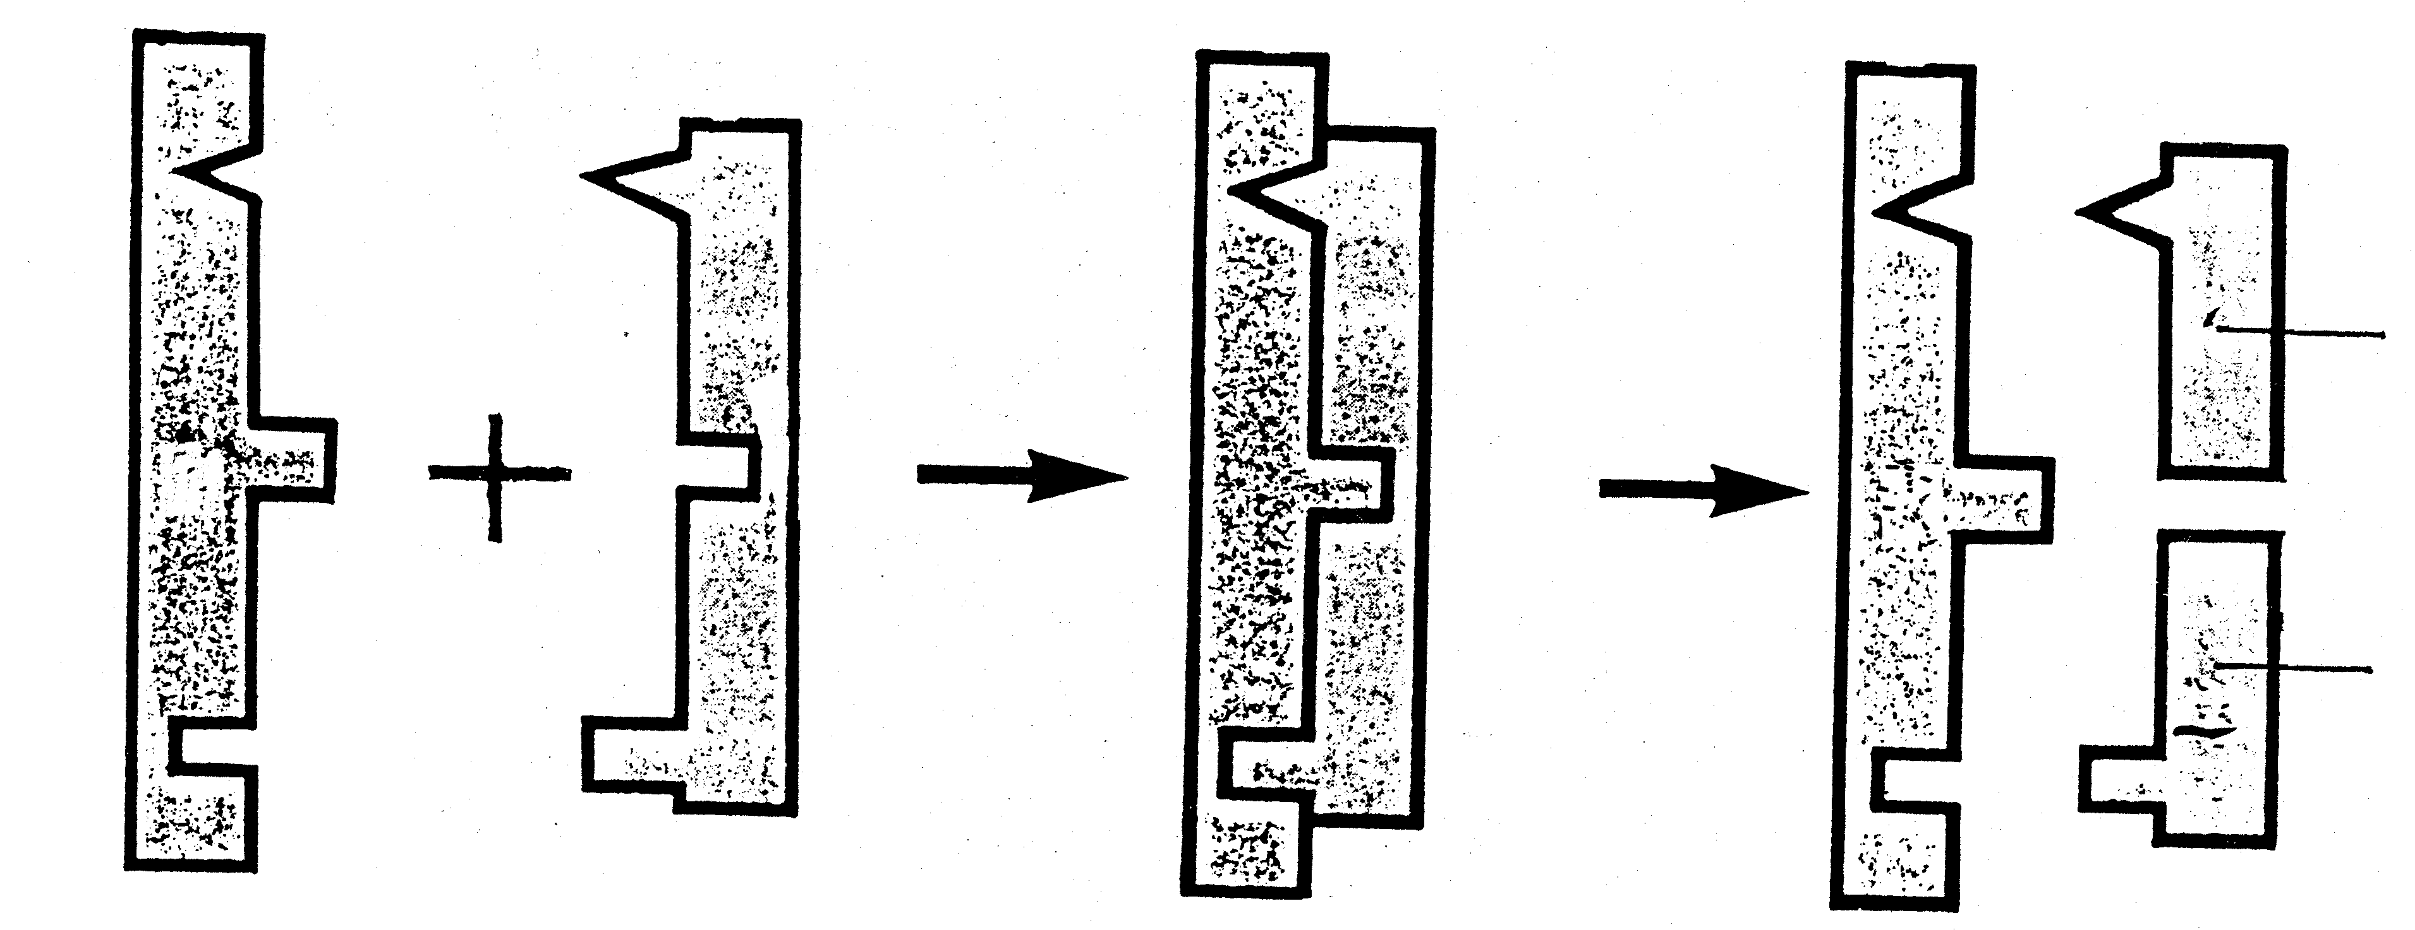

5

4

1 2 3

  - Which property of enzymes is illustrated by the sequence of diagrams? Enzymes
- function in a specific pH.
- function at an optimum temperature.
- speed up reaction.
- are specific in their reaction.

1.2 The enzyme-substrate complex is represented by label
 | A. | 1.
 | B. | 2.
 | C. | 3.
 | D. | 4.

1.3 What type of metabolic process is illustrated by the diagram?
 | A. | Anabolism
 | B. | Homeostasis
 | C. | Catabolism
 | D. | Phosphorylation

  - If structure 2 is maltose, what will labels 4 and 5 be?
- Glucose and glucose
- Glucose and fructose
- Glucose and sucrose
- Glucose and lactose

1.5 Which one of the following will increase the rate of transpiration?
 | A. | Air movements
 | B. | A dark room
 | C. | A cold room
 | D. | An enclosed space

1.6 CO₂ enters a leaf mainly through the
 | A. | phloem.
 | B. | xylem.
 | C. | stomata.
 | D. | cambium.

Question 1.7 is based on the diagram that illustrates the surface view of the tongue.
1

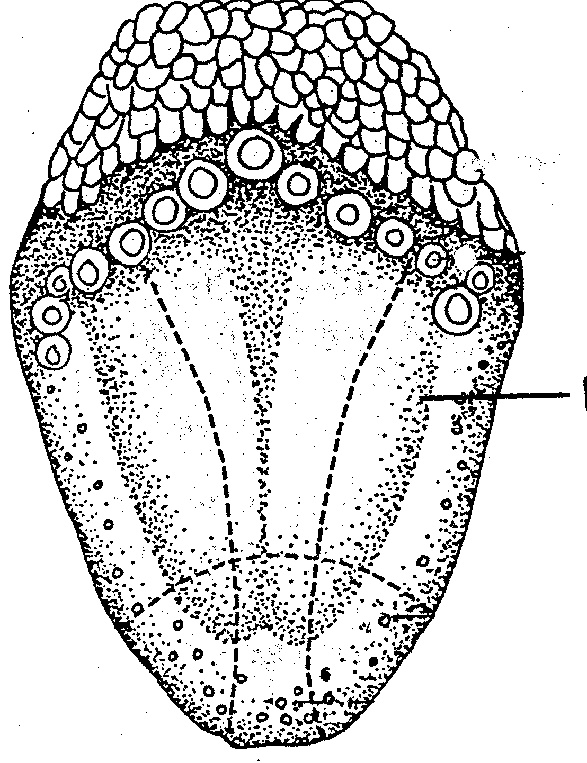

1.7 The region numbered 1 is where ______________ is tasted.
 | A. | sourness
 | B. | bitterness
 | C. | sweetness
 | D. | saltiness

1.8 In the ear, sound vibrations are converted into nerve impulses by
 | A. | the organ of Corti.
 | B. | the ossicles.
 | C. | vestibulum scala.
 | D. | Reissner’s membrane.

1.9 A solution with a pH of 6,2 is
 | A. | neutral.
 | B. | a weak acid.
 | C. | slightly alkaline.
 | D. | a strongly alkaline.

Questions 1.10 to 1.12 are based on the diagram that represents the functional unit of a human kidney.
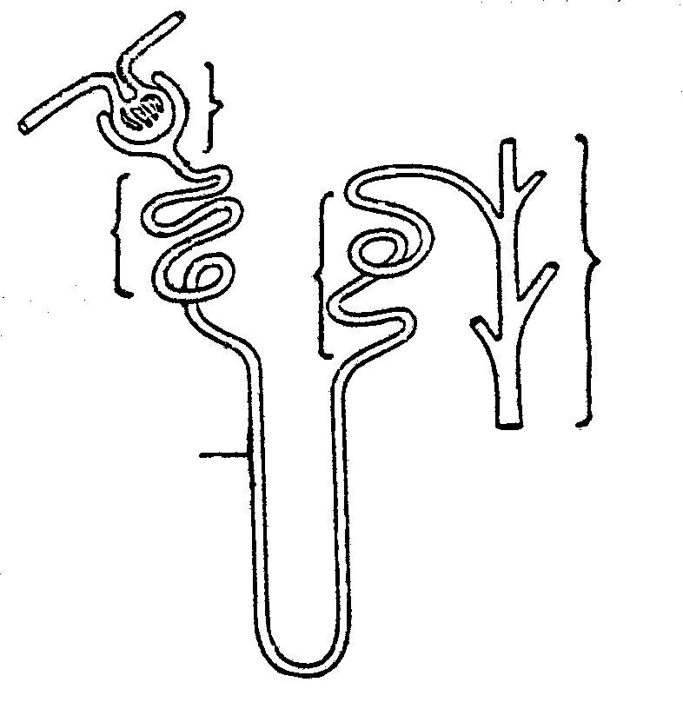

1

2
4
5

3

1.10 The diagram represents
 | A. | Nephridium.
 | B. | Malpighian body.
 | C. | Bowman’s capsule.
 | D. | Nephron.

1.11 Which sections are concerned with the reabsorption of water?
 | A. | 1, 3 and 4
 | B. | 1, 2 and 5
 | C. | 3, 4 and 5
 | D. | 1, 2 and 3

1.12 The process occurring at the part numbered 1 is
 | A. | (ultra) filtration. |  | .
 | B. | reabsorption.
 | C. | excretion.
 | D. | secretion.

1.13 When one smells perfume it stimulates the
 | A. | Ruffini’s corpuscle.
 | B. | rods and cones.
 | C. | organ of Corti.
 | D. | olfactory cells.

1.14 Vitamins belong to one of the following group of chemical compounds:
 | A. | Enzymes
 | B. | Co-enzymes
 | C. | Hormones
 | D. | Inorganic

1.15 The most important inorganic compound in human nutrition is
 | A. | glucose.
 | B. | starch.
 | C. | water.
 | D. | protein.

1.16 Organic compounds which increase resistance to infections are known as
 | A. | monosaccharides.
 | B. | vitamins.
 | C. | fats.
 | D. | micronutrients.

1.17 The force that the cell contents exert on the cell wall in a plant cell is called
 | A. | turgor pressure.
 | B. | wall pressure.
 | C. | water potential.
 | D. | osmotic potential.

Questions 1.18 to 1.21 are based on the diagrams which deal with experiments conducted in the laboratory. Each beaker contains pure water.
pure water
block of sugar
egg shell with sugar solution
1
2

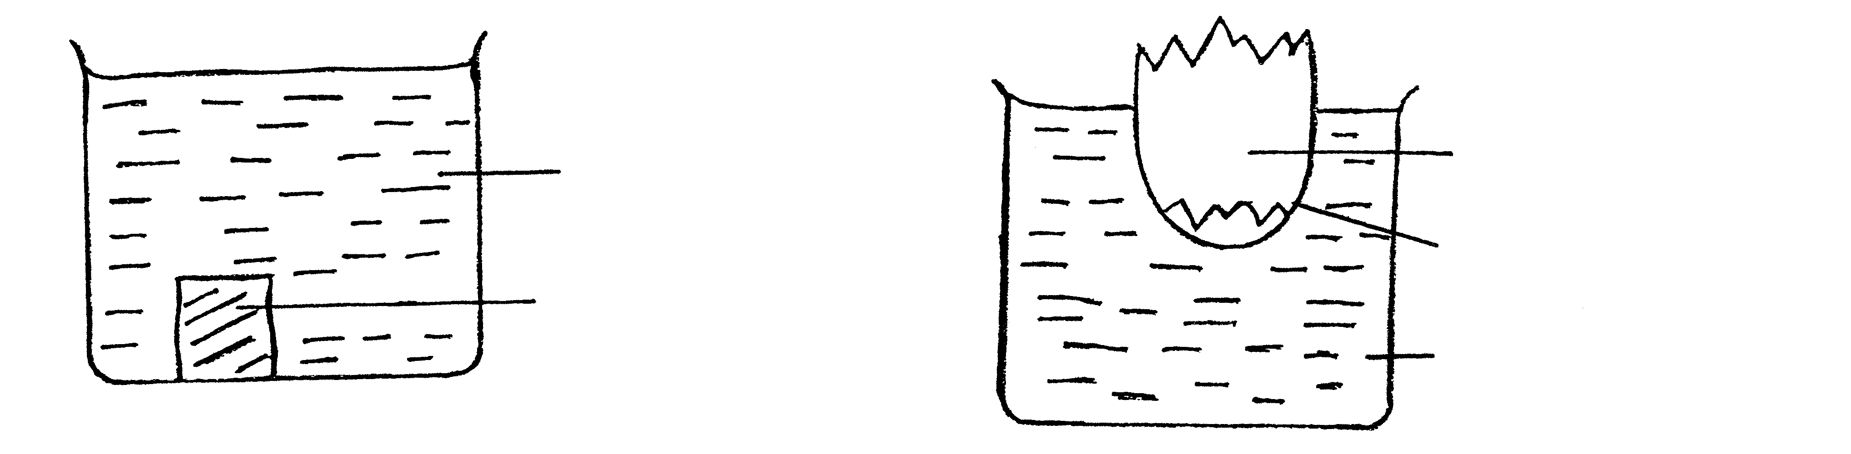
egg membrane

pure water

1.18 In which experiment, 1 or 2, is diffusion demonstrated?
 | A. | 1
 | B. | 2
 | C. | 1 and 2
 | D. | None of the above

1.19 What will happen to the level of the pure water in experiment 2?
 | A. | Increase
 | B. | Decrease
 | C. | Stay the same
 | D. | Change to water vapour

1.20 The type of solution that will form in beaker 1 after two hours is a
 | A. | colloid.
 | B. | gel.
 | C. | sol.
 | D. | pure solution.

1.21 The following is not required for photosynthesis.
 | A. | H₂O
 | B. | CO₂
 | C. | Enzymes
 | D. | O₂

Questions 1.22 to 1.24 are based on the diagram below.

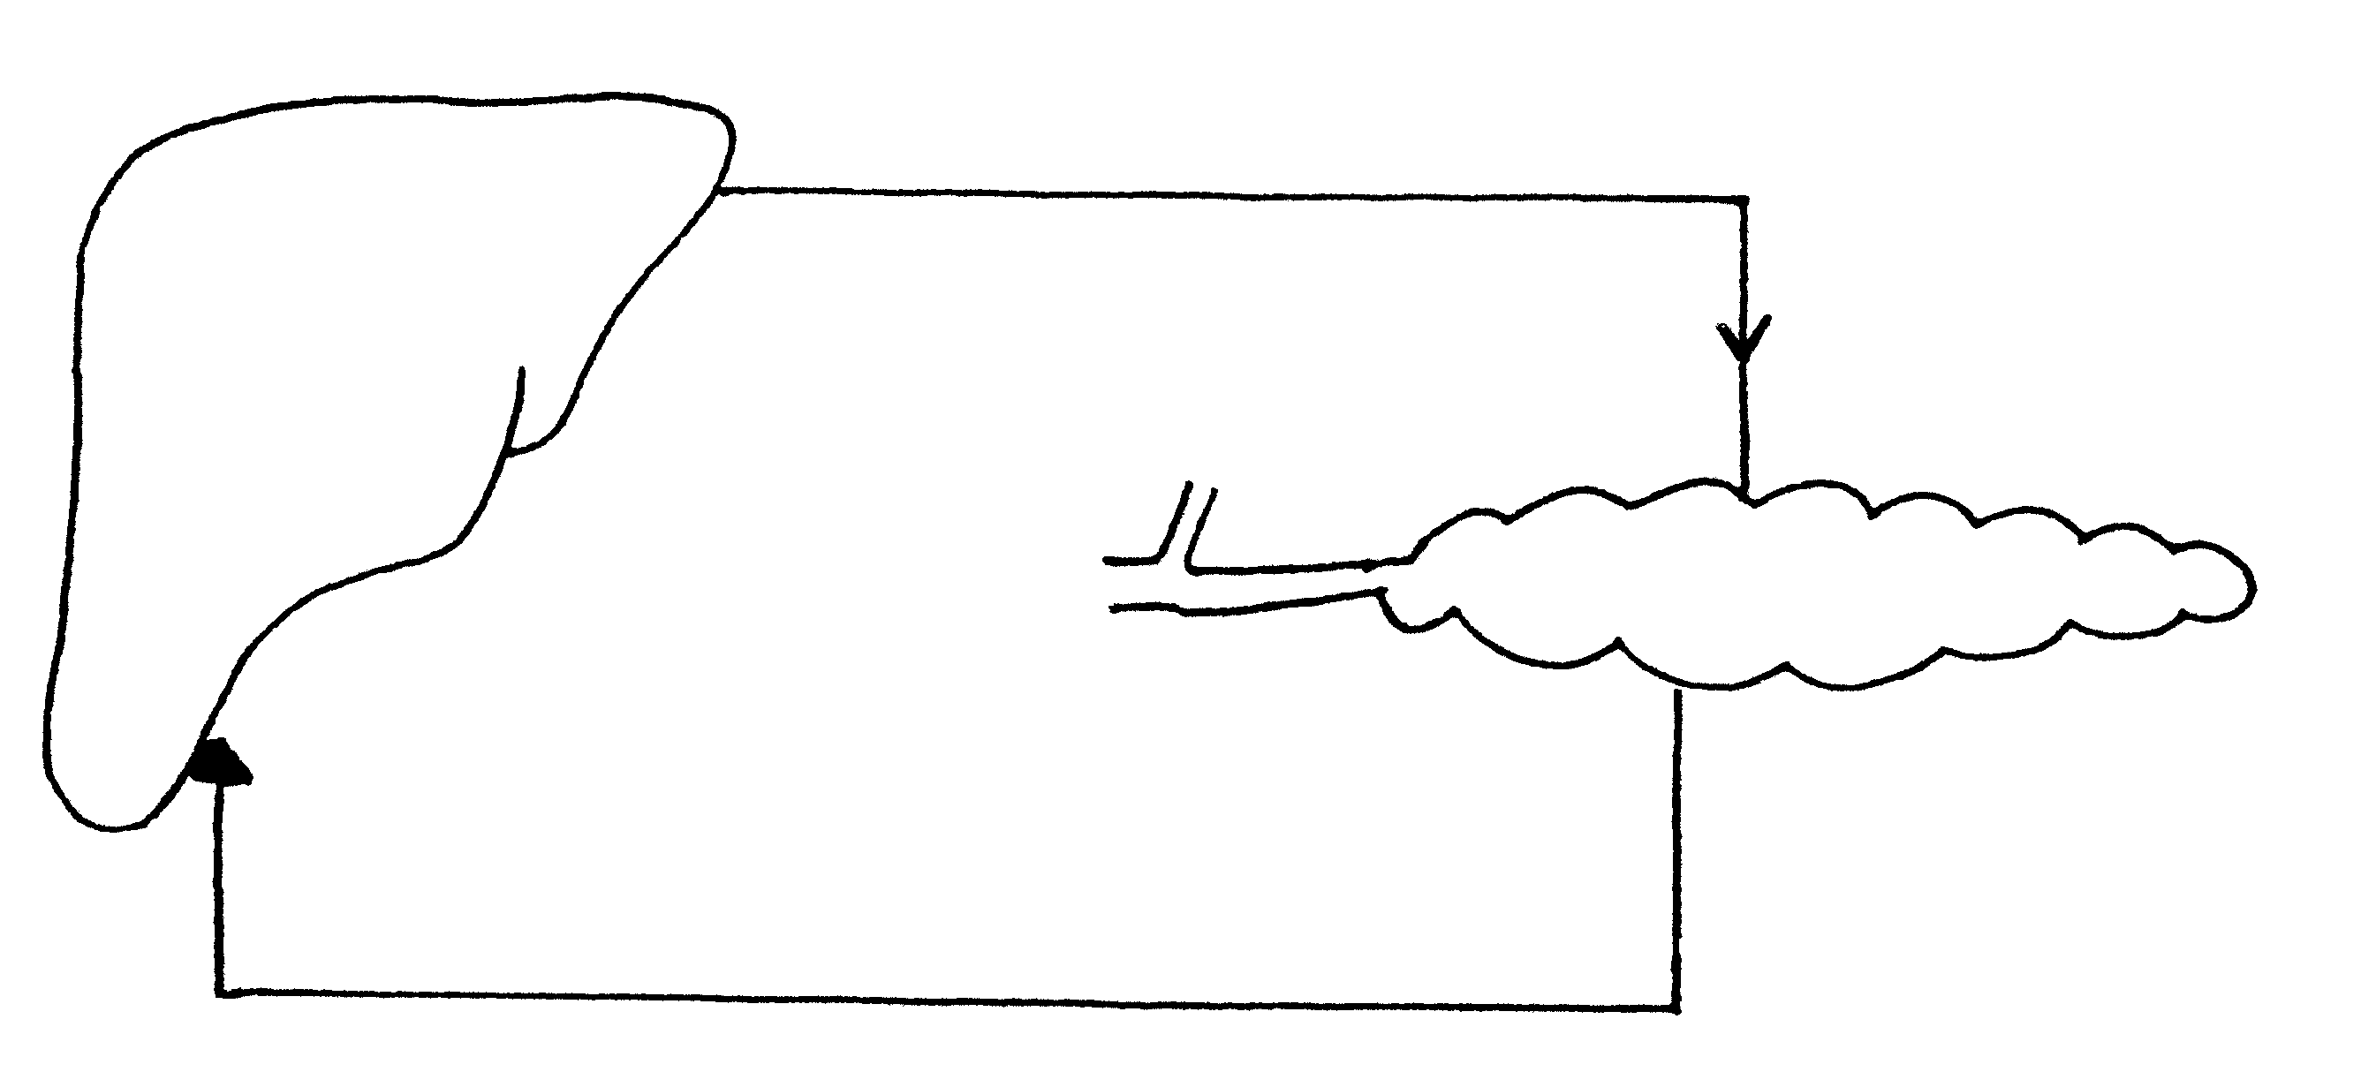
increased blood sugar level in blood
decreased blood sugar level in blood
1
2

1.22 The organs illustrated by structures numbered 1 and 2 respectively are the
 | A. | pancreas and the brain.
 | b. | spleen and the pancreas.
 | c. | liver and the pancreas.
 | D. | liver and the spleen.

1.23 This hormone increases the sugar level in the blood.
 | A. | Glycogen
 | B. | Insulin
 | C. | Glucagon
 | D. | Pepsin

1.24 This hormone is transported from structure number 1 to structure number 2 by the
 | A. | Eustachian tube.
 | B. | blood system.
 | C. | lymph.
 | D. | Malpighian body.

  - During inhalation in humans
- air is forced out of the lungs.
- the thoracic cavity becomes smaller.
- the rib cage is lifted.
- the diaphragm becomes more curved.

Questions 1.26 to 1.28 are based on the diagram of an alveolus with a blood capillary surrounding it.
water film
deoxygenated blood (less oxygen)

X

Y

P
alveolus

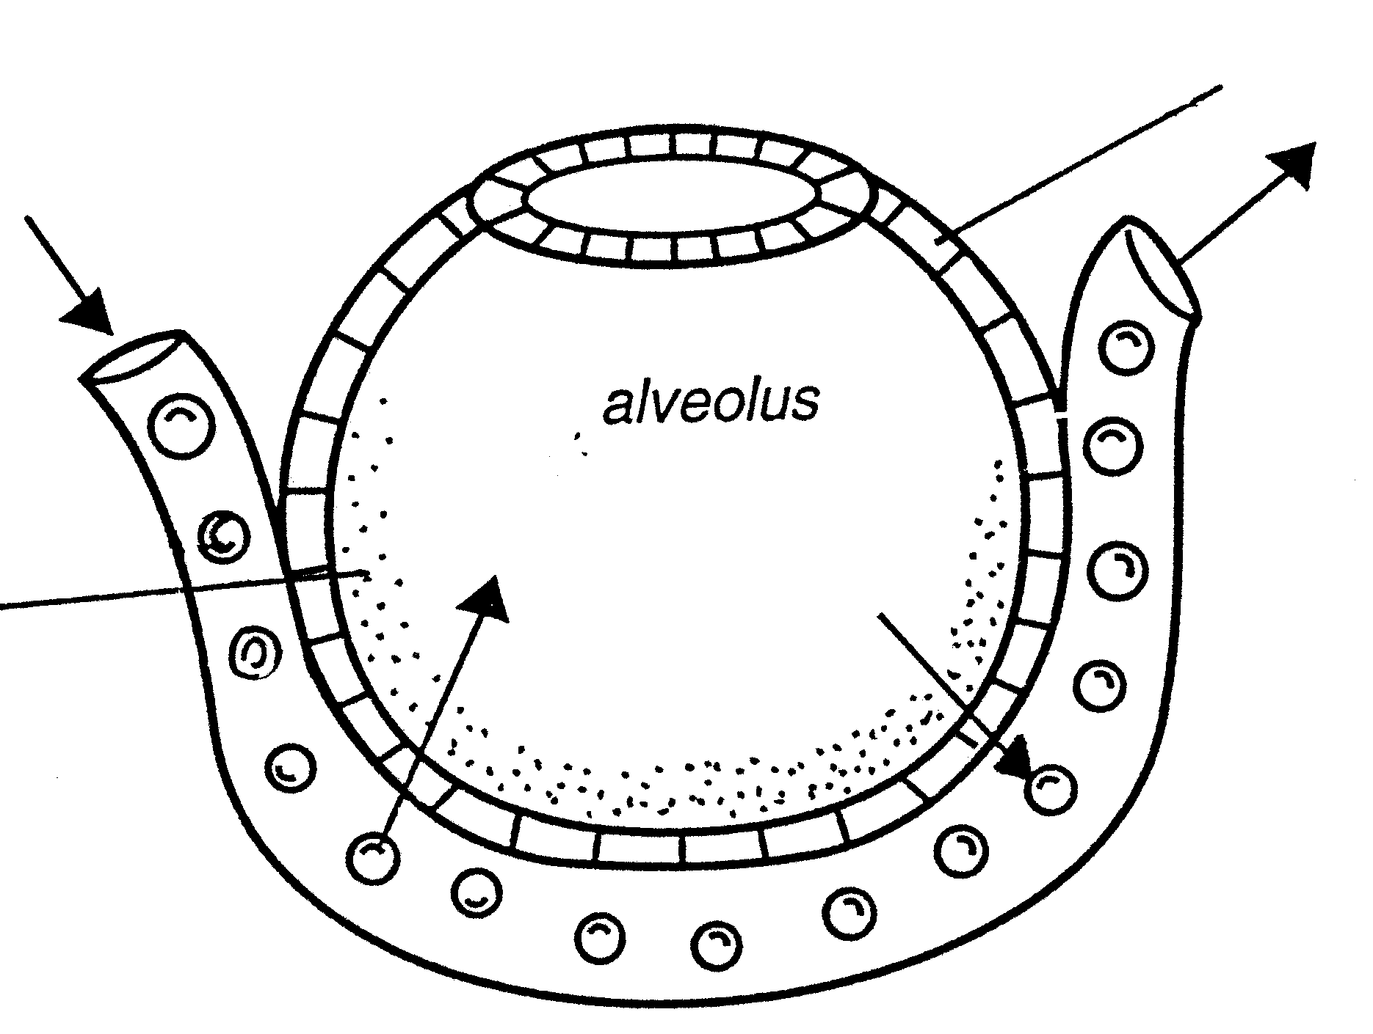

  - Which of the following functions are performed by the water film? It
- facilitates breathing movements.
- aids in diffusion of gases.
- is sensitive to high levels of pH.
- combines with sulphur.

1.27 The cells labelled P are
 | A. | podocytes.
 | B. | ciliated epithelial cells.
 | C. | endothelial cells.
 | D. | squamous epithelial cells.

1.28 The gases represented by the arrows labelled X and Y are respectively.
- water vapour; oxygen
- oxygen; carbon dioxide
- carbon dioxide; oxygen
- oxygen; water vapour

  - This diagram shows that the reptile is

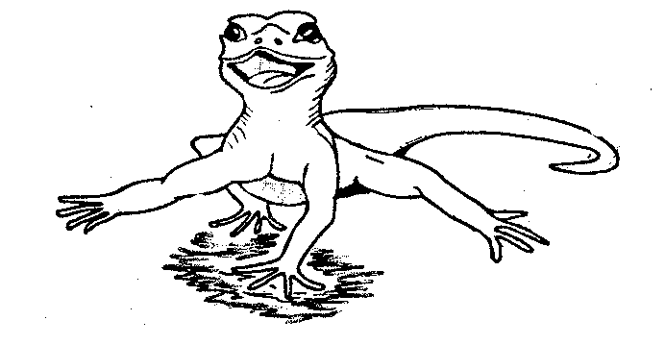

- balancing himself.
- regulating temperature.
- dancing.
- digging a hole in the sand.
1.30 If C = consumption, P = production, R= respiration, E= excretion and F= faeces, which formula is correct for a balanced energy budget in organisms?
 | A. | P = C + R + E + F
 | B. | C = P + R + E + F
 | C. | R = C + P + E + F
 | D. | C + P =E + R + F

1.31 Which one of the following does not fit in with the rest?
 | A. | Photoperiodism
 | B. | Immigration
 | C. | Emigration
 | D. | Mortality

Questions 1.32 to 1.35 are based on the following diagram that illustrates population growth.
Population size
Time

I II III IV

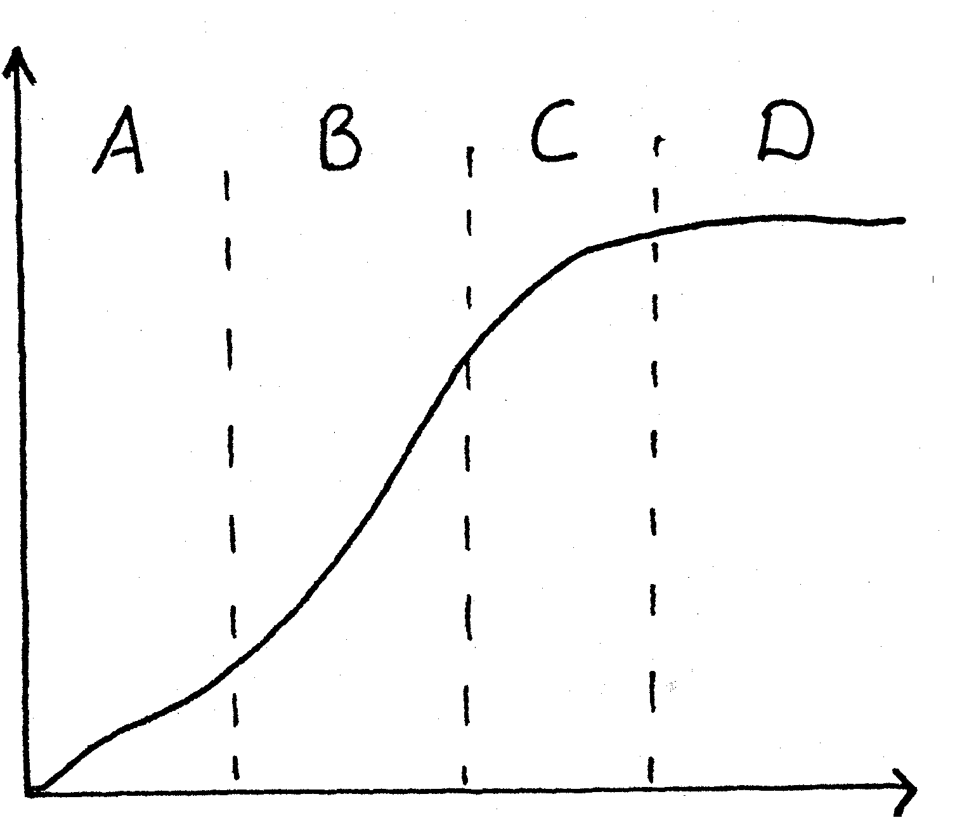

1.32 This graph illustrates
 | A. | predation.
 | B. | logistic growth
 | C. | geometric growth.
 | D. | exponential growth.

1.33 On the graph phase II indicates
 | A. | emigration and natality.
 | B. | mortality and immigration.
 | C. | emigration and mortality.
 | D. | immigration and natality.

1.34 Which label represents the lag phase?
 | A. | I
 | B. | II
 | C. | III
 | D. | IV

1.35 Phase IV on the graph indicates
 | A. | immigration.
 | B. | carrying capacity.
 | C. | predation.
 | D. | natality.

Questions 1.36 to 1.38 are based on the following diagrams that are not drawn to scale.
4
3
2
1

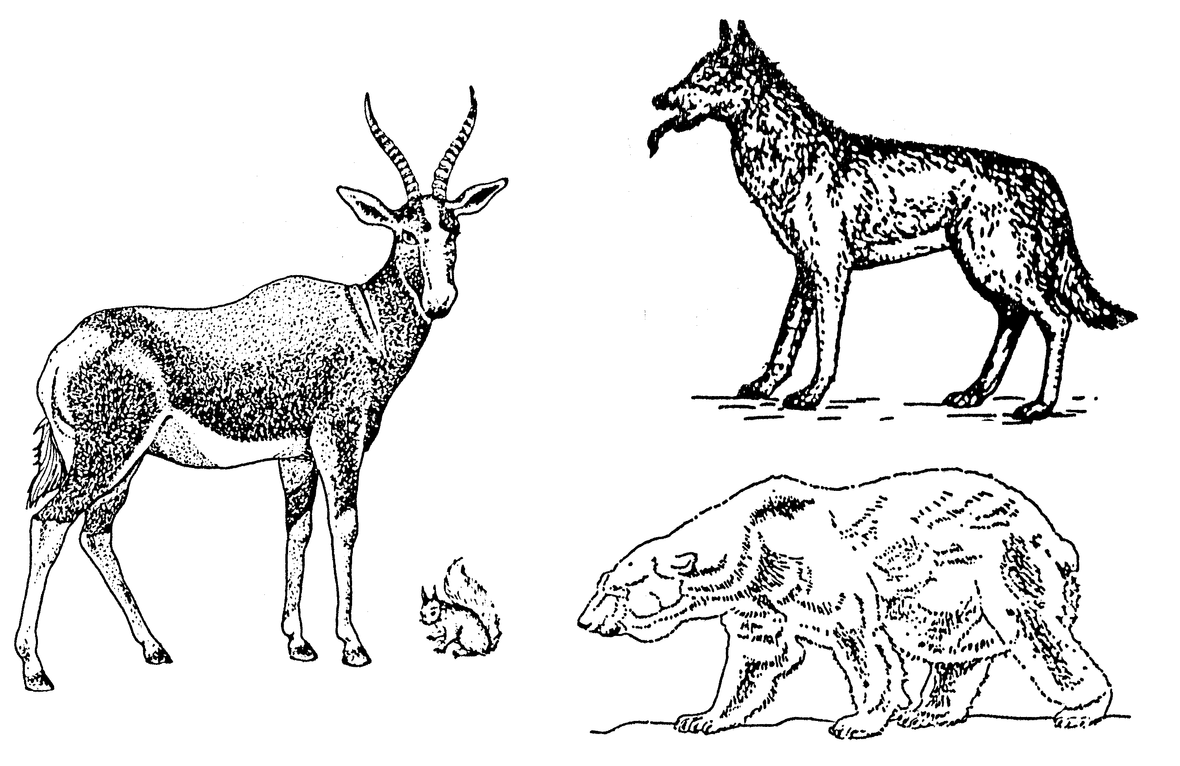

1.36 Which one of the following animals will lose the most body heat when exposed to cold environments?
 | A. | 1
 | B. | 2
 | C. | 3
 | D. | 4

1.37 Which one of the following animals is best equipped to withstand the very low temperature in the Arctic zone?
 | A. | 1
 | B. | 2
 | C. | 3
 | D. | 4

1.38 This animal loses heat by panting.
 | A. | 1
 | B. | 2
 | C. | 3
 | D. | 4

Questions 1.39 and 1.40 are based on data about the percentage of HIV / Aids infections in the various provinces.
WC
(17%)
G
(24%)
KZN
(51%)
Free State (FS)

Gauteng (G)

WesternCape (WC)

KwaZulu Natal (KZN)
FS
(8%)
Key:

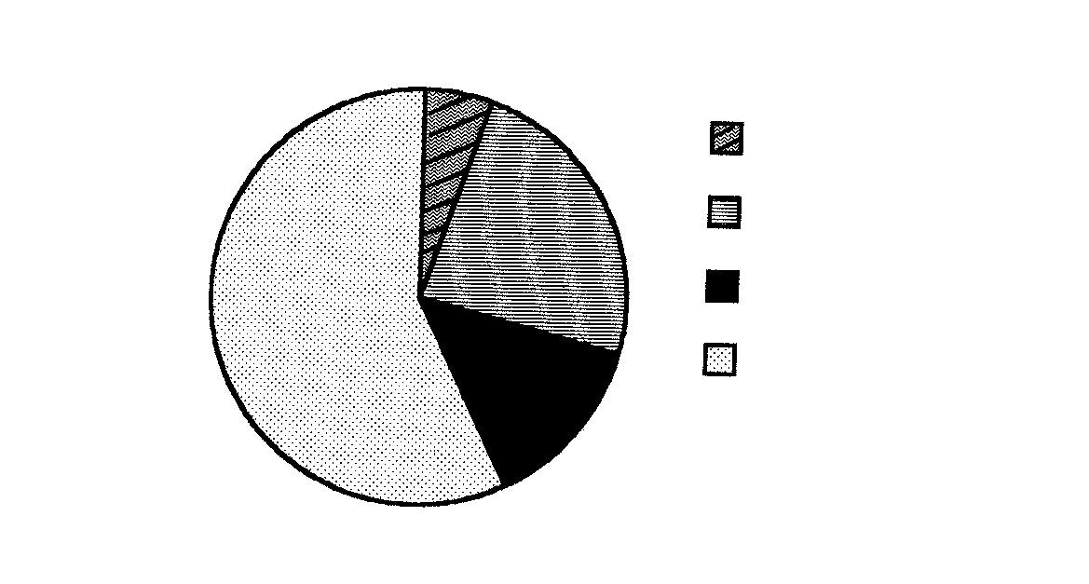

1.39 In which province is the percentage of HIV / Aids infections the highest?
 | A. | KZN
 | B. | FS
 | C. | G
 | D. | WC

- When making comparisons between KwaZulu Natal and the Western Cape, what conclusion can be made?  10  9  8  7  - % HIV / Aids is the same in both provinces.  - % HIV / Aids is three times more in KwaZulu Natal.  - % HIV / Aids is more in the Western Cape.  - % HIV / Aids is two times more in KwaZulu Natal.  40x2 = | [80]
Answer QUESTION 1B and 1C in your answer book.  2  3  1  4  5  6  7  8  9  10  QUESTION 1B  Study the diagrams and provide labels for the numbered parts. Write each number and answer on a new line.  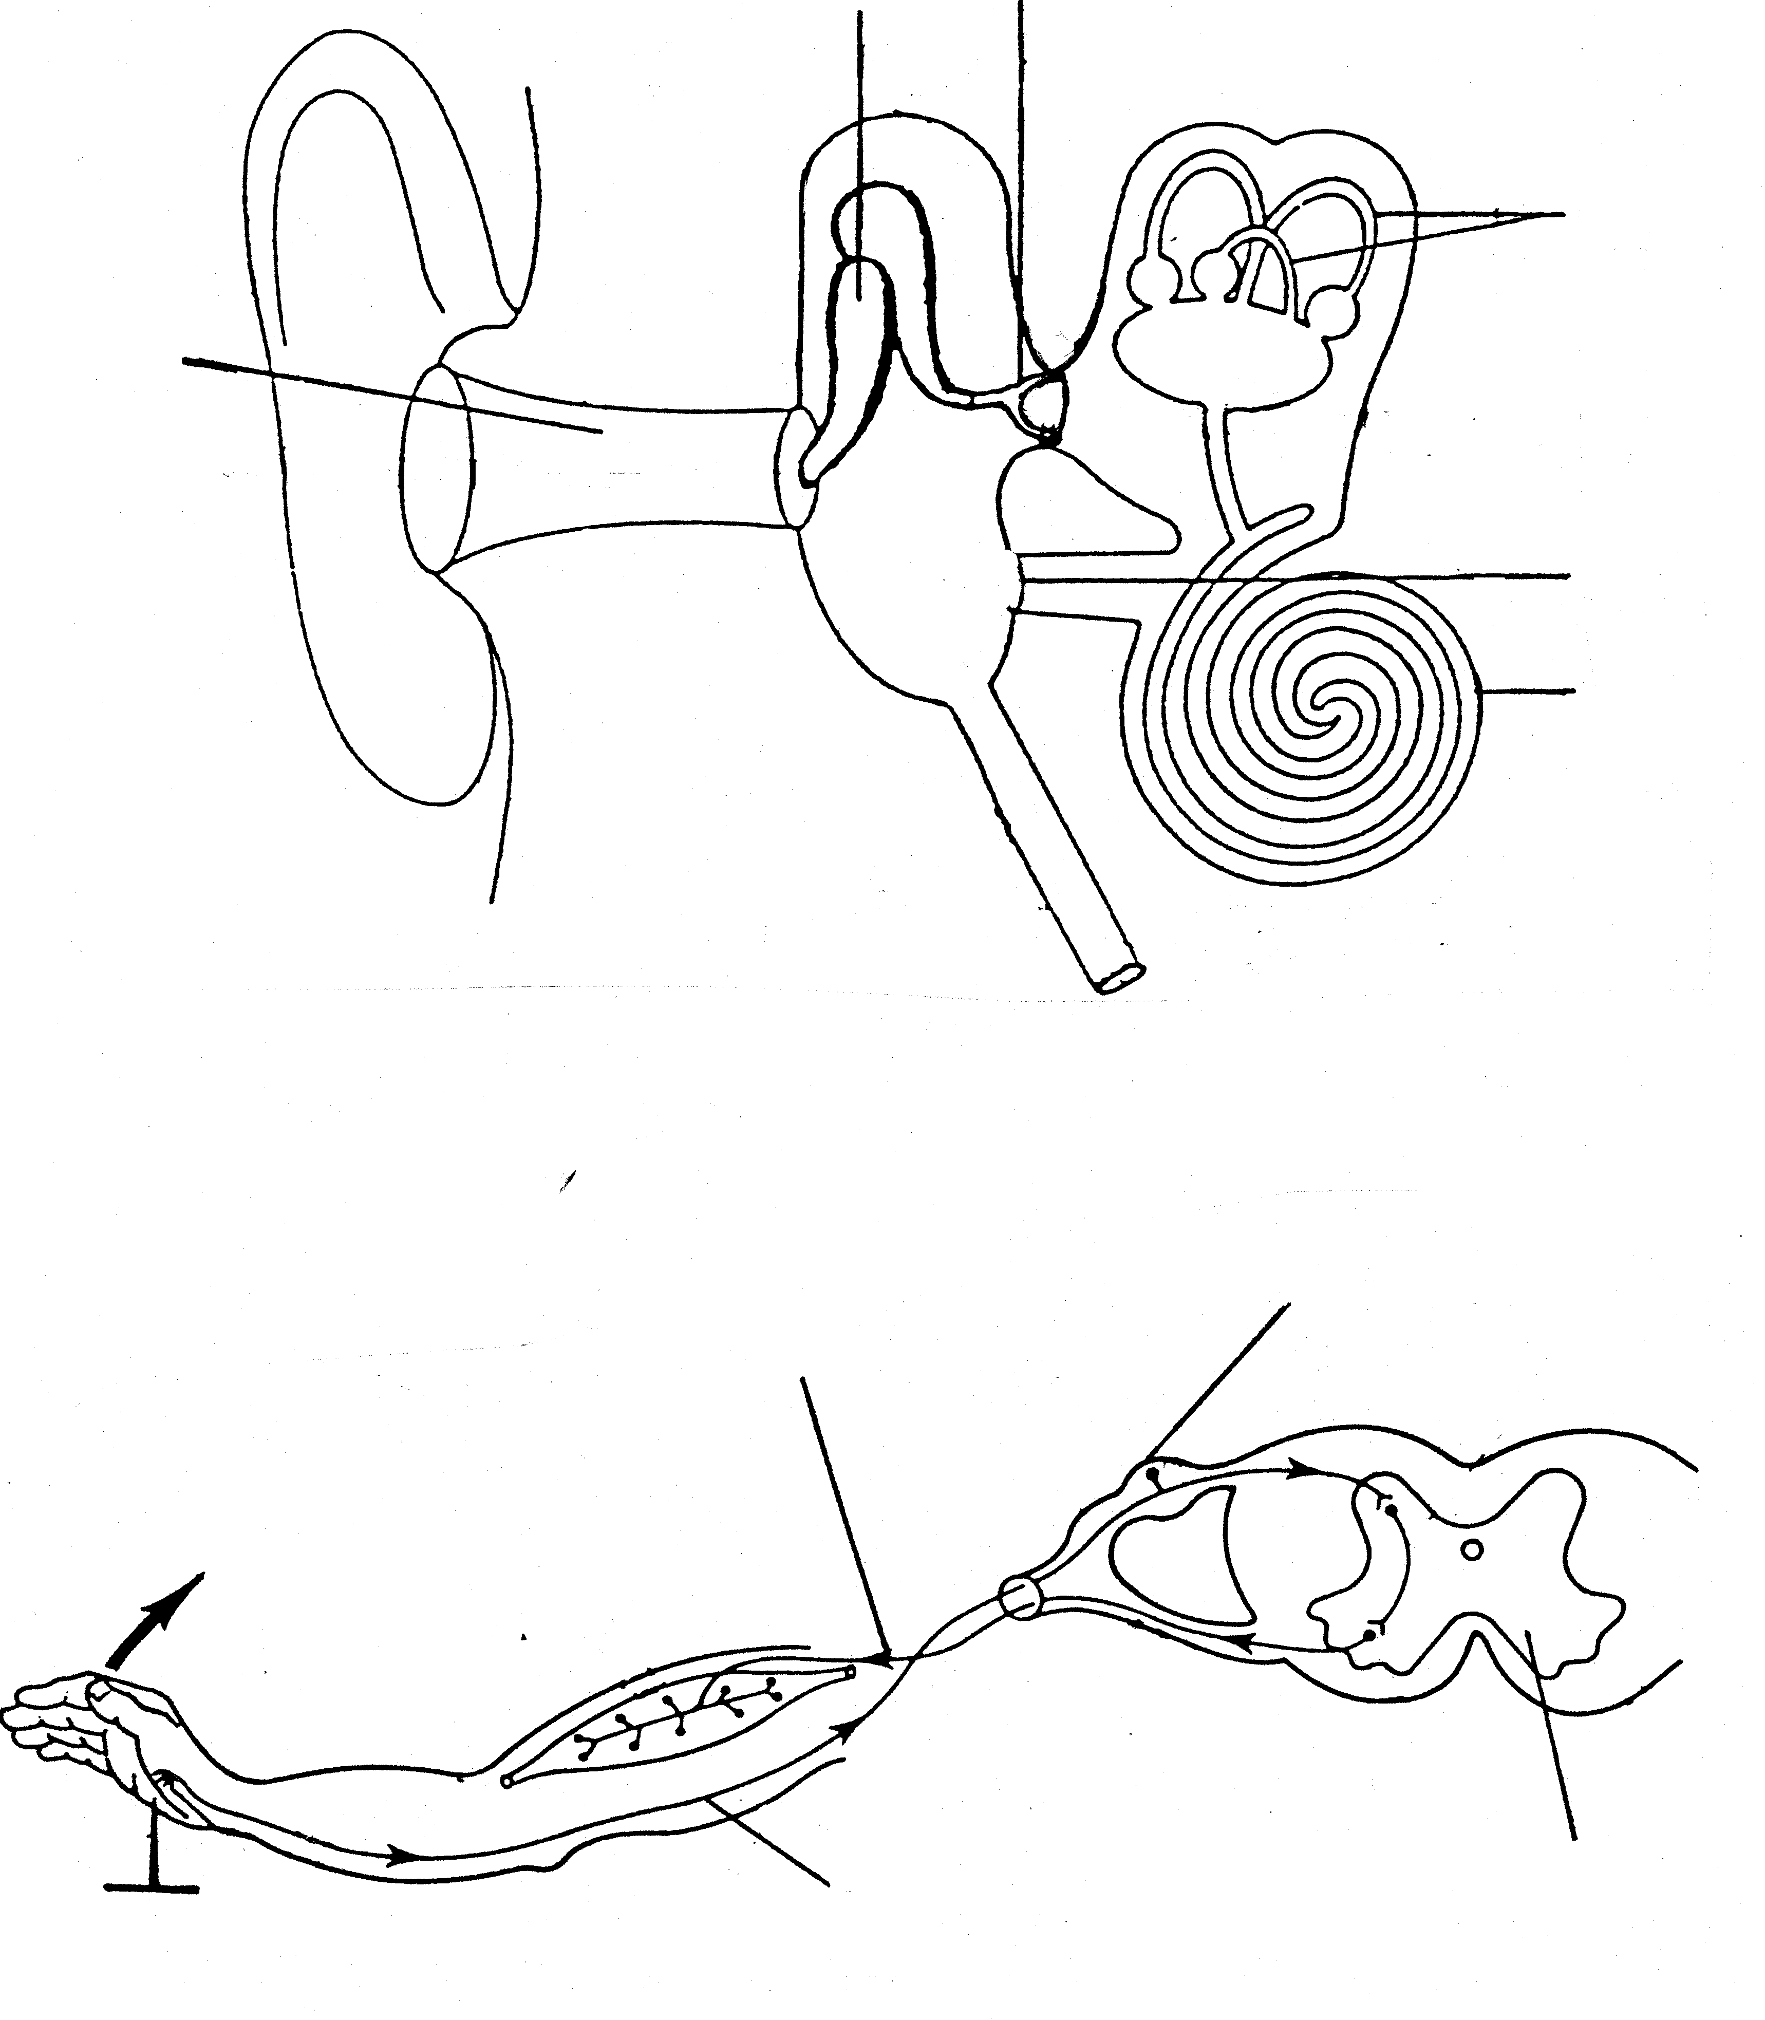 | [10]
QUESTION 1C  soda lime  chalk  rubber stopper  geranium plant  X  y  Z  1  2  3  4  5  6  7  7  12  11  10  9  8  Study the diagram of an experiment on photosynthesis and answer the questions that follow.  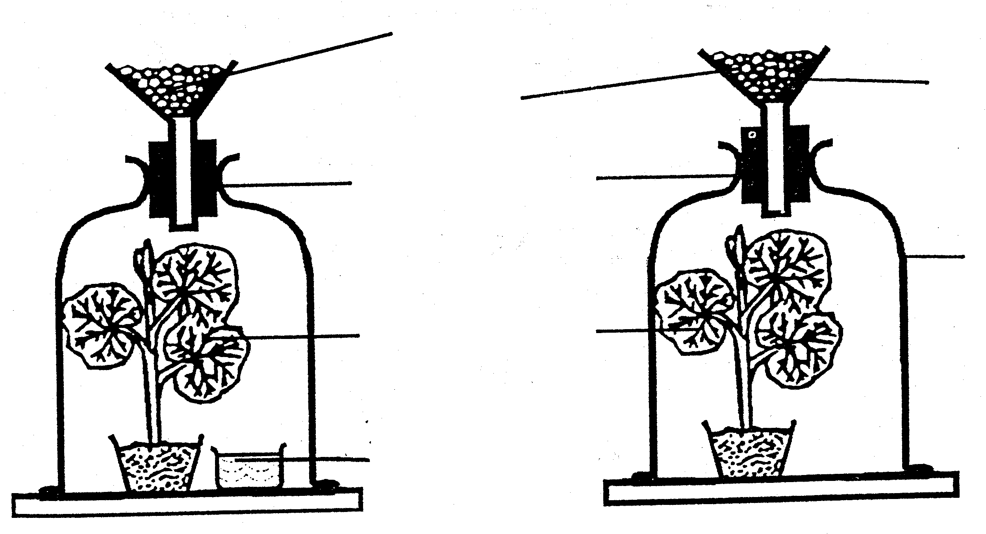  - What is the aim of this experiment?  - What is the function of the soda lime?  - Which chemical should be used at Z?  - Name the apparatus labelled X and Y in the diagram.  - Name TWO other essential factors needed for photosynthesis to take place.  TOTAL FOR SECTION A:  SECTION B  QUESTION 2  - Study the following diagram based on the human digestive system.  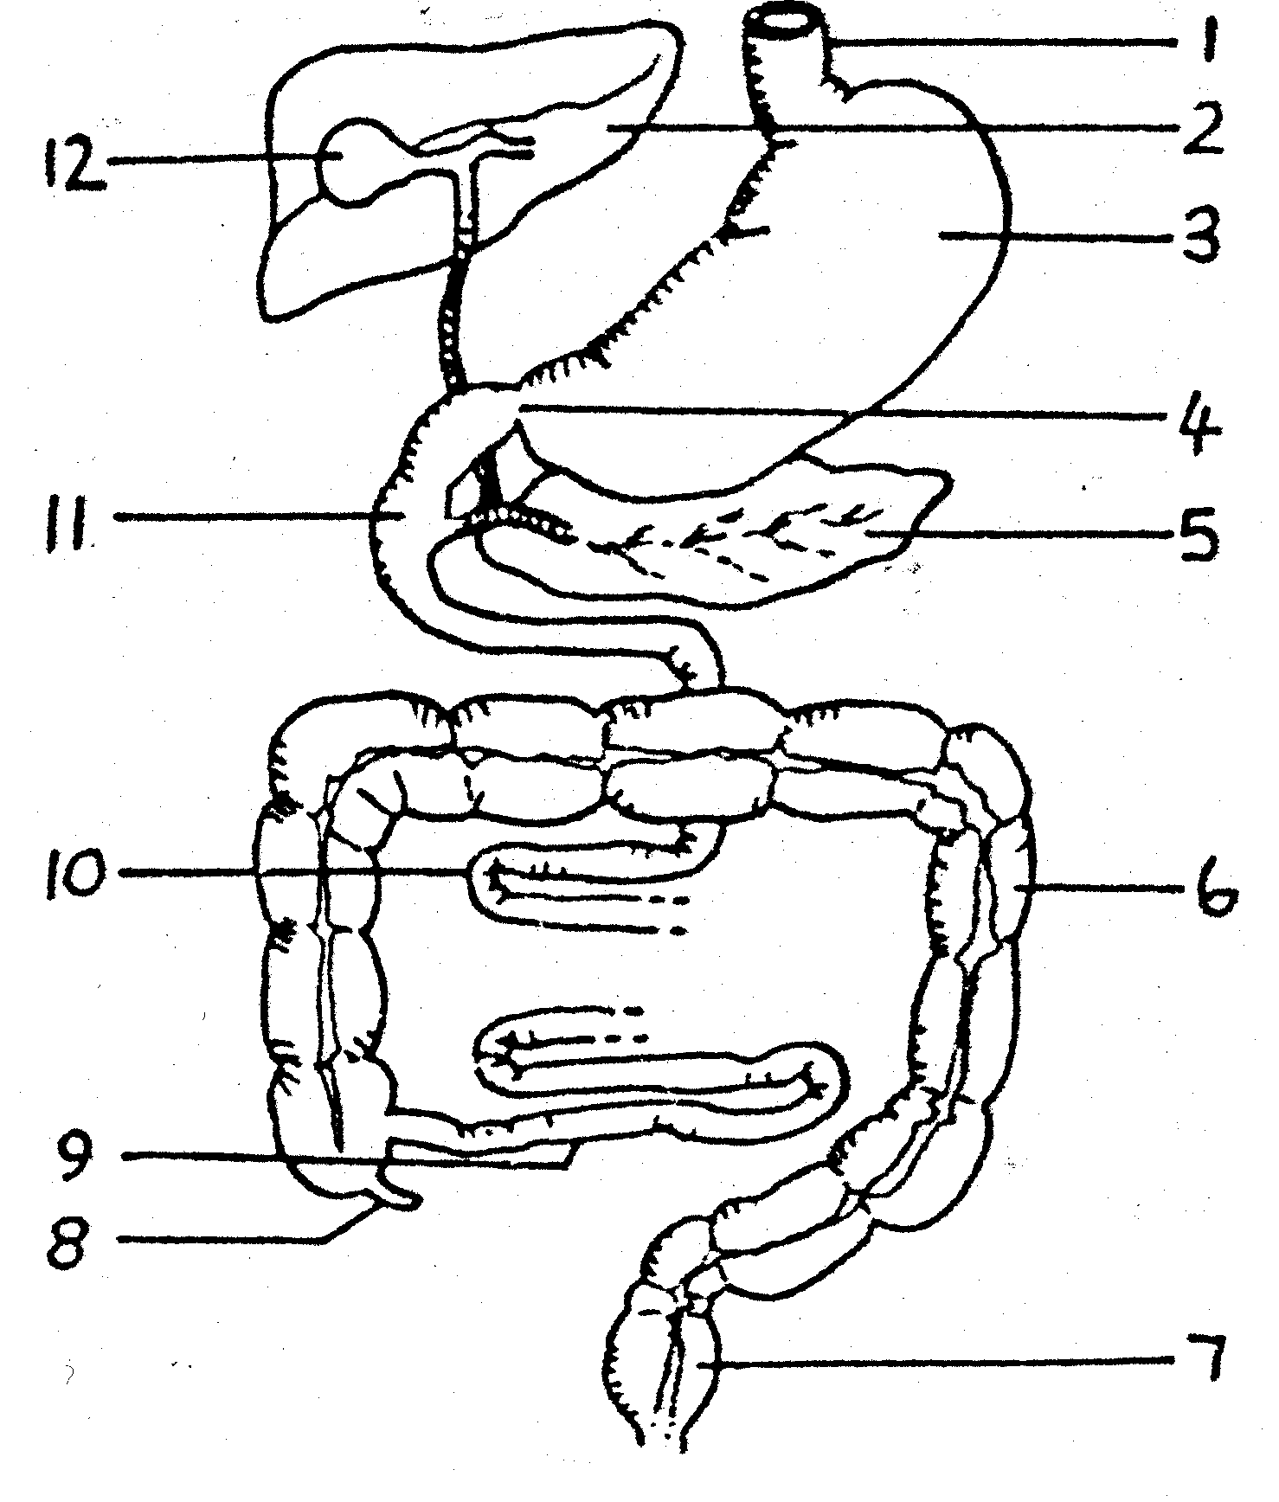 | (2)  (2)  (2)  (2)  (2)  [10]  [100]

- Identify the parts numbered 1 to 8.  5  6  1  2  3  4  7  8  - Name the THREE parts of the small intestine numbered 9, 10 and 11.  - Name the substance stored in the part numbered 12.  - Provide THREE functions of the substance mentioned in Question 2.1.3.  - What process is responsible for the movement of chyme through the digestive canal?  - Draw and label the structure of the villus.  - Study the diagram of the human respiratory organs and answer the questions that follow.  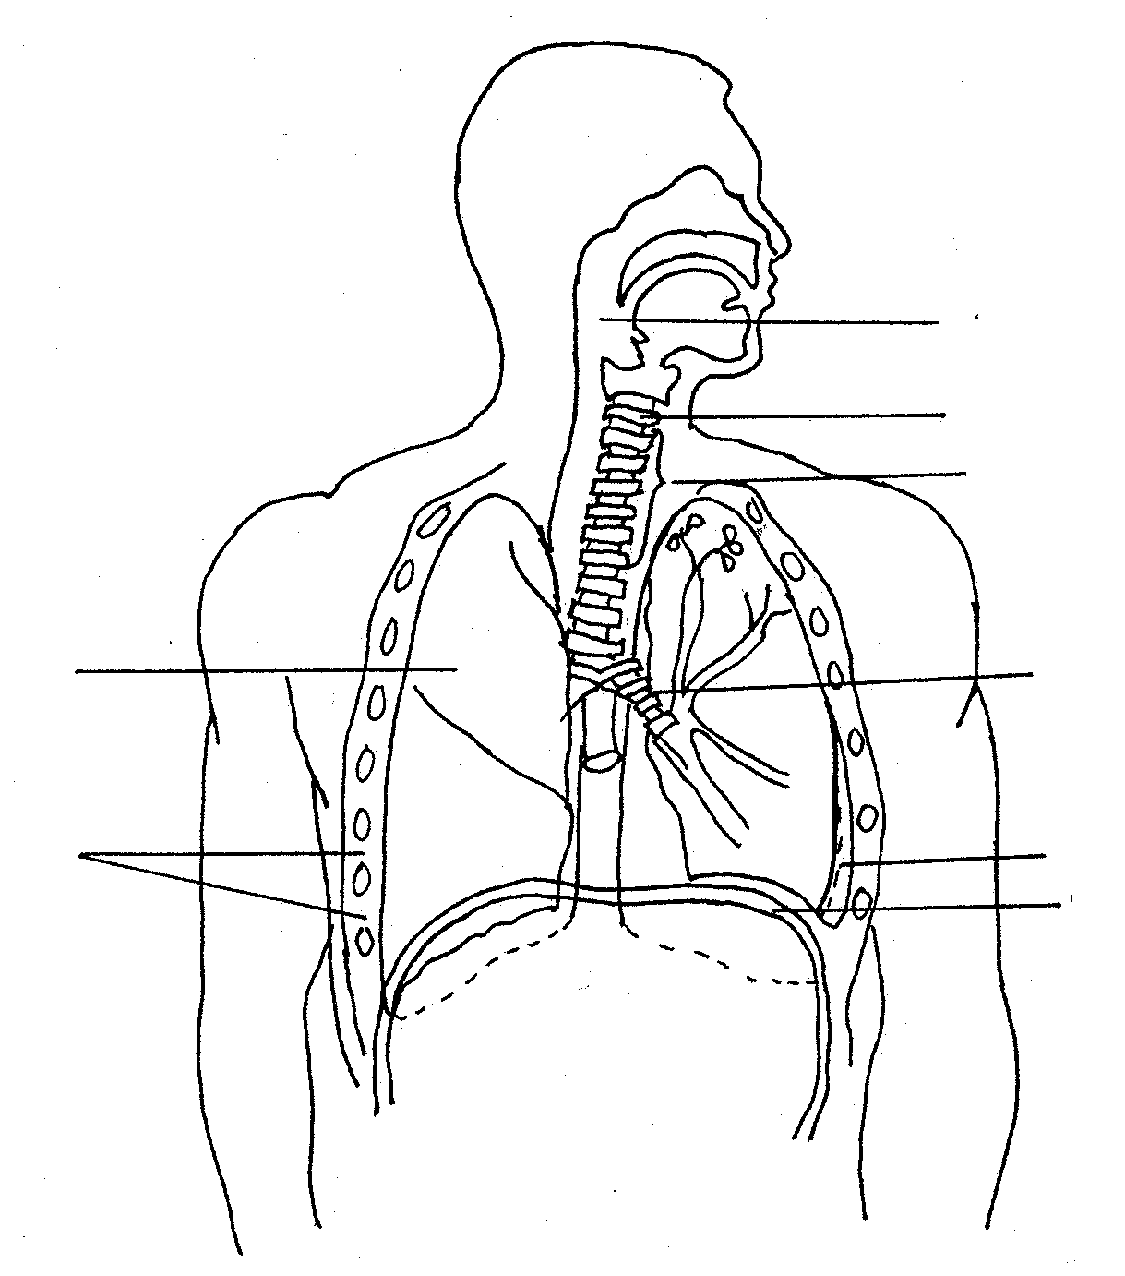  - Identify the parts numbered 1 to 8.  - List TWO ways in which the respiratory organs are protected.  - Briefly describe how inhalation occurs by referring to the role of parts numbered 6 and 8.  - What is the main form in which oxygen is transported in the blood? | (8)  (3)  (1)  (6)  (2)  (6)  (8)  (2)  (5)  (2)

- Draw the diagram below in a bigger size in your answer book.  1  3  2  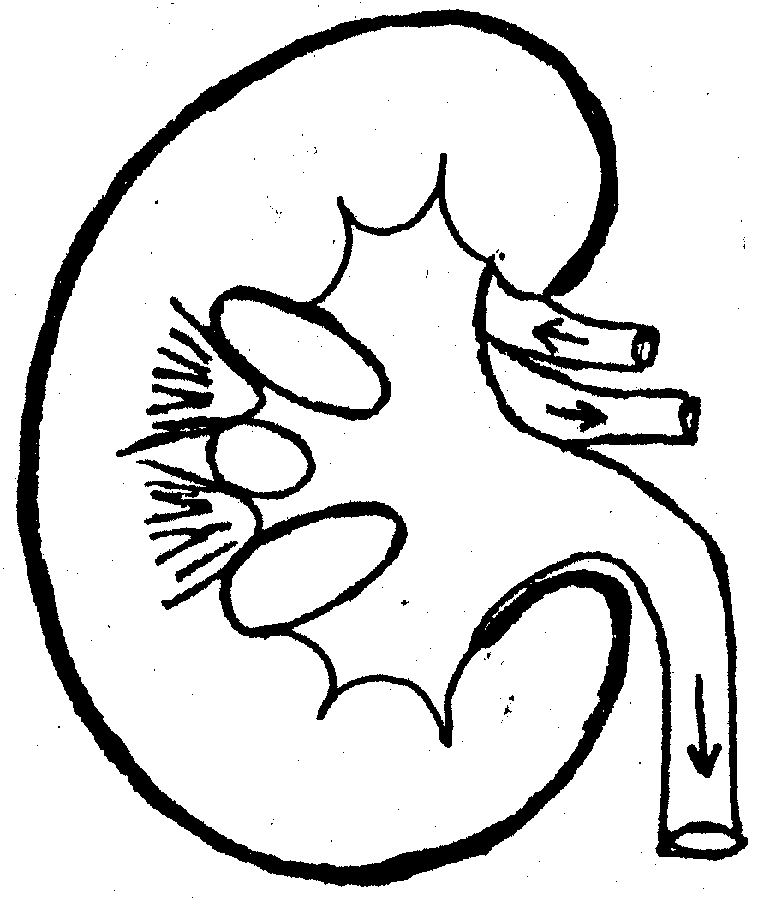  Use the following words to label the diagram.  Renal capsule, Cortex, Ureter, Medulla, Pyramid, Renal artery and Pelvis  QUESTION 3  - The brain plays an important role in co-ordination in the body. Study the diagram and answer the questions.  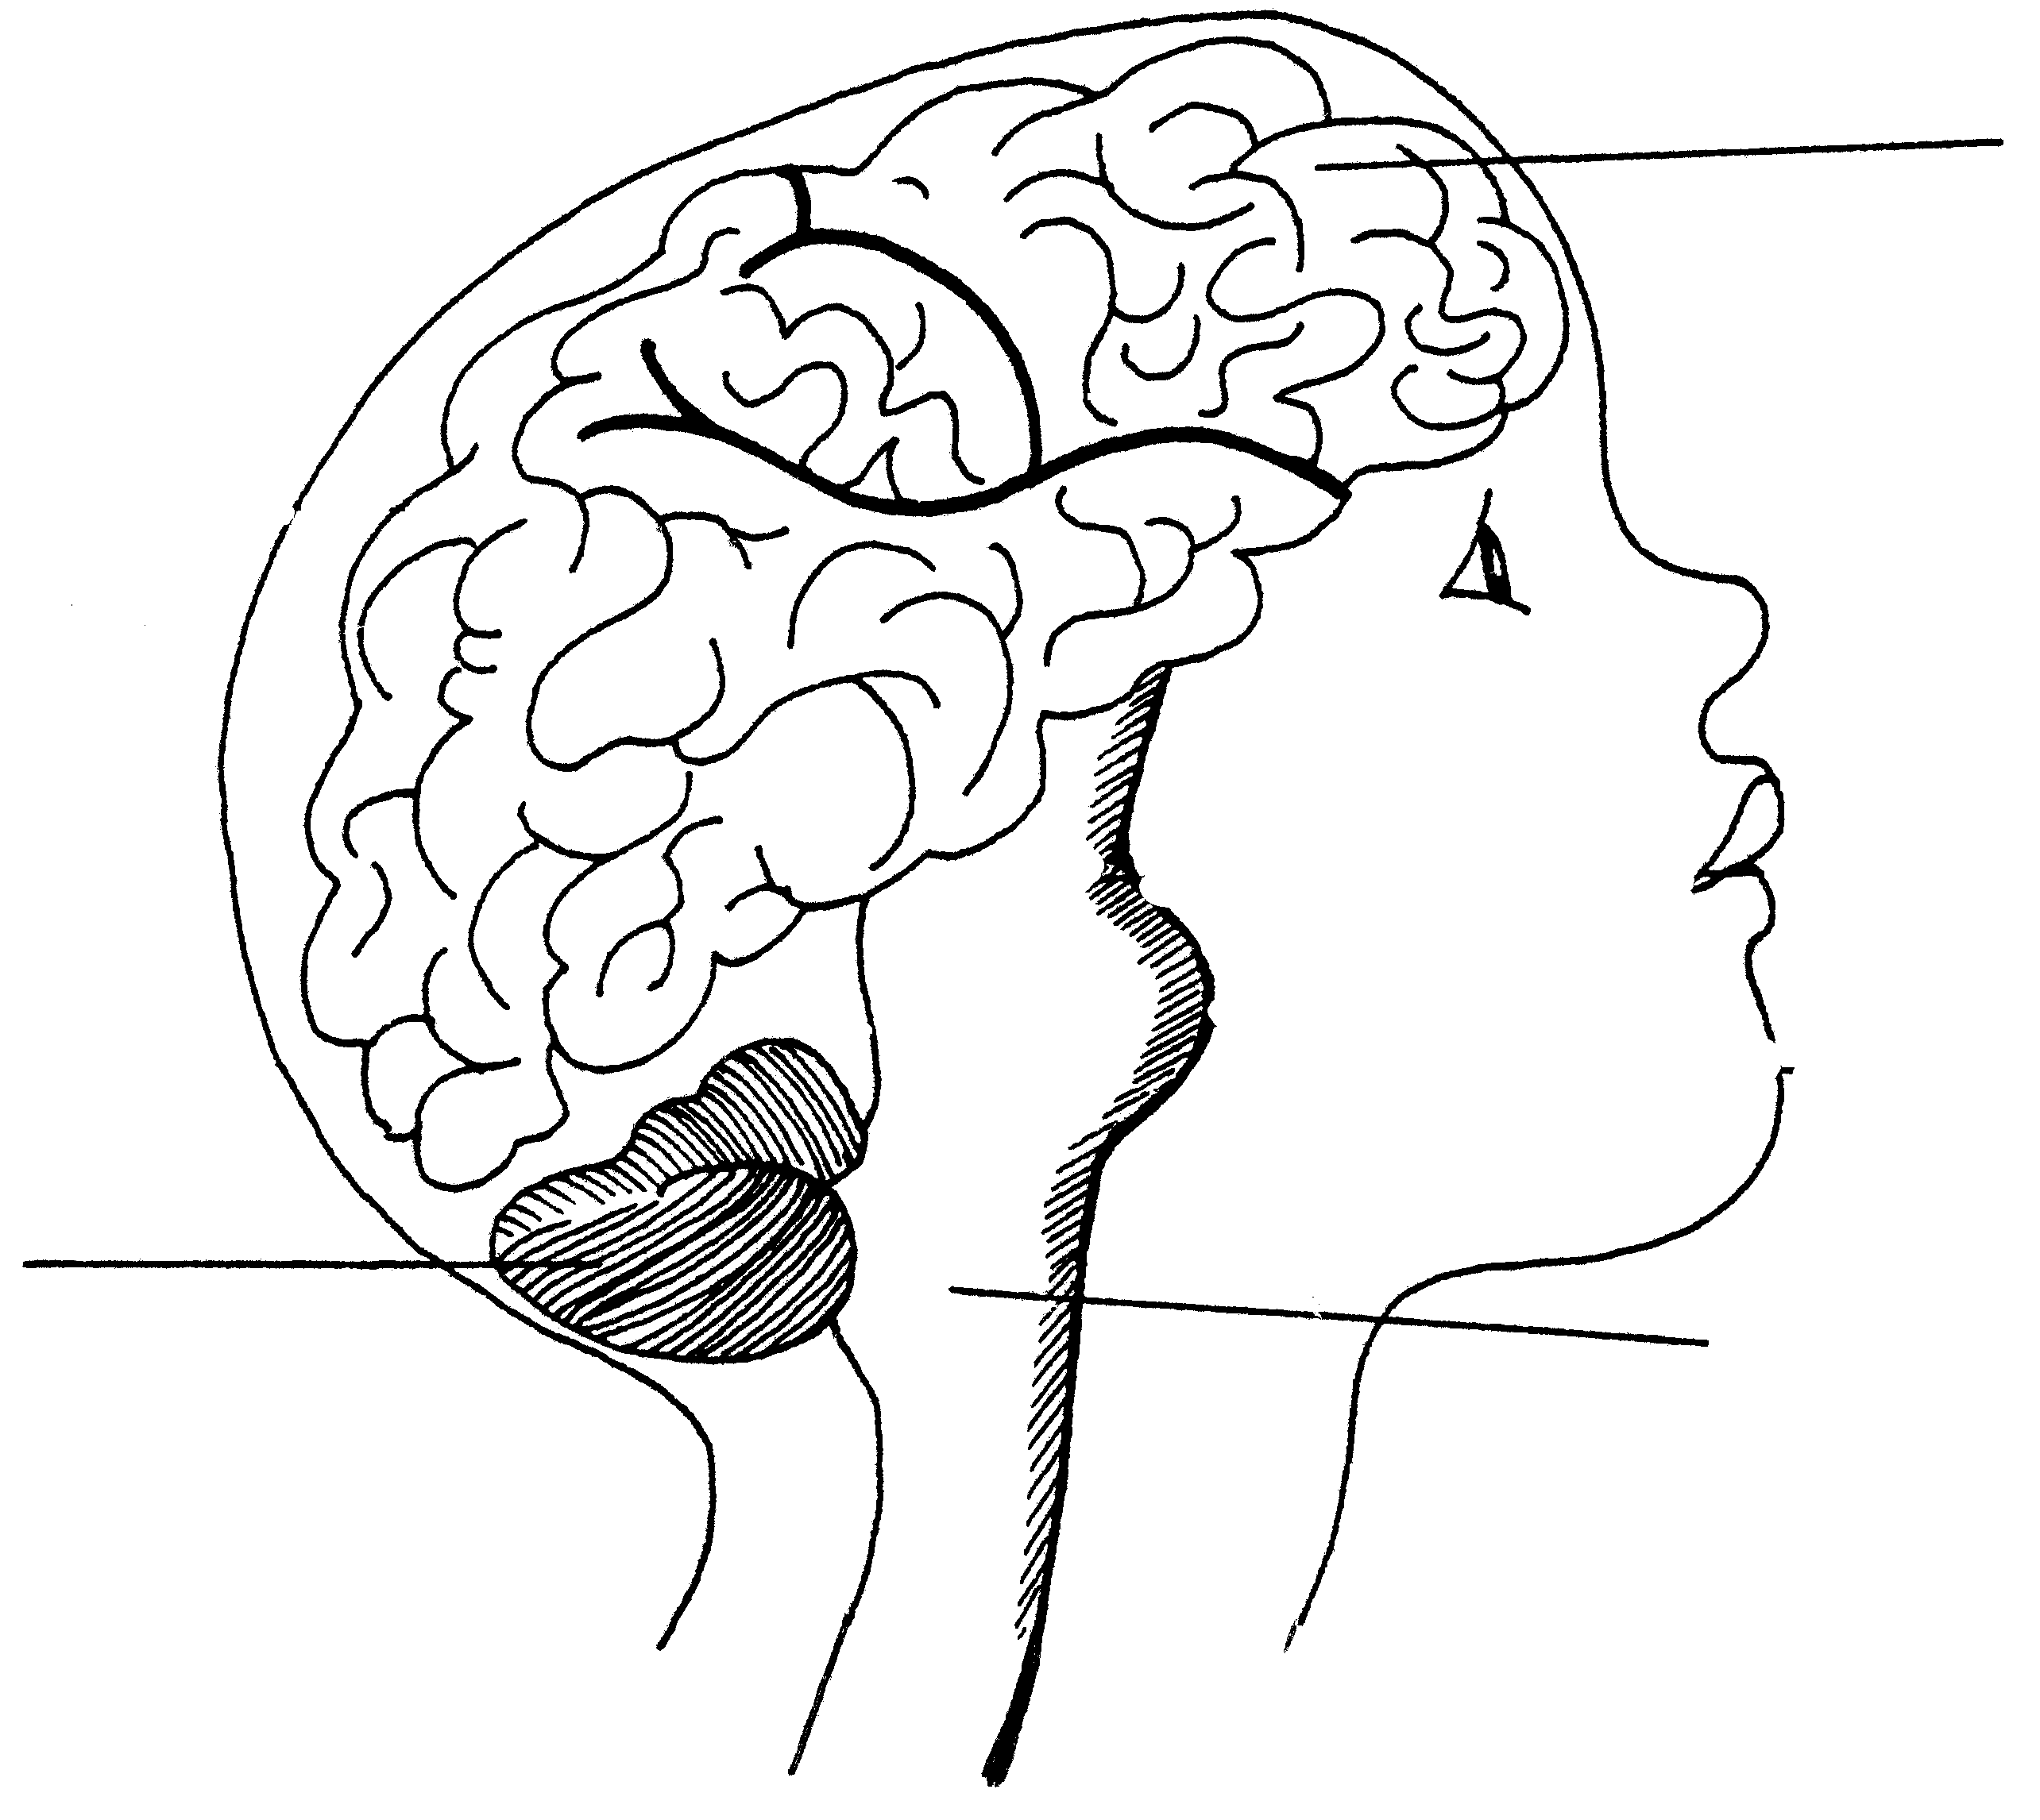  - Identify the parts numbered 1, 2 and 3.  - State ONE function each for parts numbered 1, 2 and 3.  - Name the endocrine gland found attached to part number 1.  - Name TWO hormones secreted by this gland.  - State the function of each hormone mentioned in Question 3.1.4. | (7)  [50]  (3)  (3)  (2)  (4)  (2)
- The diagram below shows a section through the human skin.  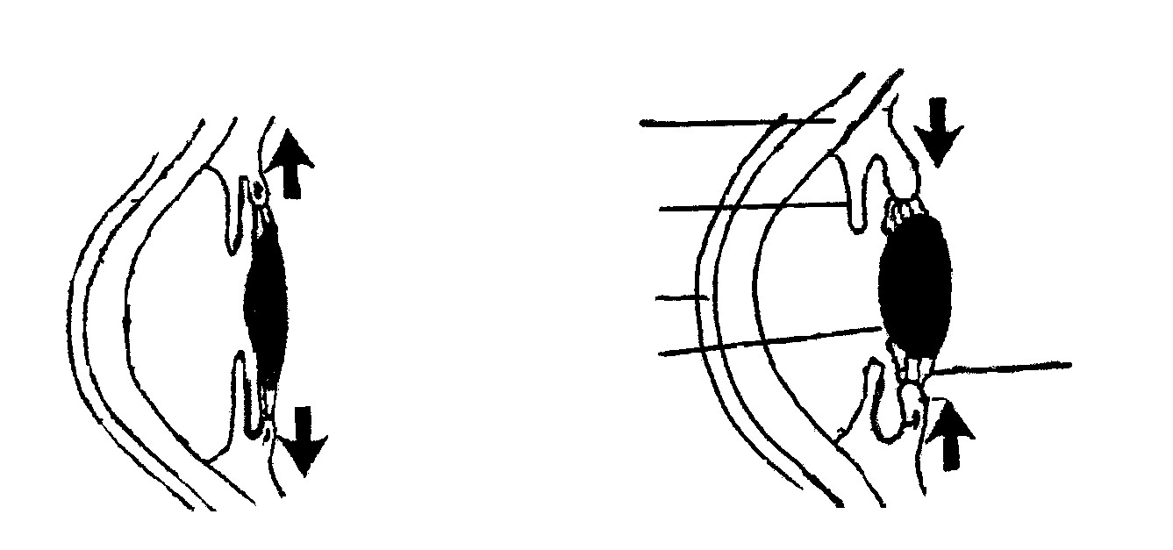  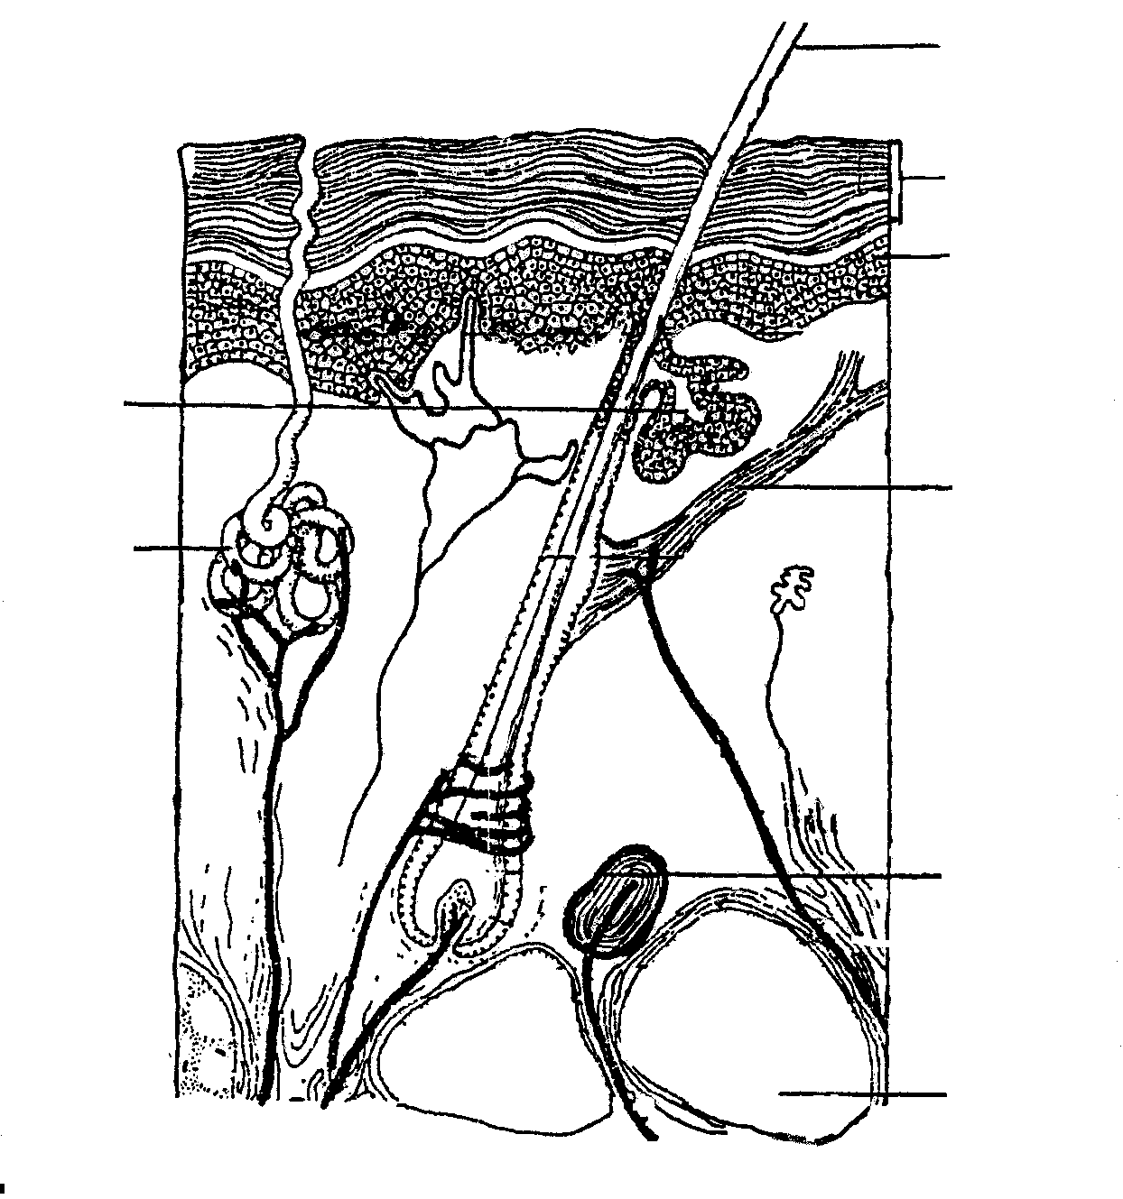  1  2  3  4  5  6  8  7  I  II  1  2  3  4  5  - Identify the parts numbered 2, 3, 5, 6 and 7.  - List ONE function the parts numbered 1 and 4 will have on a cold day.  - Explain the role of part number 7 on a very hot day.  - Study the following diagram of part of a the human eye.  - Identify the parts numbered 1, 2, 3 and 4.  - State the reason for the change from I to II.  - What term is used for the change mentioned in Question 3.3.2?  - Give ONE function of parts numbered 4 and 5 when looking at something nearby closer than 6 m. | (5)  (4)  (3)  (4)  (4)  (2)  (4)
- Study the set up of the experiment.  Number of organisms  X  Y  Time (in years)  1  2  3  4  5  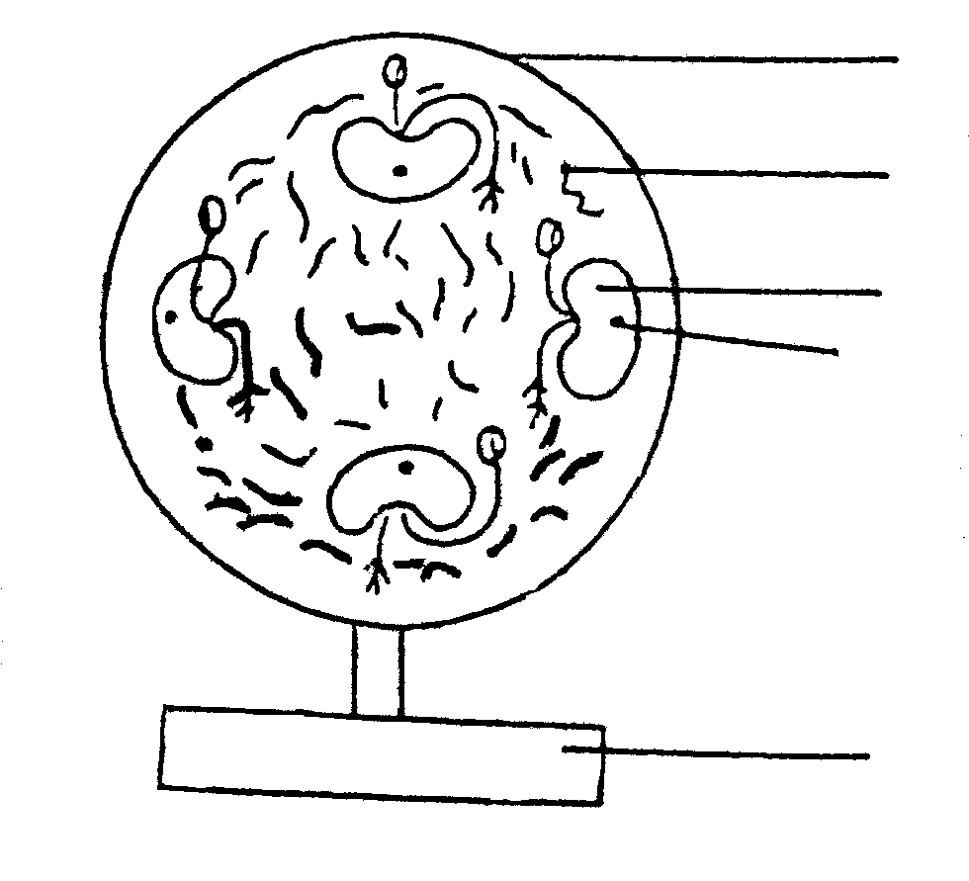  - Identify the parts numbered 1 to 5.  - How does the setting up of the control differ from the proof of the experiment?  - What is the phenomenon seen in the roots, as shown in the diagram, called?  - What organic compound of plants is responsible for the phenomenon mentioned in Question 3.4.3?  QUESTION 4  4.1 4.1.1 Define a population.  - Name FOUR factors (primary parameters) which may influence the growth of a population.  - The diagram below represents predation.  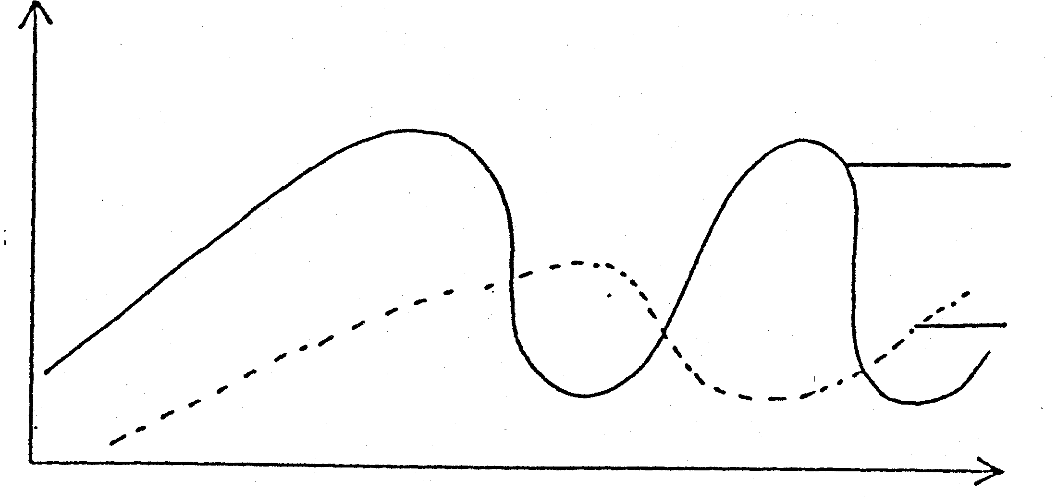  - What TWO components of predation are represented by X and Y respectively?  - Give examples of animals which could be represented by the graphs  X and Y. | (5)  (2)  (2)  (1)  [50]  (3)  (4)  (2)  (2)
- Diagrams A and B are structures found in plants.  4 (outer layer)  5  6  soil particle  1  2  3  A  B  A  B  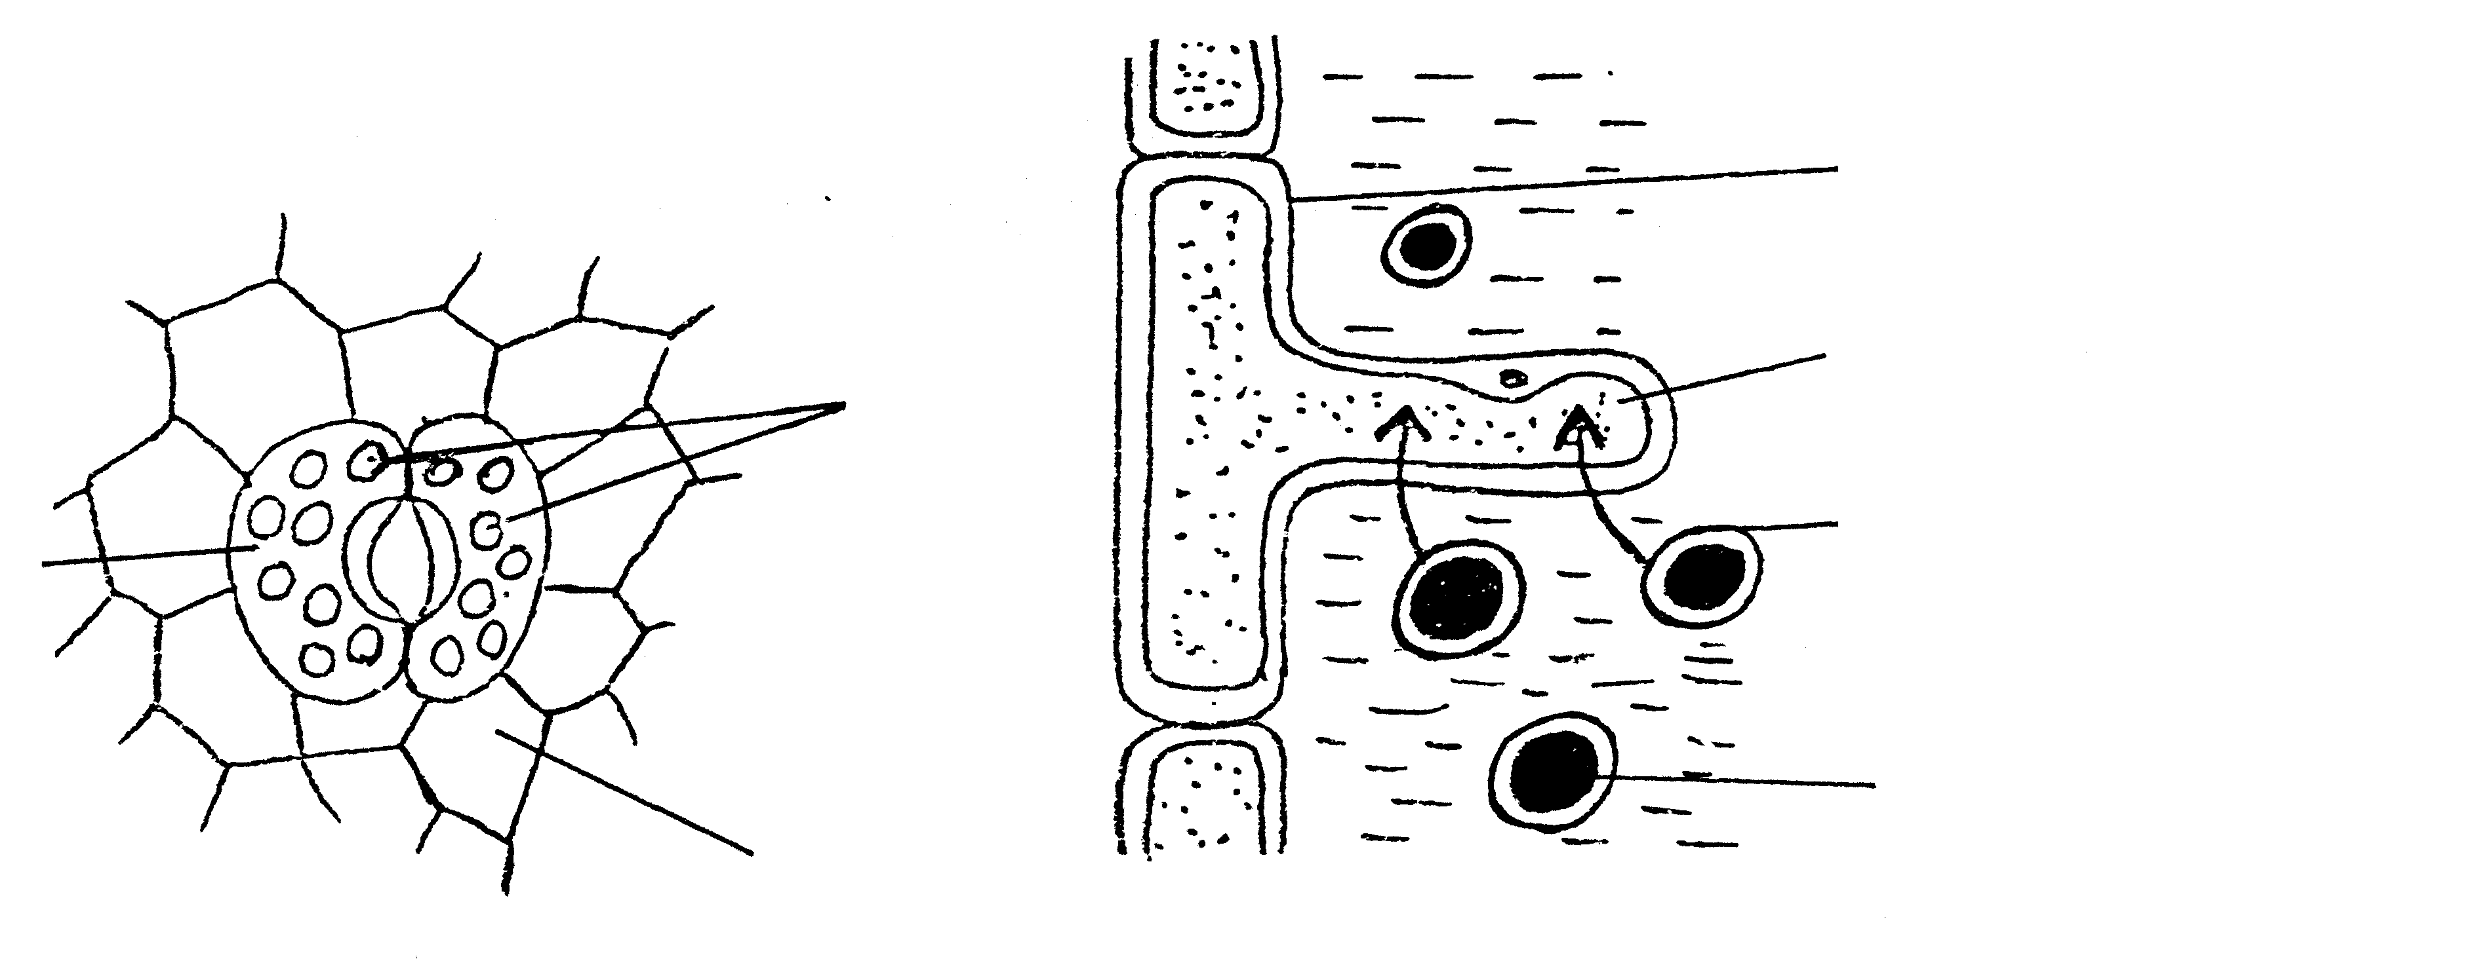  - Identify the parts numbered 1 to 6.  - Where are structures A and B found in the plant?  - Give ONE function for each of structures A and B.  - Tabulate FIVE differences between cellular respiration and photosynthesis.  - Study the diagram below and answer the questions that follow.  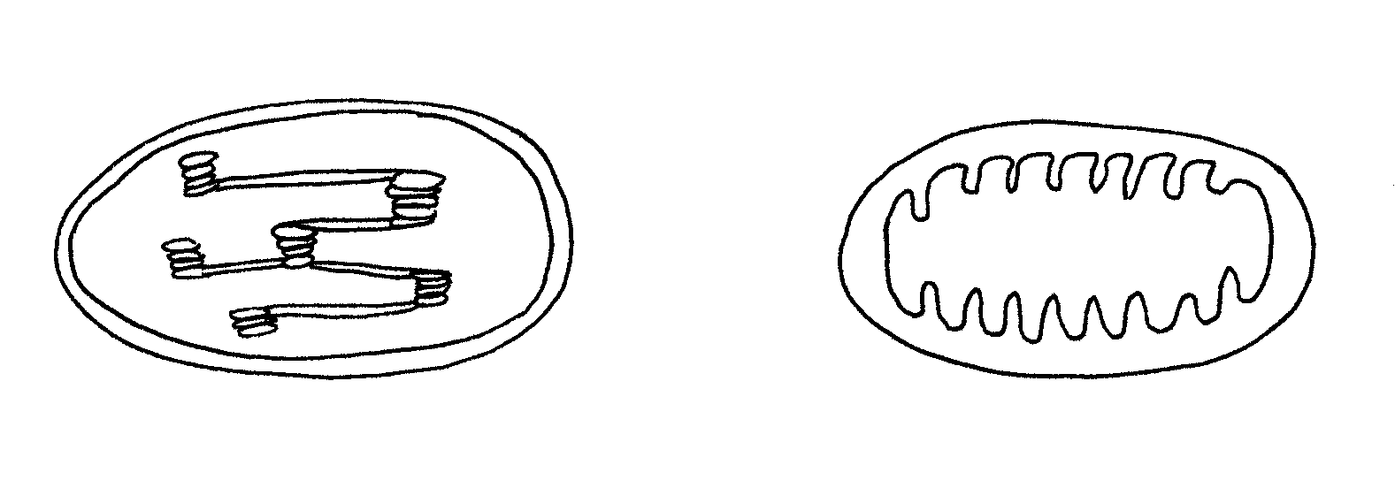  - Identify the organelles A and B.  - Which organelle is found only in plant cells?  - What process occurs respectively in organelles A and B?  - Name phases that make up each process mentioned in  Question 4.5.3. | (6)  (4)  (4)  (10)  (4)  (2)  (4)  (5)  [50]

QUESTION 5

  - The table below shows the approximate percentage composition of nutrients in four different food types.

Food types | Water | Fats | Carbohydrates | Proteins | Other nutrients and roughage
Eggs | 76% | 10% | 1% | 12% | 1%
Soya beans | 9% | 18% | 36% | 34% | 3%
Milk | 87% | 4% | 5% | 3% | 1%
Red meat | 62% | 18% | 1% | 18% | 1%

A child found suffering from a nutritional deficiency disease and having a very low mass was admitted to the health care clinic.  - Which ONE of the above nutrients would you consider to be most useful in a diet prescribed for the child so that the body mass can increase? Give a reason for your answer.  - How much fat is contained in milk?  - Why is roughage important in a diet?  - Name the monomers of proteins.  - What disease develops if there is a deficiency of protein in a diet?  - State THREE functions of each of the following nutrients in the human body:  - fats  - carbohydrates  - Give FOUR functions of water in a child’s body.  5.1.8 Which ONE of the four food types contains the highest percentage of water? | (4)  (2)  (2)  (2)  (2)  (3)  (3)  (4)  (2)

- Study the diagram below showing an experiment demonstrating cellular respiration.  thermos flask  thermometer  germinating seeds  cotton wool  EXPERIMENT  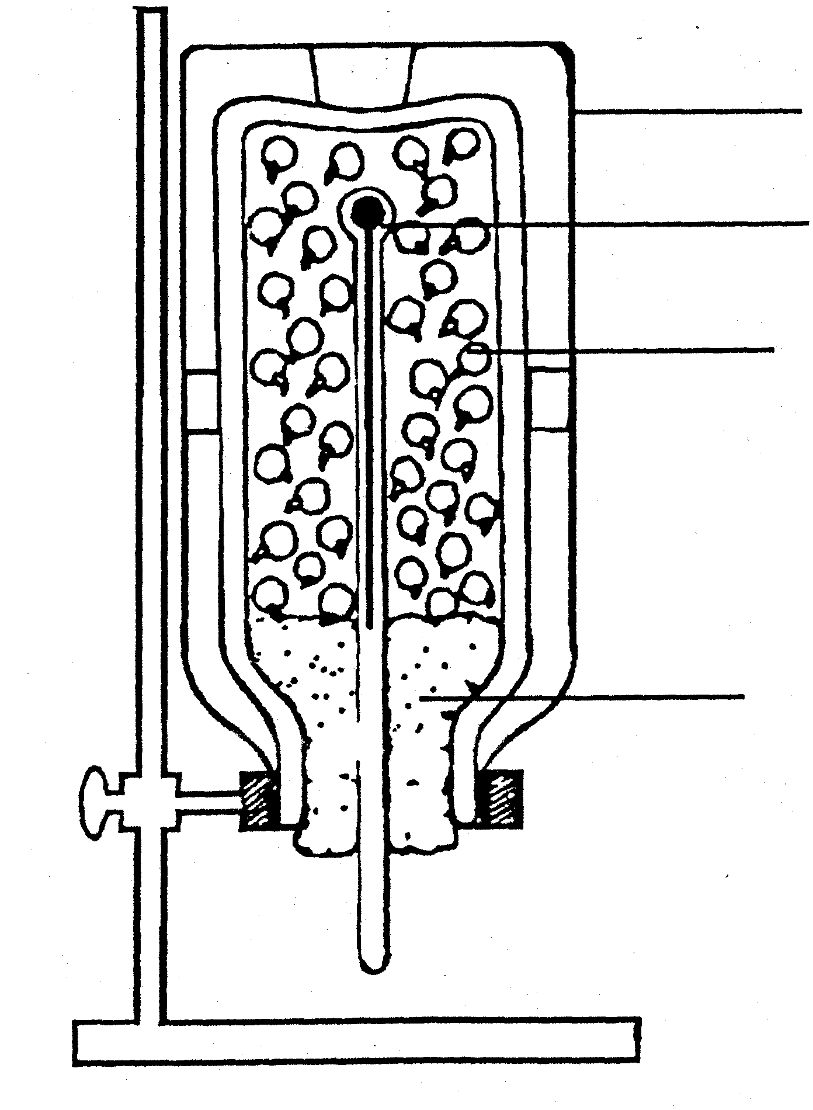  5.2.1 What is the aim of this experiment?  5.2.2 How will the setting up of the control differ from this experiment?  5.2.3 What should be observed after 24 hours?  - What is the function of cellular respiration in living organisms?  5.3 Name any FIVE factors that influence the composition of tissue fluid. | (2)  (2)  (2)  (2)  (5)

(Question 5.4 appears on the next page)

5.4 The diagram shows a structure concerned with osmoregulation.  1  2  3  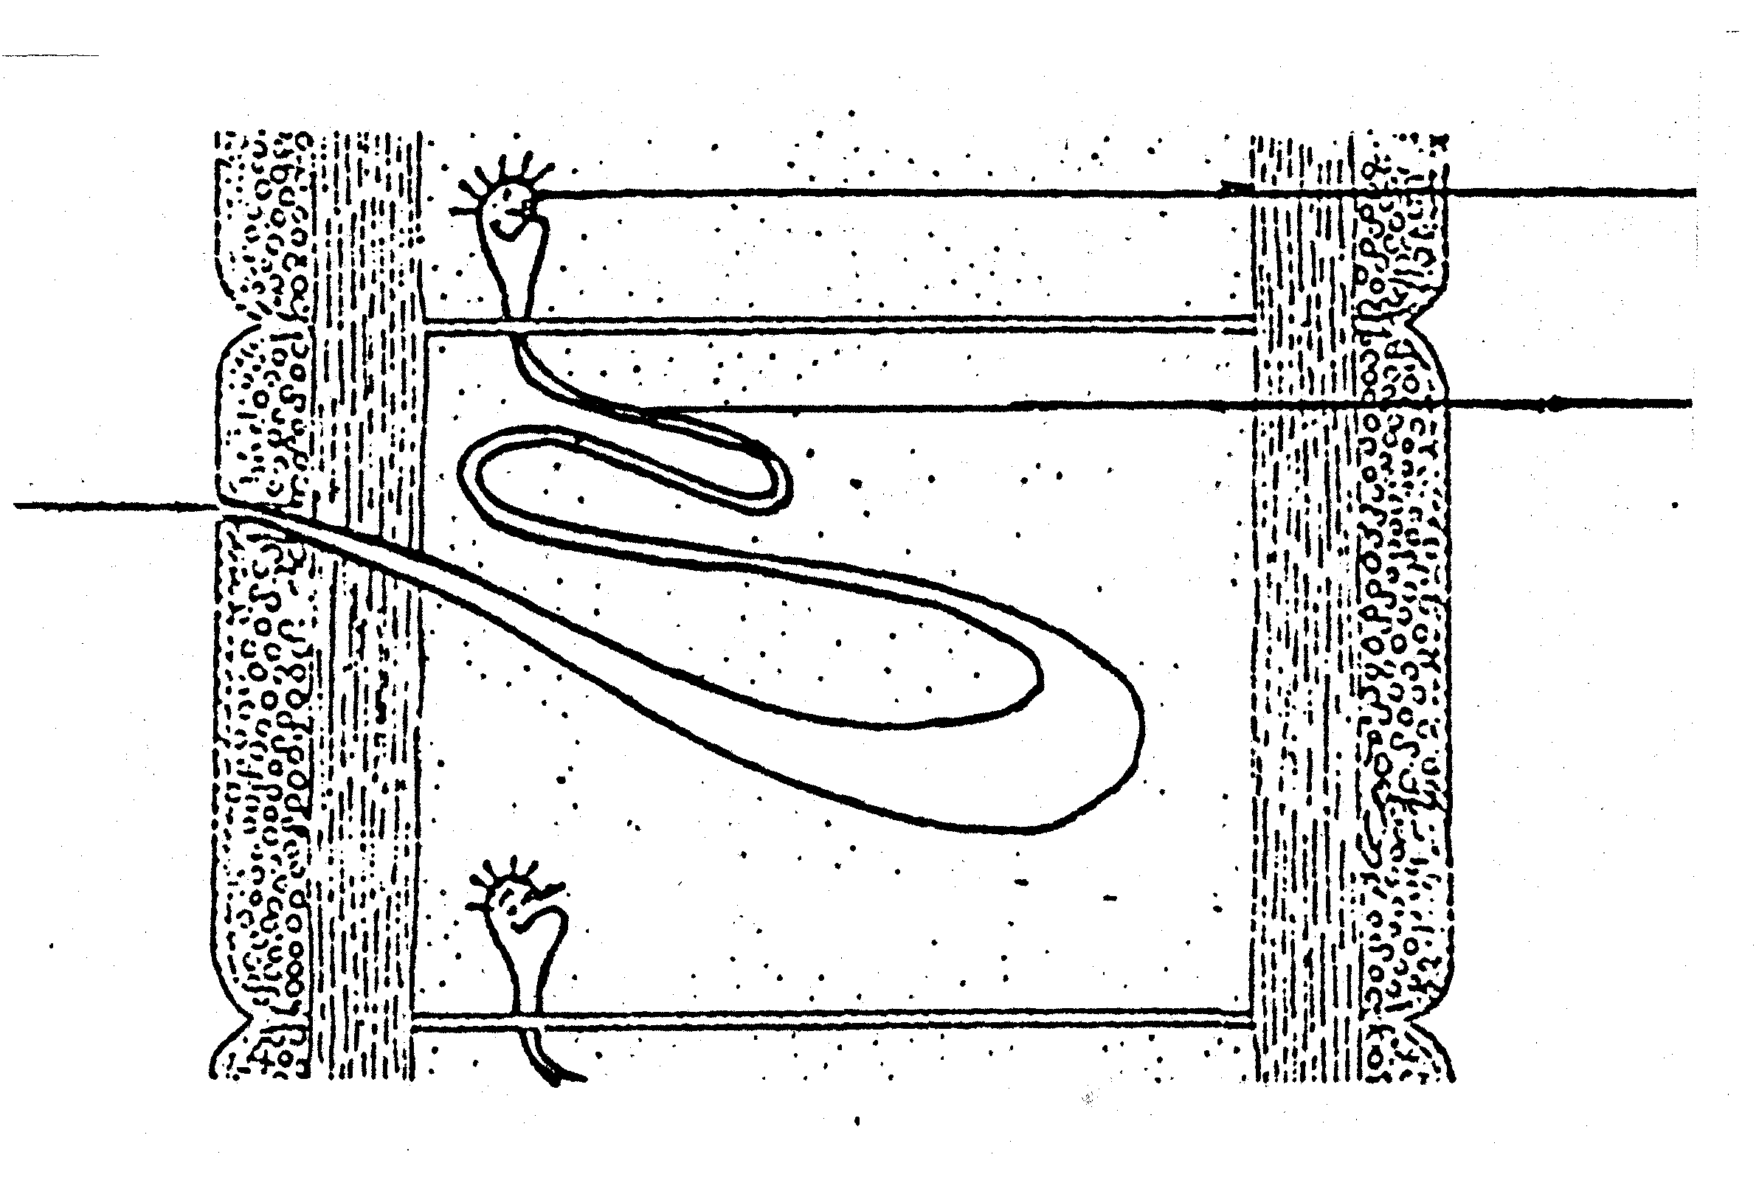  5.4.1 To which animal does this structure belong?  5.4.2 Identify the parts numbered 1, 2 and 3.  5.4.3 What organ is formed by numbers 1, 2 and 3?  5.4.4 Name TWO functions of this organ.  5.4.5 Which structure in the human body has functions similar to the organ mentioned in Question 5.4.3?  TOTAL FOR SECTION B:  TOTAL: | (2)  (3)  (2)  (4)  (2)  [50]  [200]  300

