GAUTENG DEPARTMENT OF EDUCATION
SENIOR CERTIFICATE EXAMINATION

BIOLOGY HG

TIME : 3 hours

MARKS : 300

INSTRUCTIONS:

- Answer ALL the questions in your answer book.
- Number ALL your answers clearly with the question numbers that are provided in the
question paper.
- The use of a pocket calculator is optional.

SECTION A

Answer QUESTION 1A on the answer sheet in the inside cover of the examination answer book.

QUESTION 1A

The following questions are supplied with four possible answers of which only ONE option is correct in each instance. Make use of the answer sheet on the inside cover of your answer book and draw a cross (X) over the letter which according to your knowledge agrees with the correct answer.

EXAMPLE: Saliva is secreted in the

A. mouth.
- oesophagus (food pipe)
- stomach.
D. duodenum (small intestine)

ANSWER: | A | B | C | D

  - Which of the following is important for hydrolytic reactions?

- Glucose
- Glycerol
- Calcium
D. Water

  - Which of the following reagents can be used to test for the presence of glucose in apple juice?

- Million’s reagent
- Iodine solution
- Benedict’s solution / Fehling’s A and B solution
D. Schultz’ solution

1.3 Which of the following monomers forms cellulose?

- Glycerol
- Glucose
- Amino acids
D. Fructose

1.4 A person who’s gall bladder has been removed may experience problems with the

A. digestion of fats.
B. excretion of urea.
C. storage of glycogen.
D. absorption of mineral salts.

1.5 The vitamins that are present in milk and cod liver oil, are mainly

A. vitamins A and C.
B. vitamins B and C.
C. vitamins C and D.
D. vitamins A and D.

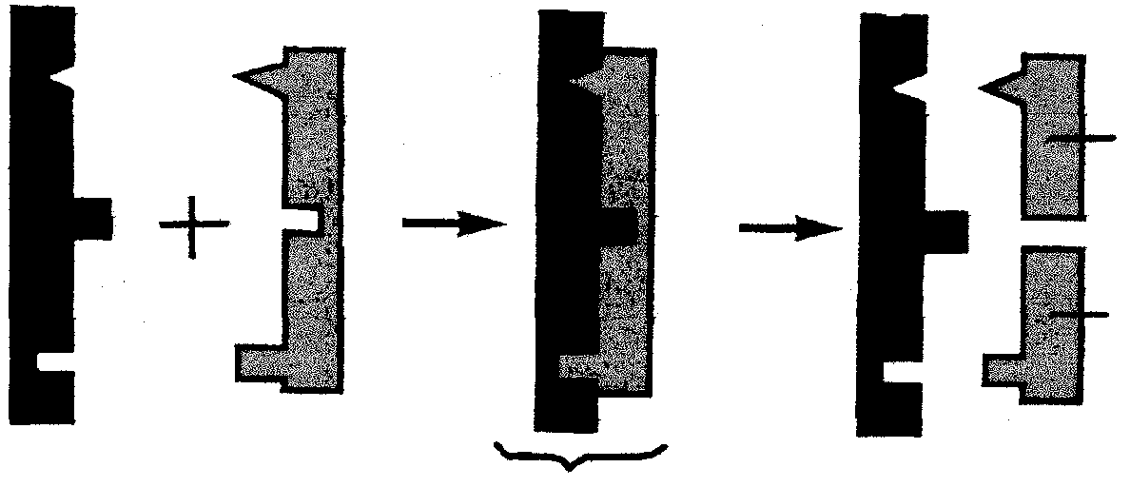
Questions 1.6 to 1.8 are based on the following diagram.
1
2
3
4
5
+ H₂0

1.6 Which number on the diagram represents the enzyme?

A. 1
B. 2
C. 3
D. 4

1.7 The reaction indicates the following process:

A. Condensation
B. Dehydration synthesis
C. Anabolism
D. Hydrolysis

1.8 If structure 2 is sucrose, what will 4 and 5 be?

A. Sucrose : glucose
B. Glucose : glucose
C. Fructose : glucose
D. Glucose : lactose

1.9 The following is not an example of a co-enzyme:

- riboflavin
- NADP
- RuDP
- Acetyl co-enzyme A

- (i)
- (iii)
- (iv)
D. (ii)

1.10 The following graph is shown on the back of an “Aquafresh Protect” chewing gum box.1.
pH value
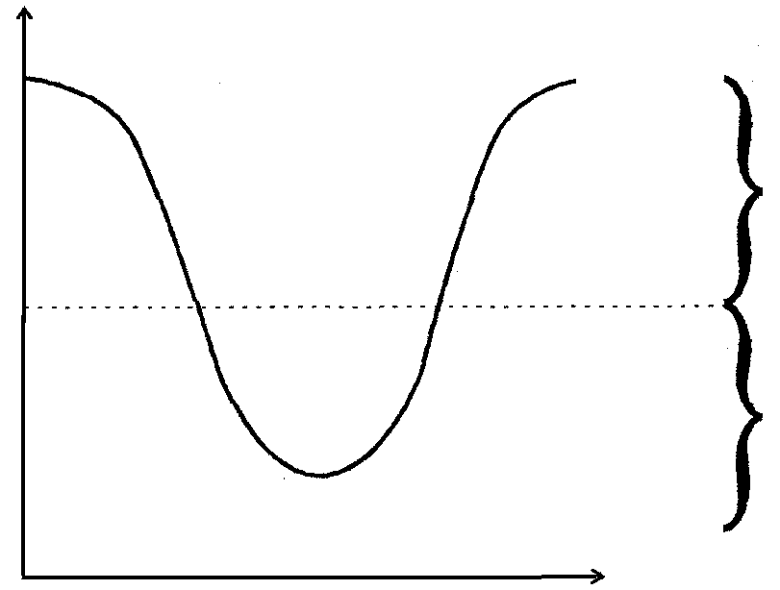
reduced
tooth decay
risk of tooth
decay
14
7
0
Time(hours)

The graph shows that tooth decay occurs:

A. from pH 7 to 14.
- in an alkaline medium.
- in a acid medium.
- at pH = 7.

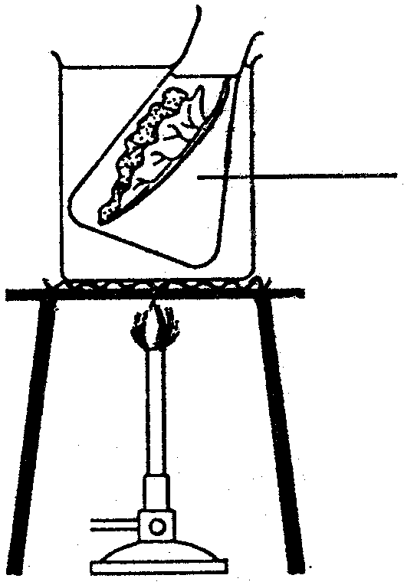
Question 1.11 to 1.13 are based on the following diagram:
etiel-
alcohol

  - Ethyl alcohol is used to

A. increase respiration.
- B. remove starch.
- C. to break cell walls.
- D. to dissolve the chlorophyll.

1.12 The alcohol is heated in a water bath because

A. glass cracks under direct heat.
- B. it supports the flask.
C. alcohol evaporates quickly.
D. alcohol is flammable

1.13 The aim of this experiment is part of a test for

A. cellulose.
B. lipids.
C. proteins.
D. starch.

Question 1.14 to 1.17 refer to the following experiment:
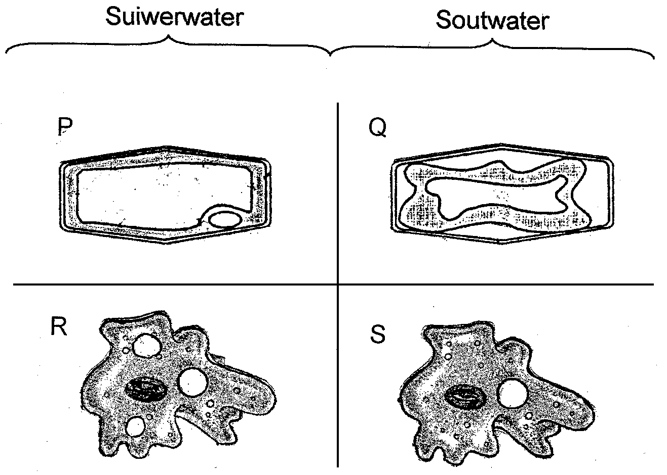
Pure water Salt water

In this experiment cells from a lettuce leaf (P and Q) and Amoeba sp. (R and S) are respectively placed in pure water and thereafter, in salt water.

1.14 Where will endosmosis occur?

A. P and R
B. Q and S
C. P and Q
D. Q and R

1.15 Which of the following structures are present in Amoeba sp. and absent in the lettuce leaf?

A. Mitochondrion
B. Cytoplasm
C. Cell membrane
D. Contractile vacuole

1.16 The following is observed at P and R:

 | P | R
A. | The cell enlarges and bursts | Turgor pressure builds up in the cell
B. | Turgor pressure builds up in the cell | A contractile vacuole forms
C. | The cell shrinks | The cell shrinks
D. | A contractile vacuole forms | The cell enlarges and bursts

1.17 What happens at Q?

A. Endosmosis
B. Exosmosis
C. Diffusion
D. Turgor pressure

1.18 Which of the following has no influence on the movement of water from level X to level Y?
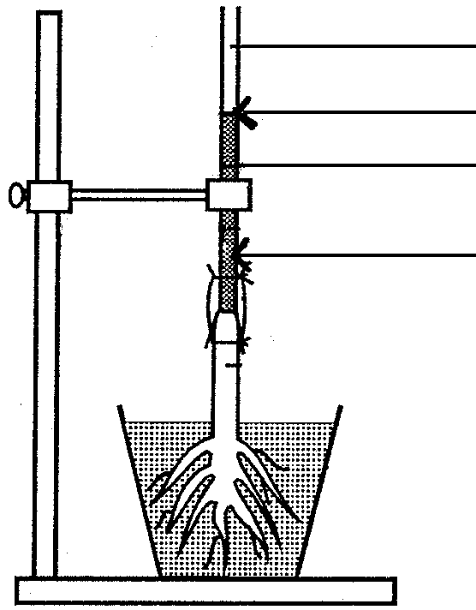
glass tube
Y
water
X

A. Transpiration
- Adhesive forces
- Root pressure
- Cohesive forces

Questions 1.19 to 1.20 refer to the diagrammatic representation of a portion of the human digestive tract.
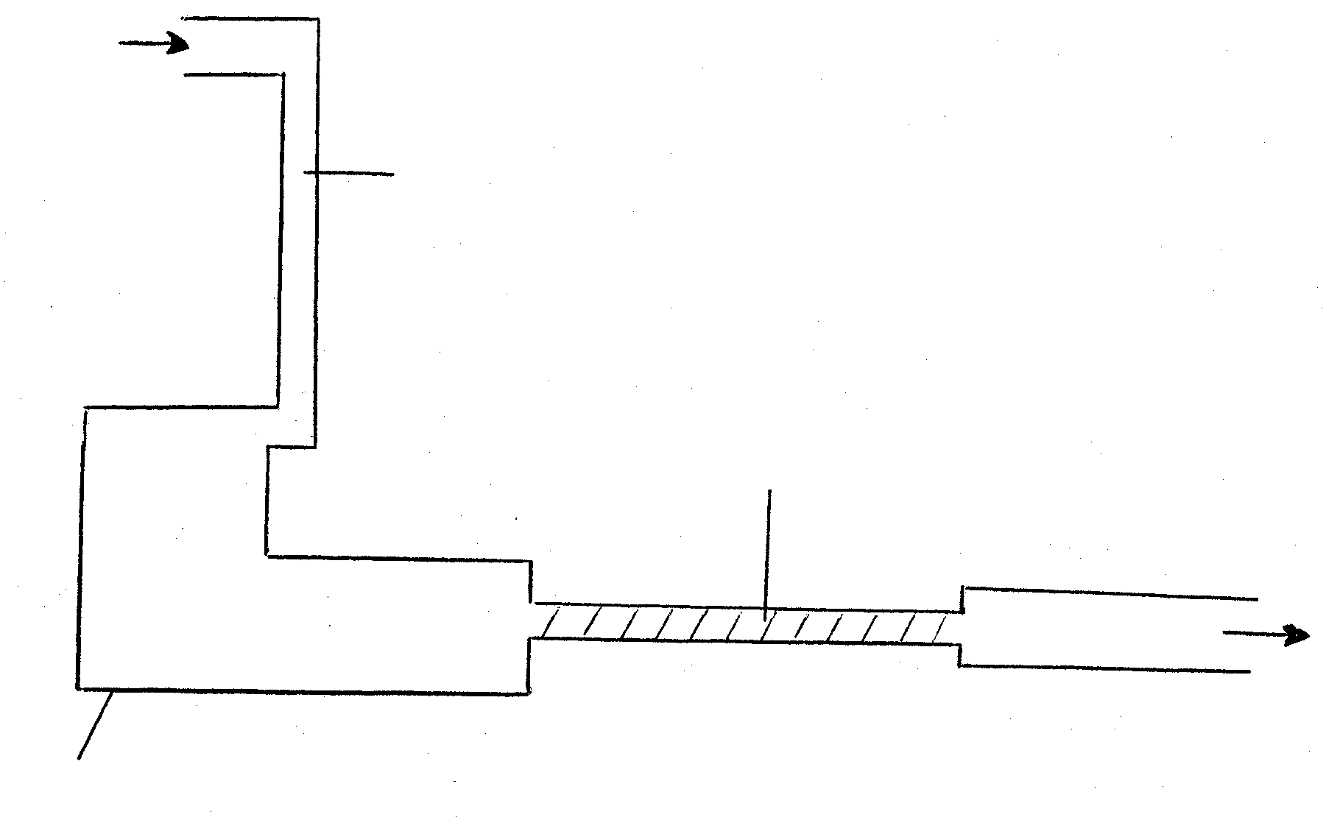
X
Z
Y
stomach

1.19 Which of the following is continuously involved in the movement of substances from X to Z?

A. Chewing
B. Osmosis
C. Excretion
D. Peristalsis

1.20 Which of the following substances is not found in region Y on the diagram?

A. Bile
B. Vitamins
C. Hydrochloric acid
D. Cellulose

1.21 Excess amino acids are broken down into urea in the

A. spleen.
B. kidneys.
C. bladder.
D. liver.

1.22 Enterokinase

A. is produced by the small intestine.
B. functions the best at a pH value of 3.
C. stimulates muscle contractions of the gall bladder.
D. activates pepsinogen which promotes protein digestion.

Questions 1.23 to 1.25 refer to a portion of the human digestive system.
4
1
2
3
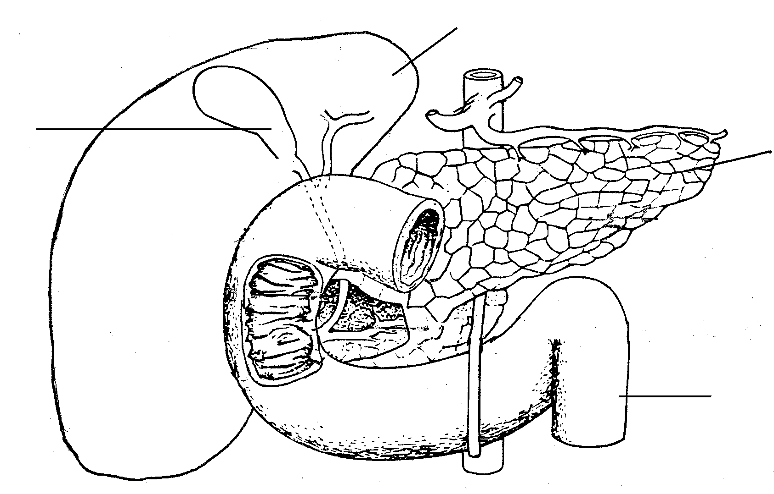

1.23 Bile is produced in the part numbered

A. 1.
B. 2.
C. 3.
D. 4.

1.24 Which of the following hormones are secreted through the walls of number 3?

A. Insulin
B. Trypsinogen
C. Secretin
D. Trypsin

1.25 Which of the following enzymes will be active in part number 3?

- Pepsin
- Lipase
(iii) Amylase

- (i) and (ii)
- (i) and (iii)
- (ii) and (iii)
D. (i), (ii) and (iii)

1.26 Which of the following shows the correct path of air movement during exhalation?

- trachea → pharynx → larynx → nasal cavity
- nasal cavity → larynx → pharynx → trachea
- nasal cavity → pharynx → larynx → trachea
D. trachea → larynx → pharynx → nasal cavity

1.27 Which of the following statements concerning haemoglobin is TRUE? It

- transports sodium ions.
- contains iron as an important element.
- transports magnesium ions.
D. appears in white blood cells.

Questions 1.28 to 1.31 refer to the following diagram.
(2)
hypophysis
Less thyroxin
More TSH
Less (1)
(3)

1.28 Which process is illustrated in the diagram above?

A. Osmoregulation
B. Temperature regulation.
C. Homeostasis.
D. Sugar regulation.

1.29 Numbers 1, 2 and 3 are respectively:

A. ADH ; adrenal glands ; less thyroxin.
B. TSH ; thyroid gland ; less thyroxin.
C. ADH ; adrenal glands ; more thyroxin.
D. TSH ; thyroid gland ; more thyroxin.

1.30 This mineral element is essential for the normal functioning of the gland number 2.

A. Sodium
B. Iodine
C. Iron
D. Calcium

1.31 The hypophysis is attached to the

A. hypothalamus
B. medulla oblongata
C. buccal cavity
D. cerebellum

1.32 A disease where the hormonal control of blood glucose is incomplete causing a shortage of insulin is

A. beri-beri.
B. cretinism.
C. goitre.
D. diabetes.

1.33 An hormone which is released during shock is

A. adrenalin.
B. glucagon.
C. insulin.
D. steroids.

1.34 What does the following diagram show?

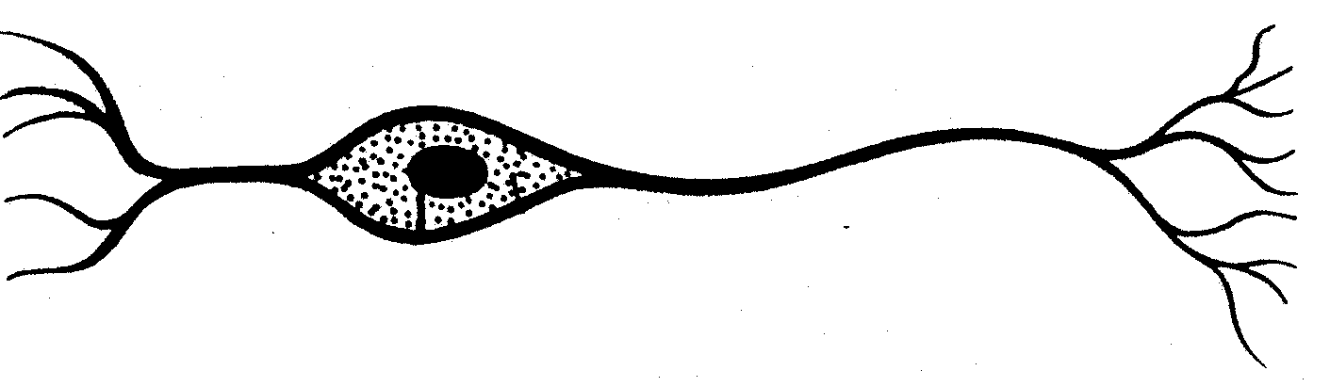

A. Unipolar / monopolar neuron
B. Bipolar
C. Multipolar / motor neuron
D. Tripolar neuron

Questions 1.35 to 1.37 deal with a section through the human skin as shown in the diagram below.
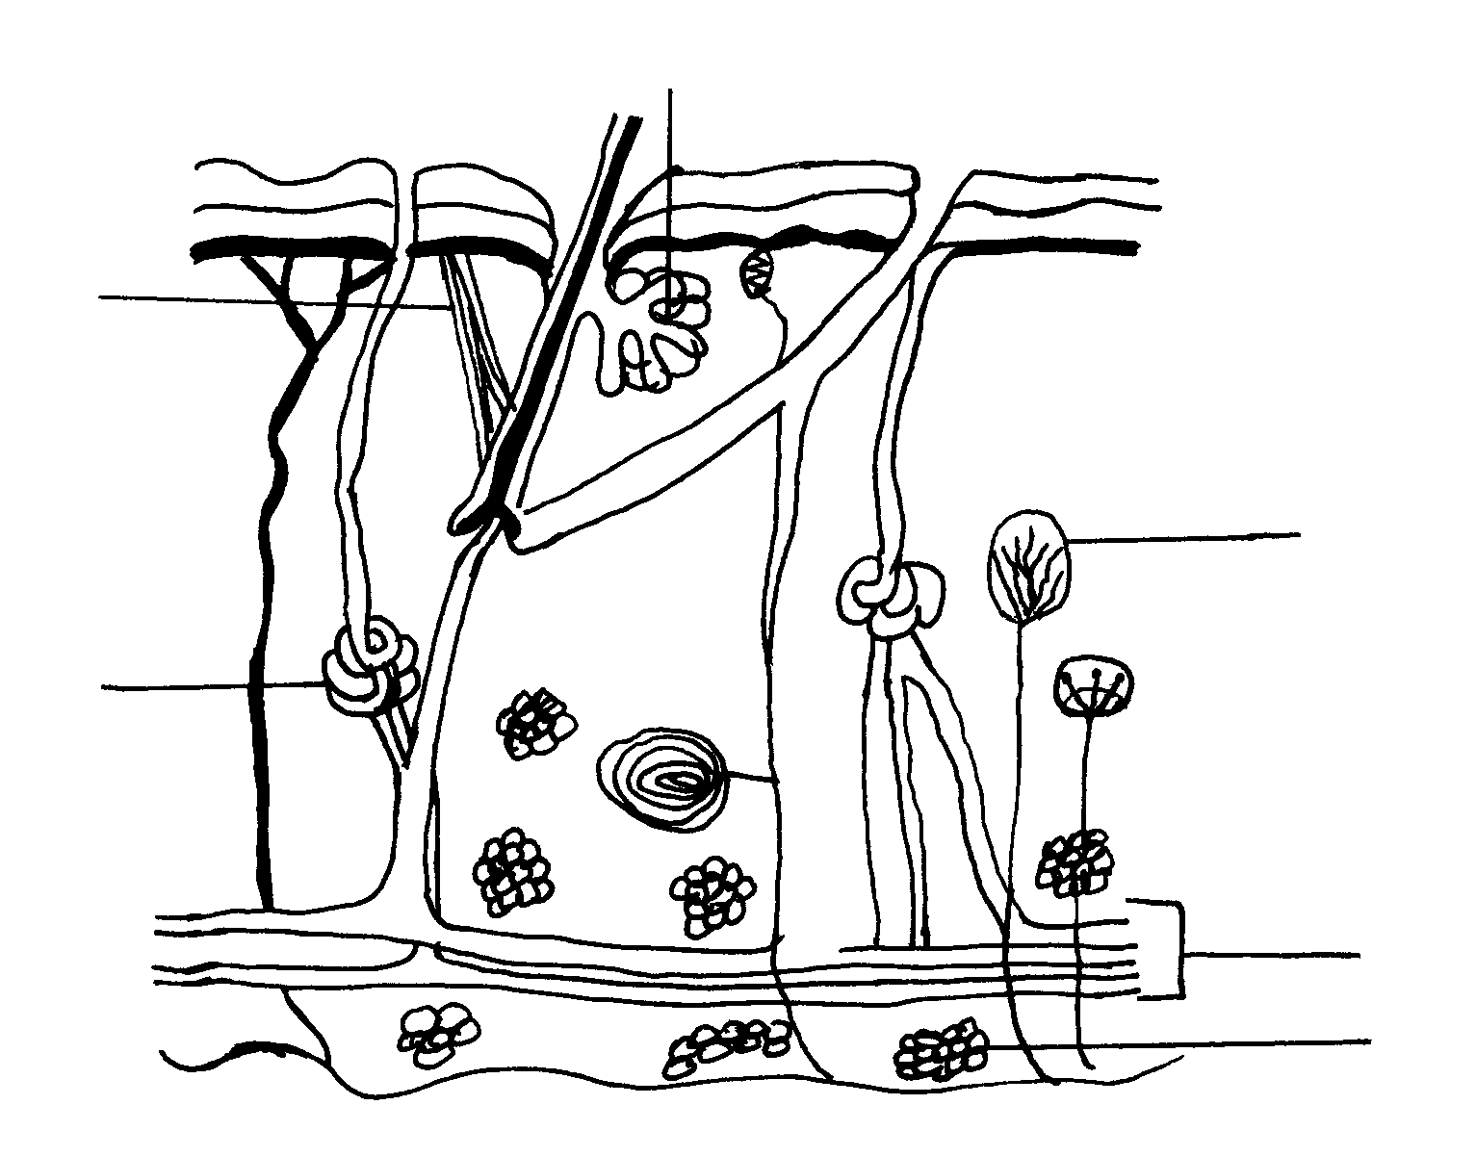
1
3
4
5

6
2

1.35 Which vitamin is manufactured in the skin in the presence of sunlight?

A. Vitamin D
B. Vitamin C
C. Vitamin B
D. Vitamin A

1.36 This group of numbers indicates the structures that are involved in temperature regulation.

A. 1, 2 and 4
B. 1, 3 and 5
C. 1, 2 and 6
D. 1, 2 and 3

1.37 These structures dilate on a hot day.

A. 4
B. 6
C. 5
D. 2

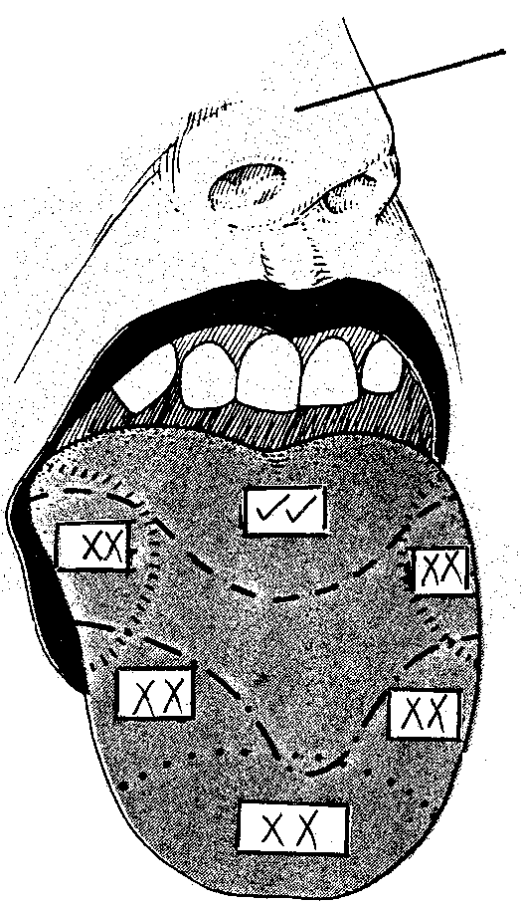
Questions 1.38 and 1.39 deal with the diagram of the human tongue.
Z

KEY:

 = positive

XX = negative

1.38 In an experiment a few drops of an unknown fluid were spotted on the tongue and the results are as indicated on the diagram. The fluid was probably

A. strawberry juice.
B. salt water
C. aloe juice
D. lemon juice

1.39 The olfactory cells in Z shown on the diagram are

A. photoreceptors.
B. proprioceptors.
C. chemoreceptors.
D. mechanoreceptors.

1.40 The cartoon below is an example of
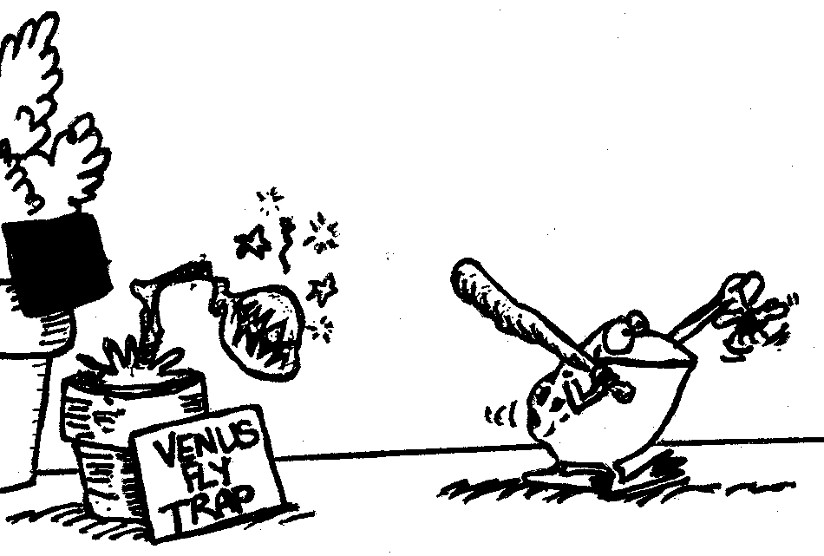

A. inter-specific parasitism.  B. intra-specific commensalism.  C. intra-specific competition.  D. inter-specific competition.  40 x 2 = | [80]

QUESTION 1B  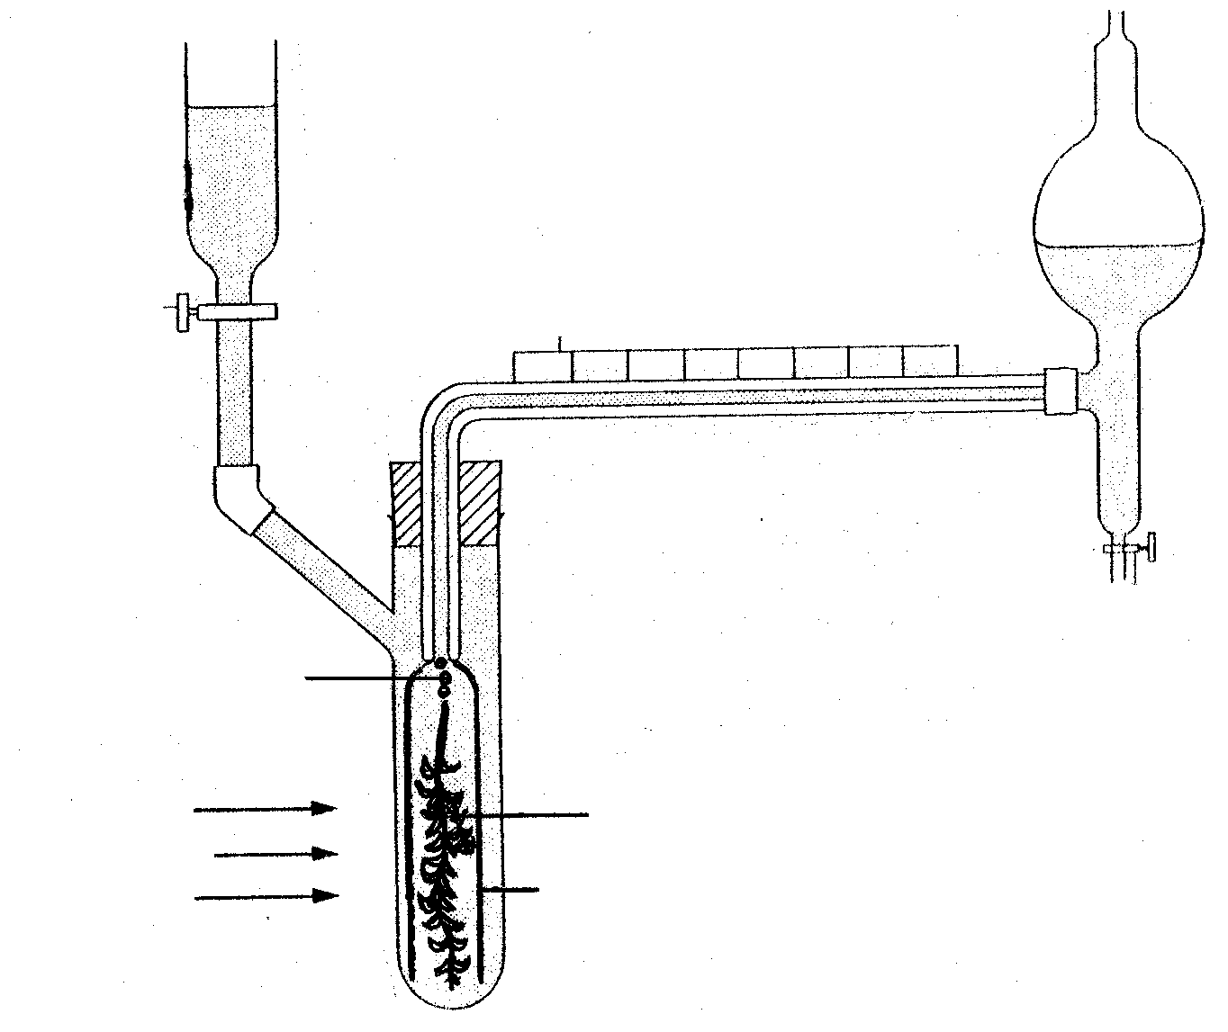  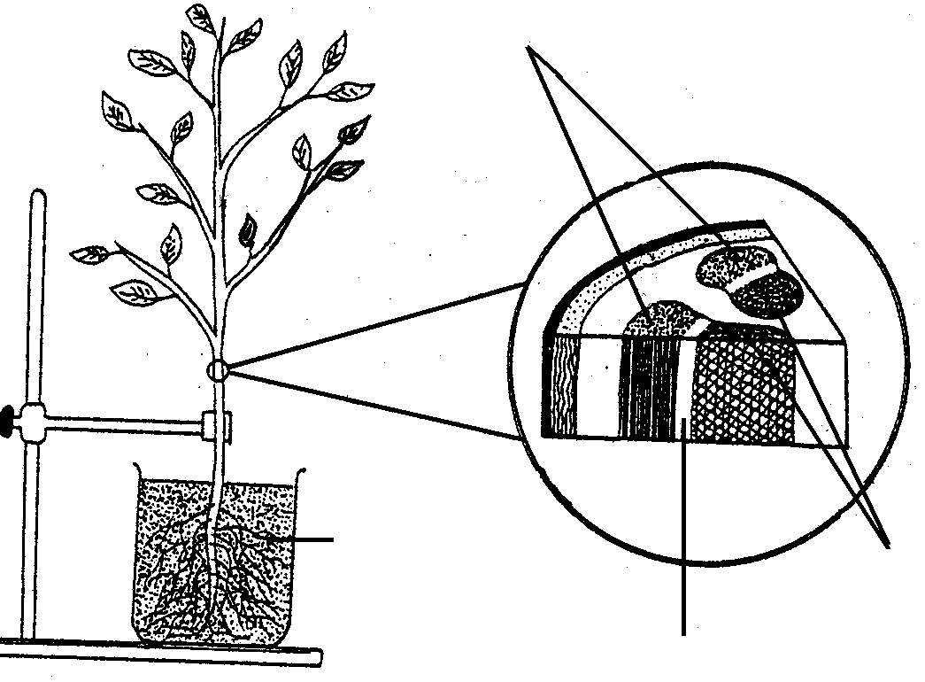  cambium  Elodea /  water plant  CO₂ bubbles  collecting  narrow funnel  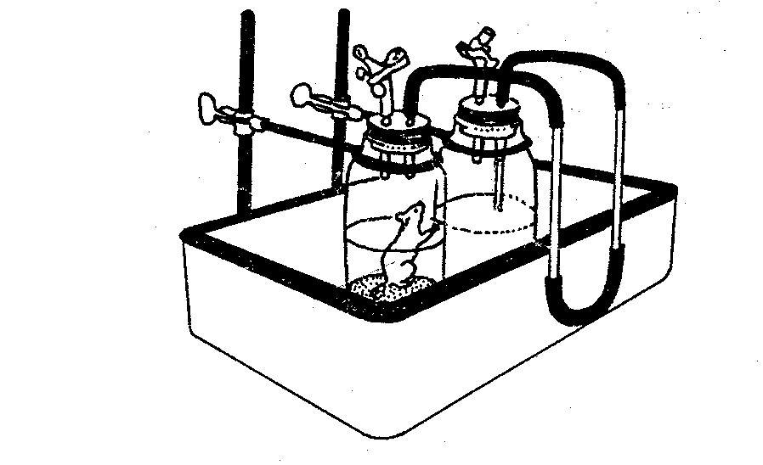  clear  sodium hydroxide  solution  living  mouse  pure  water  coloured  xylem  phloem  light source  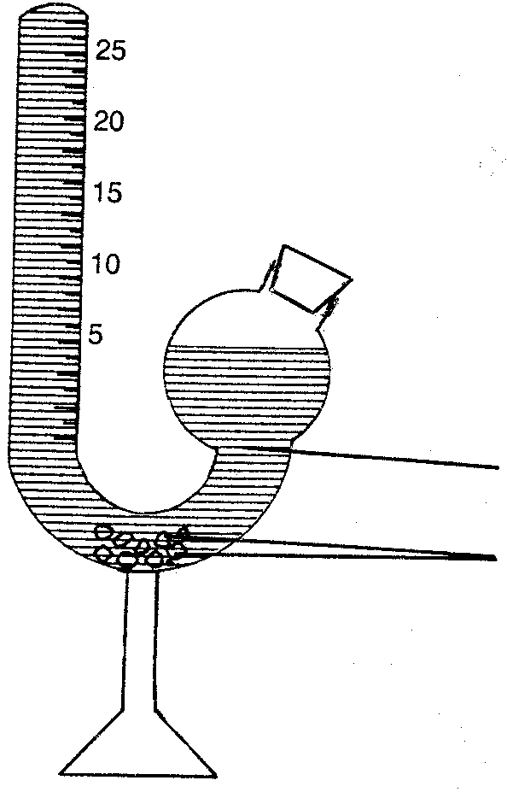  cork  protein solution  yeast granules  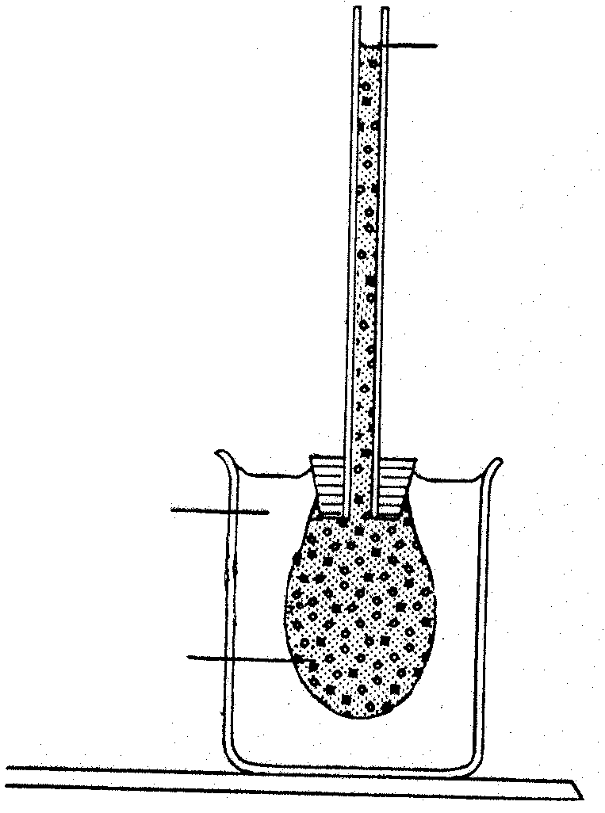  pure  water  animal  membrane  copper sulphate  solution  level of  solution drops  The following experimental drawings each have an error in the labels. Write down first the incorrect, and then the correct label of each on a new line.  A B  ligbron  C  D E | [10]

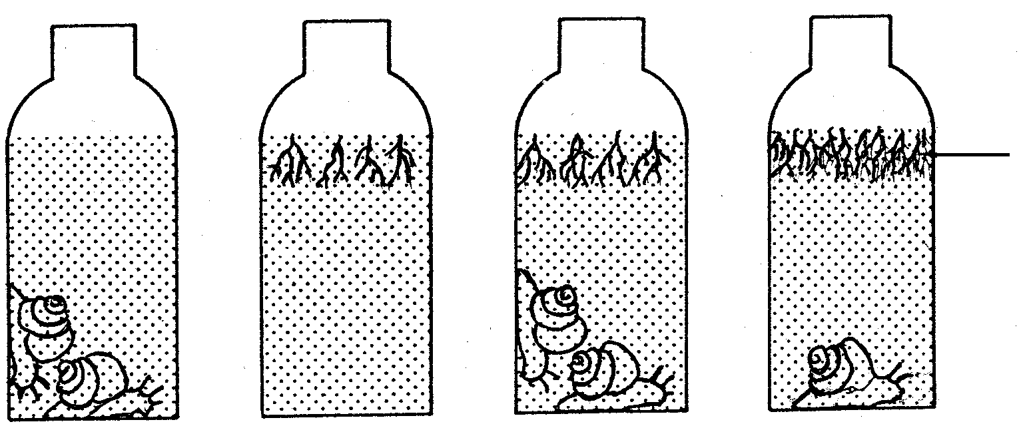
QUESTION 1C
algae
A
B
C
D

This experiment, river water, algae and snails were placed in four separate flasks (A – D) in different combinations. Each flask was sealed and placed in sunlight for the same length of time.

1. What will happen in flask A after 24 hours?  2. What process is occurring in flask B?  3. What gas is important for the process in flask B?  4. Which flask will be a balanced system at the end of the experiment? Give reasons for your answer.  5. Which flask will use all its oxygen first?  (Section B starts on the next page) | (2)  (1)  (1)  (5)  (1)  [10]  [100]

SECTION B

Answer ALL the questions.

QUESTION 2

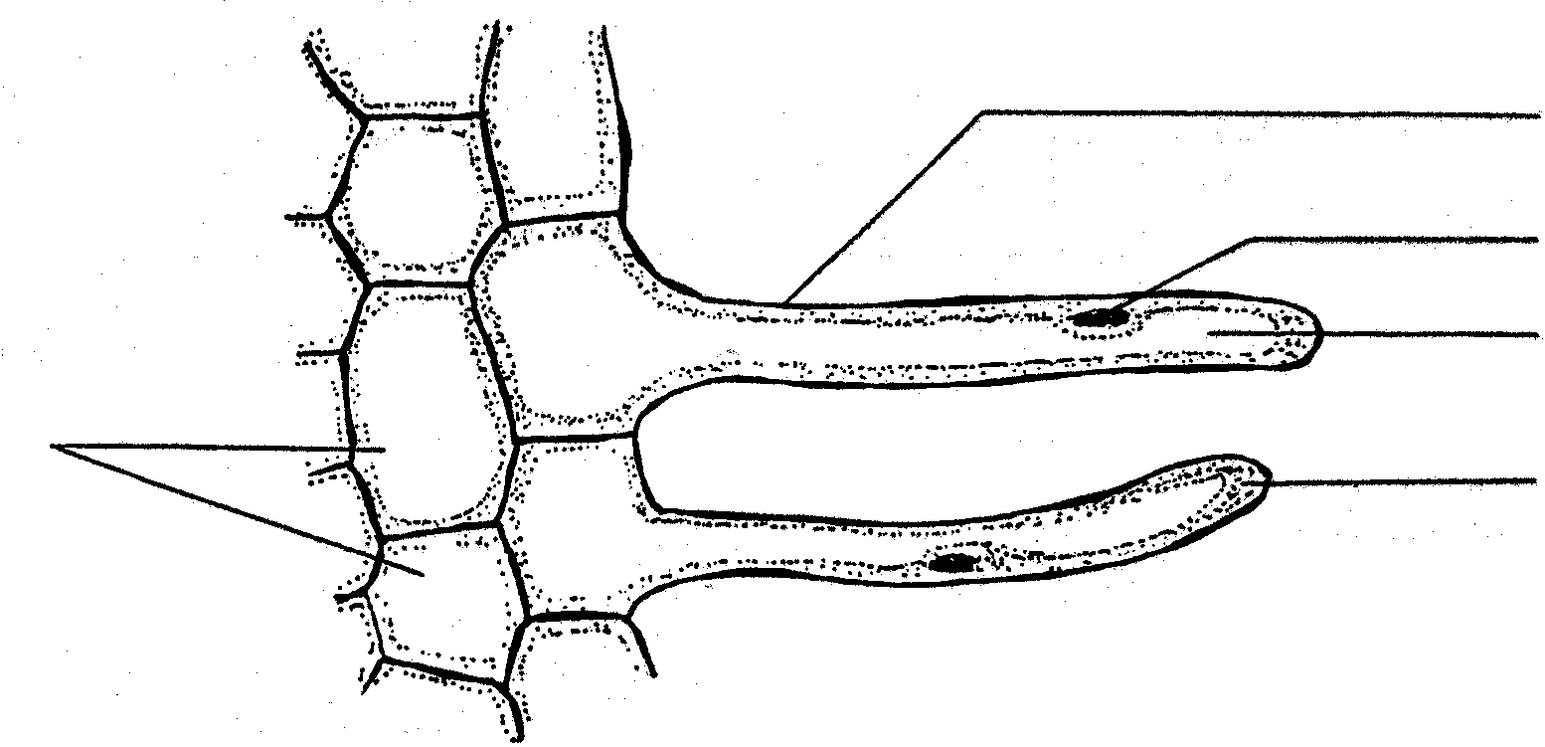
  - The diagram below is a cross section through a root hair.
5
1
2
3
4

2.1.1 Identify numbers 1, 2, 4 and 5.  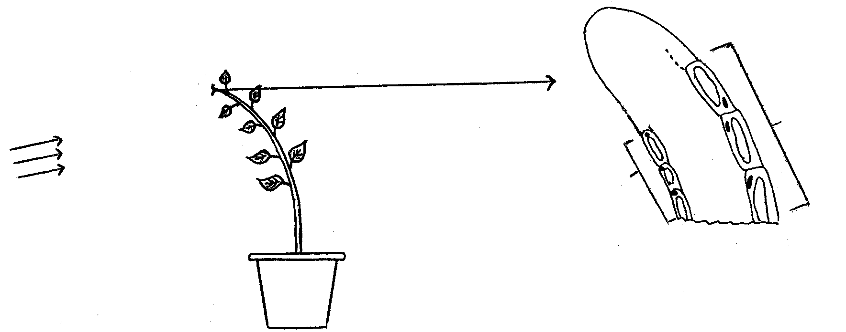  Diagram A  sunlight  Diagram B  X  Y  2.1.2 Explain how the root hair is adapted for water absorption.  2.1.3 Explain why water moves into the root hair?  2.1.4 What will happen to part number 3 when a high concentration of fertiliser (3:2:1) is applied to the area around the root?  2.2 The result of an experiment carried out on a plant is shown in the diagrams A and B. Diagram A shows the result at the end of the experiment and diagram B is a cross section of one of the shoots from the plant. | (4)  (4)  (6)  (2)

2.1.1 What is the aim of this experiment?  2.1.2 What is the chemical substance called that is responsible for this response?  2.1.3 Using diagram B’s visible features explain what happens to the regions X and Y  2.1.4 What advice can you provide to cause the shoots to grow upright? | (1)  (1)  (5)  (2)

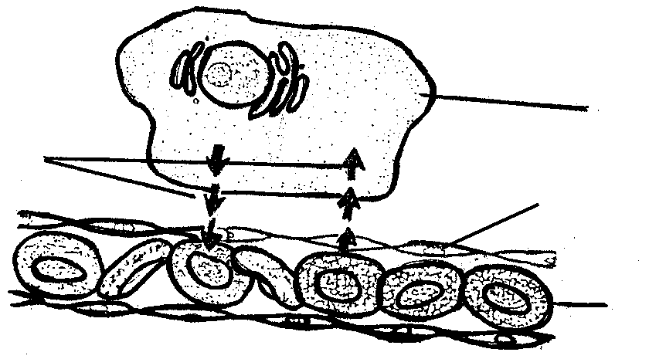
2.3 The diagram below shows a portion of the human gaseous exchange system.
4
3
2
1

2.3.1 Identify numbers 1 and 2.  2.3.2 Number 4 indicates gaseous exchange. What gases are involved here?  2.3.3 Explain in detail how the interchange of gases as shown in the diagram occurs.  2.3.4 List THREE ways in which the gaseous exchange system is adapted for effective interchange of gases between regions numbered 1 and 2.  2.4 An experiment was carried out in the dark to compare the rate of respiration of some pea seeds that had been soaked in water for six hours, then germinated in a warm place for different lengths of time. Some of the germinating seeds were placed in a large test tube with bromothymol blue indicator and a time measurement was taken until the indicator changed colour.  Bromothymol blue indicator solution turns from blue (more O₂) to yellow (more CO₂). The results are shown in the table below. | (2)  (2)  (6)  (3)

Time for colour change of  Bromothymol blue  (arbitraryunits per minute) | Time taken for seeds to germinate  (days)
- | 0
8,3 | 2
2,6 | 4
1,2 | 6
1,1 | 8
0,8 | 10

2.4.1 Draw the results as a line graph. (y-axis = time for colour change and x-axis = time for seeds to germinate).  2.4.2 What conclusion can be made by using the results from the graph?  2.4.3 State the time for a colour change on day 3.  2.4.4 What colour change would you expect after eight days if this experiment was carried out with a water plant instead of peas being placed in the test tube in the dark? Give the reason for your answer | (6)  (2)  (2)  (2)  [50]

QUESTION 3

3.1 Study the diagram below of a portion of the human digestive system.
1

2

3
4
7

6
5
6
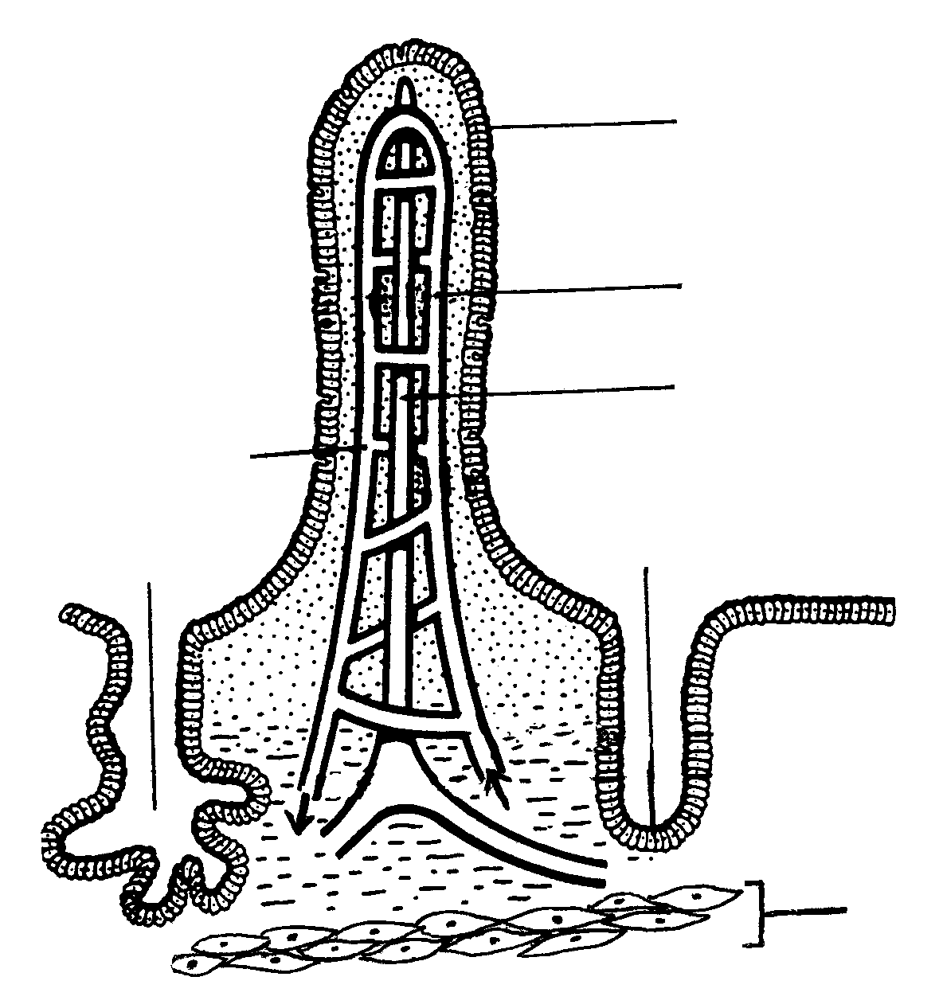

3.1.1 Identify numbers 1, 2 and 3.  3.1.2 Using numbers from the diagram, indicate ONE structure that  (a) absorbs glucose and amino acids.  (b) secretes bicarbonate ions and succus entericus (intestinal juice).  (c) is responsible for peristaltic movement.  3.1.3 Name the enzymes that are secreted by part number 4 which play a role in the digestion of carbohydrates.  3.1.4 What happens to excess glucose when the glucose level rises in part number 7?  3.2 Desert rats can live without water for long periods of time but non-desert rats cannot. The graph below shows the concentration of urea in urine produced by both types of rats when given the same diets. | (3)  (1)  (1)  (1)
50
150
100
200
250
300

Ureu (dm³)
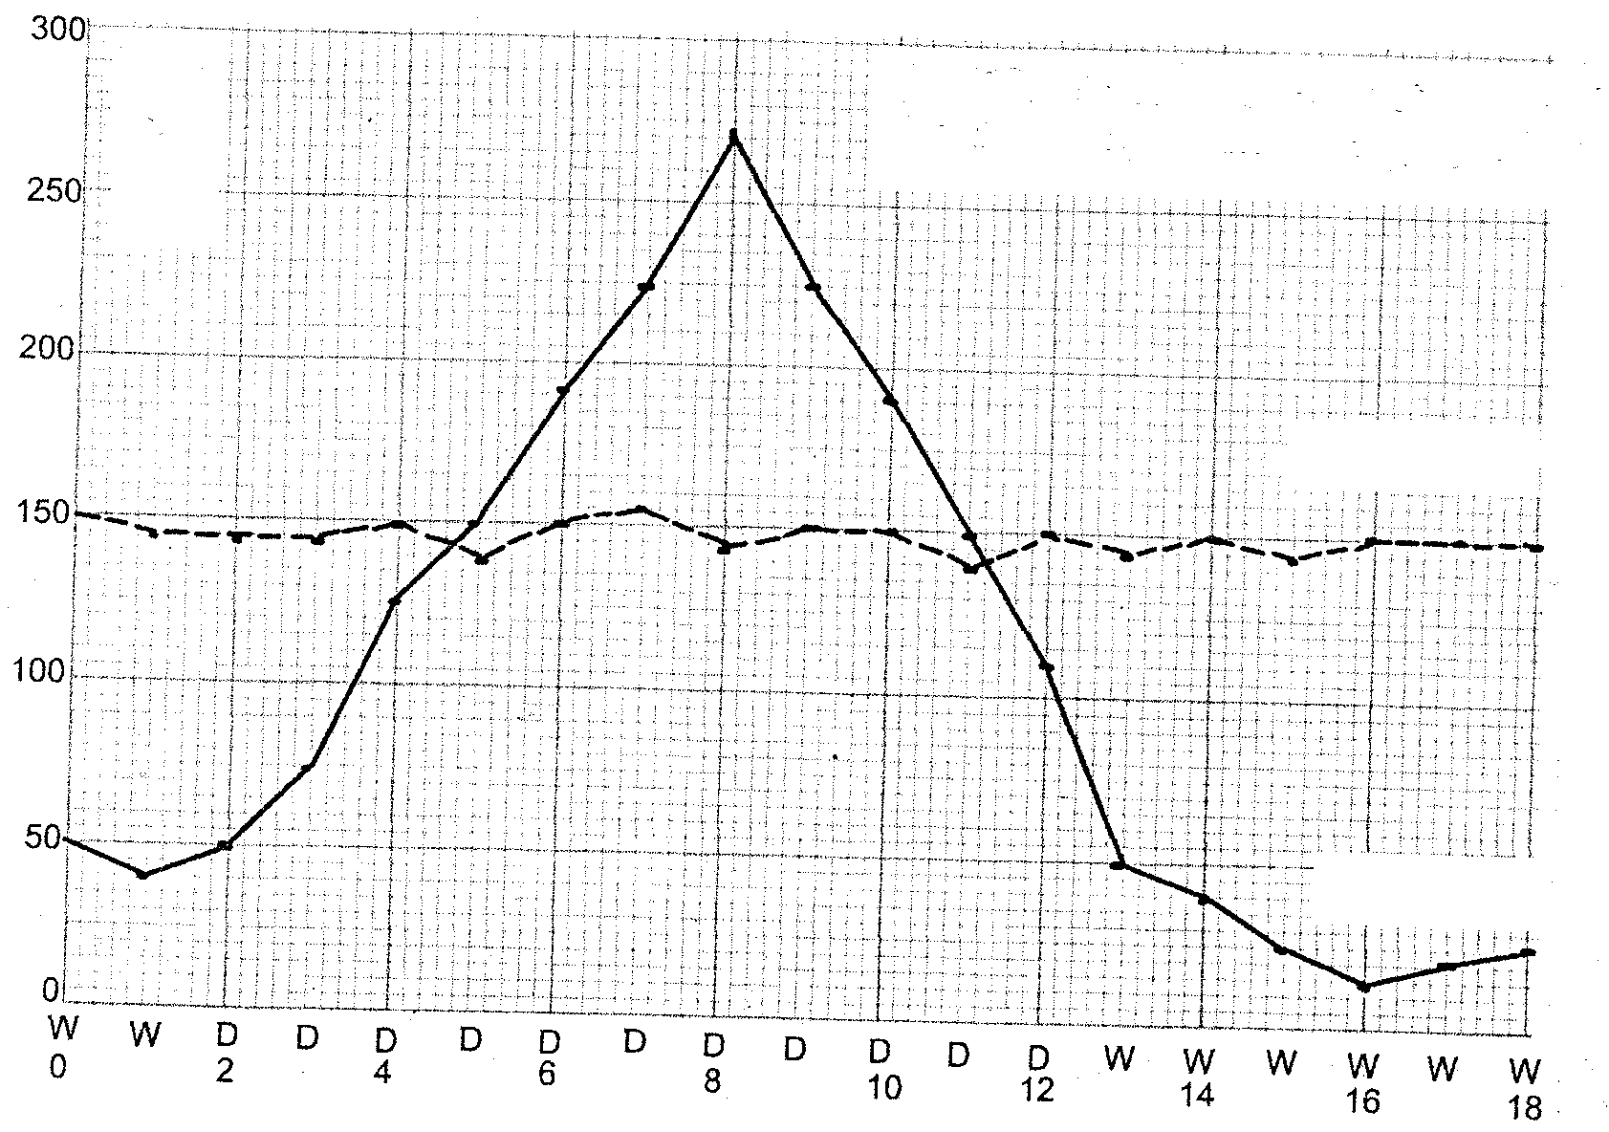
W – Days when food and water was given.
D – Days when only water was given.
non-desert rats
desert rats
Time (days)

300

250

200

150

100

50

3.2.1 State the concentration of urea produced in the urine of the non- desert rats on day 8.  3.2.2 Calculate the difference in the concentration of the urea produced by both rats when they have no water on day 8.  3.2.3 Urea contains nitrogen. Which organic compound should be modified to produce small amounts of urea?  3.3 The histograms below illustrate samples of fluid which were extracted from a human nephron at two different points. | (2)  (3)  (2)

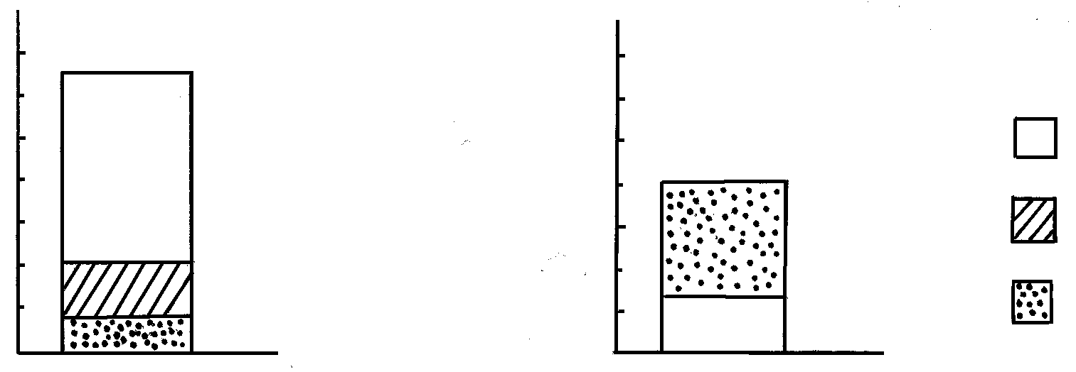
sample I
sample II
sodium ions
glucose
urea
%
of dissolved
fluids
%
of dissolved
fluids
0,30

0,20

0,10
3,0

2,0

1,0

Draw and label a diagram of the nephron and show, using arrows, where “sample I” and “sample II” were extracted.  (Question 3.4 continues on the next page) | (15)

3.4 Animal behaviour plays an important role in temperature regulation. Study the diagrams below and answer the questions that follow.

C
D
polar bear
50cm

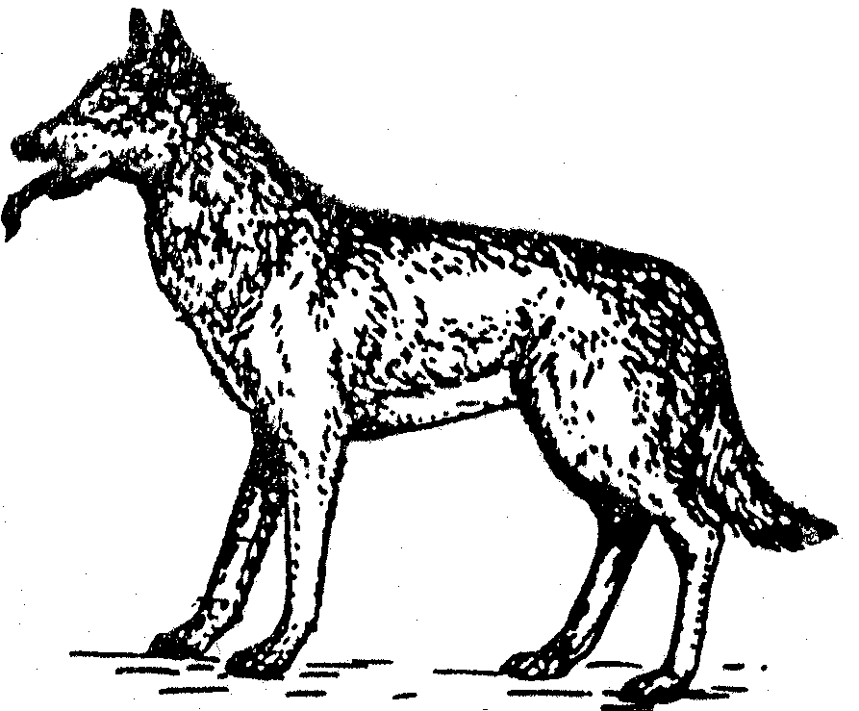
alsation
Bontebok
ground squirrel
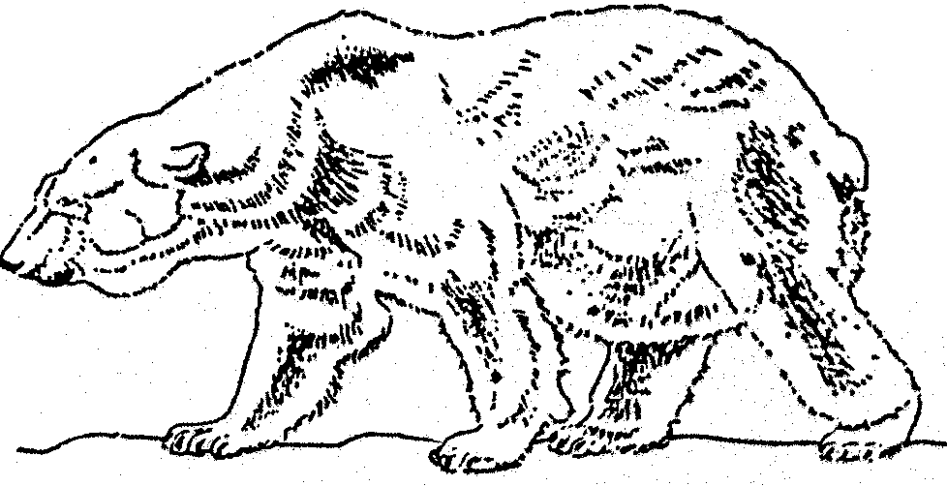
1m
1m
2m
B
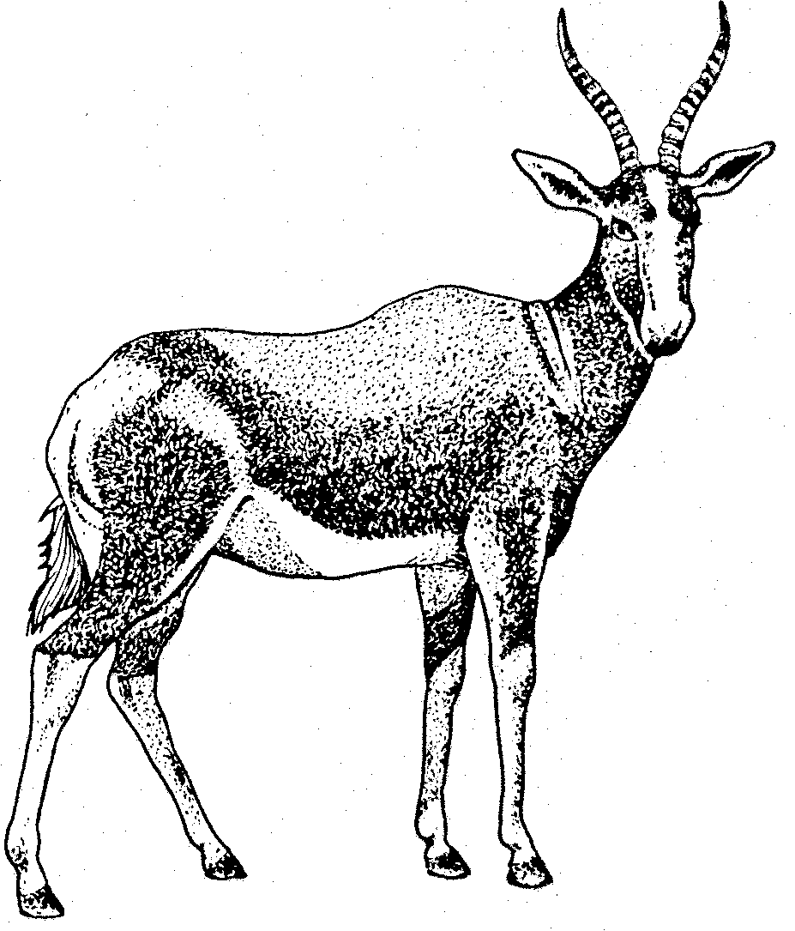

A

- Explain how the size differences in animals A and B affects temperature regulation?  - List FOUR methods whereby the animal in diagram C regulates its body temperature on a hot day.  - Explain the adaptations of the animal in diagram D to withstand the extremely low temperatures in the Arctic zone? | (4)  (4)  (4)  [50]

QUESTION 4

4.1 Read the report below and answer the questions that follow.

AIDS declared as a notifiable illness after shocking statistics

Political Editorial Beeld Newspaper – Thursday 4 March 1999

Cape Town – Dr. Nkosazana Zuma, minister of health, announced yesterday that HIV-infection was declared a notifiable illness. She said that the latest statistics on the increase in HIV-cases in 1998, especially the increase of 65% in pregnant teenagers, scares her to death.

line 5 The biggest increase occurred amongst the15 to 19 year olds, namely 12,7% to 21%. Altogether 26,1% of women in the age group 20 to 24 and 26,9% of the women between 25 and 29 years expressed the virus by the end of last year. KwaZulu Natal is the province with the highest occurrence (32,5%), followed by Mpumalanga (30%), the Free State (22,6%), Gauteng (22.5%), the North West
line 10 Province (21,3%), the Eastern Cape (15,9%), the Northern Province (11,5%),
the Northern Cape (9,9%) and the Western-Cape (5,2%).

According to her there will have to be more information programmes, especially for the youth, since it is apparent that they are not adequately informed about the illness. Furthermore, many patients are being cared for by their families and the
line 15 necessary precautionary measures need to be taken. The same applies to
corpses that are being bathed by family members. Studies show that the AIDS- virus survives for up to fifteen days after death, says Dr. Zuma.

4.1.1 What does the word AIDS mean?  4.1.2 Which age group shows the highest increase of the HIV infection?  4.1.3 Why are information programmes in relation to AIDS necessary for the youth?  4.1.4 Why should people take precautions against HIV when working with corpses?  4.1.5 Give ONE prediction as regards the HIV% in KwaZulu Natal in the coming year.  4.2 The chemical and physical components of tissue fluid are maintained at a constant balance. Study the diagram below and answer the following questions. | (2)  (2)  (2)  (2)  (2)
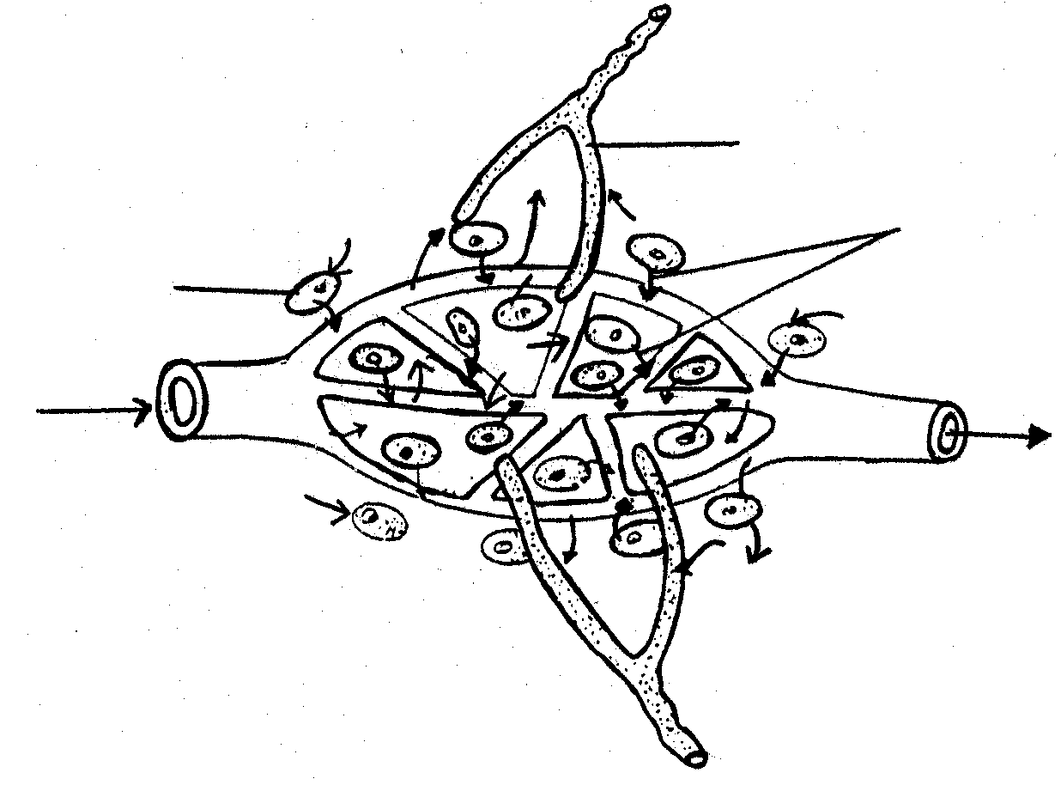
1
A
X
B
2
A
A
A
Cell

4.2.1 What term is used to describe the maintenance of a steady state of tissue fluid?  4.2.2 Which letters in the diagram depict the tissue fluid and the lymph duct, respectively?  4.2.3 List TWO ways in which tissue fluid is returned to the blood system.  4.2.4 Which gas is represented by X on the diagram?  4.2.5 During which process is the gas mentioned in question 4.2.4 formed?  4.3 Study the graph of an impala population on a fenced off game farm and answer the questions that follow: | (2)  (2)  (2)  (2)  (2)

number of impala in thousands
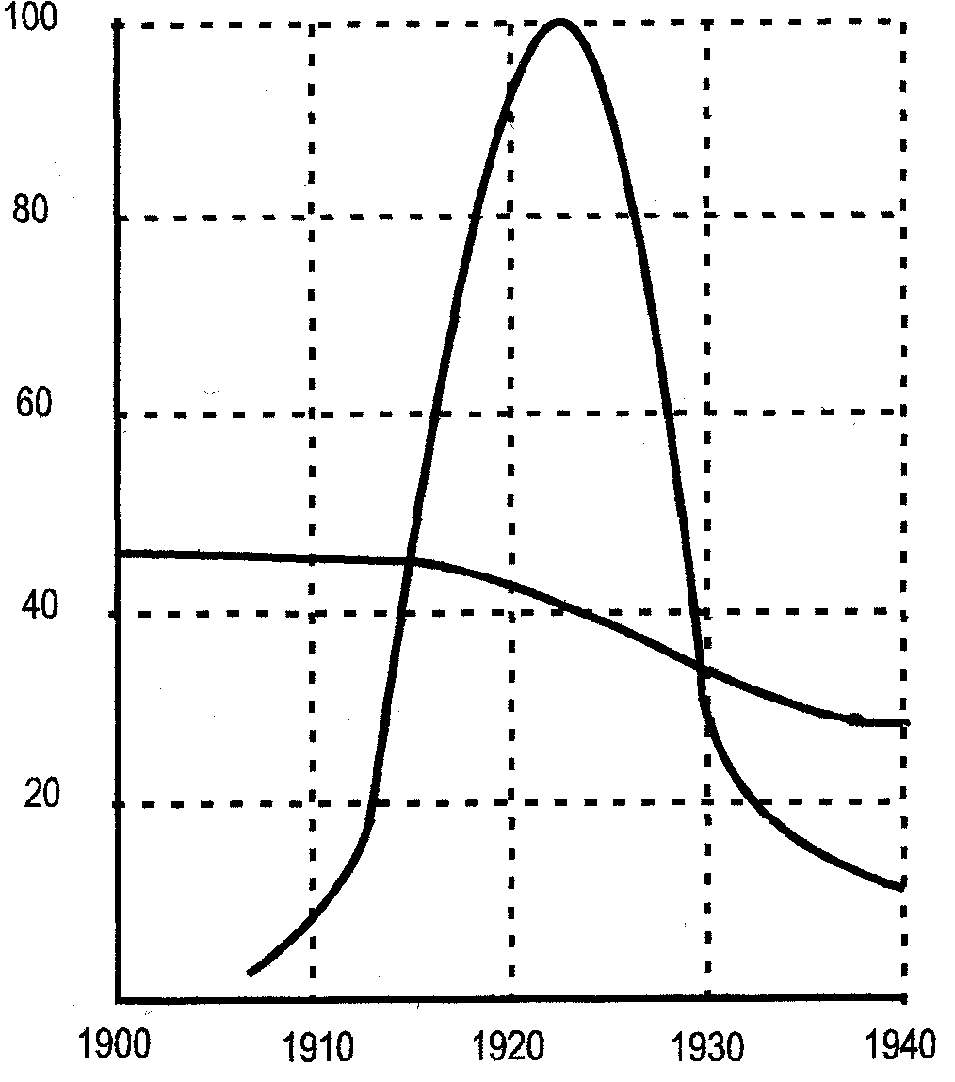
estimated carrying
capacity
impala population
year

4.3.1 Define the term “population”  4.3.2 What conclusion can be made from the graph?  4.3.3 What growth form is shown from 1905 to 1920?  4.3.4 What was the carrying capacity of the impala population in 1917?  4.3.5 When did the population start to decrease?  4.3.6 List TWO factors that were possibly responsible for this decrease.  4.3.7 How could the population size be determined? | (3)  (2)  (2)  (2)  (2)  (2)  (2)

4.4 A marathon is held annually on alternate years at Cape Town and Johannesburg. The graph below shows the variations in the number of red blood cells in the athletes at different altitudes above sea level after one day and five days at each place.

Number of red blood corpuscles
(million per mm³)
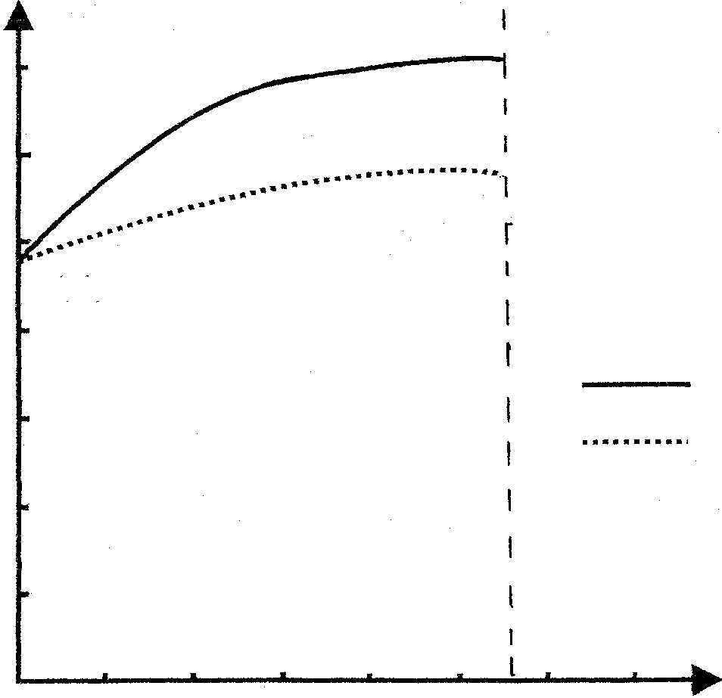
1 000
2 000
Height above sea level in meters (m)
after 5 days
after 1 day
Key

Kaapstad
7
6
5
4
3
2
1
0
JHB

4.4.1 Determine:  (a) how many red blood corpuscles are found in an athlete after 1 day at 1 000m above sea level.  (b) at what height above sea level an athlete will have 7 million red blood corpuscles per mm³ of blood after 5 days.  4.4.2 Why will Cape Town athletes experience problems if they compete in Johannesburg?  4.4.3 What advise will you give a Cape Town athlete if he / she has to compete in Johannesburg?  4.4.4 Explain the homeostatic control of oxygen levels in the blood. | (2)  (2)  (2)  (2)  (7)  [50]

SECTION C

QUESTION 5

Study the diagram of a number of organs in a certain system of an acrobat balancing on a tight rope in a circus.

9
12
10
11
3 4 5
8
6
7
1
2
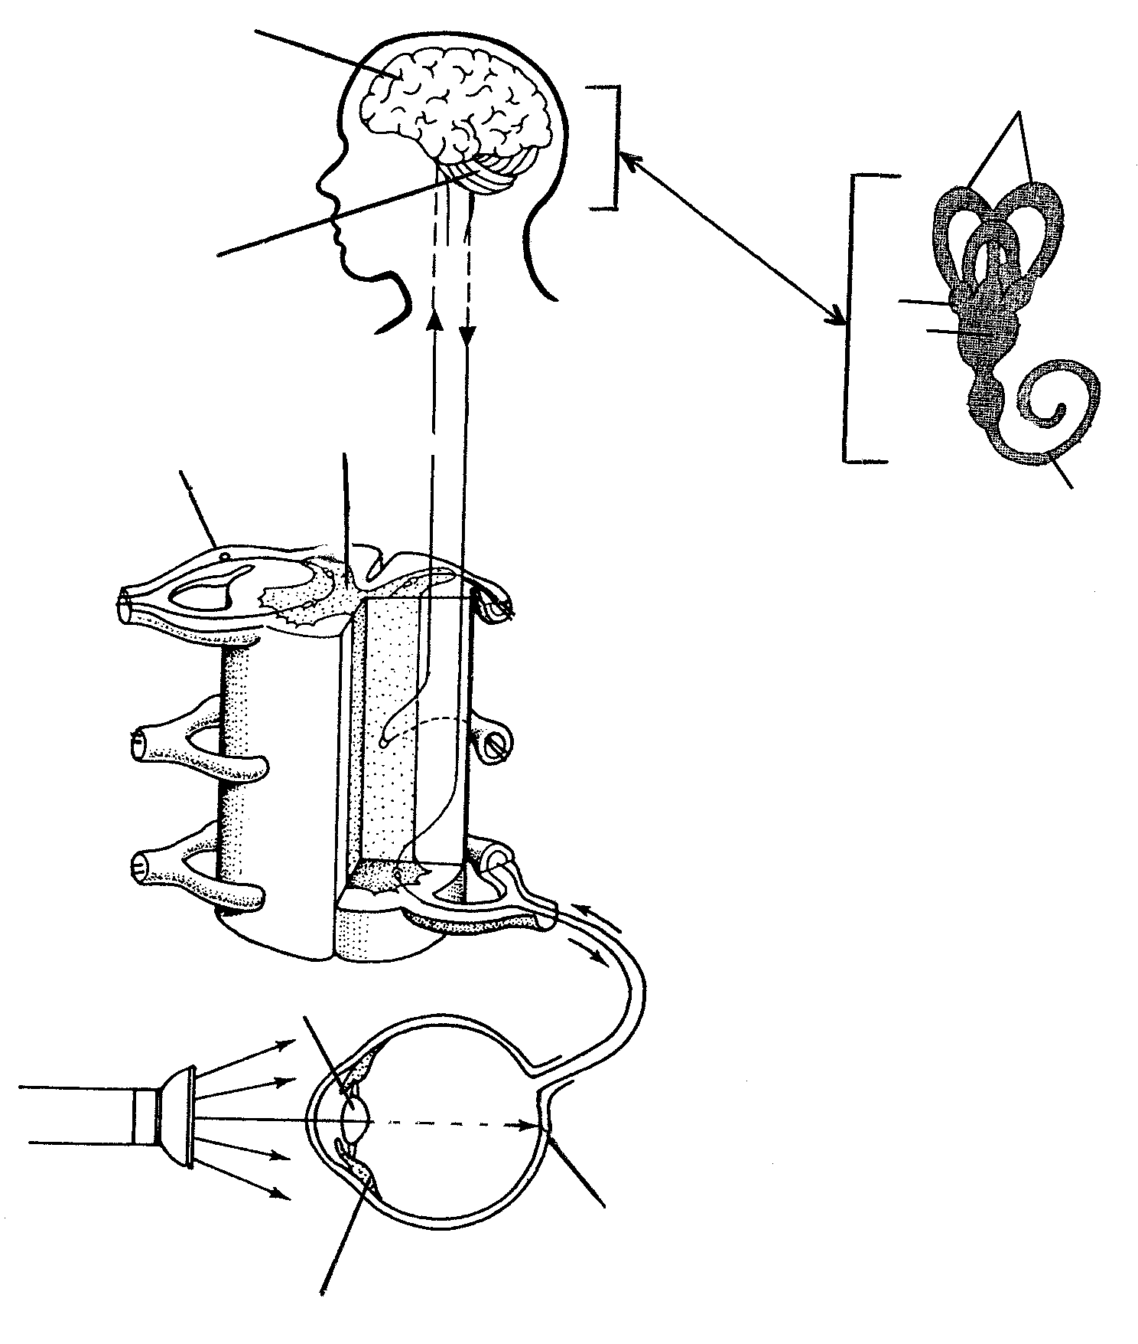

5.1 Write down the numbers in the diagram for a / the:  5.1.1 lens.  5.1.2 cerebrum.  5.1.3 semi circular canals.  5.1.4 ganglion.  5.1.5 cochlea.  5.2 Name the structure numbered:  5.2.1 11.  5.2.2 4.  5.2.3 5.  5.2.4 6.  5.3 Explain how the ear assists the acrobat to maintain his / her balance. | (1)  (1)  (1)  (1)  (1)  (1)  (1)  (1)  (1)  (10)

5.4 The graph below illustrates the changes in convexity of the lens of the acrobat as he / she continuously looks at different objects.

Increase in convexity
Time (seconds)
0
2
4
6
8
A
B
C
D
Maximum convexity
Minimum convexity

Write down the letter in the graph that best describes the following situations:  Colour vision involves rhodopsin which is made up of vitamin A (retinol) and opsin (protein)  5.4.1 A nearby (1 m), stationary object.  5.4.2 A distant (10 m), stationary object.  5.4.3 Another acrobat approaching this person.  5.4.4 The other acrobat which moves further away from this person.  5.5 Describe the changes that will occur when the eye is suddenly exposed to bright torch light  5.6 | (1)  (1)  (1)  (1)  (7)

Discuss this statement with reference to:  - The type of photoreceptors and their location for maximum vision.  - The source and results of deficiencies of vitamin A.  - The general composition and structure of proteins.  - A description of the cycle which builds up the organic (backbone) structure of a protein.  TOTAL | (5)  (3)  (6)  (6)  [50]  300

