GAUTENG DEPARTMENT OF EDUCATION

SENIOR CERTIFICATE EXAMINATION

BIOLOGY HG

TIME : 3 hours

MARKS : 300
INSTRUCTIONS:

- Answer ALL the questions in your answer book.
- Number ALL your answers clearly with the question numbers that are provided in the question paper.
- The use of a pocket calculator is optional.

SECTION A

Answer QUESTION 1A on the answer sheet in the inside cover of your answer book.

QUESTION 1A

The following questions are supplied with four possible answers of which only ONE option is correct in each instance. Make use of the answer sheet on the inside cover of your answer book and draw a cross (X) over the letter which according to your knowledge agrees with the correct answer.

EXAMPLE: Saliva is secreted in the

- mouth.
- oesophagus (food pipe).
- stomach.
- duodenum (small intestine).

ANSWER: | A | B | C | D

The vitamin concerned with photoreceptors in the rods of the human eye is:

- Vitamin C
- Vitamin A
- Vitamin D
- Vitamin B

The following substance changes colour in the presence of water:

- Bromo-thymol blue
- Sodium hydroxide
- Cobalt chloride
- Sodium bicarbonate

Animals require calcium because it

- forms part of ATP.
- is necessary for thyroid activity.
- is a component of bone tissue.
- is a component of haemoglobin.

Questions 1.4 to 1.6 are based on the following picture.
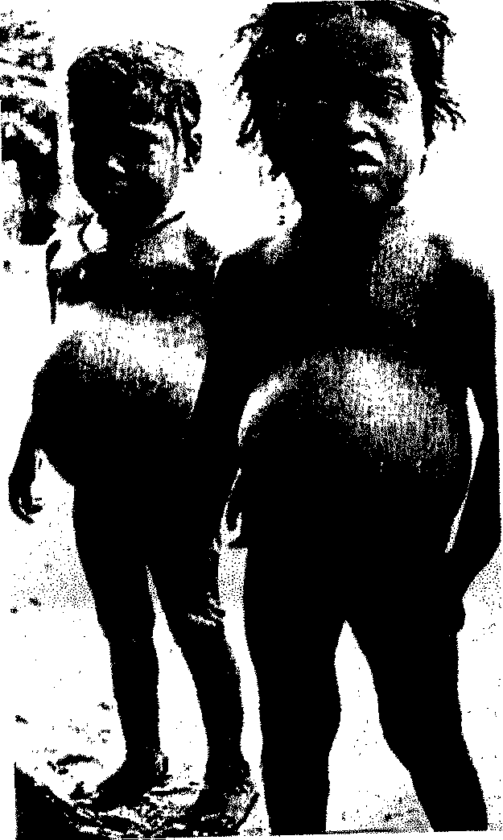

The two children in the picture show the symptoms of a deficiency in

- protein.
- fat.
- starch.
- cellulose.

The type of malnutrition represented by the picture is known as

- pellagra.
- anaemia.
- kwashiorkor.
- dermatitis.

The children suffering from the disease mentioned in Question 1.5 should be fed with the following foods to restore their health.

- Eggs and fish
- Potatoes and rice
- Beetroot and sugar cane
- Sweet potato and squash

Which organic compound is suitable for insulation against cold weather?

- Protein
- Lipid
- Carbohydrate
- Sugar

The vitamin which prevents scurvy is found in

- citrus fruit.
- spinach.
- fish oil.
- liver.

Which of the properties below are applicable to co-enzymes?

PROPERTIES

- Are involved in digestion only,
- Are substances derived from vitamins,
- Are organic substances with catalytic power,
- Are usually non-protein substances of organic origin

- (ii) and (iii)
- (i) and (iv)
- (ii) and (iv)
- (iii) and (iv)

The bond indicated in “A” in the diagram is a / an
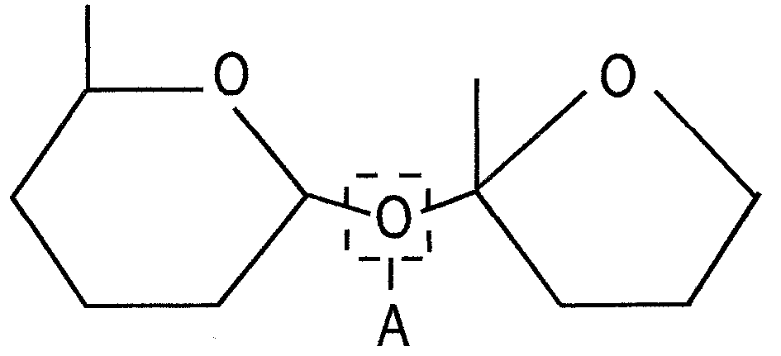

- ester bond.
- peptide bond.
- glycosidic bond.
- hydrogen bond.

Questions 1.11 to 1.13 are based on the diagrams below which illustrate the reaction of a stem and a root to a unilateral light and gravity stimulus respectively.
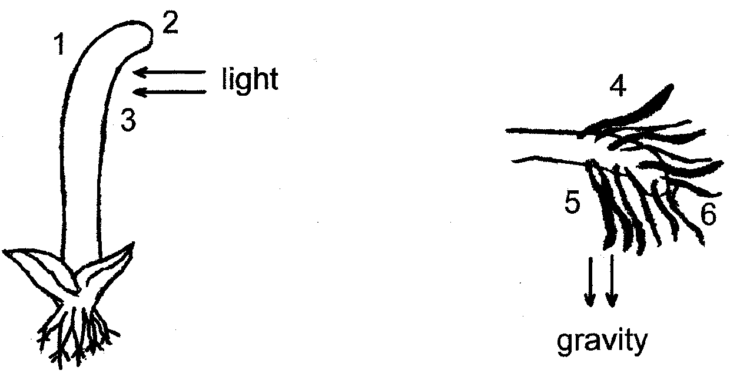

From the diagram, the stem shows a response known as

- positive phototropism
- negative phototropism.
- positive geotropism.
- negative hydrotropism.

Indicate in which of the numbered areas the concentration of auxin would be the highest.

- 2 and 6
- 1 and 4
- 3 and 5
- 1 and 5

The main effect of auxin is to increase the rate of

- cell differentiation.
- cell elongation.
- cell shrinkage.
- cell division.

An example of photoperiodism is shown by a

- growth response to a chemical substance.
- geranium plant curving towards the light.
- tortoise retracting into its shell.
- daisy opening its petals in the early morning sun.

Three jars were set up as shown in the diagram.
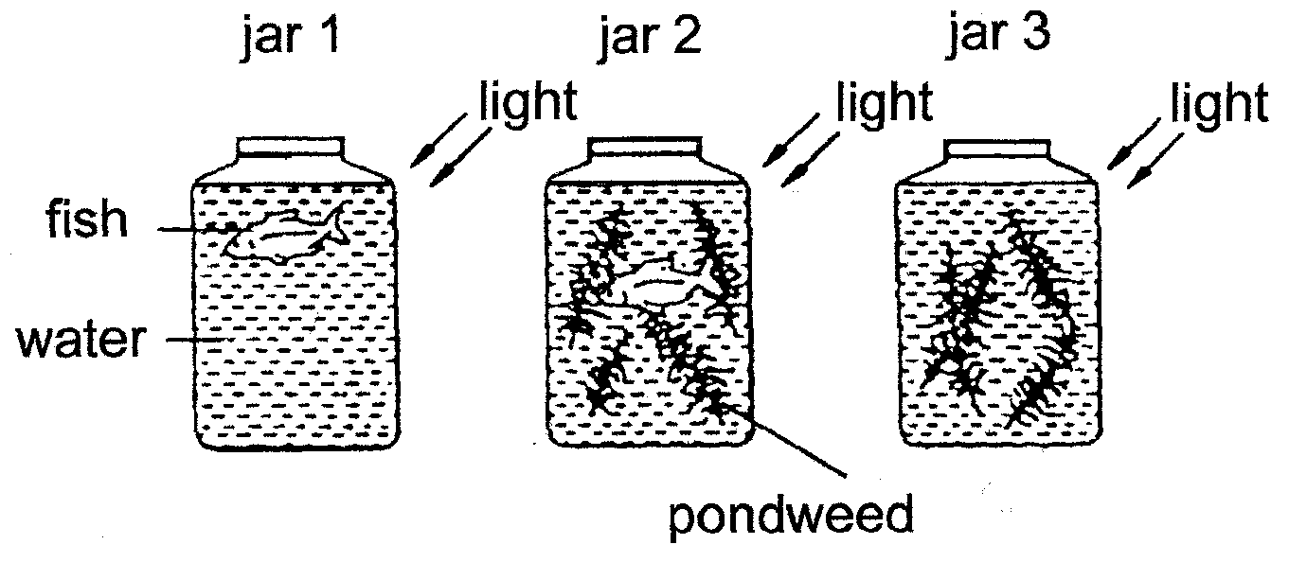

How will the concentration of dissolved oxygen in the water change after four hours in the sunlight?

 | JAR 1 | JAR 2 | JAR 3
A. | decrease | no change | no change
B. | decrease | increase | no change
C. | no change | decrease | decrease
D. | decrease | no change | increase

Questions 1.16 and 1.17 are based on the diagram below showing an experiment carried out to investigate photosynthesis.
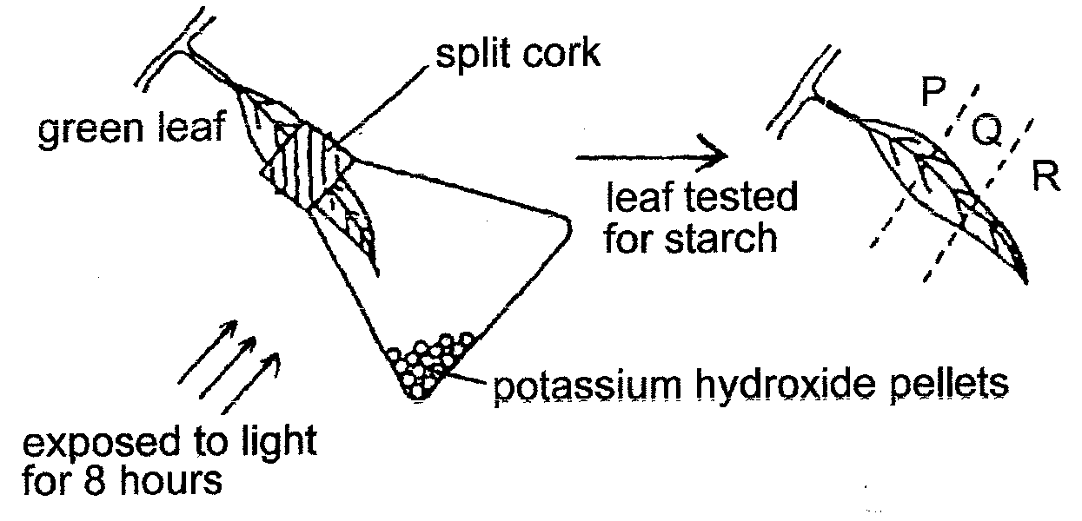

cork

Which TWO requirements for photosynthesis are investigated in this experiment?

- Sunlight and chlorophyll
- Sunlight and carbon dioxide
- Chlorophyll and oxygen
- Carbon dioxide and oxygen

1.17 The leaf was tested for starch using an iodine solution. P indicates the region outside the flask; Q is the region enclosed by the cork and R is the part of the leaf in the flask. What are the colours of regions P, Q and R after the starch test was performed?

 | P | Q | R
A. | Blue-black | Blue-black | Brown
B. | Blue-black | Brown | Brown
C. | Brown | Blue-black | Blue-black
D. | Blue-black | Brown | Blue-black

1.18 Water plants are exposed to light for one minute intervals at different temperatures. The amount of oxygen given off per minute at the different temperatures is shown graphically below.
oxygen
given off
–ml per minute
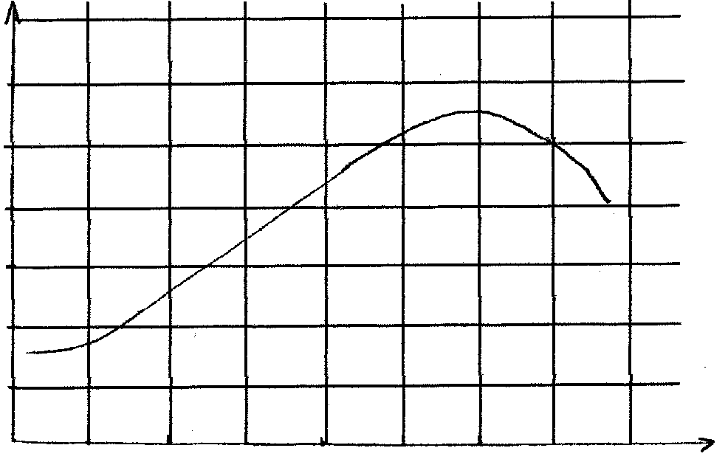
0 5 10 15 20 25 30 35 40

temperature °C
1,75

1,50

1,25

1,0

0,75

0,5

0,25

Which ONE of the following statements is the best summary of the results?

- The oxygen production is the highest between 10°C and 15°C.
- Oxygen is formed in plants exposed to light.
- A rise in temperature increases the oxygen production to a certain maximum.
- A rise in temperature decreases the oxygen production.

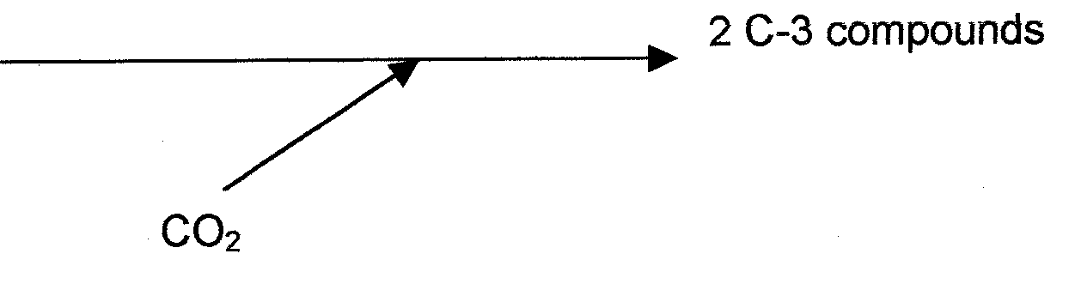
Which of the following processes is suggested by the accompanying diagram?
2 C-3 compounds
RuDP
CO₂

- The formation of CO₂ during fermentation.
- A reaction of the dark phase of photosynthesis.
- The formation of a glucose molecule.
- Oxidation of pyruvic acid.

Which of the following shows the correct path of air movement during exhalation?

- Alveoli → bronchiole → trachea → bronchus
- Alveoli → bronchiole→ bronchus→ trachea
- Trachea → alveoli → bronchiole→ bronchus
- Bronchus → bronchiole → trachea → alveoli

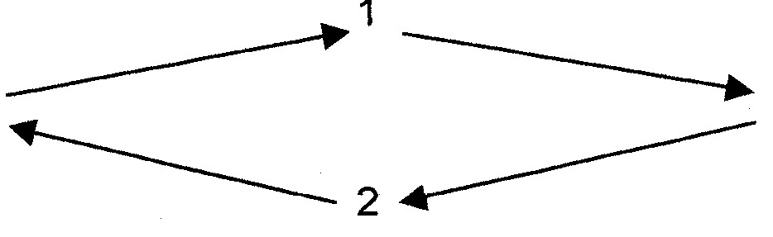
1.21 The cycle shows a simplified version of TWO processes in plants.
P + Q
A + B

If A + B represent the compounds, H₂O and CO₂ then

- 1 : photosynthesis, 2 : respiration and P+Q : glucose and oxygen.
- 1 : photosynthesis, 2 : respiration and P+Q : water and carbon dioxide.
- 1 : respiration, 2 : photosynthesis and P+Q : glucose and oxygen.
- 1 : respiration, 2 : photosynthesis and P+Q : water and carbon dioxide.

1.22 The following are involved in the process of cellular respiration:

- Energy
- Carbohydrates
- Carbon Dioxide
- Water
- Oxygen

Which of the following correctly represent their involvement in the process?

- 1 + 2 = 3 + 4 + 5
- 2 + 5 = 1 + 3 + 4
- 2 + 3 = 1 + 4 + 5
- 2 + 4 = 1 + 3 + 5

(Question 1.23 appears on the following page.)

Questions 1.23 to 1.27 are based on the accompanying diagram.

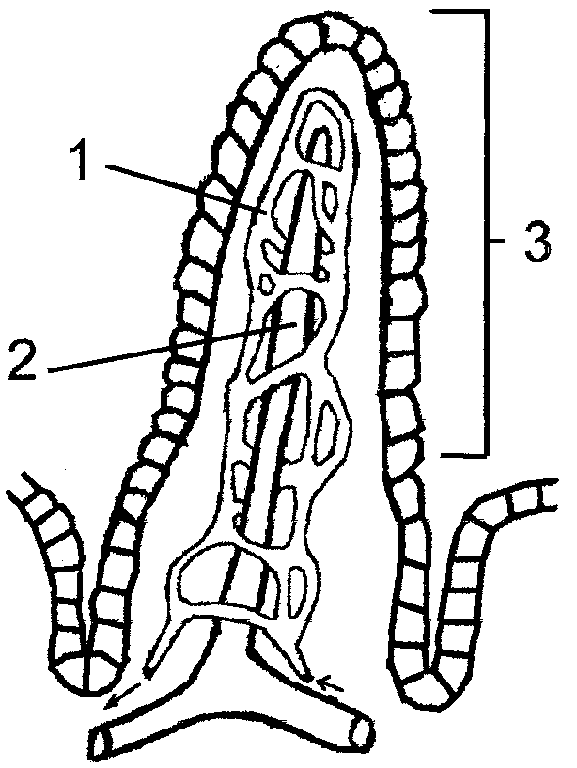 | - The structure numbered 3 is most probably found in the  - ileum.  - stomach.  - colon.  - oesophagus.  - What feature of structure number 3 makes it efficient for the absorption of digested food?  - It has no mucus layer.  - Surface cells are richly supplied with mitochondria.  - Goblet cells produce only enzymes for digestion.  - The outer layer is made of squamous epithelium cells.

The food absorbed by structure number 1 is

- cellulose.
- glucose.
- starch.
- polypeptides

The vessel associated with the transport of absorbed food from structure number 2 to the heart is the

- hepatic vein.
- hepatic artery.
- hepatic portal vein.
- thoracic duct.

Peristalsis occurs in the organ containing the structure number 3. Which one of the following statements concerning peristalsis is TRUE?

A. Circular muscles above the bolus relax.
- Longitudinal muscles are involved in the process.
- Oblique muscles are involved in the process.
- Peristalsis is a voluntary action.

Deamination occurs in the

- stomach.
- jejenum.
- liver.
- ileum.

Which substance is used to extract chlorophyll from leaves?

- Iodine solution
- Fehling’s A and Fehling’s B
- Millon’s reagent
- Alcohol

Which conditions favour guttation?

- Low root pressure, high temperature
- High root pressure, low humidity
- High root pressure, high humidity
- Low root pressure, low temperature

The urine of a normal healthy person does not contain

- urea.
- glucose.
- pigments.
- mineral salts.

Questions 1.32 to 1.35 are based on the accompanying diagram.

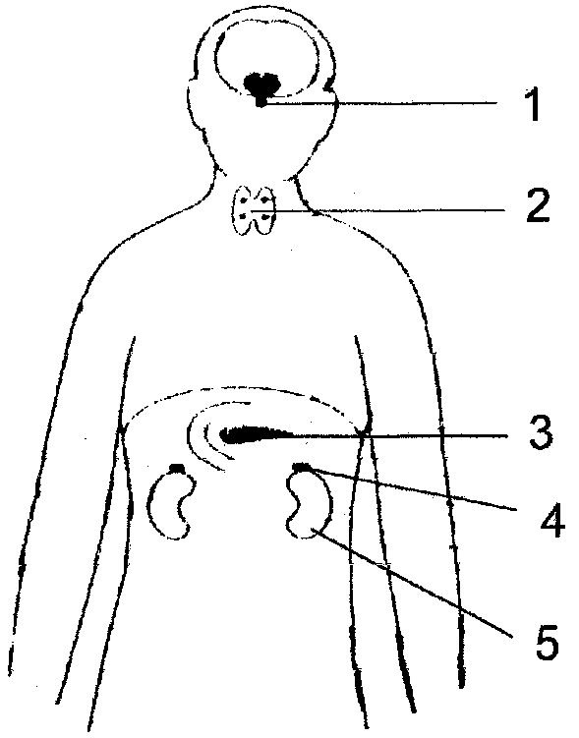 | - The structure numbered 1 is the  - thyroid gland.  - pancreas.  - hypophysis.  - adrenal gland.  - Inadequate activity of structure numbered 2 will result in the following:  - Increased growth  - Reduced growth  - Increased metabolism  - Increased mental development

Which of the following effects are caused by the gland numbered 4?

- Constricts blood vessels of the skin
- Speeds up the conversion of glucose and glycogen
- Increased blood pressure

- (i) and (ii)
- (ii) and (iii)
- (i) and (iii)
- None of the above

The functions of structure 3 are referred to as

- circulatory and respiratory.
- endocrine and respiratory.
- digestive and circulatory.
- digestive and endocrine.

The olfactory cells in the mucous membrane lining the turbinate bones are receptors for

- taste.
- pain.
- pressure.
- smell.

The taste buds of the tongue are an example of

- proprioceptors.
- thermoreceptors.
- mechanoreceptors.
- chemoreceptors.

Which control centre of the body will be activated when a long distance athlete begins to dehydrate?

- Hypothalamus
- Cerebellum
- Thyroid
- Cerebrum

Which of the following is NOT controlled by homeostatic mechanisms in the human body?

- Blood pressure
- Colour vision
- Blood sugar
- Body temperature

(Question 1.40 appears on the next page)

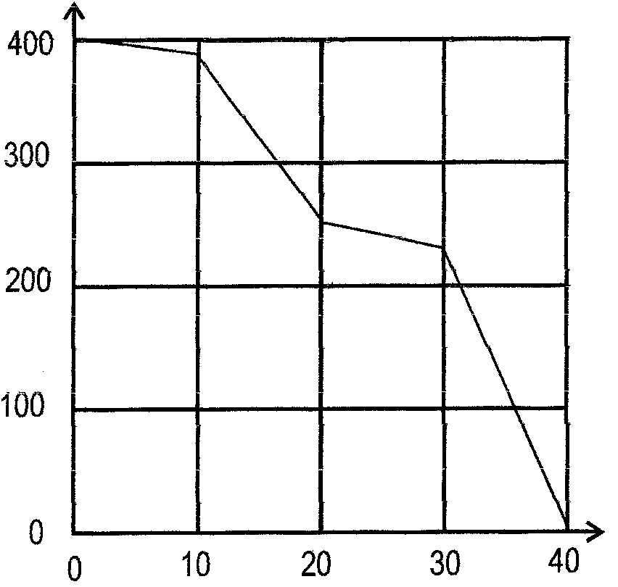
The survivorship curve of a butterfly species is usually stair-case shaped as shown in the graph below. Which of the following is represented by the flat segments of the curve?
Number of Survivors
Age

- Egg and larva
- Larva and pupa
- Pupa and adult
- Egg and pupa
40x2=[80]

QUESTION 1B

Provide either the AIM, the RESULT or the CONCLUSION as indicated by each diagram. Write the number with its answer on a new line in your ANSWER BOOK.
AIM: 1
AIM: 4
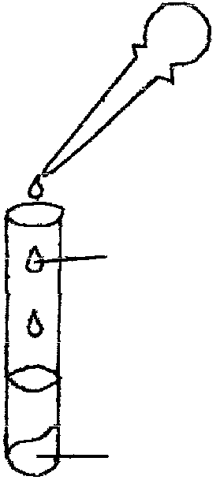
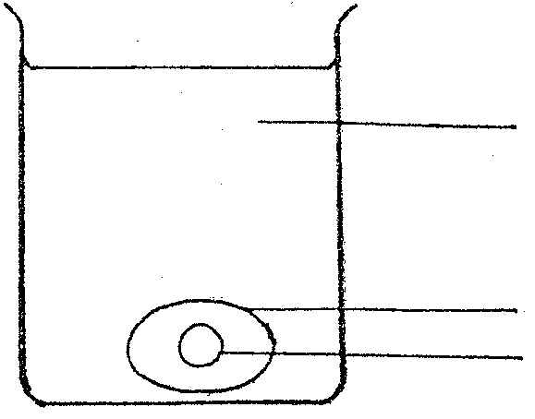
Fehling’s A and B
food sample
pure water
egg without shell
egg yolk
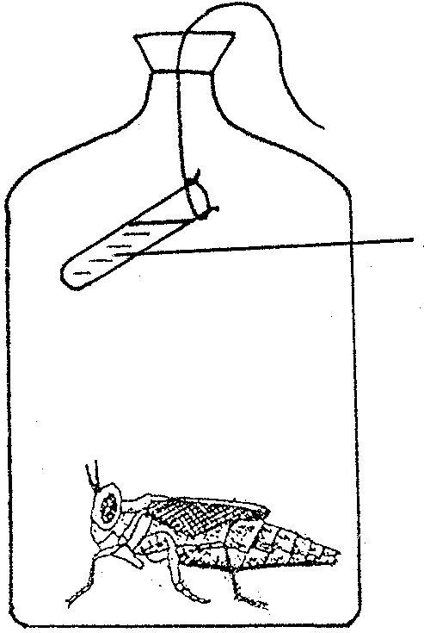
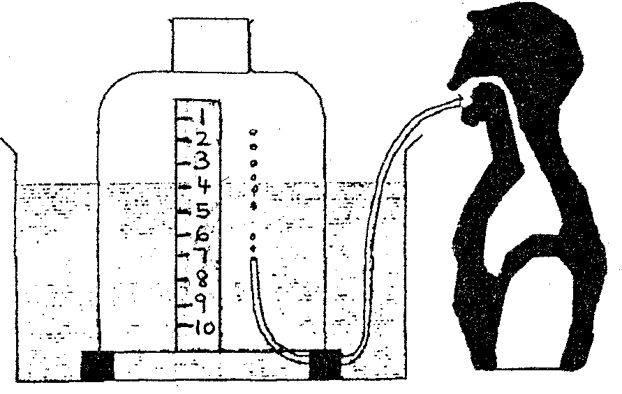
RESULT: 2
lime water

RESULT: 3

CONCLUSION: 5
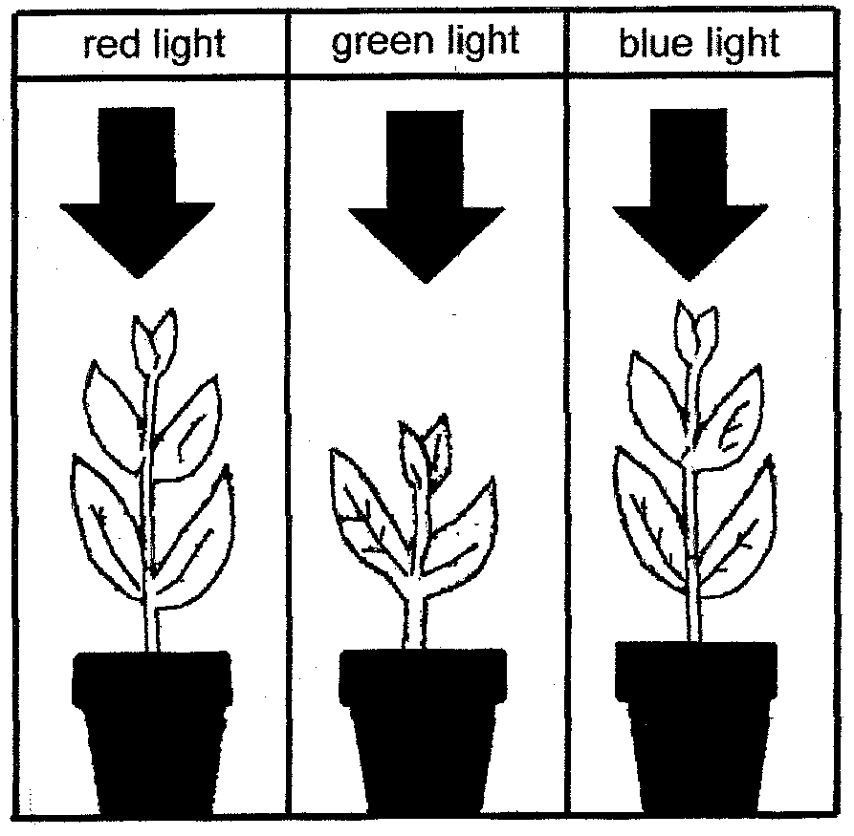

5x2=[10]

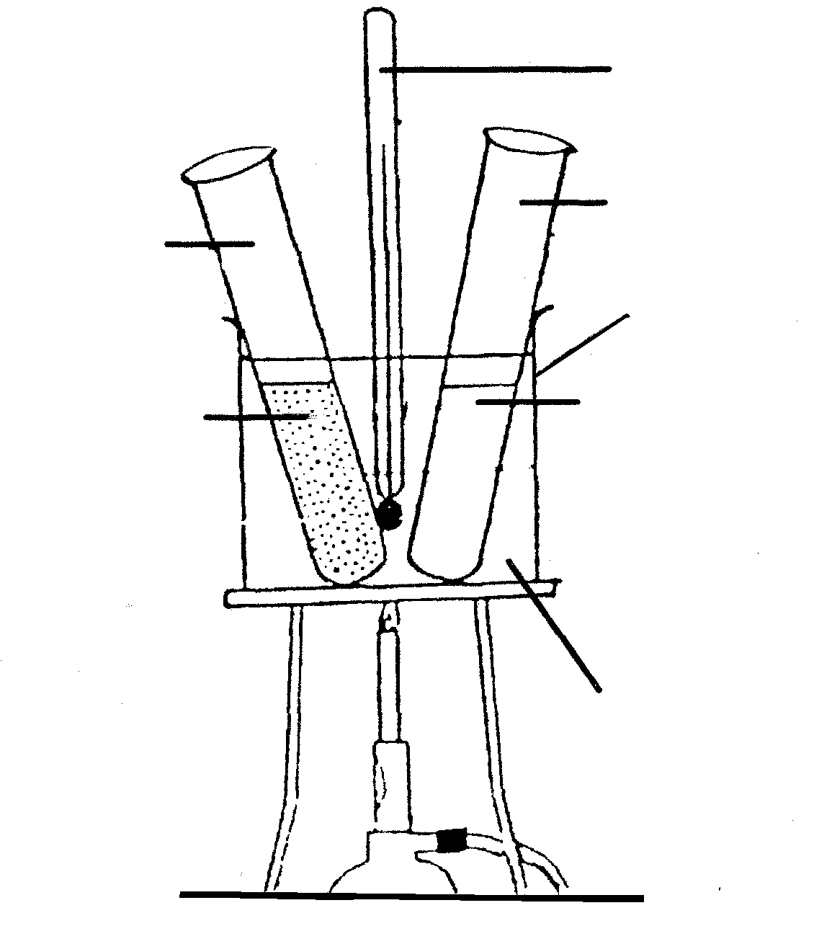
QUESTION 1C
test tube B
test tube A
starch solution and boiled saliva
starch solution and saliva
water bath
2
1

Study the experiment below and answer the questions that follow.

Identify the items numbered 1 and 2.  - Name the enzyme found in saliva. | (2)  (1)
Which of the test-tubes represents the control?  Give a reason for your answer. | (2)

At what temperature should the water in the water bath be kept?  Give a reason for your answer.  5. State the result obtained in test-tubes A and B respectively.  6. What property of an enzyme is being investigated in this experiment?  TOTAL FOR SECTION A: | (2)  (2)  (1)  [10]  [100]

SECTION B
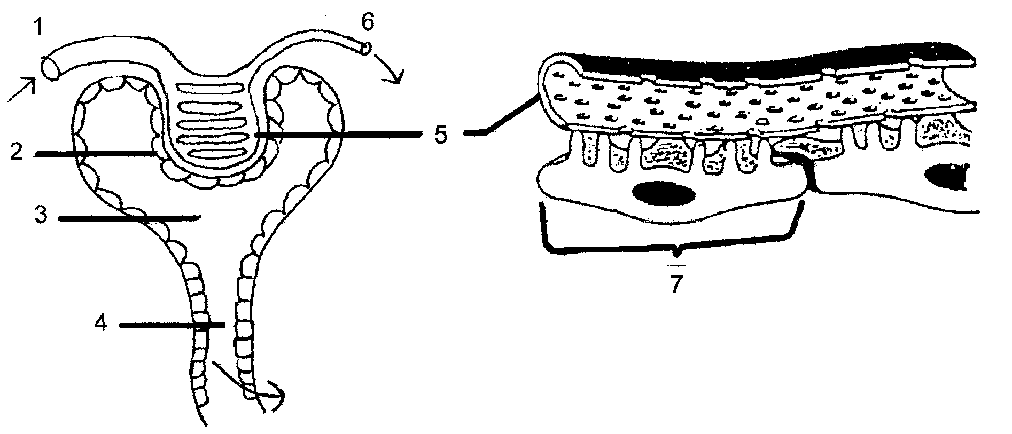

Answer ALL questions from this section in your ANSWER BOOK.

QUESTION 2

  - The diagram below shows portions of the human excretory system.

Identifiy the structures numbered 3 and 4.  - What is the structural difference between structures numbered 1 and 6?  Give ONE reason for this difference.  - Name the single process taking place in the structures numbered 5 and 7.  - Explain how the structures numbered 5 and 7 are adapted for the process mentioned in Question 2.1.3.  - Name the process occurring in part number 4 which is indicated by the arrow.  - Name ONE nutrient that enters structure number 3. | (2)  (2)  (1)  (3)  (2)  (1)

Study the diagram below and answer the questions that follow.
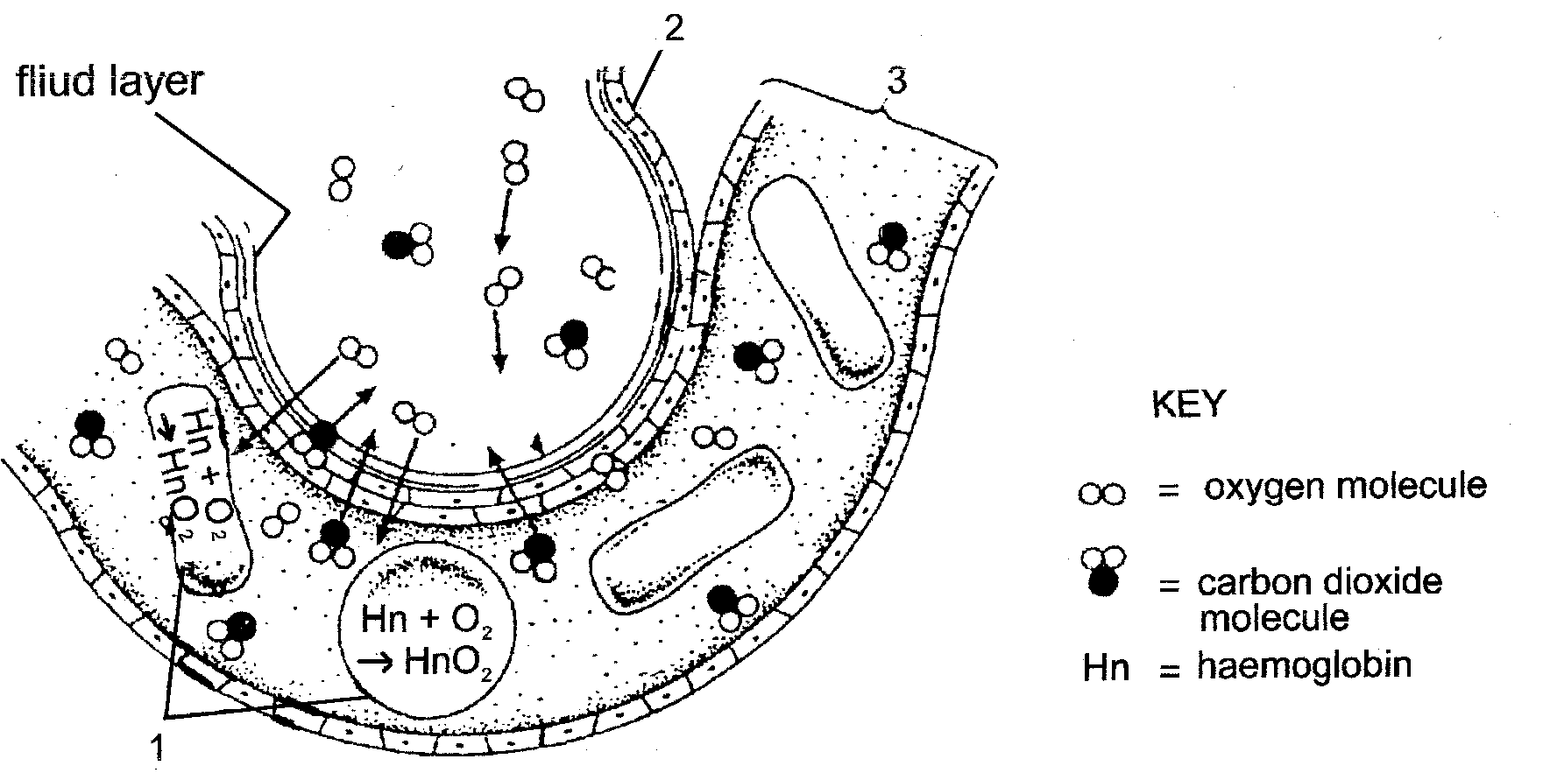

fluid layer

- Identify the parts numbered 1 and 3.  - Give ONE function of the fluid layer.  - Give FOUR ways in which structure number 2 is adapted for its function.  - List THREE ways in which carbon dioxide is transported in the blood. | (2)  (1)  (4)  (6)

2.3 Study the accompanying diagram of a portion of the human digestive system.
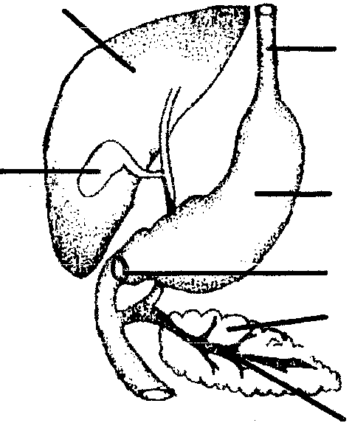
1
2
3
4
5
6
7
 | - Identify the parts numbered 1, 2, 3, 6 and 7.  - What is the purpose of structure 3?  - Structure number 4 controls the bloodglucose level.  Explain how this structure controls a very low blood glucose level.  - How does structure 7 control excess protein in the body?  - What is the effect of excess alcohol on the liver of an alcoholic?  - List TWO functions of the contents stored in structure number 6. | (5)  (1)  (4)  (4)  (1)  (2)

2.4 The diagram below shows a cross section through the human skin.

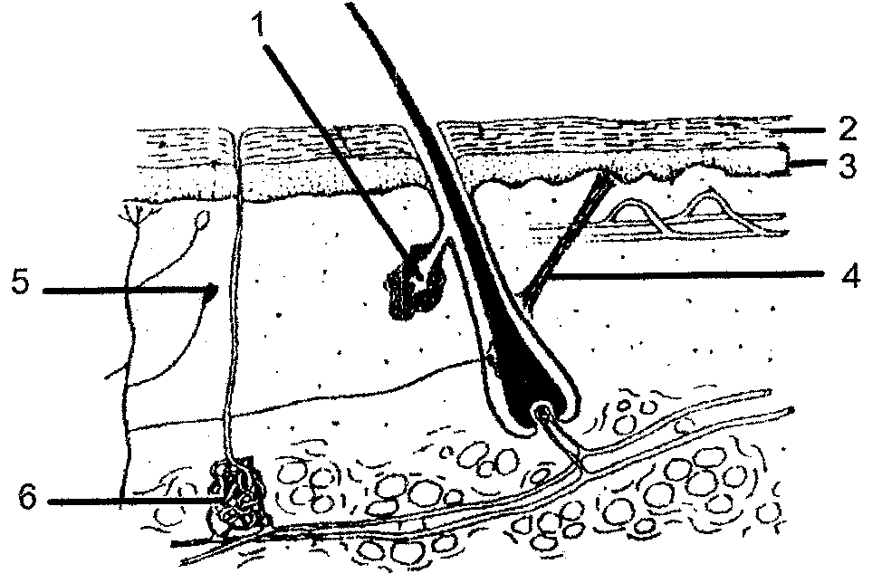 | - Identify the structures numbered 1, 4 and 6.  - NameTWO constituents of the substance excreted by number 6.  - Name the heat receptor indicated by number 5.  - Name the protein present in structure number 2. | (3)  (2)  (1)  (1)

In which numbered part is vitamin D synthesized in the presence of sunlight?  - What will happen if structure number 1 stops functioning? | (1)  (1)  [50]

QUESTION 3
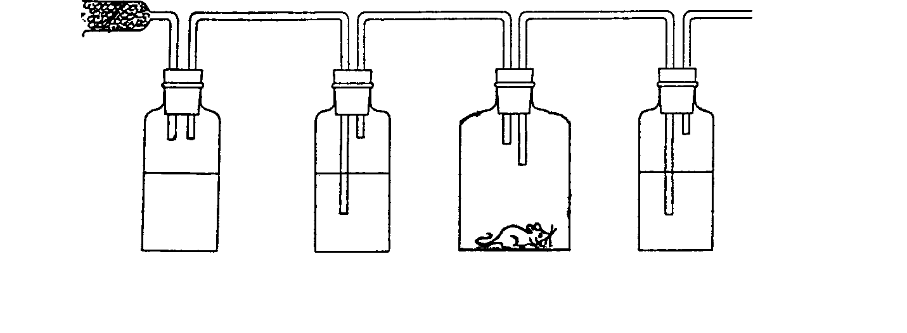

B C D E
air
A
sodium lime living lime
hydroxide water mouse water
to suction pump

3.1 Study the experiment that was set up in a laboratory and answer the questions that follow.

What is the purpose of the sodium hydroxide / soda lime in flask B?  - Identify A.  - What happens to the solution in flask E?  - Explain what will happen to the lime water in flask E if the living mouse in flask D is replaced with a non-living object or a dead mouse.  - What is the experimental design called as mentioned in Question 3.1.4?  - In setting up the experimental apparatus an observable error was made as indicated in the diagram. Identify the error.  - What observations do you expect in flask C after a few hours?  Explain your observations. | (2)  (1)  (2)  (2)  (1)  (1)  (2)

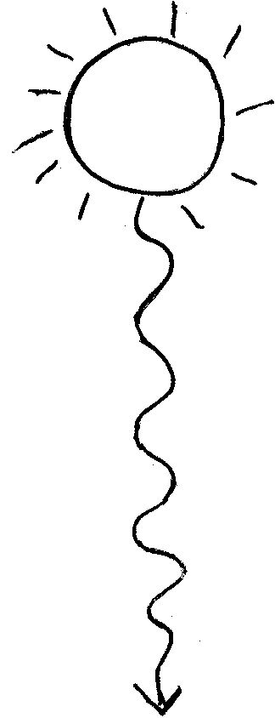
The following flow diagram is based on photosynthesis.
electron energy
chlorophyll
X
Y

To
Atmosphere

2H₂O + 4

(4OH)

H₂O H⁺ + 3

NADP 2

1 + P ATP

PHASE 1

Identify X.  - What kind of energy is represented by Y?  - Identify PHASE 1.  - Name the substances 1 to 4. | (1)  (1)  (2)  (4)

3.3 The graph shows the respiration rate of different mammals. The respiration rate is shown as a relative rate per unit of body mass in grams.
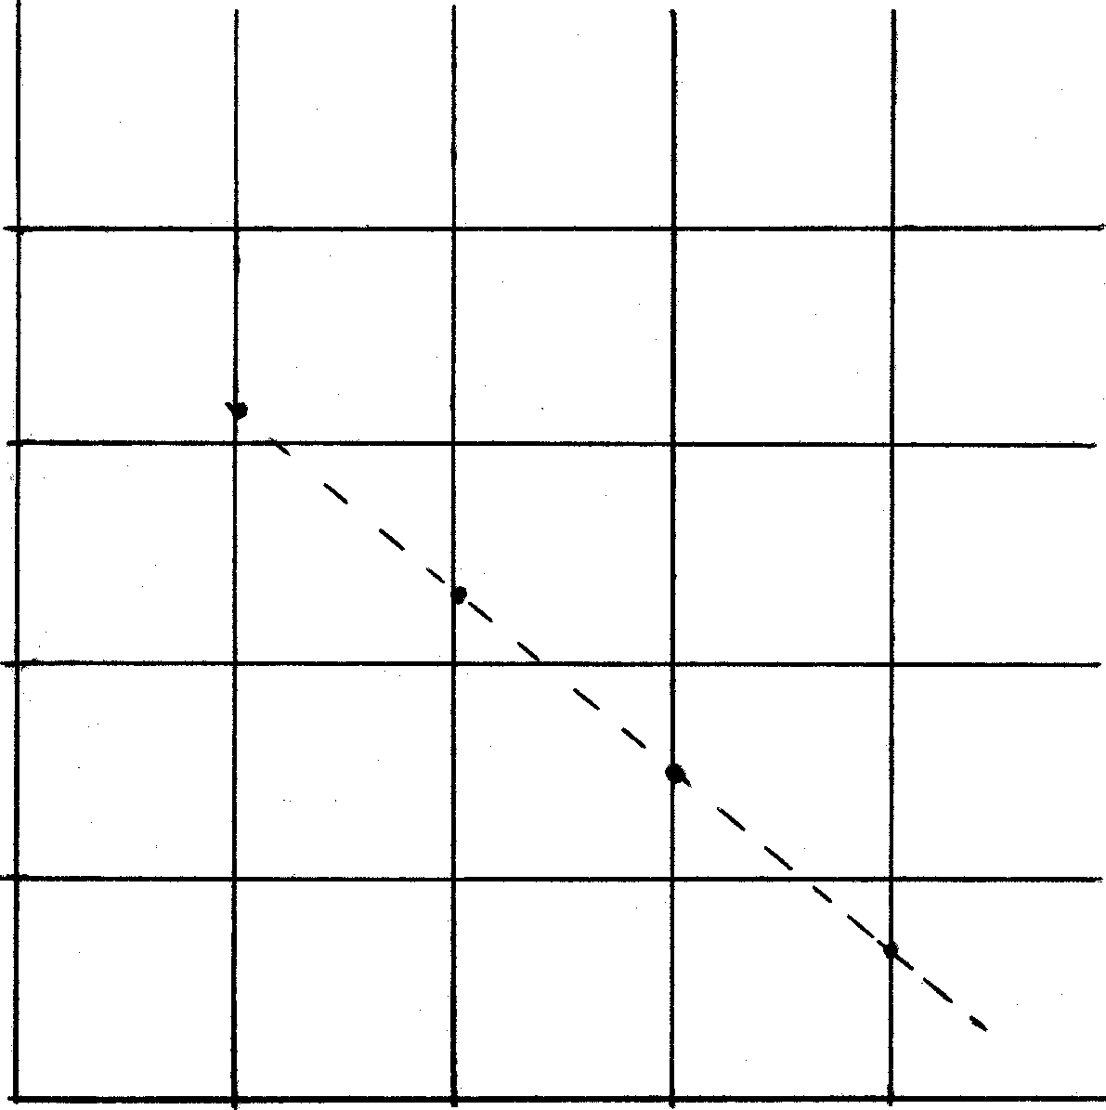  Metabolic rate mm³, oxygen per gram per hour  Body Mass in gram (x10³)  Rabbit  Dog  Human  Elephant  800  600  400  200  0  1  10  100  1 000 | - What is the body mass of the dog?  - Which animal has the lowest metabolic rate according to the graph?  - What is the body mass of the animal with the highest metabolic rate?  - What deduction can be made from the graph? |  | (2)  (2)  (2)  (4)

3.4 Read the following passage carefully and answer the questions that follow.

line 5 | Co-ordination systems  Changes constantly take place inside and outside the body. Mammals respond to the changes and their internal environment remains fairly constant. An important factor in the maintenance of a constant internal environment is the co-ordination of these stimuli.  A co-ordination system contains several components. The stimuli are
line 10 | detected, converted into an impulse, interpreted and a reaction is produced. The system must also direct information along the most appropriate channel. Co-ordination also involves negative feedback.  Mammals have two control and co-ordinating systems. Each system has different means of detecting and interpreting information. However, the two systems work as a unit.

What biological term is used to describe the maintenance of a constant internal environment (lines 3 and 4)?  - Referring to lines 2 and 3, what makes up the internal environment of a mammal?  - Name FIVE factors in the internal environment which must be kept constant.  - The term co-ordination (lines 4 and 8) is mentioned several times in the passage. Explain the meaning of this term.  - Name the TWO control and co-ordination systems referred to in lines 9 and 10. | (1)  (2)  (5)  (2)  (2)

The diagram below shows part of the human ear.
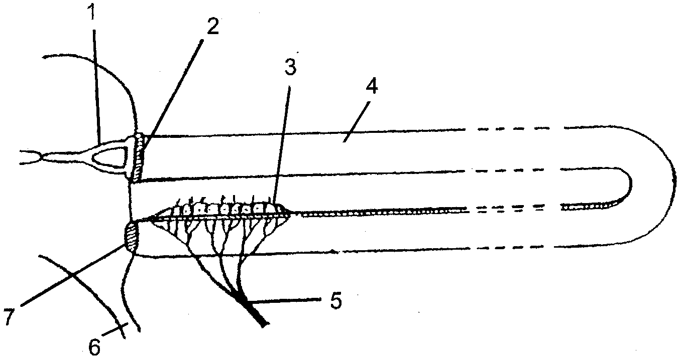

Identify the parts numbered 1 and 7.  - Using only the numbers on the diagram and using arrows, show the pathway of sound in the form of a flow diagram until the impulse reaches the brain.  - What is the function of number 7?  - Give the number and name of the organ which converts sound vibrations into a nerve impulse.  - What is structure number 6 and where does it lead to? | (2)  (2)  (1)  (2)  (2)  [50]

QUESTION 4

4.1 The table below shows the percentage of the population in Gauteng that are infected with HIV.

YEAR | % OF THE POPULATION THAT ARE HIV POSITIVE
1994 | 10
1996 | 16
1998 | 24
2000 | 40

Use the data from the table and plot a line graph to show the section of the population that is not HIV positive.  - What percentage of the population was HIV positive in the year 1997?  - State the deduction(s) that can be made from the graph.  - What technique is used to determine the population size of the HIV positive individuals? | (8)  (2)  (2)  (1)

4.2 The diagram below illustrates the energy budget of a duck observed during a fixed period of time.
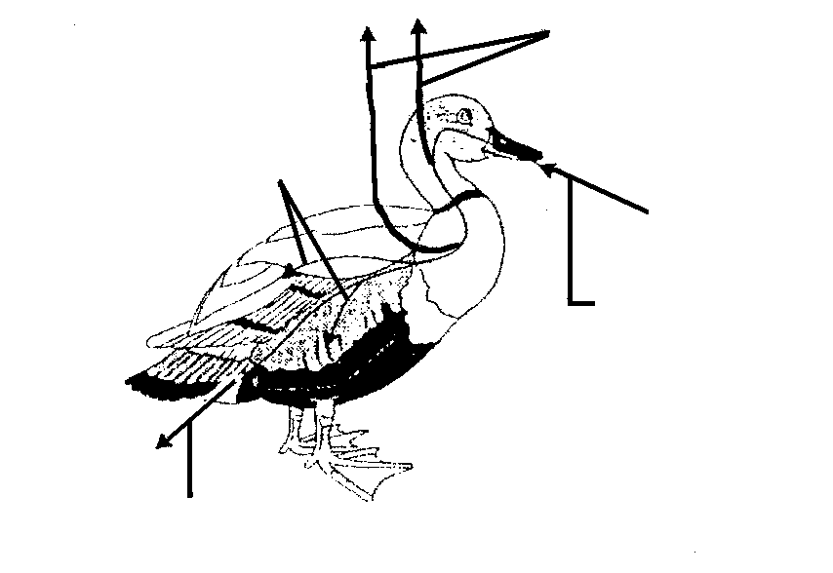
Secondary production
(SP) 84 kJ
Excretory products (E)
764 kJ
Food eaten (C)
1 200 kJ
Respiratory heat loss (R)
352 kJ
 | Use the given symbols on the diagram and state the formula for the energy budget of the duck.  - What percentage of the total energy of the food eaten is directed to secondary production of biomass?  - Explain the term ‘energy flow’. | (4)  (2)  (2)

(Question 4.3 appears on the following page.)

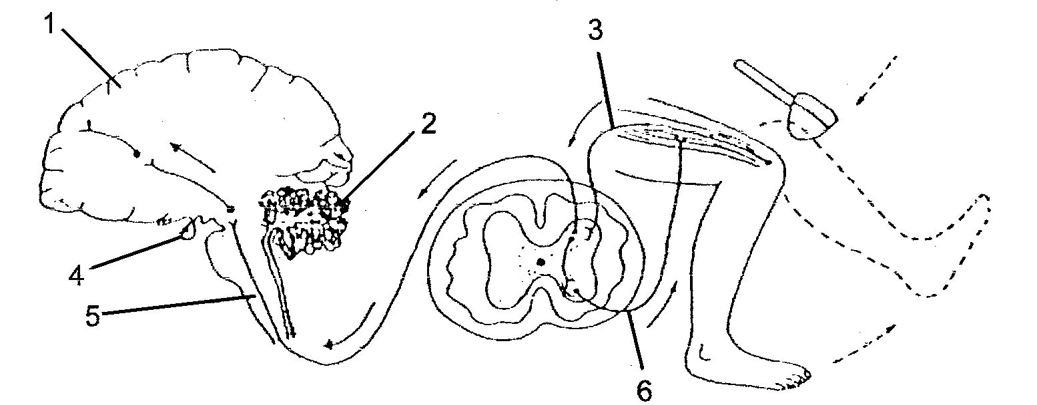
Study the diagram of a longitudinal section of the human brain, a cross-section of the spinal cord and the right leg.
BRAIN
SPINAL CORD
RIGHT LEG

Identify parts 1, 2 and 5.  What will be the effect on the body if the part numbered 2 is damaged?  4.3.3 Give the number and the name of the part which secretes TSH. | (3)  (1)  (2)
- What is the function of TSH?  - Describe the reflex action shown in the diagram.  - Draw and label the type of neuron as indicated by number 6. | (1)  (6)  (9)

A person is seated in a dark room and is asked to cover one eye. A light source held at varying distances from the person is switched on and off at one-minute intervals, for a period of 10 seconds. During this period the diameter of the pupil of the eye is measured. The results are presented below.
diameter of the pupil of the
eye (mm)
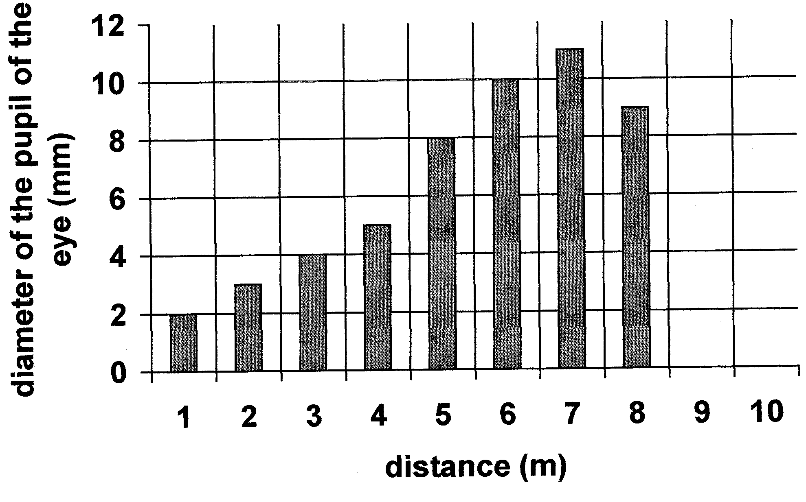
distance (m)
1 2 3 4 5 6 7 8 9 10
12

10

8

6

4

2

0

Name the structure in the eye that regulates the diameter of the pupil.  - What is the diameter of the pupil when the light source was the greatest distance away from the person?  - Why was there a change in the diameter of the pupil when the light bulb was positioned at varying distances?  - Explain the changes that occur in the pupil at the 2 metre and 6 metre distances. | (1)  (1)  (1)  (4)  [50]

TOTAL FOR SECTION B: | [150]

SECTION C

QUESTION 5

5.1 Study FIGURE 1 that illustrates organs and tissues of a plant and then answer the questions that follow.
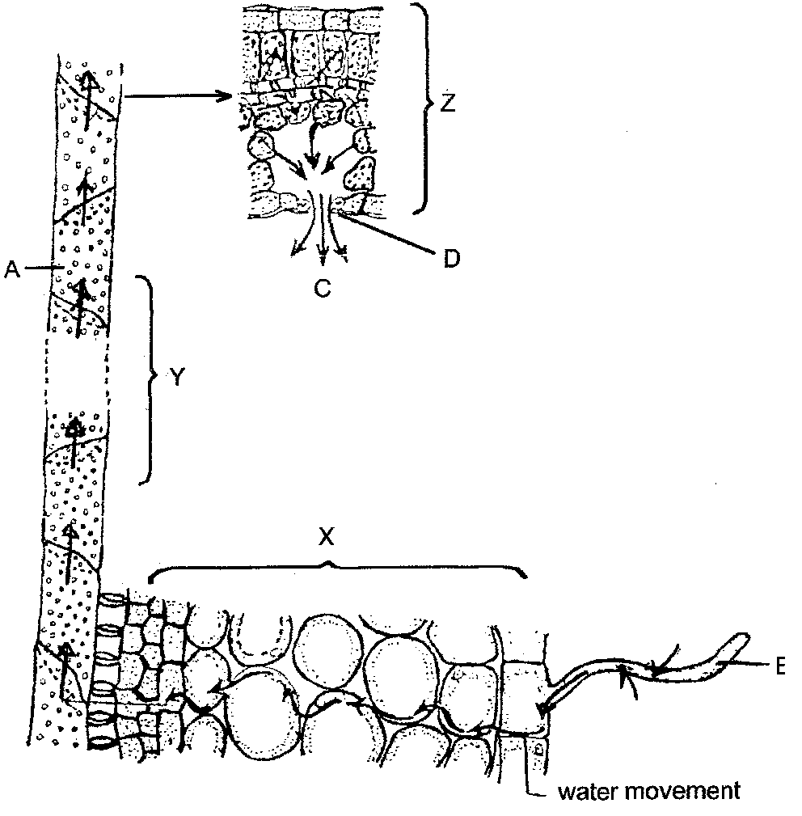
 | 5.1.1 Tissue A is responsible for the transport of water in a plant. Name this tissue.  5.1.2 List FOUR ways in which tissue A is adapted for water transport.  5.1.3 Name the plant organs X, Y and Z. | (1)  (4)  (3)

FIGURE 1  B  water movement | 5.2 Indicate ONE plant organ or structure in which each of the following will occur:  5.2.1 Osmosis  - Capillarity  5.3 Explain the following processes:  - Root pressure  - Plasmolysis | (2)  (2)  (2)  (2)

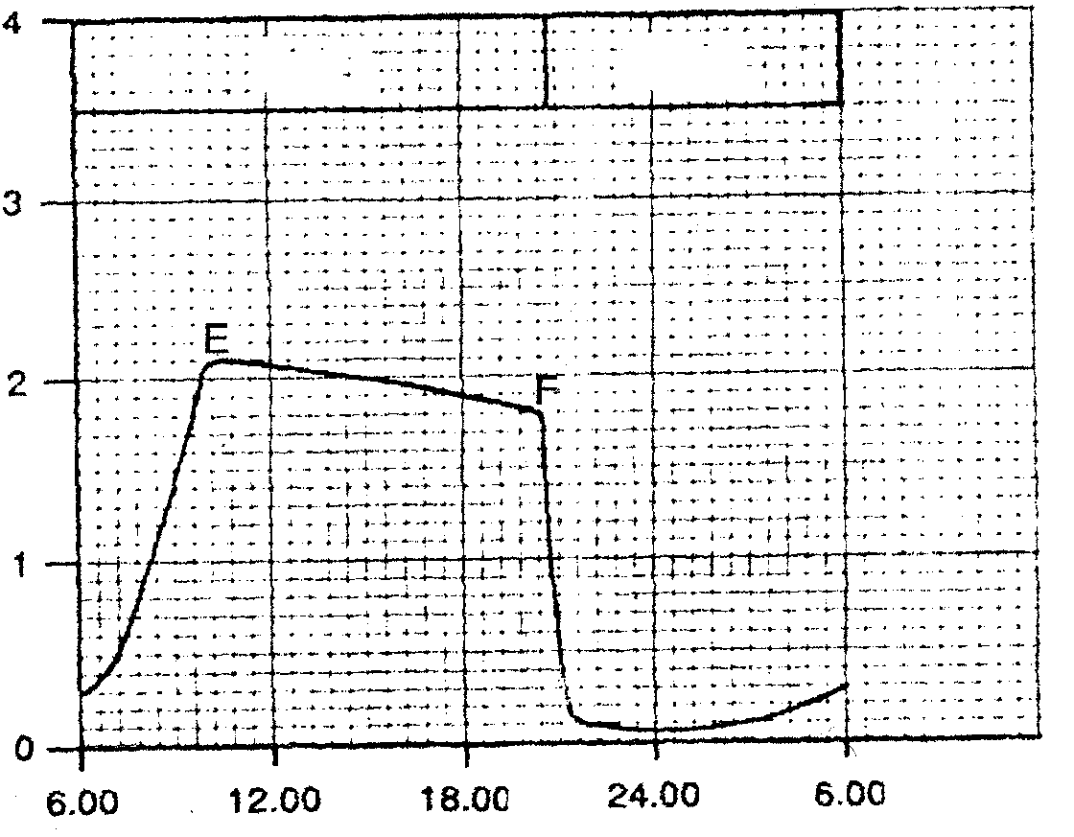
  - The graph below FIGURE 2 shows the changes occuring in the guard cell (structure D in Figure 1) over a period of 24 hours.
Time / hours
Extent of stomatal opening
Arbitrary units
light
dark

FIGURE 2

- State the time of day during which the stomata are open.  - What is happening from point E to F on the graph? Give a reason for this occurrence. | (2)  (4)

5.5 Identify if the following STATEMENTS and REASONS are true or false.
Identify the scientific error if your answer is false.

 | STATEMENT |  |  | REASON
5.5.1  5.5.2  5.5.3  5.5.4 | Water moves into the guard cells during the day  During the day glucose is produced in the guard cell  Transpiration rate increases when the stomata opens.  Carbon dioxide con-centrations change in guard cells |  | because  because  because  because | the cell sap of the surrounding epidermal cells has a higher water potential.  mitochondria are present and photosynthesis has occurred.  A suction force is needed to transport minerals to the leaves for photosynthesis.  photosynthesis and respiration occurs in the guard cells. | (2)  (2)  (2)  (2)

5.6  Water regulation occurs in many organisms.  Discuss this statement by referring to:  - A single-celled organism found in fresh water  - Water regulation in Lumbricus sp (earthworm)  - The reabsorption of water in the nephron of a camel  TOTAL FOR SECTION C: | (4)  (7)  (9)  [50]

TOTAL: | 300

