GAUTENG DEPARTMENT OF EDUCATION
SENIOR CERTIFICATE EXAMINATION

BIBLICAL STUDIES SG

TIME : 3 hours

MARKS : 300

INSTRUCTIONS:

- Answer FIVE questions. Section A Question 1 is COMPULSORY. All subsections of this question must be answered.

- In addition, TWO questions from Section B and TWO questions from Section C must be answered.

- The length of your answers should be in proportion to the marks allocated.

SECTION A

COMPULSORY

QUESTION 1

SHORT QUESTIONS

Questions 1.1 to 1.7 are short questions. Write the number of each question (including those of the subsections) in your answer book and write your answer next to the number.

- Indicate whether the following statements are TRUE or FALSE:  1.1.1 Jesus is equal to the Father.  - Jesus was truly and fully human.  - Man can be saved only through Jesus.  - Pilate knew that Jesus was innocent.  - The Second Coming is an invention of the early church.  5 x 2 = | (10)

1.2  - To whom did Luke address his Gospel?  - Who is the “Advocate” or “Comforter” referred to in the New Testament?  - Who wrote at least thirteen of the books in the New Testament?  - State the meaning of the word “Amen”. | (2)  (2)  (2)  (2)

1.3 Choose the correct answer from Column B to match the names given in Column A. Write the letter of each correct answer from Column B next to each of the numbers from Column A in your answer book, eg. 1.3.1 D.

COLUMN A | COLUMN B
- Paul  - Matthew  - Messiah  - Jesus  - Immanuel | - Saviour  - Christ  - Also known as Saul  - God with us  - Also known as Levi

5 x 2 = | (10)

- In which of Paul’s letters can the following themes be found?  1.4.1 Christ is the head of the church  - Marriage, celibacy, idolatry and the resurrection  2 x 2 = | (4)

- In which Synoptic Gospel do we find the following characteristics?  1.5.1 Exciting detail like that of an eye-witness  - The frequent use of Aramaic words  - A very human picture of Jesus  3 x 2 = | (6)

1.6 MULTIPLE CHOICE QUESTIONS

For each of the following questions or statements, four possible answers or explanations are given. Choose the appropriate answer and write down only the correct letter opposite the corresponding question number in your answer book.

    - Which one of the following themes is NOT found in the Gospel of Matthew?
- The important role played by women
- The Kingship of Jesus
- The Church of Christ
- The fulfilment of prophecies in Jesus

    - Which one of these statements about the Gospel of Mark is FALSE?
- It is the shortest Gospel.
- It has more parables than the other Gospels.
- It is the oldest Gospel.
- It contains no account of Jesus’ birth.

    - Identify the FALSE ‘I Am’ statement:
- I am the good shepherd.
- I am the salt of the earth.
- I am the bread of life.
- I am the resurrection and the life.

    - The Gospels wish to show that Jesus is the Messiah.
What does the word “Messiah” mean?
- Son of God
- Prophet
- Saviour
- Anointed

    - Who wrote the letter of Jude?
- Jude, the brother of James
- Jude of Damascus
- Jude Barsabas
- Jude Iscariot

    - Which one of the following statements does not apply to the new heaven and the new earth spoken of in Revelation 21?
- John saw the city descending from God to the earth.
- Religion will no longer exist.
- Jesus will dwell there.
- There will be no tears or sorrow.

    - Which one of the following terms can be used to describe the doctrine of the last times?
- Decalogue
- Eschatology
- Antichrist
- Revelation

- Indicate the correct statement regarding the Law of God:  - It was replaced by Jesus.  - It has existed only since the day of Pentecost.  - It is a lamp unto our feet and a light unto our path.  - It must be obeyed to obtain salvation.  8 x 2 = | (16)

1.7 Which commandment is broken when  - the crime of perjury (to lie under oath) is committed?  - the Name of Christ is used as a swear word?  - one believes that carrying a lucky charm will bring good luck?  3 x 2 = | (6)  [60]

SECTION B

INTRODUCTION TO THE NEW TESTAMENT

Answer TWO questions from this section.

QUESTION 2

- Discuss the following characteristics of the Gospel of Matthew:  2.1.1 Matthew emphasises the kingship of Jesus.  - He emphasises the importance of the Law.  - It is a Gospel for the Jews. | (10)  (10)  (10)

2.2 The theme verse of the Gospel of John is given in chapter 20 verse 31: “But there are written that you may believe that Jesus is the Christ, the Son of God, and that by believing you may have life in his Name.”  Discuss how this verse explains the aim of this gospel. | (10)

2.3 To whom is the letter of James addressed?  2.4 What comfort does the sovereignty of Jesus Christ give man according to Revelation 1 to 3? | (10)  (10)  [60]

QUESTION 3

- What does Luke’s gospel teach us about  3.1.1 prayer?  - women?  - the poor? | (8)  (8)  (4)

3.2 List the Pauline letters and state the theme of each according to the following headings:  - Pastoral letters  - Prison letters  - Letters to young churches | (6)  (8)  (12)

3.3 How was the congregation in Philippi founded? | (10)

3.4 The book of Revelations refers to seven congregations (churches) in Asia Minor. Name TWO of these congregations. | (4)  [60]

QUESTION 4

- Answer the following questions on the Gospel of Mark.  4.1.1 What was Mark’s Jewish name?  - Mark was not a disciple. How then could he give such an accurate account of Jesus’ life?  - Mark stressed the deeds of Jesus while paying little attention to his words. What could be the reason for this?  - Why do we say Mark never forgets that Jesus is divine?  - State ONE example from which we can deduce that Mark was an emotional man.  - State TWO examples to show that Mark painted a very human picture of Jesus.  - Provide TWO examples of how Mark described events in vivid detail.  - To whom did Mark write his Gospel?. | (2)  (2)  (2)  (2)  (2)  (4)  (4)  (2)

4.2 From the letter to the Philippians we can deduce that Paul was in prison:  - Explain by means of examples why this deduction can be made.  - Which prospects did he have? | (6)  (4)

4.3 In his letter, James refers to himself as “a servant of God and of the Lord Jesus Christ”. The new Testament mentions five men called James. Explain who these five men were and which one of them was the author of this letter. | (10)

4.4 Supply the FIVE main themes of the letter of James. | (10)

- Describe the greatness of Jesus Christ’s sovereignty in his church according to Revelation chapters 1 to 3. | (10)  [60]

QUESTION 5

5.1 Show how it may be deduced from the content of the Gospel of John who the author of the Gospel was. | (30)

5.2 What contributed to Paul writing a letter to the congregation (church) in Philippi? | (12)

5.3 Discuss the reasons why Peter wrote his first letter to the churches. | (12)

- To whom did John write his three letters? | (6)  [60]

SECTION C

THE BIBLICAL BASIS FOR CHRISTIAN FAITH AND LIFE

Answer TWO questions from this section.

QUESTION 6

- Is it possible for someone to gain knowledge about God even if he has never read the Bible? Name and discuss the possibility of such knowledge.  - “Faith must include both knowledge and trust.” Explain this statement.  - What is understood by the “inspiration of Scripture”?  - Why were the Scriptures written?  - How did Jesus summarise the law in Matthew 22:37 – 40? | (16)  (14)  (10)  (16)  (4)  [60]

QUESTION 7

- The early church referred to Jesus as “Lord”.  What does this title indicate about Jesus and his ministry (work)?  7.2 What evidence is there for calling the Holy Spirit a person? | (10)  (10)

7.3  - Provide a definition of sin.  - According to Genesis 3, what were the consequences of sin for Satan, man (man and woman) and nature in the Garden of Eden?  - Study the following illustrations and discuss the consequences of sin today. | (4)  (8)  (8)

GOD IS
DEAD

GOD IS
CRUEL
GOD DOES NOT CARE

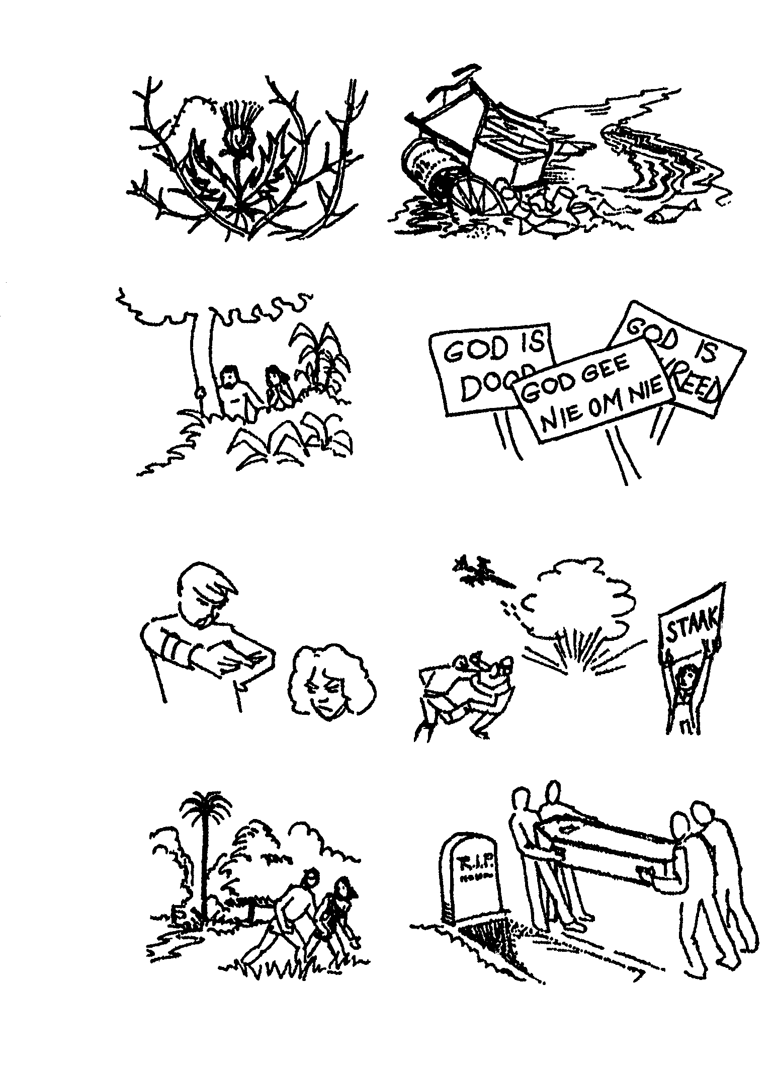

THE CONSEQUENCES OF SIN

THEN

NOW

Affects
all of
creation

Thorns and thistles
Pollution and exploitation (instead of wise use of resources)

Affects our

relationship
with God

Afraid of God
They hid from him

Propagating false

ideas about God

Affects our
relationship
with each
other

Accusing someone else of
being responsible for sin
Disputes between people
Affects our
individual
futures
Exclusion from garden

Death, corruption, exclusion
from God’s presence

7.4 Today we are living in a violent society.  - Name THREE types of violence which Christians are confronted with today.  - What should the present-day Christian’s attitude towards violence be? | (6)  (14)
[60]

QUESTION 8

- Explain how Jesus’s birth formed part of his humiliation.  8.2 The commandment “Honour your father and your mother”, guides us in our attitude to authority. Explain the meaning and significance of this commandment and particularly point out what message it has for us today. | (10)  (20)

8.3 Write notes on the following aspects of the Lord’s Prayer:  - The commencement: “Our Father in heaven …”  - The second petition: “Your Kingdom come …”  - The fourth petition: “Give us this day our daily bread …” | (10)  (10)  (10)  [60]

QUESTION 9

- The very first words of the Bible are: “In the beginning, God created the universe …” Christians believe that God created everything. Explain what Christians believe about God as Creator.  - Human beings chose to disobey God and as a result, sin entered the world. Explain God’s attitude / relationship to / with sinners.  - Mention the FOUR main characteristics of a Biblical covenant.  - Write notes on the crucifixion of Jesus.  - What is the meaning of the resurrection of Jesus to the believer? | (10)  (10)  (8)  (12)  (10)

  - Read the following article published in The Star of 17 May 1999.
Answer the questions that follow.

CALL FOR MORE OPENNESS TO HELP THOSE

INFECTED WITH HIV

BY VIVIAN WARBY

The Government and AIDS groups yesterday said that society would have to start preparing the way for more openness with regards to HIV/AIDS.  “We all see HIV/AIDS but we are afraid to call it by its name. Even today when people have openly spoken about it, they have been met with prejudice, rejection and even brutal violence,” said Mondli Gungubele, Gauteng’s Health MEC. |  | Gungubele was addressing an international candlelight memo-rial, jointly hosted in Johannes-burg by African Musicians against HIV and AIDS, the Gauteng Provincial Government and the SABC for those who have died of AIDS and those who are living with HIV/AIDS.  Less than six months ago, 36-year-old aids worker Gugu Dlamini died because she was brave enough to let the world know she was HIV-positive. |  | Dlamini, who lived in Kwa-Mancinzam near Durban, was assaulted by a mob who accused her of degrading their neighbourhood because she was HIV-positive.  “We need to support those who are HIV-positive,” said Gungubele. “We need to create an atmosphere that allows them to open up.”

9.6.1 Which one of the Ten Commandments warns against sexual dissoluteness (looseness)?  - According to the article, AIDS patients are scared to admit that they have AIDS. Why?  - Jesus teaches in Matthew that a Christian must love his fellow man the way he loves himself. In view of this instruction, how must a Christian behave towards a person with AIDS?  - Man and woman are created by God to be joined in marriage. What, according to the Bible’s teachings, are the purposes of marriage? Name TWO. | (2)  (2)  (2)  (4)  [60]

TOTAL: | 300

