GAUTENG DEPARTMENT OF EDUCATION
SENIOR CERTIFICATE EXAMINATION

ART SG
(First Paper: History of Art)

TIME: 2 hours

MARKS: 100

INSTRUCTIONS TO CANDIDATES:  The paper is divided into THREE sections.  SECTION A: INTERNATIONAL ART 1900 TO THE PRESENT  SECTION B: SOUTHERN AFRICAN ART 1900 TO THE PRESENT  SECTION C: ART APPRECIATION AND ANALYSIS | [40]  [40]  [20]  100
- Carefully read through the question paper before you select the questions you wish to answer.

- All questions must be answered in essay form. Use full sentences. Lists of facts or examples will be penalised.

- Do not repeat information or examples.

- Carefully address the requirements of each question. Questions have been set to encourage debate and discussion. Provide evidence and sound reasoning to support your viewpoint.

- Use the mark allocation as an indication of the length and scope required for each answer.

- Rule off after each answer and leave a line between subsections of each answer.

SECTION A

INTERNATIONAL ART FROM 1900 TO THE PRESENT

Answer ALL the questions in this section.

QUESTION 1

Listed below are brief clues referring to art movements and/or artists.

(a) Drippings, splattering mark making, action painting, large canvases, all over techniques.

(b) Anti-naturalism, exploring the inner world, emotive colour, colour field painting, formalism.

(c) Abstraction, simplification, two-dimensional space, non-representational colour.

(d) Photos, faithful reproductions, actuality, maximum objectivity.

(e) No use of green, absolute order, strong black lines, geometric abstract shapes.

(f) Mass media, popular consumer products, icons, billboards, bright colours.

(g) Psychic automatism, decalcomania, paranoid critical method, subconscious, soft forms, Freud.

(h) Visual animation, illusions of movement, linear quality.

(i) Anti-art, ready-mades, nihilistic, rebellion, found objects.

Select any TWO sets of clues provided above. In two separate essays, discuss the movements/artists to which the clues refer as follows:

- Write down the letters of the two clues you have chosen.  - Write down the name of the movement and artist alongside the appropriate letter.  - Write down the characteristics of the movement/artists.  - Discuss any relevant examples. 2x10 = | [20]

QUESTION 2

Sculpture in the twentieth century has changed and developed. Discuss the changes that have taken place in twentieth century sculpture, by referring to the work of ONE sculptor you have studied this year.

Provide the following:

- Name of sculptor  - Name of work/s  - Themes, techniques and media used by the sculptor  - Stylistic characteristics of specific works | [10]

QUESTION 3

There are different opinions concerning the architecture of the twentieth century. Some people believe that it is sophisticated and functional, while others see it as boring and cold. Write a short essay about the International Style architecture, in which you offer your own opinion about this style of architecture. Include the following:

- Name/s of architect/s  - Example/s of building/s  - Materials and construction methods  - Appearance of buildings  - Any other important characteristics | [10]

TOTAL FOR SECTION A: | [40]

section b

SOUTH AFRICAN ART FROM 1900 TO THE PRESENT

Answer ALL questions in this section.

QUESTION 4

South African architecture often imitates architecture in the rest of the world, and therefore reflects many similarities with American and European architecture. Many people believe that South African architecture should rather be designed to suit the climate, landscape, needs and materials of our own country.

Write down the name of a South African architect whose work you have studied and one of his/her buildings. Give attention to the following:

- Aspects of the building which are similar to the International Style architecture which you have studied.  - Aspects of the building which are characteristic of the South African environment.  - Any other important characteristics, such as materials, construction methods and appearance of the building. | [10]

QUESTION 5

Paintings can tell us about the artist who created them, as well as about the world the artist lives in. Write down the name of ONE South African painter you have studied. Give attention to the following:

- Name of at least one painting  - What the painting/s tell us about the artist  - What the paintings tell us about the world (society, culture, politics etc.) at the time the painting was created. | [10]

QUESTION 6

Art can communicate a message to the viewer. Discuss how ONE South African sculptor you have studied conveys his/her meaning and messages to his/her viewers.
Provide the following information:

- Name of the sculptor  - Name/s of work/s  - Materials and techniques used  - The meaning and message/s of his/her work | [10]

QUESTION 7

Describe the technique/s used by ONE South African printmaker (graphic artist) you have studied. Mention the following:

- Name of the printmaker (graphic artist)  - The technique/s she/he uses  - Step-by-step explanation of his/her working method  - Materials and equipment used  - Examples of his/her work and a very brief description of a work/s | [10]

TOTAL FOR SECTION B: | [40]

SECTION c

ART APPRECIATION AND ANALYSIS

QUESTION 8

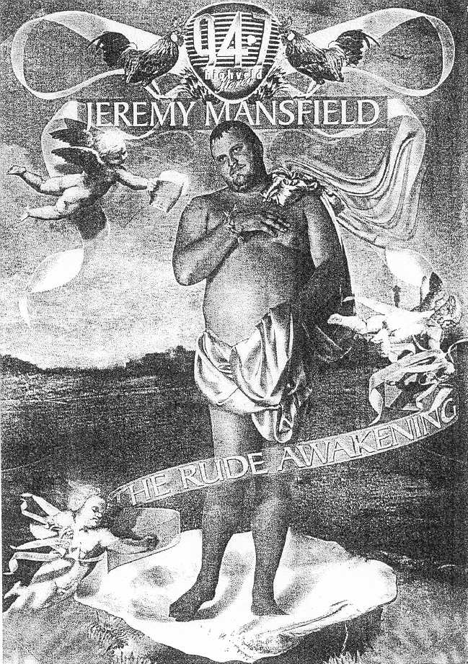

Examine the image of the poster on page 6. Write a paragraph about this work, in which you discuss the following:

- Your personal response to the image and possible reasons for this response  - The use of traditional symbols in the work (such as the drapery, shell, angels, etc.)  - The originality and value of the work  - Any other observations and comments about this work | [10]

QUESTION 9

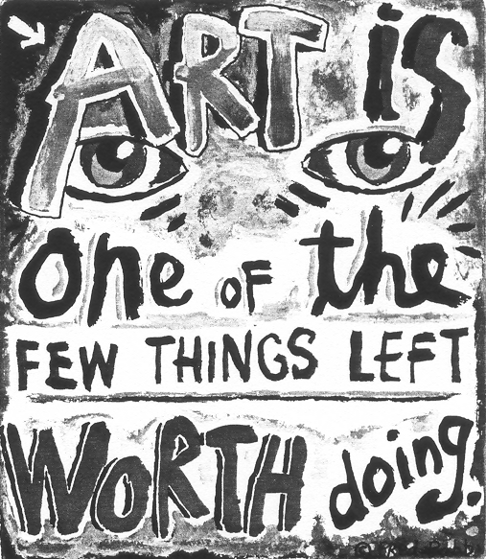

Write a paragraph explaining the value of art. Also discuss why you think it is worthwhile creating art and also provide some examples of the possible uses of art. | [10]

TOTAL FOR SECTION C: | [20]

TOTAL: | 100

