GAUTENG DEPARTMENT OF EDUCATION

SENIOR CERTIFICATE EXAMINATION

ART HG
(First Paper: HISTORY OF ART)

TIME: 3 hours

MARKS: 200
INSTRUCTIONS:

- Read through the question paper carefully before you select the questions you wish to answer.

- All answers must be written in essay form. Lists of facts or bulleted points will be penalised.

- Do not repeat information or examples.

- Study the requirements of the questions carefully. All the questions have been set to encourage debate and discussion. Provide evidence and sound reasoning to support your viewpoint.

- Use the mark allocation as an indication of the length and scope required for each question.

- Rule off after each answer and leave a line open after each subsection.

- The paper is divided into THREE sections, namely Sections A, B and C.

MARK ALLOCATION

SECTION A: International art from 1900 to the present 80

SECTION B: Southern African art from 1900 to the present 80

SECTION C: Art appreciation and analysis 40

TOTAL: 200

SECTION A

INTERNATIONAL ART FROM 1900 TO THE PRESENT

All the questions in this section are COMPULSORY.

QUESTION 1
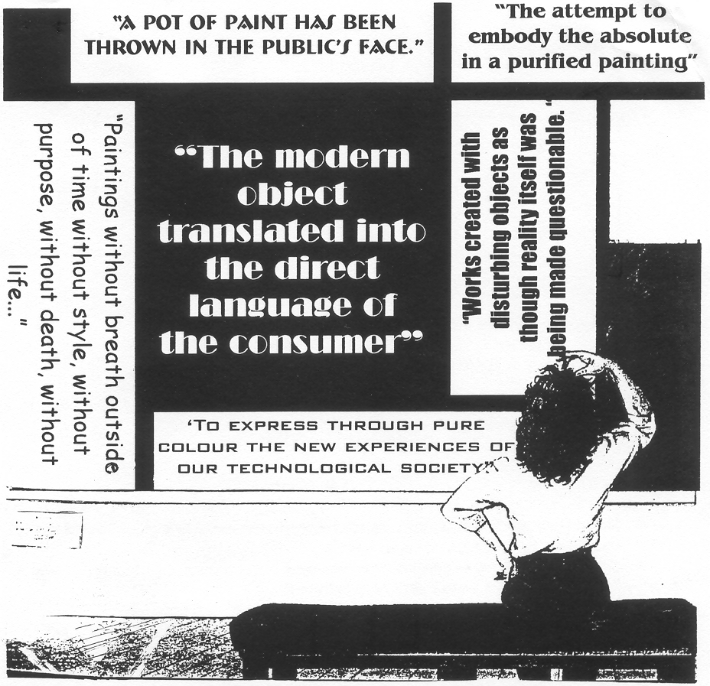
(All quotations from Farrier, J.L. 1988. Art of our century, Longman Group, UK. p. 2)

From the begining of the twentieth century to the present day, artists have explored different trends and/or concepts in their work. Some of these are depicted in the picture shown above.

Select any TWO of the statements included in the image above and write TWO separate art reviews in which you respond to each of your chosen statements. In each review refer to at least ONE twentieth century art movement and relevant artists and examples to substantiate your answer. | (40)

QUESTION 2

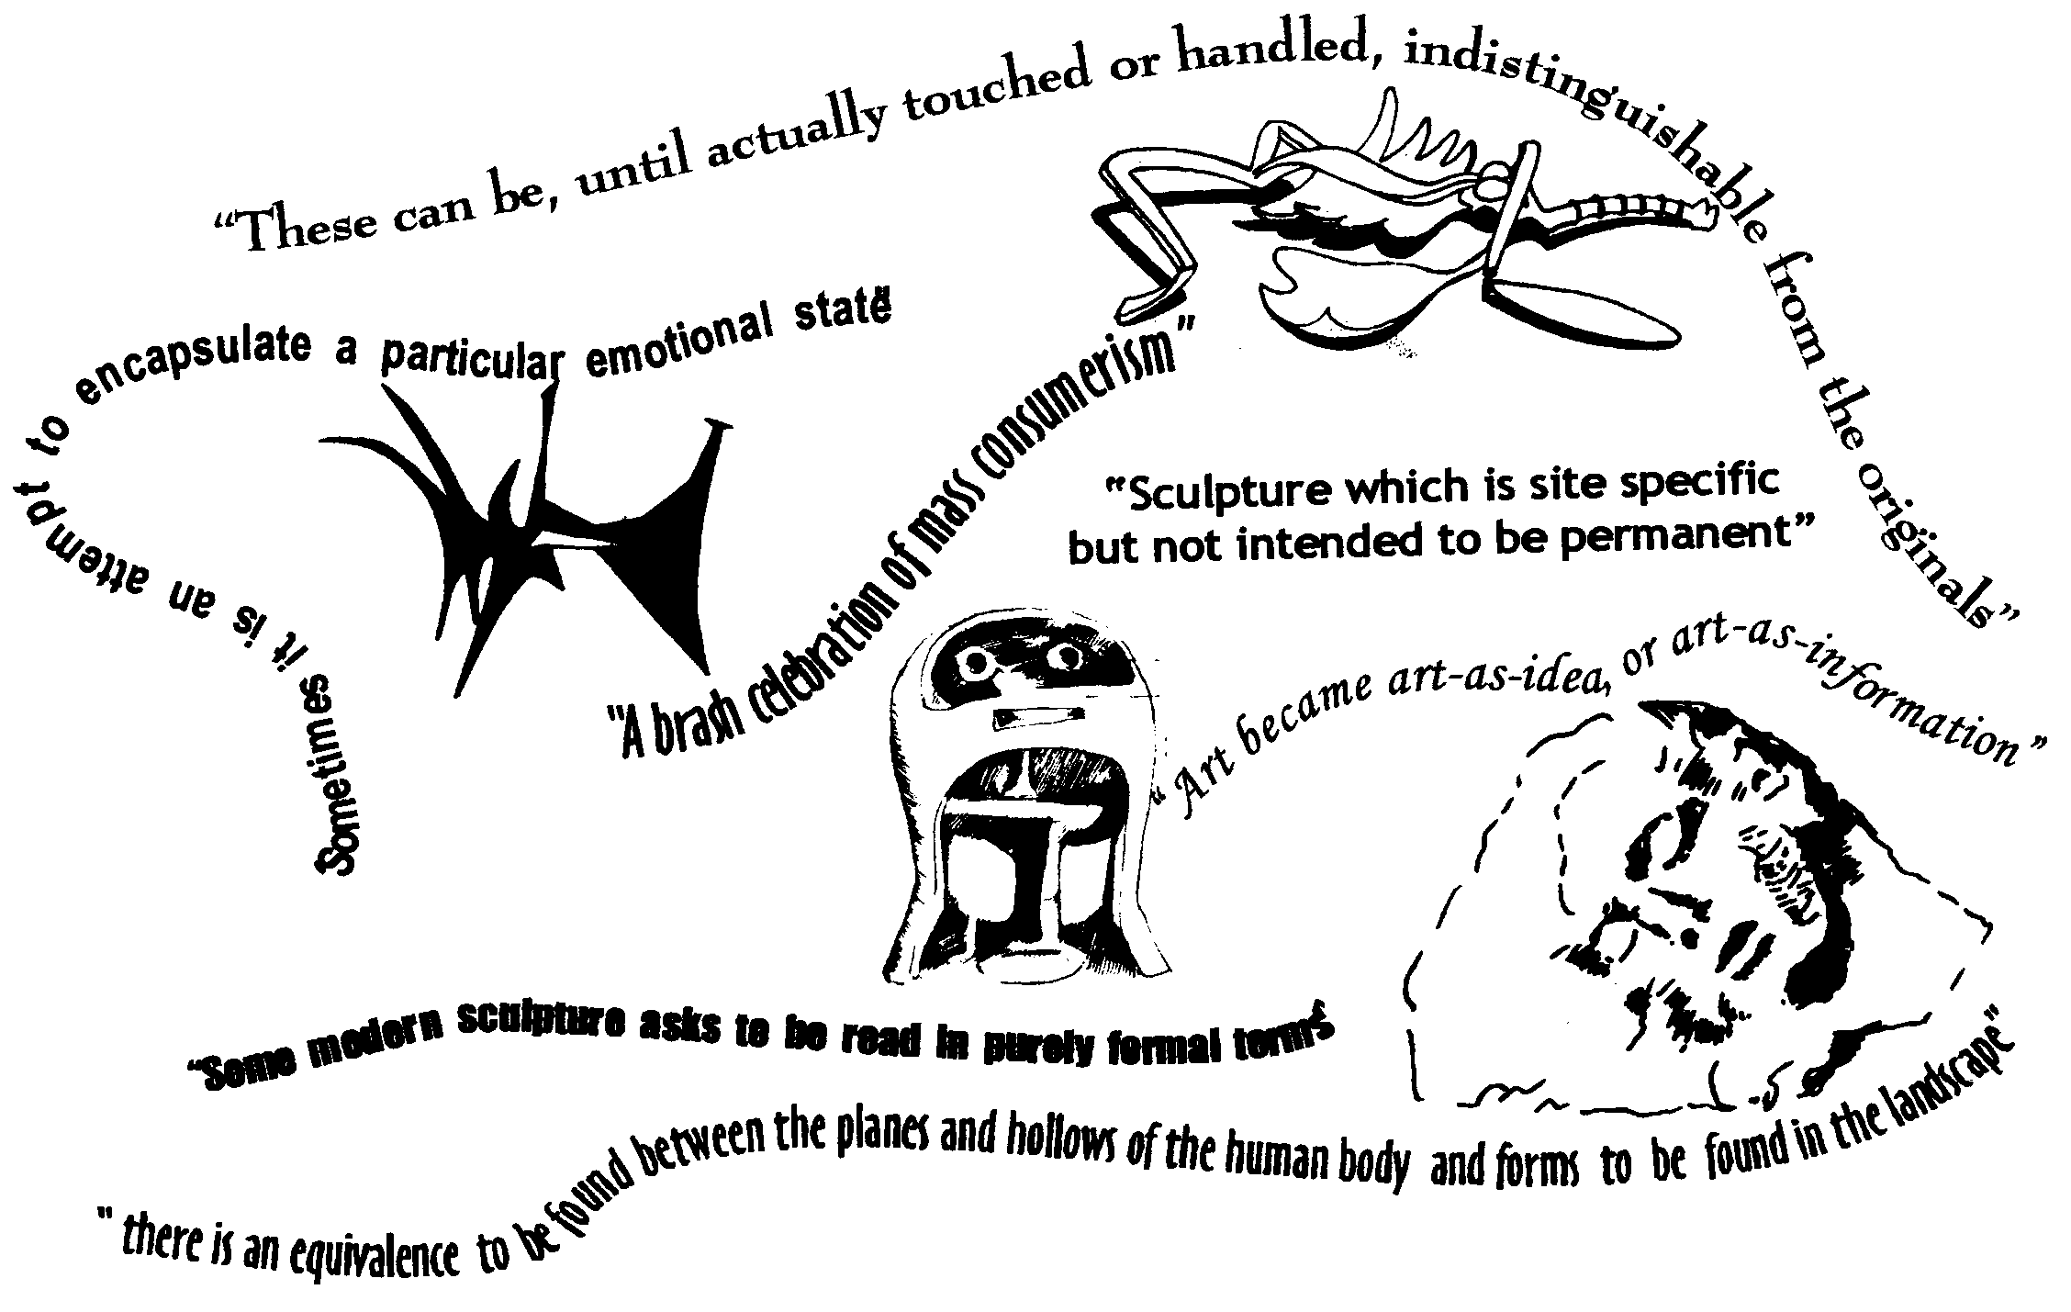

Lucie-Smith, E. 1987. Sculpture since 1945, p. 75

Choose TWO or more of the above quotes and apply them to the work of at least TWO sculptors whose work you have studied this year. At least one of your chosen sculptors must have worked after 1950.  Referring to the quotations you have chosen to respond to, write a comparative essay in which you compare the techniques, media, content and appearance of these works. Your essay should highlight the different approaches used by the sculptors. Refer to appropriate examples to substantiate your arguments.  NB Do not compare the work of the artists you have chosen in two columns, but in a continuous essay with various paragraphs. | (20)

QUESTION 3

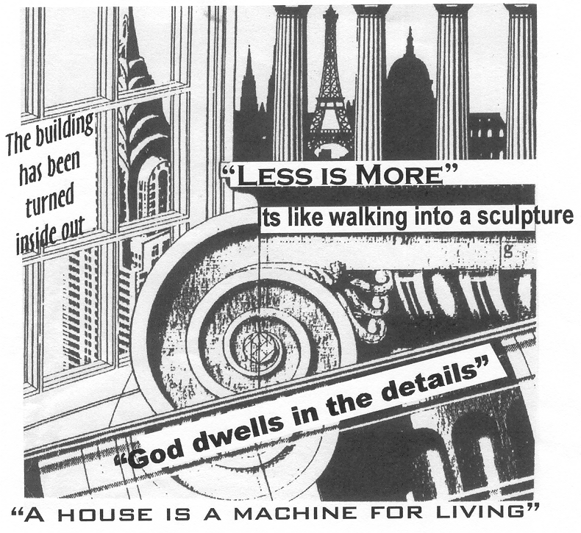

Examine the statements included in the image above. Many of these offer opposing views on the architecture of the twentieth century. Select ONE OR MORE of these statements and discuss the work of the architect(s) you have studied, with reference to relevant examples. Write down the quotation(s) you have chosen to respond to, above your discussion. | `  (20)

TOTAL FOR SECTION A: | [80]

SECTION B

SOUTHERN AFRICAN ART FROM 1900 TO THE PRESENT

Answer THREE questions from this section.
Answer Question 4.1 OR 4.2 AND Question 5 AND Question 6.1 OR 6.2.

QUESTION 4

Answer Question 4.1 OR 4.2.

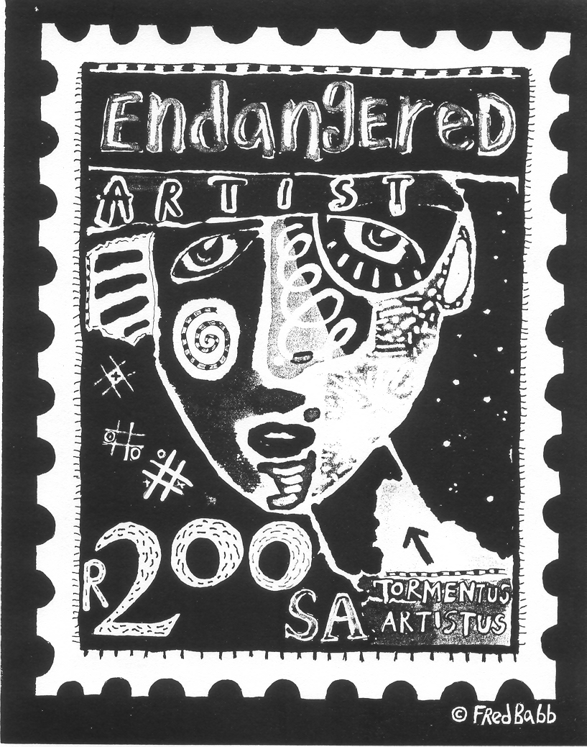

- Architecture is the art of creating space, in accordance with the environment, nature and its context. It can be described as an inhabited sculpture and as art you can walk through. However, architecture which is “South African” and which takes account of the local culture and environment, is quite rare. Many local architects tend to imitate the work of their American and European colleagues, and a truly South African architecture is becoming ‘endangered’.  With reference to the above statement and image, discuss the work of ONE South African architect. Refer to relevant examples to support your discussion. | (20)

OR

4.2 Craft artists in South Africa have been declared an ‘endangered species’ as a result of mass production, the dominance of commercialised products, and the outdated idea that ‘fine arts’ is more relevant than the crafts.  Write the introduction for an information booklet on South African crafts, in which you discuss these issues. Refer to the work, media, techniques and examples of work by at least ONE South African craftsperson. | (20)

AND

QUESTION 5
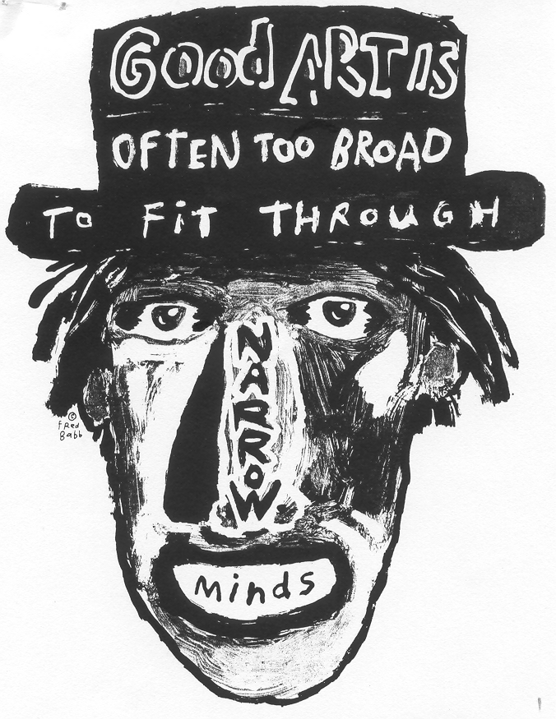

Art is about debate and confrontation, not about preconceived ideas and narrow-mindedness. Refer to the image above and discuss the work of THREE contemporary South African artists (ONE painter and ONE draughtsmen and ONE printmaker) in relation to this statement.  Describe each artist’s creative process and working methods. Refer to the themes in their work, particularly to those which provoke debate and discussion, and which challenge ‘preconceived ideas and narrow-mindedness’. | (40)

QUESTION 6

Answer Question 6.1 OR 6.2.
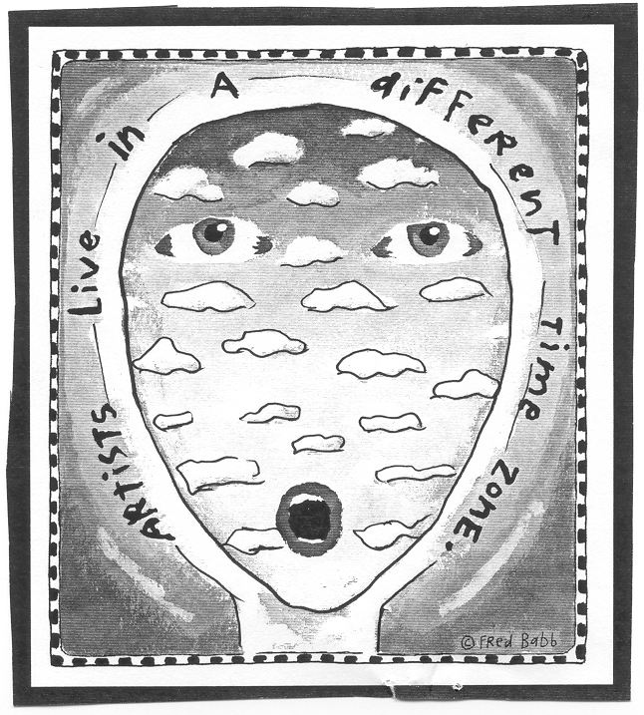

  - You are asked to write the script for a TV programme entitled ‘Everything is ART’ which focuses on the art of the future. You are to feature two artists whose work is from a different ‘time zone’, (including multimedia and/or installation and/or performance art).

Write an overview of the programme, in which you refer to some of the following tendencies, in relation to each artist:  - Assembling of installation pieces  - Environmental and site pieces  - Eclectic work/s and/or assemblage  - Conceptualism  - Electronic and/or video and/or cyber art | (20)

OR

6.2 The mobile sculpture installation of Andries Botha, entitled Conversations is a work from a different ‘time zone’ which provokes debate and interaction with the viewer. It breaks with traditional sculpture media and approaches.

Refer to the work of at least ONE contemporary South African sculptor, and explain how she/he has broken with traditional approaches and has moved to a more avant garde and futuristic approach. To substantiate your answer, refer to specific examples. | (20)

TOTAL FOR SECTION B: | [80]

SECTION C

ART APPRECIATION AND ANALYSIS

Answer ALL the questions in this section.

QUESTION 7

Art in order to be available to all, cannot be too unique or too expensive. Thus, just as modern needs for practical things must be satisfied mainly by mass production, so the multiple manufacture of inexpensive art is the inevitable answer to the new demand.

( Carpenter, P. and Graham, W. 1971. Art and ideas p. 111)

Write a motivation for an Internet website where you discuss the value of mass-produced, inexpensive art. Consider the following in your article:  - Implications of mass production and mass manufacturing  - Visual art versus functional art  - Accessibility and affordability of art for general public society  Write to: www.artforall@mweb.co.za. | (20)

QUESTION 8

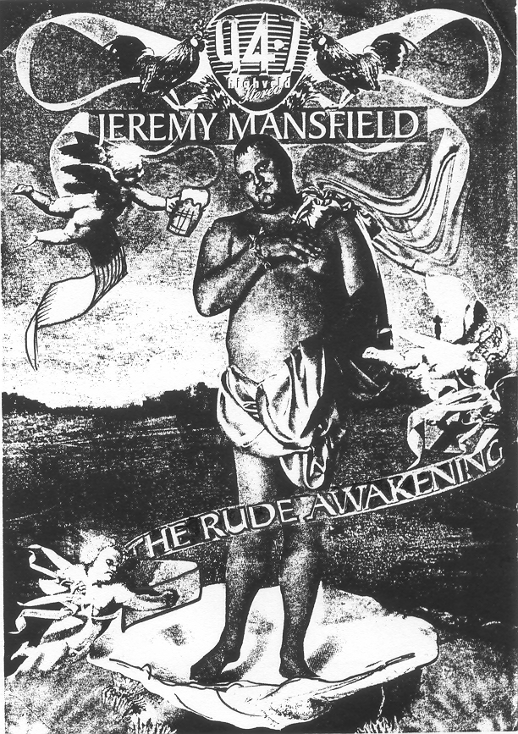

In the natural extension of the new interdependence between art and the everyday environment, there is a progressive breakdown of the division between ‘visual’ and ‘popular’ art forms.

Popular images such as posters, advertisements and billboards often make use of well-known imagery and symbols. Some consider these popular images as artwork in their own right.

Write an essay in which you discuss the following:  - The role of popular symbols in contemporary society. State whether or not they can be considered art in their right  - The uses of traditional symbols and styles in popular art forms  - The relationship between commercial/economic needs and aesthetic principles  - Discuss the image on page 10 as well as any other international or South African examples with which you may be familiar. | (20)

FOR SECTION C: | [40]

TOTAL: | 200

