GAUTENG DEPARTMENT OF EDUCATION
SENIOR CERTIFICATE EXAMINATION

ART SG
(First Paper: History of Art)

TIME: 2 hours

MARKS: 100

INSTRUCTIONS:  - Read through the whole question paper before attempting to answer any questions.  - Read the instructions for each section carefully.  * Please note that Sections A and C are COMPULSORY.  * Answer ALL questions in Sections A and C.  * You have a choice in Section B.  * You should answer a total of 8 questions.  - The last page of this examination paper (page 8) contains illustrations which pertain to Question 7 on page 7. You are advised to detach page 8 and place next to  Question 7, for easy reference.  - Use the mark and time allocation as a guide to the scope and length of your answer/s.  - Where appropriate, you may refer to the same art movements in different questions, but you may not duplicate facts about art works, artists and/or characteristics of the movement.  - Do not simply list keywords, artists and art works. Use your information in  well-constructed and continuous sentences that are pertinent to the question. Lists of  keywords will not be marked, and candidates will be penalised for not using an essay  format when required.  MARK ALLOCATION  SECTION A: International art from 1900 to the present  SECTION B: Southern African art from 1900 to the present  SECTION C: Art Appreciation and analysis  TOTAL MARKS: | (40)  (40)  (20)  100

SECTION A

THIS SECTION IS COMPULSORY

INTERNATIONAL ART FROM 1900 TO THE PRESENT
(Excluding South African Art)

Many artists work with the theme of human needs and experiences. Some artists focus on emotional expression, social, physical, physiological or practical needs.

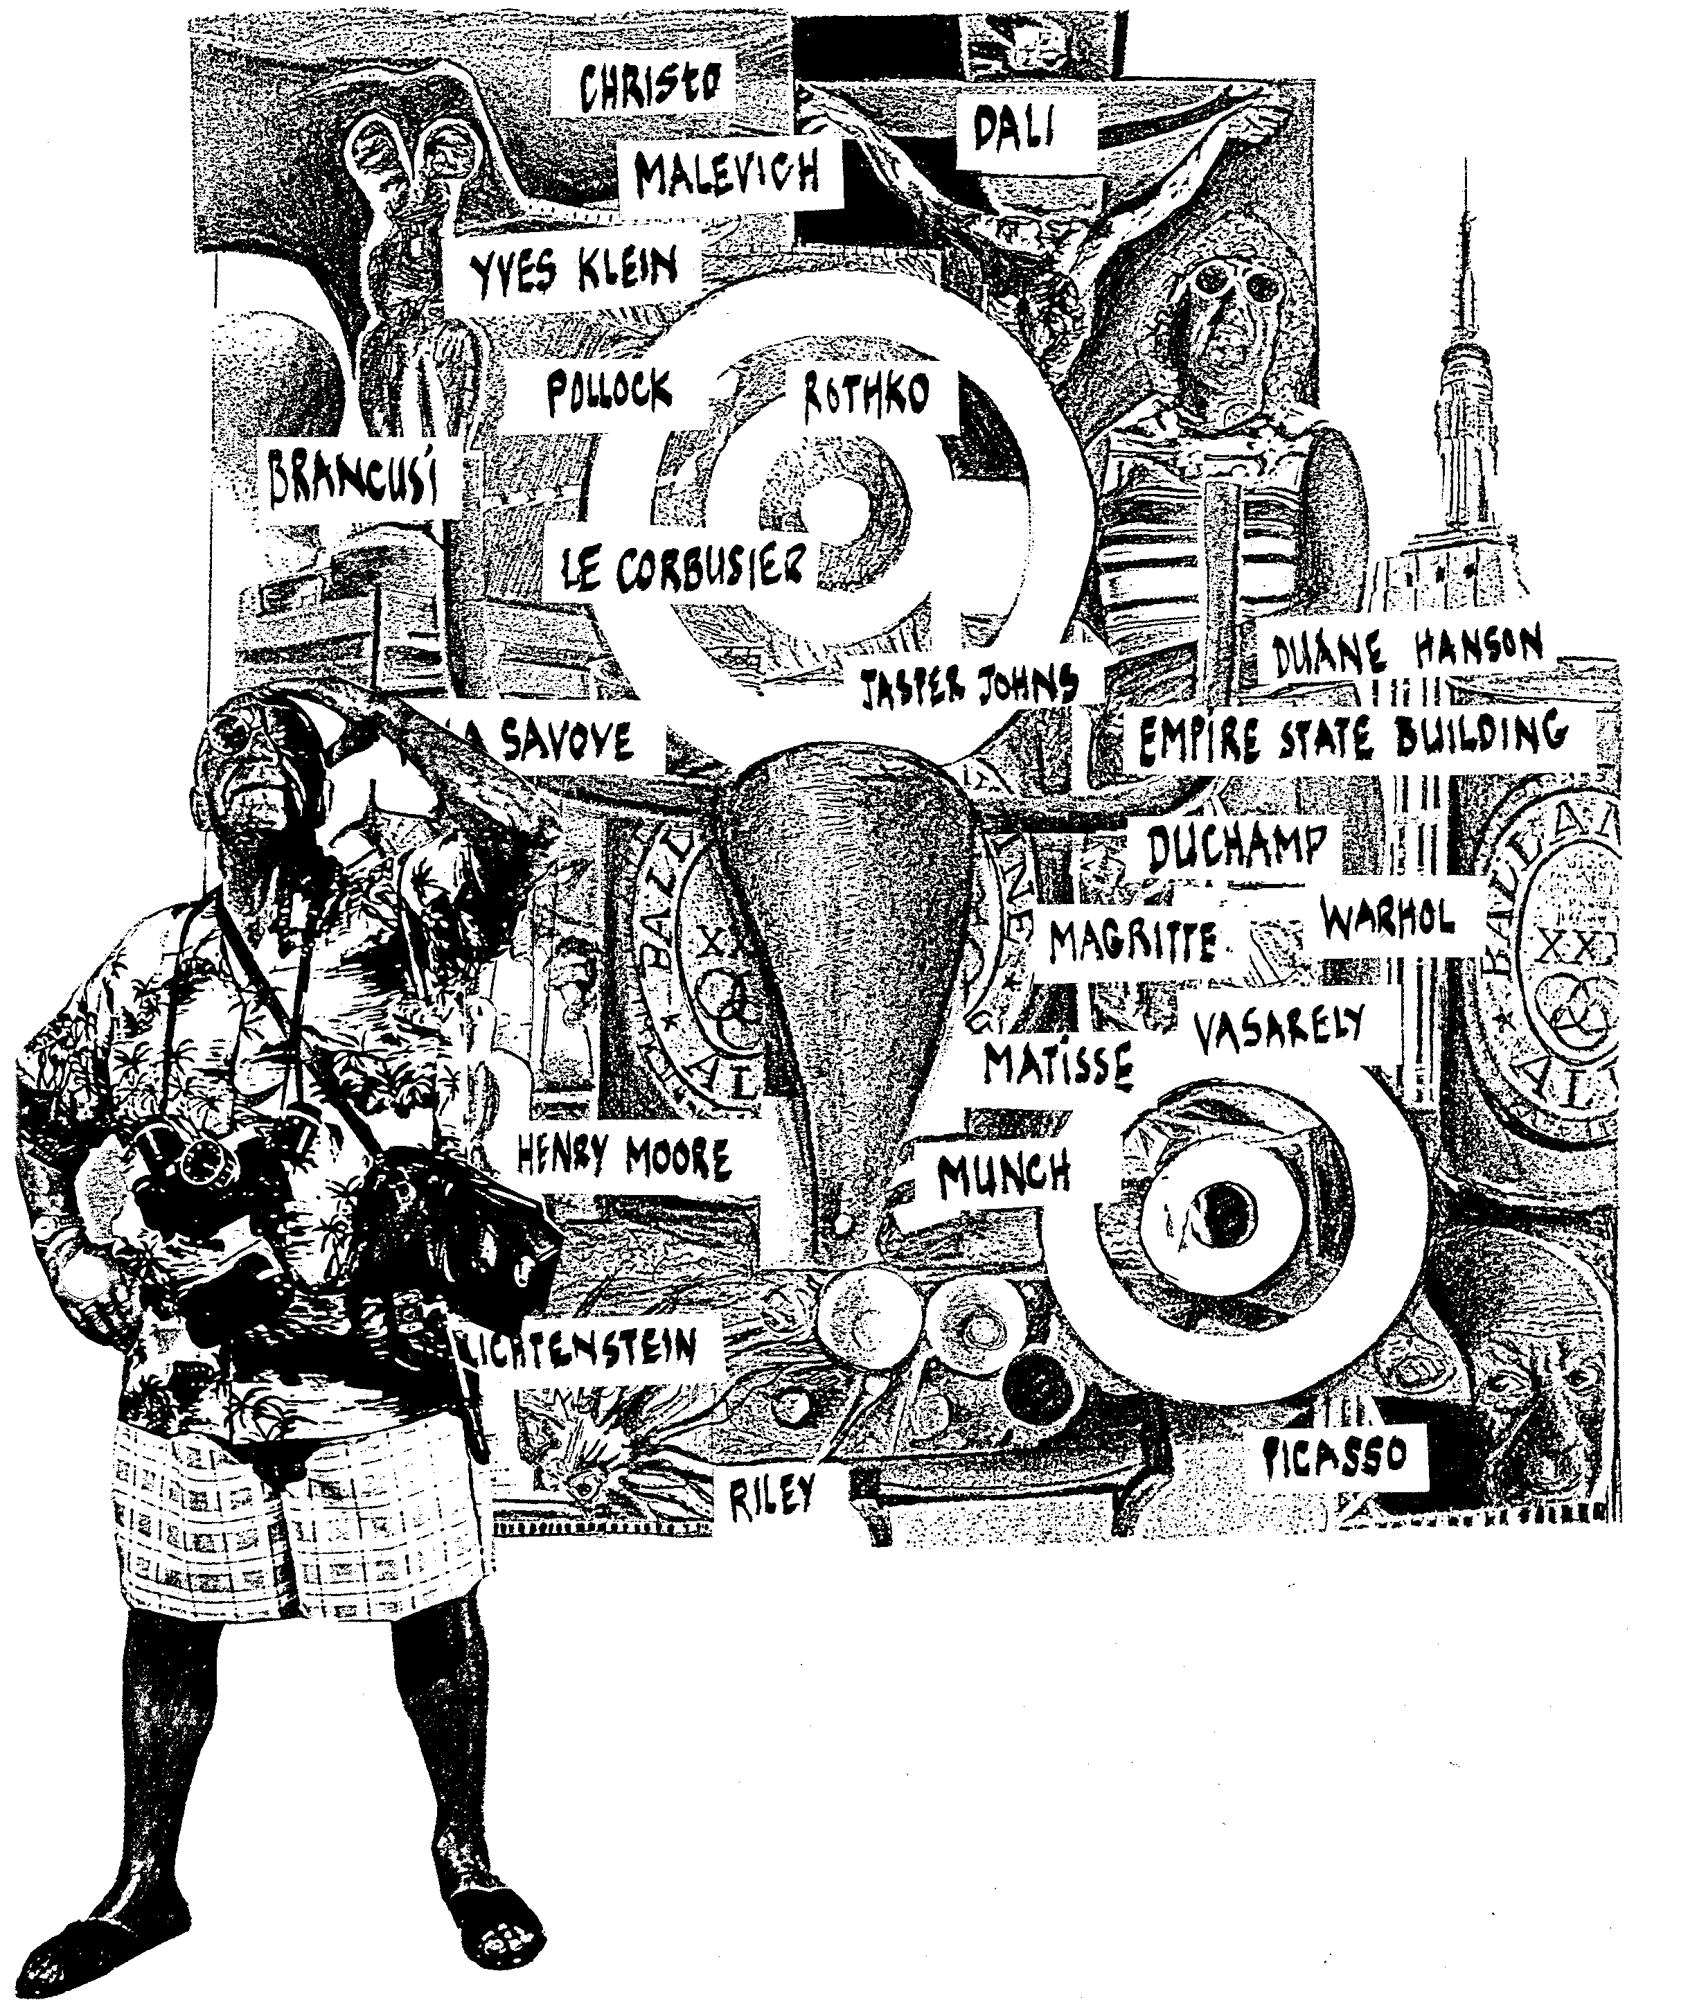

QUESTION 1  Human needs were considered in the function, proportion and designs of twentieth century international architecture.  Discuss an international building by an international architect that clearly reflects such considerations. Explain how the architect has considered human needs in the building.  AND  QUESTION 2  Many international painters express human needs and human experiences in their paintings. They often use as themes in their paintings the human body, portraits and human emotions.  Discuss TWO international artists who made use of two different approaches in their work.  For each artist provide the following information:  - Name of the artist  - Title of ONE painting  · The movement to which he/she belongs  · Characteristics of the movement and a discussion of each painting  AND  QUESTION 3  For centuries the human body or human experiences have been a source of inspiration to sculptors.  · Name ONE twentieth century international sculptor.  · Provide the title of ONE work by this sculptor.  · Discuss the sculptor’s use of materials, form and space to represent the human body or human experiences.  TOTAL FOR SECTION A: | [10]  2x10=[20]  [10]  [40]

SECTION B  SOUTHERN AFRICAN ART FROM 1900 TO THE PRESENT  Answer Question 4.1 or 4.2 and both Question 5 and Question 6.  QUESTION 4  Answer Question 4.1 OR Question 4.2.  - You are invited to present a lecture on South African painting at an international congress. Explain the influence of historic and/or political events on South African artists by referring to artworks by TWO South African painters.  Discuss the work of each artist separately and use the following points to prepare your lecture:  4.1.1 The name of the artist  4.1.2 Materials and techniques  4.1.3 Historic/political influences and symbolic meanings  4.1.4 Stylistic characteristics of the work of each artist  OR  - The art museum appoints you as the curator for the new drawing and printmaking exhibition. Write the introduction for the catalogue of the exhibition and refer to ONE South African draughtsperson and ONE South African printmaker. Discuss ONE artwork by each artist by referring to:  - The name of the artist  - Materials and techniques  - Discussion of the artworks  - Discussion of the symbolic meaning(s)  ‘Draughtsperson’ refers to an artist who specialises in drawing.  AND | 2x1=(2)  2x3=(6)  2x3=(6)  2x3=(6)  [20]  2x10=[20]

QUESTION 5  COMPULSORY  It has been claimed that art images can be evoked out of our dreams and memories. These can be found in works of a realistic; romantic; abstract or expressionistic nature or style. Their symbolic meaning can be shown through colours, textures and forms and be portrayed in different techniques and styles.  With reference to this statement, discuss the work of ONE South African sculptor or craftsperson that you have studied.  · Name the artist and ONE artwork.  · Describe the use of materials.  · Explain the theme and the deeper meaning of the work.  AND  QUESTION 6  COMPULSORY  Discuss a public building of ONE architect whose work you have studied, and refer to the following:  6.1 The name of the building  6.2 The architect  6.3 The location of the building  6.4 Functionalism  6.5 Construction methods and materials  6.6 Interior and exterior decoration  TOTAL FOR SECTION B: | [10]  (1)  (1)  (1)  (2)  (3)  (2)  [10]  [40]

SECTION C  ART APPRECIATION AND ANALYSIS  COMPULSORY  Answer Question 7 AND Question 8.  QUESTION 7  Some people feel that unless an artwork is completely original (not reproduced or mass-produced, for instance) and signed by the artist it cannot be regarded as an important artwork.  There are some works which are mass produced such as prints, cartoons or posters which can also be seen as artworks.  With reference to this statement compare and discuss the value of popular art as compared to fine art, by referring to the cartoon and lino print.  Study the examples shown on page 8. You may detach page 8 and place it next to page 7, for easy reference.  Discuss each artwork under the following headings:  - The art principles and art elements used  7.2 Do you think that these works could be seen as examples of original and genuine art? Substantiate your answer.  AND | (5)  (5)  [10]

QUESTION 8  Write a letter to an Art gallery or art shop to apply for a job as an assistant. Convince the gallery that you are the best person for the job and elaborate on your skills and abilities.  TOTAL FOR SECTION C:  TOTAL: | [10]  [20]  [100]

Please detach this page and use it to answer Question 7/Maak asseblief hierdie bladsy los en gebruik dit om Vraag 7 te beantwoord.

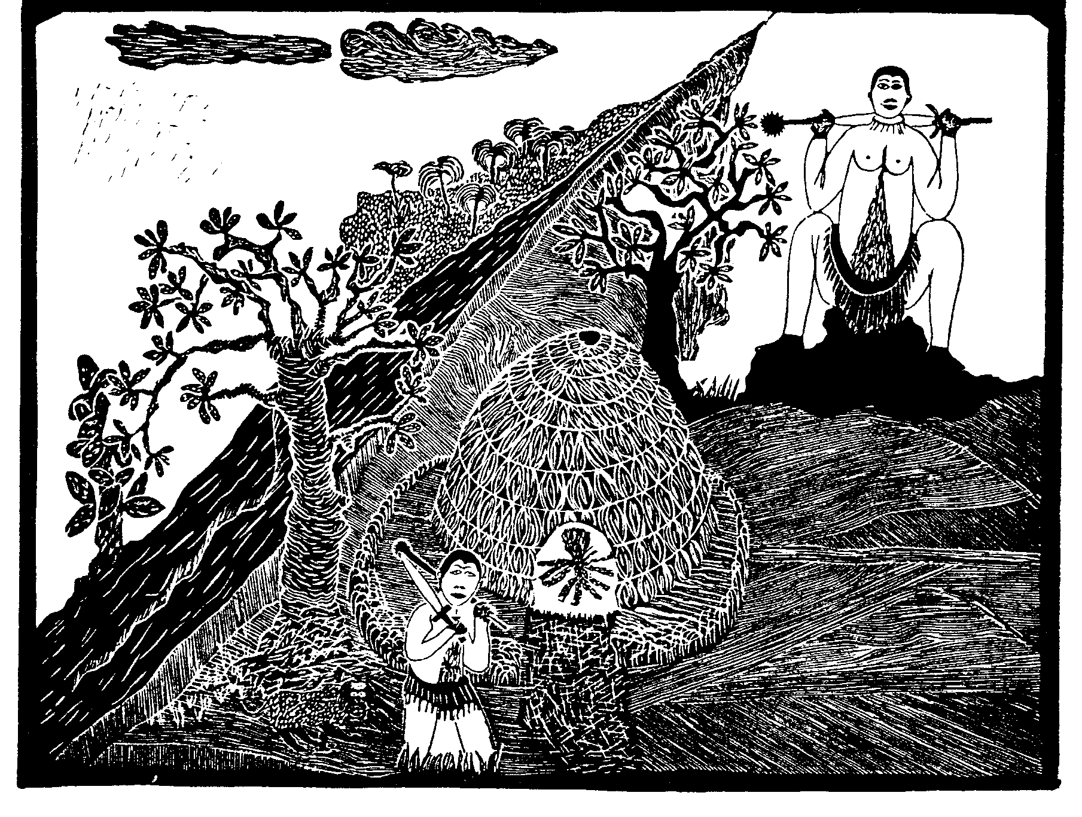
Sandile Goje Circumcision School (1996) linocut

