GAUTENG DEPARTMENT OF EDUCATION

SENIOR CERTIFICATE EXAMINATION

ART SG
(First Paper : History of Art)

TIME: 2 hours

MARKS: 100

INSTRUCTIONS:

- Read through the entire question paper before attempting to answer any questions.

- Read the instructions for each question carefully.

- Use the mark and time allocation as a guide to the scope and length of your answers.

- Where appropriate, you may refer to the same art movements in different questions, but you may not duplicate facts about artworks, artists and/or characteristics of the movement.

- Do not simply list keywords, artists and artworks. Use your information in well-constructed and continuous sentences that are pertinent to the given task. Lists of keywords will not be marked and candidates will be penalised for not using essay format when required.

MARK ALLOCATION:

SECTION A: International art from 1900 to the present 40
SECTION B: Southern African art from 1900 to the present 40
SECTION C: Analysis and appreciation 20

TOTAL: 100

SECTION A

INTERNATIONAL ART FROM 1900 TO THE PRESENT
(Excluding South African art)

THIS SECTION IS COMPULSORY

All questions must be answered.

You are requested to put an art exhibition together in the exhibition space illustrated below, that will best represent an overview of the art of the twentieth century.

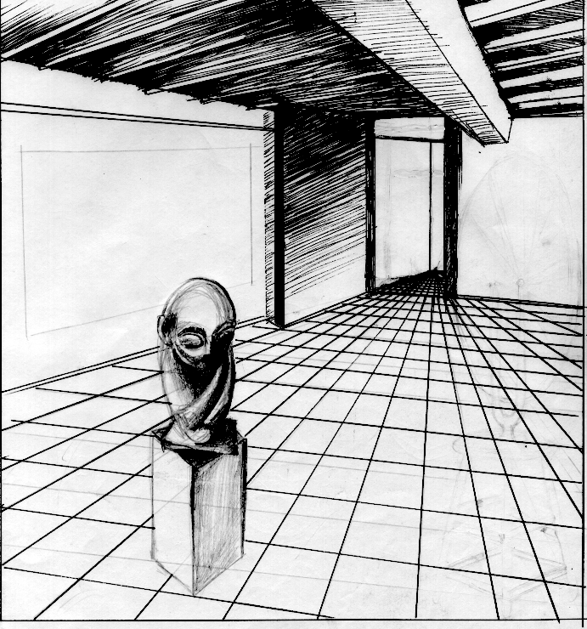

Consider the following:  QUESTION 1  Choose an important twentieth century building in which you could visualise the exhibition space reproduced above.  - Provide the name of the architect and a suitable building for this exhibition.  - Explain why you think this building is an excellent example of the development of twentieth century architecture, and why it is appropriate for the exhibition.  - List the most important characteristics and architectural features of twentieth century architecture, represented by this architect and this building.  AND  QUESTION 2  You have to choose two suitable international paintings from two different movements for this exhibition space.  - Provide the titles of the works, the names of the painters and the names of the movements, for each of these individual paintings.  2x3 =  - Explain the importance of each of the chosen paintings for the twentieth  century, and discuss the characteristics of each movement to which they belong.  2x7 =  AND  QUESTION 3  TWO appropriate international sculptures by different sculptors must be part of this exhibition.  - Which international sculptures would you choose? Write down the titles of the works and the names of both sculptors.  2x2 =  - Motivate your choices and refer to materials and techniques used by the different sculptors.  2x3 =  Total for Section A: | [10]  (6)  (14)  [20]  (4)  (6)  [10]  [40]

SECTION B  SOUTHERN AFRICAN ART FROM 1900 TO THE PRESENT  Answer Question 4 AND Question 5 AND Question 6.1 OR Question 6.2 AND Question 7.1 OR Question 7.2. (Answer Four questions in total from this section.)  QUESTION 4  COMPULSORY QUESTION  Artworks can be seen as mirrors of society and can refer to politics, religion and the social environment.  Discuss the work of TWO South African painters, whose work reflects our society today. Describe the work of each painter separately by using the following headings:  - Name of each artist  - The materials and techniques used by the artist  - The subjects and/or meaning of the work  - The individual style and the significance of their work  - Name ONE painting as an example of each artist  2x5 =  AND  QUESTION 5  COMPULSORY QUESTION  You were asked to write a review on the works which were created during the apartheid era by ONE draughtsperson or ONE printmaking artist. Who would you choose?  Consider the following aspects:  - Write down the name of the artist.  - Provide the title of one work by the artist.  - Discuss the use of materials and techniques in the artwork.  - Discuss the symbolism of the work.  * ‘Draughtsperson’ refers to an artist who specialises in drawing  AND  QUESTION 6  Answer Question 6.1 OR Question 6.2.  - As the judge of a contemporary (modern) South African sculpture competition, you may choose only ONE prizewinner.  - Which contemporary sculptor would you choose?  - Which of his/her sculptures should win this competition? |  | (10)  [10]  [10]  (1)  (1)
- Discuss the use of materials and techniques.  - Describe the sculpture and explain the possible symbolic theme and meaning.  OR  - You are asked to choose ONE South African craftsperson to represent South Africa at an international show.  - Write down the name of the craftsperson.  - Give an example of a functional or a non functional work.  - Discuss the use of materials and techniques.  - Motivate why you have chosen the work.  AND  QUESTION 7  Answer Question 7.1 OR Question 7.2.  - You have recently spent a day at a well-known South African public building or an entertainment centre. Write a letter to the Tourism Board to advertise the building. State the following in your letter:  - The name of the building  - The architect/s  - Describe the function of the building.  - Architectural style and decoration  - Building materials and construction methods  - Other relevant information  OR  - In future there will be even more pressure or architects to plan low cost housing for South Africa. Discuss the type of buildings/houses and material, which would be suitable for this housing project.  TOTAL FOR SECTION B: | (3)  (5)  [10]  (1)  (1)  (4)  (4)  [10]  (1)  (1)  (1)  (2)  (2)  (3)  [10]  [10]  [40]

SECTION C  Artist: John Roome  Clause 9: Assembly, demonstration and petition  Title: Peaceful protest  Medium: Linocut  Date: 1996  Dimensions: 570 x 377  ART APPRECIATION AND ANALYSIS  COMPULSORY  Answer both Question 8 AND Question 9.  QUESTION 8  Some South African artists have been using their art to spread social and political messages. Recently original prints were published in an “Images of Human Rights” portfolio, as illustrations for the new South African Bill of Human Rights.  Peaceful Protest by John Roome is a linocut, which refers to human rights. Study the example and discuss:  - The art principles used  - The elements of art (line, tone, texture, shape, form etc.)  - The composition  - The techniques used  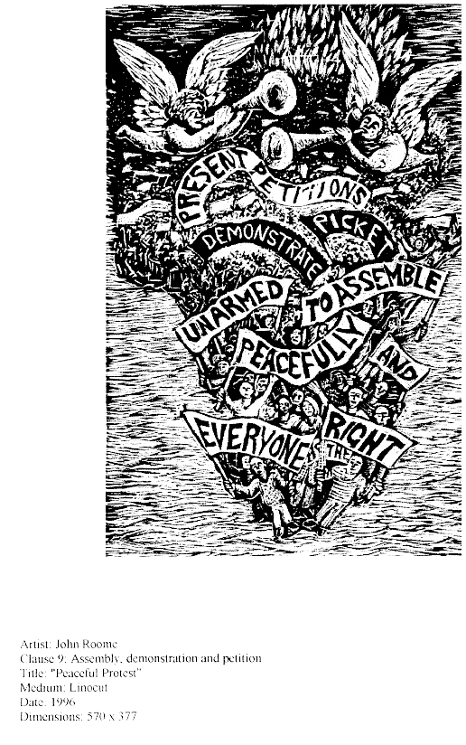 | [10]

QUESTION 9  You wish to apply for admission to a tertiary institution (e.g. university or college) as a future art student.  You must compile a portfolio of your work for selection at the institution.  Discuss what you think would be essential in such a portfolio, and motivate your answer.  Total for Section C:  TOTAL: | (10)  [20]  100

