GAUTENG DEPARTMENT OF EDUCATION

SENIOR CERTIFICATE EXAMINATION

ART HG
(First Paper: History of Art)

TIME: 3 hours

MARKS: 200

INSTRUCTIONS:

- Read through the whole question paper before attempting to answer any questions.

- Read the instructions for each question carefully.

- Use the mark and time allocation as a guide to the scope and length of your answer.

- Where appropriate, you may refer to the same art movements in different questions, but you may not duplicate facts about artworks, artists and/or characteristics of the movement.

- Do not simply list keywords, artists and artworks. Use your information in well-constructed and continuous sentences that are pertinent to the question. Lists of keywords will not be marked, and you will be penalised for not using an essay format when required.

MARK ALLOCATION

SECTION A: International art from 1900 to the present 80

SECTION B: Southern African art from 1900 to the present 80

SECTION C: ART appreciation and analysis 40

TOTAL: 200

SECTION A

INTERNATIONAL ART FROM 1900 – TO THE PRESENT
(EXCLUDING S.A. ART)

THIS SECTION IS COMPULSORY

Answer ALL questions in this section.

“There are other issues too, which call into question the role of the arts themselves in a world seething with change. None of the issues is entirely new to the century. The relationship of the arts with politics, with social action, with technology and the environment are all recurring problems for each artist to solve.”

The Arts– A history of expression of the 20th Century
Tamplin, R (1994).

All artists are continually addressing human needs and experiences. Some focus on emotional expression, social, physical, physiological or practical needs.

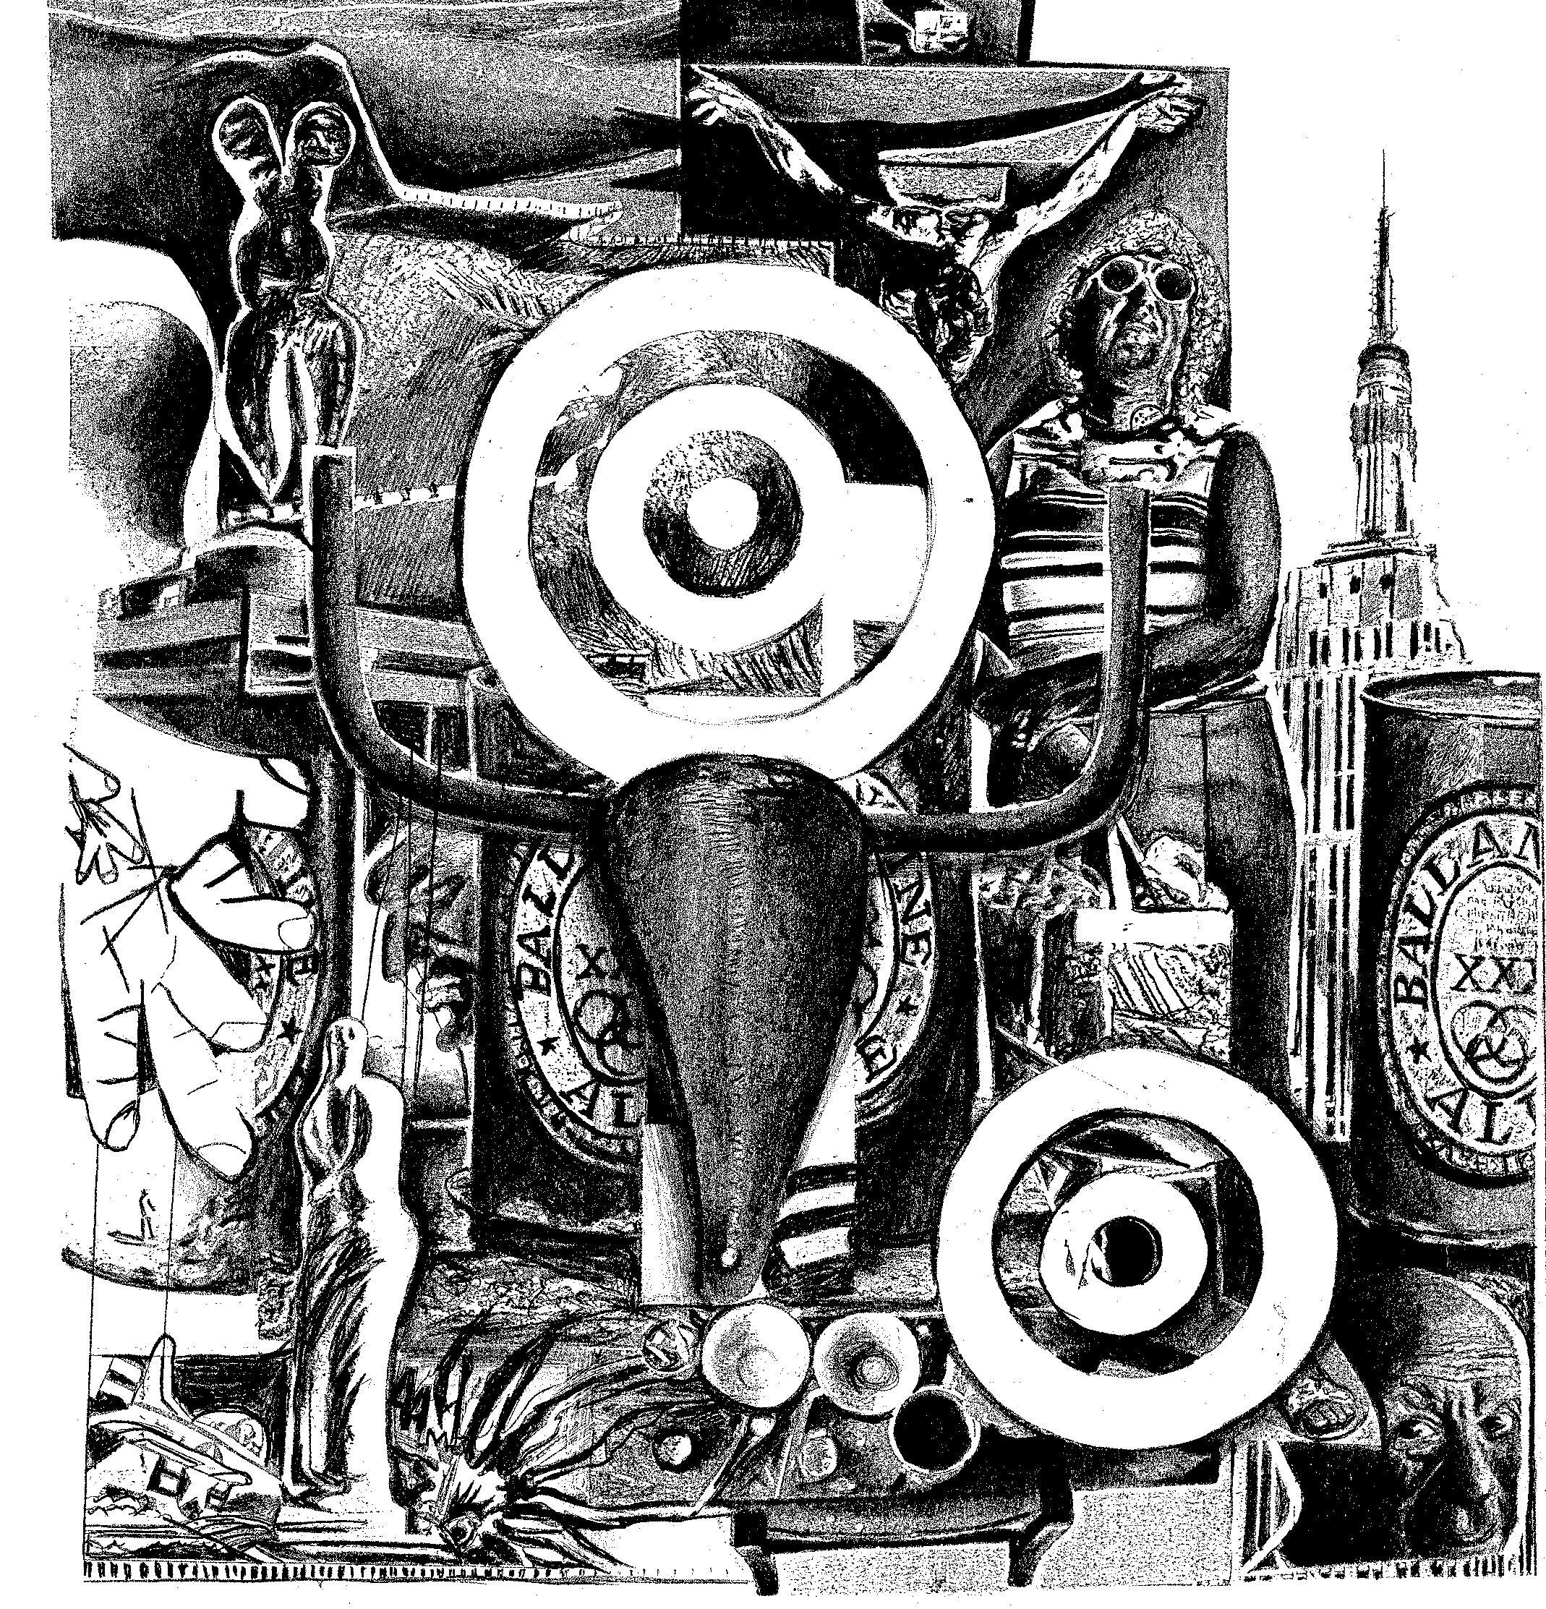

QUESTION 1  The function, proportion and design of twentieth century architecture, focus on the human being. Architecture considers human physical form and all human needs. Which architect in your opinion, was successful in addressing human needs? Refer also to TWO relevant buildings. | [20]

AND

QUESTION 2  Many painters try to express human experiences – to go beyond simply recording visual appearances. In the light of this statement, analyse FIVE different paintings from FIVE different movements. | [30]

AND

QUESTION 3  The human form has been a source of inspiration for centuries. Discuss TWO twentieth century sculptors who draw inspiration from the human form and/or human experiences. Discuss relevant examples to substantiate your choices. | [20]

AND

QUESTION 4  Functional design regards the practical needs of people, that is, the interaction of people with the world around them. Discuss an example of functional design that meets these requirements. | [10]

TOTAL FOR SECTION A: | [80]

SECTION B

SOUTHERN AFRICAN ART FROM 1900 TO THE PRESENT

Answer Question 5 AND Question 6 AND Question 7.

OR
Answer Question 8 AND Question 9 AND Question 10.
A total of THREE questions from this section must be answered.

QUESTION 5  You are invited to an interview, which forms part of the selection process for the admission to study art at a tertiary institution. Your knowledge and insight about contemporary South African artists will be tested in a speech with the title “Influences of our indigenous heritage and our social context on South African Art”. Refer to the works of THREE South African artists of your choice (ONE painter; ONE sculptor and ONE architect). | [40]

AND

QUESTION 6  You are responsible for the compilation of a prestige art calendar with the theme “Transformation in South African drawing and graphic printmaking”. It is your task to select TWO artists (ONE draughts person and ONE graphic printmaker) and to present their work to a panel of judges. Discuss relevant examples of each artist’s work and refer to the creative process and working methods, in support of their inclusion in the calendar.  ∗ The term “draughtsperson” refers to an artist who specialises in drawing | [20]

AND

QUESTION 7

“South African ceramics have gone through an extremely creative period over the past decade. The result is contemporary ceramics that are more than consumer items, they are artwork in themselves!” (Cruise, W. (1996) Contemporary South African Ceramics, cover)

This statement refers to South African craftpersons. The question is whether the crafts only have a functional value?  With reference to the above, write an essay about the work of ONE South African ceramic artist or craftsperson. Substantiate your answer by referring to specific artworks. | [20]

OR

QUESTION 8

In the Foreword of the catalogue for the Electra exhibition, which took place in 1993 in the Museé d’ Art della Ville in Paris, Frank Popper claimed that “the art of the electronic age is a global phenomenon in which Science and technology has converged”.

In your opinion, how relevant, do you think, is this statement in relation to South African art of the twenty-first century? Refer to the work of South African artists (ONE painter; ONE draughts person and ONE graphic printmaker).

∗ The term “draughtsperson” refers to an artist who specialises in drawing. | [40]

AND

QUESTION 9  As a well known artist’s agent, you receive a request from a well known company to select artworks for the foyer of the company’s head office in Sandton.  Write a motivation recommending the work of TWO South African artists (TWO sculptors OR ONE sculptor AND ONE craftsperson) and discuss their work with reference to:  - The social context in which it was created  - Themes and symbolic meanings  - Materials and construction methods | [20]

AND

QUESTION 10  You have been given a blank cheque and limitless resources to redesign your own school.  Write a proposal to your school’s Governing body in which you incorporate some of the main architectural ideas of Post-Modernism. Refer to relevant South African architects and examples of their work to support your proposals.  TOTAL FOR SECTION B: | [20]  [80]

SECTION C

ART APPRECIATION AND ANALYSIS

This section is compulsory. Both questions must be answered.

QUESTION 11

In The Art Paper No 3 of 1998 p.7, the following extract from an article on art therapy by Ruth Russel Pein was published.

“A safe, confidential and non-judgemental ‘space’ is pivotal to the process of art therapy. In this, the therapist will encourage the client to experience the healing power of creativity through the use of mark and image-making with a variety of materials. It is this experience of self expression that will promote healing rather than diagnosis of the artwork.”

Art has the ability to develop self esteem and promote healing.

If you were to use art as part of an Aids support programme:  - How would you use art to advertise and market the programme?  - In what ways would you use art in presentations to the public on the issues of Aids? Discuss performance, installations and video art forms  or any other relevant or appropriate art forms.  What other roles can art play as a tool for self expression and social commentary in South Africa today? | [25]

QUESTION 12

What is your personal opinion on the “use, abuse and misuse” of traditional and acknowledged works as popular icons in the commercial market? Refer to the illustrated examples.

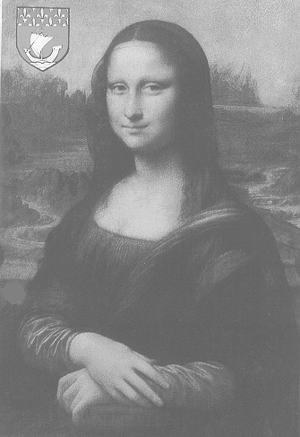
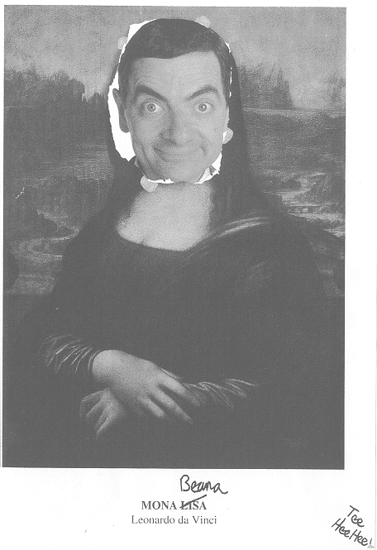

TOTAL FOR SECTION C:  TOTAL: | [15]  [40]  200

