GAUTENG DEPARTMENT OF EDUCATION

SENIOR CERTIFICATE EXAMINATION

ART HG
(First Paper: History of Art)

TIME: 3 hours

MARKS: 200

INSTRUCTIONS:

- Read through the whole question paper before attempting to answer any questions.

- Read the instructions for each question carefully.

- Use the mark and time allocation as a guide to the scope and length of your answers.

- Where appropriate, you may refer to the same art movements in different questions, but you may not duplicate facts about artworks, artists and/or characteristics of the movement.

- Do not simply list keywords, artists and artworks. Use your information in well constructed and continuous sentences that are pertinent to the given task. Lists of keywords will not be marked, and you will be penalised for not using an essay format when required.

MARK ALLOCATION

SECTION A: International art from 1900 to the present 80

SECTION B: Southern African art from 1900 to the present 80

SECTION C: Art appreciation and analysis 40

TOTAL: 200

SECTION A

INTERNATIONAL ART FROM 1900 TO THE PRESENT
(EXCLUDING S.A. ART)

THIS SECTION IS COMPULSORY

Answer ALL the questions in this section.

You have been approached to curate an international retrospective art exhibition. The purpose of the exhibition is to present an overview of the art of the twentieth century.

Below is an exhibition space you can use or which you, as the curator, may adapt, to suit your vision for such an exhibition.

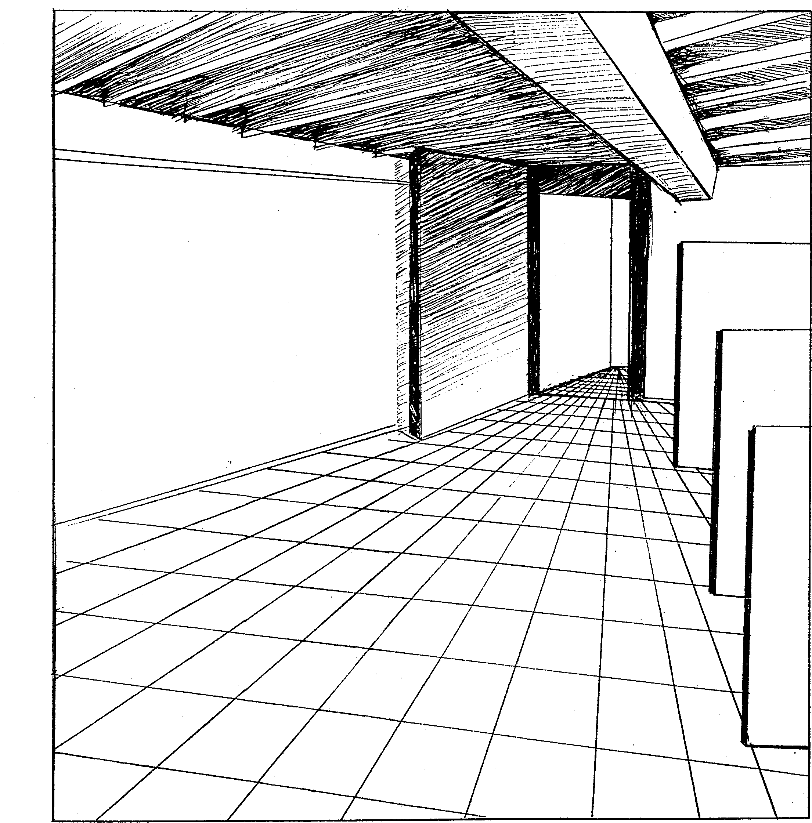

QUESTION 1  If you had a choice of architects to design a building for the exhibition space AND were to choose a relevant building by this architect to house the exhibition, which architect and building would you choose? Motivate your choice. Consider an architect whose use of light and space is appropriate for the exhibition space. | [20]

AND

QUESTION 2  As the curator you have to select FIVE paintings from five different movements that you consider represent the best chronological overview of twentieth century painting. Write an opening speech for the exhibition in which you motivate your choice of works. | [30]

AND

QUESTION 3  Select TWO sculptures with different stylistic approaches for inclusion in the exhibition. Discuss why you consider these sculptures to be very important pieces from the twentieth century. | [20]

AND

QUESTION 4  You have additional open space available for ONE artwork. You may display ONE example of Conceptual Art, or Applied Art, or Installation Art, or any other appropriate art form that you consider to be essential for inclusion in a survey of twentieth century art. Motivate your choice.  Do not repeat any works or movements from Questions 1 – 3 above. | [10]

TOTAL FOR SECTION A: | [80]

SECTION B

SOUTHERN AFRICAN ART FROM 1900 TO THE PRESENT

Answer a total of THREE questions from this section.

Please note that there is a choice within each of Questions 5, 6 and 7.

QUESTION 5  Answer Question 5.1 OR 5.2.  - Dr Joseph Sherman said: “Modern South African art is inaccessible for the ordinary person”. (Sherman, J. 1995. Three Sculptors, three readers, Jhb)  Since this statement was made, a local television station has contacted you to become involved in the production of a television program about Avante Garde (contemporary) South African art.  It is your job to produce a documentary program about the creative process in alternative art forms, with the theme “Abstraction versus reality”.  Write notes for this program in which you explain how the borders between painting; graphic art; drawing; video and computer art vanish in a multimedia world where all social and political traditions are thrown overboard. Refer to at least THREE South African artists and specific artworks. | [40]

OR

The MTN Art and Culture Institute’s art collection entitled “The road ahead – a National Heritage” reflects South Africa’s historic divided past and the multi-layered nature of our contemporary art.  You are appointed by MTN as the Media and Public liaison officer, and it is your main task to research contemporary South African art. Your other tasks include educational lectures, guided tours and workshops for the public, as well as loading the information onto the Internet.  Prepare a lecture in which you compare the work of THREE South African artists (ONE painter; ONE drawer and ONE graphic printmaker). Consider the use of media and the working methods, as well as cultural and socio-political themes in the examples of their art. Write to mtn art @ mtnartinst.com. | [40]

AND

QUESTION 6  Answer Question 6.1 OR 6.2.  - Sculptures are the summary of monumental metaphors; mysterious forms; spatial reclamation; abstract mechanical constructions; political ideologies; social commentary and different materials and techniques, in a universal three dimensional arena.  With reference to this statement, analyse ONE work of each of TWO South African sculptors that reflect one or more of the characteristics mentioned in the statement. (You may not repeat facts already discussed in Question 5.) | [20]

OR

6.2 An art gallery has refused to exhibit your craft, because of your unconventional approach and style.  As the spokesperson of the “Avante Garde artists”, write an article for a national magazine in which you explain the new approach to the crafts as non-functional art forms. In your article refer to relevant examples of ONE South African craftsperson, or the contribution of ONE South African art group. | [20]

AND

QUESTION 7  Answer Question 7.1 OR 7.2.  - More than 2000 years ago the Roman architect, Virtruvius, defined architecture as “the fusion of cultural character, functionalism and the aesthetic”.  South African architects still apply these criteria today…  Discuss the above statement by referring to the work of ONE or more South African architect/s that still apply these criteria in public architecture. Explain how his/her/their work reflects these elements. | [20]

OR

- Your architectural firm has won the tender for a new Millennium centre in Gauteng, with the stipulation that it symbolises the technological progress at the turn of the century.  Which stylistic and/or technical features of the work of the South African architect you have studied, would you use when designing this Millennium centre? Motivate your answer.  TOTAL FOR SECTION B: | [20]  [80]

SECTION C

ART APPRECIATION AND ANALYSIS

This section is COMPULSORY. Both questions should be answered.

QUESTION 8

In The Star Tonight of August 16, 1990, an article by Murray Gardner appeared in response to a critique by Kendall Geers on the works of Fee Halstead Berning and Bonnie Ntshalintshali. Geers said that the young artists’ work “fails miserably”.

Murray Gardner responded, saying that he was less than impressed by this “alleged” art critic’s somewhat vicious, condescending and sarcastic evaluation of the work of the two artists.

The above is an interesting example of how an art critic and a member of the public differ in their opinions on art.  Write an essay in which you discuss the following:  - The function of an art critic  - The responsibilities of an art critic to artists and to society in general  - The right (or not) of an art critic to be “vicious”, “condescending” or “sarcastic” about art  - The value of personal and/or objective critiques of artwork  Give your personal view about a role of an art critic without being judgmental towards any specific critic. | [25]

AND

QUESTION 9
Answer Question 9.1 OR 9.2.

  - Some South African artists have been using art to spread social messages. Printmakers like Charles Nkosi, Bongi Dhlomo, Kim Berman, Sue Williamson and Sandile Goje are but a few.

Recent examples of original prints were published for an “Images of Human Rights Portfolio”, as illustrations for the South African Bill of Human Rights publication.

Analyse ONE of the examples shown below and discuss how the artist has made use of the principles and elements of art to emphasise the message he/she wanted to convey.

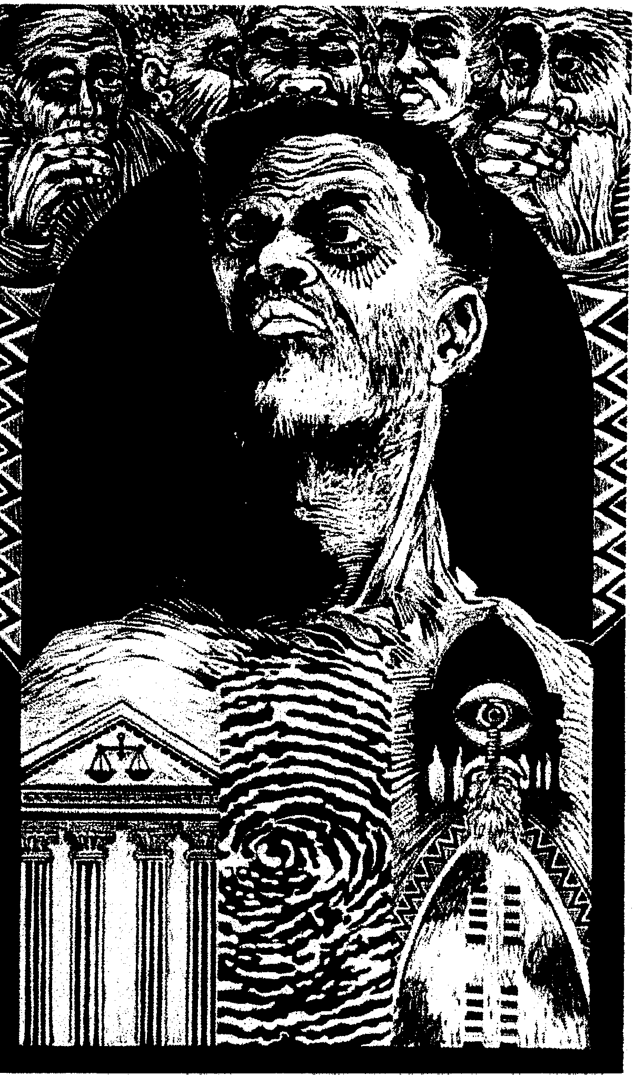
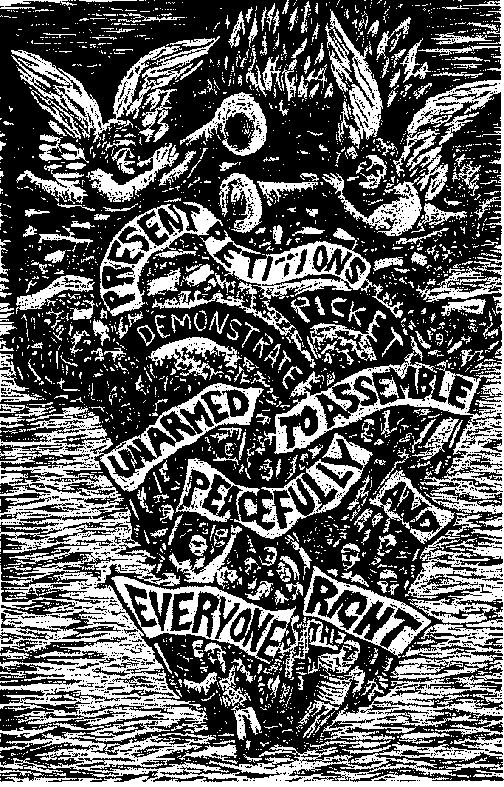

Artist: Vedant Nanackchand  Clause 26: Access to courts  Title: Access to Courts  Medium: Superwood cut  Date: 1996  Dimensions: 500 x 299 | Artist: John Roome  Clause 9: Assembly, demonstration and petition  Title: Peaceful Protest  Medium: Linocut  Date: 1996  Dimensions: 570 x 377

OR

“National Art Competitions are the barometer of our South African contemporary art” (a free translation from the Mail and Guardian, December 1996.)

Discuss the value and contribution made by ONE or more South African art competitions and motivate your opinion. Mention the criteria that were used by the adjudicators for the competitions you have selected.

TOTAL FOR SECTION C:  TOTAL: | [15]  [40]  200

