GAUTENG DEPARTMENT OF EDUCATION
SENIOR CERTIFICATE EXAMINATION

ART SG
(First Paper: History of Art)

TIME: 2 hours

MARKS: 100

INSTRUCTIONS TO CANDIDATES:  The paper is divided into THREE sections.  SECTION A: INTERNATIONAL ART 1900 TO THE PRESENT  SECTION B: SOUTHERN AFRICAN ART 1900 TO THE PRESENT  SECTION C: ART APPRECIATION AND ANALYSIS | [40]  [40]  [20]  100
- Carefully read through the question paper before you select the questions you wish to answer.
- All questions must be answered in essay form. Use full sentences. Lists of facts or examples will be penalised.
- Do not repeat information or examples.
- Make sure that you address the exact requirements of each question. All the questions have been set to encourage debate and discussion. Provide evidence and sound reasoning to support your viewpoint.
- Use the mark allocation as an indication of the length and scope required for each answer.
- Rule off after each answer and leave a line between subsections of each answer.

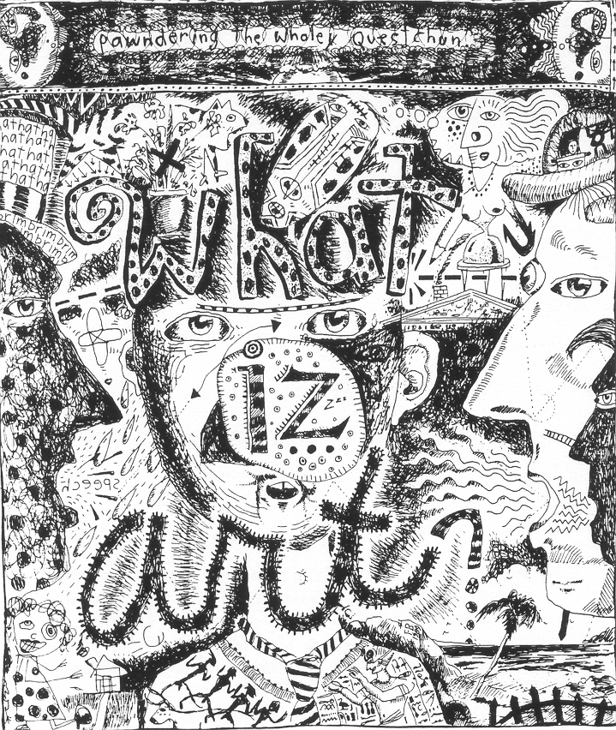

The question: “What is art”? as seen in the illustration above, is the theme of this paper.

SECTION A

INTERNATIONAL ART FROM 1900 TO THE PRESENT

Answer ALL the questions in this section.

QUESTION 1

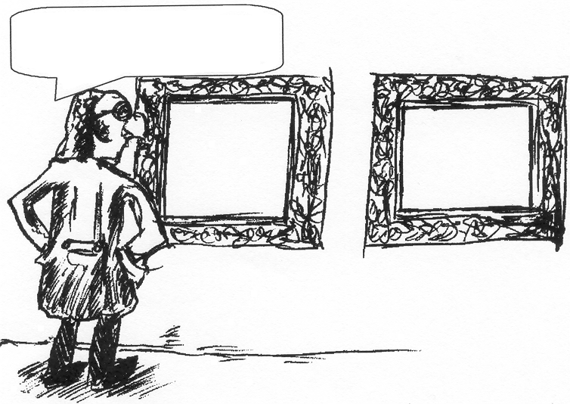

These are the two I like!

Write down your personal definition of the term Art.

Select any two paintings from two different twentieth century art movements which you think fit in best with your definition.

In two separate paragraphs:

- Write down the title of the work, the name of the artist and the movement for each work.  - Give a description of each work.  - Give reasons for your selection of each work.  2x10 = | (3)  (5)  (2)  [20]

QUESTION 2

“Modern architecture is seen intellectually as a pure art form.”

(Hollingsorth, M. 1988. Architecture of the twentieth century, p. 131)

Write a paragraph in which you discuss architecture as a form of art. In this discussion explain the International style and the work of ONE architect you have studied.
Refer to the following in your paragraph.

- Buildings you have studied  - Characteristics of the International style which are relevant to your argument  - Reasons for your opinion that architecture is/is not a form of art | [10]

QUESTION 3
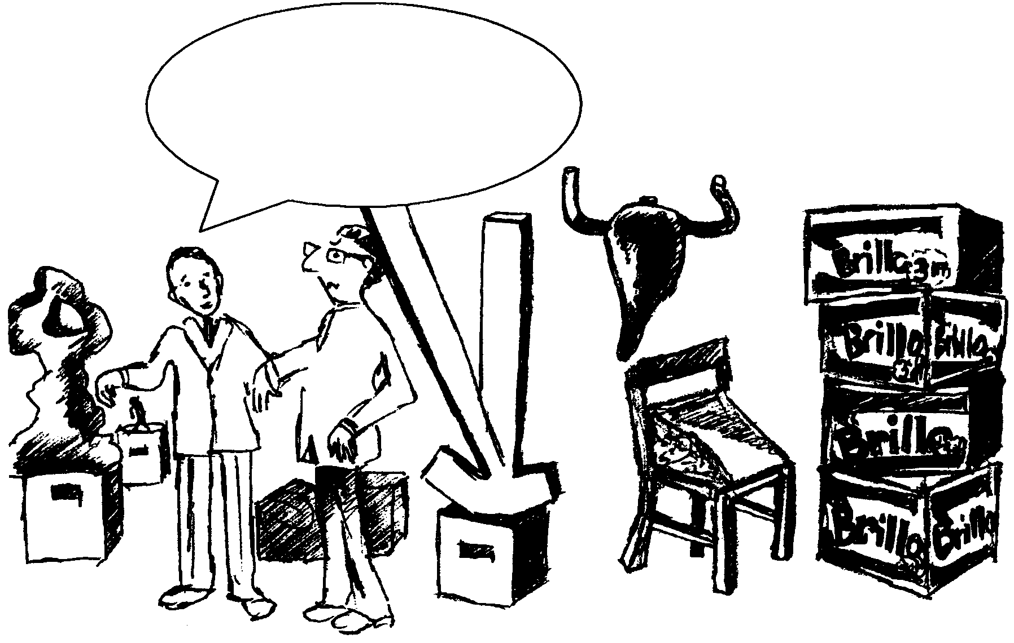
I know each sculpture must
speak freely and directly,
but I still don’t understand
them!

Art (sculpture) is a duet between the artist and his/her medium. Each must speak freely and directly and be visible in his/her own language.

(Jean Dubuffet in Ruhrberg, M. 2000. Art of the twentieth century, p. 203)

With reference to the statement and the cartoon on page 5, discuss any TWO International sculptures you have studied this year.
Give attention to the following:

- Write down the name of the sculptor/s and TWO sculptures you will be discussing.  - Discuss the ways in which the artist explores his/her medium (materials) to express his/her ideas and feelings. | [10]

TOTAL FOR SECTION A: | [40]

SECTION B

SOUTHERN AFRICAN ART 1900 TO THE PRESENT

Answer Question 4 and Question 5 and CHOOSE between Question 6.1 OR Question 6.2.

QUESTION 4

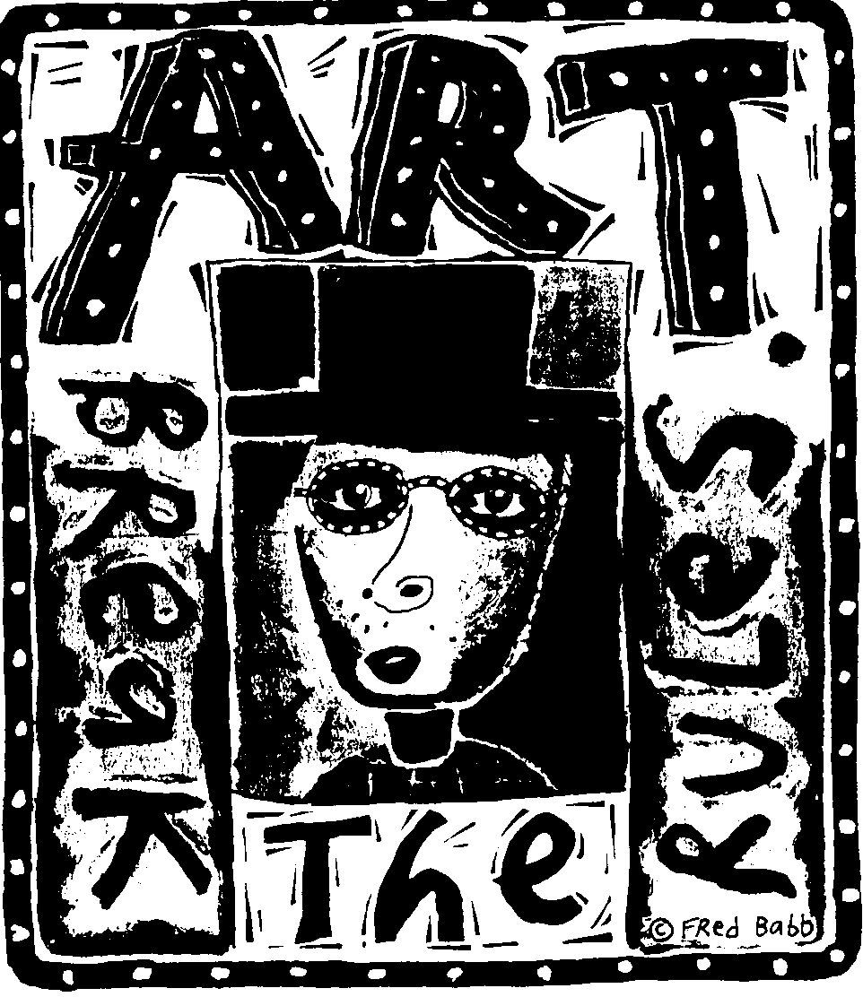

Several South African artists ‘break the rules’ when they explore their personal feelings in their paintings, sculptures and installations. Select ONE contemporary South African painter and ONE contemporary South African sculptor and discuss their work in two short separate essays:

- The name of the artist/s and art work/s  - The style and meaning of the work/s  - The creative process and working methods and materials used 2x10 = | [20]

AND

QUESTION 5

Contemporary South African architects ‘break all the rules’ of traditional architecture by using new technology and by experimenting with new materials.

Discuss this statement by referring to the work of ONE South African architect you have studied. Your discussion should include the following:

- The name of the architect  - The name of the building/s  - Stylistic elements and appearance of the building/s  - Materials and construction methods  - Interior and/or exterior finish and/or decoration. | (10)

AND

QUESTION 6

Answer Question 6.1 OR 6.2.

6.1 Which South African artist’s drawings and/or graphic prints communicate feelings, emotions, thoughts and ideas about their personal experiences of the world in which they live?

- Write down the name of the artist selected  - Write down the title/s of artwork/s  - Describe the themes and techniques used by the artist  - Discuss the meaning of the work/s | (10)

OR

6.2 The FNB VITA’S CRAFT now EXHIBITION takes place every eighteen months. It is a national showcase for local crafts. It bears testimony to our ‘Africanness.’ Many works at the “CRAFT NOW ” Millennium Exhibition have been referred to as curios. These objects might be functional or spiritual or both, or they may only be used in rituals or ceremonies.

Can a craft be called ‘art’? Motivate your answer by discussing the aims and work of ONE South African craftsperson. Refer to specific examples of his/her work to substantiate your answer. | (10)

TOTAL FOR SECTION B: | [40]

SECTION C

ART APPRECIATION AND ANALYSIS

QUESTION 7

Art, to be available to all, cannot be unique or expensive. Thus, just as modern needs for practical things must be satisfied mainly by mass production, so the multiple manufacture of inexpensive art is the inevitable answer to the new demand.

(Carpenter, P. and Graham, W. 1971 Art and ideas, p. 126)

Discuss the following:

8.1 The value of art for individuals and the role it can play in one’s personal life. | (4)

8.2 The social value and role of art and the contribution art can make to our everyday lives. | (4)

8.3 The historical and cultural value and role of art. | (4)

8.4 The economic value of art. Discuss possible careers and study opportunities in art. | (8)  [20]

TOTAL FOR SECTION C: | [20]

TOTAL: | 100

