GAUTENG DEPARTMENT OF EDUCATION

SENIOR CERTIFICATE EXAMINATION

ART HG
(First Paper: History of Art)

TIME: 3 hours

MARKS: 200
INSTRUCTIONS:

- Read through the question paper carefully before selecting questions which you would like to answer.

- All answers must be presented in essay form. Lists of facts will be penalised.

- Do not repeat information or examples

- Study the requirements of the questions carefully. All the questions have been set to encourage debate and discussion. Provide evidence and sound reasoning to support your viewpoint.

- Use the mark allocation as an indication of the length and scope required for each question.

- Rule off after each answer and leave a line open after each subsection.

Art is the creation of man, it develops from his vision, sense of design, emotional involvement, imagination and especially from his creativity. Any person in the world can tackle any sort of material and create a deliberate statement with it. The boundaries of art include a wide spectrum of art forms: popular arts and crafts, two- and three- dimensional art, architecture, functional and applied arts, creative still in visual art, literature, music, dance and performance art.

- The paper is divided into THREE sections, namely Sections A, B and C.

MARK ALLOCATION

SECTION A: International art from 1900 to the present 80

SECTION B: Southern African art from 1900 to the present 80

SECTION C: Art appreciation and analysis 40

TOTAL: 200

SECTION A

INTERNATIONAL ART FROM 1900 TO THE PRESENT

ALL the questions in this section are COMPULSORY.

QUESTION 1

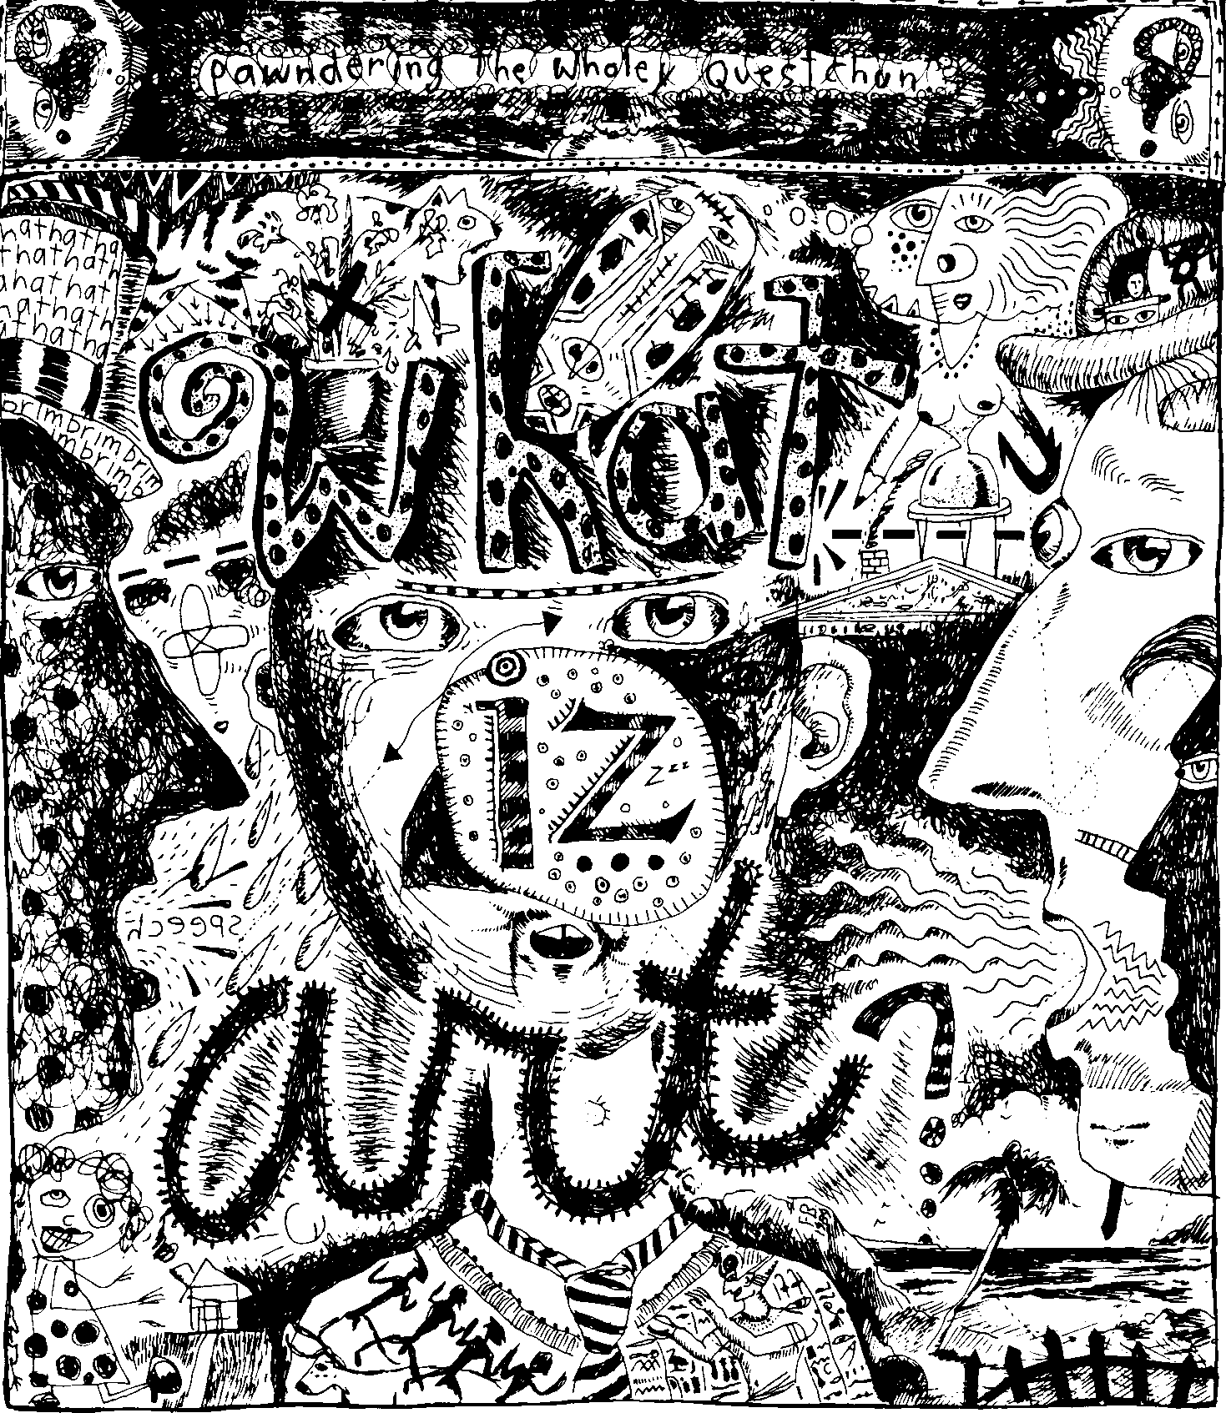

“Art is a practical joke! A hoax on the public by so-called “artists” who set themselves up on a pedestal. This is promoted by intellectuals and “critics” who think the world owes them a living”.

(Robert Crumb, quoted in Farmen, J. 1995. Art a complete and utter history, p.15)

At a school debate you have been selected to defend twentieth century art against this insulting statement. In your argument you should:  - Discuss the work of one pre-1950 painter and ONE post- 1950 painter and ONE post-1950 sculptor.  - Refer to relevant works of these selected artists to substantiate your arguments.  - Discuss the contribution these related movements made in defining the art of the twentieth century.  - Substantiate your arguments. | (40)

QUESTION 2

The twentieth century saw major developments in architectural style, construction methods and materials. The appearance of architecture distinctly differed in Modernism, International style, Post-Modernism, Late- Modernism, “High-Tech” architecture and Deconstruction.  Select the style/s or movement/s that you think define(s) twentieth century architecture, and write an article for your school newspaper, in which you explain your reasons for your choice. Refer to relevant examples. (Excluding South African Architecture) | (25)

QUESTION 3

“Just as modern needs for practical things must be satisfied mainly by mass-production, so the multiple manufacture of inexpensive art is the inevitable answer to the new demand.”

(Carpenter, P. and Graham, W. 1971, Art and ideas, p. 32)

Analyse a functional object from a specific Design school that you have studied, and refer to the following:  - Functionalism  - Design aspects and aesthetic appeal (include a small sketch)  - Material, production methods and cost effectiveness  - The extent to which this functional object fulfils your definition of “art” | (15)

TOTAL FOR SECTION A: | [80]

SECTION B

SOUTHERN AFRICAN ART FROM 1900 TO THE PRESENT

Answer THREE questions in this section.
Answer Question 4.1 AND Question 4.2 AND Question 5 AND Question 6.1 OR Question 6.2.

QUESTION 4

Answer Question 4.1 AND Question 4.2.

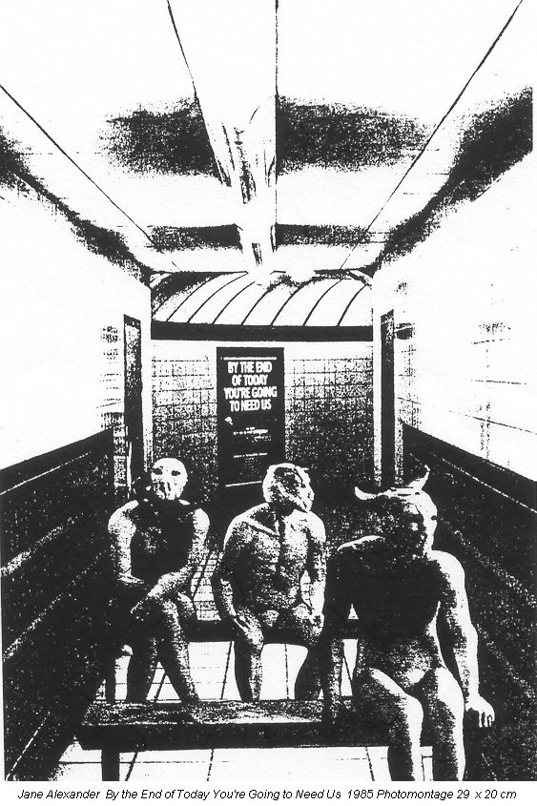

4.1 The above photomontage, by Jane Alexander is called By the end of today you’re going to need us (1985). It shows that many strange, even shocking things in today’s world, qualify as art...

Some artists feel that frames and walls are restricting, and therefore work without boundaries. Landscapes and urban structures, like stations, subways and sport stadiums, are transformed into galleries and incorporate graffiti, flags, banners, murals, sculptures, installations, video and computer art images.

But is it Art? Refer to the work of at least ONE CONTEMPORARY South African artist and discuss specific examples of Multimedia and/or Installation and/or Sculpture, which challenge the traditional definitions of art. Refer to:  - The stylistic characteristics in each artist’s work  - The creative process and working methods  - Meaning and content  - Relevant examples of his/her/their work to support your argument | (20)

AND

4.2 Using the latest technology and construction methods, architects have become pioneers in experimenting with new building materials. They offer a vision of the future by using ecologically friendly materials and new construction methods, to capture a permanent memory of a moment in time.  Discuss the above statement by referring to the work of ONE or more South African architect/s. Refer to the building as a work of public art that combines local culture, new materials and the aesthetic in an interesting concept of urban living. | (20)

AND

QUESTION 5

In an era of political turmoil and complex negotiations between personal identities, artists within a nation or culture may face difficulties in assessing meaning and value in art. Gender, nationality, ethnicity, politics and religion, all seem to have some impact on the meaning of art.  With reference to this statement, discuss the message in contemporary South African PAINTING , DRAWING AND PRINTMAKING.  Discuss any TWO South African artists. In your opinion, which paintings and/or drawings and/or prints communicate feelings, emotions, thoughts and ideas? Your choice of artworks and their techniques must be relevant to the statement. | (25)

AND

QUESTION 6

Answer Question 6.1 OR Question 6.2.

  - Art has taken on varied forms within particular historical contexts. Some art of the past now seems very alien to us, but was significant at the time it was created.

With reference to this statement,discuss the contribution of ONE South African Art Group or Art School.  Substantiate your answer by considering the following:  - The cultural and socio-political issues which were addressed by the group or art school  - Themes, materials and techniques used by the artists in the group  - Examples of works produced by this group | (15)

OR

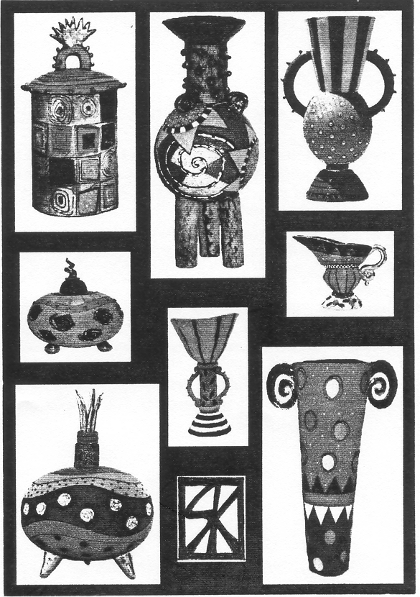

6.2 The FNB VITA Craft Exhibition takes place every eighteen months. It is a national showcase for local crafts and bears testimony to our ‘Africanness’. Many works for the CRAFT NOW Millennium awards were referred to as ‘curios’. These objects might be utilitarian or spiritual or both – or they may only have value in a ritual or ceremonial context or they may be works of art in their own right.

With reference to the above statement, discuss ONE South African craftsperson whose work can be defined as art, a craft, or as curio objects. | (15)

TOTAL FOR SECTION B: | [80]

SECTION C

ART APPRECIATION AND ANALYSIS

Answer ALL the questions in this section.

QUESTION 7

Traditionally art has been divided into distinct categories, for example, Painting , Sculpture and Graphic art. Nowadays these categories have become too restrictive, and the definition of art has become far wider. It now includes numerous experimental approaches to art. Contemporary artists such as Steven Cohen, Lisa Brice, Kendall Geers and numerous others, have created performance art, multimedia art and conceptual art, all of which extend traditional boundaries.

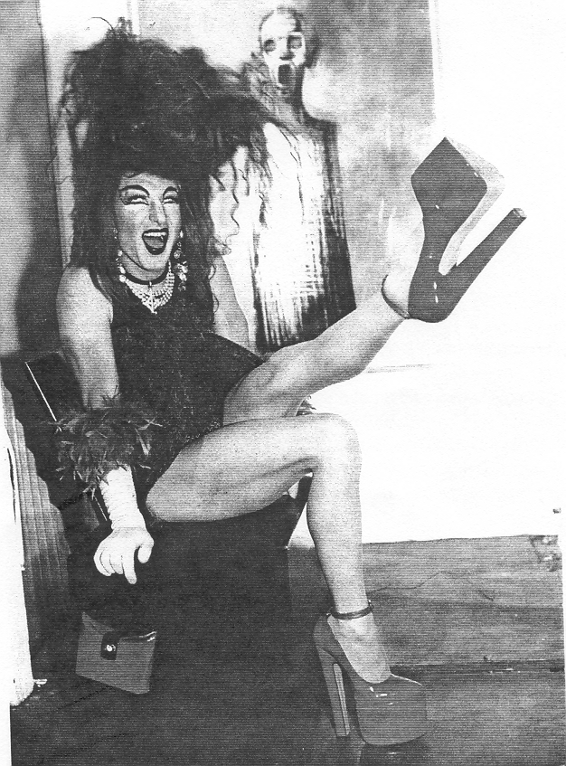

Steven Cohen The woman I live with (doesn’t take Art seriously) 1999
Performance piece: Carfax, Johannesburg

Write an introduction for a book on contemporary art in which you discuss the changing forms of art in South Africa.

Consider the following:  - Your personal opinion/s and thoughts on the changing approaches in art  - Reference to relevant examples of innovative approaches in art  - Possible definitions you would offer for contemporary art forms | (20)

QUESTION 8

“To be educated in art means considerably more than being able to manipulate some art materials, however skilful and expressive that manipulation might be.”

(Allison in Barrett, M. 1979. Art education. Heinemann Educational Books, London p. 67)

Discuss the role, value and function of art and art education, with reference to:  - The personal value and role of art  - The social value and role of art  - The historical and cultural value and role of art  - The economic value of art, including a discussion of career and study opportunities in art | (20)

TOTAL FOR SECTION C: | [40]

TOTAL: | 200

