GAUTENG DEPARTMENT OF EDUCATION
SENIOR CERTIFICATE EXAMINATION

APPLIED AGRICULTURAL SCIENCE SG

TIME: 3 hours

MARKS: 300

INSTRUCTIONS:

- This question paper consists of THREE sections. Answer ONE question in each section.

SECTION A: Animal production
SECTION B: Harvest production
SECTION C: Processing of farm produce OR Farm mechanics

SECTION A
ANIMAL PRODUCTION

Answer ONE question in this section.

QUESTION 1
DAIRY FARMING

- Briefly discuss the following characteristics used as criteria when judging a dairy cow:  1.1.1 Shape  - General appearance  - Head  - Forequarters  - Middlequarters  1.2 Which factors will determine the success of any selection method?  1.3 Discuss the technique of artificial insemination.  - State the practical hints given for the storage and feeding of colostrum.  - The diagram below represents a calf’s stomach. Provide labels for the numbered parts (1 – 5). | (10)  (4)  (10)  (9)  (5)

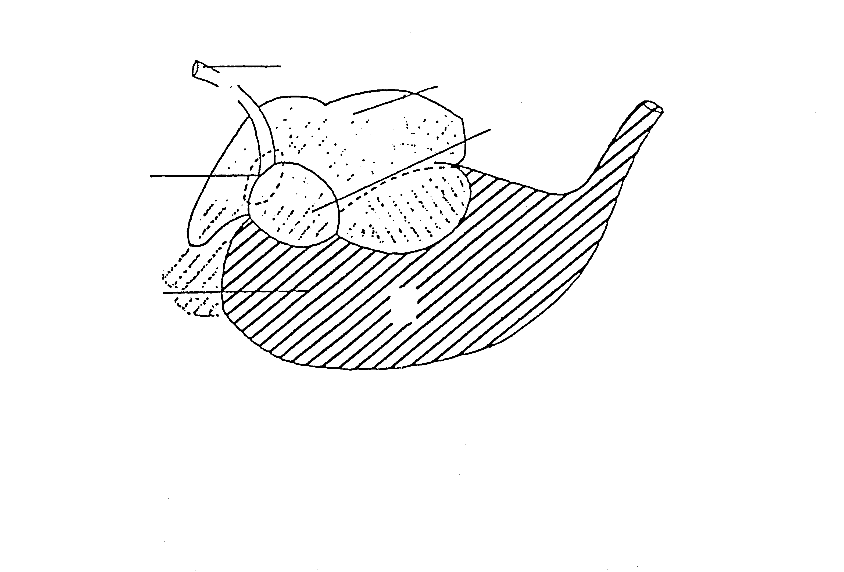

1
4
5
2
3

- Discuss the after-care of the calf under the following headings:  1.6.1 Dehorning  - Removal of extra teats  1.7 Discuss any TEN factors that can influence milk production.  1.8 Mention any EIGHT factors that will determine the composition of milk.  - Discuss the problem of external parasites under the following headings:  1.9.1 Ticks  - Stable flies  - House flies  1.10 Discuss the causes of bloat.  1.11 Mention the different types of housing used for calves. | (8)  (5)  (20)  (8)  (4)  (2)  (3)  (8)  (4)  [100]
OR

QUESTION 2  POULTRY  2.1 Discuss the factors which determine success in rearing chickens.  - Briefly describe the following breed standards/characteristics:  2.2.1 Skin  - Legs  - Feathers  2.3 The growth rate can be affected by various factors. Discuss these factors.  2.4 The following diagram shows chickens under a brooder. Explain what is happening under each brooder. |  | (8)  (3)  (3)  (5)  (12)  (8)
A  C  B  D | 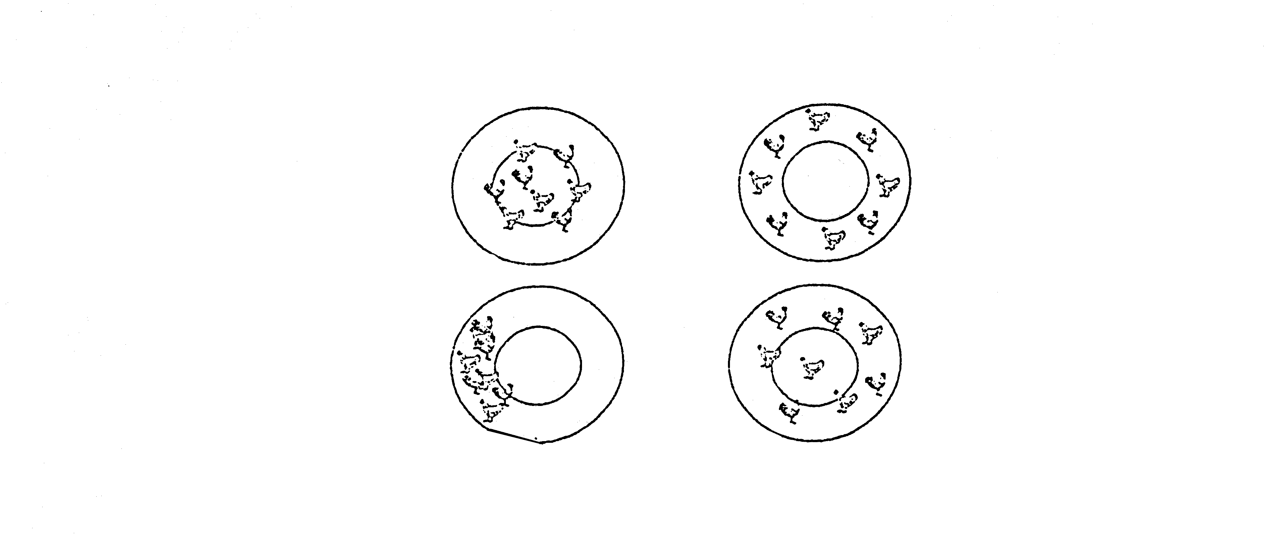

- Discuss the factors that should be taken into consideration when moving young hens.  - What factors should be taken into consideration when handling eggs for hatching?  - Discuss the requirements for the selection of day-old chicks.  - State the  2.8.1 advantages and  - disadvantages of debeaking.  2.9 List the factors that should be considered when choosing nests?  2.10 State the advantages of using laying pellets.  - State the requirements for bedding (litter).  OR | (14)  (6)  (6)  (6)  (6)  (8)  (6)  (9)  [100]

QUESTION 3  SHEEP FARMING  - Discuss the conformation of sheep under the following headings:  3.1.1 Hindquarters  - Legs  - Size  3.2 Discuss the independent culling method as a selection method.  3.3 Discuss the selection procedures of ewelambs.  - Discuss the disadvantages of artificial insemination in sheep.  - Briefly discuss the THREE different ways of castration in sheep.  - How can the stress on lambs which have been weaned, be relieved?  - Discuss the requirements for maximum fertility in rams.  - Discuss the causes and spreading of blue tongue.  - Explain the skirting of a fleece.  - Explain the marking of wool bales.  TOTAL FOR SECTION A: | (4)  (4)  (4)  (10)  (12)  (9)  (9)  (7)  (17)  (10)  (8)  (6)  [100]  [100]

SECTION B  HARVEST PRODUCTION  Answer ONE question in this section.  QUESTION 4  MAIZE PRODUCTION  4.1 The diagram below represents a maize plant. Provide labels for the numbered parts (1 – 8). |  | (8)
1  2  3  4  5  7  6  8 | 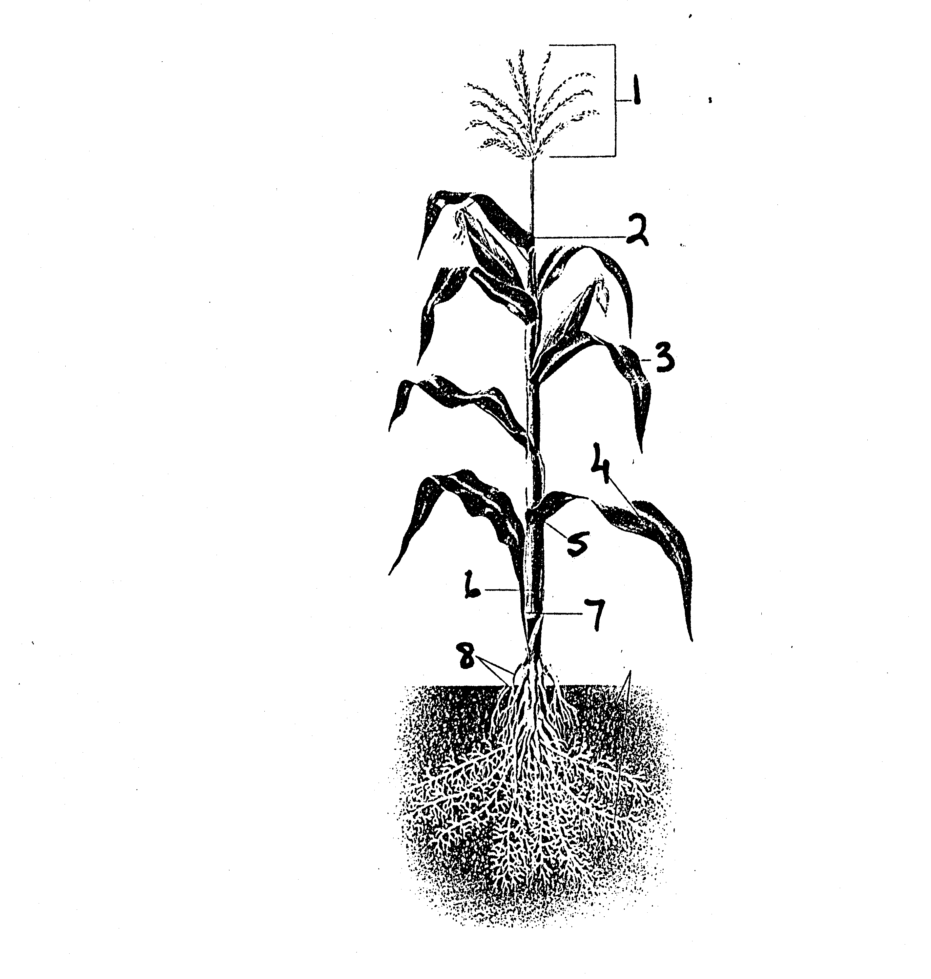

- Briefly describe the different growth stages of a maize plant.  - Discuss the soil requirements for maize.  - State any FOUR primary tillage implements.  - State the advantages and the disadvantages of no tillage as a tillage system.  - Which guidelines should be considered in cultivar planning?  - Discuss the fertilisation of maize under the following headings:  4.7.1 Soil sampling  - Application of lime  4.8 List the factors affecting the efficacy of herbicides that are applied to soil.  4.9 Name any EIGHT financial records.  - Discuss the mechanical harvesting of maize.  - Discuss cutworms under the following headings:  4.11.1 Damage symptoms  - Description of larvae  4.12 Discuss the symptoms of maize streak disease. | (20)  (8)  (4)  (11)  (5)  (4)  (4)  (8)  (8)  (8)  (3)  (5)  (4)  [100]

OR

QUESTION 5  PRODUCTION OF VEGETABLES  - Discuss the sterilization of seed.  - Briefly describe the suitable types of soil for the production of the following:  5.2.1 Fruitbearing crops, e.g. tomatoes  - Tuberous crops, e.g. potatoes  5.3 Explain the advantages of crop rotation.  5.4 Explain the role of soil tillage in weed control.  - Give the symptoms of the following pests and diseases:  5.5.1 Rust on beans  - Sucking insects  - Stem and root rot  5.6 Describe the life-cycle of the cutworm.  5.7 Discuss the control of cabbage louse under the following headings:  - Combating weeds  - Destroying isolated, infested plants  5.8 Give a short description of the FOUR types of onion cultivars.  5.9 Discuss the control of bacterial wilt in tomatoes.  - Describe the characteristics of good seed.  TOTAL FOR SECTION B: | (9)  (4)  (4)  (12)  (8)  (3)  (3)  (3)  (12)  (4)  (4)  (8)  (12)  (14)  [100]  [100]

SECTION C  Answer ONE question in this section.  QUESTION 6  PROCESSING OF FARM PRODUCE  - Discuss the packing and marketing of eggs.  - Discuss the pasteurization of eggs.  - Give the classes and age of turkeys for table use.  - Discuss the effect of heat on milk.  - Discuss the ripening of cream.  - What can be done to make cheese more digestible?  - Discuss the preparing of meat for freezer storage. | (12)  (8)  (12)  (16)  (10)  (8)  (8)

6.8 Provide labels for the numbered parts (1 to 13). (13)

1  2  3  4  5  6  7  8  9  10  11  12  13 | 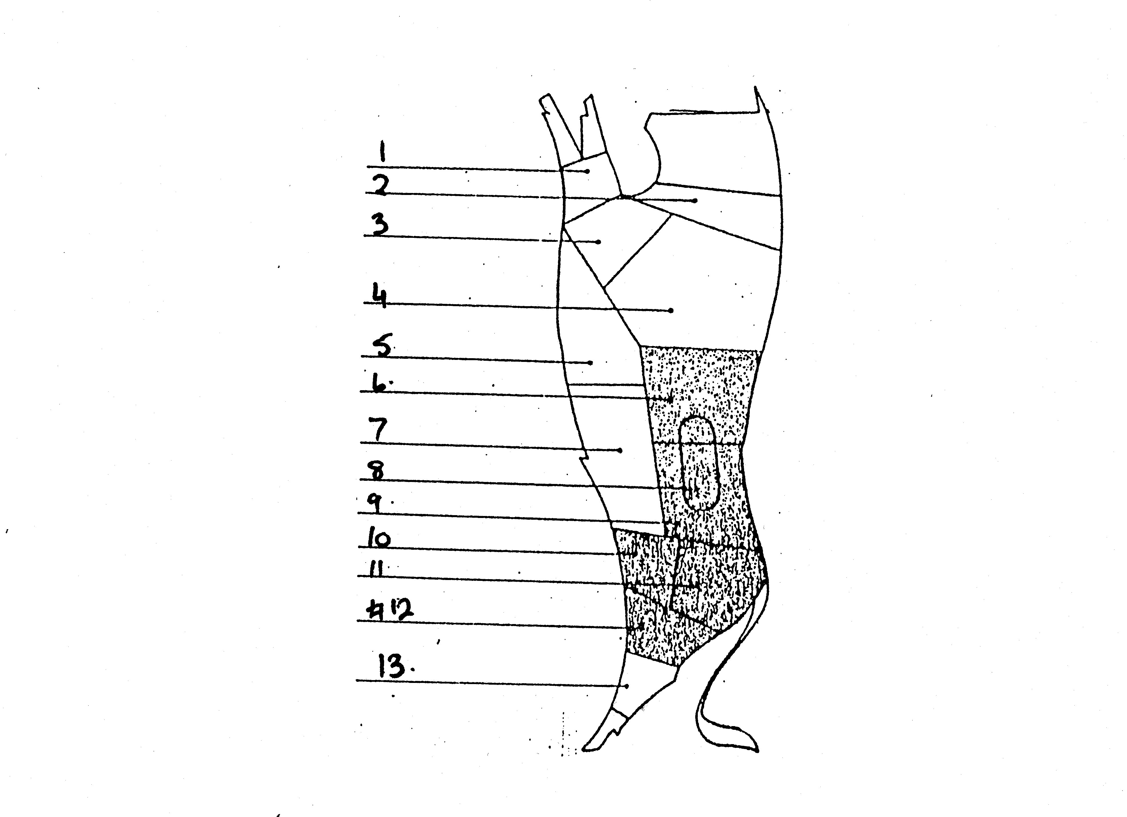

6.9 Discuss the preservation of meat under the following headings:  - Smoking  - Salting | (6)  (7)  [100]

OR

QUESTION 7  FARM MECHANICS  - Describe briefly how a clutch can be dismantled.  - Describe the construction of wooden suspended floors.  - Describe the inspection of the fly wheel when a clutch is overhauled.  - Discuss the functions of the shock-absorbing devices fitted to the friction plate of the clutch.  - Mention EIGHT different mortise and tenon joints in woodwork.  - Describe how the bleeding of hydraulic brakes is done.  - Name any FIVE engine defects that can be caused by the injector valve.  7.8 Distinguish between steel and cast iron by comparing their qualities with regard to the following:  7.8.1 Density  - Melting point  - Appearance  - Composition  - Test | (6)  (10)  (10)  (5)  (8)  (8)  (5)  (2)  (2)  (4)  (6)  (2)

7.9 List TEN safety precautions when doing woodwork.  7.10 Describe in detail the third stroke (power stroke) of the four-stroke cycle engine.  - Name the different parts of the friction plate of the clutch.  - Answer the following questions related to universal joints.  7.12.1 What is a universal joint?  - 7.12.2 Why are two universal joints necessary in a motor vehicle?  - Why is a universal joint essential?  TOTAL FOR SECTION C: | (10)  (10)  (5)  (3)  (2)  (2)  [100]  [100]

TOTAL: | 300

