GAUTENG DEPARTMENT OF EDUCATION

SENIOR CERTIFICATE EXAMINATION

APPLIED AGRICULTURAL SCIENCE SG

TIME: 3 hours

MARKS: 300

INSTRUCTIONS:

This paper consists of THREE sections:

- Section A: Animal production
- Section B: Plant production
- Section C: Food processing or farm mechanics

- Answer only ONE question in each section.

SECTION A
ANIMAL PRODUCTION

Answer ONE question in this section.

QUESTION 1
MILK PRODUCTION

1.1 Briefly describe the following characteristics of a Fries and Jersey:

- The rump  - The skin  - The neck | (5)  (4)  (3)

- Which information is used to select breeding animals?  - Discuss the points of importance when studying a family tree.  - Discuss the disadvantages of artificial insemination.  - Explain the TWO methods that can be used to teach a calf to drink.  - Name the functions of colostrum. | (4)  (10)  (10)  (7)  (6)

  - Explain how the following is done:

- Removal of extra teats  - Bloodless castration | (4)  (3)

1.8 Which factors determine the amount of concentrate to be fed? | (3)

1.9 Explain how external parasites can influence milk production. | (8)

1.10 Discuss bloat under the following headings:

- Causes  - Treatment | (4)  (6)

1.11 Mention the factors that should be kept in mind when milking by hand. | (10)

1.12 Discuss the causes of milk pollution. | (13)  [100]

QUESTION 2
POULTRY PRODUCTION

2.1 Give a brief description of the Rhode Island Red. | (8)

2.2 What factors should be kept in mind when selecting a site for a poultry house? | (6)

2.3 Discuss the preparations that should be made before receiving the chickens. | (8)

2.4 What are the advantages of pellets as a feeding method? | (6)

2.5 There are different types of nests for hens. What factors should be considered when choosing nests? | (3)

2.6 Good records will contain certain information. Mention this information. | (7)

2.7 Discuss the factors that should be taken into consideration when moving pullets. | (14)

2.8 Mention the advantages of early debeaking of poultry. | (9)

2.9 What can be done by the farmer to keep the manure as dry as possible in a battery house. | (6)

2.10 Mention the causes of cannibalism among poultry. | (7)

2.11 What precautions can be taken for the prevention of diseases? | (6)

2.12 Name the requirements which grade 1 eggs must meet. | (8)

2.13 What are the possible causes if many embryos die in the shells? | (7)

2.14 Mention FIVE causes of breakages in the precollection stage. | (5)
 | [100]

QUESTION 3
BEEF PRODUCTION

- Mention the most important points of disqualifications of the Drakensberger.  - In practice, breeding and selection go hand in hand. Therefore it is necessary for the farmer to pay attention to certain aspects. Mention these aspects.  - Discuss the factors that can influence the birth mass of a calf.  - Mention the  - advantages, as well as the  - disadvantages of artificial insemination.  - Discuss the principles behind controlled selective grazing.  - Discuss the marking of calves.  - The control of the heifer by the steer is one of the most important factors which influences mass increase, therefore certain rules must be applied. Mention these rules.  - What general methods can be applied by the farmer to prevent bacterial diseases?  - Mention the records of a calf’s performance.  - Discuss feedlot finishing as a feeding system.  - List any THREE internal and external parasites that are of importance to the cattle farmer.  - Describe the typical characteristics of beef cattle with regard to the  - udder.  - legs and feet. | (8)  (8)  (10)  (7)  (6)  (8)  (8)  (12)  (6)  (8)  (6)  (6)  (3)  (4)  [100]
TOTAL FOR SECTION A: | [100]

SECTION B
PLANT PRODUCTION LINES

Answer only ONE question in this section.

QUESTION 4
GRAIN PRODUCTION (MAIZE)

4.1 Briefly describe the main production areas of maize in South Africa. | (6)

- Describe how the following factors will influence the time for planting maize:  - Frost in autumn  - Rainfall  - Plant density  - Discuss the practice of crop rotation on maize farms. Give attention to the following:  - The reasons for a crop rotation system  - Crops suitable for rotation with maize  - Explain what is meant by stubble or mulch cultivation and give the advantage of this method of cultivation.  - The following temperatures will have an influence on maize production. Briefly discuss this statement by referring to each of the following:  - 12° to 27°C  - Frost  - Below 10°C  - Above 42°C  - A pre-plant cultivation is included in the second phase of a weed control programme. Discuss this method of weed control.  4.7 Why is a good recording system necessary in the case of the physical data of each of the following cases?  - Annual rainfall  - Cultivated areas  - Fertilizers used  - Seed used  - Yield obtained  4.8 List any SIX factors which a farmer should consider when selecting a maize cultivar for production.  4.9 Draw a labelled sketch of a maize plant.  - What is the economic importance of maize production to South Africa? | (1)  (2)  (2)  (8)  (4)  (8)  (2)  (2)  (2)  (1)  (6)  (10)  (6)  (10)  (5)

- Give in table-form the description of and the control measures for the following maize pests:  4.11.1 Wire worms  - Stalk borer  - Black maize beetle  - Cutworms  4.12 Supply the names of THREE types of herbicides which can be used in weed control. | (5)  (7)  (4)  (6)  (3)  [100]

QUESTION 5
VEGETABLES

- Discuss the characteristics of good seed.  - Discuss the sterilising of vegetable seed.  - Mention the ways in which the farmer may change the environment of his crops to make the crops grow better.  - Mention the advantages of crop rotation.  - Why is it important to exercise weed control in a vegetable garden?  - Discuss crop rotation as a biological control measure for weeds.  - Discuss the life cycle of cutworms.  - Discuss the various methods of trellising tomatoes.  - What can be done to control bacterial wilt in tomatoes?  - Discuss the harvesting and marketing of cauliflower.  - Name the different types of vegetables.  TOTAL FOR SECTION B: | (21)  (8)  (4)  (6)  (6)  (14)  (10)  (10)  (6)  (8)  (7)  [100]  [100]

SECTION C
FOOD PROCESSING OR FARM MECHANICS

Answer only ONE question in this section.

QUESTION 6
FOOD PROCESSING

6.1 Give the composition of the edible portion of the egg.  6.2 Discuss the dehydration of eggs to make powdered eggs under the following headings:  - Advantages  - Uses  - Process  - Discuss the trussing of a chicken.  - Mention the grading of chickens according to age.  - Discuss the nutritive value of milk under the following headings:  6.5.1 Proteins  - Carbohydrates  - Fats | (8)  (12)  (6)  (7)  (4)  (4)  (5)

- Give the composition of milk.  - What is the effect of sterilisation on milk?  - Explain how cream cheese is made. | (10)  (5)  (8)

6.9 Supply the sketch below with labels. | (9)
1

2

3

4

5

6

7

8

9

6.10 Mention the different categories of fat in meat.  6.11 Discuss the smoking of meat as a measure to preserve meat.  6.12 Discuss the processing of offal as a waste product. | (6)  (7)  (9)  [100]

QUESTION 7
FARM MECHANICS

- Describe how the bleeding of hydraulic brakes is done.  - Explain the differences between the ordinary power take-off shaft and the live power take-off shaft.  - Discuss the function(s) of the shock absorber fitted to the friction plate of the clutch.  - Describe the process of braizing.  - Name any FIVE engine defects that can be caused by the injector valve.  - Describe the function of a conventional differential.  - Answer the following questions on universal joints:  7.7.1 What is a universal joint?  - Why is a universal joint essential?  - Describe the TWO basic types of universal joints.  7.8 Describe in detail the third-stroke- the power stroke- of the four-stroke cycle engine.  7.9 Name the different parts of the friction plate of the clutch. | (8)  (6)  (5)  (8)  (5)  (15)  (3)  (6)  (4)  (10)  (6)

7.10 Study the sketch of a gearbox below and label the parts marked 1 to 10. | (10)
4.
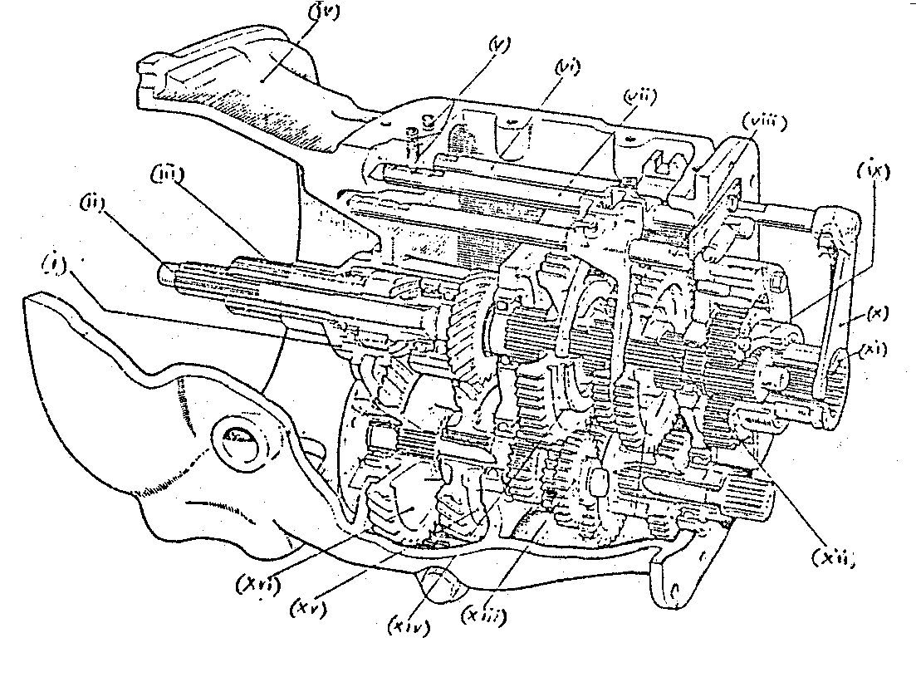
13.
5.
6.
7.
8.
9.
10.
11.
12.
14.
15.
16.
1.
2.
3.

- List TEN safety precautions when doing woodwork with power tools.  - What are the functions of gears in a tractor?  TOTAL FOR SECTION C:  TOTAL: | (10)  (4)  [100]  [100]  300

