GAUTENG DEPARTMENT OF EDUCATION
SENIOR CERTIFICATE EXAMINATION

APPLIED AGRICULTURAL SCIENCE SG

TIME : 3 hours

MARKS : 300

INSTRUCTIONS:

- This paper consists of THREE sections. Answer ONE question in each section.

- SECTION A : Animal Production
- SECTION B : Plant Production
- SECTION C : Processing or Farm Mechanics

SECTION A

ANIMAL PRODUCTION

Answer ONE question in this section.

QUESTION 1
DAIRY FARMING

- Name the most significant problems in the dairy industry.  - What should the judge be looking at while judging the udder of a dairy cow?  - Discuss the points of importance when studying a family tree.  - Discuss the insemination technique during artificial insemination.  - Discuss the care of the new-born calf.  - Discuss castration of a bull calf by using the burdizzo.  - The farmer must set certain targets against which he can measure his progress and success. Mention these targets.  - Discuss the factors that influence a cow’s milk production. | (6)  (5)  (10)  (10)  (8)  (8)  (5)  (14)

- Mention THREE groups of external parasites and state the damage they cause.  - Discuss the control of mastitis.  - Name the advantages of machine milking.  - Name the sources of milk contamination.  - Discuss the technique of the bacteriological test. | (9)  (6)  (5)  (8)  (6)  [100]

QUESTION 2
POULTRY PRODUCTION

- Discuss the factors that affect the growth rate of broilers.  - Rapid feathering in commercial broilers is desirable. Mention the reasons why it is desirable.  - Briefly discuss the FOUR methods of housing broilers.  - Which factors should be taken into consideration when handling eggs for hatching?  - The room in which the incubator is housed plays a big role in the hatching process. Discuss the factors that should be kept in mind.  - Name the requirements of day old chickens.  - Name the requirements of good litter.  - Name the precautions that must be taken to prevent diseases.  - Discuss all mash as a feeding system for broilers.  - Discuss the requirements that grade 1 eggs must meet.  - Give the possible causes of the following:  - Small chickens  - Chickens that breathe with difficulty  - Many infertile eggs  2.12 State the recommendation for the number of water troughs. | (12)  (4)  (12)  (6)  (12)  (6)  (9)  (6)  (8)  (9)  (3)  (3)  (7)  (3)  [100]

QUESTION 3
WOOL PRODUCTION

- Discuss the economic importance of wool production in South Africa.  - Mention the faults that a judge can pick up when he judges the following:  3.2.1 Legs  - Hind quarters  - Back  3.3 Discuss the selection procedures of ewe lambs.  3.4 Why is the gestation period very important for the production functions of the ewe?  - What can be done to relieve the stress on lambs during weaning?  - What is the owner of sheep which are infected with sheep scab obliged to do?  - Why should camps be rested in a grazing system?  - Discuss the aspects to be borne in mind when supplying lick.  - Explain the skirting of the fleece.  - Give the different classes and symbols of wool according to fineness.  - Discuss the marking of wool bales.  TOTAL FOR SECTION A: | (10)  (7)  (4)  (4)  (12)  (5)  (7)  (12)  (3)  (12)  (6)  (10)  (8)  [100]  [100]

SECTION B

PLANT PRODUCTION

Answer only ONE question from this section

QUESTION 4

VEGETABLES

Discuss the sterilisation of seed.  - Discuss the most suitable type of soil for the production of:  4.2.1 Leaf crops  4.2.2 Root crops  - Discuss the SIX advantages of crop rotation. | (12)  (5)  (6)  (12)

4.4 What should be done to ensure optimum results with herbicides? | (6)

4.5 Discuss the control of cutworms in beans.  - What damage is done by cabbage lice?  - Discuss the harvesting and marketing of cabbage.  - Give a brief description of the FOUR types of onion varieties.  - Discuss the transplant of tomatoes.  - Discuss the control of bacterial wilt in tomatoes.  - Mention the TWO types of records of a vegetable farmer. | (12)  (5)  (10)  (8)  (10)  (12)  (2)  [100]

QUESTION 5

MAIZE PRODUCTION

Discuss the following TWO ways to harvest maize:  5.1.1 Hand picking  - Combine harvester  5.2 Discuss the light disc implement by giving any THREE advantages and any THREE disadvantages of its use during secondary tillage operations in the maize land. | (5)  (7)  (6)

5.3 Give in table form the description of and the control measures for the following maize pests:  - Cut worms  - Wire worms  5.4 Discuss the following critical periods during the growth of maize:  - Just after germination  - Just after appearing above the (ground) surface  - At about 200 to 400 mm height  - Tussling time  5.5 Describe in table form the following diseases of maize as far as causes (organisms), symptoms of diseases and control measures are concerned:  - Streak diseases  - Root rot  - Stem and ear rot  5.6 Name any TEN examples of physical data a maize farmer should keep record of. | (7)  (5)  (3)  (1)  (2)  (4)  (3)  (5)  (4)  (10)

5.7 Name the FOUR towns of the Maize Quadrangle.  Give any EIGHT reasons for using a crop rotation system in maize cultivation.  - Explain why cross pollination can be expected in the maize field.  - Indicate all the information that is usually obtained from soil analysis.  - Discuss summer ploughing as a method of weed control in maize fields.  - Draw a labelled sketch of a maize plant.  TOTAL FOR SECTION B: | (4)  (8)  (6)  (5)  (5)  (10)  [100]  [100]

SECTION C
PROCESSING OR FARM MECHANICS

Answer only ONE question in this section.

QUESTION 6

PROCESSING OF FARM PRODUCE

Discuss the nutritive value of milk under the following headings:  6.1.1 Proteins  - Carbohydrates  - Fats  6.2 Discuss the reasons why milk on its own is not an ideal food.  6.3 What factors must be kept in mind when milk  - is stored at home?  - must be kept hygienic?  6.4 Discuss the effect of heat on milk.  6.5 Discuss the failures in butter making if  - the cream is too thin.  - the temperature is not right.  6.6 Discuss the preparation of meat for freezer storage. | (4)  (4)  (4)  (6)  (4)  (7)  (14)  (6)  (4)  (8)

6.7 Supply the sketch with labels. | (13)

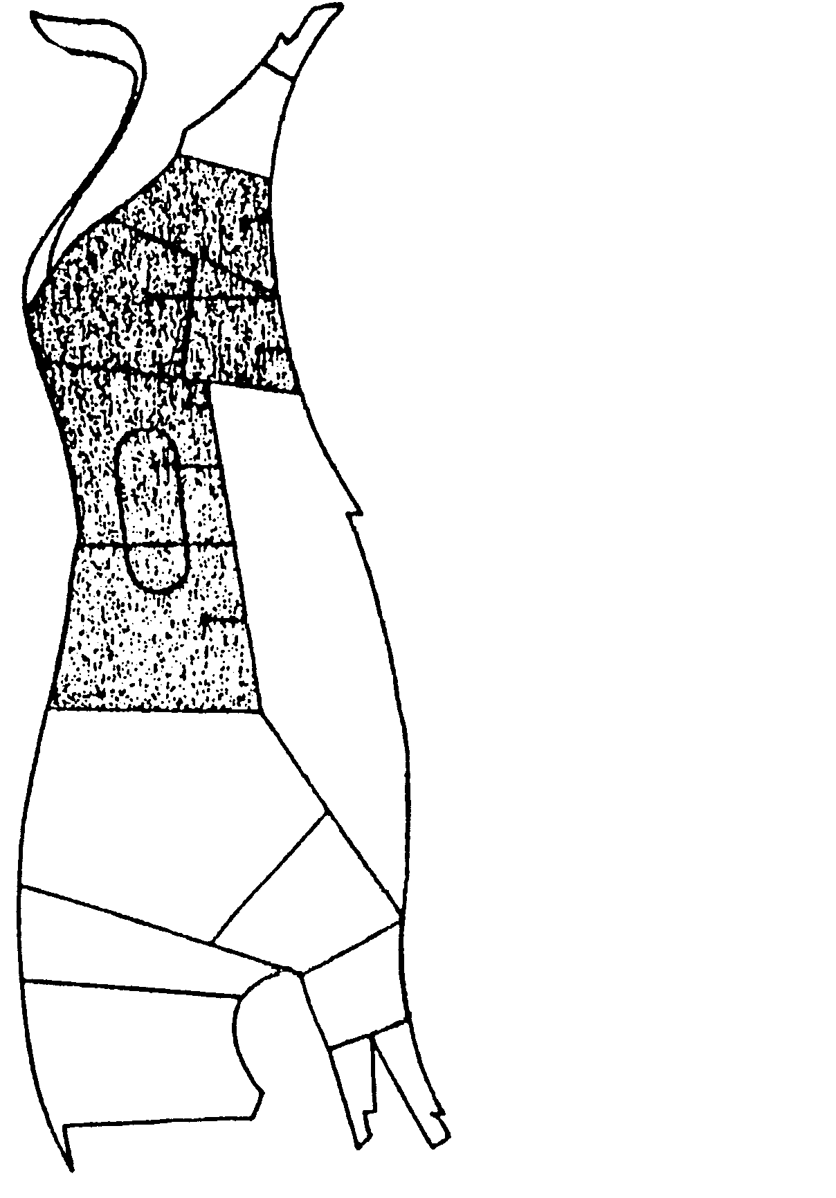
1

2

3
4
5
6
7
8
9

10

11

12
13

Name the different categories of fat in meat.  - What should be observed for long storage of meat so that the quality can be retained?  - List any  6.10.1 SEVEN meat products.  6.10.2 waste products. | (6)  (7)  (7)  (6)  [100]

QUESTION 7

FARM MECHANICS

Make a list of EIGHT different mortise and tenon joints in woodwork.  - Name SEVEN essential parts of an indirect cooling system of an engine.  - Name all the possible causes when a car pulls to one side when brakes are applied.  - Differentiate between the ordinary power take-off shaft and the live power take-off.  - When welding with oxy-acetylene equipment, certain handling procedures must be adhered to. List SIX.  - Differentiate briefly between positive and gravity circulation in the case of the cooling system of compression engines.  7.7 Name any EIGHT parts of a gearbox. | (8)  (7)  (6)  (5)  (6)  (4)  (8)

- Distinguish between steel and cast iron by comparing their qualities as far as the following are concerned:  7.8.1 Density  - Melting point  - Appearance  - Composition  - Test  - Describe how the bleeding of hydraulic brakes is done.  - Name the essential parts of the lubricating system of an engine.  - What is/are the function(s) of the shock absorber when fitted to the friction plate of the clutch?  - Explain the construction of the concrete floors that are commonly used for sheds, etc.  - Name any SIX advantages of the hydraulic system of a tractor.  - List TEN safety precautions when doing woodwork in a workshop with power equipment. | (2)  (2)  (4)  (6)  (2)  (8)  (6)  (6)  (4)  (6)  (10)  [100]

TOTAL: | 300

