GAUTENG DEPARTMENT OF EDUCATION
SENIOR CERTIFICATE EXAMINATION

AGRICULTURAL SCIENCE SG

TIME: 3 hours

MARKS: 300

REQUIREMENTS:

- An approved (non-programmable) pocket calculator. Candidates must supply their own calculators.

INSTRUCTIONS:

- The examination paper consists of TWO sections, Sections A and B.
- Answer ALL the questions.
- Answer Question 1 (Multiple-choice questions) on the answer sheet on the inside cover of your answer book.
- Please write neatly and legibly.

SECTION A

QUESTION 1
MULTIPLE-CHOICE QUESTIONS

Various possibilities are suggested as answers to the following questions, only one of which is correct. Indicate the correct answer by making a cross (X) over the corresponding letter on the answer sheet on the inside cover of your answer book.

EXAMPLE:

A | B | C | D

NB: If more than one cross appears in an answer, no marks will be awarded.

1.1 In young animals, rickets develop because of a deficiency of

- vitamin D.
- vitamin K.
- vitamin E.
- vitamin A.

1.2 The following mineral neutralizes the acids in soil:

- Phosphorus
- Potassium
- Aluminium
D. Hydrogen

1.3 An example of working capital on a farm:

- Herbicides
- Tractors
- Breeding stock
- Fruit trees

1.4 ______ is the state where demand is equal to supply.

- Floor price
- Ceiling price
- Surplus removal
- Market equilibrium

1.5 Bile is the secretion of the

- small intestine.
- villi.
- liver.
- pancreas.

1.6 Which cation is predominant in brackish soil?

- Ca++
- H+
- Na+
- Mg++

1.7 Which one of the following plants propagates by means of rhizomes?

- Potatoes
- Irises
- Strawberries
- Roses

1.8 Which veld-type is found in the largest part of the Free State?

- Machia
- Bushveld Savannah
- Grassveld
- Bush Savannah

1.9 The Karoo can be classified as

- semi-desert.
- desert.
- savannah.
- grassland.

1.10 An outcome of a soil survey is

- soil utilization.
- soil mapping.
- pasture utilization.
- area and farm planning.

1.11 Where does the production of spermatogonia take place?

- Epididymis
- Seminiferous tubules
- Cells of Sertoli
D. Glands of Cowper

1.12 During which phase are cows sexually active?  - Met-oestrus  - Oestrus  - Pro-oestrus  - Di-oestrus  1.13 A dark colour in the A-horizon can be attributed to  - a high organic matter content.  - soil organisms.  - iron.  - stones.  1.14 The fertilizer which contains 46% nitrogen is  - ammonium sulphate.  - super phosphate.  - LAN.  - urea.  1.15 The evaporation pan is used in  - scheduled irrigation.  - crop rotation.  - animal nutrition.  - soil science. 15 x 2= | [30]

QUESTION 2

2.1 Supply the correct agricultural term for each of the following descriptions:

2.1.1 A soil with a single dominant colour
2.1.2 A vertical section through soil showing the different soil horizons
2.1.3 The ability of the soil to hold a given quantity of water, after complete saturation and drainage have taken place
2.1.4 The structure found in the rumen of a calf by which milk is directly taken to the abomasum
2.1.5 The soft, bag-like enlargement in the oesophagus of fowl
2.1.6 The process by which the ripe ovum is released into the infundibulum
2.1.7 The cell plastid in which photosynthesis takes place
2.1.8 The mating of closely related animals like mother and son
2.1.9 The apparatus used by irrigation farmers to measure the moisture tension of soil
2.1.10 The amount of money that farmers have to pay back which is more than the amount borrowed
2.1.11 The energy released when a substance is completely oxidized to carbon dioxide, water and gases
2.1.12 The cultivation of a single crop on the same soil, year after year
2.1.13 The dropping of already set fruitlets or flowers
2.1.14 A potassium fertilizer needed for soil with a high sodium content
2.1.15 The element in a soil which is required in large quantities by plants  2.1.16 The phenomenon which occurs when a heifer is neither male nor female  2.1.17 The ulceration and deformation of the cornea of the eye which can lead to blindness  2.1.18 The carbohydrate stored in the liver and muscles of animals  2.1.19 The removal of excess water from the soil by artificial means  2.1.20 The form of marketing whereby the producer markets his product at his own discretion 20 x 2 = | (40)

2.2 Complete the following statements by filling in the missing words. Write only the missing word next to the corresponding question number in your answer book.  2.2.1 The primary reproductive organ of a bull is the ________.  2.2.2 The upward movement of water through micro-pores takes place by means of ________.  2.2.3 The slope plays a major role in ________.  2.2.4 The ________ is a place where buyers and sellers meet and trade.  2.2.5 ________ is necessary for clotting of blood. 5 x 1 =  TOTAL FOR SECTION A: | (5)  [45]  [75]

SECTION B

Start each question on a new page. Answer all questions in point format.

QUESTION 3

3.1 Name FIVE factors favourable for the decomposition of organic matter.  3.2 Name FIVE factors that can be applied to sandy soil to improve its productivity.  3.3 Name FIVE ways in which the farmer contributes to the destruction of soil structures.  3.4 Name SEVEN factors that help to determine the colour of soil.  3.5 State the procedure used for soil classification in South Africa.  3.6 Describe the physical influences of organic matter on soil.  3.7 Name the form of water loss that is prevented by the following measures:  3.7.1 Contour walls  3.7.2 Eradicate weeds  3.7.3 Surface cover  3.7.4 Controlled irrigation | (5)  (7)  (5)  (7)  (5)  (5)  (4)

3.8 Define the term accessible soil water. | (2)  [40]

QUESTION 4

4.1 Study the following diagram of the alimentary canal of a pig and answer the questions that follow.
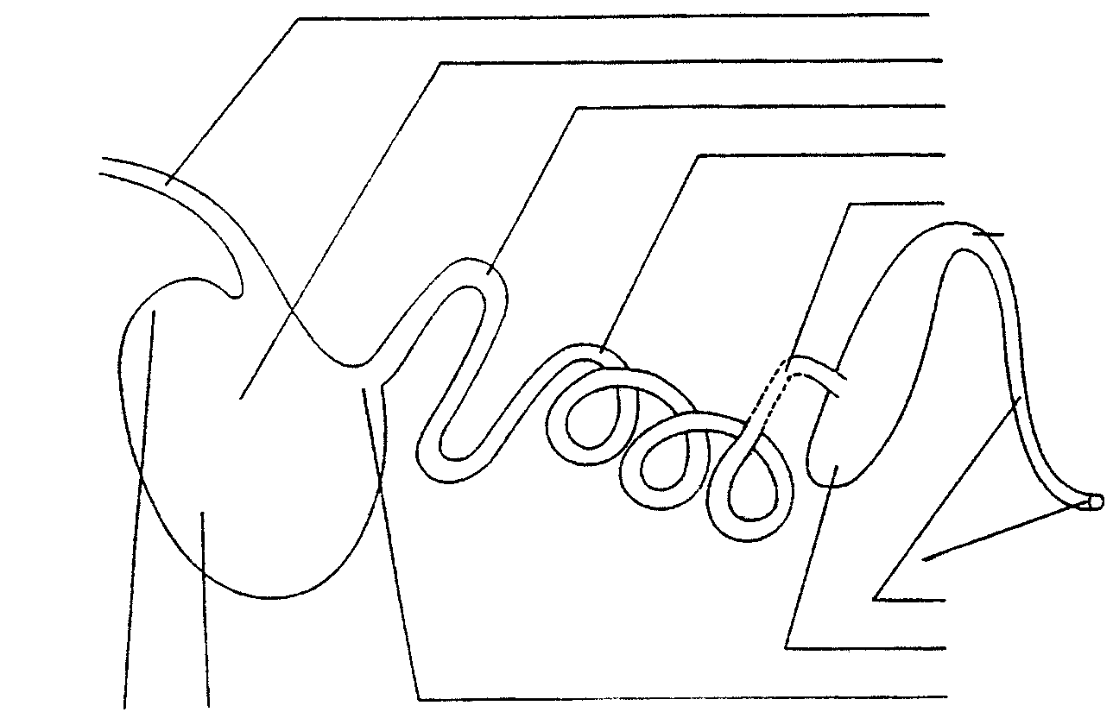
1
2

3
4
5
6

7
8

9

4.1.1 Label parts 1 to 9.  4.2 4.2.1 What do we call this type of stomach?  4.2.2 Name the antiseptic substance secreted by the gland in the stomach.  4.2.3 Name the secretion produced by number 7.  4.2.4 Name SIX functions of the secretion produced by number 7.  4.3 Write short notes on the following:  4.3.1 The functions of saliva  4.3.2 The functions of micro-organisms in ruminant digestion  4.3.3 The requirements for microbe activity in the rumen  4.4 Name the nutrient deficiency responsible for each of the following:  4.4.1 Goitre  4.4.2 Wasting disease  4.4.3 Anaemia  4.4.4 Night blindness | (9)  (1)  (1)  (1)  (6)  (5)  (4)  (4)  (1)  (1)  (1)  (1)

4.5 Name FIVE methods of mineral supplementation in animal nutrition.  4.6 List FIVE factors which determine the digestibility of a feed. | (5)  (5)  [45]

QUESTION 5

5.1 Study the schematic representation of spermatogenesis and answer the questions that follow.
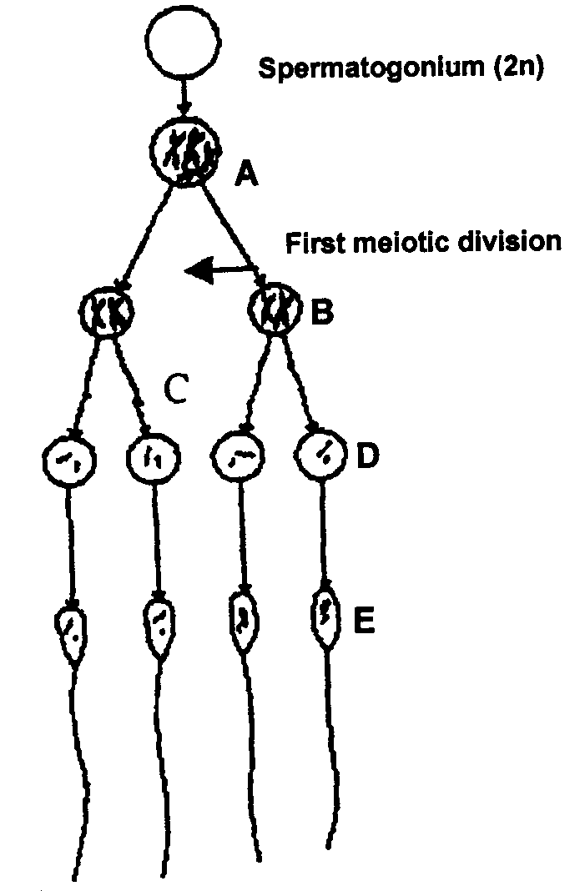

5.1.1 Identify parts labelled A to E.  5.1.2 In which organ does this process occur?  5.1.3 Which organ is responsible for the maturation of the product of spermatogenesis?  5.1.4 Which cells are responsible for the nourishment of the product mentioned in the above process? | (5)  (1)  (1)  (1)

5.2 Which organ is the primary reproductive organ of a bull?  5.3 Name the functions of the following:  5.3.1 Scrotum  5.3.2 Prostate gland  5.3.3 Penis | (1)  (2)  (3)  (2)

5.4 Which signs indicate that a cow is about to give birth?  5.5 Describe the second stage of parturition (birth) in cows.  5.6 Briefly describe the factors that cause infertility under the following headings:  5.6.1 Lack of libido in bulls  5.6.2 Infertility in cows  5.7 Name FOUR advantages of inbreeding. | (4)  (8)  (6)  (7)  (4)  [45]

QUESTION 6

6.1 Study the diagrammatic representation of a wheat flower and answer the questions that follow.

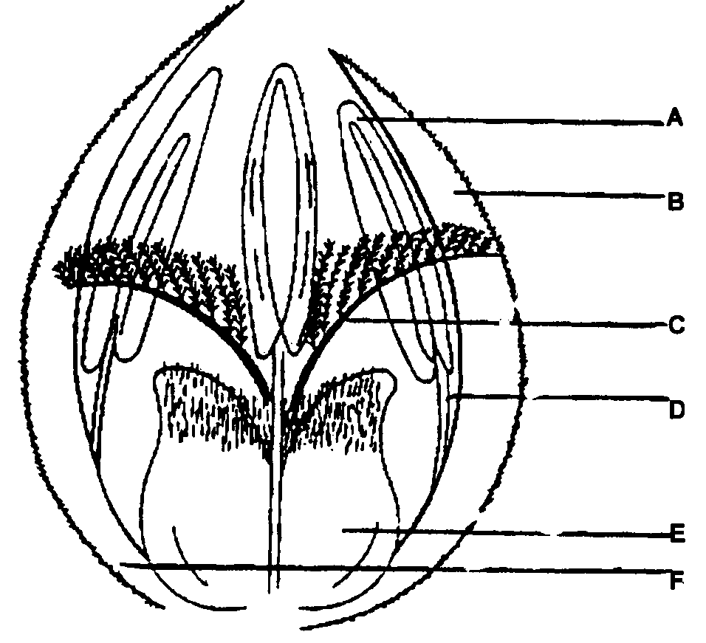

A

B

C

D

E
F

6.1.1 Identify the parts labelled A to F.  6.1.2 What are the functions of the parts labelled A and E? | (6)  (2)

6.2 Compare a monocotyledonous flower with a dicotyledonous flower in table form.  6.3 Briefly state the functions of the following parts of a dicotyledonous flower:  6.3.1 Pedicel  6.3.2 Receptacle  6.3.3 Petal corolla  6.4 Discuss artificial pollination with special reference to the following:  6.4.1 What is meant by artificial pollination?  6.4.2 Where is artificial pollination applied?  6.4.3 How can self-pollination in the seed parent be prevented?  6.4.4 How can the flowers be protected from foreign pollen? | (10)  (3)  (2)  (2)  (2)  (2)

6.5 What is the importance of nitrogen in plant nutrition?  6.6 List FOUR factors which influence the composition of farm manure.  6.7 What are the functions of water in plants?  6.8 Define the concept grafting. | (6)  (4)  (5)  (2)  [46]

QUESTION 7

7.1 Spray irrigation will give the best results under certain circumstances. Name six of these circumstances.  7.2 Explain the concept crop rotation.  7.3 Discuss SIX advantages of micro-irrigation.  7.4 List EIGHT examples of how injudicious agricultural practices can cause pollution of the environment.  7.5 Name seven advantages of mulch cultivation in crop production.  7.6 List SIX ways of improving the productivity of farm labourers.  7.7 Name and briefly describe the THREE types of capital involved in farming. Supply an example of each type of capital.  7.8 State FOUR advantages of free marketing.  TOTAL FOR SECTION B:  TOTAL: | (6)  (2)  (6)  (8)  (7)  (6)  (6)  (4)  [45]  [225]  300

