GAUTENG DEPARTMENT OF EDUCATION

SENIOR CERTIFICATE EXAMINATION

AGRICULTURAL SCIENCE SG

TIME: 3 hours

MARKS: 300

REQUIREMENTS:

- An approved (non-programmable) pocket calculator. Candidates must supply their own calculators.

INSTRUCTIONS:

- The examination paper consists of TWO sections.
- Answer ALL the questions.
- Answer Question 1 (Multiple-choice questions) on the answer sheet on the inside cover of your answer book.
- Please write neatly and legibly.

SECTION A

QUESTION 1
MULTIPLE-CHOICE QUESTIONS

Various possibilities are suggested as answers to the following questions, only one of which is correct. Indicate the correct answer by making a cross (X) over the appropriate letter next to the question number on the answer sheet on the inside cover of your answer book.

EXAMPLE:

A | B | C | D

NB: If more than one cross appears in an answer, no marks will be awarded.

  - The vitamin essential for blood clotting is

A. vitamin A.
- vitamin C.
- vitamin D.
D. vitamin K.

  - The fertilization of an ovum by a sperm cell takes place in the

- fallopian tubes.
- follicles.
- vagina.
D. cervix.

  - The parotid salivary glands are situated

- below the ears.
- underneath the tongue.
- above the tongue.
- below the lower jaw.

  - In the alimentary canal of fowl food is stored in the

- gizzard.
- proventriculus.
- crop.
- small intestine.

  - Which portion of the alimentary canal of a ruminant contains micro-organisms that help with digestion?

- Oesophagus
- Rumen
- Small intestine
- Pharynx

  - The aim of oestrus synchronisation is

- to facilitate management.
- to achieve greater uniformity of the progeny.
- Both A and B.
- to improve meat production.

  - Hydrochloric acid in gastric juice changes

- protein to amino acids.
- fats to glycerol and fatty acids.
- sucrose to glucose and fructose.
- peptides to amino acids.

  - Which one of the following colours indicates that the soil was formed from sandstone and contains very few iron compounds?

- Yellow
- Dark
- Red
- A light colour

  - Soil classified as acid soil contains excess

- hydrogen ions.
- magnesium ions.
- sodium ions.
- calcium and magnesium ions.

  - A _________ is an example of a simple fruit.

- fig
- pineapple
- tomato
- raspberry

  - Milk fever indicates a deficiency of

- phosphorus.
- vitamin D.
- magnesium.
- calcium.

  - Example(s) of working capital:

- Dams
- Fertilizers
- Cattle
- Machinery

  - Which one of the following is an example of an overhead sprinkler irrigation system?

- Micro-irrigation
- Drip irrigation
- Spray irrigation
- Flood irrigation

  - A factor influencing the supply of a product is the

- usage of goods.
- prices of competitive goods.
- sacrifice and expenses.
- buying power of the consumer.

  - Savannah is always associated with

- sparse grass covering.
- the Karoo.
- succulents.
- the Western Cape.

  - Ovulation in cows occurs during

- pro-oestrus.
- met-oestrus.
- di-oestrus.
- oestrus.

  - What is the percentage of nitrogen contained in the fertilizer mixture 3:1:5 (38)?

- 12.7% nitrogen
- 4.2% nitrogen
- 10% nitrogen
- 15% nitrogen

  - Example(s) of fixed capital:

- Buildings
- Fertilizers
- Machinery
- Livestock

- The most concentrated nitrogeneous fertilizer in South Africa is  - limestone ammonium nitrate.  - urea.  - potassium sulphate.  - superphosphate.  - ________ are examples of parthenocarpic fruit.  - Figs  - Navel oranges  - Pears  D. Pawpaws 20 x 2 = | [40]

QUESTION 2

2.1 Supply the correct term for each of the following descriptions:  2.1.1 A disease which results in the ulceration of the cornea of the eyes, which can lead to blindness  2.1.2 The soil fraction that has a diameter less than 0,002mm  2.1.3 The process whereby a ripe ovum is released from the Graafian follicle  2.1.4 The small fingerlike growths of the mucous membranes of the small intestine  2.1.5 The organ in the bull where sperms reach maturity and achieve full mobility  2.1.6 The transfer of ripe pollen from the anther to the ripe, receptive stigma of another flower on the same plant  2.1.7 The phenomenon where plant growth changes from one community to another until climax plant species are established  2.1.8 The information needed for scientific planning of a country’s total land surface  2.1.9 The apparatus used by irrigation farmers to measure the moisture tension of soil  2.1.10 The type of drainage system which is used for the fast transportation of surface water  2.1.11 Too much capital invested in farming in relation to land and available labour  2.1.12 The energy application which refers to the human action, physical or mental, aimed at the achievement of a useful goal  2.1.13 The problem related to soil which implies that maximum production does not necessarily mean maximum profit  2.1.14 The phase of photosynthesis during which the water molecule is split  2.1.15 The process by which food is moved through the alimentary canal  15x2 = | [30]

2.2 Match the definition in Column A with the term in Column B. Only write down the question number and the appropriate letter next to it, e.g. 2.2.11 M.

COLUMN A  DEFINITION |  | COLUMN B  TERM
2.2.1 | Compared with the simple stomach of a pig | A. | Bulk density
2.2.2 | Stored carbohydrates in the animal body | B. | Tensiometer
2.2.3 | Cross-breeding | C. | Dicotyledonous flower
2.2.4 | Mass of a soil sample (total volume of soil) | D. | Spray irrigation
2.2.5 | Capillary water movement | E. | Sertoli cells
2.2.6 | Receptacle carries various corollas | F. | Organic matter
2.2.7 | Uniform application of water | G. | Abomasum
2.2.8 | Irrigation scheduling | H. | Leydig cells
2.2.9 | Responsible for feeding and development of sperms | I. | Glycogen
2.2.10 | Dark soil colour | J. | Microspores
 |  | K. | Bonsmara
 |  | L. | Glucose
10x1 = [10]

TOTAL FOR SECTION A: | [80]

SECTION B
QUESTION 3

3.1 Study the following illustration of the different ways in which water can be lost in agriculture, then answer the questions that follow.

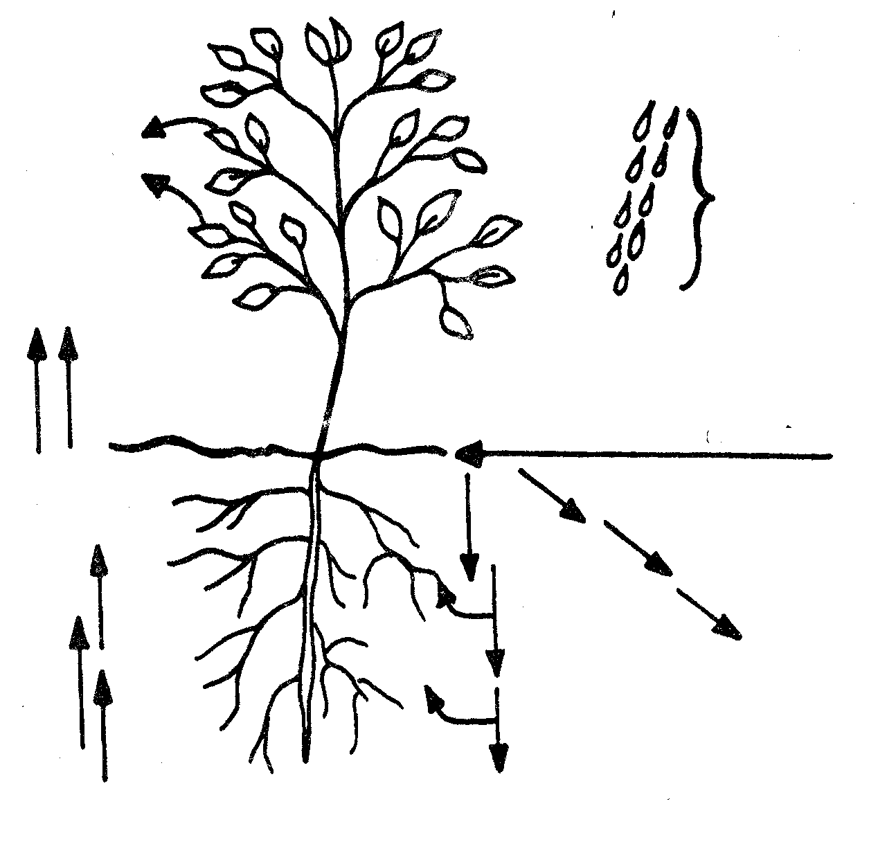
precipitation
soil surface
b
a
f
d
c
e

3.1.1 Identify the different ways in which water is lost according to the arrows labelled a to d.  3.1.2 Indicate how the loss identified in (a) can be controlled.  3.1.3 Identify the movement of water, as illustrated by (f).  3.1.4 Name the form of water loss that is prevented by contour walls.  3.1.5 State FIVE factors that play a role in the development of soil structure.  3.1.6 Explain what is meant by soil is an open system.  3.1.7 Define soil profile and soil horizon.  3.1.8 Which soil factors can influence soil temperature?  3.1.9 Give FIVE harmful effects of black brack on soil.  3.1.10 List FIVE soil-forming factors. | (4)  (5)  (1)  (1)  (5)  (3)  (4)  (7)  (5)  (5)  [40]

QUESTION 4

4.1 Study the diagrammatic representation of the alimentary canal of cattle and answer the questions that follow.

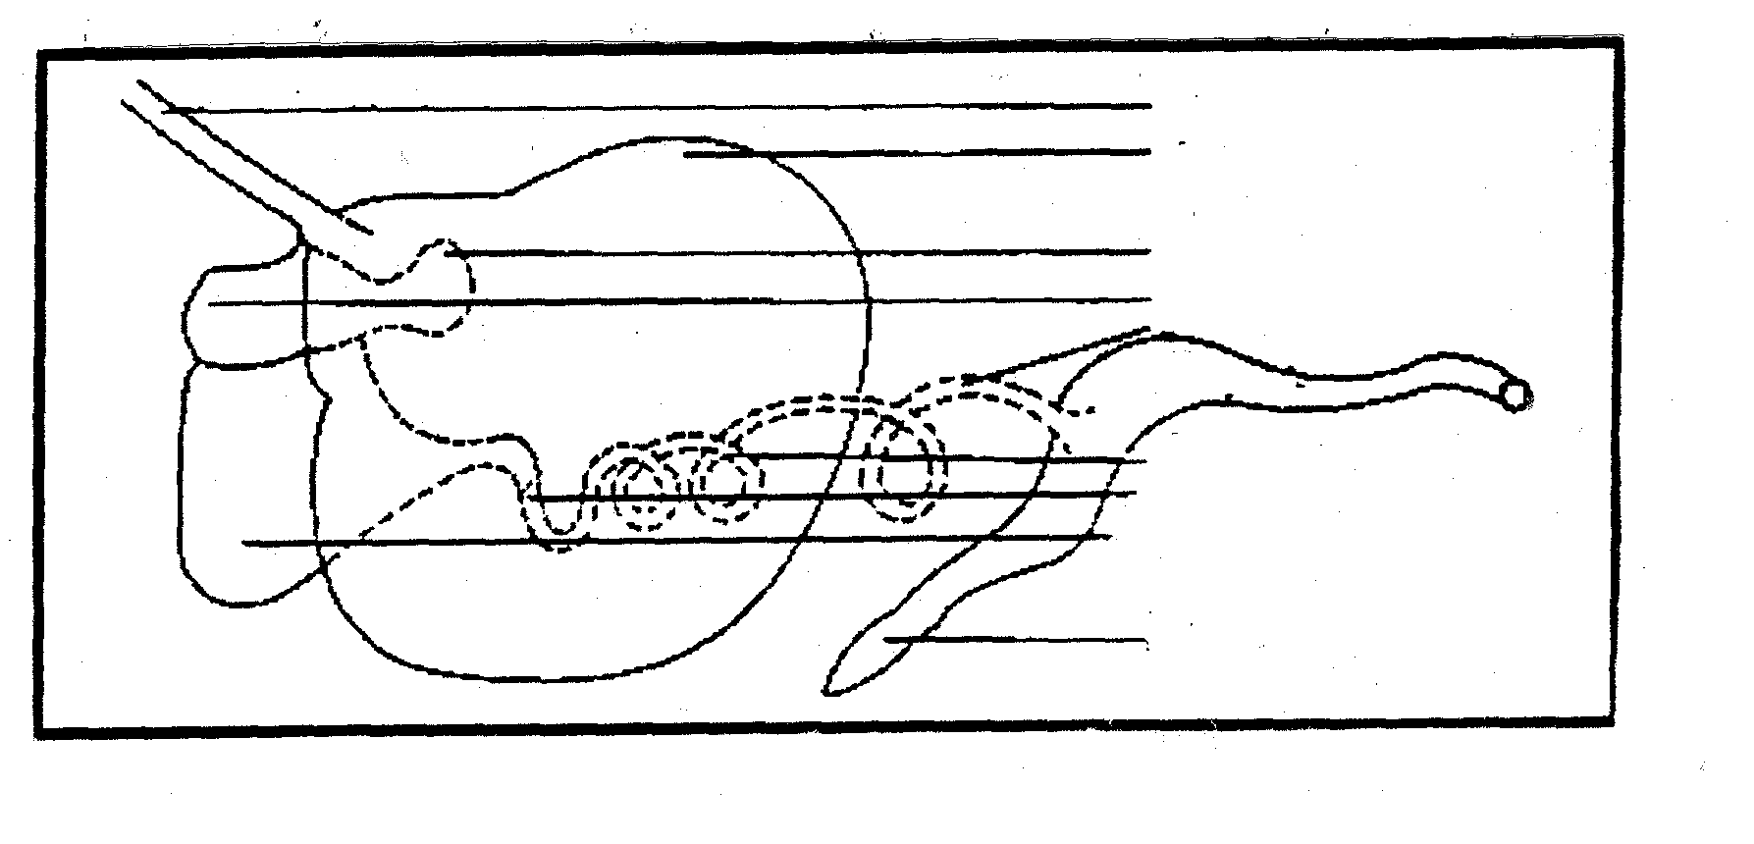
A
B

C
D
E

F
I
J

K
G
H

4.1.1 Label parts A to J.  4.1.2 Write down the relevant letter from the diagram that represents the part of the alimentary canal where each of the following occurs:  - Grinding and drying-out of feed  - No digestive juices or enzymes secreted  - Excretion of waste products  - Absorption of feed  - Absorption of water | (10)  (5)

4.2 List THREE requirements for micro-organisms.  4.3. State the functions of bile.  4.4 Vitamin A deficiency gives rise to various symptoms. Name NINE of these symptoms.  4.5 List SEVEN factors that determine the digestibility of feeds. | (6)  (8)  (9)  (7)  [45]

QUESTION 5

5.1 Study the schematic representation of the reproductive organs of a bull and answer the questions that follow.

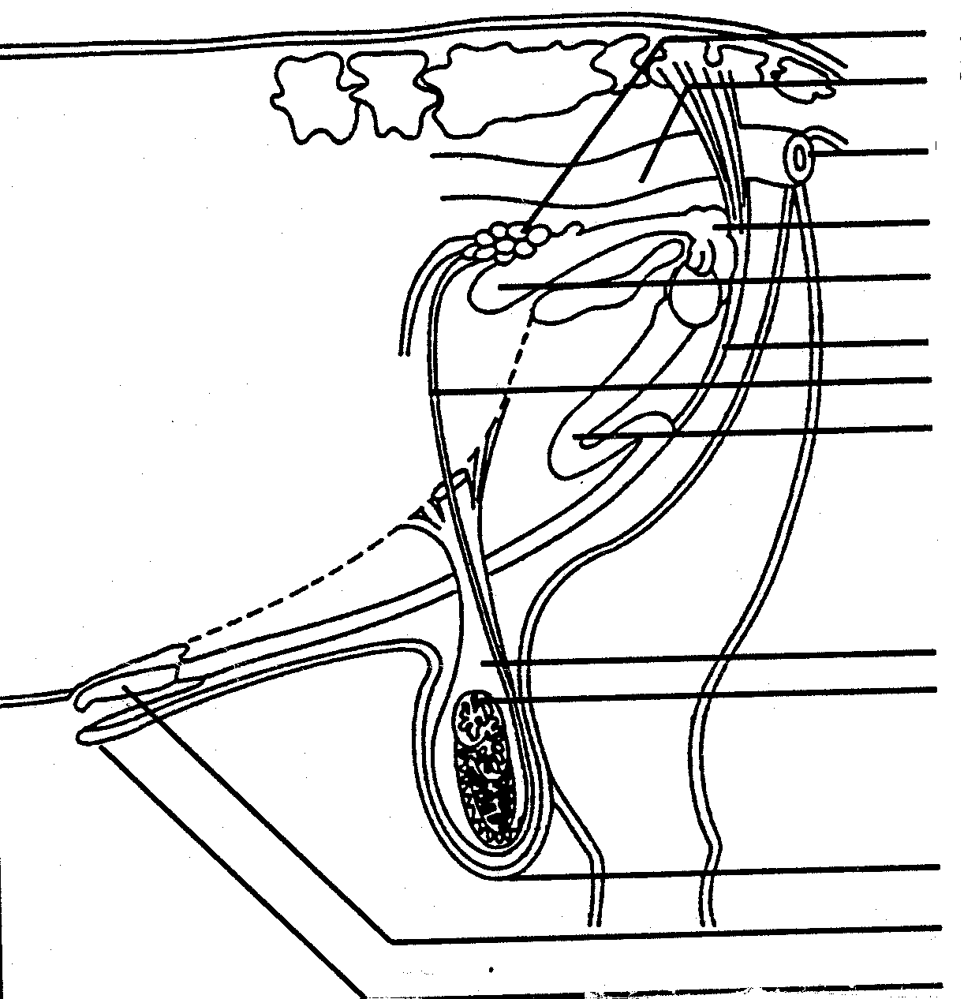
A

B

C

D

E

F

G

H

I

J

K

L

M

5.1.1 Label parts A to M.  5.1.2 Which letter on the sketch represents the part where the following takes place?  - Production of the male sex hormone  - Transports semen during mating  - Temperature control mechanism during spermatogenesis  - Transport and store sperm cells  5.2 List SIX factors which cause a lack of libido.  5.3 Name SIX characteristics whereby oestrus is identified in cows.  5.4 Name SEVEN causes of infertility in cows.  5.5 Name any SIX advantages of artificial insemination.  5.6 Name THREE disadvantages of cross-breeding. | (13)  (4)  (6)  (6)  (7)  (6)  (3)  [45]

QUESTION 6

6.1 Study the diagrammatic representation of a dicotyledonous flower and answer the questions that follow.

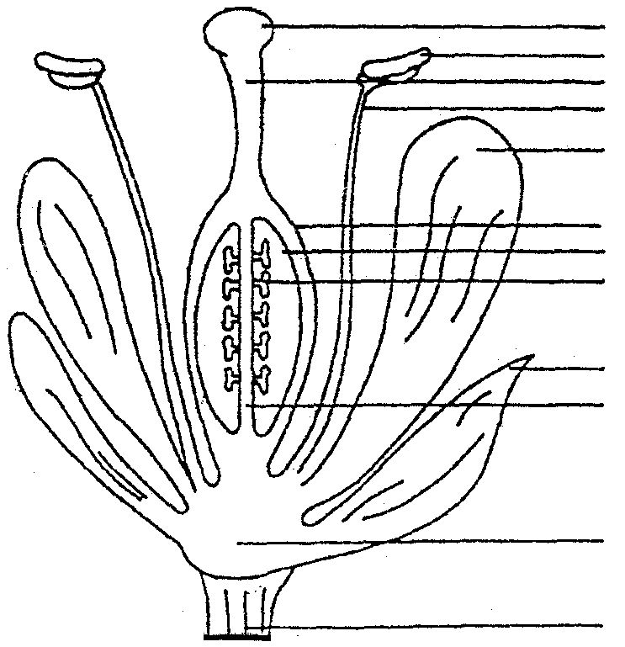
A
B
C
D

E

F
G
H

I

J

K

L
M

6.1.1 Identify the parts labelled A to L.  6.1.2 What are the functions of the following parts?  (a) A  (b) C  (c) E  6.2 Discuss pollination under the following headings:  6.2.1 Self-pollination  6.2.2 Artificial cross-pollination  6.2.3 Agents for cross-pollination  6.3 Calculate the percentage plant nutrients in the fertilizer mixture 3:1:5 (26).  6.4 Discuss black brak under the following headings:  6.4.1 Prevention  6.4.2 Reclamation  6.5 Discuss the importance of water in plants. | (12)  (3)  (2)  (2)  (6)  (7)  (3)  (5)  (5)  [45]

QUESTION 7  7.1 Name the FIVE main types of natural veld.  7.2 List the SIX steps followed when soil surveys are conducted.  7.3 Discuss crop rotation under the following headings:  7.3.1 SIX advantages  7.3.2 Conditions under which it is not recommended | (5)  (6)  (6)  (3)

7.4 Briefly discuss the following with reference to micro-irrigation systems:  7.4.1 FOUR advantages  7.4.2 THREE disadvantages  7.5 The rate of soil erosion has increased in Southern Africa.  Name SIX reasons for this state of affairs.  7.6 Name FOUR factors that determine the supply of agricultural products.  7.7 Answer the following on free marketing:  7.7.1 Define free marketing.  7.7.2 List SIX advantages of free marketing.  TOTAL FOR SECTION B:  TOTAL: | (4)  (3)  (6)  (4)  (2)  (6)  [45]  [220]  300

