GAUTENG DEPARTMENT OF EDUCATION
SENIOR CERTIFICATE EDUCATION

AGRICULTURAL SCIENCE HG

TIME: 3 hours

MARKS: 400

REQUIREMENTS:

- An approved (non-programmable) scientific pocket calculator

INSTRUCTIONS:

- Answer ALL the questions.
- Answer Questions 1A (Multiple-Choice Questions) on the answer sheet on the inside cover of your answer book.
- Use the same numbers as those in the examination paper, e.g. 2.1.1.
- Please pay attention to the legibility of your writing and the neatness of your work.

SECTION A

QUESTION 1A

MULTIPLE-CHOICE QUESTIONS

1.1 The following questions are provided with four possible answers of which only ONE possibility is correct in each case. Indicate the answer of your choice by making a cross (X) over the corresponding letter next to the question on the answer sheet on the inside cover of your answer book, for example:

A | B | C | D

1.1.1 The presence of manganese changes the colour of quartz to

- purple.
- brown.
- black.
- yellow.

1.2 Soil with a red colour indicates the presence of

- lime.
- organic matter.
- iron oxides.
- aluminium compounds.

1.1.3 A soil which contains iron in the ferric form has

- no oxygen.
- a yellow colour.
- enough oxygen.
- a large amount of calcium.

1.1.4 Haematite in soil is responsible for

- a red colour.
- a yellow colour.
- a black colour.
- flecks.

1.1.5 Unsaturated flow of water means water

- flows from high tension areas to low tension areas.
- flows upwards.
- flows downwards.
- flows from low tension areas to high tension areas.

1.1.6 Which one of the following does not determine the speed of percolation through soil?

- Infiltration capacity of topsoil
- Drainage of subsoil
- Microbe activity in the soil
- The water capacity of the soil

1.1.7 An organic fertilizer which increases the nitrogen content of the soil, is

- limestone ammonium nitrate.
- rock phosphate.
- guano.
- agricultural lime.

1.1.8 The sac-like membrane which surrounds the animal embryo and embryonic fluid, is the

- allantois.
- chorion.
- placenta.
- amnion.

1.1.9 The process during which a climax vegetation is replaced by a community lower in the succession pattern is called

- plant succession.
- plant composition.
- retrogression.
- crop rotation.

1.1.10 In soil there are two types of colloid, viz

- clay and organic material.
- silt and clay.
- clay and vermiculite.
- organic matter and silt.

1.1.11 The apparatus used to place the semen into the uterus of a cow during artificial insemination is known as a

- pulsator.
- emasculator.
- pistilet.
- burdizzo.

1.1.12 Dolomitic agricultural lime is mostly applied on acid sandy soils where the rainfall is high, because the soils are poor in

- Ca and K.
- Ca and Mg.
- Ca and Fe.
- Ca and Mn.

1.1.13 In one bag of 3.2.1 (26) there is ______ kg of nitrogen.

- 4,3
- 6,5
- 8,5
- 13

1.1.14 ________ are examples of vegetative parthenocarpic fruit.

- Currants
- Peaches
- Strawberries
- Bananas

1.1.15 The end product of the dark phase of photosynthesis is

- ATP.
- O₂.
- carbohydrates.
- protein.

1.1.16 The hormone in the female animal responsible for the flow of milk, is

- oxytocin.
- oestrogen.
- progesterone.
- prolactin.

1.1.17 The duration of the oestrus cycle of cows is normally an average of _________ days.

- 19
- 20
- 21
- 22

1.1.18 The hormone secreted by the corpus luteum that maintains pregnancy, is

- oestrogen.
- relaxin.
- oxytocin.
- progesterone.

1.1.19 The cation on which colloids have the weakest hold, is

- hydrogen.
- potassium.
- calcium.
- sodium.

1.1.20 Spermatozoa are mainly stored in the

- vas deferens.  - epididymis.  - urethra.  - ovaries. | 20x2=(40)

QUESTION 1 B

1.2 Write down the correct term for each of the following descriptions next to the corresponding number in your Answer Book.

1.2.1 The enzyme in the intestinal juice that is responsible for the digestion of fats.

1.2.2 The veld type found in sandstone soils in the winter rainfall region.

1.2.3 The hormone used for synchronization of oestrus among cows.

1.2.4 The part of feed energy used by the animal during labour, for maintenance of body temperature and the build-up of new products.

1.2.5 The occurrence of one or both testes remaining behind in the body cavity and not descending into the scrotum.

1.2.6 The method of vegetative propagation where the bud of a mother tree is implanted on a suitable root stem.

1.2.7 A cheap, non-protein nitrogen source generally included in the rations of ruminants.

1.2.8 The process in sandy acid soil by which mobilisation and migration of iron and aluminium to the B-horizon takes place.

1.2.9 The disease found in fully grown animals when too much calcium has been removed from their skeletons.

1.2.10 The method used to apply fertiliser to a specific place with respect to the seed or plant.

1.2.11 Soil pores responsible for the drainage and aeration of soil.

1.2.12 The soil moisture content from which plants cannot obtain sufficient water to provide for their transpiration needs.

1.2.13 The fore-stomach of the ruminant that is characterised by numerous leaf-shaped projections.

1.2.14 The fixed ratio between surface evaporation and evapo-transpiration that is taken into account in irrigation scheduling.

1.2.15 The application of fertilizers over the whole surface. | 15x2=(30)

QUESTION 1C

Write the reference letter (capital letters must be used) of the term/phase in Column B which corresponds best with the word(s) in Column A, next to the corresponding number in your answer book.

COLUMN A |  | COLUMN B
1. | Bile salts | A | Testosterone
2. | Insulin | B | A clearly distinguishable succession of soil layers
3. | Acid soil | C | Progesterone
4. | Glycogen | D | Excess hydrogen ions
5. | Cells of Leydig | E | Absorption of fatty acids
6. | Soil profile | F | Highest stage in the process of plant succession
7. | Abomasum | G | Islands of Langerhans
8. | Climax plants | H | Carrier molecule
9. | Active iron absorption | I | Reserve energy source
10. | Colon | J | Constituent of all proteins
 |  | K | Absorption of water
 |  | L | Pioneer plants
 |  | M | Enzymatic digestion

10x2=(20)

QUESTION 1d

Study the schematic representation of a soil profile and answer the questions below.

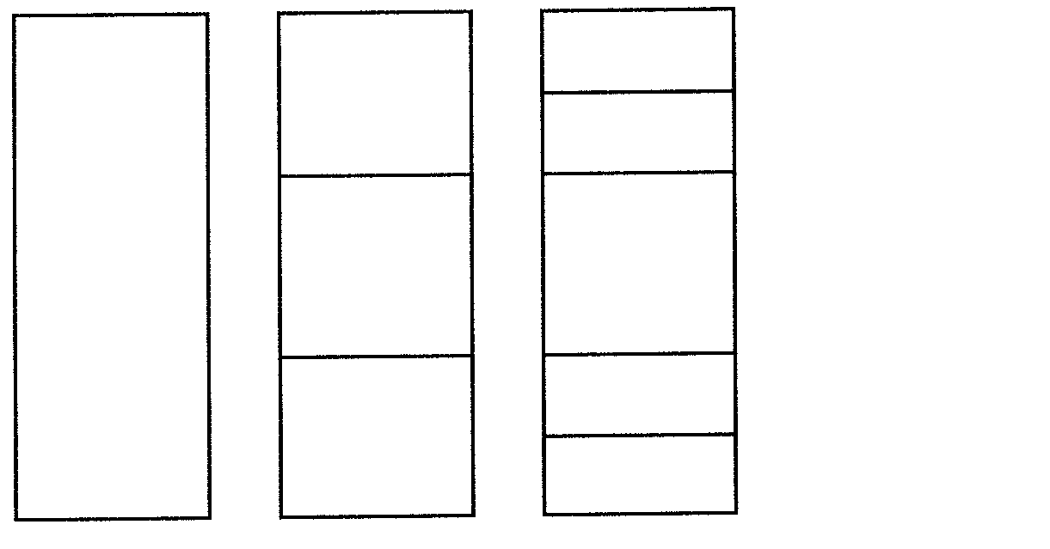
E

B
F

A
C
G
J

H
D
I

Write down the letter of the part from the above diagram where the following is found or takes place:

- The soil forming zone  - Solid rock  - Undecomposed organic matter  - Ideal soil profile  - Concentration of clay  - Unconsolidated material  - Substrata  - Humus  - Oxides of iron, aluminium and manganese  - Subsoil | (10)

TOTAL FOR SECTION A: | [100]

SECTION B

QUESTION 2

Please begin Question 2 on a new page.

2.1 Answer the following questions on soil.

2.1.1 Define a soil

(a) profile.  (b) horizont. | (2)  (2)

2.1.2 What is meant by the statement soil is an open system? | (3)

2.1.3 Name THREE factors that can contribute to a homogeneous soil colour. | (3)

2.2 Study the diagram representing the soil texture and answer the questions that follow.

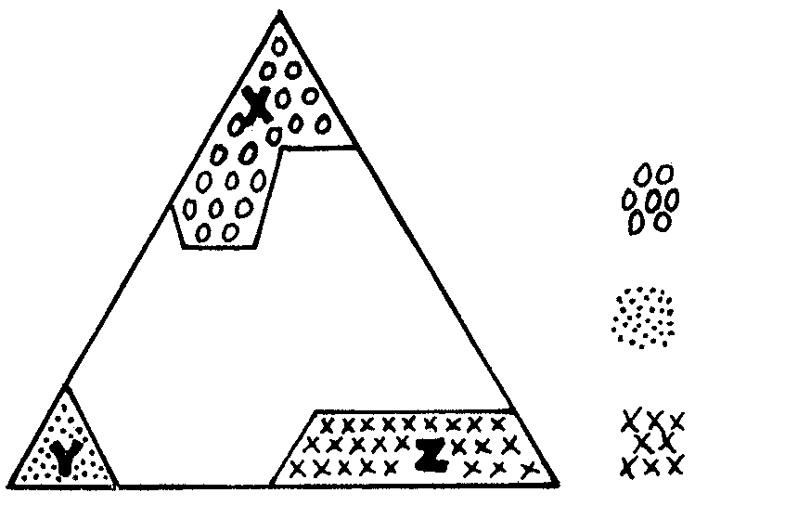

clay

sand

silt

2.2.1 What is meant by soil texture? | (2)

2.2.2 What is the approximate diameter of the fraction marked

(a) X?  (b) Z? | (1)  (1)

2.2.3 Briefly explain the limitation on the productivity of a soil represented by X. | (7)

2.3 A farmer may use the so-called field method to determine soil texture in place of laboratory testing.

2.3.1 Briefly describe the field method process. | (6)

2.3.2 Identify the texture classes of the following: | (4)
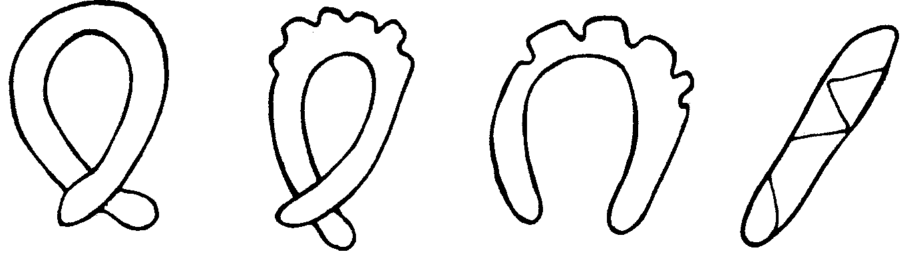
A
B
C
D

2.4 Discuss the influence of soil temperature on crop production under the following headings:

- Slope  - Chemical reaction | (3)  (4)

2.5 Explain the chemical reactions which take place when a brackish soil is treated with gypsum (CaSO₄). | (4)

2.6 Answer the following questions on organic matter:

2.6.1 Name the influences of organic matter on the physical properties of soil.  - Briefly describe the chemical influences of organic matter on soil. | (4)  (4)  [52]

QUESTION 3

3.1 Study the following diagram and answer the questions which follow.
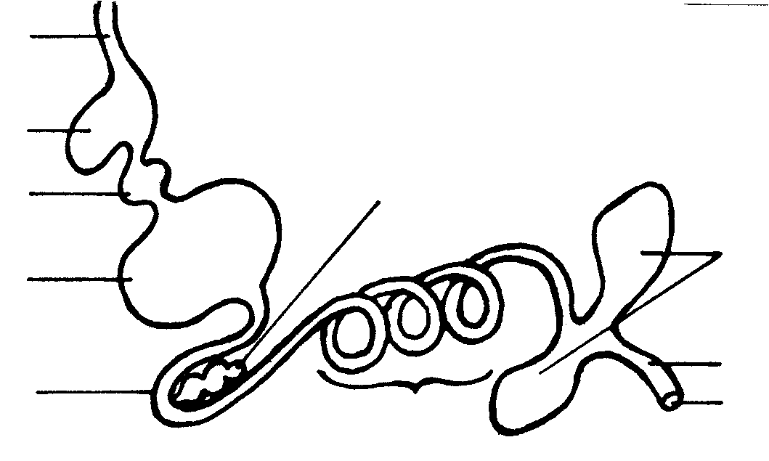
(i)
(vi)
(vii)
(viii)
(ix)
(x)

(ii)

(iii)

(iv)

(v)

3.1.1 Name the farm animal that has a digestive system indicated above. | (1)

3.1.2 Give the name and number of the part in which the following takes place:

(a) Hydrochloric acid is secreted  (b) Digested nutrients are absorbed  (c) The grinding of food  (d) The storage and softening of food  (e) The depositing of pancreatic juice | (1)  (1)  (1)  (1)  (1)

3.1.3 How are parts (iii) and (iv) structurally adapted to perform their functions? | (2)

3.1.4 Label the parts (i) to (vi). | (6)

3.2 Briefly discuss the functions of the micro-organisms in the rumen. | (9)

3.3 Answer the following questions based on carbohydrates.

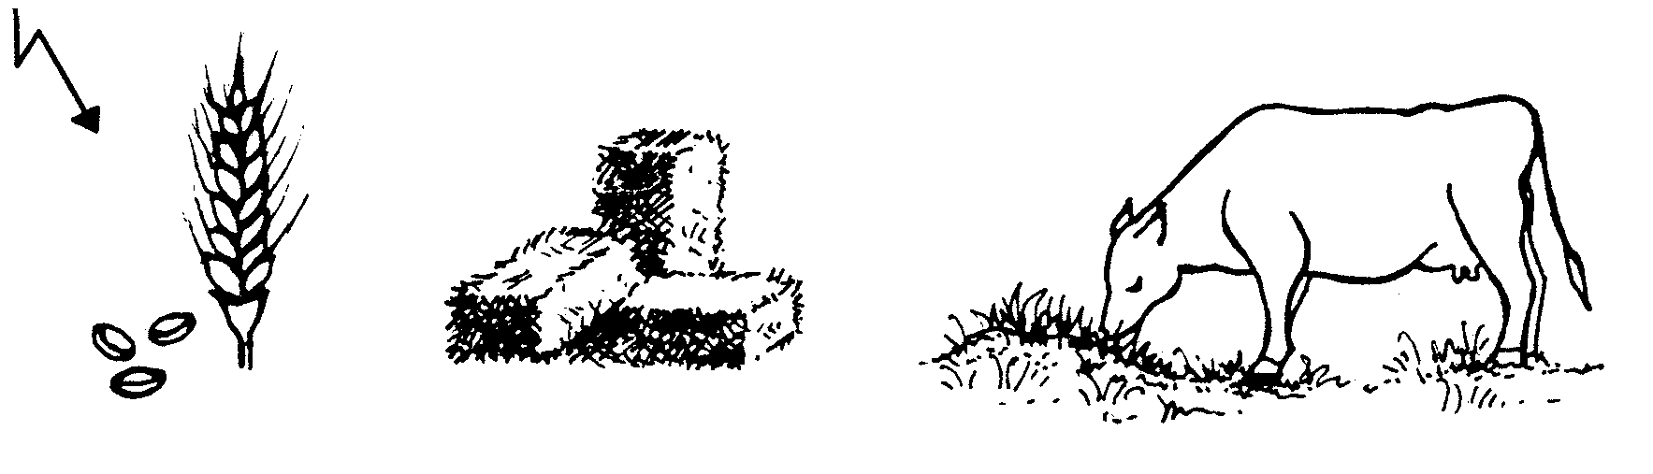
radiant energyA
A
B
C

wheat
veld hay
grazing

3.3.1 Name the process during which carbohydrates are formed in plants (diagram A). | (1)

3.3.2 Name TWO examples of crude fibre as illustrated by diagrams B and C. | (2)

3.3.3 Name THREE reasons why crude fibre is an essential substance of a ration. | (3)

3.3.4 Name the functions of carbohydrates. | (5)

3.4 Calculate the digestible dry material coefficient of the following:

A cow ate 30 kg of hay with moisture content 10%.  8 Kg manure was excreted with a moisture content of 25%. | (8)

3.5 Give a diagrammatic summary to illustrate the relationship between different measures of feed energy. | (8)  [50]

QUESTION 4

4.1 Study the illustration below and answer the questions which follow.

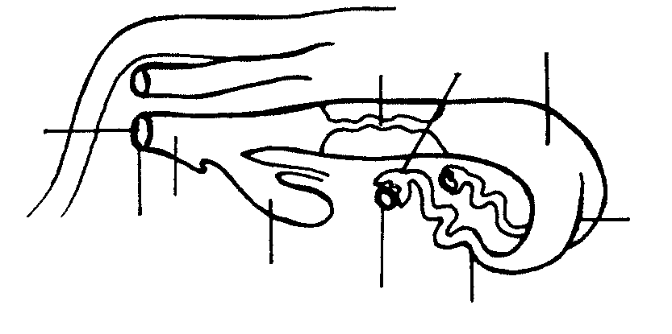
D
B
C

A

I
E
J

H
F
G

4.1.1 Which letter represents the primary sex organ? | (1)

4.1.2 Which letter represents the area where fertilisation takes place? | (1)

4.1.3 The implantation of the blastocyst takes place in the area labelled _________. | (1)

4.1.4 Which letter represents the area where semen is placed during artificial insemination? | (1)

4.1.5 Out of which THREE layers do number D consist? | (3)

4.1.6 Provide labels for parts A to H. | (8)

4.2 Give a schematic representation of the spermatogenis process. | (7)

4.3 Answer the following questions on crossbreeding:

4.3.1 Name the most distinctive feature of in-crossbreeding. | (2)

4.3.2 List the advantages of in-crossbreeding. | (7)

4.3.3 Give reasons for why one should not apply in-crossbreeding. | (3)

4.4 Study the diagram and answer the questions set on it.
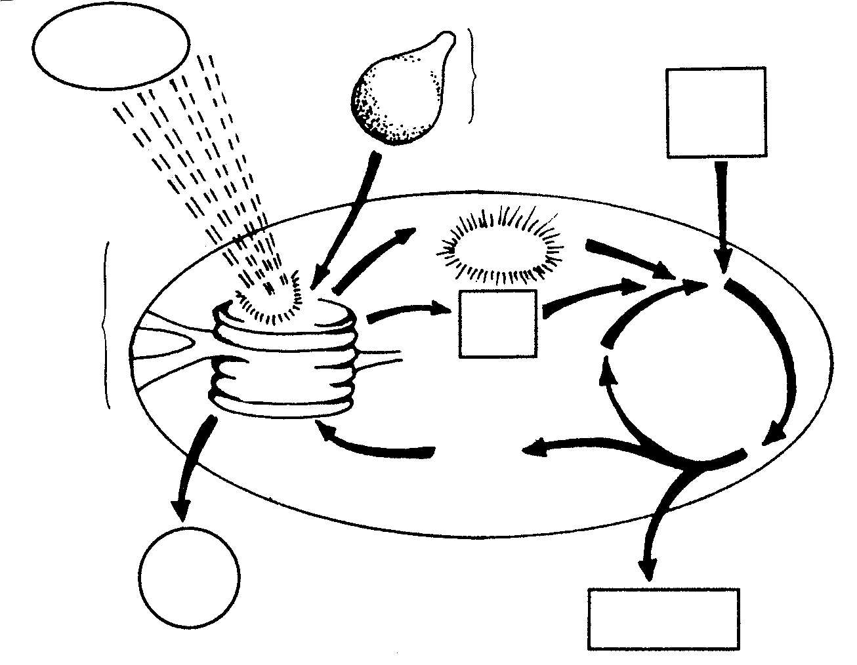
1 energy
inorganic molecule from the
soil

2
3
gas

7

8
plastid
4
pigment
9
ADP
NADP

5
6

4.4.1 Define the process illustrated above. | (5)

4.4.2 Identify the plant plastid where the process takes place. | (1)

4.4.3 Name the TWO main phases through which the process takes place. | (2)

4.4.4 In which part of the plastid does each phase takes place? | (2)

4.4.5 Name the requirements of steps numbered 1 to 4 in the process. | (4)

4.4.6 Identify the energy carrier numbered 7. | (1)

4.4.7 Name the atom carrier numbered 9. | (1)  [50]

QUESTION 5

5.1 Discuss the functions of water in the plant. | (10)

5.2 Answer the following question on the use of lime:

5.2.1 Name the TWO types of lime commonly used. | (2)

5.2.2 State the chemical composition of each type of lime identified in Question 5.2.1. | (2)

5.2.3 Mention the detrimental effect of acid soil on plant growth. | (6)

5.3 Compare a monocotyledonous flower with a dicotyledonous flower. | (10)

5.4 Label the following sketch from a to j. | (10)

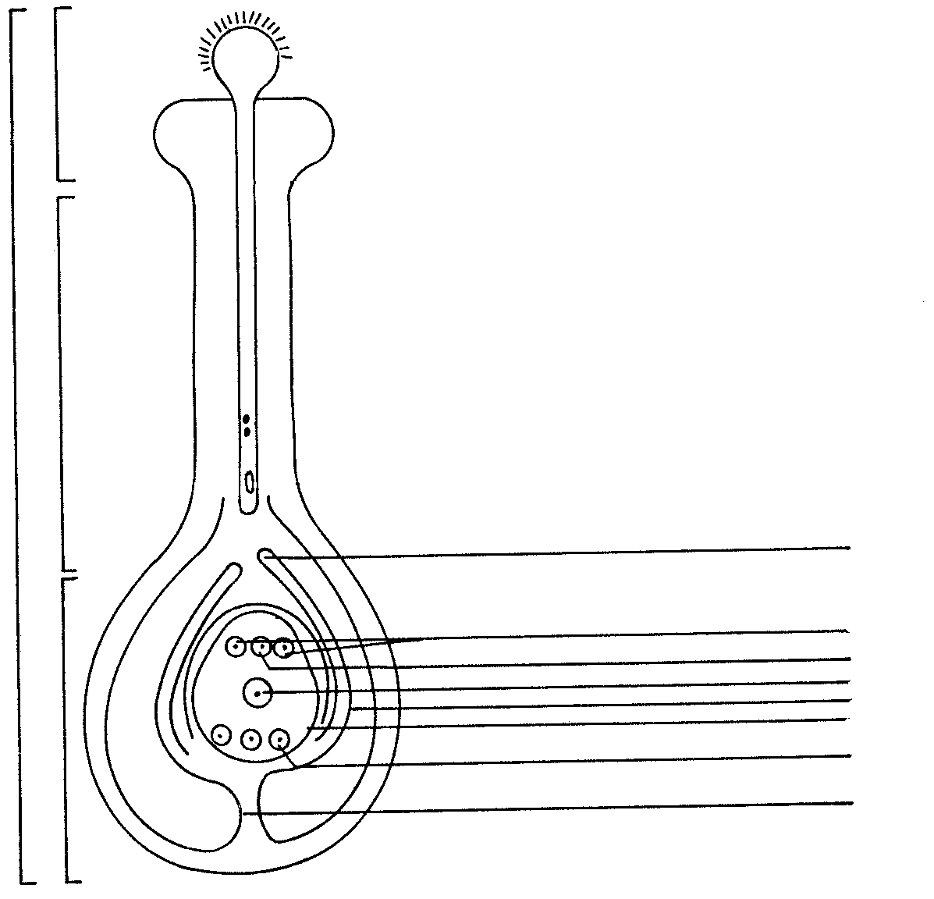
b

c

a
e

f
g
h
d
i
j

5.5 Briefly discuss the climatic factors which influence crop adaption. | (10)  [50]

QUESTION 6

6.1 Indicate step by step the procedure you would follow to gather information which will enable you to determine for which production aim the soil is most suitable. | (6)

6.2 Answer the following questions on plant succession.

6.2.1 What is meant by plant succession? | (2)

6.2.2 Name THREE factors which influence plant succession. | (3)

6.2.3 Name TWO reasons for retrogressive plant succession. | (2)

6.3 With reference to micro irrigation, list

6.3.1 FIVE advantages and | (5)

6.3.2 FIVE disadvantages. | (5)

6.4 What are the disadvantages of using open draining systems? | (4)

6.5 Discuss EIGHT reasons why crop rotation should be practised. | (16)

6.6 Briefly discuss the aims of soil cultivation. | (7)  [50]

QUESTION 7

7.1 List SEVEN economical characteristics of soil. | (7)

7.2 Answer the following questions on capital:

7.2.1 Name the main sources of capital in agriculture. | (3)

7.2.2 Name and briefly describe the THREE types of capital involved in agriculture and supply an example of each type. | (6)

7.2.3 Discuss the problems associated with capital as a production factor. | (10)

7.3 Briefly discuss the factors determining the demand of products. | (6)

7.4 Briefly discuss the marketing function of exchange. | (6)

7.5 Mention the disadvantages of free marketing. | (6)

7.6 One of the management tasks of a farmer is planning. Briefly explain the different steps involved in the planning process. | (6)  [50]

TOTAL FOR SECTION B: | [300]

TOTAL: | 400

