GAUTENG DEPARTMENT OF EDUCATION
SENIOR SERTIFICATE EXAMINATION

AGRICULTURAL SCIENCE HG

TIME: 3 hours

MARKS: 400

REQUIREMENTS:

- An approved (non-programmable) scientific pocket calculator

INSTRUCTIONS:

- Answer ALL the questions.
- Answer Question 1A (multiple-choice questions) on the answer sheet on the inside cover of your answer book.
- Use the same numbers as those in the examination paper, e.g. 2.1.1.
- Please write clearly and neatly.

SECTION A

QUESTION 1

MULTIPLE-CHOICE QUESTIONS

The following questions are provided with four possible answers of which only ONE is correct. Indicate the answer of your choice by making a cross (X) over the corresponding letter next to the question on the answer sheet on the inside cover of your answer book, for example:

A | B | C | D

1.1.1 The amorphous colloid with the greatest specific area is

- kaolinite.  - illite.  - humus.  - vermiculite. | (2)

1.1.2 Which of the following soil texture classes has the greatest total pore space?

- Sand  - Sandy-loam  - Sandy clay-loam  - Clay-loam | (2)

1.1.3 Mainly as a result of considerable swelling and shrinking, the strongest structural development will be found in

- clay soil.  - loam soil  - sand soil.  - sand-loam soil. | (2)

1.1.4 The dominant colour of soil is the result of large quantities of _________ present in the soil.

- quarts  - ironoxide  - impurities  - water | (2)

1.1.5 The R-mayor horizont consists of

- consolidated material (rock).  - organic rests.  - topsoil.  - subsoil. | (2)

1.1.6 A characteristic of a well-developed soil is

- vaguely distinguishable horizonts.  - a stony quality in the soil.  - clearly distinguishable horizonts.  - a large quantity of organic matter. | (2)

1.1.7 The unit value of urea (46%) which costs R690 per ton is

- R10,00.  - R25,00.  - R20,00.  - R15,00. | (2)

1.1.8 Self-pollination in nature is the highest form of

- upgrading.  - crossbreeding.  - linebreeding  - inbreeding | (2)

1.1.9 ______ is the element, which is required for the normal functioning of Rhizobium bacteria.

- Mg  - Zn  - Mo  - Mn | (2)

1.1.10 The chlorophyll in green leaves of plants absorbs the __________ light that falls on a leaf.

- red and violet  - red and blue  - yellow and blue  - green and blue | (2)

1.1.11 The following floral part are absent in the monocotyledonous flower (wheat); that is the

- petal crown.  - sepal crown.  - stamen crown.  - ovary. | (2)

1.1.12 The most concentrated nitrogenous fertiliser available in South Africa is

- urea.  - super phosphate.  - LAN  - ammonium nitrate. | (2)

1.13 Starch in animals is hydrolised to maltose by the enzyme

- maltase.  - amylase.  - lipase.  - erepsien. | (2)

1.1.14 The process of oxidation of carbohydrate foods together with the release of CO₂ and H₂O and energy for metabolism is called

- transpiration.  - respiration.  - photosynthesis.  - photolysis. | (2)

1.1.15 Visible light, as part of the electromagnetic spectrum, is within the following boundaries of wavelengths:

- 400 to 700 nm  - 100 to 400 nm  - 700 to 900 nm  - 700 to 1 000 nm | (2)

1.1.16 The aim of synchronising the oestrus cycle is to

- facilitate management.  - improve meat production.  - achieve more constant milk production.  - save on the cost of labour. | (2)

1.1.17 Large quantities of the following two mineral elements are found in the teeth and skeleton:

- Ca and P  - Zn and Ca  - Mg and Na  - Ca and S | (2)

1.1.18 The ideal ratio in the soil of solid particles to macro-pores to micro- pores should be in the vicinity of:

- 25:50:25  - 25:25:50  - 50:25:25  - 70:20:10 | (2)

1.1.19 When cattle swallow foreign objects such as nails, glass or baling wire, these items collect in the

A. rumen.  B. small intestine.  C. reticulum.  D. omasum. | (2)

1.1.20 The economic characteristic of land which accounts for it still being regarded as a sound and safe investment is its

- variations in production potential.  - durability.  - indestructibility.  - fixed location. | (2)

1.1.21 The increasing scarcity of farm labour is a result of

- competition from industries.  - political instability.  - poor labour management.  - deficient training facilities. | (2)

1.1.22 In farming, ______may be regarded as an example of working or floating capital.

- breeding livestock  - oxen  - fruit trees  - dams | (2)

1.1.23 Long-term credit can be used for

- building a dam.  - buying fertiliser.  - buying farm animals.  - buying seed. | (2)

1.1.24 Which one of the following concepts does not fit in with the others?

- Soil  - Planning  - Capital  - Labour | (2)

1.1.25 Which one of the following is not an advantage of co-operative marketing?

- Lower marketing costs  - Grading of products  - Greater publicity  - Lower producer prices | (2)

1.1.26 The type of marketing which is not influenced by the State or any other organisation is called

- co-operative marketing.  - free marketing.  - controlled marketing.  - the pool system. | (2)

1.1.27 A tensiometer is used to measure

- sweetness of fruit.  - soil pH.  - pressure of tractor tyres.  - soil moisture tension. | (2)

1.1.28 The cheapest source of animal feed for the production of wool and meat is

- crop production.  - animal products.  - natural veld.  - concentrates. | (2)

1.1.29 A requirement for thorough veld management is

- prevention of erosion.  - soil classification.  - crop rotation.  - rotational grazing. | (2)

1.1.30 The spacing of drainage pipes is determined by the

- soil texture.  - colour of the soil.  - suction effect.  - amount of run-off water. | (2)  30x2=(60)

Answer this question in your Answer Book.

1.2 Write down the correct term for each of the following statements:

1.2.1 The force of attraction between water molecules

1.2.2 The weak acid formed when carbon dioxide dissolves in soil water

1.2.3 The clay mineral that is formed when biotite perishes

1.2.4 The opening between a pig’s oesophagus and its stomach

1.2.5 The element which is a constituent of thyroxin

1.2.6 The concept which describes animals that can regulate their body temperatures

1.2.7 Twins that develop when two ova are formed and fertilised

1.2.8 The type of cell division which takes place just after fertilisation

1.2.9 The cell plastid in which photosynthesis takes place

1.2.10 The ratio which exists between surface evaporation and evapotranspiration | 10x2=(20)

1.3 Match the description in Column B with the term in Column A. Write down only the numbers 1.3.1 to 1.3.10 in your Answer Book and the correct letter next to each number, e.g. 1.3.11. M.

COLUMN A  TERM |  | COLUMN B  DESCRIPTION
1.3.1 | Limestone ammonium | A | Gas and liquid
1.3.2 | Manganese sulphate | B | Saucer-leaf disease
1.3.3 | Ammonium hydroxide | C | 46% N
1.3.4 | Zinc | D | Increase taste
1.3.5 | Calcium | E | Small-leaf disease
1.3.6 | Molybdenum | F | Fertiliser mixture
1.3.7 | Magnesium | G | Leaf spraying
1.3.8 | Copper | H | Reserve fertiliser for orchards
1.3.9 | Raw phosphate | I | Leaves curl
1.3.10 | Urea | J | Boiling-water disease
 |  | K | Green V pattern on base of leaves
 |  | L | Use on sandy acid soil

TOTAL FOR SECTION A: | 10x2=(20)  [100]

SECTION B

QUESTION 2

2.1 Study the diagram below which represents the major horizonts of a soil and answer the questions that follow.
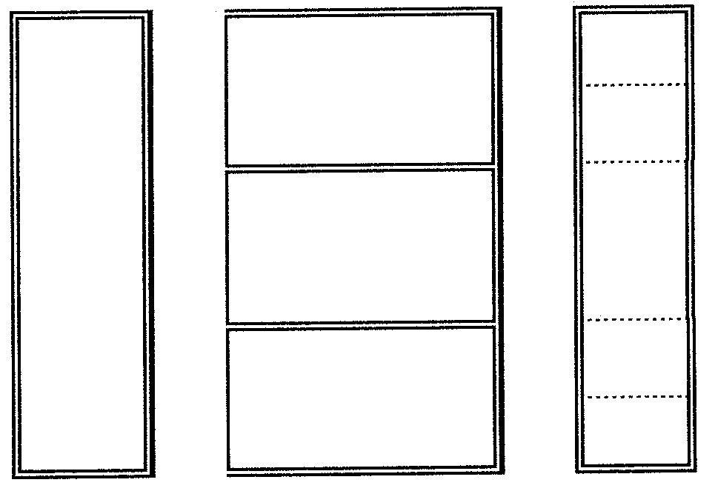
v
iii
iv
Topsoil
i
A.
B.
C.
ii

2.1.1 Write the numbers i to v below one another and indicate what each number represents. | (5)

2.1.2 List FOUR factors which can change the above soil profile. | (4)

2.1.3 Name the soil type that is characterised by the following soil profile:

(a) $\frac{A}{R}$  (b) $\frac{B}{C}$  (c) $\frac{O}{G}$ | (6)

2.1.4 Which one of the A- or B-horizonts has the highest bulk density? Motivate your answer. | (5)  [20]

2.2 Soil moisture:

2.2.1 Name ALL the types of soil moisture that are unavailable to the plant and explain why the plant root cannot absorb this water. | (6)

2.2.2 Explain FOUR measures which can be taken to reduce transpiration losses. | (8)

2.3 Discuss the influence of temperature on crop production. | (8)

2.4 Labour:

2.4.1 How can the farmer increase the productivity of workers? | (8)

2.5 Study the schematic representation of an exchange reaction and answer the questions that follow.

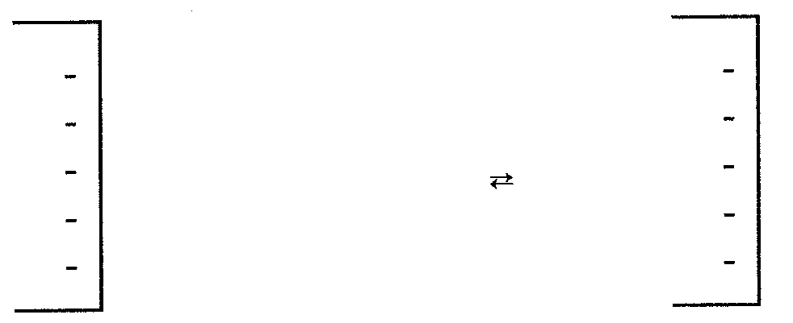
H⁺
H⁺
+ CaCO₃
(a)+ H₂CO₃

2.5.1 Indicate what (a) represents. | (2)

2.5.2 What is the effect on the pH of the soil if the reaction is to the  right-hand side? | (2)

2.5.3 Name a practical method by which the farmer can promote the above reaction to the right-hand side. | (2)

2.5.4 Which time of the year is regarded as the most favourable for promoting the reaction to the right-hand side? | (2)

2.5.5 Indicate which natural conditions may be responsible for the reaction progressing to the left-hand side. | (2)  (10)

[60]

QUESTION 3

3.1 Reproduction:

3.1.1 Label the diagram of the reproductive system of a cow. | (12)

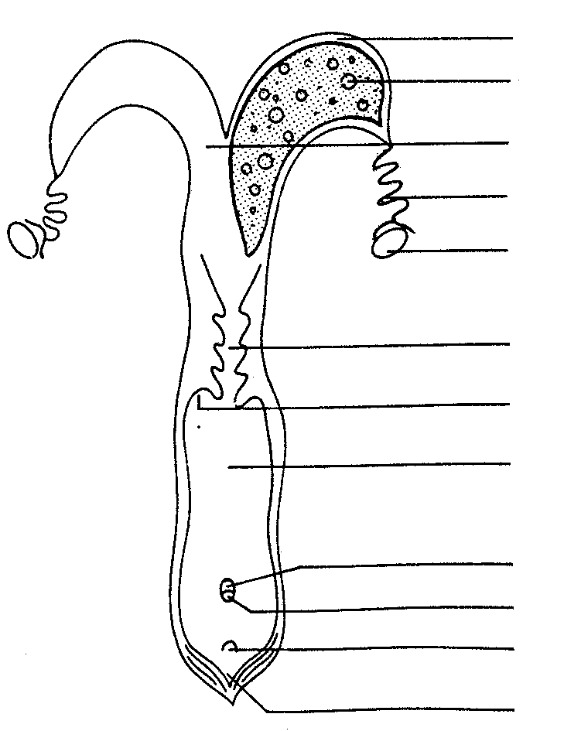
a
b
c

d
5e

f

g
h

i
j
k

l

3.1.2 Where does fertilisation take place in the cow? | (2)

3.1.3 Which hormone is responsible for maintaining pregnancy? | (2)

3.1.4 How many days after fertilisation does implantation normally occur? | (2)

3.1.5 Name THREE muscles which assist with the expulsion of the foetus. | (3)

3.1.6 Give the name of the hormone which is responsible for the powerful contractions of the muscles identified in Question 3.1.5. | (2)

3.2 Capital:

3.2.1 What is meant by the term capital? | (2)

3.2.2 Distinguish between the various types of capital used in agriculture and give an example of each. | (6)

3.2.3 Briefly discuss FOUR problems associated with capital as a production factor in agriculture. | (8)

3.3 Natural pastures:

3.3.1 Name FIVE pasture regions of Southern Africa. | (5)

3.3.2 Discuss how pastures must be managed to maintain the maximum production of the pasture over a long period.  3.4 Name NINE advantages of artificial insemination. | (7)  (9)

[60]

QUESTION 4

4.1 Study the drawing below which represents the stomach of a ruminant and answer the questions that follow.

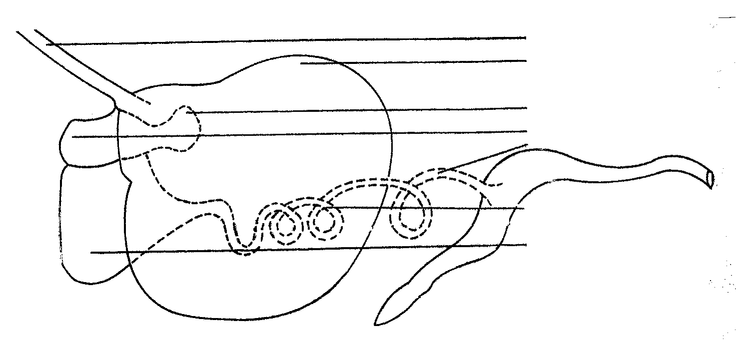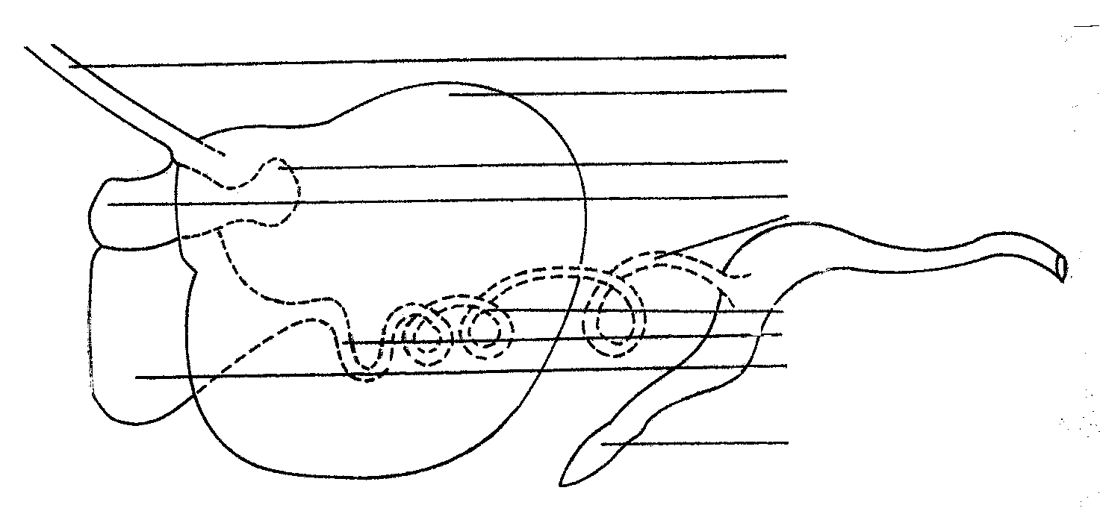
a
b
c
d

e

f

4.1.1 Identify the parts numbered a to f. | (6)

4.1.2 In which part(s) is/are certain fatty acids and glucose absorbed? | (4)

4.1.3 Explain how straw which consists of cellulose is digested. | (8)

4.1.4 Name TWO enzymes in the digestive system of the cow which are responsible for the digestion of microbial proteins. | (2)

4.1.5 Name the end products of the digestion of

- starch.  - fats.  - proteins. | (1)  (2)  (1)

4.2 Discuss the properties of silage. | (10)

4.3 If a feed has a TDR content of 72% and a digestible protein content of 12%, calculate the nutritive ration of the feed and indicate whether the NR is wide or narrow. | (5)

4.4 Marketing:

4.4.1 What is the purpose of controlled marketing? | (2)

4.4.2 What is the basic principle involved in co-operative marketing? | (2)

4.4.3 Name FOUR advantages of controlled marketing to the producer. | (4)

4.5 Breeding:

4.5.1 Explain why breeders, in general, avoid inbreeding. | (7)

4.5.2 What is the genetic effect of cross-breeding? | (2)

4.5.3 Explain how inbreeding can be valuable for the improvement of farm animals. | (4)

[60]

QUESTION 5

5.1 Indicate the most suitable fertiliser that would be recommended in each of the following cases:

5.1.1 Nitrogen fertiliser used as a leaf spray | (2)

5.1.2 An alkaline soil, with a deficiency in potassium | (2)

5.1.3 An acid, sandy soil, poor in nitrogen | (2)

5.1.4 A soil with a low pH and a deficiency in magnesium | (2)

5.1.5 A Phosphate fertilizer applied at sowing. | (2)

5.1.6 A Nitrogen fertiliser that will not burn plants | (2)

5.1.7 The application of nitrogen by means of micro irrigation | (2)

5.2 Alkaline soil:

5.2.1 Name FOUR physical signs which indicate that the soil is alkaline. | (4)

5.2.2 Explain the method used to reclaim an alkaline soil under irrigation if the soil analysis indicates an excessive amount of sodium absorbed by the soil colloids. | (6)  [10]

5.3 Give all possible reasons why a soil on the northern slope of a hill will produce crops that ripen earlier than a soil on the southern slope.

5.4 During a digestibility experiment a cow ate 15 kg of hay with a moisture content of 10% and excreted 7 kg of manure with a moisture content of 20%. | (10)

5.4.1 Calculate the digestible dry material content of the hay. | (5)

5.4.2 Why is biuret preferred to urea in animal nutrition? | (2)

5.4.3 During which time of the year would a vitamin A deficiency generally be found on natural pastures in the summer rainfall regions? Give a reason for your answer. | (2)

5.4.4 Where is excess vitamin A stored in the body of the animal? | (2)

5.4.5 Name FOUR symptoms displayed by animals with a vitamin A deficiency. | (4)

5.5 Distinguish between the following fruits and give ONE example of each:

- Multiple fruits  - Compound fruits  - Accessory fruits | (4)  (3)  (4)

[60]

QUESTION 6

6.1 Choose, from the list below, the nutrition element that corresponds best with the function mentioned. Write down only the number and the element.

iodine; zinc; cobalt; copper; iron; magnesium; sulphur.

6.1.1 Forms a component of cystine | (2)

6.1.2 Prevents anaemia | (2)

6.1.3 Necessary for the formation of thyroxin | (2)

6.1.4 Prevents degeneration of the spinal nerves | (2)

6.1.5 Prevents parakeratosis of the skin | (2)

6.2 Plant reproduction:

6.2.1 Label the following diagram of a dicotyledonous flower. | (12)

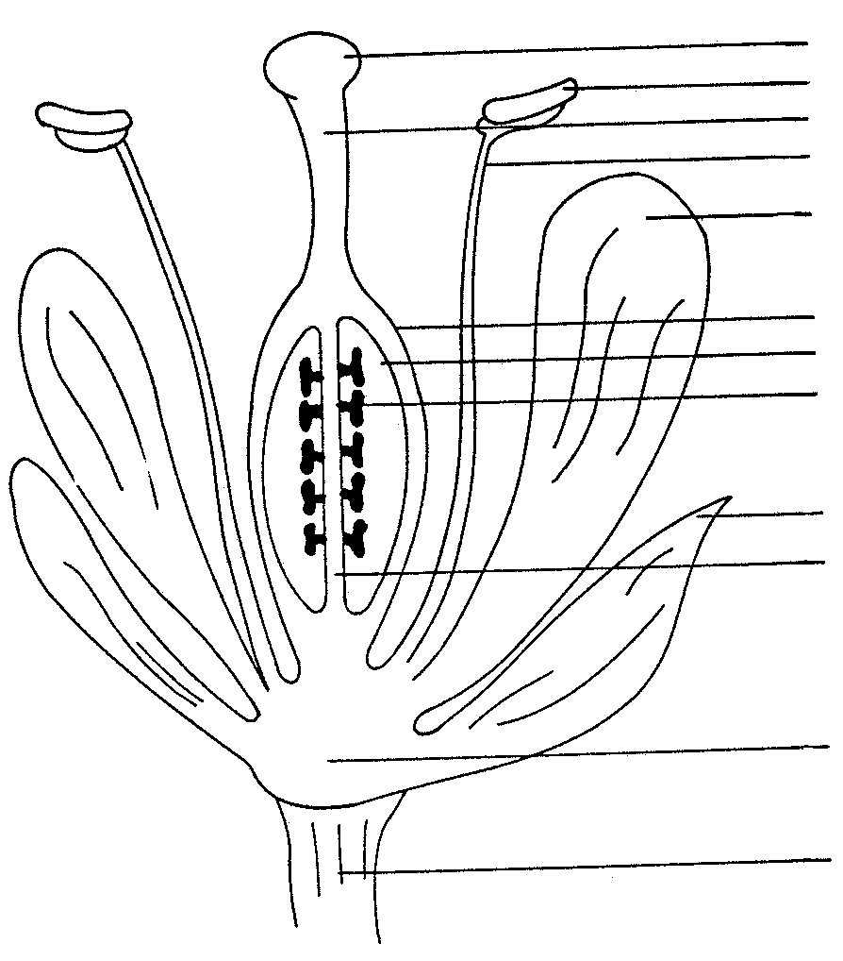
a
b
c
d
e

f
g
h

i
j

k

l

6.2.2 Discuss the functions of the different nuclei. | (4)

6.2.3 Explain the difference between starch-free and starch-containing seed. | (4)

6.3 Farm manure:

6.3.1 Briefly explain the advantageous chemical effects of farm manure on agricultural soil. | (6)

6.3.2 Briefly explain the accessibility of nitrogen in farm manure. | (4)

6.4 Plant nutrition:

6.4.1 Explain how the availability of potassium is influenced by the following factors:

- Type of clay mineral  - Soil reaction | (3)  (3)

6.4.2 Explain how the availability of nitrogen is influenced by the following factors:

- The carbon to nitrogen ratio of the organic material  - Environmental factors which influence the microbial activity in the soil  - Colloidal content of the soil | (3)  (3)  (3)

6.5 Name FIVE ways in which various agricultural practices can lead to the pollution of the environment. | (5)

[60]

TOTAL FOR SECTION B: | [300]

TOTAL: | 400

