GAUTENG DEPARTMENT OF EDUCATION
SENIOR CERTIFICATE EXAMINATION

AGRICULTURAL SCIENCE SG

TIME: 3 hours

MARKS: 300

INSTRUCTIONS:

- Answer ALL questions.

- Answer Questions 1.1 – 1.15 (multiple choice questions) on the answer sheet on the inside cover of your answer book.

- Write neatly and legibly.

SECTION A

QUESTION 1

To each of Questions 1.1.1 to 1.1.15, various answers are given of which only ONE is correct. Indicate the answer of your choice by making a cross (X) over the appropriate letter next to the question number on the answer sheet on the inside cover of your answer book.

EXAMPLE:

A | B | C | D

    - Alkaline brack is caused by

A. sodium carbonate.
B. magnesium sulphate.
C. potassium carbonate.
D. calcium sulphate.

    - Hydrochoric acid in gastric juice changes

A. proteins to amino acids.
B. fats to glycerol and fatty acids.
C. sucrose to glucose and fructose.
D. peptides to amino acids.

1.1.3 Soils which were formed from sandstone formations containing little iron have a _________ colour.

A. dark
- B. red
- C. yellow
- D. light

    - A mottled colour in soils is an indication of

A. organic matter.
- B. dry soil.
- C. wet soil.
- D. sandy soil.

    - Soil classified as acid soil contains a surplus of _______ ions.

A. magnesium
- B. calcium and magnesium
- C. hydrogen
- D. sodium

    - The main source of energy for animals is

A. minerals.
- B. carbohydrates.
- C. proteins.
- D. vitamins.

    - Rickets is caused by

A. viruses.
- B. a deficiency of calcium and phosphorus.
- C. bacteria.
- D. fungi.

    - The liver secretes

A. pancreatic juice.
- B. gastric juice.
- C. amilose.
- D. bile.

    - The nitrogenous fertiliser that has the highest nitrogen content per unit, is

A. ammonium sulphate.
- B. ammonium nitrate.
- C. urea.
- D. di-ammonium sulphate.

    - For which crop is green manuring the most suitable?

A. Lupins
- B. Maize
- C. Sunflowers
- D. Grass

    - The ____ is a secondary sex organ of a bull.

A. testes
- B. epididymis
- C. vas deferens
- D. scrotum

    - The period in the oestrus cycle during which the corpus luteum develops is called the __________ period.

A. pro-oestrus
- B. oestrus
- C. met-oestrus
- D. di-oestrus

    - The ______ is an example of a simple fruit.

A. pineapple
- B. tomato
- C. fig
- D. blackberry

    - Scrub is the type of vegetation that occupies much of the

A. Free State.
- B. Cape Peninsula.
- C. Kalahari
- D. Northern Province.

- __________ is/are an example of working capital  A. Fodder  - B. Dams  - C. Fences  - D. Cattle | 15x2=[30]

1.2 Supply the correct agricultural term for each of the following descriptions. Write the word next to the appropriate question number in your answer book.

1.2.1 The soil cultivation practice whereby an attempt is made to keep all plant residue on the surface of the soil.

1.2.2 The type of lime applied to soils which are predominantly acid and low in magnesium.

1.2.3 The mass per volume unit of oven-dried soil.

1.2.4 The soil fraction that has a diameter of 0,02 to 0,002 mm.

1.2.5 The specific combination and succession of diagnostic horizons in the soil.

1.2.6 The disease amongst sheep, caused by a deficiency of cobalt.

1.2.7 The breaking up of fats into small droplets by bile.

1.2.8 The short muscular tube which gives passage to both food and air.

1.2.9 Elements that occur in the soil in small quantities, and which plants use in minute quantities.

1.2.10 Flowers that contain both the pistil and stamen in the same flower.

1.2.11 The transfer of artificially collected semen to the reproductive truct of a female animal.

1.2.12 Flowers that have only male or female flowers.

1.2.13 The mating of animals that are closely related.

1.2.14 An instrument used to measure the moisture tension in the soil.

1.2.15 The inner mucous lining of the uterus.

1.2.16 The breeding of different species of animals.

1.2.17 The hard external cover of a pollen grain.

1.2.18 The micro-irrigation system where dripper nozzles are installed.

1.2.19 Physical and mental human endeavour performed in the expectation of remuneration.

1.2.20 Capital invested in durable assets. | 2x20=[40]

1.3 Complete each of the following statements by writing down only the missing words in your answer book.

1.3.1 Sodding of crops leads to the formation of ____________ in the soil.

1.3.2 Goitre may occur in all farm animals when ________ is deficient.

1.3.3 The hormone progesterone is secreted by the ______ during di-oestrus.

1.3.4 The amount of water loss through transpiration can be determined by using a ________.

1.3.5 The lower the ______ of a product, the greater the demand. | (5)

TOTAL FOR SECTION A: | [75]

SECTION B

- Start each question on a new page.
- Answer all questions in point form.

QUESTION 2

2.1 Name FIVE conditions under which humus will decay in the soil. | (5)

2.2 Discuss in point form the chemical effects of organic matter on soil. | (8)

- Define the following soil-water concepts.  2.3.1 Field water capacity  2.3.2 Permanent wilting point  2.3.3 Unavailable water | (3)  (3)  (3)

2.4 Mention SIX factors which have an influence on soil temperature. | (6)

2.5 Discuss FIVE factors that influence the development of soil structure. | (10)

2.6 Name the measures that can be taken by farmers to overcome or minimise evapotranspiration. | (7)  [45]

QUESTION 3

- Write short explanatory notes on the following:  3.1.1 The functions of saliva  3.1.2 The functions of hydrochloric acid  3.1.3 The symptoms of a deficiency of vitamin A. | (5)  (5)  (5)

3.2 Explain FIVE methods of mineral supplementation in farm animals. | (10)

3.3 Mention the symptoms present in farm animals if they have a deficiency of the following minerals:  - Copper  - Cobalt | (4)  (5)

3.4 Explain the following concepts  3.4.1 Dry matter of feed  3.4.2 Nutritive ratio  3.4.3 Maintenance ration | (3)  (3)  (3)

3.5 Which minerals would you recommend as a supplement to feed for animals with deformed bones? | (2)  [45]

QUESTION 4

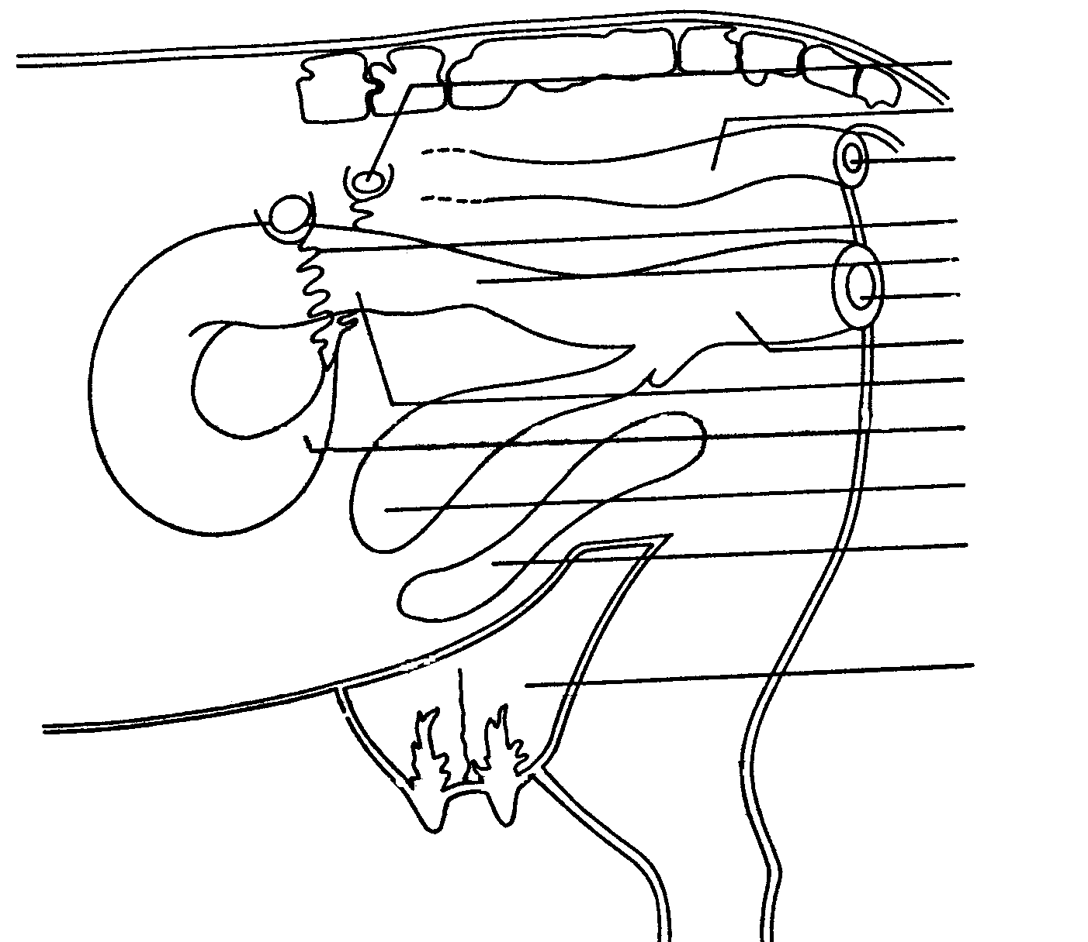

A
B
C

D
E
F
G
H
I

J

K

L

4.1 Figure 1 is a schematic representation of the reproductive organs of a cow.

4.1.1 Write down the missing labels from A – J. | (10)

- Write down the letter on the sketch which represents the part where each of the following takes place:  - Fertilisation  - Ovulation  - Secretion of oestrogen  - Deposit of semen by artificial insemination | (1)  (1)  (1)  (1)

4.2 A bull is seemingly normal but pays no attention to cows. Name SIX possible causes for his lack of libido. | (6)

4.3 Describe the warning signs of parturition. | (8)

4.4 Briefly discuss the causes of hereditary infertility in cows. | (10)

- Upgrading is a very good method of improving the quality of a herd. Discuss upgrading under the following headings:  4.5.1 Advantages  4.5.2 Disadvantages | (4)  (3)  [45]

QUESTION 5

5.1 Figure 2 is a schematic representation of a dicotyledonous flower.

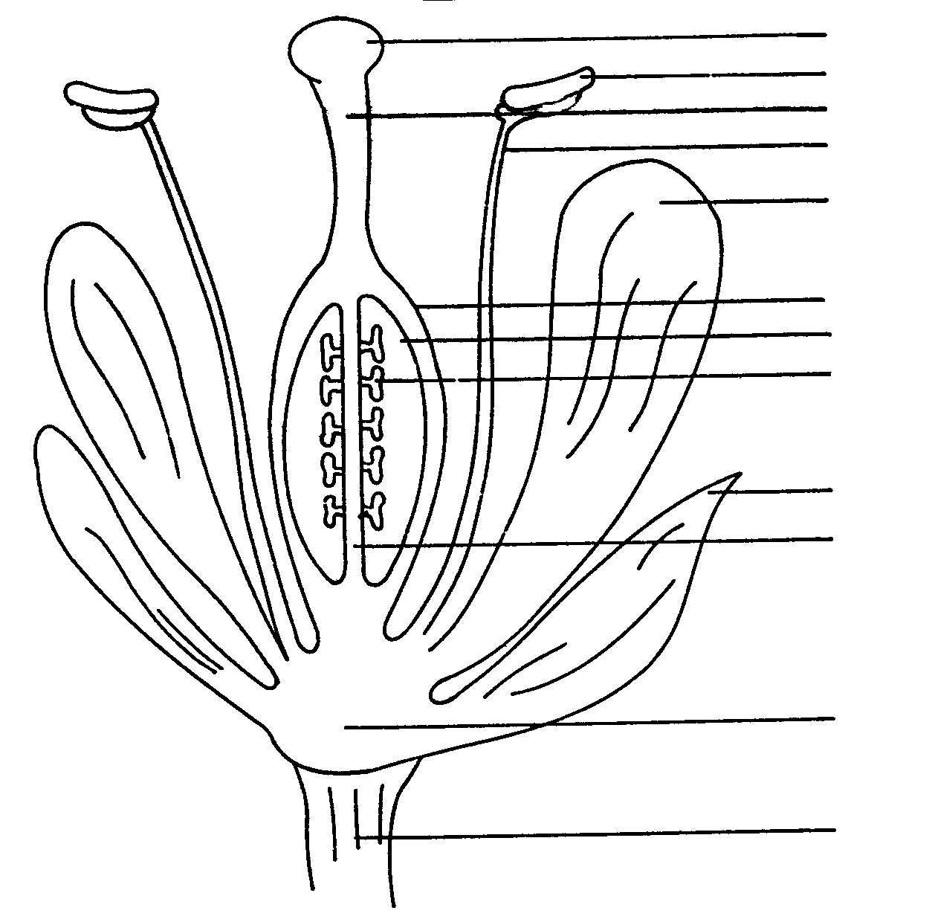

A
B
C
D
E

F
G M
H

I
J

K

L

5.1.1 Write down the missing labels from A to M. | (13)

- Write down the letter on the sketch which represents the part where the following takes place:  - pollen is received for fertilisation  - pollen is produced | (2)

5.2 Discuss the importance of nitrogen in plant nutrition. | (6)

5.3 Discuss the value of farm manure organic as an organic fertiliser. | (5)

5.4 Discuss cross pollination of plants under the following headings:

5.4.1 Agents of cross-pollination  5.4.2 Artificial cross-pollination | (6)  (7)

5.5 The price of urea is R45 per 100 kg. There is 45% nitrogen in urea. Calculate the unit price of urea. | (6)  [45]

QUESTION 6

6.1 Various factors determine the climate of an area. Name FIVE of these factors. | (5)

6.2 Micro-irrigation systems are becoming increasingly used in farming. Discuss the micro-irrigation systems under the following headings:

- Advantages  - Disadvantages | (9)  (4)

6.3 Discuss the advantages of crop rotation. | (10)

6.4 Mention SEVEN ways in which a farmer can increase the productivity of his labourers. | (7)

6.5 Name the FOUR most important functions of soil as a production factor. | (4)

6.6 Mention SIX advantages of the free-market system. | (6)  [45]

TOTAL FOR SECTION B: | [225]

TOTAL: | 300

