GAUTENG DEPARTMENT OF EDUCATION
SENIOR CERTIFICATE EXAMINATION

AGRICULTURAL SCIENCE SG

TIME: 3 hours

MARKS: 300

INSTRUCTIONS:

- Answer ALL the questions.
- Answer Question 1 (Multiple Choice questions) on the answer sheet on the inside cover of your answer book.
- Please write neatly and legibly.

SECTION A

QUESTION 1
MULTIPLE CHOICE QUESTIONS

To each of questions 1.1 to 1.15 various answers are given of which only ONE is correct. Indicate the correct answer of your choice by making a cross (X) over the appropriate letter next to the question number on the answer sheet on the inside cover of your answer book for example A B C D .
If there is more than one cross in an answer NO MARKS will be awarded.

  - The plant element which promotes the growth of leaves and stems is

- potassium.
- calcium.
- nitrogen.
- aluminium.

  - The gall bladder opens in the

- stomach.
- duodenum.
- jejenum.
- ileum.

  - Which vitamin is essential for blood clotting?

- Vitamin A
- Vitamin C
- Vitamin D
- Vitamin K

  - Starch is changed to maltose by the enzyme

- rennin.
- lactose.
- amylase.
- lipase.

  - Which of the following soil horizons consists of weathering rock?

- R-horizon
- B-horizon
- C-horizon
- O-horizon

  - Which type of soil is well drained and aerated?

- Sandy clay loam
- Silty clay loam
- Sandy loam
- Silty clay

  - A red coloured soil will be indicative of the presence of ___________ in the soil.

- phosphorus
- iron
- calcium
- magnesium

  - Milk fever indicates a ___________ deficiency.

- calcium
- magnesium
- vitamin A
- vitamin B₁₂

  - Endocrine glands that secrete testosterone are known as

- Leydig cells.
- Sertoli cells.
- Brunner glands.
- Cowper glands.

  - Which is a secondary male sex organ?

- Testes
- Epididymis
- Vas deferens
- Scrotum

  - The repeated mating of thoroughbred males with inferior females is called

- selection.
- inbreeding.
- upgrading.
- line breeding.

  - A crop that can improve the nitrogen content of soil symbiotically is

- maize.
- sunflowers.
- soyabean.
- tomatoes.

1.13 A seed develops from a/an

- pollen grain.
- fertilised embryo sac.
- fertilised ovule.
- egg cell.

1.14 It is difficult to control irrigation with the _________ method.

- flood
- drip
- sprinkler
- micro-jet

1.15 ___________ is/are an example of movable capital.  - Buildings  - Silos  - Machinery  - Seed | 15x2=[30]

1.2 Supply the correct agricultural term for each of the following descriptions.

1.2.1 The type of soil in which hydrogen ions predominate.

1.2.2 The fineness or coarseness of soil particles.

1.2.3 The caecum, colon and rectum.

1.2.4 The soluble protein in milk.

1.2.5 Deformation and ulceration of the cornea of the eye.

1.2.6 The form in which carbohydrates are stored in the animal body.

1.2.7 The mating of two purebred animals of different breeds.

1.2.8 The external part of the female reproductive system.

1.2.9 The secretion ejaculated by the testes and the secondary sex glands of the male during copulation.

1.2.10 The period from conception to birth.

1.2.11 The ploughing back of a crop when it is at an immature succulent stage.

1.2.12 A fertiliser that contains 46% nitrogen.

1.2.13 The micro-element that is required by Rhizobium bacteria for nitrogen fixation.

1.2.14 The stigma, style and ovary of a flower.

1.2.15 The grading or choosing of plants or animals for breeding purposes so as to obtain the ideal type.

1.2.16 The removal of excess water from the soil by artificial means.

1.2.17 The growing of a crop on the same piece of land year after year.

1.2.18 The form of marketing where the producer is able to market his product according to his own discretion.

1.2.19 Capital invested in durable assets.

1.2.20 Money borrowed from financial institutions. | 20x2=[40]

1.3 Complete each of the following statements by filling in the missing words. Write only the number of the question and next to it the missing word.

1.3.1 The highest price that a producer can get for his product in a controlled market is called the __________ price.

1.3.2 The oldest method of irrigation is known as _____________ irrigation.

1.3.3 The primary reproductive organ of a cow is the _______________.

1.3.4 The end product of the decomposition of organic matter in soil is called ____________.

- Curled toe paralysis amongst chicks occurs as a result of ___________. | 5x1=[5]

TOTAL FOR SECTION A: | [75]

SECTION B

- Start each question on a new page.
- Answer the questions in point form.

QUESTION 2

- Give a brief description of the properties of the following soil-horizons:  - A-horizon  - B-horizon  - C-horizon  - O-horizon  - R-horizon | (10)

2.2 Which special measures can be undertaken by farmers who are cultivating crops on sandy soil, in order to improve productivity? | (5)

2.3 Give the FIVE different types of soil structures based on the shape of their particles. | (5)

2.4 Give FIVE conditions under which humus will decrease in the soil. | (5)

2.5 List SIX factors that have an important effect on soil temperature. | (6)

2.6 Name FIVE properties of saline soil. | (5)

2.7 Differentiate between a soil profile and a soil horizon. | (4)

2.8 Outline the procedure used to classify soil in South Africa. | (10)  [45]

QUESTION 3

3.1 Figure 1 shows a schematic representation of the alimentary canal of a fowl.

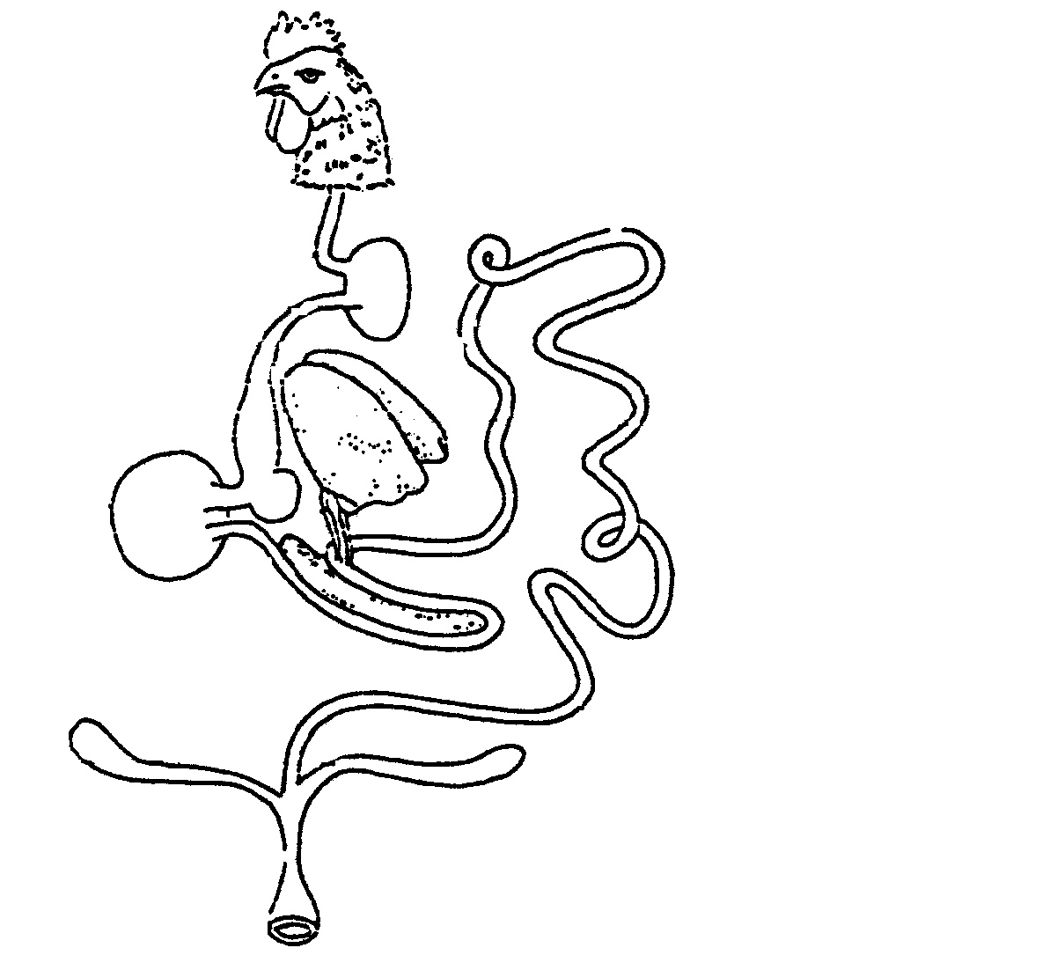

A

C

G

B

D

E

F

H

I

J

Figure 1

3.1.1 Write down the missing labels A – J. | (10)

3.1.2 Supply the letter on the sketch that represents a part of the alimentary canal where each of the following takes place:

(a) The soaking and storage of food
(b) The secretion of bile
(c) The digestion of fats
(d) The production of bile
(e) The excretion of faeces and urine | (5)

3.2 Name SEVEN factors which influence the digestibility of feeds. | (7)

- Mention functions of the following in the digestive system:  3.3.1 Succus Entericus  3.3.2 Micro-organisms in the rumen | (10)  (8)

3.4 A feed sample contains 80% total digestive nutrients (TDN) and 20% digestible proteins (DP). Calculate the nutritive ratio (NR) of the feed sample. | (5)  [45]

QUESTION 4

4.1 Figure 2 shows a schematic representation of the partially opened reproductive tract of a cow.

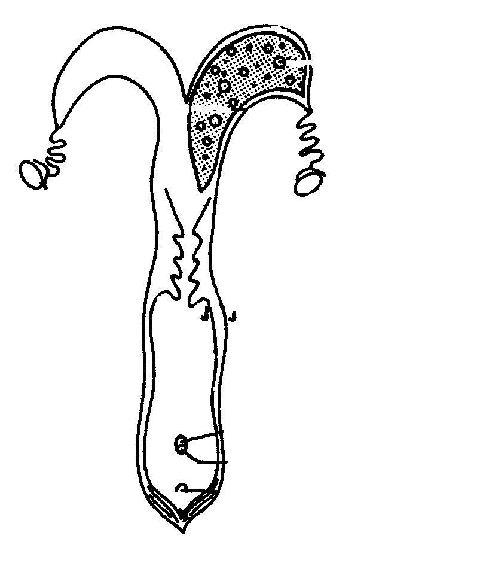

A

B

E

D

C

H

G

F

I

J

K

Figure 2

4.1.1 Supply the missing labels A – K. | (11)

4.1.2 Which letter in the sketch represents the part where each of the following takes place?

- Accommodation of the penis during copulation  - Production of ova  - Excretion of urine | (3)

4.2 Describe the process of spermatogenesis. | (14)

4.3 Discuss the factors that cause infertility under the following headings:

4.3.1 Impotence in bulls | (4)

4.3.2 Functional infertility in cows | (6)

4.4 Describe the first stage of parturition in cows. | (10)

4.5 Name the THREE disadvantages of cross-bred animals. | (3)  [45]

QUESTION 5

5.1 Figure 3 shows the schematic representation of a germinating pollen grain.

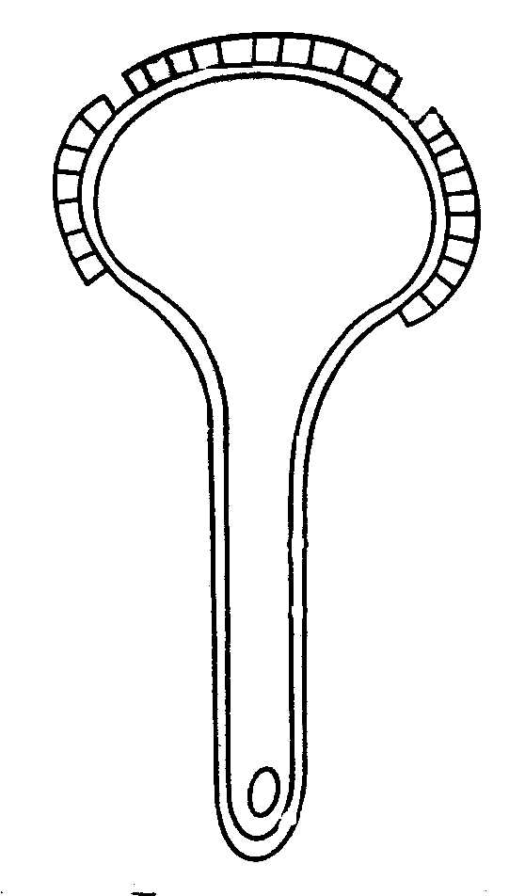
A
E
D
C
B

Figure 3

5.1.1 Supply the missing labels A – E. | (5)

5.1.2 What are the functions of the structures indicated below?

(a) A  (b) C  (c) D | (3)

5.2 Calculate the percentage N, P and K in the fertilizer mixture 2:3:2 (21) + 0,5% Zn. | (6)

5.3 Name FIVE factors that affect the availability of nutritional elements to plants in soil. | (5)

5.4 Mention SIX important functions of water in plants. | (6)

5.5 Discuss cross pollination under the following headings:

5.5.1 Agents of cross-pollination | (6)

5.5.2 Artificial cross-pollination | (7)

5.6 Discuss acid soil under the following headings:

5.6.1 Detrimental effects | (5)

5.6.2 Prevention and reclamation of acid soil | (2)  [45]

QUESTION 6

6.1 Name FIVE functions of soil as a growth medium. | (5)

6.2 Name the FIVE main types of grazing regions or natural veld. | (5)

6.3 Briefly discuss micro-irrigation systems under the following headings:

6.3.1 Advantages | (9)

6.3.2 Disadvantages | (4)

6.4 Give FOUR reasons why soil erosion occurs in most areas in South Africa. | (4)

6.5 Name SIX factors that will influence the demand of a product. | (6)

6.6 What are the disadvantages of free-marketing in agricultural production? | (6)

6.7 Name SIX general principles of co-operative marketing. | (6)  [45]

TOTAL FOR SECTION B: | [225]

TOTAL: | 300

