GAUTENG DEPARTMENT OF EDUCATION
SENIOR CERTIFICATE EXAMINATION

AGRICULTURAL SCIENCE HG

TIME : 3 hours

MARKS : 400

REQUIREMENTS:

- Calculator.

INSTRUCTIONS:

- Answer ALL questions.
- Answer Question 1 (Multiple Choice Questions) on the answer sheet on the inside cover of your answer book.
- Please number your answers exactly as the questions are numbered, using the decimal numbering system e.g. 2.1.1.
- Please pay attention to the legibility of your writing and the neatness of your work.

SECTION A

QUESTION 1
MULTIPLE CHOICE QUESTIONS

1.1 The following questions are provided with four possible answers of which only ONE possibility is correct in each case. Indicate the correct answer of your choice by making a cross (X) over the appropriate letter next to the question number on the answer sheet on the inside cover of you answer book, for example:

 | A | B | C | D

    - A sandy soil will be
- A. well drained.
B. rich in nutrients.
- C. badly aerated.
- D. poorly drained.

    - Water that is available to plants is termed
A. hygroscopic water.
- B. capillary water.
- C. gravitational water.
- D. free water.

    - The R-horizon in a soil consists of
A. hard rock.
- B. organic matter.
- C. leached soil.
- D. weathering rock.

    - The stomach wall consists of
A. circular muscles.
- B. longitudinal muscles.
- C. diagonal muscles.
- D. all of the above.

    - The enzyme in the pancreas that changes proteins and peptines into amino acids is
A. trypsin.
- B. amylase.
- C. erepsin.
- D. invertase.

    - Swayback in sheep is caused by a deficiency of
A. iodine.
- B. zinc.
- C. iron.
- D. copper.

    - The amount of phosphorus in 100 kg 2:3:2 (21) + 0,5%Zn is
A. 2 kg.
- B. 6 kg.
- C. 9 kg.
- D. 21 kg.

    - Which chemical is not used to treat alkaline soils?
A. Sodium chloride
- B. Sulphur
- C. Gypsum
- D. Potassium sulphate

    - The hormone responsible for the release of milk in cows is
A. oxytocin.
- B. oestrogen.
- C. progesterone.
- D. prolactin.

    - The prostate gland
A. is embedded in the bulbo muscle.
- B. surrounds the urethra completely.
- C. is the largest of the secondary sex organs.
- D. is situated at the base of the penis.

    - The grading of plants or animals for breeding purposes so as to obtain the ideal type is called
A. selection.
- B. in-breeding.
- C. line-breeding.
- D. cross-breeding.

    - A good example of accessory fruit is
A. an apple.
- B. a strawberry.
- C. an orange.
- D. an almond.

    - The best method by which to cultivate strawberries is by making use of
A. runners.
- B. tubers.
- C. rhizomes.
- D. bulbs.

    - A hormone that affects growth in plants by increasing cell elongation is
A. auxin.
- B. cytokinin.
- C. thyroxin.
- D. somatotropin.

    - The formula Ft = F x Eo refers to
A. scheduled irrigation.
- B. animal nutrition.
- C. reproduction.
- D. soil science.

    - Retrogression
A. leads to climax vegetation.
- B. is the opposite of succession.
- C. is the progressive changing of vegetation.
- D. refers to deforestation of land.

    - A farming practice that captures the ideal of optimal utilisation of resources for agricultural production is
A. crop rotation.
- B. overcropping.
- C. strip cropping.
- D. minimum tillage.

    - A disadvantage of co-operative marketing is
A. fluctuating prices.
B. high marketing costs.
- C. that the responsibility for marketing rests on the producer.
- D. that farmers have less power.

    - A factor influencing the demand for a product is
A. increasability of goods.
- B. knowledge.
- C. available production factors.
- D. the number of consumers.

- An example of working capital is  A. fodder.  - B. dams.  - C. fences.  - D. cattle.  20 x 2 = | [40]

1.2 Supply the correct agricultural term for each of the following descriptions:

1.2.1 The succession of horizons which are visible in a vertical section through soil.

    - Charts that are used to describe soil colour in a standardised formula.

    - Long-term weather of a specific area.

    - The mass per unit volume of soil.

    - The process by which food is forced from the stomach of a cow, back to the mouth for chewing the cud.

    - Intestinal juice secreted by the glands of Lieberkuhn.

    - The soluble protein in milk.

    - The caecum, colon and rectum.

    - The application of fertilizers in strips on one or both sides of a row of plants.

    - A fertilizer that contains 46% nitrogen.

    - The loss of water via the stomata on the leaves of plants.

    - A fruit produced by a single flower with many simple pistils.

    - Fruit that develop from a single ovary.

    - The transfer of ripe pollen grains from the anther of a flower to the ripe receptive stigma of the same flower.

1.2.15 The fusion of the nucleus of a spermatozoon with the nucleus of an ovum to form a zygote.

1.2.16 Different crops grown one after another on the same piece of land.  1.2.17 The removal of excess water from the soil by artificial means.  1.2.18 The quantity of a particular product bought at a quoted price at a particular moment.  - Capital invested in permanent structures on a farm.  - The lowest price at which products may be sold on controlled markets.  20x2= | [40]

1.3 Write down the letter of the word / phrase in Column B which can best be associated with each description in Column A next to the relevant question number in your answer book.

COLUMN A | COLUMN B
1.3.1 Night blindness  1.3.2 Blood clotting  1.3.3 Anaemia  1.3.4 Swayback  1.3.5 Parakeratosis  1.3.6 Ketosis  1.3.7 Blue tongue  1.3.8 Growth  1.3.9 Photosynthesis  1.3.10 Lipids | - Bile  - Vitamin A  - Vitamin E  - Iron  - Phosphorus  - Zinc  - CO₂  - Copper  - Cobalt  - Carbohydrates  - Proteins  - Vitamins  - Succulent grazing  - Vitamin K

10 x 2 = | [20]

TOTAL FOR SECTION A: | [100]

SECTION B

QUESTION 2

2.1 Study Figure 1 below and answer the questions that follow.

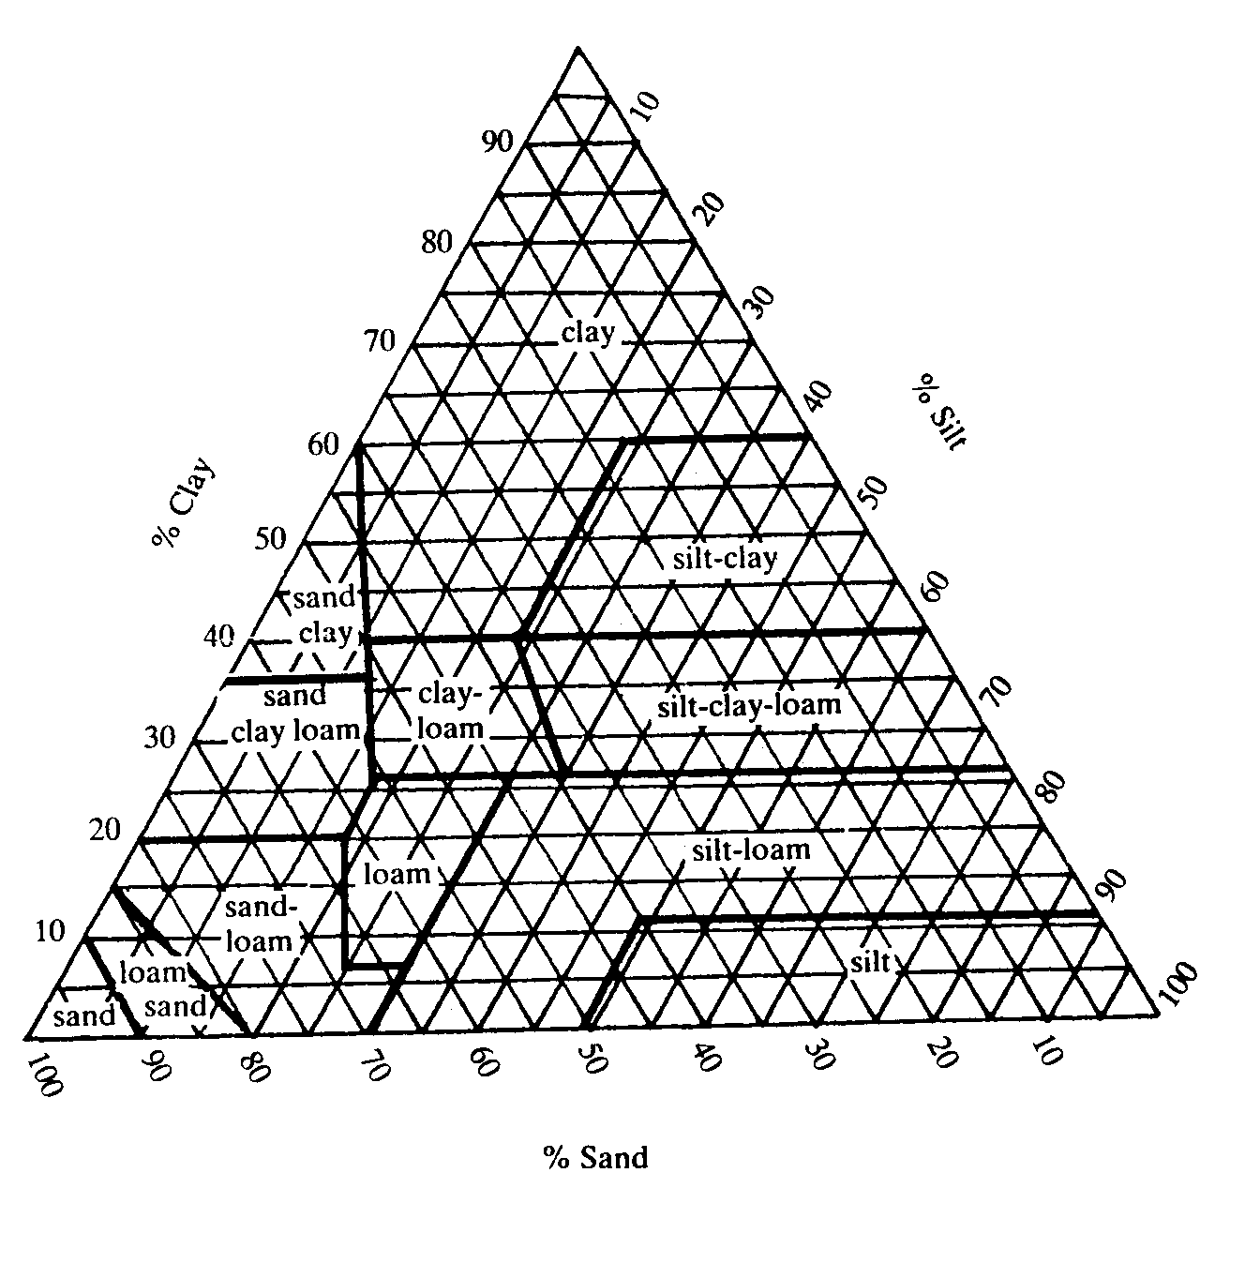
100

Figure 1 – Texture Triangle

2.1.1 Determine the texture for the following soil descriptions:  - 40% silt, 50% sand and 10% clay  - 50% clay 10% sand and 30% silt  - 30% sand 40% silt and 30% clay 3 x 2 = | (6)

2.2 Discuss FIVE factors that have an influence on the development of soil structure. | (10)

2.3 Water is a very scarce resource in South Africa. In agricultural production, what are the different forms of water loss and what can be done to reduce or prevent water loss? | (15)

2.4 Discuss the chemical effects of organic matter in soil. | (10)

- Indicate which soil horizon will form part of the following types of soil:  2.5.1 Adult or old soil  2.5.2 Eroded soil  2.5.3 Young soil 3 x 3 = | (9)  [50]

QUESTION 3

3.1 In a ruminant, carbohydrates are digested by organisms in the rumen, an acid in the stomach, and mainly enzymes in the small intestine. Name the organisms, acid and enzymes, the substrate on which they react and the final products formed in each case. Tabulate your answer. | (18)

Draw the table as follows:

Organ/Location | Substrate | Enzyme/Acid | Products

- Discuss the functions of the following in the digestive system.  3.2.1 The tongue  3.2.2 Micro-organisms in the rumen | (6)  (8)

3.3 Briefly discuss the functions of the following minerals in an animal’s body:  3.3.1 Copper  3.3.2 Zinc | (6)  (5)

3.4 Name SEVEN methods of supplementing minerals in animal feed. | (7)

QUESTION 4

- Discuss the process of spermatogenesis.  - Discuss factors that cause sterility in bulls under the following headings:  4.2.1 Lack of libido  4.2.2 Impotence | (10)  (12)  (8)

  - Figure 2 is a schematic representation of the reproductive system of a cow.

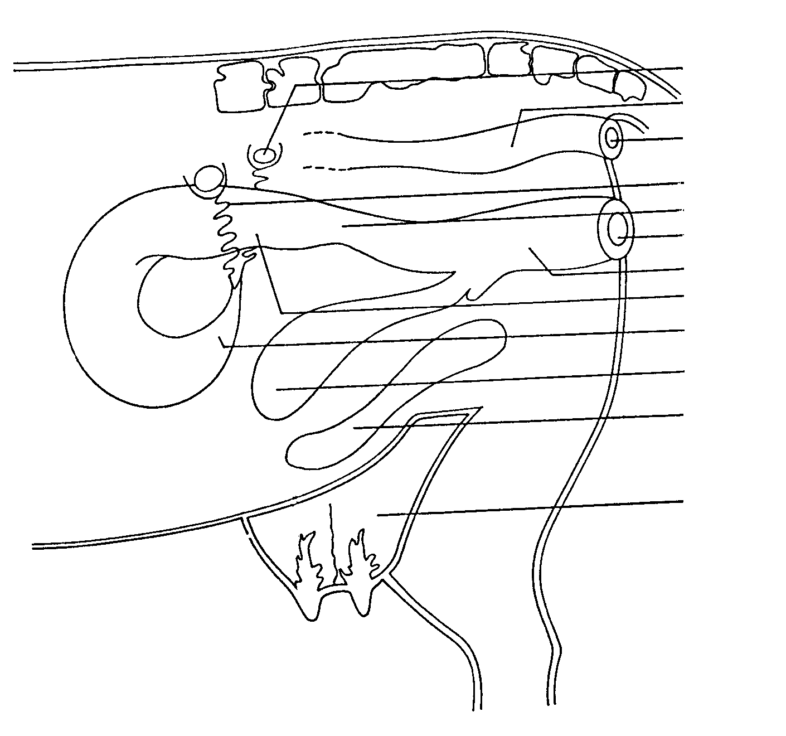

A

B
C

D
E
F
G
H
I
J

K

L

Figure 2

4.3.1 Supply the missing labels A – L. | (12)

- Write down the letters on the diagram which represent the organ where the following take place:  - Accommodation of the penis during copulation  - Collection of urine  - Production of ova  - Defecation | (4)

- Give FOUR functions of the epididymis in the reproductive system of male animals. | (4)  [50]

QUESTION 5

- Describe SEVEN signs of heat in a cow.  - Discuss artificial insemination under the following headings:  5.2.1 Advantages  5.2.2 Disadvantages  - Discuss parturition under the following headings:  5.3.1 Important warning signs of imminent parturition  5.3.2 The second stage of parturition  5.4 Discuss the disadvantages of inbreeding in animal production. | (7)  (10)  (8)  (8)  (10)  (7)  [50]

QUESTION 6

6.1 A maize farmer has sent his soil for analysis. The results indicate that the soil requires 184 kg of nitrogen. If the farmer has urea 46%N at his disposal, how many 50 kg bags of urea will be needed to replenish the soil nitrogen status? | (10)

6.2 Discuss the light phase of the process of photosynthesis. | (10)

6.3 How could you advise a farmer to prevent and control acid soil? | (10)

6.4 Figure 3 is a schematic representation of a dicotyledonous flower:

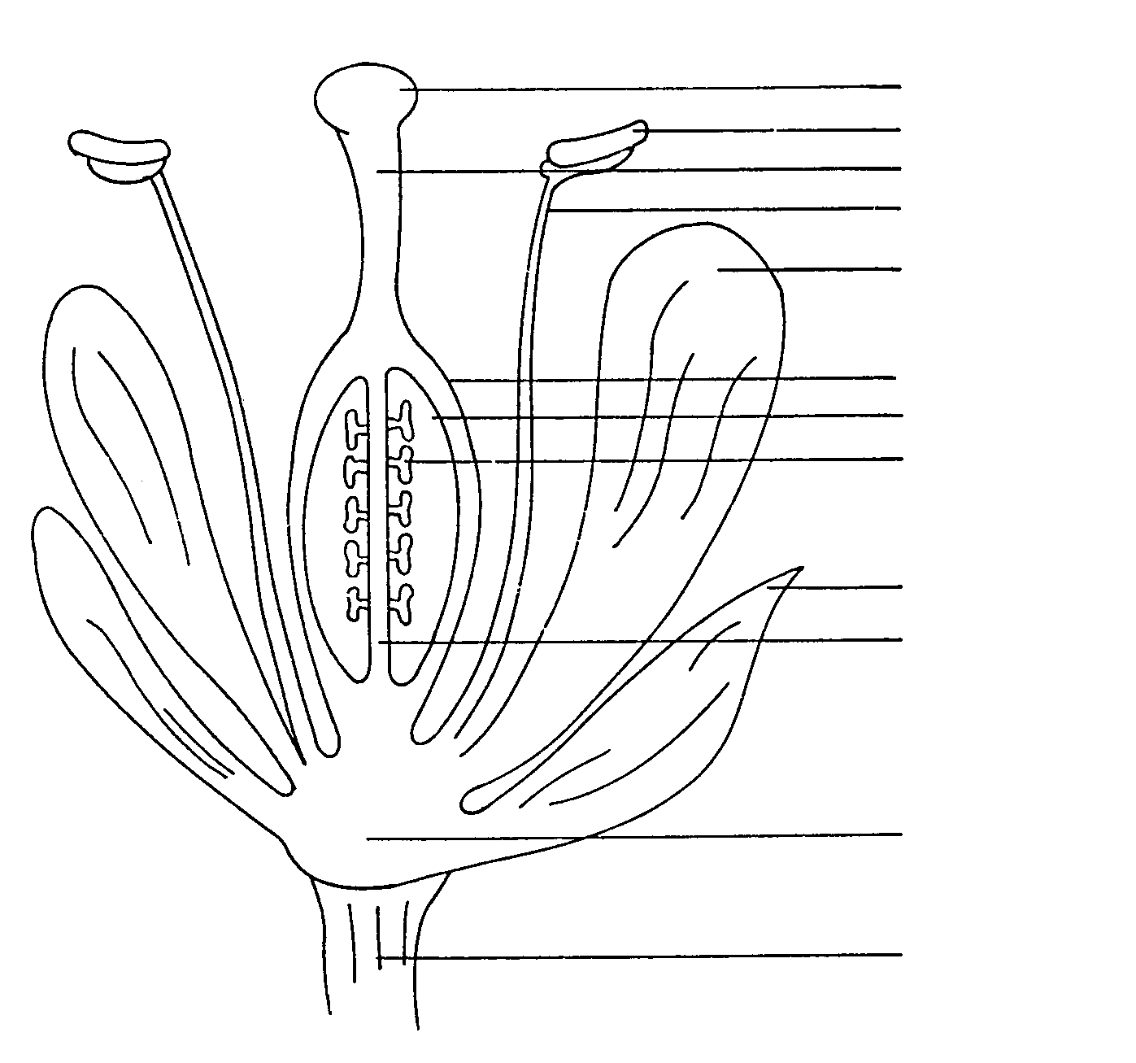

A
B
C
D

E

F
G
H

I

J

K

L
M

Figure 3

- Supply the missing labels A – K.  - Write down the letters on the diagram which represent a structure where the following take place:  - Reception of pollen  - Production of pollen  (c) Production of ova. | (10)  (3)

6.5 Explain parthenocarpy under the following headings:  6.5.1 Vegetative parthenocarpy  6.5.2 Stimulative parthenocarpy | (3)  (4)  [50]

QUESTION 7

- South Africa is divided into FIVE pasture regions. Name and discuss each region briefly.  - Discuss the factors which influence plant succession.  - Discuss crop rotation under the following headings:  7.3.1 Advantages  7.3.2 Circumstances under which crop rotation is not recommended  7.4 Name the factors which influence the demand for a specific product.  7.5 Discuss the disadvantages of the free-marketing system. | (15)  (9)  (10)  (6)  (6)  (4)  [50]

TOTAL FOR SECTION B:  TOTAL: | [300]  400

