GAUTENG DEPARTMENT OF EDUCATION
SENIOR CERTIFICATE EXAMINATION

AGRICULTURAL SCIENCE HG

TIME : 3 hours

MARKS : 400

REQUIREMENTS:

- Calculator

INSTRUCTIONS:

- Answer ALL questions.
- Answer Question 1 (Multiple Choice Questions) on the answer sheet on the inside cover of your answer book.
- Please number your answers exactly as the questions are numbered, using the decimal numbering system e.g. 2.1.1.
- Please pay attention to the legibility of your writing and the neatness of your work.

SECTION A

QUESTION 1

1.1 The following questions are provided with four possible answers of which only ONE possibility is correct in each case. Indicate the answer of your choice by making a cross (X) over the appropriate letter next to the question number on the answer sheet on the inside cover of your answer book, for example:

A
B
C
D

1.1.1. The gall bladder opens in the
- stomach.
- colon.
- duodenum.
- jejenum.

    - The smallest component of the complex stomach of a ruminant is the
- rumen.
- reticulum.
- omasum.
- abomasum.

1.1.3 Which vitamin is essential for normal bone development?
- Vitamin A
- Vitamin C
- Vitamin D
- Vitamin E

1.1.4 ATP
- has more energy than ADP.
- has less energy than ADP.
- has no energy.
- is phosphorylated into ADP.

    - The possibility of brackishness is greater when there is a large concentration of
- hydrogen ions.
- aluminium ions.
- sodium ions.
- calcium ions.

    - Which soil colour indicates badly drained soil?
- Dark brown
- Red
- Black
- Grey

    - Rickets may be caused by
- viruses.
- a deficiency of iodine.
- a deficiency of calcium and phosphorus.
- fungi.

    - _______ is an easily digestible carbohydrate.
- Starch
- Lignin
- Cellulose
- Maltose

    - Carbohydrates are stored in the liver in the form of
- glucose.
- glycogen.
- amylopectin.
- dextrin.

    - The fertilizer containing the highest percentage of nitrogen is
A. ammonium sulphate.
- superphosphate.
- ammonium nitrate.
- urea.

    - Ovulation in cows occurs during
- oestrus.
- pro-oestrus.
- met-oestrus.
- di-oestrus.

    - Which one of the following is a secondary male sex organ?
- Testes
- Epididymis
- Vas deferens
- Scrotum

    - Superphosphate is never used as a top dressing because it
- hardly moves into the soil.
- is not soluble in water.
- is readily available to the plant.
- is easily leached from the soil.

    - White brack soils are referred to as ______ soils.
- acid
- alkaline
- fertile
- saline

    - The best way to cultivate strawberries is by making use of
- runners.
- tubers.
- bulbs.
- buds.

    - Savannah is always associated with
- A. grasslands.
B. succulents.
- C. the Karoo.
- D. sparse grass covering.

    - The formula: Et = F x Eo refers to
A. scheduled irrigation.
- B. animal nutrition.
- C. reproduction.
- D. soil conservation.

    - ______ is an example of working capital.
A. Livestock
- B. Implements
- C. Machinery
- D. Seed

    - A disadvantage of co-operative marketing is
A. fluctuating prices.
- B. compulsory membership.
- C. that farmers have less power.
- D. higher marketing costs.

- _______ is an example of fixed capitals.  A. Machinery  - B. Buildings  - C. Livestock  - D. Seed 20 x 2 = | [40]

1.2 Supply the correct agricultural term for each of the following descriptions.

1.2.1 A disease which results in the ulceration of the cornea of the eye.

1.2.2 The rhythmic contraction and relaxation of muscles in the digestive tract which result in food being pushed forward.

    - The inner mucus lining of the uterus.

    - The soil fraction that has a diameter of 0,02 to 0,002mm.

    - Gross energy value of feed minus the energy lost in faeces.

    - The opening of the urogenital system of fowls.

    - The uniform application of fertilizer over the whole surface before planting.

    - A micro-element required by Rhizobium bacteria for nitrogen fixation.

    - Absorption of nutrients whereby energy is required.

    - Flowers that contain both the pistil and the stamen on the same flower.

    - The hard external cover of a pollen grain.

    - A fruit produced by a single flower with many simple pistils.

    - A process by which a ripe ovum is released by a Graafian follicle.

1.2.14 The ability of plants to develop fruit without fertilisation.

1.2.15 The sterility brought about in a heifer where the heifer is one of a twin and the other member of the twin is a bull.

- The development process of vegetation from the smallest pioneering form to a climax community.  - Water loss via the leaves of a plant.  - The means used to promote the sale of agricultural products.  - Money that is borrowed from financial institutions.  1.2.20 Too much capital invested in relation to other production factors on the farm. 20 x 2 = | [40]

1.3 Write down the letter of the word / phrase in Column B which can best be associated with the description in Column A next to the appropriate question number in your answer book.

COLUMN A | COLUMN B
- Anaemia  - Fodder with a high energy content  - Rickets  - Environmental factor influencing the production potential of veld  - Dark soil colour  - Co-operative marketing  - Semi-desert  - Controls the growth direction of the pollen tube  - Bushveld  - Vitamin C | - Spike  - Scurvy – in humans  - Flocculation  - Pool system  - Iron  - Low rainfall  - Vitamin D  - Maize  - Organic matter  - Climate  - Soil compaction  - Northern Province  - Vegetative nucleus

10 x 2 = | [20]

TOTAL FOR SECTION A: | [100]

SECTION B

- Start each question on a new page.

- Answer all questions in point form.

QUESTION 2

- Discuss the FIVE factors that influence the development of soil structure.  - Describe the properties of the following types of soil in terms of colour.  2.2.1 Red soil  2.2.2 Yellow soil  2.2.3 Grey soil  2.2.4 Dark soil 4 x 4 = | (10)  (16)

2.3 Discuss the procedure used for classifying soil.  2.4 Study the reaction below and answer the questions which follow. | (10)

COLLOID =
COLLOID =
₂
Ca² + 2H₂ CO₃ + Ca (HCO₃)

- Which process takes place when the reaction proceeds to the right?  - Which physical property of soil will cause this reaction to proceed faster to the right?  - Which climatic condition will affect this reaction?  - How could the soil reaction be affected if the reaction proceeds to the left? | (1)  (1)  (1)  (1)

2.5 Discuss the influence of soil temperature on crop production. | (10)  [50]

QUESTION 3

- Discuss SEVEN factors influencing the digestibility of feeds. | (14)

3.2 Study the schematic representation below of the alimentary canal of a pig in Figure 1 and supply the missing labels A – L. | (12)

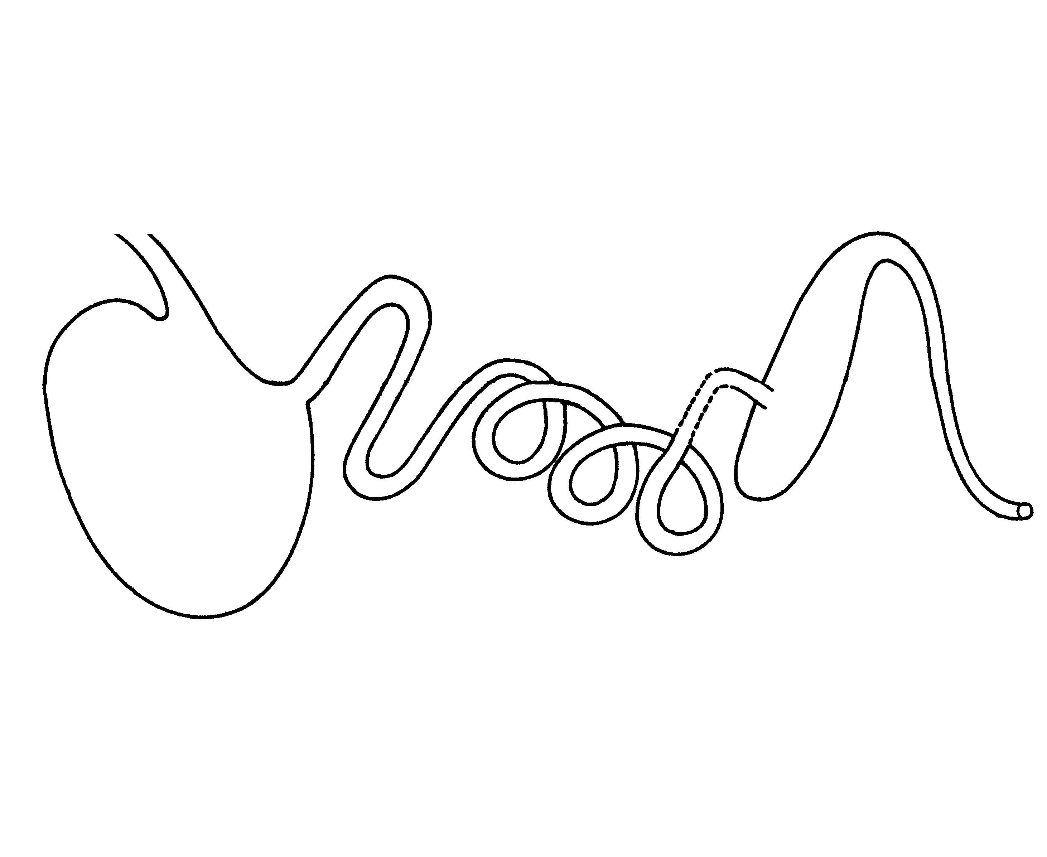
A

B

C

D

E

F
G

H

I

J

K
L

Figure 1

3.3 Write down the letters on the diagram which represent the part where the following functions take place:  3.3.1 Defecation  3.3.2 Initial digestion of proteins | (1)  (1)

3.4 Define the following terms:  3.4.1 Roughage  3.4.2 Nett energy  3.4.3 Amino acid  3.4.4 Maintenance ration  3.4.5 Production ration 5 x 2 = | (10)

3.5 A cow consumes 5 kg of fodder with a dry mass of 30% daily. The cow daily excretes 1 kg of faeces with a moisture content of 40%. Calculate the digestibility coefficient of the feed.  3.6 Explain the concept nutritive ratio of feed. | (10)  (2)  [50]

QUESTION 4

Figure 2 is a schematic representation of the reproductive system of a bull:

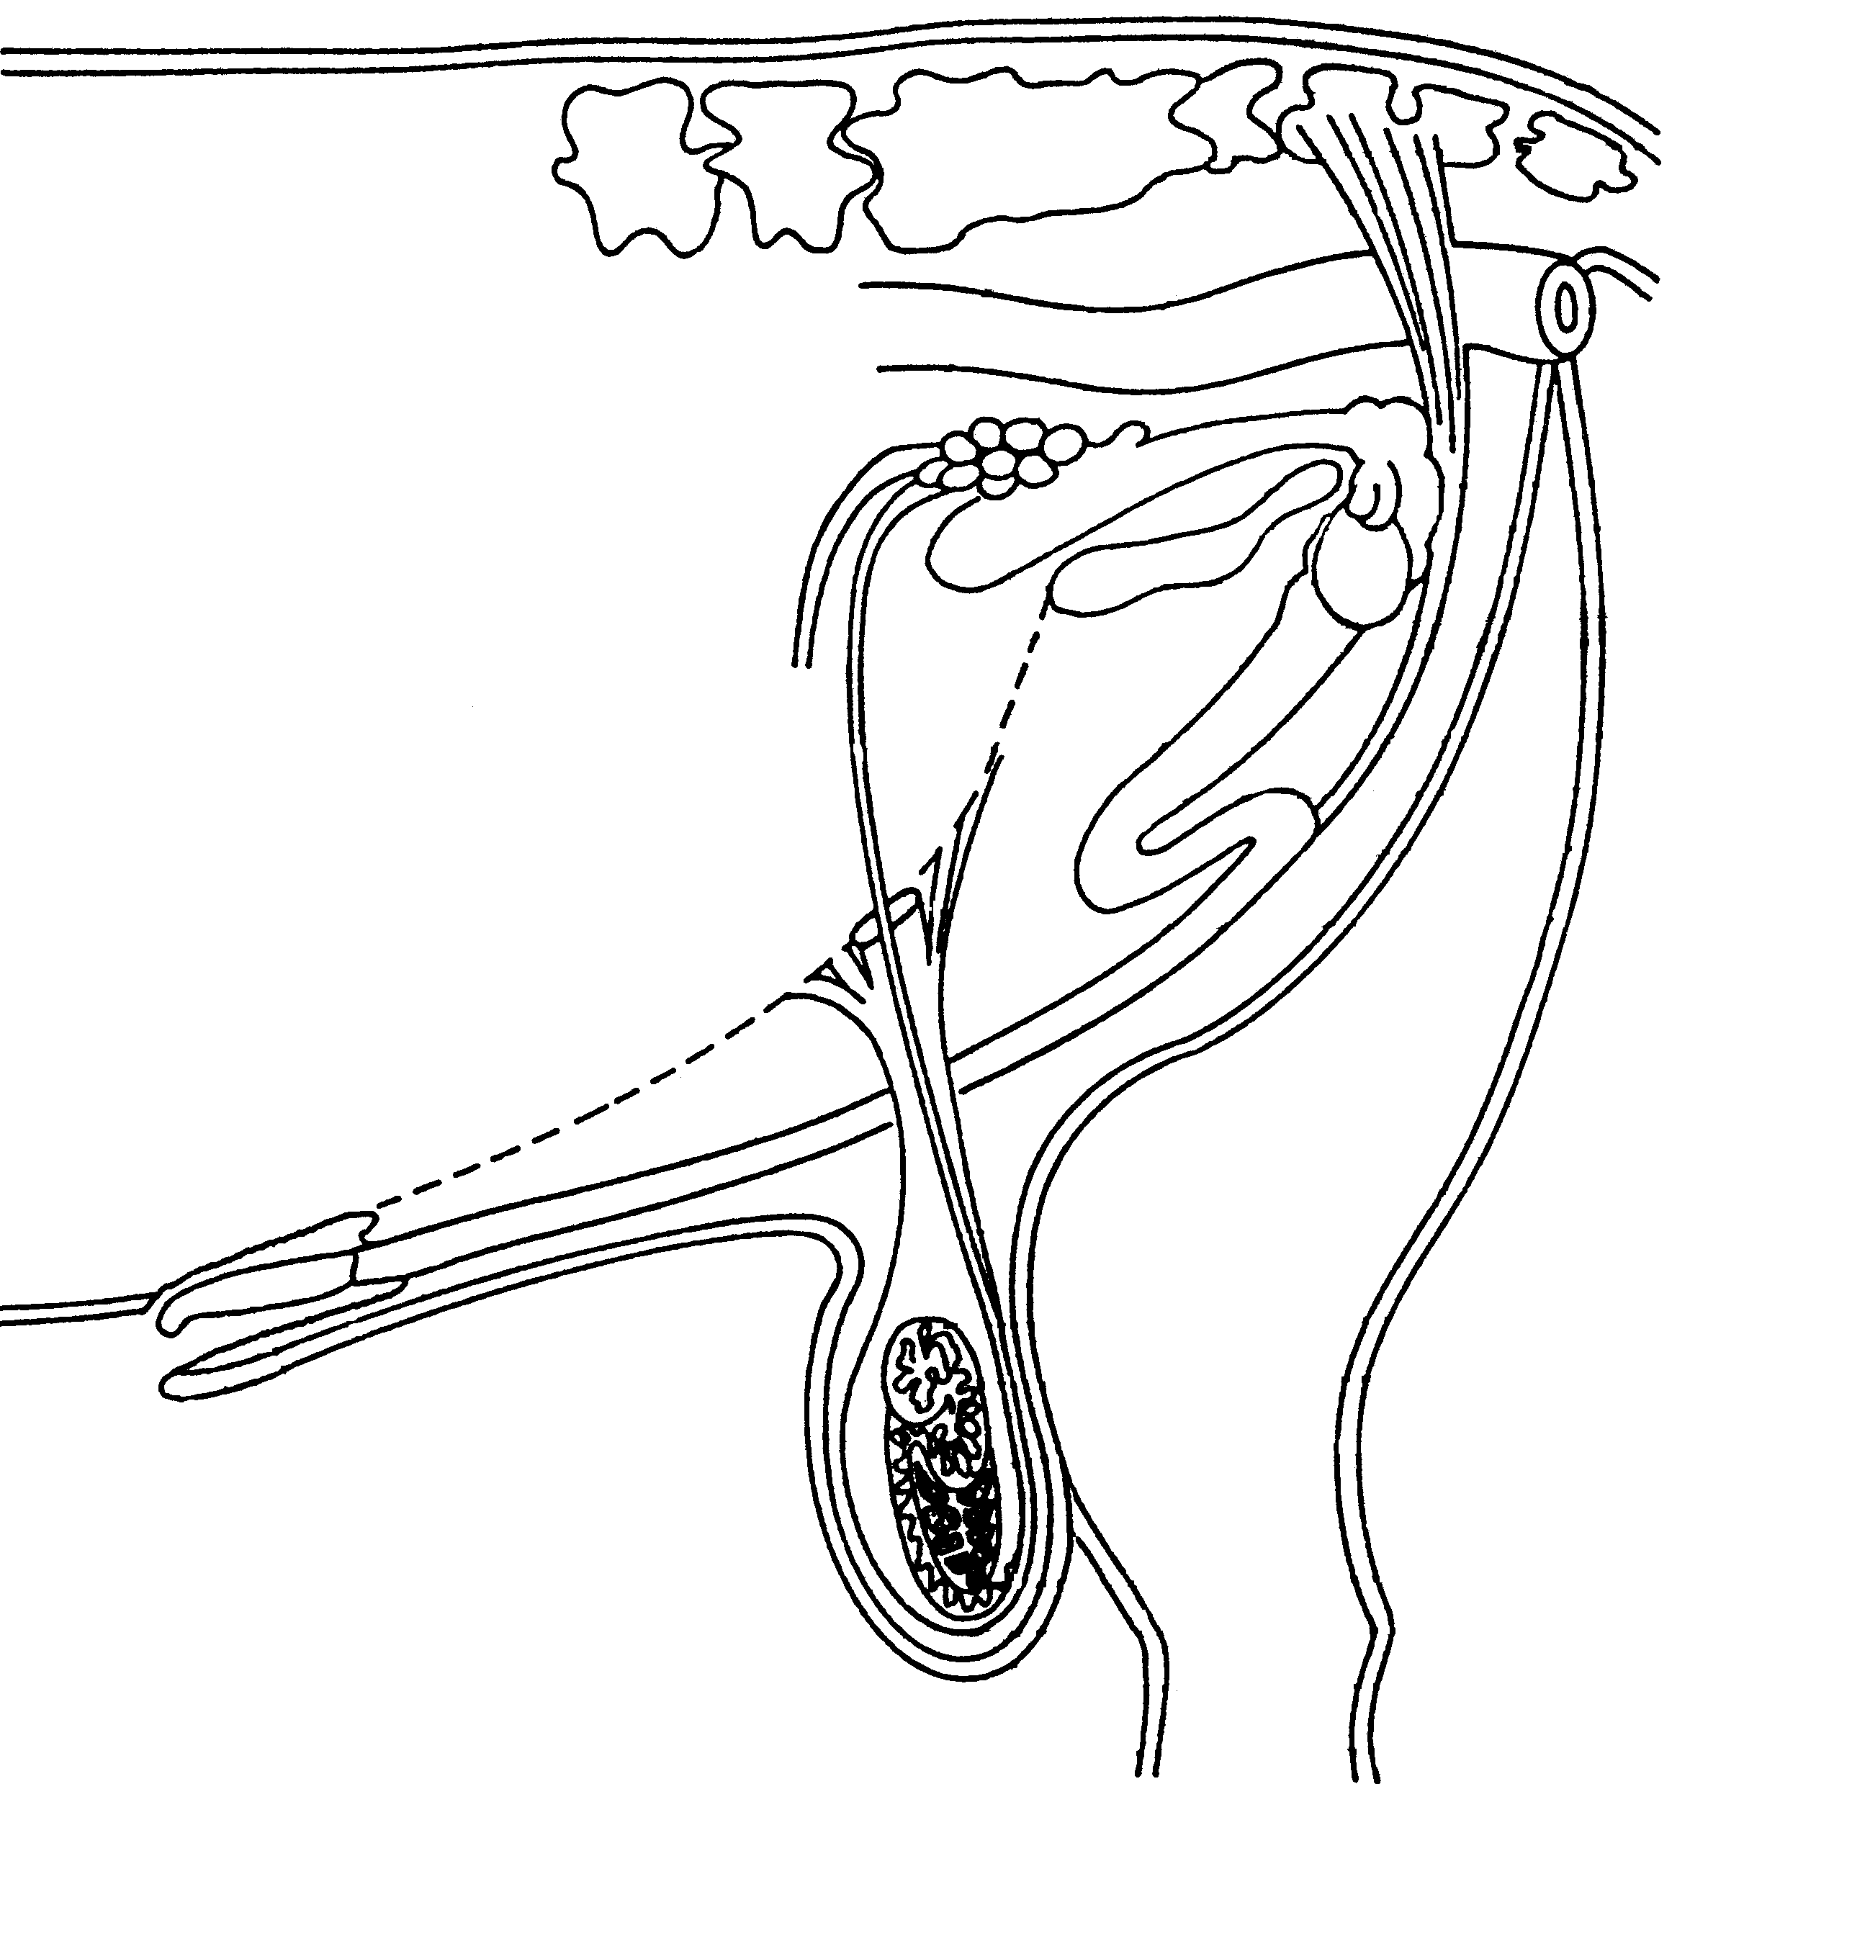
A
B

C

D

E

F
G
H
I
J
K

L

M

Figure 2

- Supply the missing labels A – M.  - Write down the letter on the diagram which represents an organ where the following take place:  4.2.1 Defecation  4.2.2 Collection on urine  4.2.3 Protection of testicles  4.2.7 The passage of excretion and urine | (13)  (4)

4.3 Describe the route that sperms follow starting at the germ epithelium, through the different parts of the testes, up to fertilisation. Include all the glands that secrete essential fluids.  Please present answer in point form and logical sequence. | (20)

4.4 Discuss the causes of sterility in bulls.  4.5 Mention any THREE causes of lack of libido in bulls. | (10)  (3)  [50]

QUESTION 5

- Discuss the following pregnancy problems as they occur in cows:  5.1.1 Resorption of the embryo  5.1.2 Mummification and maceration  5.1.3 Miscarriage | (7)  (7)  (5)

5.2 Describe the following phases of the oestrus cycle:  5.2.1 Met-oestrus  5.2.2 Di-oestrus | (6)  (6)

5.3 Discuss the advantages of artificial insemination.  5.4 Discuss the first stage of parturition as it occurs in cows. | (10)  (9)  [50]

QUESTION 6

6.1 How would you advise a farmer to control alkaline soil?  6.2 Explain the different uses of Lime Stone Ammonium Nitrate (LAN) as a fertilizer.  - Explain plant nutrient analysis under the following headings:  6.3.1 The taking of leaf samples  6.3.2 The preparation of leaf samples | (10)  (10)  (4)  (4)

6.4 Figure 3 is a schematic representation of the wheat flower.

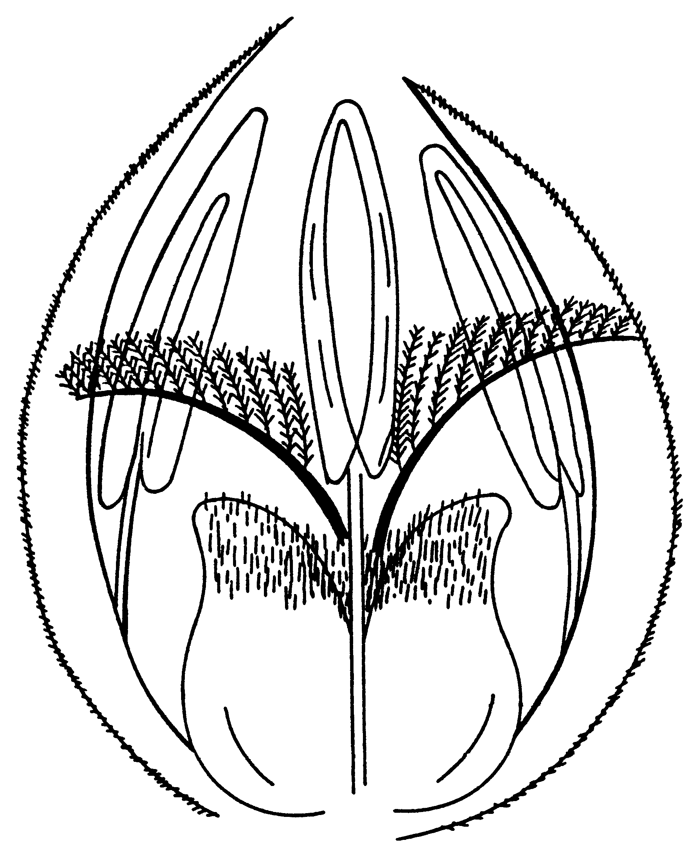

A

B

C

D

E

F

Figure 3

- Provide the diagram with the missing labels A – F.  - What is the function of the structure labelled A on the diagram?  6.5 Explain in detail how you would carry out split grafting on fruit trees.  6.6 Discuss artificial cross pollination. | (6)  (1)  (8)  (7)  [50]

QUESTION 7

- Climate is the dominant factor which determines whether a region is suitable for the cultivation of a particular crop. Discuss these factors which influence crop adaptation.  - What are the advantages of mulch cultivation in crop production?  - Explain how you would go about carrying out a soil survey for a given piece of land.  - Discuss the principles of co-operative marketing.  - Briefly describe how the following factors complicate the marketing of agricultural products:  7.5.1 Seasonal production  7.5.2 Perishability  7.5.3 Standardisation  7.5.4 Lack of control over production 4 x 2 = | (10)  (7)  (12)  (10)  (8)

7.6 Explain the concept of free marketing. | (3)

TOTAL FOR SECTION B:  TOTAL: | [50]  [300]  400

