GAUTENG DEPARTMENT OF EDUCATION

SENIOR CERTIFICATE EXAMINATION

ADDITIONAL MATHEMATICS HG

TIME: 3 hours

MARKS: 400

INSTRUCTIONS:

- This examination paper consists of FIVE sections.

- Section A is COMPULSORY and must be answered by ALL candidates.

- A further TWO sections must be answered from Sections B, C, D and E. (Only TWO of these sections will be marked.)

- Answer each section in a separate answer book. Please indicate the relevant section clearly on the cover. Place all the answer books inside the answer book for Section A before handing in all your scripts.

- Unless otherwise indicated, non-programmable calculators may be used.

- The examination paper consists of 14 pages. A Formula Sheet can be found on page 13 and Statistical Tables for Section E on page 14. Please check that your examination paper is complete.

- All essential calculations must be clearly shown.

- Please write legibly.

- All angle sizes must be expressed in radians.

SECTION A
DIFFERENTIAL CALCULUS
COMPULSORY

QUESTION 1

1.1 On the same set of axes, sketch the graphs of f (x) = arctan x and g(x) = arcsin x. | (12)

- Use the graph in Question 1.1 to answer the following questions:  - For which values of x will f ◦ g be defined?  - Determine the value of (g ◦ f ) (1) correct to 1 decimal place.  - Determine f '(0) if it exists. | (2)  (6)  (4)  [24]

QUESTION 2

2.1 2.1.1 Define the notion “ f is continuous at the point x = a”.  2.1.2 State the condition under which f will be “jump discontinuous” at this point. | (6)  (6)

3 + x – x² if x$∈$(–∞ , 1)  2.2 Given the function f defined by f (x) =  x² + ax + 5 if x$∈$[1 ; ∞)  - Determine the values of a for which f will be jump discontinuous at x = 1.  - Sketch the graph of f ' (the derivative of f ), if a = -3.  - Use your graph to determine the values of x for which f ' (x) > 0.  - Discuss the differentiability of f at the point x = 1 if a = -1. | (8)  (8)  (4)  (10)  [42]

QUESTION 3

3.1 Determine D_{x} $\left[\frac{\text{arcsin}2x}{\sqrt[3]{x^{4}−3x}}\right]$ | (10)

3.2 3.2.1 Determine $\frac{d^{2}y}{{\text{dx}}^{2}}$ where y = sec x and hence  3.2.2 the value of this derivative if x = $\frac{5π}{6}$. | (6)  (4)

- Consider the following function: f (x) = (1 + 2x)^{n}  - Determine f ^{(n)} (x)  - Hence determine f ⁽¹⁰⁾ (x) if f (x) = (1 + 2x)¹⁰ | (10)  (4)  [34]

QUESTION 4

4.1 Determine the following definite integral and interpret your answer:$\int{x(x^{2}−\sqrt{2})\text{dx}}$ | (12)

- Determine the following indefinite integrals:  4.2.1 $\int{\frac{\text{dx}}{\sqrt{7+6x−x^{2}}}}$  4.2.2 $\int{\text{12}x^{2}\text{sin}x^{3}\text{dx}}$ | (8)  (6)
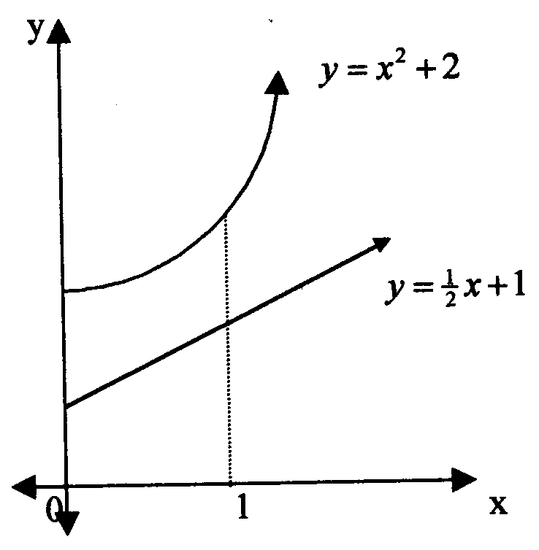
4.3

The diagram above shows the graphs of : y = x² + 2 and y = $\frac{1}{2}$x + 1.  By finding the volumes of the solids generated when y = x² + 2 and y = $\frac{1}{2}$x + 1 are rotated about the x axis between x = 0 and x = 1, determine the volume of the resulting ring that is formed. | (14)  [40]

QUESTION 5
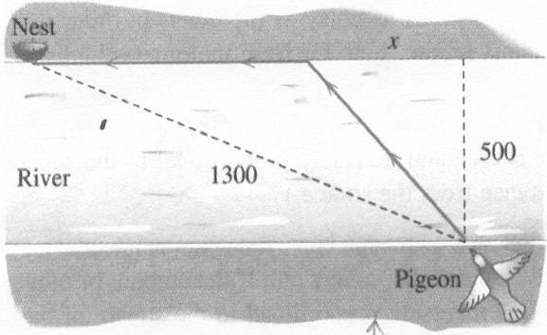

It is a well-known fact that homing pigeons fly faster over land than over water. Assume that they fly at 10 metres per second over land, and only 8 metres per second over water.

A pigeon is located at the edge of a straight river bank, 500 metres wide, and must fly to its nest, located 1 300 metres away on the opposite bank of the river (as indicated in the figure above).

5.1 Show that the time taken for the journey home can be expressed as:  $T(x)=\frac{\sqrt{x^{2}+\text{250}\text{000}}}{8}+\text{120}−\frac{x}{\text{10}}$.  5.2 Describe the path that would minimise the pigeon’s flying time. | (14)  (16)  [30]

QUESTION 6

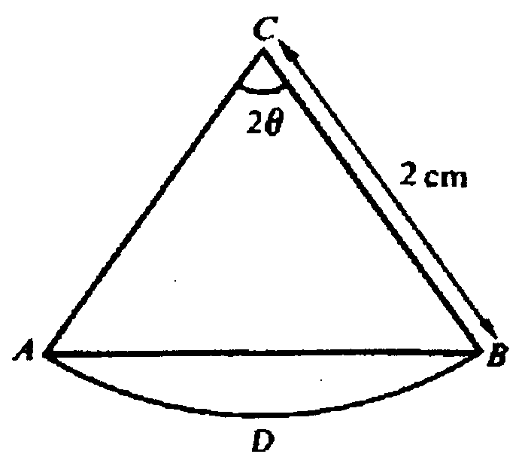

In the figure above, the chord AB, of a circle with radius 2 cm, divides the sector CADB into two portions such that the area of triangle ABC is three quarters of the area of the sector. Angle ACB is 2θ radians.

6.1 Show, by using the information about the areas, that 2 sin 2θ = 3θ.  - Show that a solution to this equation lies between 0,63 and 0,65.  - Using 0,63 as a first approximation to this root, apply the Newton-Raphson procedure to calculate the root correct to 6 decimal places. | (8)  (6)  (16)  [30]

TOTAL FOR SECTION A: | [200]

SECTION B
FINANCIAL MATHEMATICS

QUESTION 7

Mark takes out an annuity that will supplement his pension when he retires, thirty years from now. He estimates that he will need R2,5 million in this retirement fund, and he earns interest at 9% per annum compounded monthly.

- Calculate his monthly payment into this fund if he starts paying immediately, and makes his final payment 28 years from now.  - The retirement fund does not pay out the R2,5 million when Mark retires. Instead he will be paid monthly amounts, for a period of 20 years, starting one month after his retirement. If the interest rate that he earns over this period is calculated at 7% per annum compounded monthly, determine the monthly payment he will receive.  - Five years after retirement, Mark decides to emigrate and the retirement fund agrees to pay only 80% of the money still owing to him. How much does Mark receive as payment from the fund? | (12)  (10)  (8)  [30]

QUESTION 8

Shannyn has to choose between two banking institutions, Zorab Investment Bank and Business-on-line Bank. She is in need of R750 000 to purchase a computer business which is up for sale.

Shannyn is offered the following deals:

Zorab Investment Bank: | Business-on-line Bank:

A loan for the full amount (for a five-year period from today) at 11,2% simple interest per annum, to be paid back in equal monthly instalments, starting 6 months from now. | A loan (to be paid back over a five-year period) for the full amount at 13,5% per annum compounded monthly. She will have to pay back 60 monthly instalments of R17 000, and a final payment that will amortise the loan. Payments start one month from now.

Calculate the monthly payments for each option, and then advise Shannyn as to which option she should choose, and why? | [26]

QUESTION 9

A sinking fund is established to replace expensive equipment 10 years from now. The current equipment has a purchase value of R820 000, and is expected to escalate in replacement value at an effective rate of 12% per annum, compound interest, whilst the value of the current equipment will depreciate at an effective rate of 8% per annum, compound interest.

- Determine the amount that the sinking fund must accrue to make provision for the replacement of the old equipment, 10 years from now. (Assume that the old equipment will be sold to defray expenses.)  - The sinking fund must make provision for 19 half-yearly services costing R2 500 per service, with the first service 6 months from now, and a last service 6 months before the old equipment is sold. Determine the monthly payment to be paid into the sinking fund, to provide for both the services and the replacement of the old equipment. The sinking fund pays 14% interest per annum, compounded monthly, and payments start immediately. | (14)  (20)  [34]

QUESTION 10

The marginal profit function for a company that manufactures q lawnmowers, is given by:  P(q) = 0,3q${}^{\frac{2}{3}}$– $\frac{1}{7}$q²  Determine the average profit made on the first 50 lawnmowers. | (10)  [10]

TOTAL FOR SECTION B: | [100]

SECTION C
ANALYTICAL GEOMETRY

QUESTION 11

11.1 Sketch the curve C parameterized by x = 1 – 2t and y = –3 + 4t for all t and indicate the direction P(t) moves along C as t increases. | (10)

11.2 Describe the curve of C with parametric equations x = r cos t and y = r sin t where r > 0 and 0 ≤ t ≤ 2π. Also draw a rough sketch of the curve C. | (10)  [20]

QUESTION 12

Given the equation: 9x² – 18x + 4y² + 16y = 11  - Show that this is the equation of an ellipse.  - Write down the co-ordinates of the centre of the ellipse, and also determine the co-ordinates of its foci and the vertices.  - Determine the eccentricity of the ellipse and hence write down the equations of its directrices.  - Sketch the ellipse, showing the co-ordinates / equations of the properties determined in Questions 12.2 and 12.3 above.  - Determine the length of the minor axis as well as the area of the ellipse. | (12)  (12)  (8)  (4)  (6)  [42]

QUESTION 13

13.1 Cassandra and Craig, who are talking to each other by telephone, are 8 800 metres apart. Cassandra hears the thunder 4 seconds before Craig does. Sketch a rough graph indicating clearly the locations where the lightning could have struck. Assume the speed of sound to be 1 100 metres per second, and clearly indicate their respective positions on your graph. | (6)
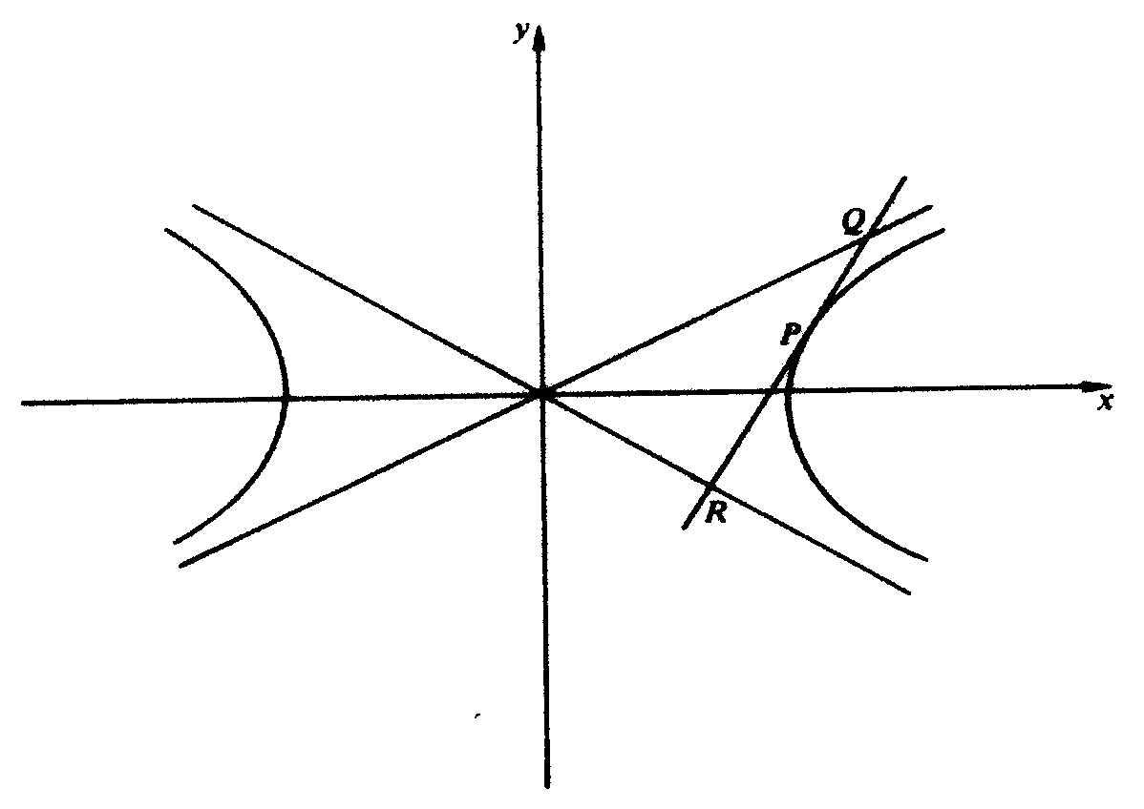
13.2

The tangent to a hyperbola at the point P meets the asymptotes at points Q and R. Show that P is the midpoint of QR. | (20)

13.3 13.3.1 Determine the equations of the asymptotes of the hyperbola y² = $\frac{x^{2}}{9}$–1.  13.3.2 Determine the eccentric angle θ of this hyperbola at the point where x = 9. | (4)  (8)  [38]

TOTAL FOR SECTION C: | [100]

SECTION D
ALGEBRA

QUESTION 14

By making use of mathematical induction, prove that 1 + 2 + 3 + ....... + n < $\frac{1}{8}$(2n + 1)² for n $∈$ N. | [14]

QUESTION 15

Given the rational function f (x) = $\frac{3x^{2}−7}{x^{2}+x−6}$.  15.1 Show that $\frac{3x^{2}−7}{x^{2}+x−6}$= 3 – $\frac{4}{x+3}+\frac{1}{x−2}$, by decomposing f into its partial fractions. | (12)

Determine the  - equations of any vertical and/or horizontal asymptotes that the graph of f may have.  - co-ordinates of the turning points of f.  - x– and y– are intercepts of f.  - point of intersection of f with its horizontal asymptote.  - Sketch the graph of f. | (8)  (12)  (6)  (6)  (6)  [50]

QUESTION 16

- Formulate without proof, the conjugate surds theorem.  - If it is given that 1–$\sqrt{3}$ is a zero of the polynomial 2x⁴ – x³ – 9x² – 8x – 2, determine the other three zeros.  16.3 If (x + 1) is a factor of both f (x) and f ' (x), where  f (x) = 3x⁵ + 10x⁴ + 9x³ + 6x² + 10x + 6, fully factorise f (x) in Z[x]. | (6)  (16)  (14)  [36]

TOTAL FOR SECTION D: | [100]

SECTION E
STATISTICS

QUESTION 17

- How many five digit numbers can be formed using the digits 1, 2, 3, 4 and 5? (Repetition is not allowed.)  - How many of these five digit numbers formed as defined in Question 17.1 are greater than 45321?  - What is the probability that any of the five digit numbers, chosen at random, is less than 45321? | (2)  (4)  (4)  [10]

QUESTION 18

During their stay at a coastal resort, holidaymakers were questioned as to which activities they had engaged in. Of the 145 questioned, 72 had been fishing, 98 had gone to the beach and 57 had spent time in the casino. Three of the holiday makers had just relaxed in their rooms and walked in the hills and had not taken part in any of the three activities. 21 had fished and gone to the beach but not spent time in the casino, 19 had fished and spent time in the casino but had not gone to the beach. 7 had gone to the beach and spent time in the casino but had not gone fishing.

- Illustrate the given data in a Venn diagram.  - What is the probability that one of the 145 holidaymakers, chosen at random, had engaged in fishing, gone to the beach and spent time in the casino? | (14)  (6)  [20]

QUESTION 19  Ten movie tickets are to be distributed at random to 100 members in a club. There are 43 men and 57 women belonging to the club. Write down the probability mass function for the random variable X, defined as the number of men who will get movie tickets. | [12]

QUESTION 20

A sample of 50 shad (or elf) was used to calculate a 95% confidence interval for the mean mass (in kg) of shad caught off the South African coast. The interval calculated was (1,52; 1,92).  - Calculate the sample mean and the sample standard deviation.  - What is the probability that the population mean is greater than 1,92 kg? | (8)  (2)  [10]

QUESTION 21  Five cards are drawn simultaneously from a set numbered 1 to 25. The probability of drawing any particular number in any one draw is therefore 0,2.  - What is the probability of drawing the number 25 in exactly two of five successive draws of five cards? (The cards drawn are replaced and re-shuffled between each draw).  - What is the probability of drawing at least two 25s in five draws? | (6)  (8)

21.3 Write down the probability that all the numbers chosen in a single draw are less than the integer n, where 6 ≤ n ≤ 25. | (12)  [26]

QUESTION 22  The mean mark obtained in an examination was 57 and the standard deviation was 11,5.  - If 40 was the pass mark, what percentage of the candidates failed?  - It was decided that 15% of the candidates should be awarded a distinction. Calculate, correct to the nearest whole number, the minimum mark that would award a candidate a distinction. | (8)  (14)  [22]

TOTAL FOR SECTION E: | [100]

TOTAL: | 400

FORMULA SHEET / FORMULEBLAD

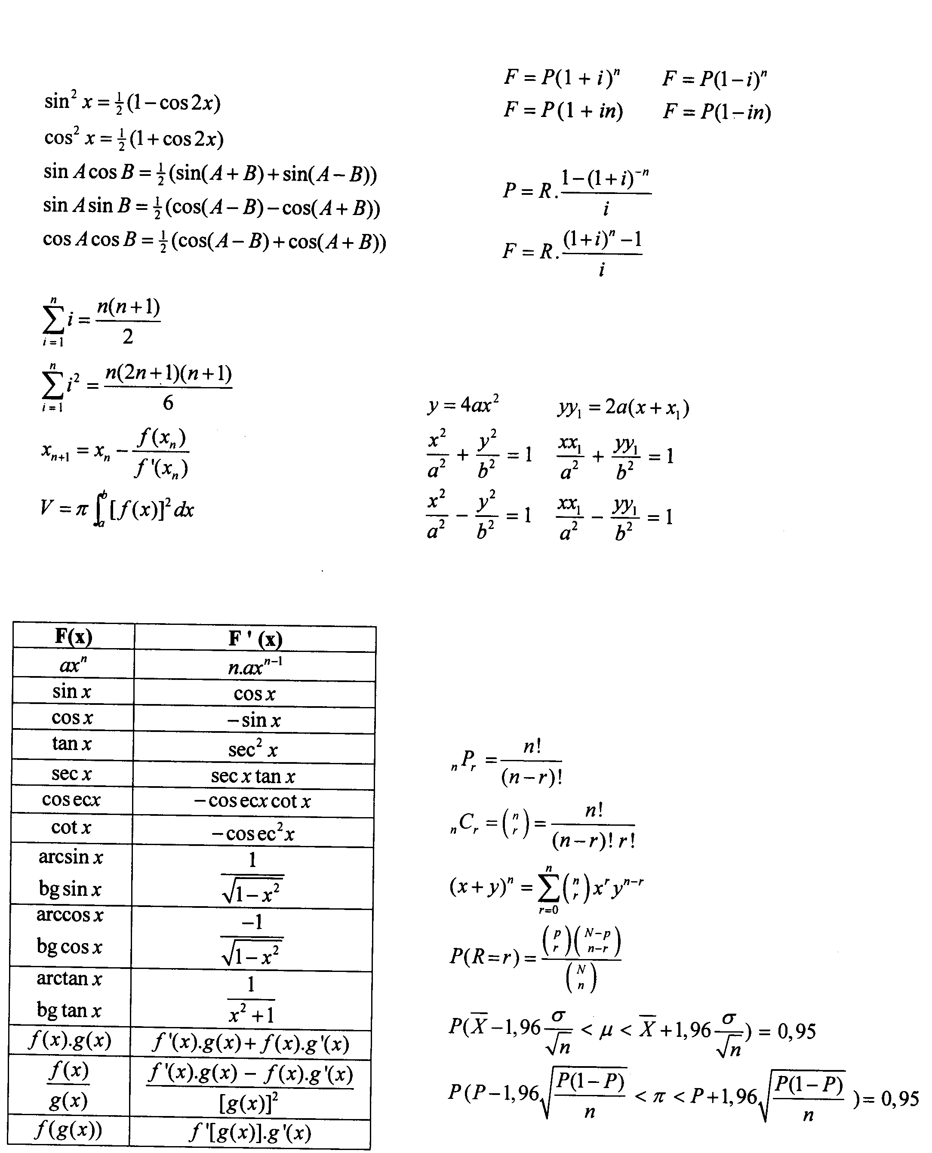
Differential and Integral Calculus
Differensiaal- en Integraalrekene
Finance
Finansies
Analytical Geometry /
Analitiese Meetkunde
Statistics / Statistiek

AREA UNDER THE NORMAL CURVE
Entries in the table are values of H(z) for positive values of z where H(z) = P(0<Z<z)
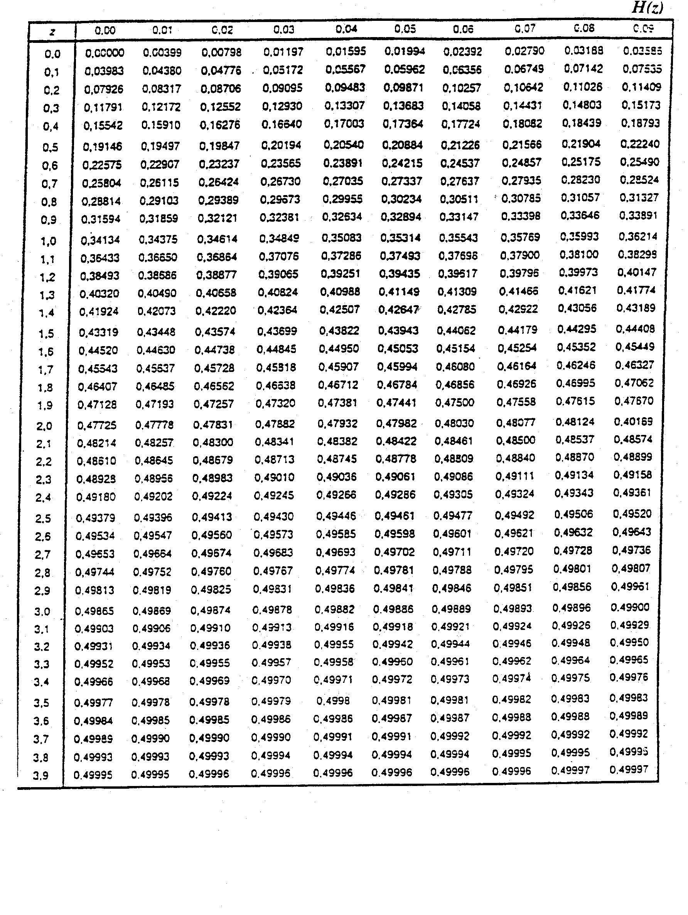
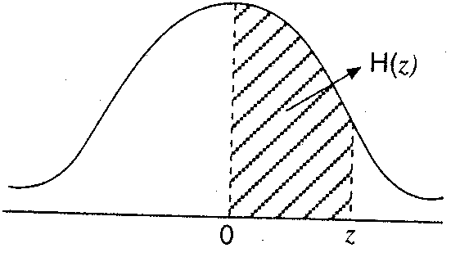
OPPERVLAKTE ONDER NORMAALKROMME
Die tabel bevat die waardes van H(z) vir positiewe waardes van z waarby H(z) = P(0<Z<z)

