GAUTENG DEPARTMENT OF EDUCATION

SENIOR CERTIFICATE EXAMINATION

ADDITIONAL MATHEMATICS HG

TIME: 3 hours

MARKS: 400

INSTRUCTIONS:

- This examination paper consists of FIVE sections.

- SECTION A is COMPULSORY and must be answered by ALL candidates.

- A further TWO sections must be answered from sections B, C, D and E. (Only TWO of these sections will be marked.)

- Answer each section in a separate answer book. Please indicate the relevant section clearly on the cover. Place all the answer books inside the answer book for Section A before handing in all your scripts.

- Unless otherwise indicated, non-programmable calculators may be used.

- The examination paper consists of 14 pages. A Formula Sheet can be found on page 13 and Statistical Tables for Section E on page 14. Please check that your examination paper is complete.

- All essential calculations must be clearly shown.

- Please write legibly.

SECTION A
DIFFERENTIAL CALCULUS
COMPULSORY

QUESTION 1

x³ for x ≤ a
Investigate the continuity and differentiability of y = f (x) =
3x + 2 for x > a
at x = a when a =

- 2  - 1  - -1  Justify all your conclusions fully. | [30]

QUESTION 2

Calculate the following limits:

- lim$\frac{x^{3}+\text{27}}{x+3}$  x → –3  - lim$\frac{θ}{3\text{tan}2θ}$  θ → 0 | (6)  (8)  [14]

QUESTION 3

- Calculate the domain and range of the function y = arcsin(3x + 1)  - Consider the equation arcsin(3x + 1) = arccos x  - Explain why no root of this equation can be negative.  - Solve the equation. | (8)  (6)  (8)  [22]

QUESTION 4

- Determine from first principles, the derivative of f (x) = $\frac{1}{\sqrt{x}}$  - Use the rules for differentiation to:  - prove that $\frac{d}{\text{dx}}\left(\text{arcsin}x−\sqrt{1−x^{2}}\right)=\frac{1+x}{\sqrt{1−x^{2}}}$ (Show all working)  - calculate f ' (x) if f (x) = $\frac{(3x−5)^{3}}{2x^{2}}$  - determine the gradient of the graph of y = 2 tan² ($\frac{π}{2}$ – 3θ) when θ = $\frac{π}{4}$ | (14)  (8)  (8)  (10)  [40]

QUESTION 5

Consider the graph of y = x⁴ – 2x³ + x.  - Show that the graph has a turning point at x = 0,5  - Explain why this turning point could not have been found by Newton’s method, starting with an initial value of either 0 or 1.  - Show that there is another turning point between 1 and 2 and hence, by Newton’s method (or otherwise), calculate the x-coordinate of this turning point (correct to three decimal places). | (6)  (10)  (14)  [30]

QUESTION 6

Evaluate the following integrals:  6.1 $\int{\frac{1}{x^{2}+2x+3}\text{dx}}$  6.2 $\int{\frac{2}{\sqrt{x+4}}\text{dx}}$  6.3 $\int{{\text{sin}}^{5}θ\text{.}dθ}$ (Hint: sin⁵ θ = (1 – cos² θ)².sin θ ) | (10)  (8)  (14)  [32]

QUESTION 7  Determine  - the points of intersection of the parabola 3y = 14 – 2x² and the hyperbola xy = 4.  - the area, in the first quadrant, enclosed by the graphs 3y = 14 – 2x² and xy = 4. | (8)  (12)  [20]

QUESTION 8  Calculate the volume obtained when the section of the circle (x – 2)² + y² = 36 between x = –1 and x = 5 rotated about the x-axis. | [12]

TOTAL FOR SECTION A: | [200]

SECTION B
MATHEMATICS OF FINANCE

QUESTION 9

How much (correct to the nearest rand) do I need to invest now at 9,3% p.a. compounded quarterly, to provide for the purchase of two airline tickets in two years’ time and another two in four years’ time? The first two tickets are expected to cost R15 000 (R7 500 each). An inflation rate of 7% p.a. must be taken into consideration in the two years between the purchase of the first and the second set of tickets. | [14]

QUESTION 10

The marginal cost function in millions of rand for a mining enterprise after t years of operation is 0,2t + 3. If the total cost of running the mine for the first 5 years was  R 20 million, and the revenue function in millions of rand for t years is 9t – 0,2t², calculate  - the fixed costs,  - the number of years that the mine should be kept operational for a maximum profit and  - the average profit per year over the fifth to the tenth year (inclusive). | (8)  (6)  (6)  [20]

QUESTION 11

A sinking fund is started to provide for the purchase of new machinery, expected to cost R2,5 million in 8 years’ time, as well as for a service contract for the existing machinery of R10 000 per year, payable at the beginning of each of the next seven years. Calculate the amount of the monthly payments (correct to the nearest rand), starting in a month’s time and ending in 8 years’ time, if interest at 10,75% p.a., compounded half-yearly is available. | [20]

QUESTION 12

A father decided to buy a holiday cottage in the Eastern Cape for his family for R120 000. He agreed to pay monthly instalments of R3 000 on a loan which incurred interest at 14,5% p.a., compounded monthly. The first payment was made at the end of the first month.  - Show that it would take the man 55 months to amortise the loan.  - What would be the amount of the last payment (less than R3 000)?  - The man encountered unexpected expenses and was unable to pay instalments at the end of the 20th, 21st, 22nd and 23rd months. At the end of the 24th month, he increased his payments so as to still pay off the loan in the same time, by 29 equal monthly payments. Calculate the amount of these payments. | (14)  (12)  (20)  [46]

TOTAL FOR SECTION B: | [100]

SECTION C
ANALYTICAL GEOMETRY

QUESTION 13

The sketch above is the parabola y = x². Normals to the parabola at P and Q intersect at R.  - Show that the equation of the normal to the parabola at any point (t;t²) is  2t³ + (1 – 2y)t – x = 0.  - Hence or otherwise, calculate the co-ordinates of R if t = –2 at P and t = –1 at Q.  - Determine the equation of the third normal to the parabola which passes through R. | (10)  (8)  (10)  [28]

QUESTION 14

Consider the hyperbola 16x² – 9y² = 144.  - Show that the foci are F(5;0) and F' (–5;0).  - Determine the equations of the directrices and asymptotes.  - Show that the tangent to the hyperbola at any point P (3 sec θ ; 4 tan θ ) has equation 4x – 3y sin θ = 12 cos θ. | (4)  (8)  (8)

- Given that 0 < θ < $\frac{π}{2}$, shows that Q, the point of intersection of the tangent to the hyperbola at P and the nearer directrix, has y–co-ordinate $\frac{\text{12}−\text{20}\text{cos}θ}{5\text{sin}θ}$.  - By calculating the gradients of PF and FQ, show that $P\hat{F}Q$is a right angle. | (8)  (10)  [38]

QUESTION 15

- Determine the equation of the conic section with eccentricity 0,5, foci (–5;0) and (5;0) and directrices with equations x = –20 and x = 20.  - Sketch the conic section defined in Question 15.1, showing clearly the co-ordinates of any intercepts with the co-ordinate axes.  - Determine the equation of the circle which is tangential to the conic section defined in Question 15.1 (and sketched in Question 15.2) at the points (5;7,5) and (5;–7,5). | (8)  (8)  (18)  [34]

TOTAL FOR SECTION C: | [100]

SECTION D
ALGEBRA

QUESTION 16

- If γ is a zero of the polynomial x³ + 5, rationalise the denominator of $\frac{γ}{γ^{2}−γ−1}\text{.}$  16.2 Given that n$∈$N, prove by using mathematical induction that 7^{n} + 3n – 1 is divisible by 9. | (20)  (14)  [34]

QUESTION 17

The equation x² + 2bx + c = 0, where b and c are non-zero constants, has roots α and β.  - Show that α³ + β ³ = 2b(3c – 4b²).  - Determine in terms of b and c, a quadratic equation whose roots are $\frac{α^{2}}{β}\text{and}\frac{β^{2}}{α}$. | (10)  (8)  [18]

QUESTION 18

- Without proof, state the conjugate surd theorem.  - Given the following polynomial h(x) = 2x⁵ – 3x⁴ – 14x³ + x² + 22x + 12 has a factor  (x + $\sqrt{5}−1)$ in R[x], and (x + 1) is a factor of both h(x) and h' (x). Fully factorise h(x) over Z[x]. | (6)  (16)  [22]

QUESTION 19

Consider the rational function f (x) = $\frac{x^{2}−4x+4}{x^{2}+x−6}\text{.}$  - Determine the equations of any asymptotes that the graph may have.  - Determine the values of x for which f ' (x) > 0.  - Sketch the graph of f indicating clearly on your graph the x- and y- intercepts as well as any asymptotes the graph may have. | (8)  (10)  (8)  [26]

TOTAL FOR SECTION D: | [100]

SECTION E
STATISTICS

QUESTION 20

- How many different “words” can be formed using the letters: BULUNGULA? (The “words” do not have to make sense.)  - What is the probability that a randomly chosen word, formed as described above, starts and ends with the letter ‘L’? | (6)  (8)  [14]

QUESTION 21

A confectioner makes a special mixture of toffees and chocolates in the ratio 2:3 and stores them in a huge drum. What is the probability that in a sample of 10 of these sweets, taken from the drum there are  - exactly six chocolates and four toffees?  - more than two chocolates? | (6)  (10)  [16]

QUESTION 22

In a medical research project, investigating the side effects of a certain type of medication, four out of every five patients are male.  - If the events of ‘being a male’ and ‘experiencing side effects’ are independent, and the probability of experiencing the side effects is $\frac{2}{3}$, draw a tree diagram to illustrate the situation and hence calculate the probability that a randomly selected patient would be a female who experienced the side effects.  - If the situation in Question 22.1 changes such that only one in four of the women on the project experienced the side effects, compared to $\frac{2}{3}$ of the men, what is the overall probability that a randomly selected patient experienced the side effects?  - What conclusion might be drawn (or investigated further), based on the data in Question 22.2? | (6)  (6)  (2)  [14]

QUESTION 23  A group of Additional Mathematics learners decided to conduct research into the use of cellular phones by Grade 12s at school. They chose a sample of 50 learners in Gauteng, taking care to use an unbiased sample. If the percentage in their sample who used cellular phones turned out to be 48%, calculate a 90% confidence interval for the percentage of all Grade 12’s in Gauteng who use cellular phones at school (correct to 1 decimal place). | [10]

QUESTION 24  The mean mark in a general knowledge competition was 52, and the standard deviation was 12.  - Calculate the percentage of contestants who obtained a mark of less than 30. (Give your answer correct to 1 decimal place).  - The competition organisers decide to issue certificates to the top 20% of the contestants. What minimum mark (rounded off to the next whole number) should be used to demarcate certificate winners from the other contestants? | (10)  (10)  [20]

QUESTION 25

- There are 3 black balls and ‘r’ red balls in a bag.  - Mpho takes one ball from the bag, notes the colour, puts it back, shakes the bag and then takes out another ball. The probability that these balls are of the same colour is $\frac{5}{8}$. Calculate all the possible values of r.  - If Piet takes two balls simultaneously from the same bag, containing 3 black balls and ‘r’ red balls, the probability that these balls are of the same colour is $\frac{1}{2}$. Calculate the value of ‘r’. | (8)  (8)

- There are 3 black and 7 red balls, and you are required to put one or more balls into one box and the rest into a second, identical box.  25.2.1 How many of each colour should be placed in the two boxes to provide the best chance of drawing a red ball if first a box is chosen at random and then a ball is drawn at random from that box? | (4)

25.2.2 Calculate the probability of drawing a red ball, using your answer in Question 25.2.1. | (6)  [26]

TOTAL FOR SECTION E: | [100]

TOTAL: | 400

FORMULA SHEET / FORMULEBLAD
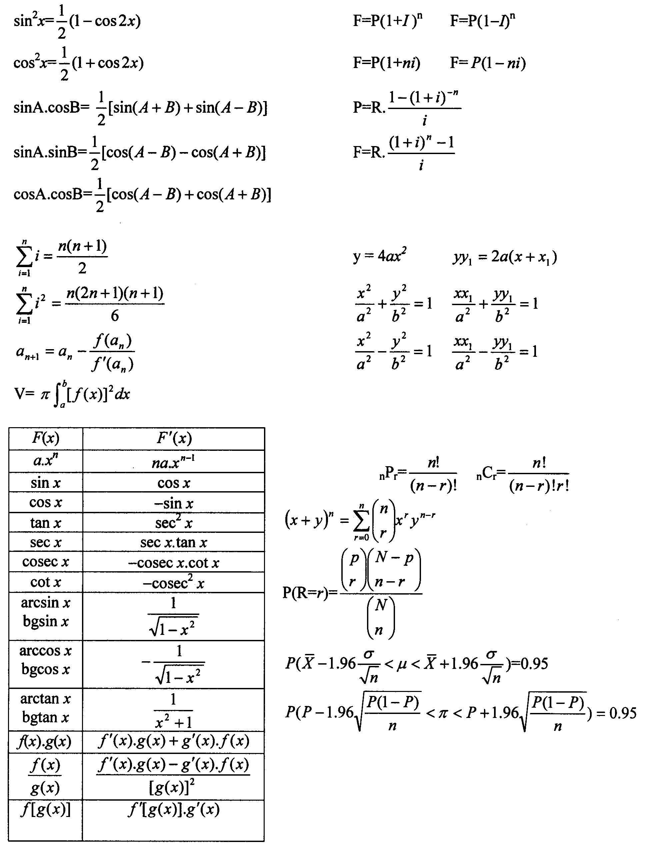
Differential and Integral Calculus
Differensiaal- en Integraalrekene
Finance
Finansies
Analytical Geometry /
Analitiese Meetkunde
Statistics / Statistiek

AREA UNDER THE NORMAL CURVE
Entries in the table are values of H(z) for positive values of z where H(z) = P(0<Z<z)
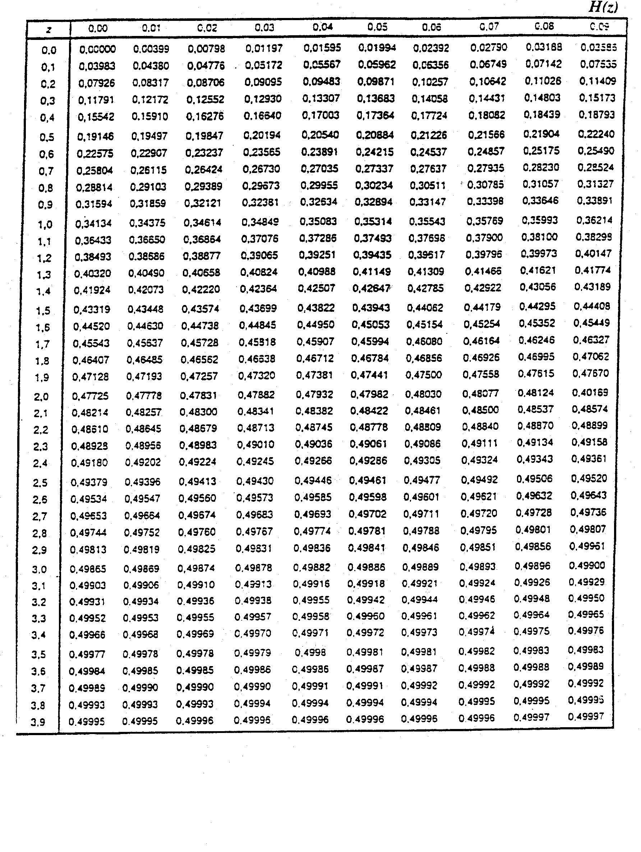
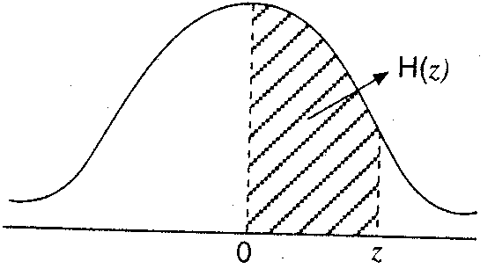
OPPERVLAKTE ONDER NORMAALKROMME
Die tabel bevat die waardes van H(z) vir positiewe waardes van z waarby H(z) = P(0<Z<z)

