Part 13 The d-Block Elements (Book 4, p.175 – 180)

15. 1. Cr and Fe form coloured compounds, but Mg and Al form colourless compounds. e.g. Cr³⁺ is green, Fe²⁺ is pale green.
2. Cr and Fe form compounds with different oxidation states while Al and Mg form compounds of fixed oxidation state.
3. Cr and Fe form a large number of complex ions but Mg and Al do not readily form complexes.
e.g. [Cr(C₂O₄)₃]^{3–}, [Cr(H₂NCH₂CH₂NH₂)₃]³⁺, [Fe(SCN)(H₂O₅)²⁺, [Fe(CN)₆]^{3–}, etc.
4. Cr, Fe and their compounds often show catalytic properties but Mg and Al do not. e.g. Fe / Fe₂O₃ in Haber process, Fe(OH)₃ in the decomposition of H₂O₂.

16. (a) The s-block elements such as calcium readily lose their valence electrons (2 electrons for calcium) to achieve stable noble gas electronic configuration. Hence, their oxidation state is fixed (+2 for calcium). However, for transition metals, due to the close proximity in terms of energy levels of the 3d and 4s orbitals, they can lose different number of 3d electrons in addition to the 4s electrons when forming stable compounds. Hence, transition metals show variable oxidation states.

(b) (i) Cr: +3 in CrCl₃
+6 in K₂Cr₂O₇
Fe: +2 in FeSO₄
+3 in Fe₂O₃
(ii) Iodide ions can reduce dichromate(VI) ions to chromium(III) ions.
$\frac{1}{2}$Cr₂O₇^{2–} + 7H⁺ + 3e– 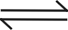 Cr³⁺ + $\frac{7}{2}$H₂O 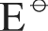 = +1.33 V
$\frac{1}{2}$I₂ + e– I– = +0.54 V
Overall:
Cr₂O₇^{2–} + 14H⁺ + 6I– ⎯→ 2Cr³⁺ + 7H₂O + 3I₂
 = +1.33 – (+0.54) = +0.79 V > 0
Copper can reduce iron(III) ions to iron(II) ions
Fe³⁺ + e– Fe²⁺ = + 0.77 V
Cu²⁺ + 2e– Cu = +0.34 V
Overall:
2Fe³⁺ + Cu ⎯→ 2Fe²⁺ + Cu²⁺
= +0.77 – (+0.34) = +0.43 V > 0

17. (a) The yellow solution of copper(II) chloride in dilute hydrochloric acid contains [CuCl₄]^{2–} ions.
[Cu(H₂O)₆]²⁺ + 4Cl– [CuCl₄]^{2–} + 6H₂O
  - When aqueous ammonia is added, the yellow solution turns green initially due to the presence of a mixture of the yellow [CuCl₄]^{2–} ion and the blue [Cu(H₂O)₆]²⁺ ions.
Blue [Cu(H₂O)₆]²⁺ ions are formed as aqueous ammonia neutralizes dilute hydrochloric acid and so the concentration of chloride ions decreases and the above equilibrium shifts to the left.
  - The green solution then turns pale blue as more [Cu(H₂O)₆]²⁺ ions are formed.
  - Finally, the pale blue solution forms a pale blue precipitate of copper(II) hydroxide (Cu(OH)₂) which dissolves in excess aqueous ammonia to give a deep blue solution containing [Cu(NH₂)₄]²⁺ ion.
NH₃(aq) + H₂O(l) NH₄⁺(aq) + OH–(aq)
Cu²⁺(aq) + 2OH–(aq) ⎯→ Cu(OH)₂(s)
Cu(OH)₂(s) + 4NH₃(aq) [Cu(NH₃)₄]²⁺(aq) + 2OH–(aq)

(b) (i) [Co(H₂O)₆]³⁺ + e– ⎯→ [Co(H₂)]₆]²⁺ = +1.82 V
[Co(NH₃)₆]³⁺ + e– ⎯→ [Co(NH₃)₆]²⁺ = +0.11 V
  - Cobalt(III) ions in aqueous solution are readily reduced to cobalt(II) ions as shown by the highly positive value (+1.82 V). Thus, aqueous cobalt(III) ions are unstable and are a good oxidizing agent.
  - [Co(NH₃)₆]³⁺ is more stable than [Co(H₂O)₆]³⁺ because ammonia is a stronger ligand than water and hence, stabilizing the cobalt(III) ion.
(ii) Dilute, acidic solutions of cobalt(II) salts are stable in air because the +2 state of cobalt is more stable than the +3 state in normal aqueous conditions.
On adding an excess of aqueous ammonia [Co(NH₃)₆]²⁺ is formed which is readily oxidised to [Co(NH₃)₆]³⁺ because the +3 state is more stable in complexes.

18. (a) Transition metal complexes are often coloured because they have incompletely filled d orbitals.
  - In the presence of ligands, the 3d orbitals of transition metal become non-degenerate and split into two groups with slightly different energy (d-d splitting). When a d electron from the lower energy group is promoted to the higher energy group (d-d electron transition), radiation in the visible region of the electromagnetic spectrum is absorbed. The light energy not absorbed will be seen as the colour of the complex.
  - The colour of a particular transition metal complex is determined by the nature of the ligand.

(b) (i) The addition of thiocyanate ions to aqueous iron(III) ions produces a deep blood-red colour due to the formation of [Fe(SCN)(H₂O)₅]²⁺(aq) ion.
[Fe(H₂O)₆]³⁺ + SCN– ⎯→ [Fe(SCN)(H₂O)₅]²⁺ + H₂O
blood-red
When aqueous sodium fluoride is added, the colour disappears due to the formation of a stable complex fluoride, [FeF₆]^{3–}(aq).
(ii) Anhydrous cobalt(II) chloride is blue due to the complex ion, [CoCl₄]^{2–}.
[Co(H₂O)₆]²⁺ + 4Cl– [CoCl₄]^{2–} + 6H₂O
pink blue
The addition of water shifts the position of equilibrium to the left and so, a pale pink solution is produced.

19. (a) (i) Potassium manganate(VI) is green in colour.
(ii) The manganese-containing ion in the purple solution is MnO₄–.
- 3MnO₄^{2–} + 4H⁺ ⎯→ 2MnO₄– + MnO₄^{2–} + 2H₂O
(iv) 2MnO₂ + O₂ + 4OH– ⎯→ 2MnO₄^{2–} + 2H₂O
(b) (i) MnO₂ + 4H⁺ + 2e– ⎯→ Mn²⁺ + 2H₂O = +1.23 V
To convert MnO₂ to MnSO₄ in acid solution, the reducing agent must have a value more negative than +1.23 V.
Hence, Sn²⁺ (or Fe²⁺) would convert MnO₂ to MnSO₄ in acid solution.
MnSO₄ in acid solution.
(ii) MnO₂ + Sn²⁺ + 4H⁺ ⎯→ Mn²⁺ + Sn⁴⁺ + 2H₂O
= (+1.23 – (+0.15)) V
= +1.08 V
OR
MnO₂ + 2Fe²⁺ + 4H⁺ ⎯→ Mn²⁺ + 2Fe³⁺ + 2H₂O
= (+1.23 – (+0.77)) V
= +0.46 V
(iii) With Sn²⁺ as reducing agent, the final solution is colourless.
[With Fe²⁺ as reducing agent, the final solution is pale yellow in colour.]

(c)
Since the mole ratio of Mn : O : Cl is 1 : 2 : 2,
∴ the empirical formula is MnO₂Cl₂.
Let the oxidation number of Mn be x.
x + 2(–2) + 2(–1) = 0
∴ x = +6
The oxidation number of Mn is +6.

20. (a) (i) The manganese-containing ion in the green solution is MnO₄^{2–}.
The oxidation number of Mn is +6.
(ii) 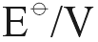
MnO₄– + e– ⎯→ MnO₄^{2－} +0.56
O₂ + 2H₂O + 4e－ ⎯→ 4OH– +0.46
4MnO₄– + 4OH– ⎯→ 4MnO₄^{2–} + O₂ + 2H₂O
= (+0.56 – 0.40) V = +0.16 V
Since > 0, the reaction is feasible.
Hence, the species responsible for the reduction of the Mn(VII) is OH–.
The balanced equation for the redox reaction is:
4MnO₄– + 4OH– ⎯→ 4MnO₄^{2–} + O₂ + 2H₂O
(b) The brown solid is MnO₂ and the purple solution is KMnO₄(aq).
3MnO₄^{2–} + 2H₂O ⎯→ 2MnO₄– + MnO₂ + 4OH–
The equation for the reaction between brown MnO₂ and aqueous SO₂:
MnO₂ + SO₂ ⎯→ Mn²⁺ + SO₄^{2–}
  - The equation for the reaction between purple MnO₄– and aqueous SO₂:
2MnO₄– + 5SO₂ + 2H₂O ⎯→ 2Mn²⁺ + 5SO₄^{2–} + 4H⁺

21. (a) Transition metal complexes are often coloured because they have incompletely filled d orbitals.
  - In the presence of ligands, the 3d orbitals of transition metal become non-degenerate and split into two groups with slightly different energy (d-d splitting). When a d electron from the lower energy group is promoted to the higher energy group (d-d electron transition), radiation in the visible region of the electromagnetic spectrum is absorbed. The light energy not absorbed will be seen as the colour of the complex.
  - Compounds of other metals are usually white because they have no d electrons and so,
d-d electron transition is not possible.

(b) (i) When concentrated hydrochloric acid is added to blue aqueous copper(II) sulphate, a yellow solution is obtained due to the formation of [CuCl₄]^{2–} complex ion.
Cu²⁺(aq) + 4Cl–(aq) ⎯→ [CuCl₄]^{2–}(aq)
blue yellow
The yellow solution reverts to a light blue colour when an excess of water is added due to the gradual replacement of ligands of chloride ions by water ligands to form the blue [Cu(H₂O)₆]²⁺ ion.
[CuCl₄]^{2–} + 6H₂O [Cu(H₂O)₆]²⁺ + 4Cl–
yellow blue
Adding water drives the equilibrium over to the right hand side.
(ii) When dilute aqueous ammonia is added to blue aqueous copper(II) sulphate, a blue precipitate of copper(II) hydroxide is first formed, which dissolves in excess aqueous ammonia to give a deep blue solution containing [Cu(NH₃)₄]²⁺ ion.
NH₃ + H₂O NH₄⁺ + OH–
Cu²⁺(aq) + 2OH–(aq) ⎯→ Cu(OH)₂(s)
Cu(OH)₂ + 4NH₃ [Cu(NH₃)₄]²⁺ + 2OH–
Aqueous EDTA forms a more stable complex with copper(II) ions than aqueous ammonia. Thus, only a small amount of aqueous EDTA is required to cause the deep blue solution to change to a paler blue as the more stable [Cu(EDTA)]^{2–} complex is formed.
[Cu(NH₃)₄]²⁺ + EDTA^{4–} [Cu(EDTA)]^{2–} + 4NH₃
deep blue pale blue

22. (a) The electronic configuration of chromium is 1s²2s²2p⁶3s²3p⁶3d ⁵4s¹.
Likely oxidation states of chromium: +6 and +3
(b) (i) For the reaction between iron(II) ions and acidified dichromate(VI) solution,
= +1.33 – 0.77 = +0.56 V > 0 V ⇒ reaction is energetically feasible.
Iron(II) ions are oxidized to iron(III) ions while dichromate(VI) ions are reduced to chromium(III) ions
Chemical equation:
Cr₂O₇^{2–}(aq) + 6Fe²⁺(aq) + 14H⁺(aq) ⎯→ 2Cr³⁺(aq) + 6Fe³⁺(aq) + 7H₂O(l)
(ii) For the reaction between iodide ions and acidified dichromate(VI) solution
= +1.33 – 0.54 = +0.79 V > 0 V ⇒ reaction is energetically feasible.
Iodide ions are oxidized to iodine while dichromate(VI) ions are reduced to chromium(III) ions.
Chemical equation:
Cr₂O₇^{2–}(aq) + 6I–(aq) + 14H⁺(aq) ⎯→ 2Cr³⁺(aq) + 3I₂(aq) + 7H₂O(l)

(c) (i)
The empirical formula of the red solid is BaFeO₄.
Let the oxidation state of Fe be x.
+2 + x + 4(–2) = 0
x = 8 – 2 = 6
Hence, the oxidation state of Fe in the red solid is +6.
(ii) Relative molecular mass of the solid = 137 + 55.8 + 16.0 × 4 = 256.8
Number of moles of the solid formed = $\frac{1\text{.}\text{00}}{\text{256}\text{.}8}$ = 3.894 × 10^{–3} mol
To oxidize Fe to FeO₄–, 6 mole of electrons is required for the formation of 1 mole of FeO₄–.
Hence, number of moles of e– required = 6 × 3.894 × 10^{–3} = 0.02336.
Coulombs of electricity needed = Number of moles of e– × F
= 0.02336 × 9.65 × 10⁴ C
= 2255 C (to 4 significant figures)

23. (a) Iron: [Ar] 3d ⁶4s²
Chromium: [Ar] 3d ⁵4s¹

(b) The oxidation state of iron in chromite is +2.

(c) (i) The environmental problems posed by the carbon monoxide produced in the process can be minimized by oxidizing to carbon dioxide, e.g. by burning carbon monoxide in air / oxygen and utilise the heat evolved.
(ii) Relative molecular mass of FeCr₂O₄ = 55.8 + 52.0 × 2 + 16.0 × 4 = 223.8
Number of moles of FeCr₂O₄ = $\frac{2\text{.}\text{24} × {\text{10}}^{3}}{\text{223}\text{.}8}$ = 10.01 mol
Number of moles of CO = 4 × Number of mole of Fe₂Cr₂O₄ = 4 × 10.01
= 40.04 mol
Volume of CO = 40.04 × 24 dm³ = 961 dm³ (to 3 s.f.)
(iii) Corrosion resistance

(d) (i)
(ii) 2Al(s) + Cr₂O₃(s) ⎯→ Al₂O₃(s) + 2Cr(s)

24. (a) (i) 1s²2s²2p⁶3s²3p⁶3d ²4s
(ii) TiCl₂, TiCl₄

(b) (i) The white solid first turns blue where hydrated copper(II) sulphate (CuSO₄ • 5H₂O) is first formed. It then dissolves in water to give a blue solution.
(ii) A blue precipitate is first formed due to the formation of copper(II) hydroxide (Cu(OH)₂).
Cu²⁺(aq) + 2OH–(aq) ⎯→ Cu(OH)₂(s)
The precipitate dissolves in excess ammonia solution to give a deep blue solution. A soluble complex ion is formed.
Cu(OH)₂(s) + 4NH₃(aq) ⎯→ [Cu(NH₃)₄]²⁺(aq) + 2OH–(aq)

25. (a) In transition element complexes, the central metal (ion) has partially filled d sub-shell. This allows d-d transition. When an electron in a lower d sub-shell is excited, it absorbs wavelength in the visible spectrum .Hence, colour complementary to these wavelengths absorbed is observed.
(b) The white powder first turns into blue crystals (CuSO₄ • 5H₂O).
CuSO₄(s) + 5H₂O(l) ⎯→ CuSO₄ • 5H₂O(l)
It then dissolves in water to give a blue solution.
CuSO₄ • 5H₂O(s) $\vec{\text{aq}}$ Cu²⁺(aq) + SO₄^{2–}(aq) + 5H₂O(l)
blue
When aqueous ammonia is added, blue precipitate of copper(II) hydroxide is formed, which then dissolves in excess ammonia to give a deep blue solution containing [Cu(NH₃)₄]²⁺.
Cu²⁺(aq) + 2OH–(aq) ⎯→ Cu(OH)₂(s)
Cu(OH)₂(s) + 4NH₃(aq) ⎯→ [Cu(NH₂)₄]²⁺(aq) + 2OH–(aq)

(c) (i) 4Fe³⁺(aq) + 3[Fe(CN)₆]^{4–}(aq) ⎯→ Fe₄[Fe(CN)₆]₃(s)
(ii) Cyanide ion is a strong ligand and it stabilizes iron(III) ions with respect to iron(II) ions. Hence, it makes [Fe(CN)₆]^{3–} more difficult to be reduced to the iron(II) state compared to [Fe(H₂O)₆]³⁺. Therefore, the value for [Fe(CN)₆]^{3–} is lower.
Fluoride ion is a stronger ligand than thiocyanate ion. When it is added to the complex, it displaces thiocyanate ion. The product formed is colourless.
[Fe(SCN)(H₂O)₅]²⁺ + F– ⎯→ [FeF(H₂O)₅]²⁺ + SCN–
red colourless

26. (a) (i) Cu atom: [Ar] 3d¹⁰4s¹
Cu⁺ ion: [Ar] 3d¹⁰
(ii) It is because copper(I) ions do not have unpaired d electrons from d-d electronic transition and absorption of visible light to occur.

(b) (i) 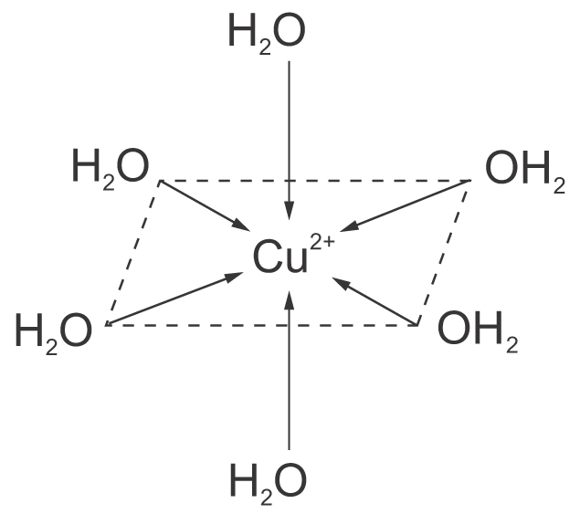

The ion has an octahedral shape.
(ii) The mixture of copper(II) sulphate, copper and concentrated hydrochloric acid is warmed until a brown solution is obtained.
The resulting mixture is then poured into water. The white precipitate of copper(I) chloride is then separated out by filtration.
CuSO₄ + 2HCl ⎯→ CuCl₂ + H₂SO₄
CuCl₂ + Cu $\vec{\text{HCl}}$ 2CuCl

27. (a) Mn: [Ar] 3d ⁵4s²
Mn²⁺: [Ar] 3d ⁵
Manganese(II) ion has a half-filled 3d sub-shell which is a stable electronic configuration.

(b) (i) The product of the reaction acts as the catalyst for the same reaction.
(ii) Manganese(II) ion is able to exhibit variable oxidation states.
(iii) 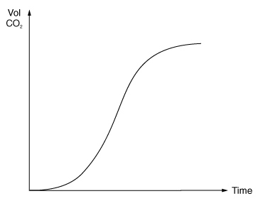

(c) (i) MnO₄–(aq) + 8H⁺(aq) + 5Fe²⁺(aq) ⎯→ Mn²⁺(aq) + 5Fe³⁺(aq) + 4H₂O(l)
(ii) $\frac{{\text{Number of moles of Fe}}^{2+}}{{\text{Number of moles of MnO}}_{4^{−}}}$ = $\frac{5}{1}$
Number of moles of Fe²⁺ = 0.020 × $\frac{\text{24}\text{.}8}{\text{1000}}$ × 5
n = 2.48 × 10^{–3} mol
Mass of Fe = 2.48 × 10^{–3} × 55.6 = 0.138 g
% by mass of Fe = $\frac{0\text{.}\text{138}}{2\text{.}\text{80}}×\text{100}$% = 4.93 %

28. (a) V³⁺ ion
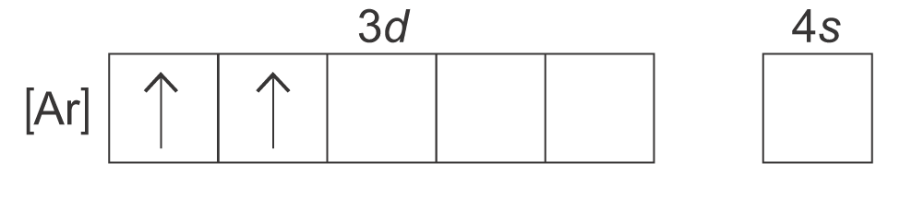

(b) Vanadium can form complex when ligand is present. Vanadium has various oxidation states.

(c) (i) +5
(ii) Dioxovanadium(V) ion

(d) (i) Mixture of VO₂⁺(aq) and VO²⁺(aq)
(ii) V³⁺(aq)
(iii) V²⁺(aq)

(e) (i) Reducing agent is a substance which reduces others by oxidizing itself.
The process involves the loss of electrons.
(ii) Zn(s) ⎯→ Zn²⁺(aq) + 2e–

(f) (i) VO₂⁺(aq) + 2H⁺(aq) + e– ⎯→ VO²⁺(aq) + H₂O(l)
(ii) 2VO₂⁺(aq) + 4H⁺(aq) + Zn(s) ⎯→ 2VO²⁺(aq) + 2H₂O(l) + Zn²⁺(aq)

29. (a) (i) +5 +5
VO₃–(aq) + 2H⁺(aq) ⎯→ VO₂⁺(aq) + H₂O(l)
The solution formed is yellow in colour.
(ii) Potassium iodide
2VO₂⁺(aq) + 4H⁺(aq) + 2I–(aq) ⎯→ 2VO²⁺(aq) + 2H₂O(l) + I₂(aq)

(b) (i) The oxidation state of vanadium is +2.
The solution formed is violet.
(ii) It is because V⁵⁺ ion is highly charged and has a very small size, it binds the coordinating water molecules strongly. The O – H bond in water molecules are loosened and therefore the ion exists as VO₂⁺. As V²⁺ ion has a lower charge to volume ratio, so it is stable with water molecules as [V(H₂O)₆]²⁺.

(c) Vanadium(V) oxide is used as a heterogeneous catalyst in the Contact Process.

30. (a) (i)
MnO₄– + e– MnO₄^{2–} +0.56
−) 4H⁺ + MnO₄^{2–} + 2e– MnO₂ + 2H₂O +2.26
2MnO₄– + MnO₂ + 2H₂O ⎯→ 3MnO₄^{2–} + 4H⁺ −1.70
The reaction is not feasible under standard conditions due to the negative 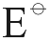 value.
(ii) By increasing the pH, the electrode potential of the reaction MnO₄^{2–} + 2H₂O + 2e– ⎯→ MnO₂ + 4OH– will be lowered. Then the overall reaction potential will be reversed. The reaction becomes feasible after the increase in pH.
MnO₄– + e– MnO₄^{2–} +0.56
−) MnO₄^{2–} + 2H₂O + 2e– MnO₂ + 4OH– +0.60
2MnO₄– + MnO₂ + 4OH– ⎯→ 3MnO₄^{2–} + 2H₂O −0.04
(iii)
MnO₄– + e– MnO₄^{2–} +0.56
−) 2H₂O + O₂ + 4e– 4OH– +0.40
4MnO₄– + 4OH– ⎯→ 4MnO₄^{2–} + 2H₂O + O₂ +0.16
The hydroxide ions are oxidized to oxygen gas as the oxidation number of oxygen in hydroxide ion increases from −2 to 0 in oxygen gas.

(b) As the 3d and 4s electrons are of similar energy levels, manganese is able to exhibit variable oxidation states by losing different numbers of 3d and 4s electrons. When it reacts with other substances to form compounds, it can form ions of roughly the same stability by losing different numbers of 3d and 4s electrons. Thus, it can form compounds with a wide variety of oxidation states.
As aluminium does not have 3d electrons, it cannot form different kinds of cations by losing lower energy 3d electrons. It only attains the stable electronic configuration by losing all the three valence electrons to form aluminium ion.

(c) (i) As aluminium atom has a small size and is highly charged, it distorts the electron cloud of the O – H bond in coordinating with water molecules. So the O – H bond is weakened. When another water molecule attacks, the hydrogen is removed as proton. Thus the aqueous solution of aluminium salts are acidic.
(ii) [Al(H₂O)₆]³⁺(aq) + OH–(aq) ⎯→ [Al(OH)(H₂O)₅]²⁺(aq) + H₂O(l)
[Al(OH)(H₂O)₅]²⁺(aq) + OH–(aq) ⎯→ [Al(OH)₂(H₂O)₄]⁺(aq) + H₂O(l)
[Al(OH)₂(H₂O)₄]⁺(aq) + OH–(aq) ⎯→ [Al(OH)₃(H₂O)₃](s) + H₂O(l)
white precipitate
[Al(OH)₃(H₂O)₃](s) + OH–(aq) ⎯→ [Al(OH)₄(H₂O)₂]–(aq) + H₂O(l)

31. (a) (i) 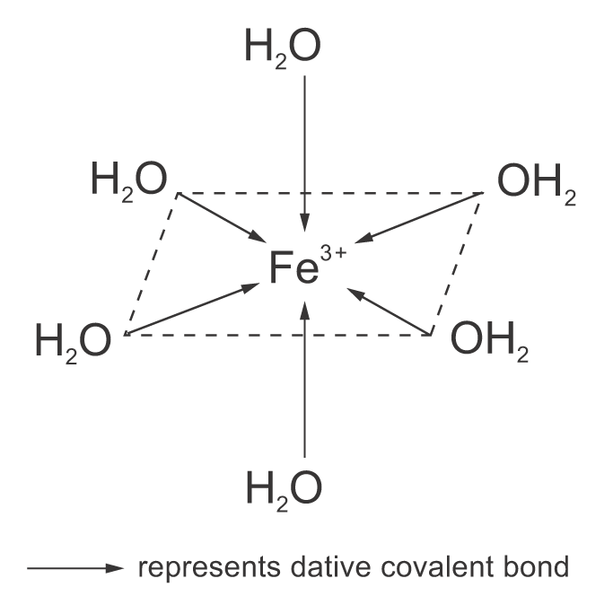

(ii) Complex ion

(b) (i) [Fe(H₂O)₆]³⁺(aq) + 6NH₃(aq) [Fe(NH₃)₆]³⁺(aq) + 6H₂O(l)
reddish brown precipitate
(ii) Hexaammineiron(III) ion
(iii) Displacement reaction

(c) (i) [Fe(H₂O)₆]²⁺(aq) + 6CN–(aq) [Fe(CN)₆]^{4–}(aq) + 6H₂O(l)
(ii) Displacement reaction
(iii) 2[Fe(CN)₆]⁴⁻(aq) + Cl₂(aq) ⎯→ 2[Fe(CN)₆]^{3–}(aq) + 2Cl–(aq)
This is a redox reaction. Iron(II) ion is oxidized to iron(III) ion while chlorine is reduced to chloride ion.

