Part 7 Fundamentals of Organic Chemistry (Book 3A, p. 142 – p.144)

17. (a) Electrophilic addition
(b) Free radical substitution
(c) Nucleophilic substitution
(d) Reduction

18. (a) Structures B and C are cis-trans isomers.
(b)
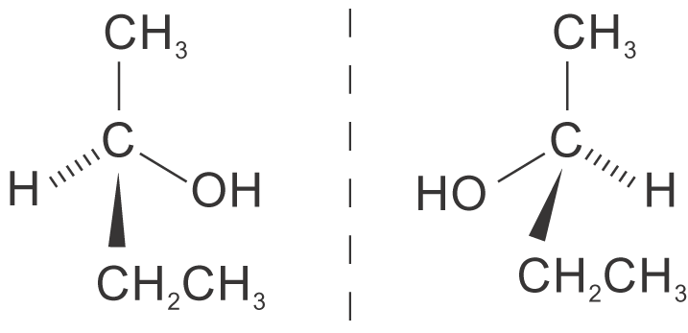
Note: Structure A reacts with steam to give butan-2-ol, CH₃CH₂CH(OH)CH₃, which is chiral.

19. Linoleic acid:
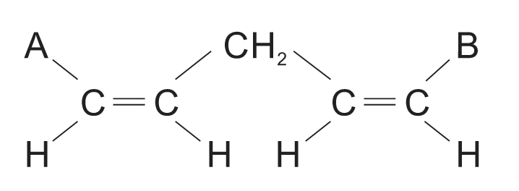
Other isomers:
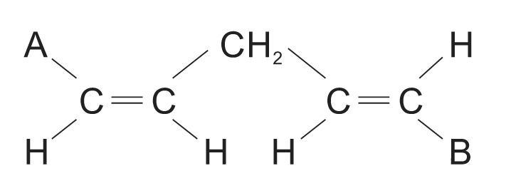
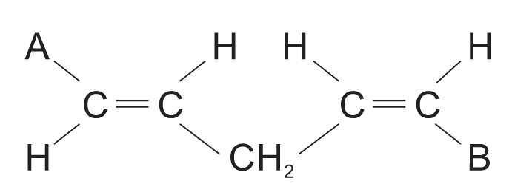
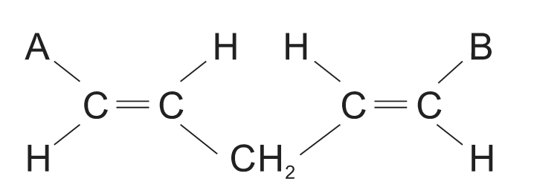

20. Optical isomerism
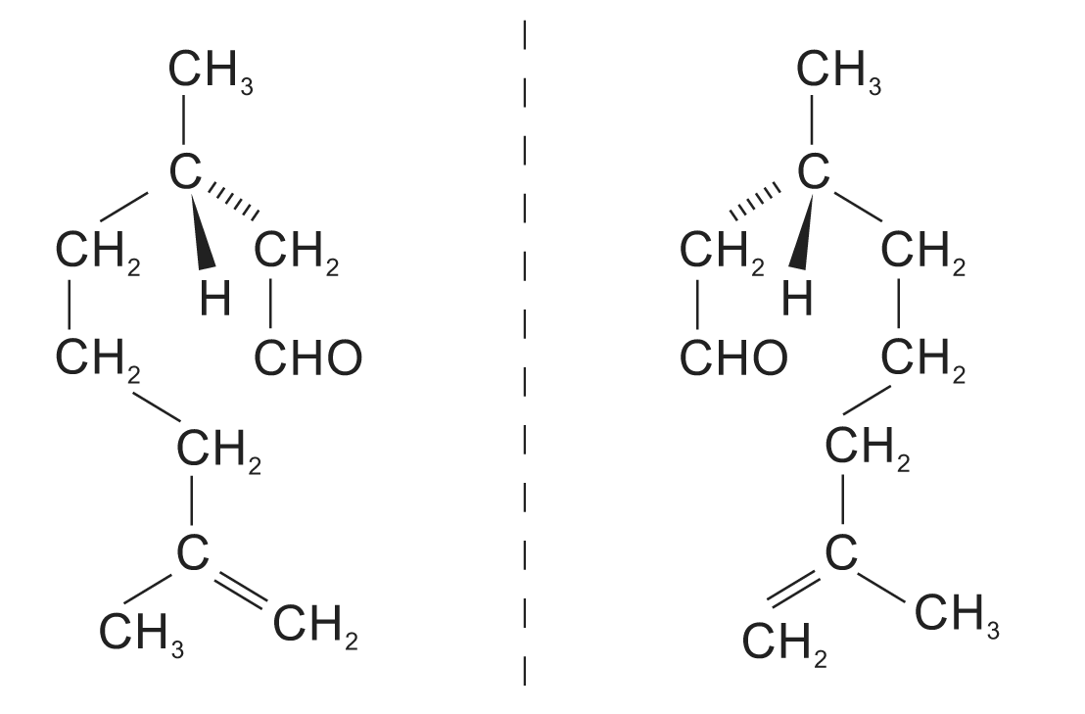

21.

22. (a) Nucleophiles are electron-rich species that tend to seek an electron-deficient site for reaction.
(b) Electrophiles are electron-deficient species that tend to accept electron(s).
(c) In a substitution reaction, an atom or a group of atoms of the reactant molecule is replaced by another atom or group of atoms.
(d) In an addition reaction, two molecules react to give a single product.

23. (a) In a σ bond, the bonding electrons are localized symmetrically along the internuclear axis of the bonding atoms.

(b) In a π bond, the bonding electrons are located laterally above and below the plane of 2 bonding atoms forming a nodal plane.

24. (a) Cyclopentanol or pentan-2-one
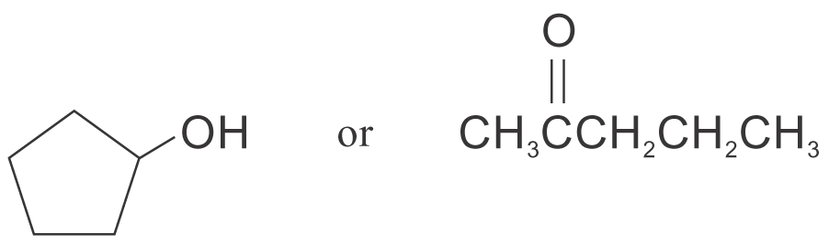
(b) (i)
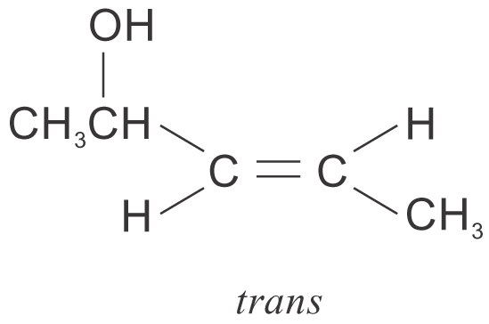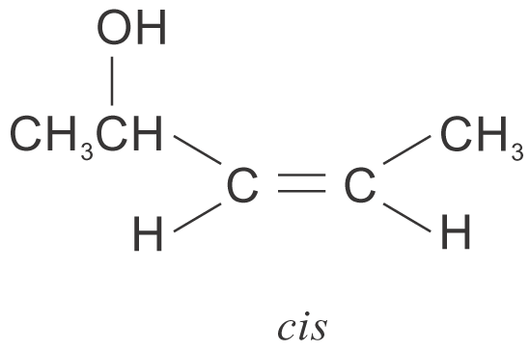
Due to the presence of the C=C double bond, free rotation about a covalent bond is restricted. This leads to difference in spatial arrangement of the atoms in Q.
(ii)
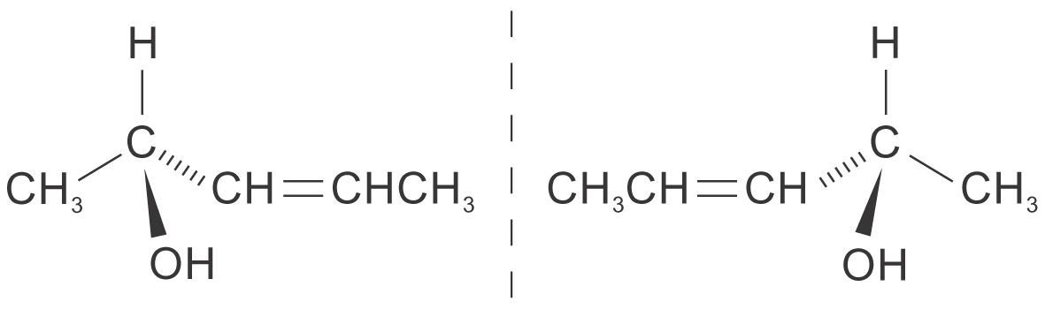
When a beam of plane polarized monochromatic light passes through a solution of optical isomers Q, the plane of polarization rotates. Two optical isomers that are mirror images of one another cause exactly the same extent of rotation, but in opposite directions, clockwise(+) in one case, and anticlockwise(−) in the other.

25. (a) A chiral molecule is one that is not superimposable with its mirror image.

(b)

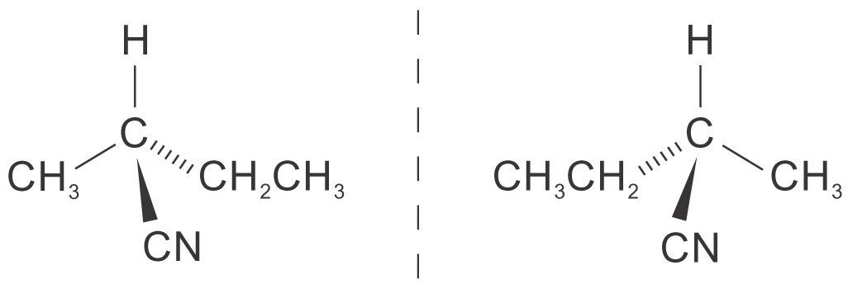
26. (a) (i) A homologous series is a series of compounds that have the same functional group, and each member differs from the next member by —CH₂— unit in their formulae.
(ii) Alkene

(b)
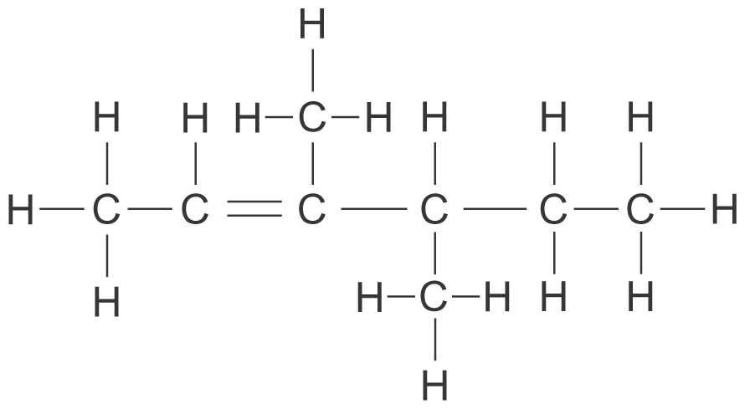

(c) (i) Electrophilic addition
(ii) Chloroethane

27. (a) (i)
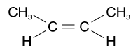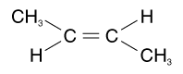
cis trans
(ii) Geometric isomerism refers to the difference in the spatial arrangement of atoms in space on the sides of double bond because of restricted rotation about a covalent bond.

(b) (i)
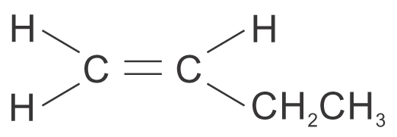
(ii) This is because the atoms on one of the sides are equivalent. Thus, restriction on bond rotation does not lead to different arrangement of atoms.

