Part 9 Chemistry in Action (Book 3B, p.223 – 225)

15. (a) (i) 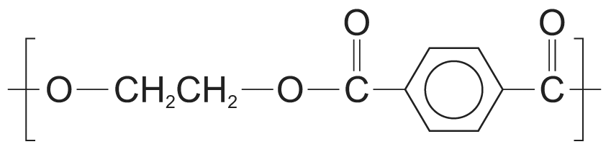
(ii) Condensation polymerization

(b) (i) A: HOCH₂CH₂CH₂CH₂OH
B: HO₂C – CH₂CH₂ – CO₂H
The reactions taking place are:
A + 2Na -⎯→ Na^{+–}OCH₂CH₂CH₂CH₂O–Na⁺ +H₂
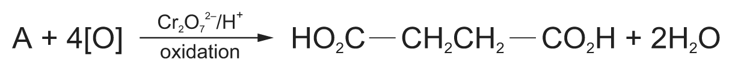
B + 2NaOH ⎯→ Na^{+–}O₂C – CH₂CH₂ – CO₂–Na⁺ + 2H₂O
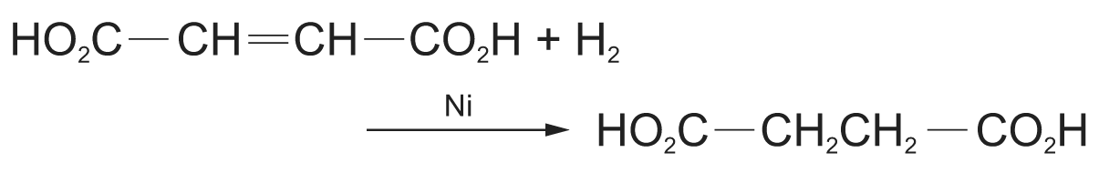
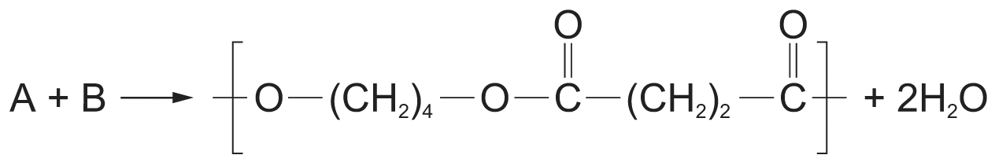
(ii) 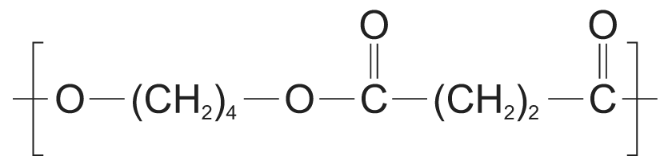
(iii) Terylene has a higher melting point than poly(A-B). Per repeating unit, Terylene has more electrons i.e. larger molecular size. Hence, Terylene shows greater van der Waals’ forces of attraction.

16. (a) Formula of repeating unit = C₁₀H₈O₄
Relative molecular mass of repeating unit = (10 × 12.0) + (8 × 1.0) + (4 × 16.0) = 192.0
Percentage by mass of carbon = $\frac{\text{10}×\text{12}}{\text{192}\text{.}0}$ × 100% = 62.5%

(b) (i) 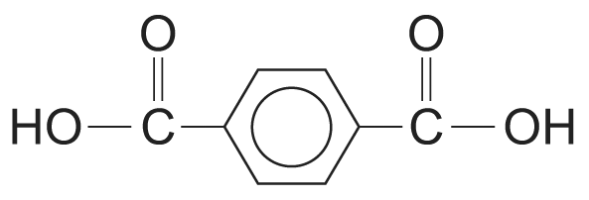 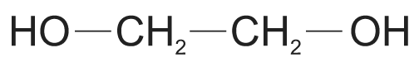
(ii) Hydrogen chloride
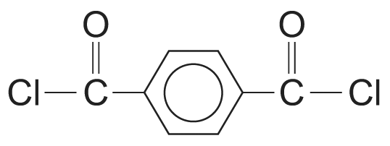

(c) (i) Terylene is a polyester. It undergoes hydrolysis slowly when exposed to alkali, causing the ester linkages to break.
(ii) 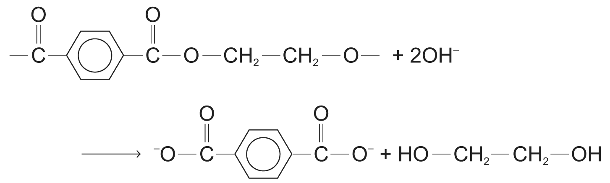

17. (a) Difference between addition polymerization and condensation polymerization:
In addition polymerization, monomer molecules join together to form one product molecule while in condensation polymerization, monomer molecules join together to form a product molecule with small molecules such as water eliminated. The relative molecular mass of an addition polymer is the sum of the relative molecular masses of the monomers that made it up but the relative molecular mass of a condensation polymer is less than the sum of the relative molecular masses of the monomers that made it up.
Addition polymerization usually occurs between monomers containing double bonds while condensation polymerization usually occurs between monomers with two functional groups which can react with each other in a condensation type of reaction.
(i) Structural formula of starting material for addition polymerization:
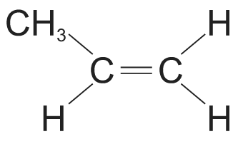
Structural formulae of starting materials for condensation polymerization:
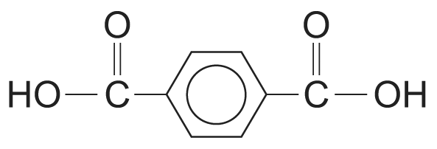 and 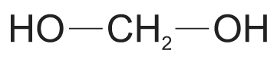
(ii) Addition polymer showing two repeating units:
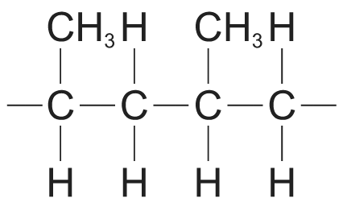
Condensation polymer showing two repeating units:
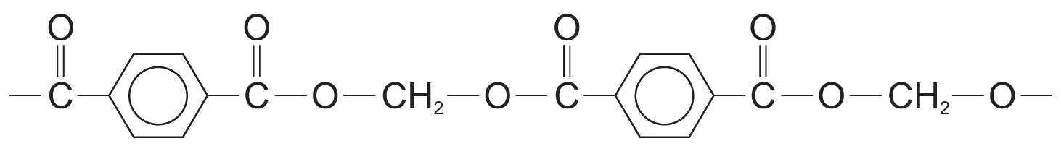

(b) (i) 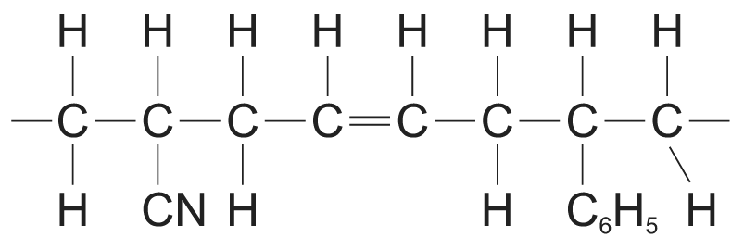
(ii) Addition polymerization
(iii) The π bond of the double bond is formed by the side-on overlap of p-orbitals on the carbon atoms involved in the double bond. The overlap is effective only if the p-orbitals are aligned parallel to each other so that presence of double bonds restrict the rotation of the polymeric chain. This restriction of rotation instills rigidity to ABS.

18. (a) For reaction I:
Reagent: dilute hydrochloric / sulphuric acid
Condition: reflux
For reaction II:
Reagent: concentrated aqueous ammonia
Condition: warming in a sealed tube

(b) (i) 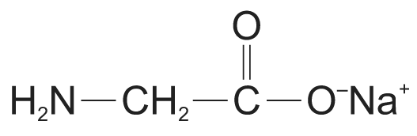
(ii) 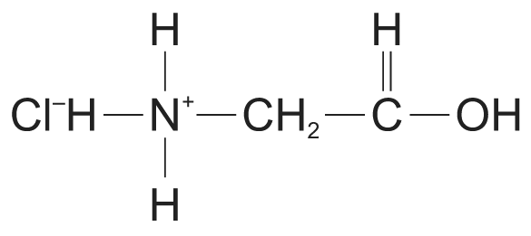
(c) (i) Amide linkage:
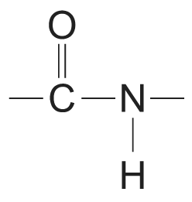
(ii) Reagents: dilute acid such as dilute hydrochloric acid or dilute alkali such as aqueous sodium hydroxide
Condition: reflux

(d) From the structures of the two dipeptides NH₂CH₂CONHCH₂CO₂H and NH₂CH(CH₃)CONHCH(CH₃)CO₂H, it can be seen that in the tetrapeptide, two molecules of NH₂CH₂CO₂H are linked consecutively to each other and two molecules of NH₂CH(CH₃)CO₂H are linked consecutively to each other respectively.
From the structure of the dipeptide NH₂CH₂CONHCH(CH₃)CO₂H, it can be seen that starting form the – NH₂ end, NH₂CH₂CO₂H appears before NH₂CH(CH₃)CO₂H.
From this information, it can be deduced that starting with the – NH₂ end, the order in which the four amino acids are bonded in the tetrapeptide is NH₂CH₂CO₂H, NH₂CH₂CO₂H, NH₂CH(CH₃)CO₂H and NH₂CH(CH₃)CO₂H.

19. (a) Condensation polymerization
(b) The diol is saturated and thus does not undergo addition polymerization.

20. (a) 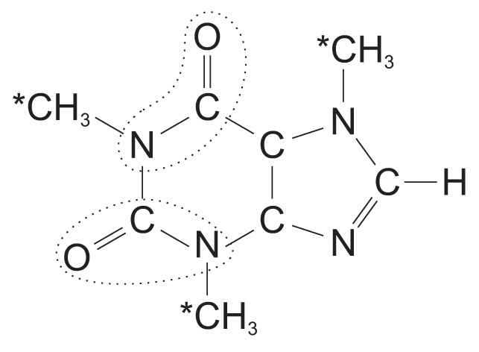

(b) Liquid carbon dioxide
Reason 1: Caffeine contains polar amide and amine groups and hence is soluble in liquid carbon dioxide which is also polar.
Reason 2: After extraction, carbon dioxide can be easily removed since it is very volatile.

(c) (i) C₈H₁₀N₄O₂
(ii) Relative molecular mass of caffeine
= 12.0 × 8 + 1.0 × 10 + 14.0 × 4 + 16.0 × 2
= 194.0
(iii) Number of moles of caffeine = $\frac{\text{50}×{\text{10}}^{−3}}{\text{194}\text{.}0}$mol
Concentration of caffeine = $\frac{\frac{\text{50}×{\text{10}}^{−3}}{\text{194}\text{.}0}}{\frac{\text{330}}{\text{1000}}}$ = 7.81 × 10^{–4} mol dm^{–3}

21. (a) (i) 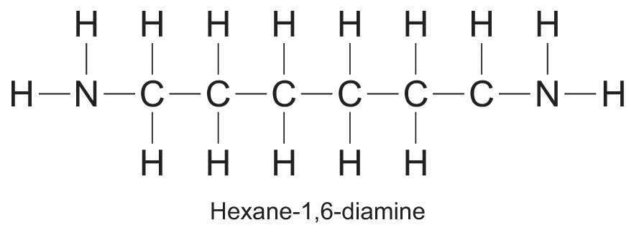
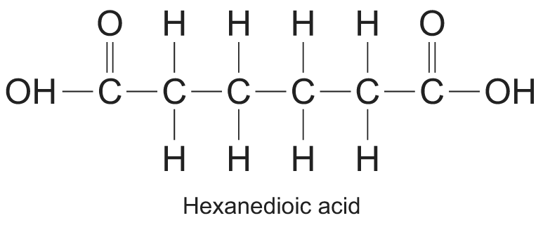
(ii) Condensation polymer

(b) (i) 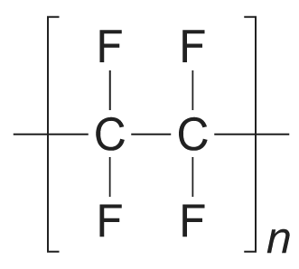
(ii) As the coating of frying pans / As the insulating coating of electrical wires / As sealing tapes for plumbing joints / For making values and bearings (Any one)

(c) Polytetrafluoroethene
It is because in nylon, the polymer chains are held together through hydrogen bonds formed between the amide groups. But in polytetrafluoroethene, the polymer chains are held together by weak van der waals’ forces only.

22. Condensation polymerization is a chemical process in which monomer molecules are joined together to form a polymer with elimination of small molecules such as water, ammonia and hydrogen chloride.
Polyamides are polymers with repeating units held together by amide linkages.
For example, nylon-6,6 is made from the condensation polymerization between hexane-1,6-diamine and hexanedioic acid. Nylon-6,6 is a polyamide because the repeating units are held together by amide linkages.
