Part 8 Chemistry of Organic Compounds (Book 3B, p.140 – 148)

24. (a)

(b) (i) It contains at least one chiral carbon atom. The molecule is chiral.
(ii) It contains – CO₂H group and is acidic.
(iii) It is an alcohol that contain 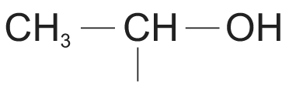 group or a carbonyl that contains 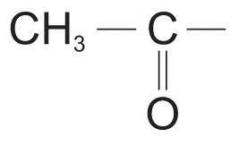 group.

(c) A is C₃H₆O₃, i.e. 2-hydroxypropanoic acid.
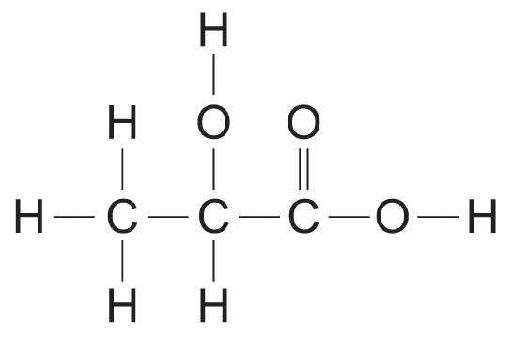

(d) 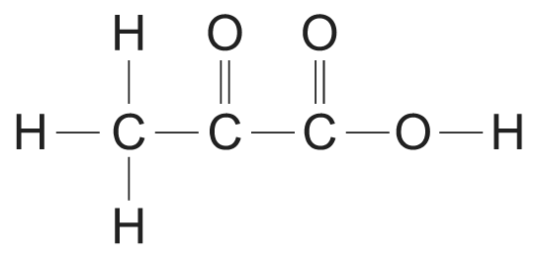

(e) Ester functional group.
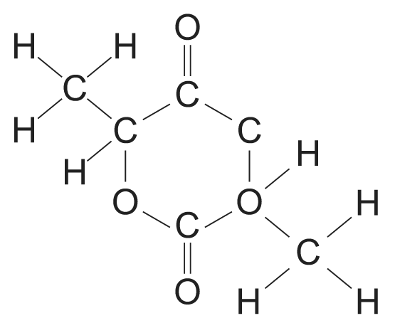

25. (a) (i) Aqueous chlorine
(ii) 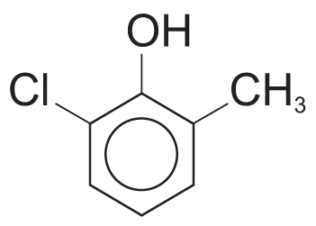

(b) 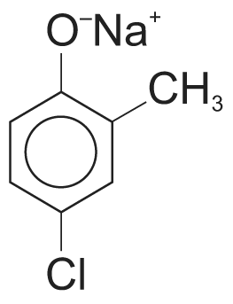

(c) HCl(aq)

26. (a) Nucleophilic addition
CN– is generated by the reaction between HCN and a base (e.g. NaOH).
HCN + OH– ⎯→ H₂O + CN–
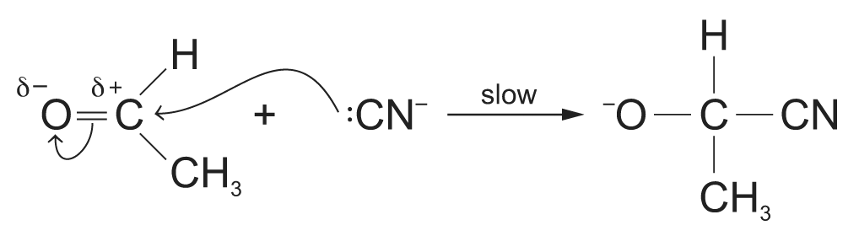
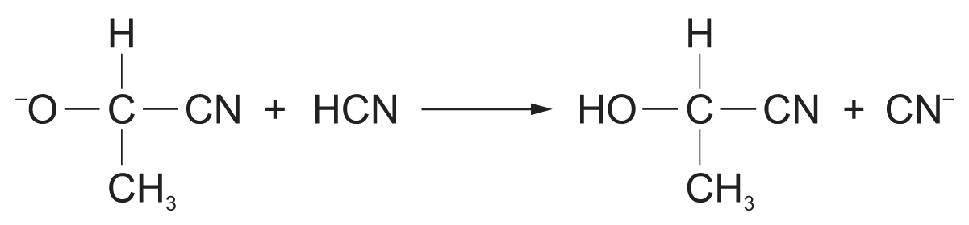
CN– is the nucleophile and it attacks the electron-deficient carbonyl carbon atom. The tetrahedral intermediate formed then captures a proton from HCN to form the product and generates another CN– for further reaction.
Thus, the overall reaction is:
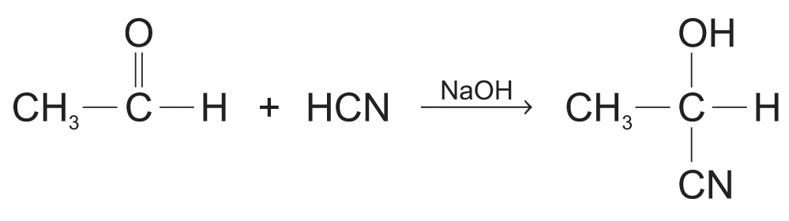

(b) Optical isomerism
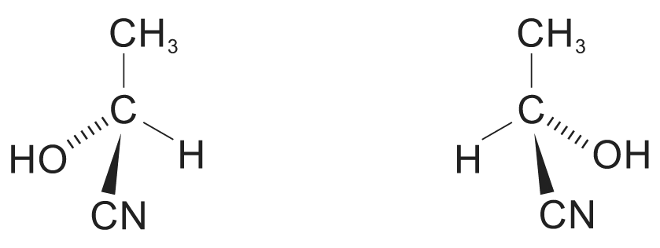

(c) (i) Add Na₂CO₃.
3-Oxobutanoic acid, being an acid, gives effervescence of CO₂ with Na₂CO₃ while propanone does not.
2CH₃COCH₂CO₂H + Na₂CO₃ ⎯→ 2CH₃COCH₂CO₂–Na⁺ + H₂O + CO₂
(ii) Add 2, 4-dinitrophenylhydrazine.
Being a ketone, 2-oxobutanoic acid forms an orange precipitate while 3-hydroxybutanoic acid does not.
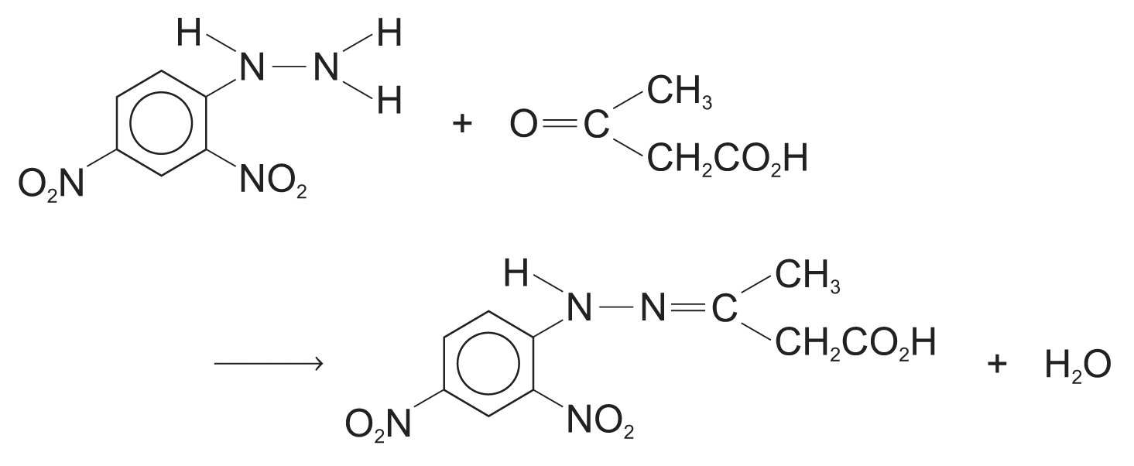

27. (a) The reaction of chloroethane with ammonia proceeds via a nucleophilic substitution mechanism as shown below:
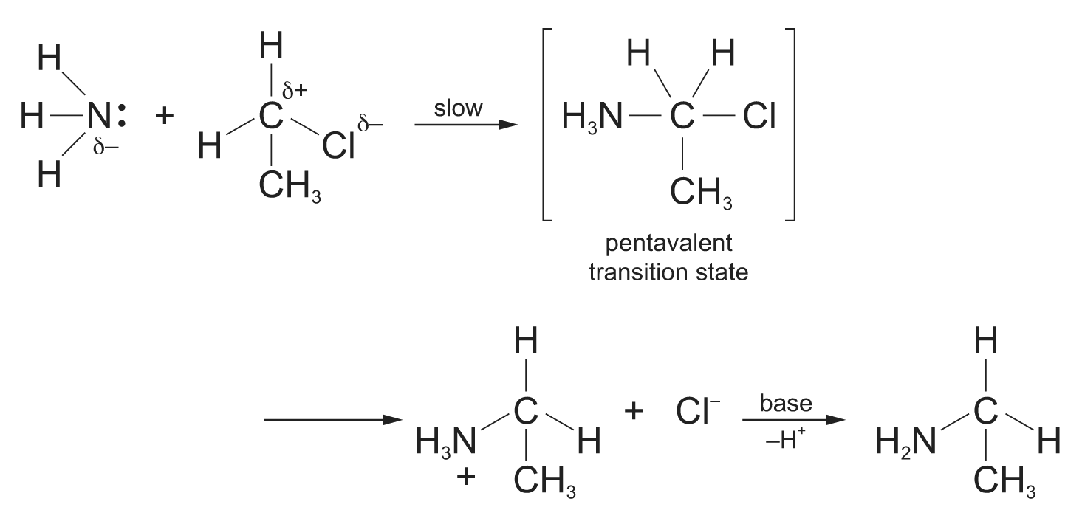
The nucleophilic ammonia attacks the partially positive carbon to which the electronegative chlorine is attached resulting in the formation of a pentavalent transition state. The C – Cl bond is being broken as the C – N bond is formed. The resultant organic product is ethylamine, CH₃CH₂NH₂. The amine is basic and it reacts with the acidic HCl to give ethylammonium chloride. Ethylamine is obtained by reacting the salt formed with a base such as NaOH.

(b) The rate of this reaction increases when chloroethane is replaced by bromoethane or iodoethane. This is because the reaction involves the breaking of the C – X bond. E(C – Cl) > E(C – Br) > E(C – I) since the overlap between the carbon and the halogen becomes less effective as the halogen increases in size from Cl to I. It is thus easier to break the C – Br and C – I bond than C – Cl bond, and the rate of reaction increases when chloroethane is replaced by bromoethane or iodoethane.

(c) P: CH₃CH₂CH₂CN
Q: CH₃CH₂CH₂COOH
R: CH₃CH₂CH₂COOCH₂CH₃

(d) (i) Reagents: ethanolic potassium hydroxide / sodium hydroxide
Condition: reflux / heat
(ii) 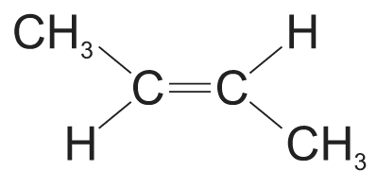 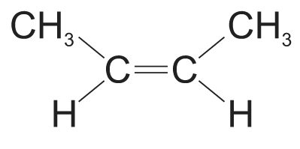 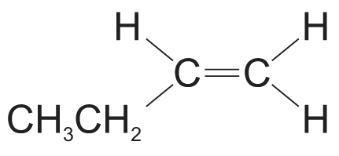
28. (a) 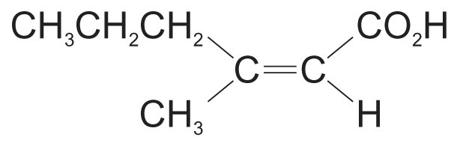 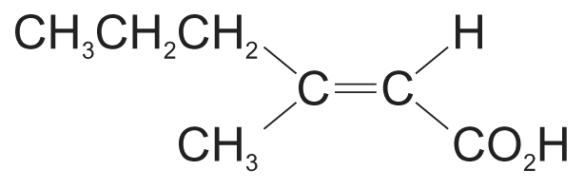

(b) CH₃CH₂CH₂C(CH₃) = CHCO₂–Na⁺
The salt formed is ionic when strong electrostatic forces between oppositely charged CH₃CH₂CH₂C(CH₃) = CHCO₂– and Na⁺. The salt is thus non-volatile and does not vaporize easily and is odourless.
(c)

29. (a)

(b) 2: nucleophilic substitution
3: hydrolysis
4: reduction

30. (a) 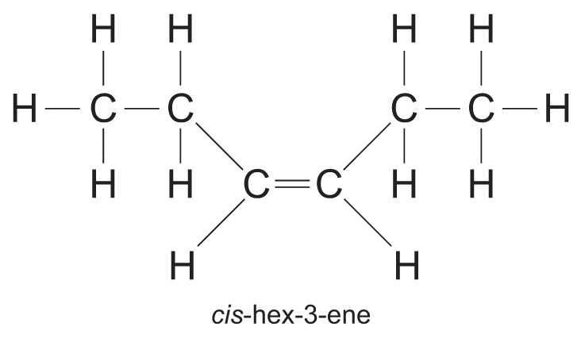 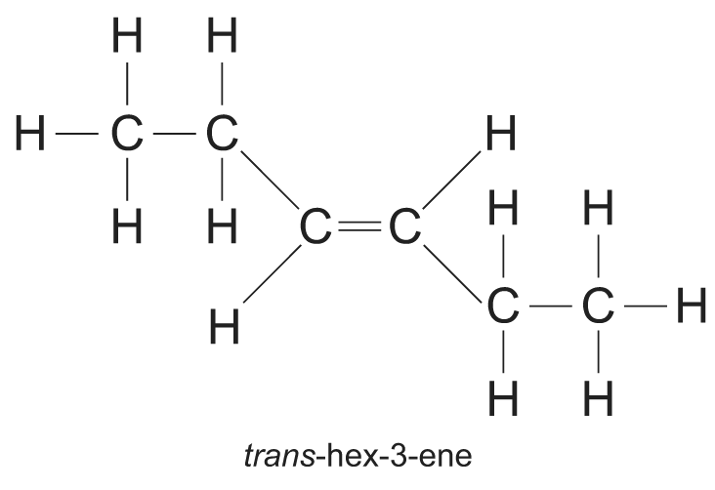
Such isomerism is not possible for cyclohexene because in a 6-membered ring, only the cis-form is possible:
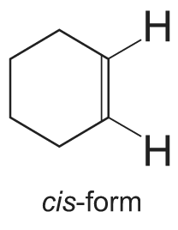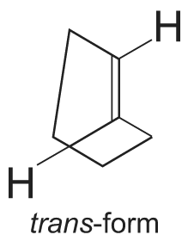
As shown in the diagram above, the trans-form results in distorted ring with great angle strain and is not formed.

(b) Type of reaction: electrophilic addition
Condition: room temperature
Mechanism:
(1) 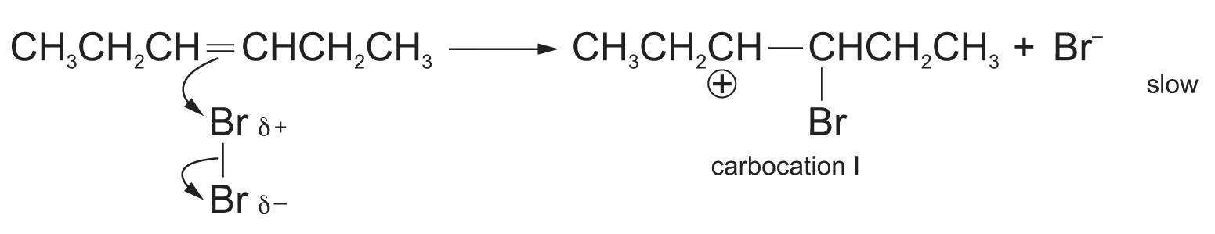
(2) 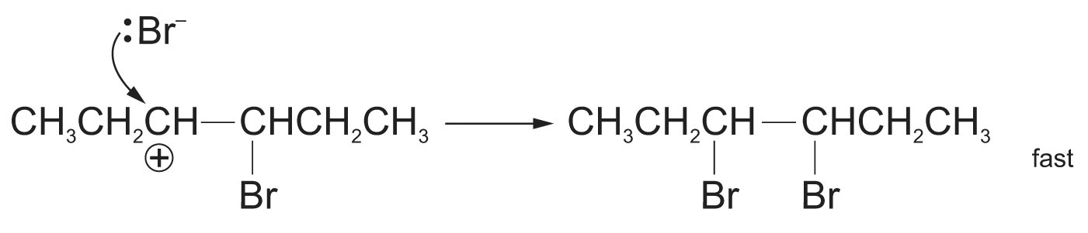
The electron-rich C = C polarizes a bromine molecule and causes the bromine molecule to cleave heterolytically forming the carbocation 1 and bromide ion in the slow rate determining step as shown in step (1).
A bromide ion then attacks the carbocation 1 to from 3,4-dibromohexane as shown in step (2).

(c) The reaction of HBr with both trans- and cis-hex-3-ene results in the formation of the same product, 3-bromohexane, CH₃CH₂C*HBrCH₂CH₂CH₃. Since carbon-3 is chiral, the product exhibits optical isomerism. In the reaction, H⁺ is first added to the carbon-4 to form a carbocation. The “+” charge is on carbon-3 which has a sp² hybridization and the molecular geometry about this carbon is thus trigonal planar. Subsequent attack by Br– can be from above or below the plane resulting in both optical isomers of 3-bromohexane being formed. Since there is equal likelihood of carbon-3 being attacked from both above and below, equimolar amount of the isomers of the product is formed.
(d) CH₃CH₂COOH and HOOCCH₂COOH

31. (a) (i) Optical isomerism
(ii) 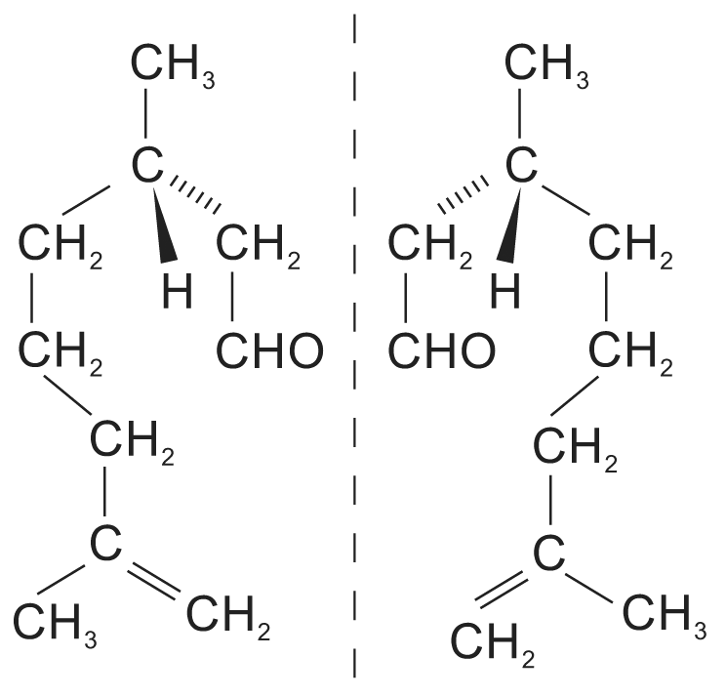

(b) 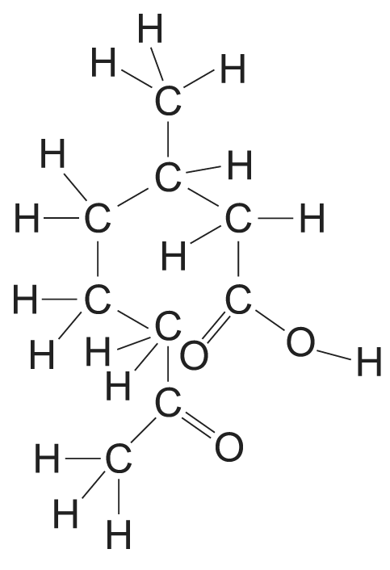

(c) (i) Q can be distinguished from R using Fehling’s solution. Q reacts with blue Fehling’s solution to give the brick-red precipitate of Cu₂O whereas no brick-red precipitate is observed with R.
(ii) R can be distinguished from Q using sodium. Effervescene of hydrogen is observed when sodium is added to R while no hydrogen is evolved when sodium is added to Q.

(d) 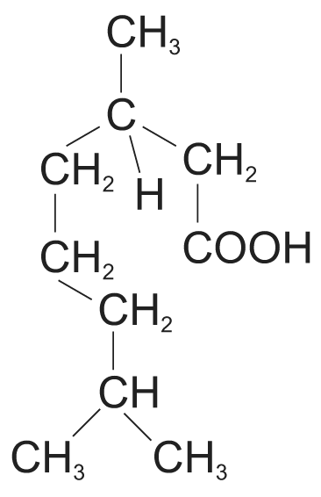

32. (a) Due to the hydrophobic benzene ring, eugenol is not very soluble in water despite the presence of the phenolic – OH group which enables eugenol molecules to form hydrogen bonds with water molecules.
The phenolic – OH group is acidic and loses a proton when reacted with aqueous NaOH so that the sodium salt of eugenol is formed. Being ionic, the attraction between this salt and water is ion-dipole interaction which is stronger than hydrogen bonds. Hence eugenol is more soluble in aqueous NaOH than water.

(b) (i) Cold, dilute manganate(VII) ions
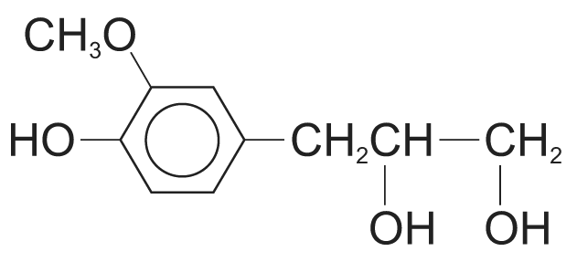
(ii) Hot concentrated manganate(VII) ions
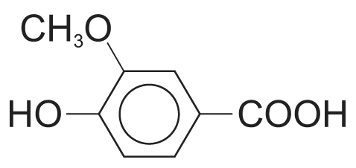
(iii) Ethanoyl chloride
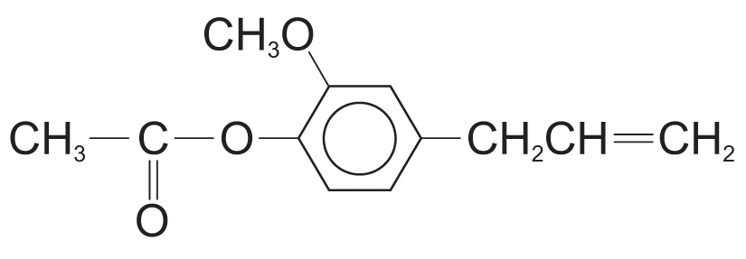
(iv) Aqueous bromine
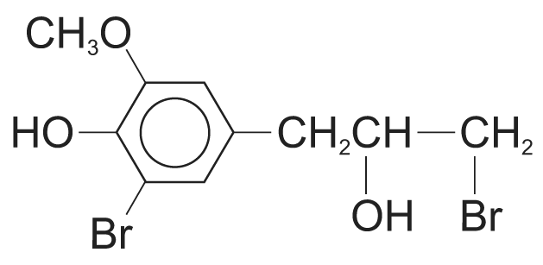

(c) (i) Addition polymerization
(ii) 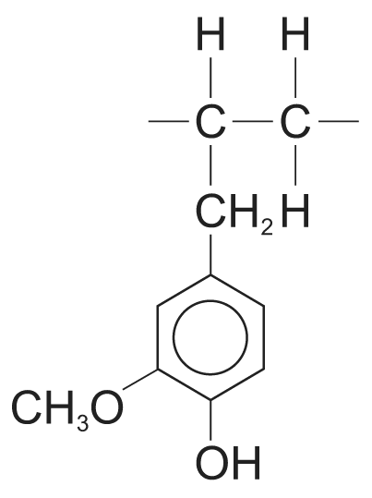

33. (a) Reagent: hydrogen gas
Condition: nickel catalyst, heat

(b) The type of reaction is oxidation.
Reagent: potassium dichromate(VI) solution acidified with dilute sulphuric acid
Condition: reflux

(c) 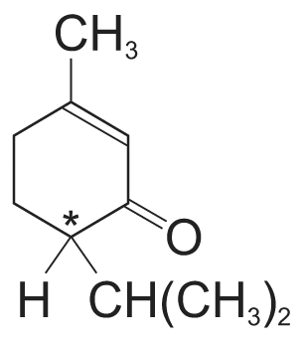 ‘*’ denotes chiral atom
(i) Menthone has two chiral atoms.
(ii) Menthol has three chiral atoms.

(d) (i) Reagent for dehydration of alcohol: concentrated sulphuric acid
Condition: temperature of 170°C, excess concentrated sulphuric acid
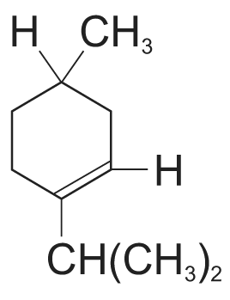
(ii) Reagent for nucleophilic substitution of alcohol: hydrogen chloride gas
Condition: zinc chloride as catalyst, heat
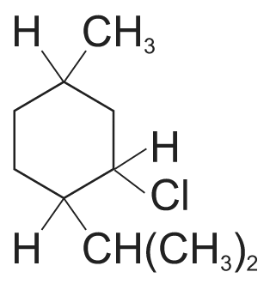

(e) The simple test-tube reaction is to add 2,4-dinitrophenylhydrazine to menthol and menthone separately. An orange precipitate of 2,4-dinitrophenylhydrazone is observed for the test tube containing menthone but no such orange precipitate is observed for the test tube containing menthol.

34. (a) (i) FeCl₃ / AlCl₃ as catalyst
(ii) Ultra-violet light

(b) (i) A does not react. This is because the chlorine atom is directly attached to the benzene ring. Due to the delocalization of a lone-pair of electrons on the chlorine atom into the benzene ring, the C – Cl bond has partial double bond character and does not cleave easily.
(ii) 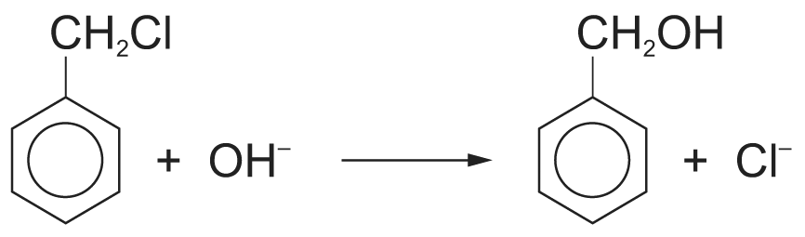

35. (a) (i) To produce A from methylbenzene, methylbenzene is reacted with chlorine in the presence of aluminium chloride.
To produce B from methylbenzene, methylbenzene is reacted with chlorine in the presence of ultraviolet radiation.
(ii) The compound is first warmed with aqueous sodium hydroxide. The mixture is cooled and excess dilute nitric acid followed by aqueous silver nitrate is then added. A gives no white precipitate of silver chloride but B gives a white precipitate of silver chloride.

(b) (i) 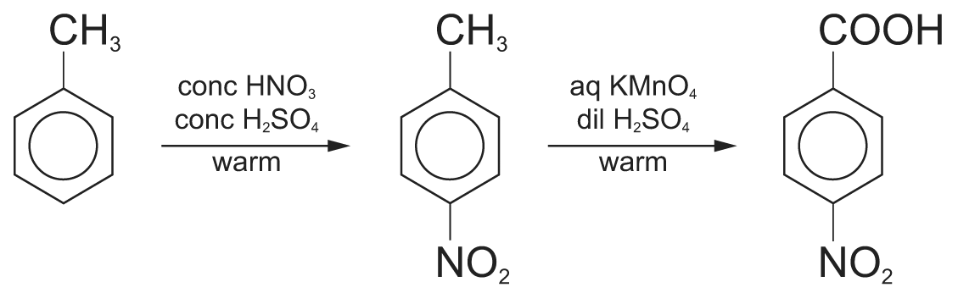
(ii) 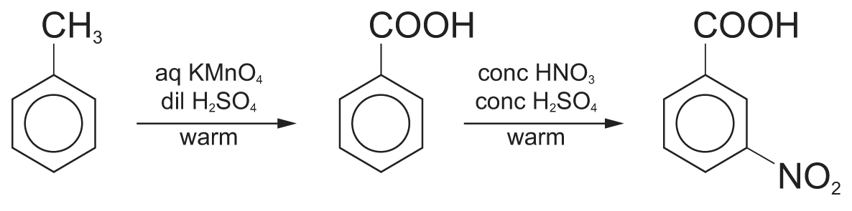

(c) Reagents and conditions for step C: tin and concentrated hydrochloric acid, reflux
Reagents and conditions for step D: ethanol, concentrated sulphuric acid as catalyst, reflux

36. (a) Limited amount of Cl₂ and ultra-violet light
(b) Cl₂ and FeCl₃ catalyst
(c) 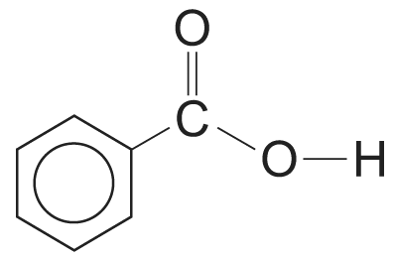

(d) Reagents: I₂, aqueous NaOH, heat
Observation with C: yellow precipitate
Observation with F: no yellow precipitate

(e) Mass of CN = 0.030 g m^{–3} × 60 m³
= 1.8 g
Relative molecular mass of CN (C₆H₅COCH₂Cl) = 154.5
Number of moles of CN = $\frac{1\text{.}8}{\text{154}\text{.}5}$ = 0.01165 mol

(f) (i) H, D, G
(ii) G is an acid chloride and undergoes hydrolysis readily in water.
D undergoes hydrolysis only when heated with aqueous NaOH.
H does not undergo hydrolysis even when heated with aqueous NaOH. The C – Cl bond has partial double bond character and is difficult to cleave.
37. (a)

(b) For 2-methylpropan-2-ol as the starting material, the products of reactions I, II and III are shown in the following table:
 | Reaction I | Reaction II | Reaction III
Product | 2-bromo-2-methylpropane | No reaction | 2-methylpropene

38. (a) (i) 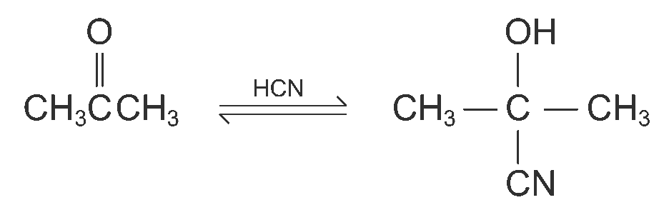
(ii) 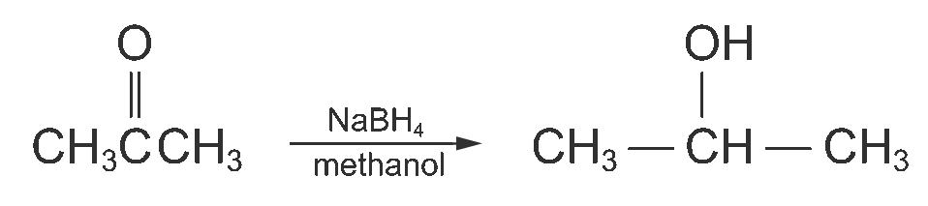

(b) (i)
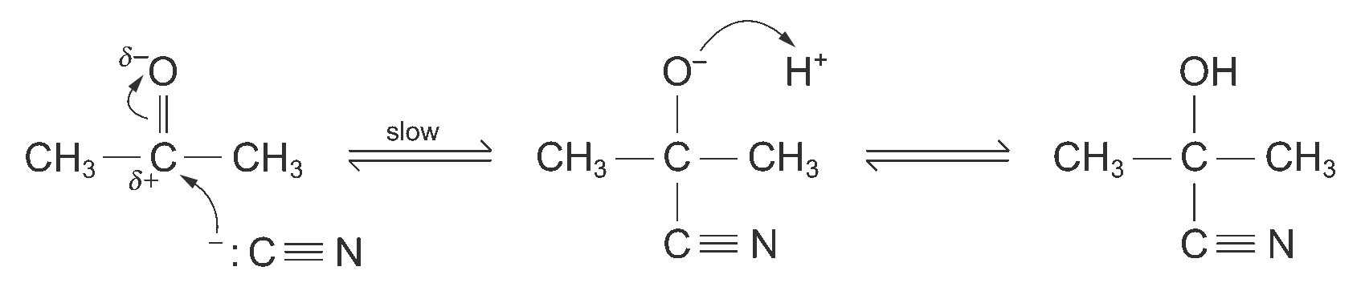
(ii) Nucleophilic addition reaction
(iii) Due to the difference in electronegativity between carbon and oxygen, the carbonyl carbon bears a partial positive charge and the carbonyl oxygen bears a partial negative charge. As the carbonyl carbon carries a partial positive charge, the carbonyl group is susceptible to nucleophilic attack. When the nucleophile attacks the carbonyl group, it uses its lone pair electrons to form a bond with the carbonyl carbon atom. The carbonyl carbon atom can accept this electron pair because one pair of bonding electrons of the carbon-oxygen bond can shift out to the carbonyl oxygen atom. This electron-rich oxygen then transfers its electron pair to an electropositive agent.
(iv) Ethene contains a C = C double bond. As there is no difference in electronegativity between two carbon atoms, the electrons in the double bond are evenly distributed over the C = C double bond. Besides, the C = C double bond is an electron-rich centre. Therefore, there is no electron-deficient centre for the attack of the nucleophile CN⁻. Thus, ethene would not react with HCN in a similar way.

39. (a) No. Because there is no chiral carbon centre in the molecule.

(b) Yes. Because the groups (or atoms) on the sides of both double bonds are different. Thus geometrical isomerism would occur.

(c) (i)
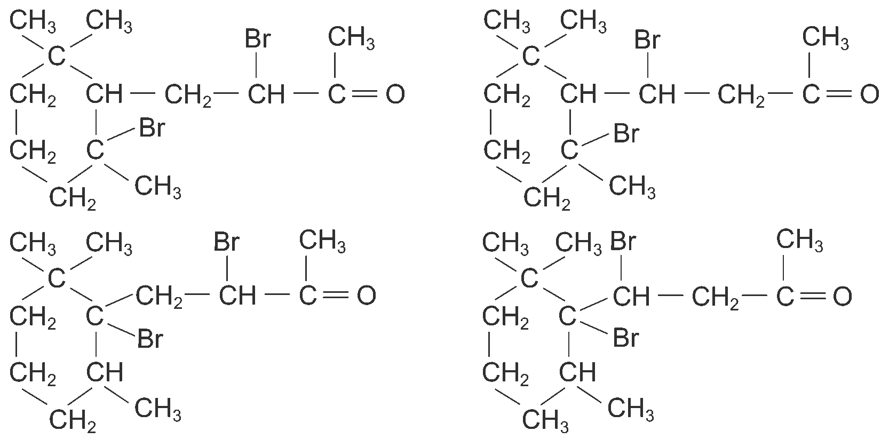
(ii) 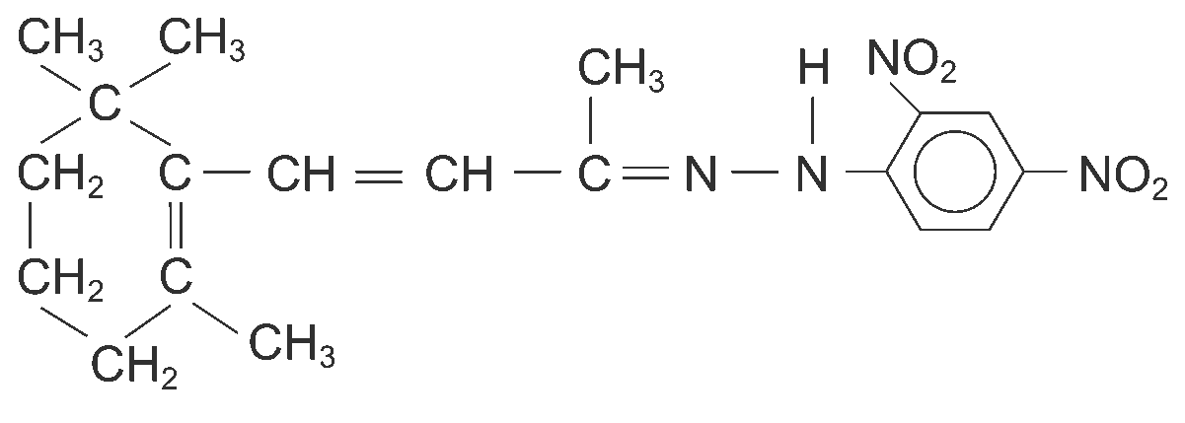
(iii) 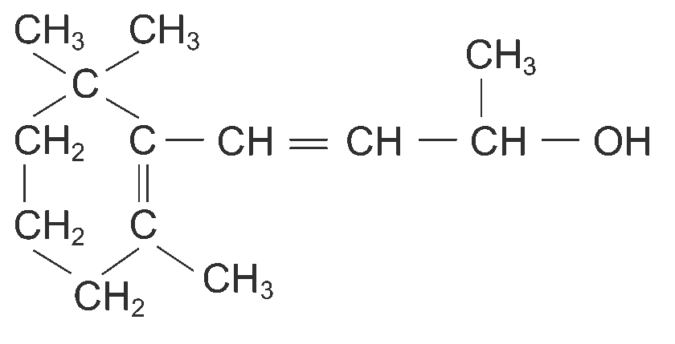

40. (a) 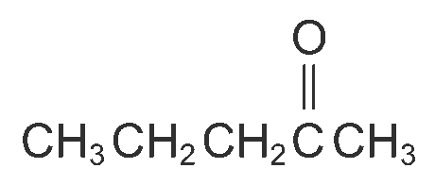

(b) (i) 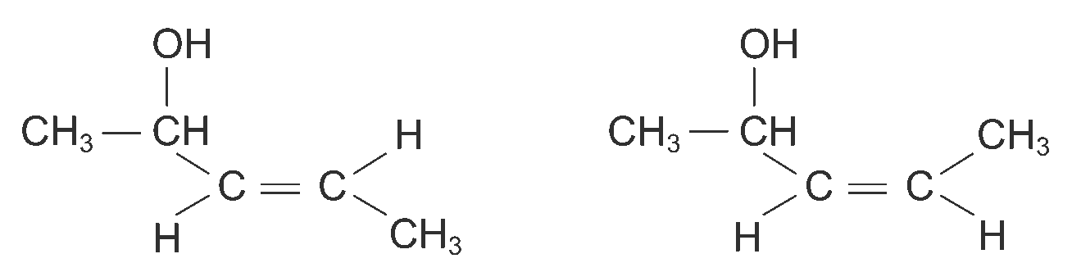
It is because the spatial arrangements of the atoms or groups of atoms are different due to restricted rotation about the C = C double bond.
(ii) 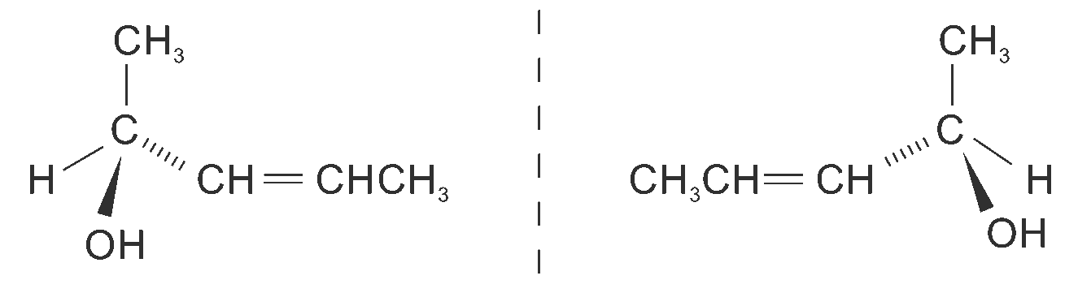
The plane of plane polarized monochromatic light rotates.

(c) 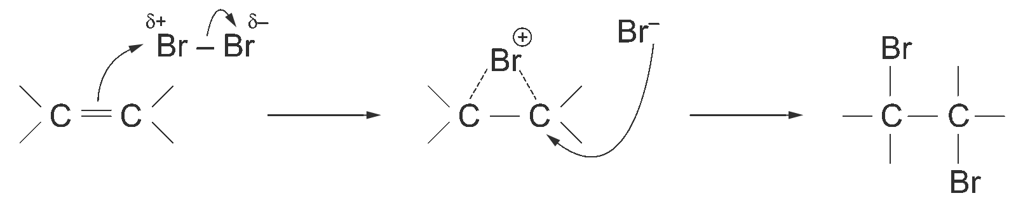

(d) (i) 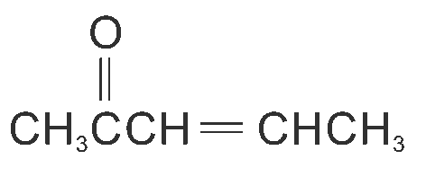
(ii) Add 3 cm³ of the product formed in (i) to a test tube. Then add 2 cm³ of 2,4-dinitrophenylhydrazine to the test tube. An orange precipitate is formed. The formation of the orange precipitate shows that the product formed in (i) contains a carbonyl group.
Add Fehling’s solution (an alkaline solution of copper(II) tartrate) to a test tube. The solution is deep blue. Then add a few drops of the product formed in (i) to the test tube. The solution remains deep blue showing that there is no reaction. Therefore the product formed in (i) is not an aldehyde. So the product should be a ketone.

41. (a) (i) 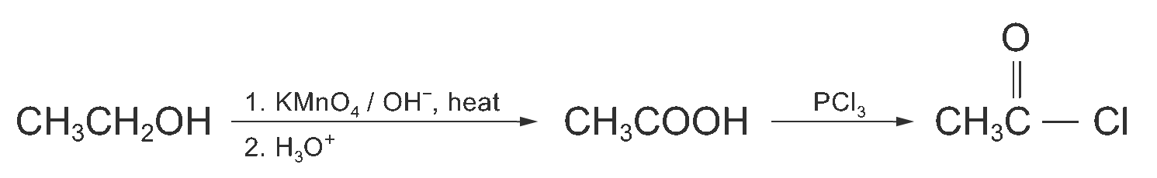
(ii) In CH₃COCl, the acyl carbon is highly electron-deficient. It is because both oxygen and chlorine are electron-withdrawing groups. They draw the electron in the bonds towards themselves making the carbon atom highly electron-deficient. Therefore, CH₃COCl is susceptible to nucleophilic attack.
However, in the case of CH₃CH₂Cl, the degree of electron deficiency of the carbon adjacent to the chlorine atom is much lower than that in the acyl carbon of CH₃COCl. Thus, the reaction between water and CH₃CH₂Cl is extremely slow.

(b) (i) 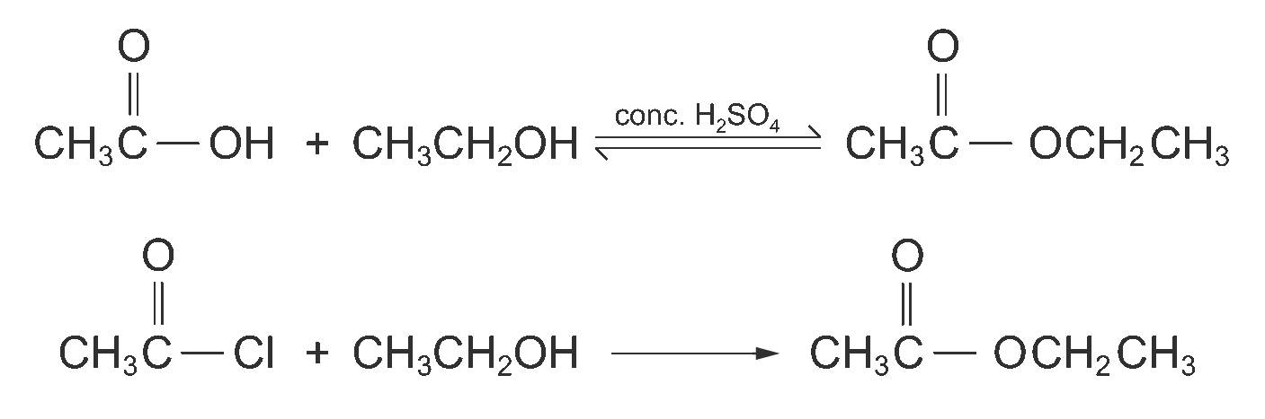
(ii) It is because the esterification between ethanoic acid and ethanol is a reversible reaction while the ester formation between ethanoyl chloride and ethanol is an irreversible reaction. Moreover, ethanoyl chloride is much more reactive than ethanoic acid. Thus, the reaction with ethanoyl chloride gives a better yield of the ester.

42. (a) (i) UV light provides energy for chlorine molecules to break homolytically, forming reactive free chlorine radicals.
(ii) The reaction between ethane and chlorine proceeds by a free radical chain mechanism. The chlorine radical formed attacks an ethane molecule, forming CH₃CH₂• radical which attacks a chlorine molecule to form chloroethane. The chloroethane formed may be attacked by another chlorine radical to form CH₃CHCl• radical. The CH₃CHCl• radical may further attack a chlorine molecule to form dichloroethane. The chain reaction continues to occur until hexachloroethane is reached. The formation of polychlorinated ethane depends on the relative amounts of chlorine and ethane. If chlorine is in excess, the major product is hexachloroethane. If ethane is in excess, chloroethane becomes the major product. If both were in similar amounts, more than one chlorine-containing organic product would be formed.
(iii) Butane. It is formed in the chain-terminating step when two CH₃CH₂• radicals are joined together.

(b) (i) 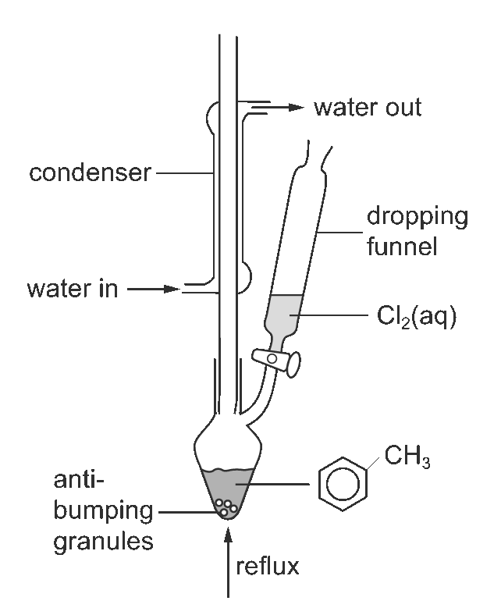
(ii) One of the products formed in the reaction is HCl gas which is highly corrosive.

43. (a) Free radicals are electrically neutral atoms or groups of atoms possessing an unpaired electron.

(b) Substitution reactions are the reactions with an atom or a group of atoms of the reactant molecule being replaced by another atom or group of atoms.

(c) The chlorine radical attacks one of the hydrogen atoms in the ethane molecule. Then, one of the bonding electrons in the C – H bond forms a bond with the chlorine radical forming hydrogen chloride. Another electron of the C – H bond then shifts to the carbon atom giving a carbon free radical.
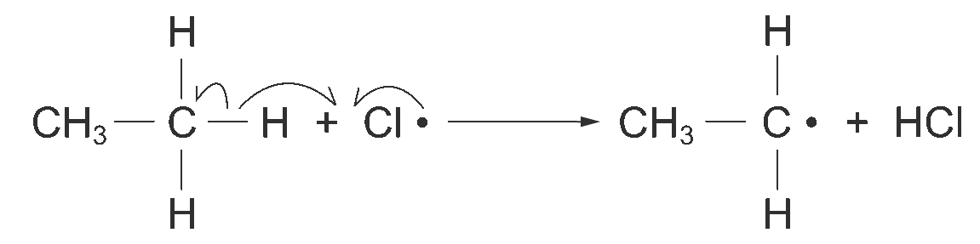

(d) 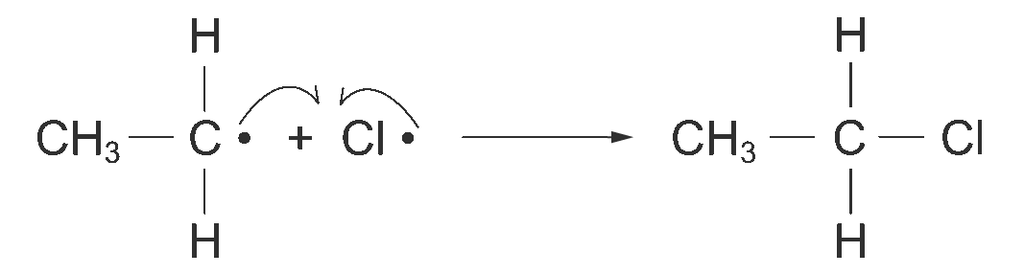

44. (a) CH₃CH(Br)COOH + OH– ⎯→ CH₃CH(OH)COOH + Br–

(b) 2-Bromopropanoic acid contains a chiral centre which bonded to four different atoms or groups of atoms. Therefore, the 2-bromopropanoic acid molecule and its mirror image are not superimposable.
If the plane of polarized light is rotated when the solution of 2-bromopropanoic acid is placed in the polarizer, we can conclude that 2-bromopropanoic acid shows optical isomerism.

(c)
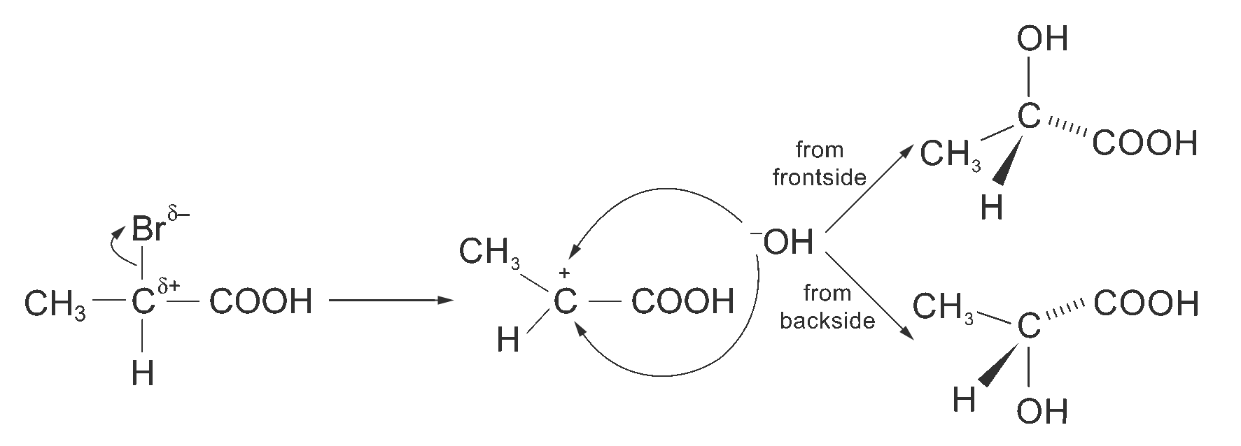
As the reaction between 2-bromopropanoic acid and sodium hydroxide solution proceeds by the S_{N}1 mechanism, this would lead to the formation of the carbocation which is planar. When it reacts with a nucleophile, the nucleophile may either attack from the frontside or the backside. This results in the formation of racemic mixture (i.e. the mixture of containing equal amounts of both enantiomers). Thus, the optical activity of the product is lost.

45. (a) 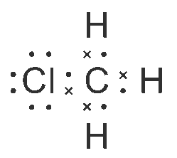

(b) 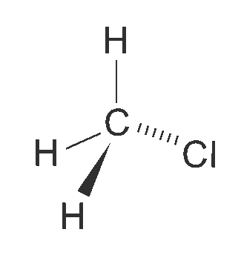
Chloromethane has a tetrahedral shape. According to the electron pair repulsion theory, the electron pairs in the outermost shell of the central atom in a molecule should stay as far apart as possible to minimize the electrostatic repulsion between electron pairs in the valence shell. In chloromethane, carbon is the central atom of the molecule and it carries four bond pairs of electrons. The four electron pairs in three dimensions are separated at a maximum with bond angles of 109.5°. The shape of the molecule is therefore tetrahedral.

(c) As chloromethane is a polar molecule, the molecules are held together by dipole-dipole interactions. But in the case of methane, its molecules are non-polar. Therefore, methane molecules are only held together by instantaneous dipole-induced dipole interactions. As dipole-dipole interactions are stronger than instantaneous dipole-induced dipole interactions, more energy is required to separate chloromethane molecules in the process of boiling. As a result, chloromethane has a higher boiling point than methane.

(d) In methanol, there are extensive intermolecular hydrogen bonds between methanol molecules. However, chloromethane molecules are only held together by dipole-dipole interactions. As hydrogen bonds are much stronger than dipole-dipole interactions, more energy is required to separate methanol molecules in the process of boiling. Therefore, methanol has a higher boiling point than chloromethane.
46. (a) (i) Bromine in 1,1,1-trichloroethane
(ii) 1,2-Dibromoethane

(b) 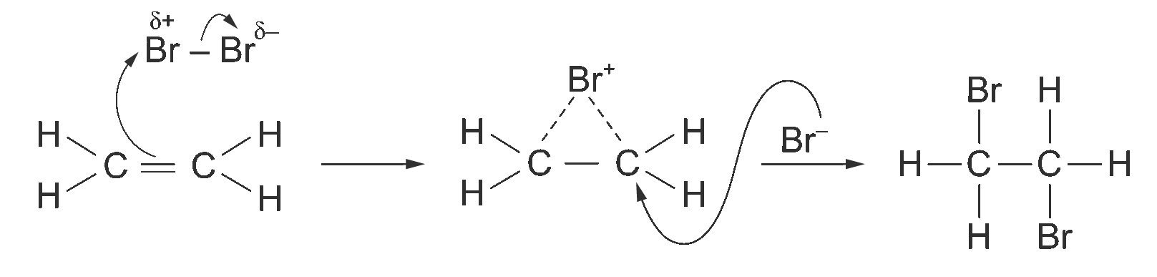

(c) (i) 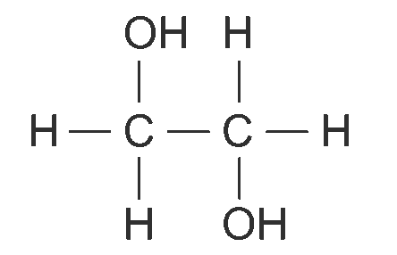
(ii) H – C ≡ C – H

(d)
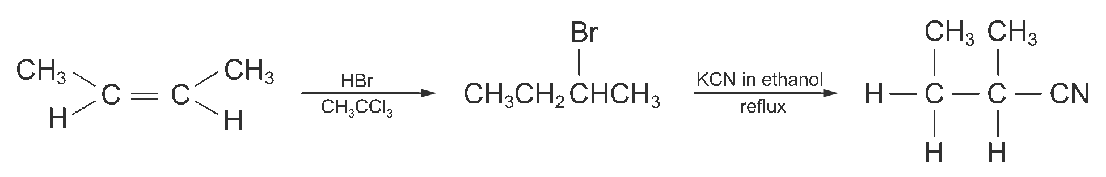

(e) (i) A chiral molecule is one that is not superimposable on its mirror image.
(ii) 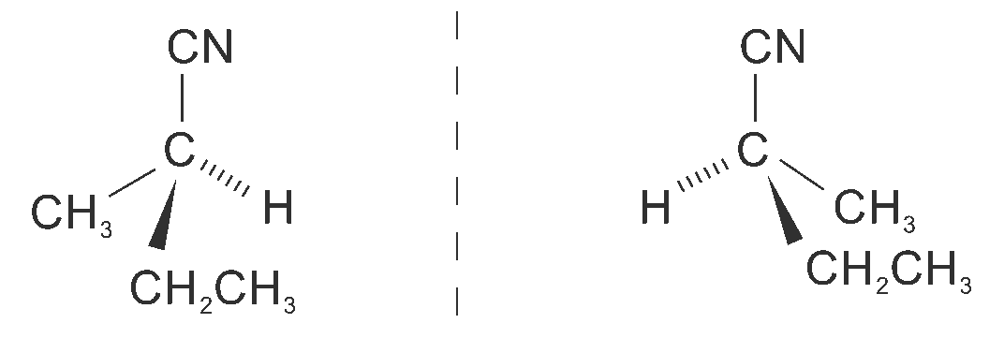

47. (a) 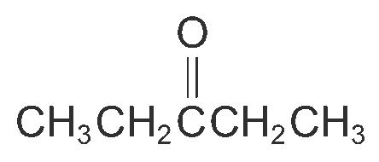

(b) 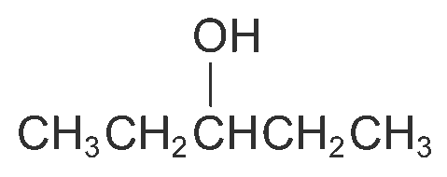

(c) Ketones

(d) Firstly, the test below is done in order to show that X is a carbonyl compound.
1. Add 1 – 2 drops of X into a test tube.
2. Add 2 cm³ of 2,4-dinitrophenylhydrazine to the test tube.
As an orange precipitate is formed in the test, this shows that X is a carbonyl compound.
In order to show that X is a ketone, Tollen’s test can be carried out. The procedure is shown as follows:
1. Add 1 cm³ of 0.05 M AgNO₃ with 3 – 4 drops of NaOH into a very clean test tube.
2. Add NH₃ solution drop by drop until the Ag₂O precipitate is nearly dissolved.
3. Add 1 – 2 drops of X and shake the tube gently. Warm the tube in a hot water bath.
As a silver mirror is not appeared in the test tube, this shows that X is a ketone.

48. (a) (i) 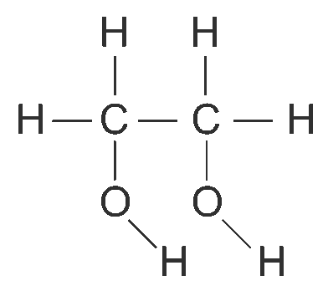
(ii) 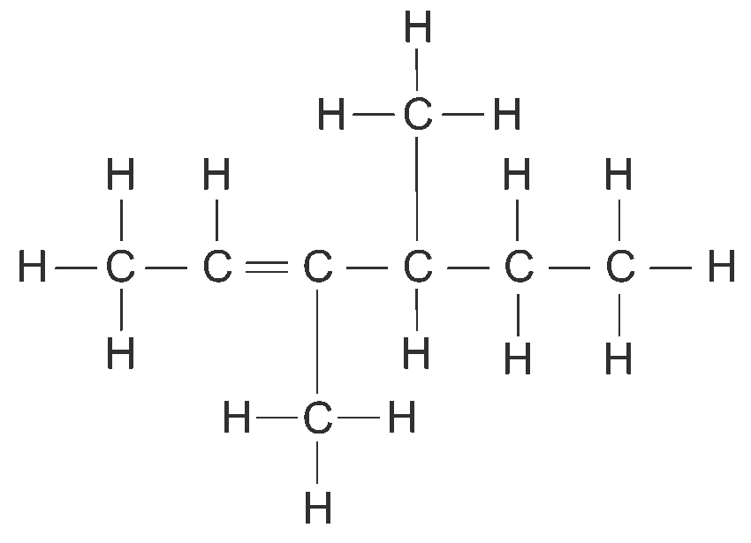
(iii) 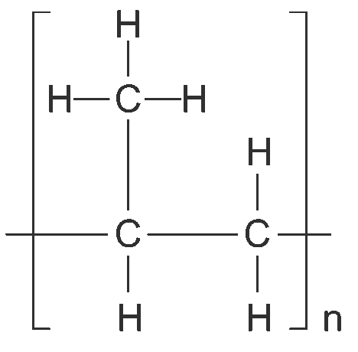

(b) (i) Electrophilic addition
(ii) Chloroethane

49. (a) (i) CH₃CH₂CH₂CN
(ii) CH₃CH₂CH₂NH₂ ; (CH₃CH₂CH₂)₂NH ; (CH₃CH₂CH₂)₃N

(b) The procedure of the test is shown below:
1. Add 5 drops of 2-chlorobutane and 5 drops of butan-2-ol into each of two test tubes.
2. Add 2 cm³ of iodine solution into each test tube.
3. For each test tube, add NaOH solution drop by drop until the brown colour of the solution almost disappears.
The test tube containing 2-chlorobutane remains unchanged. But in the test tube containing butan-2-ol, a pale yellow precipitate (CHI₃) is formed.

50. (a) Let the mass of compound E be 100%.
 | C | H | O
Mass (g) | 54.6 | 9.1 | 36.4
No. of moles (mol) | 4.55 | 9.1 | 2.275
Relative Number of moles | 2 | 4 | 1
∴ The empirical formula of E is C₂H₄O.

(b) From the IR spectrum, the peak at around 1700 cm^{–1} corresponds to the stretching vibration of the C = O bond. The peaks at around 3500 cm^{–1} correspond to the stretching vibration of the C – H bond.
From the mass spectrum, the base peak is at m/e 29. This corresponds to the formation of the ion [H – C = 0]${}_{}^{+}$. Therefore, compound E is ethanal.

