Part 6 Chemical Equilibria (Book 2, p.237 – p.249)

30. | (a) | 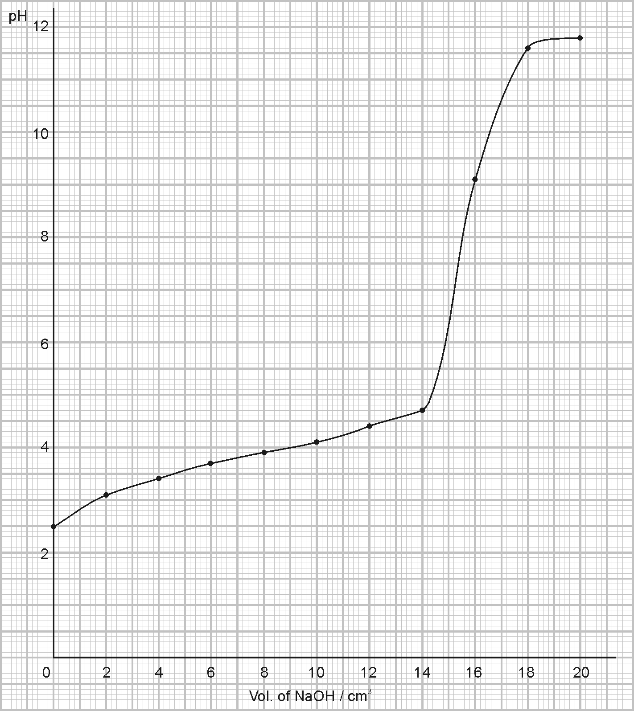

Before neutralization: pH increases sharply at first, then very gradually (behaving as a buffer solution).
During neutralization: pH increases very sharply from 5 to 11.
After neutralization: pH increases gradually.

(b) Phenolphthalein (pH range 8 – 10) lies within the region of sudden pH increase during neutralization.

(c) (i) Volume of NaOH required for neutralization = 16.0 cm³
$\frac{c×\text{10}}{0\text{.}\text{05}×\text{16}}$ = $\frac{1}{1}$ c = 0.08 mol dm⁻³
(ii) Molar mass = 90 g mol⁻¹
Concentration in g dm⁻³ = 0.08 × 90
= 7.2 g dm⁻³

(d) At the mid-point of neutralization, i.e. Volume of NaOH added = 8.0 cm³
pH = 3.9 = pK_{a}
K_{a} = 1.26 × 10^{–4} mol dm⁻³

31. (a) (i) Increasing pressure on I shifts the equilibrium to the left-hand side to produce more H₂O(g). The change favours reaction that produces fewer gas molecules.
(ii) Increasing temperature on I shifts equilibrium to the right-hand side to produce more H₂ and CO since the forward reaction is endothermic and it uses up the additional heat applied.
(iii) Increase [H⁺] on II shifts the equilibrium to the right-hand side to produce more Cr₂O₇^{2–} to use up the additional H⁺.

(b) 2SO₂(g) + O₂(g)2SO₃(g)
Initial pressure $\frac{2}{3}$ × 3 $\frac{1}{3}$ × 3
= 2 atm = 1 atm –

Equilibrium pressure 2 – 1.9 1 – $\frac{1\text{.}9}{2}$ 1.9 atm
= 0.1 atm = 0.05 atm

(i) At equilibrium, $P_{{\text{SO}}_{2}}$ = 0.1 atm
At equilibrium, $P_{O_{2}}$ = 0.05 atm
New total pressure = 1.9 + 0.1 + 0.05 = 2.05 atm
% conversion = $\frac{2−0\text{.}1}{2}$ × 100 % = 95 %
(ii) K_{p} = $\frac{(P_{{\text{SO}}_{3}})^{2}}{(P_{{\text{SO}}_{2}})^{2}(P_{O_{2}})}$ = $\frac{(1\text{.}9)^{2}}{(0\text{.}1)^{2}(0\text{.}\text{05})}$ = 7 220 atm^{–1}

32. (a) (i) A buffer solution is a solution in which the pH almost remains unchanged when a small amount of acid or alkali is added to it.
(ii) The additional H⁺ ions are removed by the large concentration of NH₃ present in the buffer. Therefore, pH remains almost unchanged.
H⁺ + NH₃ ⎯→ NH₄⁺
The additional OH– ions are removed by the large concentration of NH₄⁺ from the salt. Therefore, the pH remains virtually unchanged.
OH– + NH₄⁺ ⎯→ NH₃ + H₂O

(b) (i) NH₄Cl ⎯→ NH₄⁺ + H₂O
Number of moles of NH₄⁺ = Number of moles of NH₄Cl
= $\frac{\text{53}\text{.}5}{\text{14}+(4×1)+\text{35}\text{.}5}$
= $\frac{\text{53}\text{.}5}{\text{53}\text{.}5}$
= 1.0
∴ [NH₄⁺(aq)] = 1.0 mol dm⁻³
(ii) Number of moles of NH₃ = 15.0 × $\frac{\text{400}}{1\text{000}}$ = 6.0 mol
∴ [NH₃(aq)] = 6.0 mol dm⁻³

(c) (i) NH₄⁺NH₃ + H⁺
(ii) K_{a} = $\frac{[{\text{NH}}_{3}][H^{+}]}{[{\text{NH}}_{4^{+}}]}$
(iii) [H⁺] = K_{a}$\frac{[{\text{NH}}_{4^{+}}]}{[{\text{NH}}_{3}]}$
= 6.00 × 10⁻¹⁰ × $\frac{1\text{.}0}{6\text{.}0}$
= 1.0 × 10⁻¹⁰ mol dm⁻³
∴pH = −log₁₀[H⁺]
= −log₁₀(1.0 × 10⁻¹⁰)
= 10

33. (a) (i) Cu²⁺ + 2e⁻ ⎯→ Cu 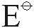 = + 0.34 V
Fe³⁺ + e⁻ ⎯→ Fe²⁺ = + 0.77 V
∴ = [+0.77 – (+0.34)]V
= +0.43 V
(ii) Reaction occurring in each half cell:
Cu(s) ⎯→ Cu²⁺(aq) + 2e⁻
Fe³⁺(aq) + e⁻ ⎯→ Fe²⁺(aq)
Overall reaction:
Cu(s) + 2Fe³⁺(aq) ⎯→ Cu²⁺(aq) + 2Fe²⁺(aq)

(b) The positive value indicates that the reaction is feasible but it gives no information about the rate. Nevertheless, the activation energy for the reaction in (a)(ii) is likely to be small since it involves simple electron transfer without involving breaking of covalent bonds. Therefore, the reaction will proceed.
(c) To reverse the direction of electron flow in the Fe³⁺(aq), Fe²⁺(aq)│Pt(s) half-cell, the other half-cell must have value more positive than +0.77 V.
Therefore, Cu²⁺(aq)│Cu(s) half-cell could be replaced by Ag⁺(aq)│Ag(s) half-cell.
The electrode is silver metal and the reagent is aqueous silver nitrate.

34. (a) The standard electrode potential of an element, is defined as the potential difference between a standard hydrogen half-cell and a half-cell of the element in a solution of its ions at 1 mol dm⁻³ and at 298 K and 1 atm.

(b) (i)
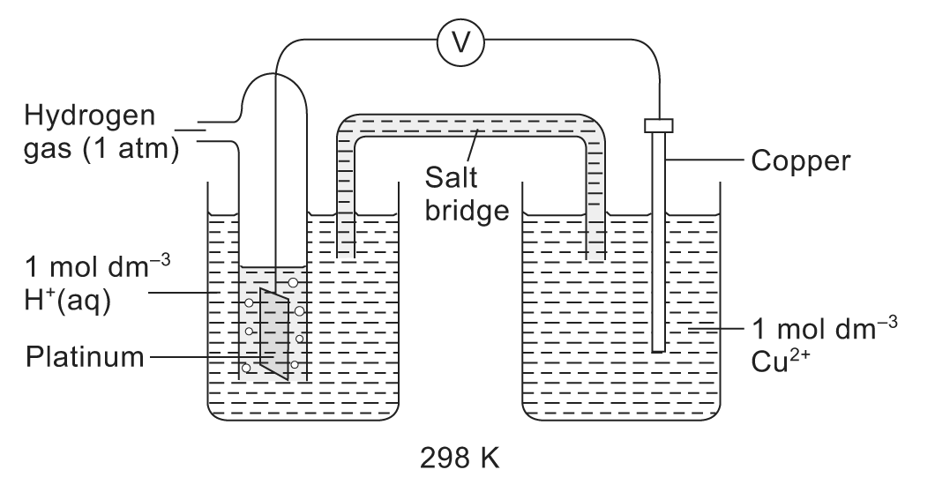
(ii)
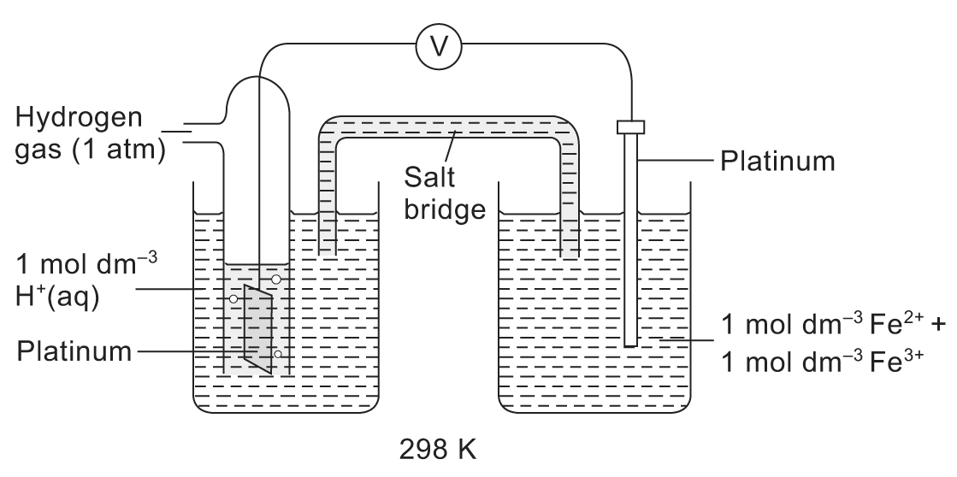

(c) (i) $\frac{1}{2}I_{2}$ + e⁻I⁻ = +0.54 V
Cr³⁺ + e⁻Cr²⁺ = −0.41 V
Overall reaction:
Cr²⁺ + $\frac{1}{2}I_{2}$ ⎯→ I⁻ + Cr³⁺
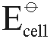 = +0.54 − (−0.41) = +0.95 V > 0
The reaction is energetically feasible under standard conditions.
(ii) MnO₄⁻ + 8H⁺ + 5e⁻Mn²⁺ + 4H₂O = +1.52 V
O₂ + 2H⁺ + 2e⁻H₂O₂ = +0.68 V
Overall reaction:
2MnO₄⁻ + 5H₂O₂ + 6H⁺ ⎯→ 2Mn²⁺ + 5O₂ + 8H₂O
= +1.52 − (+0.68) = +0.84 V > 0
The reaction is energetically feasible under standard conditions.

35. (a) The Bronsted-Lowry theory of acids and bases means that acids are proton donors while bases are proton acceptors.

(b) (i) In C, the two acids are H₂O and NH₄⁺ while the two bases are NH₃ and OH⁻.
In D, the two acids are CH₃CO₂H and C₆H₅OH while the two bases are C₆H₅O⁻ and CH₃CO₂⁻.
(ii) The degree of proton exchange is illustrated by the K_{c} value. Since K_{c} value is greater in D, it shows that the position of equilibrium is shifted more to the right in D and shifted more to left in C. Thus, CH₃CO₂H is the stronger acid while OH⁻ is the stronger base.

(c) (i) [H⁺]_{CH3CO2H} : [H⁺]_{HCl} = 10 − 2.4 : 10⁻¹
= 3.98 × 10⁻³ : 0.1
= 1 : 25
(ii) 2CH₃CO₂H + Zn(CH₃CO₂)₂Zn + H₂
2HCl + Zn ⎯→ ZnCl₂ + H₂
• The ionization equilibrium for ethanoic acid is shifted completely to the right by the excess Zn reacting with the H⁺ formed.
• In each case, 1 mole of H₂ is obtained from 2 moles of acid.
∴ Number of moles of H₂ = $\frac{1}{2}$ × Number of moles of acid
= $\frac{1}{2}$ × 0.1 × $\frac{\text{100}}{1\text{000}}$
= 5.0 × 10⁻³
∴ Volume of H₂ = (5.0 × 10⁻³ × 24 × 10³) cm³
= 120 cm³

36. (a) (i) Electrode at the left-hand side: H₂(g) + 2OH⁻(aq) ⎯→ 2H₂O(l) + 2e⁻
(ii) Electrode at the right-hand side: O₂(g) + 2H₂O(l) + 4e⁻ ⎯→ 4OH⁻(aq)

(b) = 0.40 − (−0.83) = +1.23 V

(c) 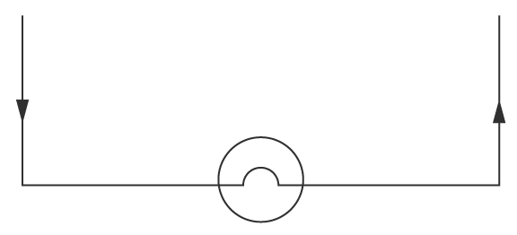

37. (a) A buffer solution is the one that undergoes small changes in pH when small amounts of acid or alkali are added to it.

(b) (i) A⁻ (aq) + H⁺(aq)HA(aq)
(ii) HA(aq) + OH⁻ (aq)A⁻ (aq) + H₂O(l)

(c) (i) For a weak acid like ethanoic acid, HA,
HA(aq)H⁺(aq) + A⁻(aq)
K_{a} = $\frac{[H^{+}][A^{−}]}{[\text{HA}]}$
(ii) pK_{a} = −log₁₀ K_{a}
(iii) pH = −log₁₀(1.8 × 10⁻⁵) – log₁₀($\frac{0\text{.}\text{04}}{0\text{.}\text{02}}$)
= 4.44
(iv) [salt]_{new} = (0.20 + 0.05) mol dm⁻³
= 0.25 mol dm⁻³
[acid]_{new} = (0.40 − 0.05) mol dm⁻³
= 0.35 mol dm⁻³
pH = −log₁₀(1.8 × 10⁻⁵) – log₁₀($\frac{0\text{.}\text{35}}{0\text{.}\text{25}}$)
= 4.59
∴ Change in pH = 4.59 – 4.44
= 0.15
(v) pH of water = 7.0
NaOH ⎯→ Na⁺ + OH⁻ (0.050 mol dm⁻³)
pOH = −log₁₀[OH⁻]
= −log₁₀(0.050)
= 1.30
pH = 14 – pOH = 12.7
∴ Change in pH = 12.7 – 7.0
= 5.7

(d) A buffer system which helps to control the pH of blood is HCO₃⁻/CO₃²⁻.

38. (a) pK_{a} = −log₁₀K_{a}

(b) C₆H₅B(OH)₂C₆H₅B(OH)O⁻ + H⁺

(c) pK_{a} = −log₁₀K_{a} = 8.86
∴ K_{a} = 1.38 × 10⁻⁹ mol dm⁻³
Let α be the degree of dissociation of the acid. Since α is relatively very small,
K_{a} = $\frac{[C_{6}H_{5}B(\text{OH})O^{−}][H^{+}]}{[C_{6}H_{5}B(\text{OH})_{2}]}$
= $\frac{[H^{+}]^{{}_{{}^{2}}}}{0\text{.}\text{010}}$
∴[H⁺] = $\sqrt{0\text{.}\text{010}×K_{a}}$
= $\sqrt{0\text{.}\text{010}×1\text{.}\text{38}×{\text{10}}^{−9}}$
= 3.72 × 10⁻⁶ mol dm⁻³
pH = −log₁₀[H⁺]
= −log₁₀(3.72 × 10⁻⁶)
= 5.43

(d) Benzoic acid is the stronger acid because its pK_{a} value is smaller showing that benzoic acid is more dissociated.

(e) (i)
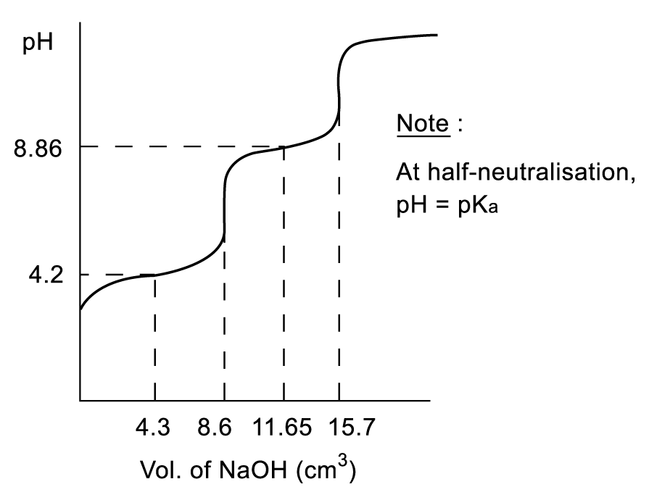
(ii) Number of moles of benzoic acid = Number of moles of NaOH
= 0.050 × $\frac{8\text{.}6}{1\text{000}}$
= 4.30 × 10⁻⁴ mol
[benzoic acid] = $\frac{1\text{000}}{\text{10}\text{.}0}$ × 4.30 × 10⁻⁴
= 0.0430 mol dm⁻³
Number of moles of C₆H₅B(OH)₂ = Number of mole of NaOH
= 0.050 × $\frac{7\text{.}1}{1\text{000}}$
= 3.55 × 10⁻⁴
[C₆H₅B(OH)₂] = $\frac{1\text{000}}{\text{10}\text{.}0}$ × 3.55 × 10⁻⁴
= 0.0355 mol dm⁻³

39. (a) K_{p} = $\frac{p^{2}(H_{2})×p(O_{2})}{p^{2}(H_{2}O)}$

(b) 2H₂O(g)2H₂(g) + O₂(g)
Initial: 2 mol 0 mol 0 mol
Eqm: 1.6 mol 0.4 mol 0.2 mol
Total number of moles = 1.6 + 0.4 + 0.2 = 2.2 mol
∴ p(H₂O) = ($\frac{1\text{.}6}{2\text{.}2}$ × 1) = 0.727 atm
p(H₂) = ($\frac{0\text{.}4}{2\text{.}2}$ × 1) = 0.182 atm
p(O₂) = ($\frac{0\text{.}2}{2\text{.}2}$ × 1) = 0.0909 atm

(c) K_{p} = $\frac{p^{2}(H_{2})×p(O_{2})}{p^{2}(H_{2}O)}$
= $\frac{(0\text{.}\text{182})^{2}(0\text{.}\text{0909})}{(0\text{.}\text{727})^{2}}\text{atm}$
= 0.00570 atm
Its unit is atm.

40. (a) (i) K_{sp} = [Mg²⁺(aq)][OH⁻(aq)]²
(ii) At pH = 9,
pOH = 14 − 9 = 5 and [OH⁻(aq)] = 10⁻⁵ = 1 × 10⁻⁵ mol dm⁻³.
Maximum value of [Mg²⁺(aq)] = $\frac{K_{\text{sp}}}{[{\text{OH}}^{−}(\text{aq})]^{2}}$
= $\frac{1\text{.}8×{\text{10}}^{−\text{12}}}{(1\text{.}0×{\text{10}}^{−5})^{2}}$
= 1.8 × 10⁻² mol dm⁻³
(iii) At pH = 6.5,
pOH = 14 − 6.5 = 7.5 and [OH⁻(aq)] = 10^{−7.5} = 3.16 × 10⁻⁸ mol dm⁻³.
Maximum value of [Mg²⁺(aq)] = $\frac{K_{\text{sp}}}{[{\text{OH}}^{−}(\text{aq})]^{2}}$
= $\frac{1\text{.}8×{\text{10}}^{−\text{12}}}{(3\text{.}\text{16}×{\text{10}}^{−8})^{2}}$
= 1803 mol dm⁻³
(iv) Peat-based soil

(b) Relative molecular mass of (NH₄)₂Mg(SO₄)₂ ⋅ 6H₂O
= 14.0 × 2 + 1.0 × 8 + 24.3 + 32.1 × 2 + 16.0 × 8 + 18.0 × 8
= 360.5
Percentage by mass of magnesium = $\frac{\text{24}\text{.}3}{\text{360}\text{.}5}$ × 100 % = 6.74 %

(c) NH₄⁺ is a strong conjugate acid and hydrolyzes in water:
NH₄⁺(aq) + H₂O(l)NH₃(aq) + H₃O⁺(aq)
The hydroxonium ion is acidic. Since an increase in acidity reduces alkalinity, the presence of ammonium ions decreases the formation of insoluble magnesium hydroxide and favours the formation of magnesium ions, the form which is absorbed by plants.

41. (a) Ammonia is important in the manufacture of chemicals such as nitric acid and urea. Ammonia is also used as a cleaning agent to remove grease.

(b) (i) 3H₂(g) + N₂(g) ⎯→ 2NH₃(g)
(ii) Activation energy is high due to the breaking of the very strong N ≡ N triple bond.
(iii) According to Le Chatelier’s principle, for a reversible reaction, an increase in pressure favours the reaction which causes a reduction in pressure. Since pressure is directly proportional to the number of moles of gaseous molecules, the forward reaction with less gaseous molecules would be favoured by high pressure. Hence, in order to increase the yield of ammonia, the process is carried out at a high pressure.

(c) (i) K_{c} = $\frac{[{\text{NH}}_{3}(g)]^{2}}{[N_{2}(g)][H_{2}(g)]^{3}}$
(ii) K_{c} = $\frac{[{\text{NH}}_{3}(g)]^{2}}{[N_{2}(g)][H_{2}(g)]^{3}}$
= $\frac{(0\text{.}\text{142})^{2}}{(1\text{.}\text{36})(1\text{.}\text{84})^{3}}$
= 0.00238
Unit of K_{c} = mol⁻² dm⁶

42. (a) Partition coefficient, K, is defined as the ratio of the concentration of a solute in solvent A to the concentration of the solute in solvent B while A and B are immiscible solvents.
K=$\frac{[\text{solute}]_{\text{solvent A}}}{[\text{solute}]_{\text{solvent B}}}$
K is a constant when the temperature is constant and the solute has the same molecular form in both solvents.

(b) Mass of X extracted = (5.00 – 0.8) g = 4.2g
Partition coefficient = $\frac{[X]_{\text{ether}}}{[X]_{\text{aq}}}$
= $\frac{\frac{4\text{.}2}{\text{100}}}{\frac{0\text{.}\text{80}}{\text{50}}}$
= 2.63

43. (a) Mg²⁺(aq) + 2OH⁻(g) ⎯→ Mg(OH)₂(s)

(b) Number of moles of OH⁻ needed to react with Mg²⁺
= Volume of NaOH required for equivalence point × [OH⁻(aq)]
= 20 × 10⁻³ × 1.0
= 0.02 dm³
Number of moles of Mg²⁺ = $\frac{1}{2}$ × Number of moles of OH⁻
= 0.01 mol
[MgCl₂(aq)] = [Mg²⁺(aq)]
= $\frac{0\text{.}\text{01}}{\text{50}×{\text{10}}^{−3}}$
= 0.2 mol dm⁻³

(c) (i) [OH⁻(aq)] = 10^{− (14 − pH)}
= 1 × 10⁻⁵ mol dm⁻³
(ii) [Mg²⁺(aq)] = $\frac{1}{2}$ × Original concentration
= $\frac{1}{2}$ × 0.2
= 0.1 mol dm⁻³

(d) (i) K_{sp} = [Mg²⁺(aq)][OH⁻(aq)]²
(ii) K_{sp} = 0.1 × (1 × 10⁻⁵)²
= 1 × 10⁻¹¹ mol³ dm⁻⁹

(e) Number of moles of excess OH⁻ = (30 − 20) × 10⁻³ × 1.0
= 0.01 mol
[OH⁻(aq)] = $\frac{0\text{.}\text{01}}{(\text{30}+\text{50})×{\text{10}}^{−3}}$
= 0.125 mol dm⁻³
pOH = −log [OH⁻(aq)]
= 0.90
pH = 14 − pOH
= 13.1

44. (a) The temperature in the car engine is very high. The high temperature causes N₂ and O₂ found in air to react together to form NO₂.
NO₂ can be removed from exhaust gases by the use of a catalytic converter which reduces NO₂ to N₂.

(b) (i) I: Dimerisation is favoured by a high pressure since there is less gaseous molecules after dimerisation. By Le Chatelier’s principle, when the pressure is increased, the system opposes the change by favouring the side with less gaseous molecules.
II: Dimerisation is favoured by a low temperature since dimerisation is exothermic. By Le Chatelier’s principle, when the temperature is decreased, the system opposes the change by favouring the reaction which gives out heat, i.e. the exothermic dimerisation reaction.
(ii) NO₂ has a bent shape. N₂O₄ has the following structural formula: 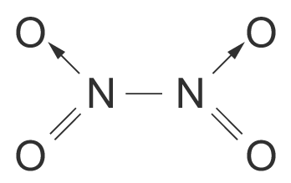

(c) Let n be the number of moles of gaseous molecules present.
Assuming that the mixture behaves as an ideal gas, pV = nRT.
∴ n = $\frac{\text{pV}}{\text{RT}}$
= $\frac{1\text{.}0×{\text{10}}^{5}×\text{190}×{\text{10}}^{−6}}{8\text{.}\text{31}×\text{320}}$
= 7.14 × 10⁻³ mol
Average M_{r} = $\frac{m}{n}$
= $\frac{0\text{.}\text{50}}{7\text{.}\text{14}×{\text{10}}^{−3}}$
= 70.0

(d) K_{p} = $\frac{p_{N_{2}O_{4}}}{p_{{\text{NO}}_{2^{2}}}}$
= $\frac{0\text{.}6}{(0\text{.}4)^{2}}$
= 3.75 atm⁻¹

45. (a) Le Chatelier’s principle states that when a system in equilibrium is subjected to a stress, processes occur in the system to counteract the stress applied.

(b) (i) KNO₃(s) + aqK⁺(aq) + NO₃⁻(aq) ΔH_{sol} > 0
The forward reaction of dissolution of KNO₃ is an endothermic process as the temperature drops as it dissolves. The backward reaction of crystallization is an exothermic process. On cooling a saturated solution from 100 °C to room temperature, heat is removed from the system. By Le Chatelier’s principle, processes occur in the system to counteract the loss of heat by favouring the reaction that gives out heat. Since the crystallization of potassium nitrate is an exothermic process, it is favoured and crystals formed.
(ii) Ca²⁺(aq) + SO₄²⁻(aq)CaSO₄(s)
When concentrated sodium sulphate solution is added to a saturated solution of calcium sulphate, the concentration of sulphate ions, [SO₄²⁻(aq)], is increased. By Le Chatelier’s principle, processes occur in the system to counteract this increase in [SO₄²⁻(aq)] by favouring the reaction that decreases [SO₄²⁻(aq)]. Since the forward precipitation step removes SO₄²⁻ from the solution, it is favoured and the white precipitate of calcium sulphate appears.
(iii) 2NO₂(g)N₂O₄(g) ΔH < 0
Since cooling favours the exothermic reaction which gives out heat, the dimerisation of brown NO₂ to form the colourless N₂O₄ is an exothermic process. On compressing the gaseous mixture, the total pressure of the system is increased. By Le Chatelier’s principle, processes occur in the system to counteract this increase in pressure by favouring the reaction that decreases pressure. Since the forward reaction produces less gaseous molecules, total pressure is decreased when it occurs and the brown colour fades as brown NO₂ forms the colourless N₂O₄. On warming the syringe, heat is supplied to the system. By Le Chatelier’s principle, processes occur in the system to counteract the increase in heat by favouring the reaction that absorbs heat. Since the backward reaction is endothermic, it absorbs heat and is favoured. The brown colour is restored as colourless N₂O₄ dissociates to form brown NO₂.

(c) (i) K_{p} = $\frac{P_{H_{2}}×P_{\text{CO}}}{P_{H_{2}O}}$; unit of K_{p} = atm
C(s) + H₂O(g)H₂(g) + CO(g)
(ii) Initial partial pressure: (atm) 1 0 0
Equilibrium partial pressure: (atm) 0.1 0.9 0.9
Change in partial pressure of steam = 1 − 0.1 = 0.9 atm.
The steam has reacted to form hydrogen and carbon monoxide.
Since 1 mole of steam produces 1 mole of H₂ and 1 mole of CO, partial pressure of H₂ = partial pressure of CO = partial pressure of steam used = 0.9 atm.
K_{p} = $\frac{P_{H_{2}}×P_{\text{CO}}}{P_{H_{2}O}}$
= $\frac{0\text{.}9×0\text{.}9}{0\text{.}1}$
= 8.1 atm

46. (a) (i) 2HNO₃ + 2SO₂ + H₂O ⎯→ N₂O₃ + 2H₂SO₄
In the above reaction, only N and S undergo changes in their oxidation numbers.
Let the oxidation number of N in HNO₃ be a.
+1 + a + 3(−2) = 0 ⇒ a = 6 − 1 = +5
Let the oxidation number of N in N₂O₃ be b.
2(b) + 3(−2) = 0 ⇒ 2b = 6 and hence b = +3.
Since the oxidation number of N decreases in the reaction, N is reduced.
Let the oxidation number of S in SO₂ be c.
c + 2(−2) = 0 ⇒ c = +4
Let the oxidation number of S in H₂SO₄ be d.
2(+1) + d + 4(−2) = 0 ⇒ d = 8 − 2 = +6
Since the oxidation number of S increases in the reaction, S is oxidized.
(ii) FeO₄²⁻ + MnO₂ + 4H⁺ ⎯→ Fe²⁺ + MnO₄⁻ + 2H₂O
In the above reaction, only Fe and Mn undergo changes in their oxidation numbers.
Let the oxidation number of Fe in FeO₄²⁻ be e.
e + 4(−2) = −2 ⇒ e = −2 + 8 = +6
Oxidation number of Fe in Fe²⁺ = +2
Since the oxidation number of Fe decreases in the reaction, Fe is reduced.
Let the oxidation number of Mn in MnO₂ be f.
f + 2(−2) = 0 ⇒ f = +4
Let the oxidation number of Mn in MnO₄⁻ be g.
g + 4(−2) = −1 ⇒ g = −1 + 8 = +7
Since the oxidation number of Mn increases in the reaction, Mn is oxidized.

(b) (i) The experimental set-up is shown in the diagram below:
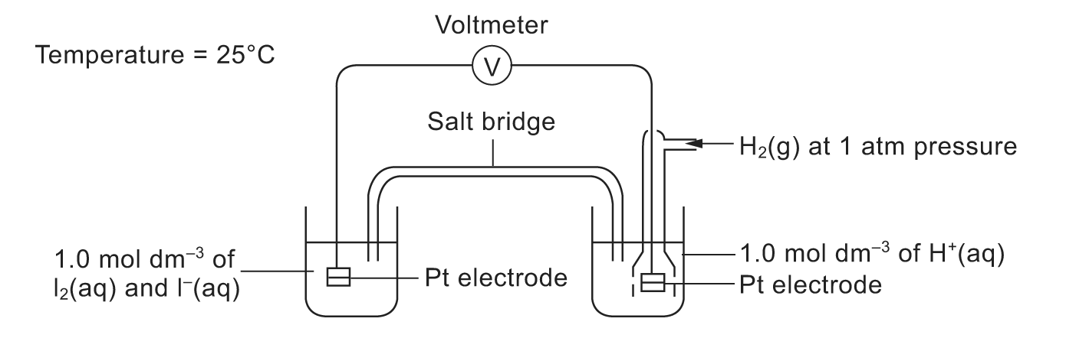
The temperature is maintained at 25 °C.
To determine the standard electrode potential of the I₂(aq) / I⁻(aq) system, a solution containing iodine and potassium iodide (each of concentration 1 mol dm⁻³) is prepared. A platinum electrode is dipped into this solution. This is the I₂(aq) / I⁻(aq) half-cell.
The half-cell of I₂(aq) / I⁻(aq) is connected to a standard hydrogen electrode.
The standard hydrogen electrode consists of a platinised platinum electrode dipped into a solution containing hydrogen ions of 1 mol dm⁻³ and hydrogen gas at a pressure of 1 atm. A voltmeter is connected as shown to record the voltage. To complete the circuit, a salt bridge is used.
The reading on the voltmeter y V is noted. If electrons flow from the I₂(aq) / I⁻(aq) half-cell to the standard hydrogen electrode, the standard electrode potential of the I₂(aq) / I⁻(aq) system is −y V. If electrons flow from the standard hydrogen electrode to the I₂(aq) / I⁻(aq) half-cell, the standard electrode potential of the
I₂(aq) / I⁻(aq) system is +y V.
(ii) An increase in the concentration of the iodide ion causes the of the system to decrease.

(c) (i) From the Data Booklet,
Cr₂O₇²⁻ + 14H⁺ + 6e⁻2Cr³⁺ + 7H₂O = +1.33 V
Fe³⁺ + e⁻Fe²⁺ = +0.77 V
For the reaction between Fe²⁺ and acidified Cr₂O₇²⁻,
= +1.33 − 0.77 = +0.56 V > 0 V ⇒ reaction is energetically feasible.
Fe²⁺ is oxidized to Fe³⁺ while Cr₂O₇²⁻ is reduced to Cr³⁺.
Cr₂O₇²⁻(aq) + 6Fe²⁺(aq) + 14H ⁺(aq) ⎯→ 2Cr³⁺(aq) + 6Fe³⁺(aq) + 7H₂O(l)
(ii) From the Data Booklet,
MnO₄⁻ + 8H⁺ + 5e⁻Mn²⁺ + 4H₂O = +1.52 V
SO₄²⁻ + 4H⁺ + 2e⁻SO₂ + 2H₂O = +0.17 V
For the reaction between SO₂(aq) and acidified MnO₄⁻,
= +1.52 − 0.17 = +1.35 V > 0 V ⇒ reaction is energetically feasible.
SO₂ is oxidized to SO₄²⁻ while MnO₄⁻ is reduced to Mn²⁺.
2MnO₄⁻(aq) + 5SO₂(aq) + 2H₂O(l) ⎯→ 2Mn²⁺(aq) + 5SO₄²⁻(aq) + 4H⁺(aq)

47. (a) (i) pH = –log [H⁺]
(ii) [Al(H₂O)₆]³⁺ + H₂O ⎯→ [Al(H₂O) ₅(OH)]²⁺ + H₃O⁺
Increasing in [H₃O⁺] lowers the pH of water.

(b) (i) A buffer solution is one that tends to resist changes in pH when a small amount of acid or base is added to it.
(ii) CO₃^{2–} + H₃O⁺HCO₃– + H₂O
CO₃^{2–} “removes” the additional H₃O⁺ from acid.
HCO₃– + OH– ⎯→ CO₃^{2–} + H₂O
HCO₃– “removes” the additional OH– from alkali.
Hence, the pH remains fairly constant with addition of small amounts of acid and alkali.

(c) (i) K_{a} = $\frac{[{\text{CO}}_{3^{2−}}][H_{3}O^{+}]}{[{\text{HCO}}_{3^{−}}]}$
(ii) $\frac{[{\text{CO}}_{3^{2−}}]}{[{\text{HCO}}_{3^{−}}]}$ = 0.003, [H₃O⁺] = $\frac{(4\text{.}8 × {\text{10}}^{−\text{11}})}{0\text{.}\text{003}}$ = 1.6 × 10^{–8}
pH = 7.796
$\frac{[{\text{CO}}_{3^{2−}}]}{[{\text{HCO}}_{3^{−}}]}$ = 0.960, [H₃O⁺] = $\frac{(4\text{.}8 × {\text{10}}^{−\text{11}})}{0\text{.}\text{960}}$ = 5.0 × 10^{–11}
pH = 10.30
(increase)
Change in pH = 2.504

48. (a) (i) A Bronsted-Lowry acid is a substance which donates hydrogen ions.
(ii) (1) Acid HF / base HNO₃
Acid H₂NO₃⁺ / base F–
(2) Acid HN₃ / base H₂O
Acid H₃O⁺ / base N₃–

(b) (i) K_{a} = $\frac{[H_{3}O^{+}][N_{3^{−}}]}{[{\text{NH}}_{3}]}$
(ii) pK_{a} = –log K_{a}
(iii) pH = 2.86 ⇒ [H₃O⁺] = 0.001 38 mol dm⁻³
K_{a} = $\frac{(0\text{.}\text{001}\text{38})^{2}}{0\text{.}1}$ ⇒ pK_{a} = 4.72

(c) Strongest acid: CH₂ClCOOH (largest K_{a})
Weakest acid: CH₃CH₂COOH (smallest K_{a})
Cl – electron-withdrawing, facilitate the removal of H⁺
CH₃ – electron-denoting group makes the removal of H⁺ more difficult when it is compared with CH₃COOH.

49. (a) (i) K_{a} = $\frac{[{\text{RCO}}_{2^{−}}][H_{3}O^{+}]}{[{\text{RCO}}_{2}H]}$
(ii) RCO₂H + H₂ORCO₂⁻ + H₃O⁺
At start: 0.200 0 0
At eqm: (0.200 –x) x x
K_{a} = $\frac{[{\text{RCO}}_{2^{−}}][H_{3}O^{+}]}{[{\text{RCO}}_{2}H]}$
7.4 × 10⁻⁴ = $\frac{x^{2}}{(0\text{.}\text{200}−x)}$
x² + 7.4 × 10⁻⁴ x – 7.4 × 10⁻⁴ = 0
x = 0.0268 or –0.0276 (rejected)
∴[H₃O⁺] = 0.0268
pH = –log [H₃O⁺] = 1.57

(b) (i) The function of a buffer solution is to resist the changes in pH when a small amount of acid or base is added to it.
(ii) & (iii)
Sodium citrate is completely ionized in water but critic acid is only slightly ionized in water.
When a small amount of acid is added to the system, the reaction will shift to the left. The additional H₃O⁺ ions are removed mostly by forming the partially ionized citric acid.
RCO₂⁻(aq) + H₃O⁺(aq) ⎯→ RCO₂H(aq) + H₂O(l)
Similarly, when a small amount of a base is added to the system, the additional OH⁻(aq) will react with undissociated citric acid molecules to form RCO₂⁻ and water molecules.
OH⁻(aq) + RCO₂H(aq) ⎯→ RCO₂⁻(aq) + H₂O(l)
pH = pK_{a} = log$\frac{[\text{salt}]}{[\text{acid}]}$
= −log (7.4 × 10⁻⁴) + log$\frac{[0\text{.}\text{400}]}{[0\text{.}\text{200}]}$= 3.43

50. (a) Although a low temperature will increase the yield of ammonia, a chemical reaction carried out at low temperature is likely to be slow. That is, the time to reach equilibrium is likely to be long.

(b) Since a large amount of energy is required to produce a higher pressure, it is uneconomic to use pressure higher than 200 atm.

(c) (i) & (ii)
The iron acts as a catalyst during the production of ammonia. The iron increases the rate of reaction by providing an alternative pathway with a lower activation energy. However, since a catalyst does not change the equilibrium position of the reaction, the amount of ammonia in the equilibrium mixture remains unchanged.

51. (a) $\frac{1}{2}$H₂(g) + $\frac{1}{2}$I₂(g)HI(g)
K_{c} = $\frac{[\text{HI}(g)]}{[H_{2}(g)]^{\frac{1}{2}}[I_{2}(g)]^{\frac{1}{2}}}$
(b)
Reactant / Product | Initial number of moles (mol) | Change in number  of moles (mol) | Number of moles at equilibrium (mol)
H₂ | 1.9 | −1.5 | 0.4
I₂ | 1.9 | −1.5 | 0.4
HI | 0 | 3 | 3

K_{c} = $\frac{[\text{HI}(g)]}{[H_{2}(g)]^{\frac{1}{2}}[I_{2}(g)]^{\frac{1}{2}}}$
K_{c} = $\frac{(\frac{\text{3mol}}{{\text{250cm}}^{3}})}{(\frac{0\text{.}\text{4mol}}{{\text{250cm}}^{3}})^{\frac{1}{2}}(\frac{0\text{.}\text{4mol}}{{\text{250cm}}^{3}})^{\frac{1}{2}}}$
= $\frac{\frac{3}{\text{250}}}{\frac{0\text{.}4}{\text{250}}}$
= 7.5

52. (a) K_{p} = $\frac{P({\text{PCl}}_{3})⋅P({\text{Cl}}_{2})}{P({\text{PCl}}_{5})}$

(b) PCl₅(g)PCl₃(g) + Cl₂(g)
At start: 1 mol 0 mol 0 mol
At eqm.: (1−0.39) mol 0.39 mol 0.39 mol
(i) Mole fraction of PCl₅(g) = $\frac{1−0\text{.}\text{39}}{1−0\text{.}\text{39}+0\text{.}\text{39}+0\text{.}\text{39}}$
= $\frac{0\text{.}\text{61}}{1\text{.}\text{39}}$
= 0.44
Partial pressure of PCl₅(g) = Mole fraction × Total pressure
= 0.44 × 2 atm
= 0.88 atm
(ii) Mole fraction of PCl₃(g) = $\frac{0\text{.}\text{39}}{1\text{.}\text{39}}$
= 0.28
Partial pressure of PCl₃(g) = 0.28 × 2 atm
= 0.56 atm
(c) K_{p} = $\frac{0\text{.}\text{56 atm}×0\text{.}\text{56 atm}}{0\text{.}\text{88 atm}}$
= 0.36 atm

53. (a) (i) Lead plate
(ii) Lead(IV) oxide
(iii) Sulphuric acid

(b) Pb(s) + PbO₂(s) + 4H⁺(aq) + 2SO₄²⁻(aq)2PbSO₄(s) + 2H₂O(l)

(c) e.m.f. of cell = 1.69 – (−0.36) = +2.05 V

(d) 2PbSO₄(s) + 2H₂O(l) ⎯→ Pb(s) + PbO₂(s) + 4H⁺(aq) + 2SO₄²⁻(aq)

(e) If the car is not used for a long time, the battery would lose its charge and becomes flat.

54. (a) The concentration of hydrogen ions in 0.01 mol dm⁻³ HCl is 0.01 mol dm⁻³
pH = −log ([H⁺(aq)])
= −log (0.01)
= 2

(b) [H⁺(aq)] = 0.1 mol dm⁻³

(c) pH = pK_{a} + log$\frac{[\text{salt}]}{[\text{acid}]}$
1.57 = −log(0.01) + log $\frac{[H^{+}(\text{aq})]}{[0\text{.}1]}$
1.57 = 2 + log$\frac{[H^{+}(\text{aq})]}{[0\text{.}1]}$
log$\frac{[H^{+}(\text{aq})]}{[0\text{.}1]}$ = −0.43
$\frac{[H^{+}(\text{aq})]}{[0\text{.}1]}$ = antilog(−0.43)
[H⁺(aq)] = 0.037 mol dm⁻³
[H⁺(aq)] in 0.1 mol dm⁻³ of H₂SO₄
= 0.1 mol dm⁻³ + 0.037 mol dm⁻³
= 0.137 mol dm⁻³

(d) Since the K_{a} for the reaction I is very large, the reaction will shift to the right-hand side. The HSO₄⁻ ions produced in reaction I will push the reaction II to the right-hand side, thus the K_{a} in reaction II may be larger than 0.01 mol dm⁻³. The concentration of hydrogen ions in 0.1 mol dm⁻³ sulphuric acid thus larger than 0.137 mol dm⁻³, i.e. 0.15 mol dm⁻³.

(e) The reaction is endothermic because an increase in temperature will favour the forward reaction of reaction II.

(f) The increase in temperature will decrease the pH value of the solution.

55. (a)
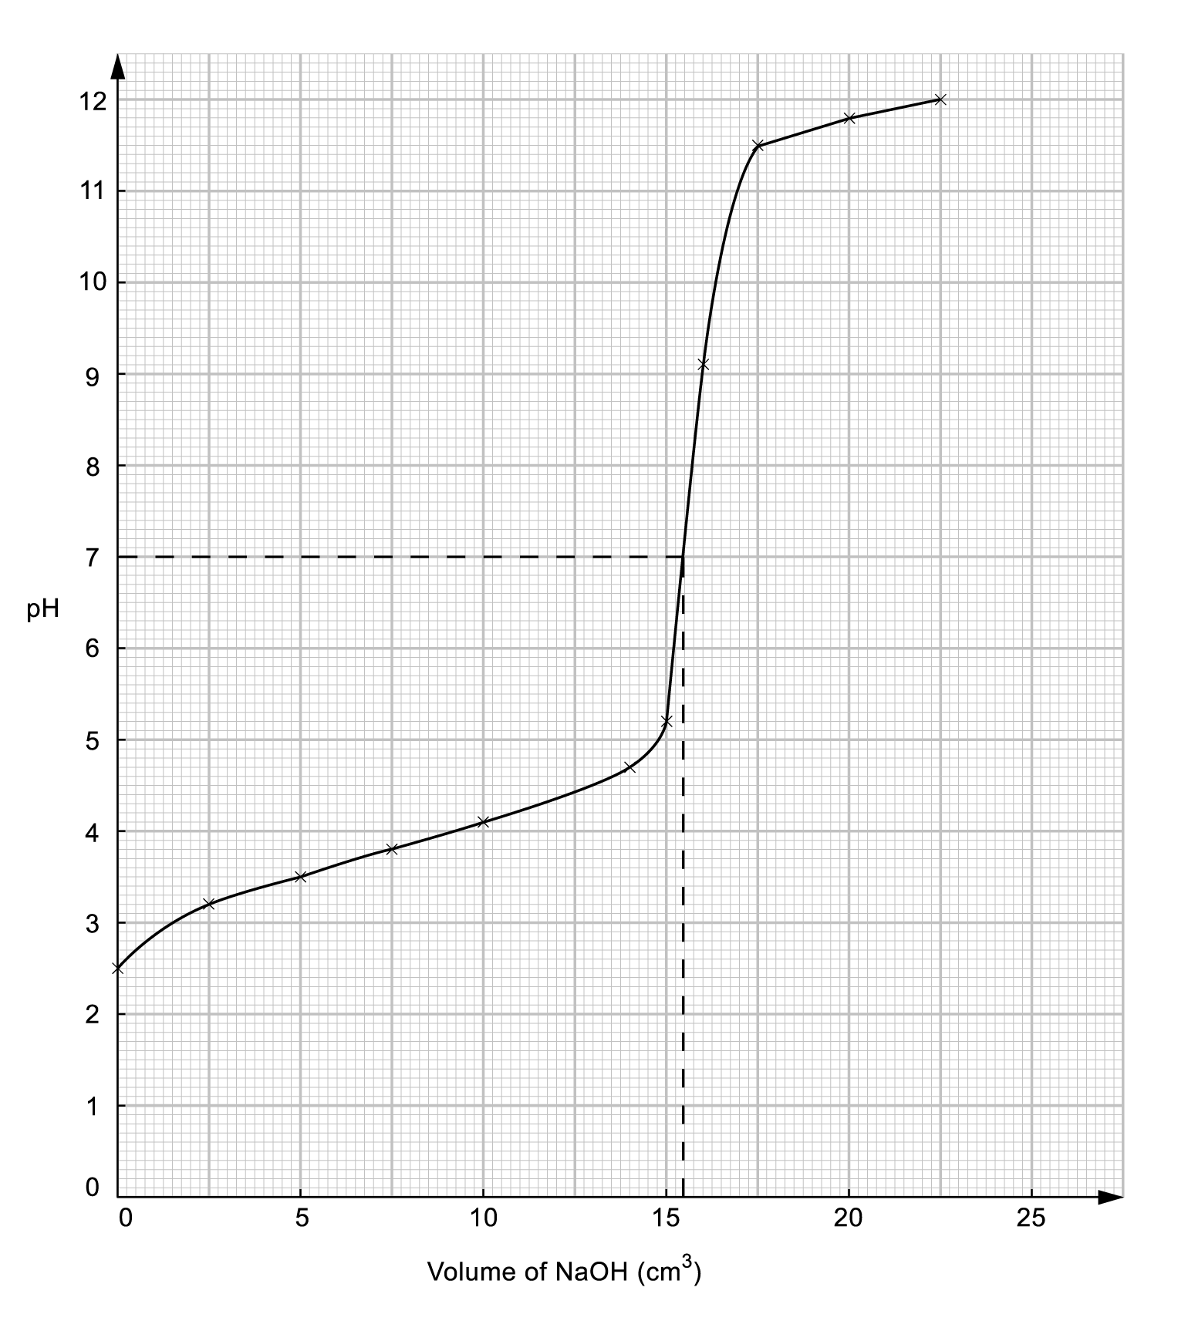
The end point reached when 15.5 cm³ of NaOH was used.

(b) Number of moles of NaOH used = 0.050 mol dm⁻³ × $\frac{\text{15}\text{.}5}{1\text{000}}$ dm³
= 7.75 × 10⁻⁴ mol
= Number of moles of A
Mass of A= $\frac{7\text{.}\text{20}{\text{ g dm}}^{−3}×\text{10}{\text{ dm}}^{3}}{1\text{000}}$ = 0.072g
Molar mass of A = $\frac{\text{Mass of A}}{\text{Number of mole of A}}$
= $\frac{0\text{.}\text{072g}}{7\text{.}\text{75}×{\text{10}}^{−4}\text{mol}}$
= 92.9 g mol⁻¹

56. (a) The nature of a dynamic equilibrium is that the forward reaction is proceeding at the same rate as the backward reaction.

(b) K_{c} = $\frac{[{\text{SO}}_{3}(g)]^{2}}{[{\text{SO}}_{2}(g)]^{2}[O_{2}(g)]}$
unit of K_{c} = $\frac{({\text{mol dm}}^{−3})^{2}}{({\text{mol dm}}^{−3})^{2}({\text{mol dm}}^{−3})}$
= mol⁻¹ dm³

(c) (i) The equilibrium position will shift to the left-hand side since the reaction is exothermic.
(ii) The presence of a catalyst has no effects on the equilibrium position because it affects the rate of reaction instead of changing its equilibrium position.

57. (a) Since fluorine is a very strong oxidizing agent, it will oxidize water to form hydrogen fluoride and oxygen when it is bubbled into it.
The chemical equation for the reaction is shown below:
2F₂(g) + 2H₂O(l)4HF(aq) + O₂(g)

(b) As the standard electrode potential of chlorine is higher than water, the expected reaction should be shown as the following equation:
2Cl₂(g) + 2H₂O(l)4HCl(aq) + O₂(g)

(c) Since the potential difference is 0.13 V which is very small, the reaction may not be favourable. Disproportionation is occurred instead of oxidation.

58. (a) Air

(b) 4Al(s) + 3O₂(g) + 6H₂O(l) ⎯→ 4Al(OH)₃(s)

(c) As the aluminium will be used to produce Al(OH)₃ which is a solid, the efficiency of the cell may be reduced over a period of time.

59. (a) (i) pH = pK_{In} + log$\frac{[{\text{In}}^{−}]}{[\text{HIn}]}$
pH = −log (1 × 10⁻⁴) + log 1
= 4
(ii) When $\frac{[{\text{In}}^{−}]}{[\text{HIn}]}$ < $\frac{1}{\text{10}}$,
pH < pK_{In} + log$\frac{1}{\text{10}}$
< −log (1 × 10⁻⁴) + log $\frac{1}{\text{10}}$
< 3
When $\frac{[{\text{In}}^{−}]}{[\text{HIn}]}$ > 10
pH > pK_{In} + log 10
> −log (1 × 10⁻⁴) + log 10
> 5
The approximate range of pH over which indicator changes can be detected at pH value which is lower than 3 or higher than 5.

(b) (i) Since there is a sharp increase in pH of the equivalence point of titrations of a strong alkali against a strong acid, any indicators which show colour change at this range can be used.
For most indicators, the pH range is within ± 1 of the pK_{In} value. When solution with concentration of 1.00 mol dm⁻³ is used, the range of equivalence point is about pH 2 – 12. Therefore, the titration can be performed with any indicator. However, the range of equivalence point is about pH 4 − 10 if the concentration is 0.01 mol dm⁻³ , only methyl red and bromothymol blue can be used as indicators.
(ii) As the change in pH at the equivalence point does not occur sharply, all indicators will not give a sharp colour change at the equivalence point but will change colour gradually over a large volume of the acid or base added.
(iii) NaOH(aq) + CO₂(g) ⎯→ NaHCO₃(aq)
NaHCO₃ which is a base is formed. It will affect the pH value of the titration mixture.
(c) (i) pH = pK_{a} + log$\frac{[\text{salt}]}{[\text{acid}]}$
When the acid has been half-neutralized, [salt] = [acid]
pH = pK_{a} + log 1 = pK_{a}
(ii) At this pH, there are CH₃COO⁻ ions to react with the additional acids and CH₃COOH molecules to react with the additional bases. It is most effective because there are same amounts of CH₃COO⁻ ions and CH₃COOH molecules at this pH.

60. (a)
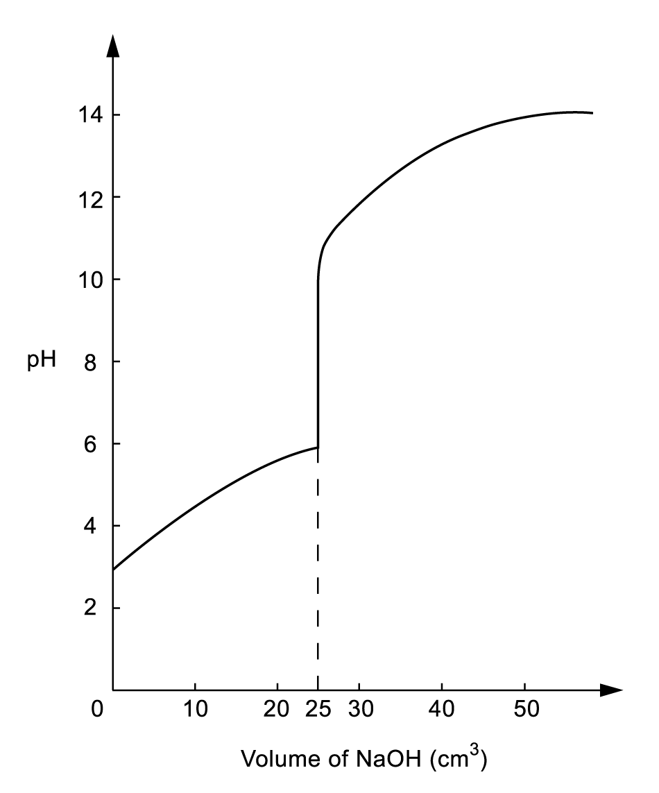

(b) Since the equivalent point occurs at the pH range of about 6-11, thymol blue would be the best for this titration. As thymol blue changes from yellow to blue at the pH range of about 7.9 – 9.9.

61. (a) (i) 2 × ($\frac{1}{2}$Cl₂ + e⁻ ⎯→ Cl–) = +1.34 V
–) Fe²⁺ + 2e⁻ ⎯→ Fe = –0.44 V
Fe + Cl₂ ⎯→ FeCl₂ = +1.80 V
3 × ($\frac{1}{2}$Cl₂ + e⁻ ⎯→ Cl–) = +1.34 V
–) Fe³⁺ + 3 e⁻ ⎯→ Fe = –0.04 V
Fe + $\frac{3}{2}$Cl₂ ⎯→ FeCl₃ = +1.40 V

Although both the formation of iron(II) chloride and iron(III) chloride from iron metal seems to be feasible by considering the electrode potentials (E), the formation may not be occurred actually. It is because the positive values of E only imply the reaction is energetically feasible but not necessarily kinetically feasible. The reaction of iron metal with dilute hydrochloric acid gives iron(II) chloride but not iron(III) chloride, means that the formation of iron(III) chloride is kinetically not feasible.

(ii) 3 × (Co³⁺ + e⁻ ⎯→ Co²⁺) = +1.82 V
–) Fe³⁺ + 3e⁻ ⎯→ Fe = –0.04 V
3Co³⁺ + Fe ⎯→ 3Co²⁺ + Fe³⁺ = +1.86 V
–) 3 × ($\frac{1}{2}$Cl₂ + e⁻ ⎯→ Cl⁻) = +1.34 V

3Co³⁺ + Fe + $\frac{3}{2}$Cl₂ + 3e⁻ ⎯→ FeCl₃ = +1.40 V
By adding an aqueous cobalt(III) solution to the iron metal and hydrochloric acid, an aqueous solution of iron(III) chloride could be made.

(b) Rusting is an electrochemical process.
At the anodic region: Fe ⎯→ Fe²⁺ + 2e⁻
At the cathodic region: $\frac{1}{2}$O₂ + H₂O + 2e⁻ ⎯→ 2OH⁻
The Fe²⁺(aq) and OH⁻(aq) formed react with each other and precipitate as Fe(OH)₂.
= 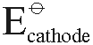 – 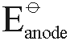 = +0.40V – (–0.44V) = + 0.84V
The Fe(OH)₂ is further oxidized by air to form hydrated iron(III) oxide, i.e. rust.
2Fe(OH)₂ + $\frac{1}{2}$O₂ + (x – 2)H₂O ⎯→ Fe₂O₃ ⋅ xH₂O

62. (a) “Homogeneous equilibrium” means that the reactants and the products are in the same phase.

(b) K_{p} = $\frac{P_{{\text{PCl}}_{3}}⋅{\text{ P}}_{{\text{Cl}}_{2}}}{P_{{\text{PCl}}_{5}}}$
Unit of K_{p} = atm

(c) PCl₅(g)PCl₃(g) + Cl₂(g)
At start: 1 mol 0 mol 0 mol
At eqm.: 0.67 mol 0.33 mol 0.33 mol
Mole fraction of PCl₅(g) = $\frac{0\text{.}\text{67}}{0\text{.}\text{67}+0\text{.}\text{33}+0\text{.}\text{33}}$
= $\frac{0\text{.}\text{67}}{1\text{.}\text{33}}$
= 0.50
Partial pressure of PCl₅(g) = 1.1 × 0.50
= 0.55 atm
Mole fraction of PCl₃(g) = Mole fraction of Cl₂(g)
= $\frac{0\text{.}\text{33}}{1\text{.}\text{33}}$
= 0.25
Partial pressure of PCl₃(g) = Partial pressure of Cl₂(g)
= 1.1 × 0.25
= 0.28 atm

(d) ΔH for the forward reaction = –306 – (–399)
= + 93 kJ mol ^{–1}

(e) The forward reaction is endothermic. The equilibrium position will shift to the right-hand side if the temperature is increased.

63. (a) MnO₂ + 2MnO₄⁻ + 2H₂O ⎯→ 4H⁺ + 3MnO₄²⁻
= + 0.56 – 2.26 = –1.7 V
The reaction is not feasible under standard conditions.

(b) Increasing the pH of the reaction mixture can make the reaction become feasible. It is because the OH⁻ ions react with the H⁺ ions on the right-hand side of the reaction, so the forward reaction can be more favourable.

(c) 4MnO₄⁻ + 4OH⁻ ⎯→ 4MnO₄²⁻ + 2H₂O + O₂
(green)
= +0.56 – 0.04 = + 0.52V
In an alkaline medium, MnO₄⁻ will be oxidized to MnO₄²⁻ which is green in colour. The reaction is feasible because the difference in the standard potential has a positive value.

64. (a) Dynamic equilibrium means that the forward reaction is proceeding at the same rate as the backward reaction.

(b) According to Le Chatelier’s principle, the equilibrium position of the system will shift in a way to minimize the effect of raising the temperature. Since the reaction is exothermic, the equilibrium position will shift to the backward side and less ammonia is being produced.

(c) It is because the rate of formation of ammonia will be reduced if the temperature is too low. The temperature chosen should be high enough to the reaction to proceed quickly but low enough to have a satisfactory yield of product.

(d) The mixture of gases is passed through a heat exchanger and cooled. The ammonia formed in the process is then absorbed in water and liquefied under pressure.

(e) (i) A catalyst is a substance that can change the rate of a reaction but remains
chemically unchanged at the end of the reaction.
(ii)
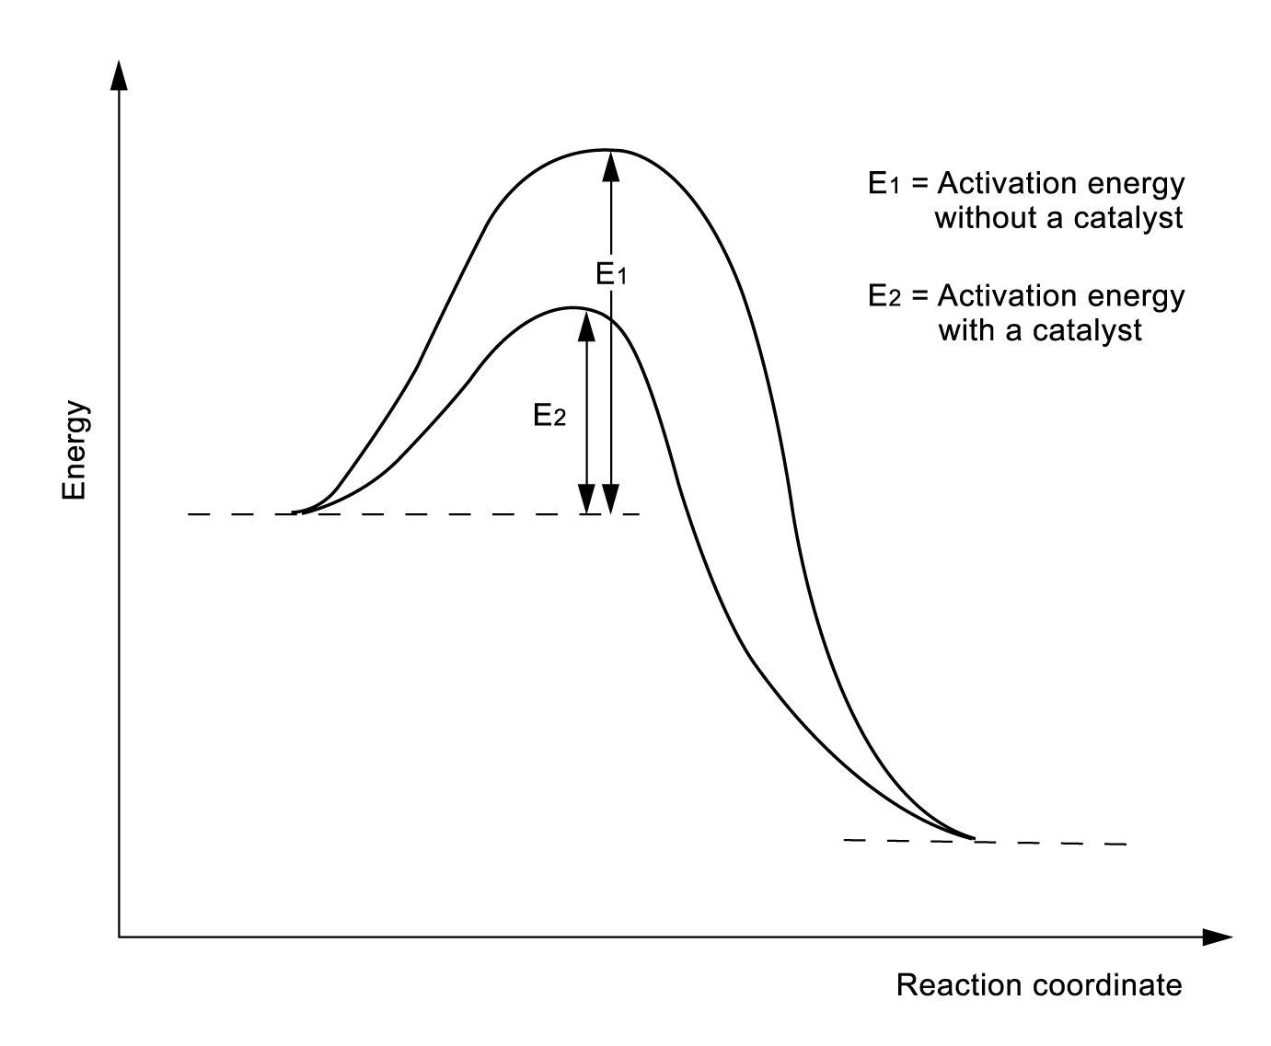

The catalyst increases the rate of the reaction to achieve the equilibrium by providing an alternative pathway with a lower activation energy.
(iii) The catalyst is chemically unchanged at the end of the reaction, so it does not change the position of the equilibrium and the yield of ammonia.

65. (a) K_{p} = $\frac{(P_{\text{AlCl}})^{3}}{P_{{\text{AlCl}}_{3}}}$

(b) Mole fraction of AlCl₃ = $\frac{0\text{.}\text{67}}{0\text{.}\text{67}+0\text{.}\text{63}}$
= $\frac{0\text{.}\text{67}}{1\text{.}3}$
= 0.52
Mole fraction of AlCl = $\frac{0\text{.}\text{63}}{1\text{.}3}$
= 0.48
P(AlCl₃) = 2 atm × 0.52 = 1.04 atm
P(AlCl) = 2 atm × 0.48 = 0.96 atm
K_{p} = $\frac{(P_{\text{AlCl}})^{3}}{P_{{\text{AlCl}}_{3}}}$
= $\frac{0\text{.}{\text{96}}^{3}{\text{atm}}^{3}}{1\text{.}\text{04}\text{atm}}$
= 0.85 atm²

(c) The enthalpy change should be positive because the forward reaction is endothermic.

(d) (i) The equilibrium constant remains unchanged because it is related to the temperature of the reaction condition only.
(ii) Also remains unchanged because both left and right hand sides of the chemical reaction contain 3 moles of gases.

(e) We should induce the backward reaction by using lower temperature.

66. (a) (i) Standard electrode potential is the potential difference between the measured half-
cell and the standard hydrogen electrode.
(ii) Fluorine

(b) (i) F₂, Cl₂, Br₂ and I₂
(ii) I₂
(iii) We can add iodine solution to the aqueous chromium(II) solution which is sky blue in colour. If the solution shows dark green, that means the prediction in (ii) actually worked in practice.

67. (a) It is because ammonium nitrate is a solid, in considering K_{p}, we only consider the reactants and products which are in the gaseous state.

(b) Molar mass of NH₄NO₃ = 14.0 × 2 + 1.0 × 4 + 16.0 × 3
= 80 g mol⁻¹

Number of moles of NH₄NO₃ = $\frac{6\text{.}\text{00 g}}{{\text{80 g mol}}^{\text{-1}}}$
= 0.075 mol
For completely dissociation of ammonium nitrate, the pressure in the system
= 0.075 mol × 50 atm × 2
= 7.5 atm
K_{p} = PNH₃ ⋅ PHNO₃ = 15.7 atm²
P_{NH3} = $\sqrt{\text{15}\text{.}7{\text{atm}}^{2}}$
= 3.96 atm
∴ Percentage dissociation of ammonium nitrate = $\frac{3\text{.}\text{96}×2}{7\text{.}5}$ × 100 %
= 105.6 %

68. (a) Dynamic equilibrium means that the forward reaction is proceeding at the same rate as the backward reaction.

(b)
 | Effect on the rate  of the reaction | Effect on the position  of equilibrium
Increasing the temperature | Increases | Shifts to the left
Increasing the pressure | Increases | Shifts to the right

(c) (i) The reaction is exothermic, thus a low temperature will increase the yield of the product. However, the rate of the reaction to attain the equilibrium will be too low if the temperature is too low. Therefore, the process is operated at the temperature of 450 °C, which would result in the highest percentage of conversion.
(ii) A high pressure will increase the yield of the product but under the operating temperature of 450 °C, the conversion is already high. A pressure of 2 atm is enough because a higher pressure often requires costly equipment.
(iii) A catalyst is used to increase the rate of the reaction.

(d) Platinum

