Part 5 Chemical Kinetics (Book 2, p.80 – p.86)

15. (a) (i) The graph is a decreasing curve. As temperature increases, the shelf-life becomes shorter.
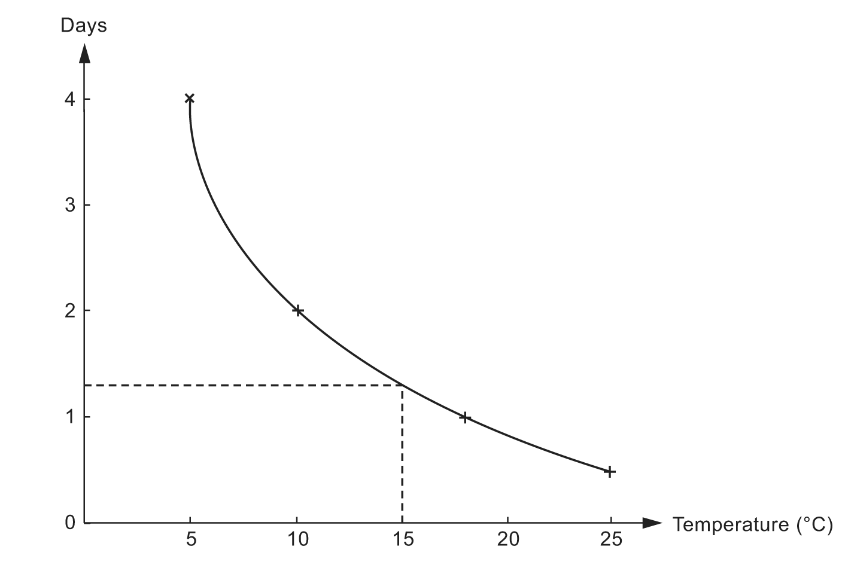
(ii) 1.3 days

(b) Rate $\frac{1}{\text{time}}$

(c)
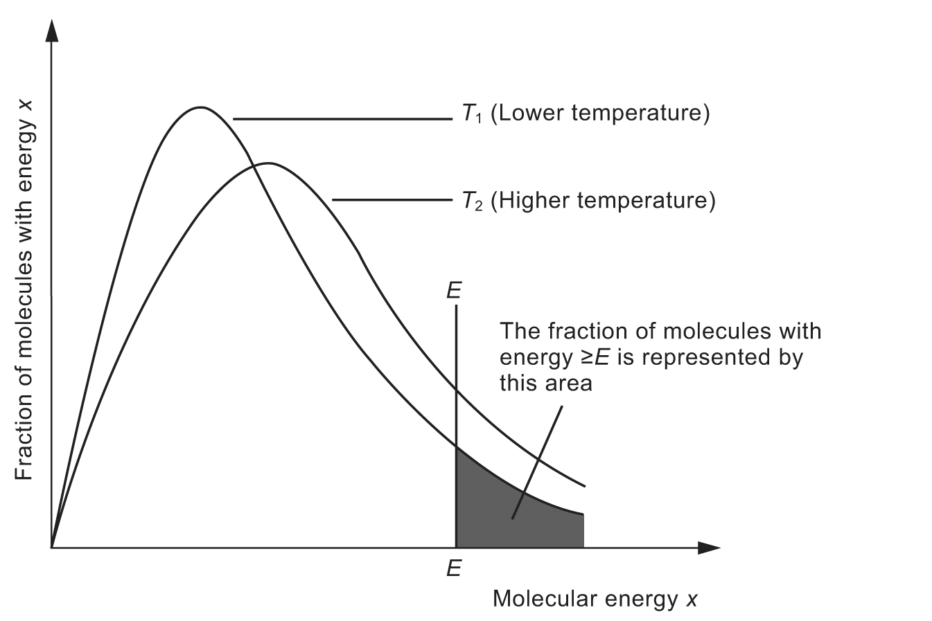
For a chemical reaction to take place, the colliding particles must possess energy greater than the activation energy, E_{a}. From the Boltzmann distribution, it can be seen that at a higher temperature (T₂), there are much greater number of particles with energy greater than E_{a}. Furthermore, at a higher temperature, the particles move faster and the frequency of collisions also increases. Consequently, there is a higher frequency of collisions of particles with sufficient energy for the reaction to take place. Hence, the rate of reaction increases.

(d) The enzymes that catalyze the souring of milk are decomposed by the high temperature.

16. (a)
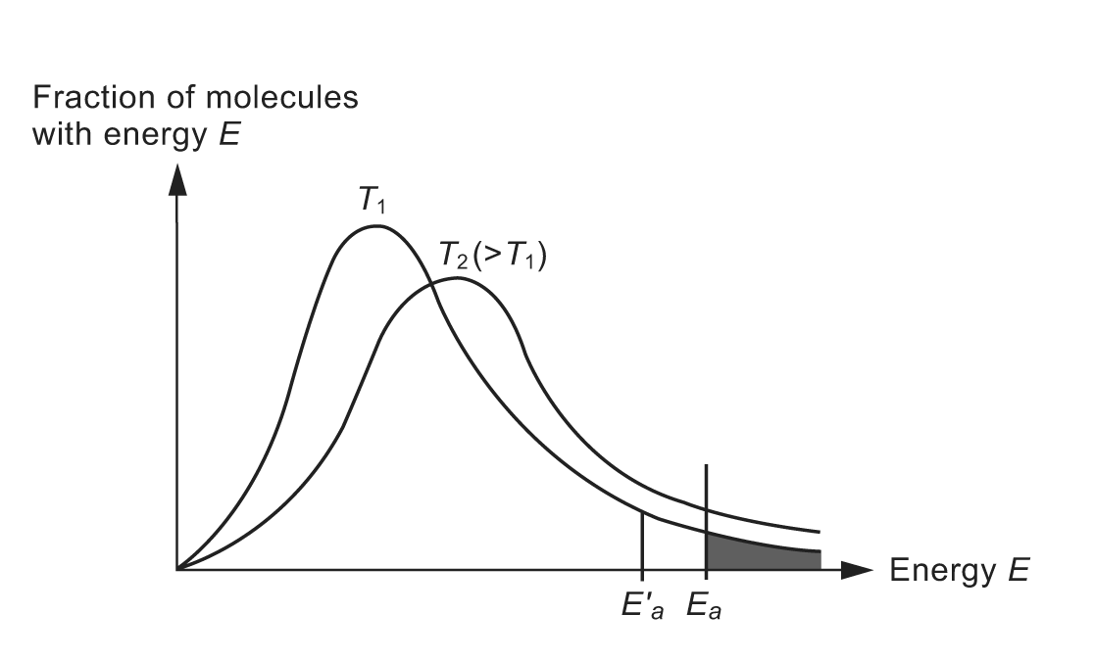
For a chemical reaction to take place, the colliding particles must possess enough energy greater than the activation energy E_{a}. The shaded area represents the fraction of particles with energy greater than E_{a} at temperature T₁. From the Boltzmann distribution, it can be seen that at a higher temperature, T₂, there are much greater number of particles with energy greater than E_{a}. Hence, the reaction rate increases.
At the same temperature, T₁, when a suitable catalyst is used, the reaction pathway is altered such that the new activation energy, $E_{a}^{'}$, is lower. There is a greater number of particles with energy greater than $E_{a}^{'}$. Hence, the reaction rate increases.

(b) (i) E_{a} = 173.2 + 9.6
= 182.8 kJ mol⁻¹
(ii) B increases more in rate as the temperature is increased because it has a higher activation energy.

17. (a) Comparing experiments 3 and 4, [O₂] remained constant while [NO] doubled, the initial rate is increased by a factor of 4.
The reaction is second order with respect to NO.
Comparing experiments 1 and 2, [NO] remained constant while [O₂] doubled, the initial rate is also doubled.
The reaction is first order with respect to O₂.

(b) The rate-determining step is:
2NO + O₂ ⎯→ 2NO₂

(c) This rate-determining step is unusual because the overall order is three, suggesting that three molecules have to collide together.

18. (a) (i) CH₃COCH₃ + I₂ ⎯→ CH₃COCH₂I + HI
(ii) The rate equation is:
rate = k[CH₃COCH₃][H⁺]
overall order = 1 + 1 = 2
unit of rate constant = $\frac{{\text{moldm}}^{−3}s^{−1}}{({\text{moldm}}^{−3})^{2}}$
= dm³ mol⁻¹ s⁻¹
(iii) Mechanism A fits the observed kinetic data. The reason is that the rate equation shows only one molecule of propanone and one hydrogen ion are involved in the rate-determining step. However, I₂ is not involved in the rate-determining step.
(iv) I₂ is a reagent while H⁺ is a catalyst.
(v) The rate would be the same. It is because I₂ and Br₂ do not appear in the rate
equation.

(b) Oxides of nitrogen act as a homogeneous catalyst in the following reactions:
NO₂(g) + SO₂(g) ⎯→ NO(g) + SO₃(g)
NO(g) + $\frac{1}{2}$O₂(g) ⎯→ NO₂(g)

19. (a) (i) Na(s) + C₂H₅OH(l) ⎯→ C₂H₅O⁻Na⁺(l) + $\frac{1}{2}$H₂(g)
(ii) This is because Na is rapidly oxidized by O₂ in air to form a layer of Na₂O on its surface. Moreover, Na reacts with the water vapour present in air.

- (i)
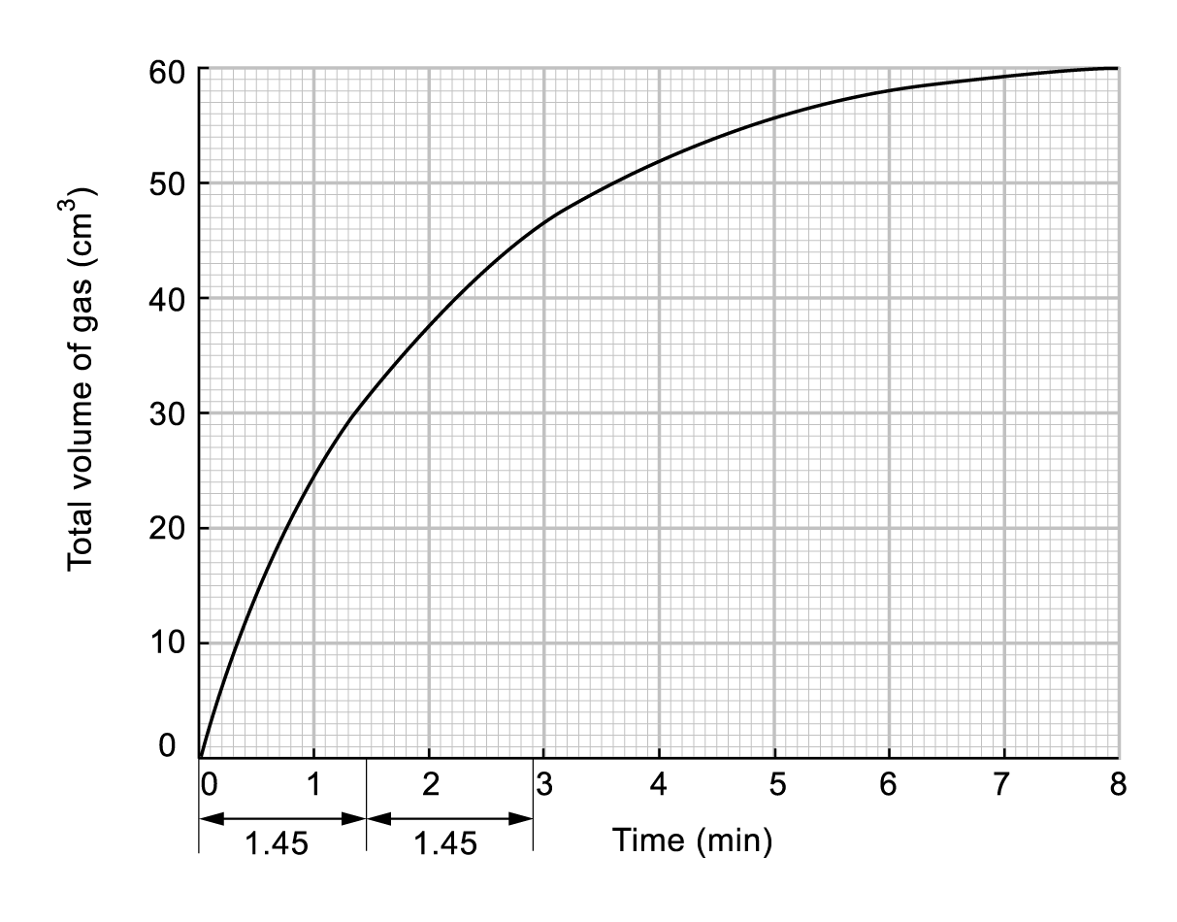

(ii) From the graph, t_{1/2} is constant indicating that the overall kinetics are first order.
(iii) Since ethanol is present in excess, the concentration of ethanol does not change throughout the reaction. Hence, the reaction rate is independent of the concentration of ethanol; i.e. zero order with respect to ethanol.

(c) (i) Total volume of H₂ = 60 dm³
∴ Number of moles of gas = $\frac{\text{60}}{\text{24}\text{000}}$ = 2.5 × 10⁻³ mol
(ii) Number of moles of Na = 2 × number of moles of H₂
= 2 × 2.5 × 10⁻³
= 5.0 × 10⁻³
∴ Mass of Na = (5.0 × 10⁻³ × 23) g
= 0.115 g

(d) (i) This is because water also reacts with sodium.
Na(s) + H₂O(l) ⎯→ NaOH(aq) + $\frac{1}{2}$H₂(g)
(ii) Any organic solvent which has no O ⎯ H group, e.g. propanone, methylbenzene and hexane.

20. (a) Rate equation is an equation that relates the reaction rate to the concentrations of the reactants.
Order of a reaction with respect to a reactant refers to the power to which the concentration of the reactant is raised in a rate equation. The overall order of reaction is the sum of all the powers to which the concentrations of the reactants are raised in the rate equation.
Rate constant is a constant of proportionality between the reaction rate and the concentrations of reactants that appear in the rate equation.
Hence, for the reaction A + B ⎯→ C, if the rate is first order with respect to A and B, then the rate equation is Rate = k[A][B]. Overall order of reaction is 1 + 1 = 2 and rate constant = k.

(b) (i) Graph A: [ethyl ethanoate] against time with [HCl] = 0.1 mol dm⁻³
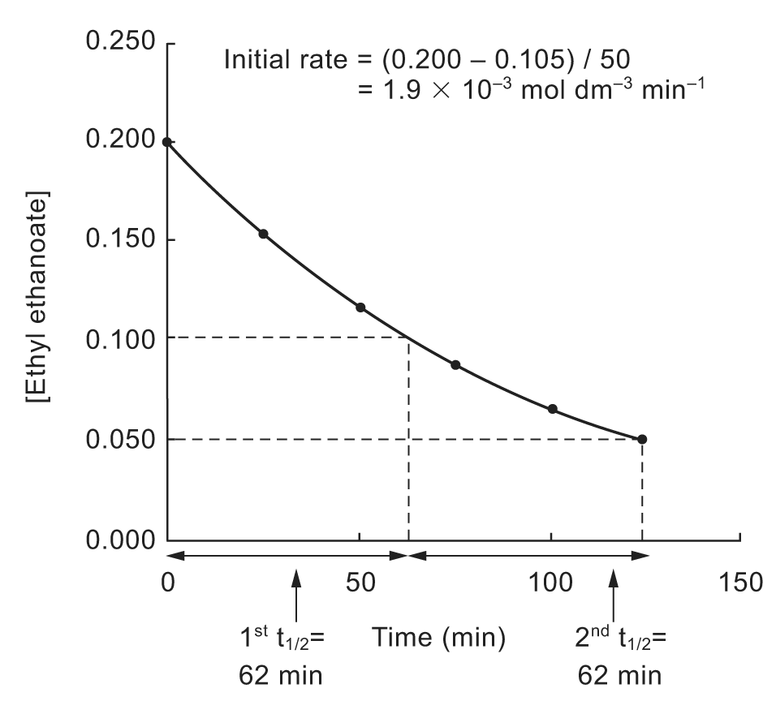
Graph B: [ethyl ethanoate] against time with [HCl] = 0.2 mol dm⁻³
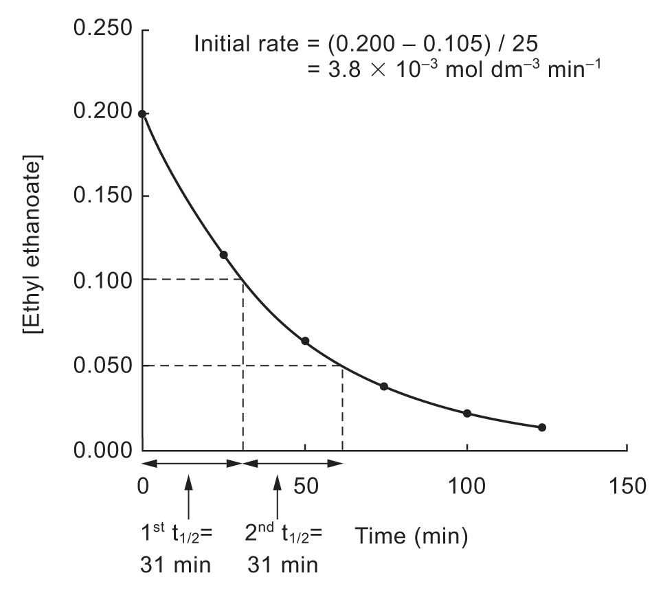
(ii) From graph A, it is seen that the half-life is a constant. Hence, the rate of reaction is first order with respect to ethyl ethanoate.
Since HCl is a catalyst, [HCl] is a constant.
Let the order of reaction with respect to HCl be a.
Hence, the rate equation is Rate = k[ethyl ethanoate][HCl]ª.
For the first experiment,
Initial rate, R_{i}1 = k[0.200][0.1]ª = slope of graph A at t = 0 min
= 1.9 × 10⁻³ mol dm⁻³ min⁻¹
For the second experiment,
Initial rate, R_{i}2 = k[0.200][0.2]ª = slope of graph B at t = 0 min
= 3.8 × 10⁻³ mol dm⁻³ min⁻¹
$\frac{R_{i}1}{R_{i}2}$:$\frac{0\text{.}1^{a}}{0\text{.}2^{a}}$=$\frac{1\text{.}9×{\text{10}}^{−3}}{3\text{.}8×{\text{10}}^{−3}}$ ⇒ a = 1
(iii) Rate equation: Rate = k[ethyl ethanoate][HCl]
Rate constant, k = $\frac{\text{In 2}}{t_{1/2}[\text{HCl}]}$ = $\frac{\text{In 2}}{\text{62}×0\text{.}1}$ = 0.112 min⁻¹

(c) Water is used as a solvent , so its concentration is very high and remains approximately constant as the reaction proceeds.

21. (a) (i) Rate = k[NO(g)]²[Br₂(g)] where k is the rate constant
Unit of k = mol⁻² dm⁶ s⁻¹
(ii)
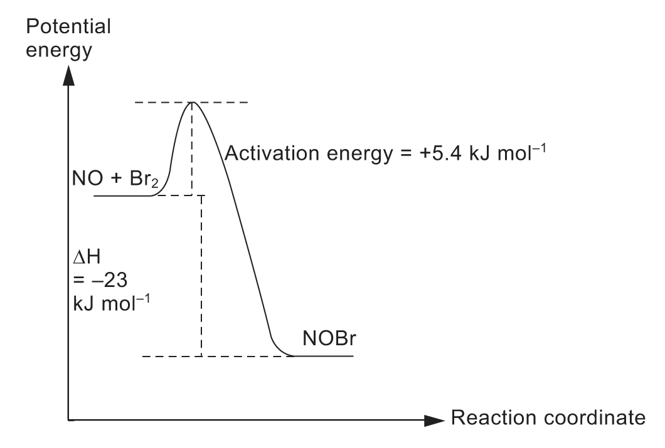

(b) (i) RBr + NaOH ⎯→ ROH + NaBr
Nucleophilic substitution reaction
(ii) Graph of [RBr] is plotted against time:
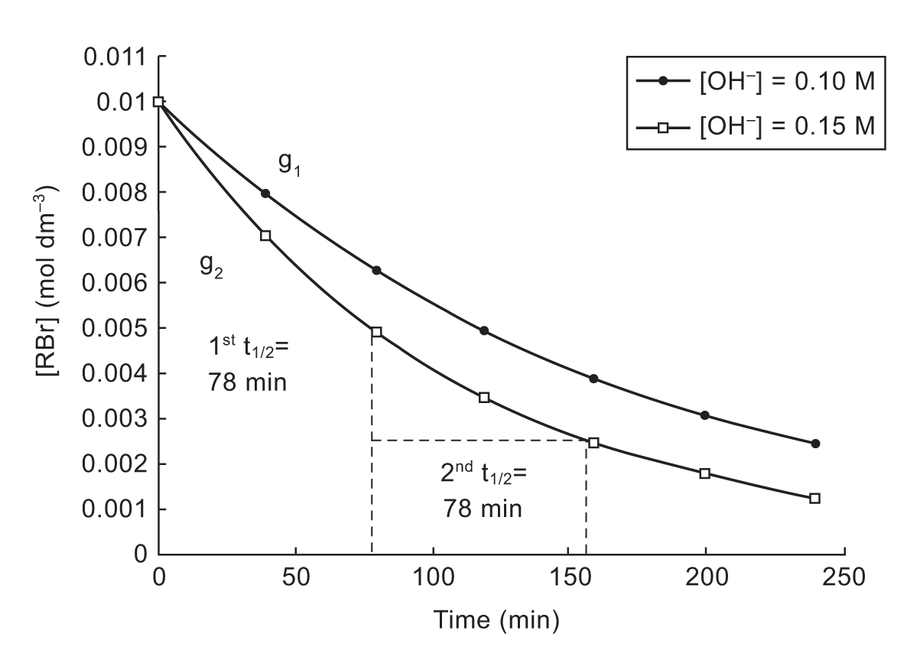
(1) Since OH⁻ is used in great excess, the shape of the graph is dependent on the order of reaction with respect to RBr and not OH⁻.
From the graph, when [OH⁻] = 0.15 mol dm⁻³, both the first and second half-lives = 78 min. = is a constant ⇒ order of reaction with respect to RBr is one.
(2) Let g₁ and g₂ be the slopes of the graph at t = 0 min. when [OH⁻] = 0.10 mol dm⁻³ and 0.15 mol dm⁻³ respectively.
Initial rate when [OH⁻] is 0.10 mol dm⁻³,
r₁ = −g₁
= $\frac{−(0\text{.}\text{0079}−0\text{.}\text{0100})}{\text{40}−0}$
= 5.25 × 10⁻⁵ mol dm⁻³ min⁻¹

Initial rate when [OH⁻] is 0.15 mol dm⁻³,
r₂ = −g₂
= $\frac{−(0\text{.}\text{0068}−0\text{.}\text{0100})}{\text{40}−0}$
= 8.00 × 10⁻⁵ mol dm⁻³ min⁻¹
Ratio of r₂ to r₁ = 8.00 × 10⁻⁵ : 5.25 × 10⁻⁵ = 1.5 : 1
Since the rate also increases 1.5 times when [OH⁻] is increased 1.5 times, the rate of reaction with respect to OH⁻ is one.
(3) Rate = k[RBr][OH⁻]
Substitute initial rate = 5.25 × 10⁻⁵ mol dm⁻³ min⁻¹, [RBr] = 0.010 mol dm⁻³ and [OH⁻] = 0.10 mol dm⁻³ into the above equation:
∴ 5.25 × 10⁻⁵ = k × 0.010 × 0.10
⇒ k = $\frac{5\text{.}\text{25}×{\text{10}}^{−5}}{0\text{.}\text{010}×0\text{.}\text{10}}$
= 0.0525 mol⁻¹ dm³ min⁻¹

22. (a) The rate of a chemical reaction is defined as the change in the concentration of reactants or products per unit time.

(b) (i) Rate = k[CH₃CH₂CH₂CH₂Br][OH⁻]
(ii) Unit of k is mol⁻¹ dm³ s⁻¹.
(iii) The rate equation indicates that the rate-determining step involves one CH₃CH₂CH₂Br molecule and one OH⁻ ion, i.e. it is bimolecular. The reaction proceeds via an S_{N}2 mechanism.

(c) (CH₃)₃CBr ⎯→ (CH₃)₃C⁺ + Br⁻ slow
(CH₃)₃C⁺ + OH⁻ ⎯→ (CH₃)₃COH fast

23. (a) A suitable experimental technique is colorimetry. A sample of the ester and alkaline mixture is prepared and placed in a colorimetric cell. The cell is then placed in a colorimeter and the absorbances of a suitable wavelength of light at specific times (e.g. 1 minute intervals) are taken.
Samples of the yellow product of known concentration are then prepared and the absorbance of each sample is measured. A graph of absorbance against concentration is plotted so that the concentration of the yellow product at various absorbance may be determined from the graph.
A graph of concentration of the yellow product is plotted against time. The rate of this reaction at time t will be the gradient of the graph at time t.

(b)
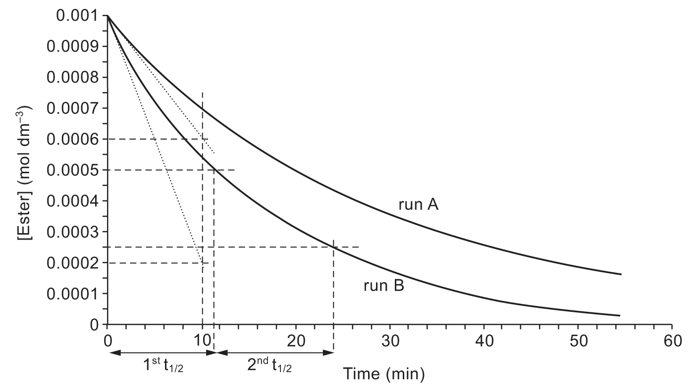
(i) Initial rate of run A = $−\frac{(0\text{.}\text{0006}−0\text{.}\text{001})}{(\text{10}−0)}$mol dm⁻³ min⁻¹
= 4.00 × 10⁻⁵ mol dm⁻³ min⁻¹
Initial rate of run B = $−\frac{(0\text{.}\text{0002}−0\text{.}\text{001})}{(\text{10}−0)}$mol dm⁻³ min⁻¹
= 8.00 × 10⁻⁵ mol dm⁻³ min⁻¹
(ii) When the concentration of OH⁻ ions is doubled from run A to run B, the initial rate is also doubled. Hence the order of reaction with respect to [OH⁻] is one.
(iii) The order of reaction with respect to [ester] is one.
(iv) For run B, the first half-life is 11.5 min, while the second half-life is 24 − 11.5 = 12.5 min. Since the two half-lives are approximately constant, the order of reaction with respect to [ester] is one.
(v) The rate equation is: rate = k[ester][OH⁻]
(vi) From run B, when [ester] = 0.001 mol dm⁻³ and [OH⁻] = 0.40 mol dm⁻³,
initial rate = 8.00 × 10⁻⁵ mol dm⁻³ min⁻¹
∴ 8.00 × 10⁻⁵ mol dm⁻³ min⁻¹ = k × 0.001 mol dm⁻³ × 0.40 mol dm⁻³
k = $\frac{(8\text{.}\text{00}×{\text{10}}^{−5})}{(0\text{.}\text{001})(0\text{.}\text{40})}$ mol⁻¹ dm³ min⁻¹
= 0.200 mol⁻¹ dm³ min⁻¹

24. (a) In the collision theory, the rate of a reaction depends on the frequency of effective collisions between reactant particles. When the concentrations of reactants are increased, there are more particles within a unit volume. Hence, they are more likely to collide with each other. This in turn increases the rate of the reaction.

(b) (i) As₂O₃ + 4VO₂⁺ + 4H⁺ ⎯→ As₂O₅ + 4VO²⁺ + 2H₂O
(ii)
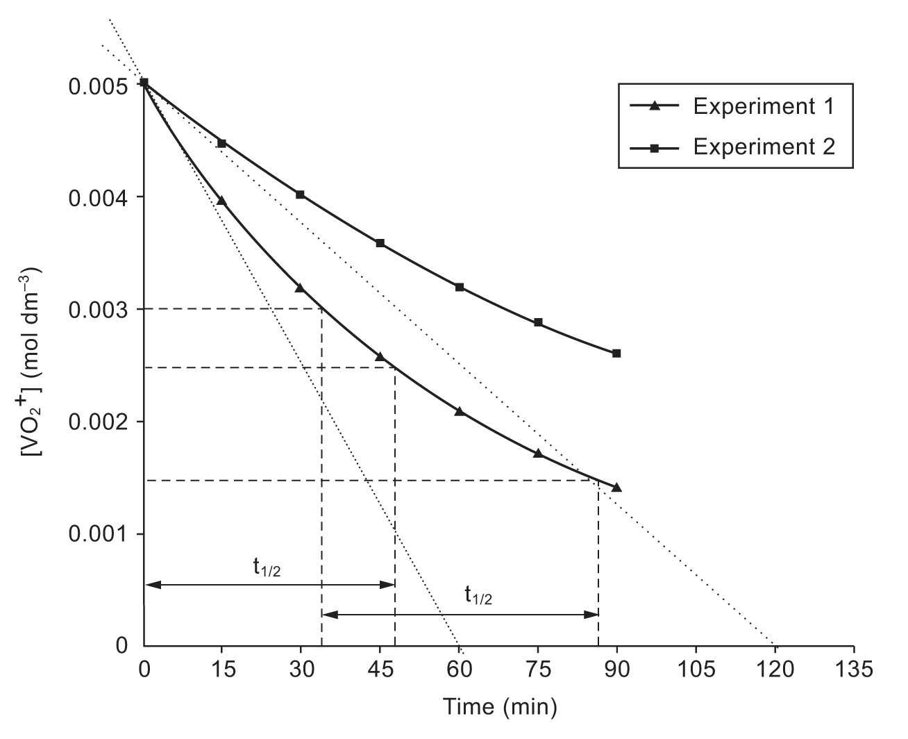
(iii) Using experiment 1,
from [VO₂⁺] = 0.005 mol dm⁻³ to 0.0025 mol dm⁻³,
$t_{\frac{1}{2}}$ = 50 s.
from [VO₂⁺] = 0.003 mol dm⁻³ to 0.0015 mol dm⁻³,
$t_{\frac{1}{2}}$ = 51 s.
Since the two $t_{\frac{1}{2}}$ are relatively constant, the reaction is first order with respect to VO₂⁺.
Initial rate for experiment 1 = $\frac{0\text{.}\text{005}}{\text{60}}$ = 8.33 × 10⁻⁵ mol dm⁻³ min⁻¹
Initial rate for experiment 2 = $\frac{0\text{.}\text{005}}{\text{120}}$ = 4.17 × 10⁻⁵ mol dm⁻³ min⁻¹
When [As₂O₃] is halved, the initial rate is also halved. The rate of reaction is first order with respect to As₂O₃.
Hence, the rate equation is Rate = k[VO₂⁺][ As₂O₃].
(iv) 8.33 × 10⁻⁵ = k × 0.10 × 0.0050
k = 0.167 (mol dm⁻³)⁻¹ min⁻¹

25. NO(g) + $\frac{1}{2}$O₂(g) ⎯→ NO₂(g)

(a) (i) Increase in pressure ⇒ increase in concentration of reactants (more molecules per unit volume) ⇒ frequency of molecular collisions increases ⇒ reaction rate increases.
- Increase in temperature ⇒ increase in average kinetic energy of molecules ⇒ the rate of collisions increases.
Moreover, the number of molecules with collision energies equal to or greater than activation energy increase greatly. Hence, the reaction rate increases.

(b) (i) R₁ = 2R₂
(ii) R₁ = R₃

(c)
(i) The reaction is first order with respect to O₂. This is because the reaction rate doubles when P_{O2} doubles (compared with A and B).
The reaction is second order with respect to NO. This is because the reaction rate quadruples when P_{NO} doubles (compared with B and C).
(ii) Rate = k(P_{O2})(P_{NO})²
(iii) Using results from A,
0.8 = k(0.7)(0.3)²
k = 12.7 atm^{–2} s^{–1}
(d) (i) $\frac{1}{2}$O₂(g) + SO₂(g) ⎯→ SO₃(g)
(ii) NO is a homogeneous catalyst in reaction. It is oxidized by O₂ to NO₂ (an intermediate compound), and then reduced by SO₂ back to NO, while SO₂ forms SO₃.

26. (a) (i) The reaction is first order with respect to O₂.
(ii) Overall order = 2
(iii) The reaction rate doubles.

(b) (i) Rate = k[Hb][O₂]
= (2.1 × 10⁶) × (8 × 10^{–6}) × (1.6 × 10^{–6})
= 2.69 × 10^{–5} mol dm^{–3} s^{–1}
(ii) Rate of formation of HbO₂ = Rate of consumption of O₂
= 2.69 × 10^{–5} mol dm^{–3} s^{–1}

(c) Number of moles of O₂ consumed per hour from 200 cm³ of blood
= (2.69 × 10^{–5}) × 60 × 60 × $\frac{1}{5}$
= 0.019 4 mol
Volume of O₂ = 0.019 4 × 25 dm³
= 0.484 dm³

(d) (i) Increasing the concentration of O₂ will increase the rate of formatio of oxyhaemoglobin. Other means of increasing the reaction rate, such as increasing body temperature or addition of catalysts, are unacceptable as these would affect other body functions.
(ii) 1.1 × 10^{–4} = (2.1 × 10⁶) × [O₂] × (8 × 10^{–6})
[O₂] = 6.55 × 10^{–6} mol dm^{–3}
(iii) Increase breathing rate

27. (a) (i) Unit of k: mol^{–2} dm⁶ s^{–1}
(ii) The rate of reaction would be also doubled if the concentration of O₂ was doubled while all other factors remain constant. It is because the reaction is first order with respect to O₂.
(iii) The rate of reaction would be decreased by a factor of 4 if the concentration of NO was halved and all other factors remain constant. It is because the reaction is second order with respect to NO.

(b) (i) Order of reaction = 1 + 2 = 3
∴ It is a third order reaction.
(ii) The collision theory states that reactant molecules must collide with each other in order to react. However, it is very difficult for the three molecules to collide together at the same time. This is why the reaction is unlikely to occur in a single step.

28. (a) The order of the reaction is one with respect to iodine.

(b) Rate = k [H₂][I₂]
1.5 × 10^{–5} mol dm^{–3} = k$(\frac{0\text{.}\text{10}\text{mol}}{0\text{.}5{\text{dm}}^{3}})$$(\frac{0\text{.}\text{10}\text{mol}}{0\text{.}5{\text{dm}}^{3}})$
k = 1.5 × 10^{–5} mol dm⁻³ $(\frac{0\text{.}{\text{5dm}}^{3}}{0\text{.}\text{10mol}})^{2}$
= 3.75 × 10^{–4} mol^{–1} dm³ s^{–1}
The value of k at 200°C is 3.75 × 10^{–4} with the unit of mol^{–1} dm³ s^{–1}.

29. (a)
Time (min) | 0 | 7 | 15 | 27 | 44 | 60
ln[Concentration] (mol dm^{–3}) | –2.52 | –2.73 | –2.92 | –3.19 | –3.58 | –3.91
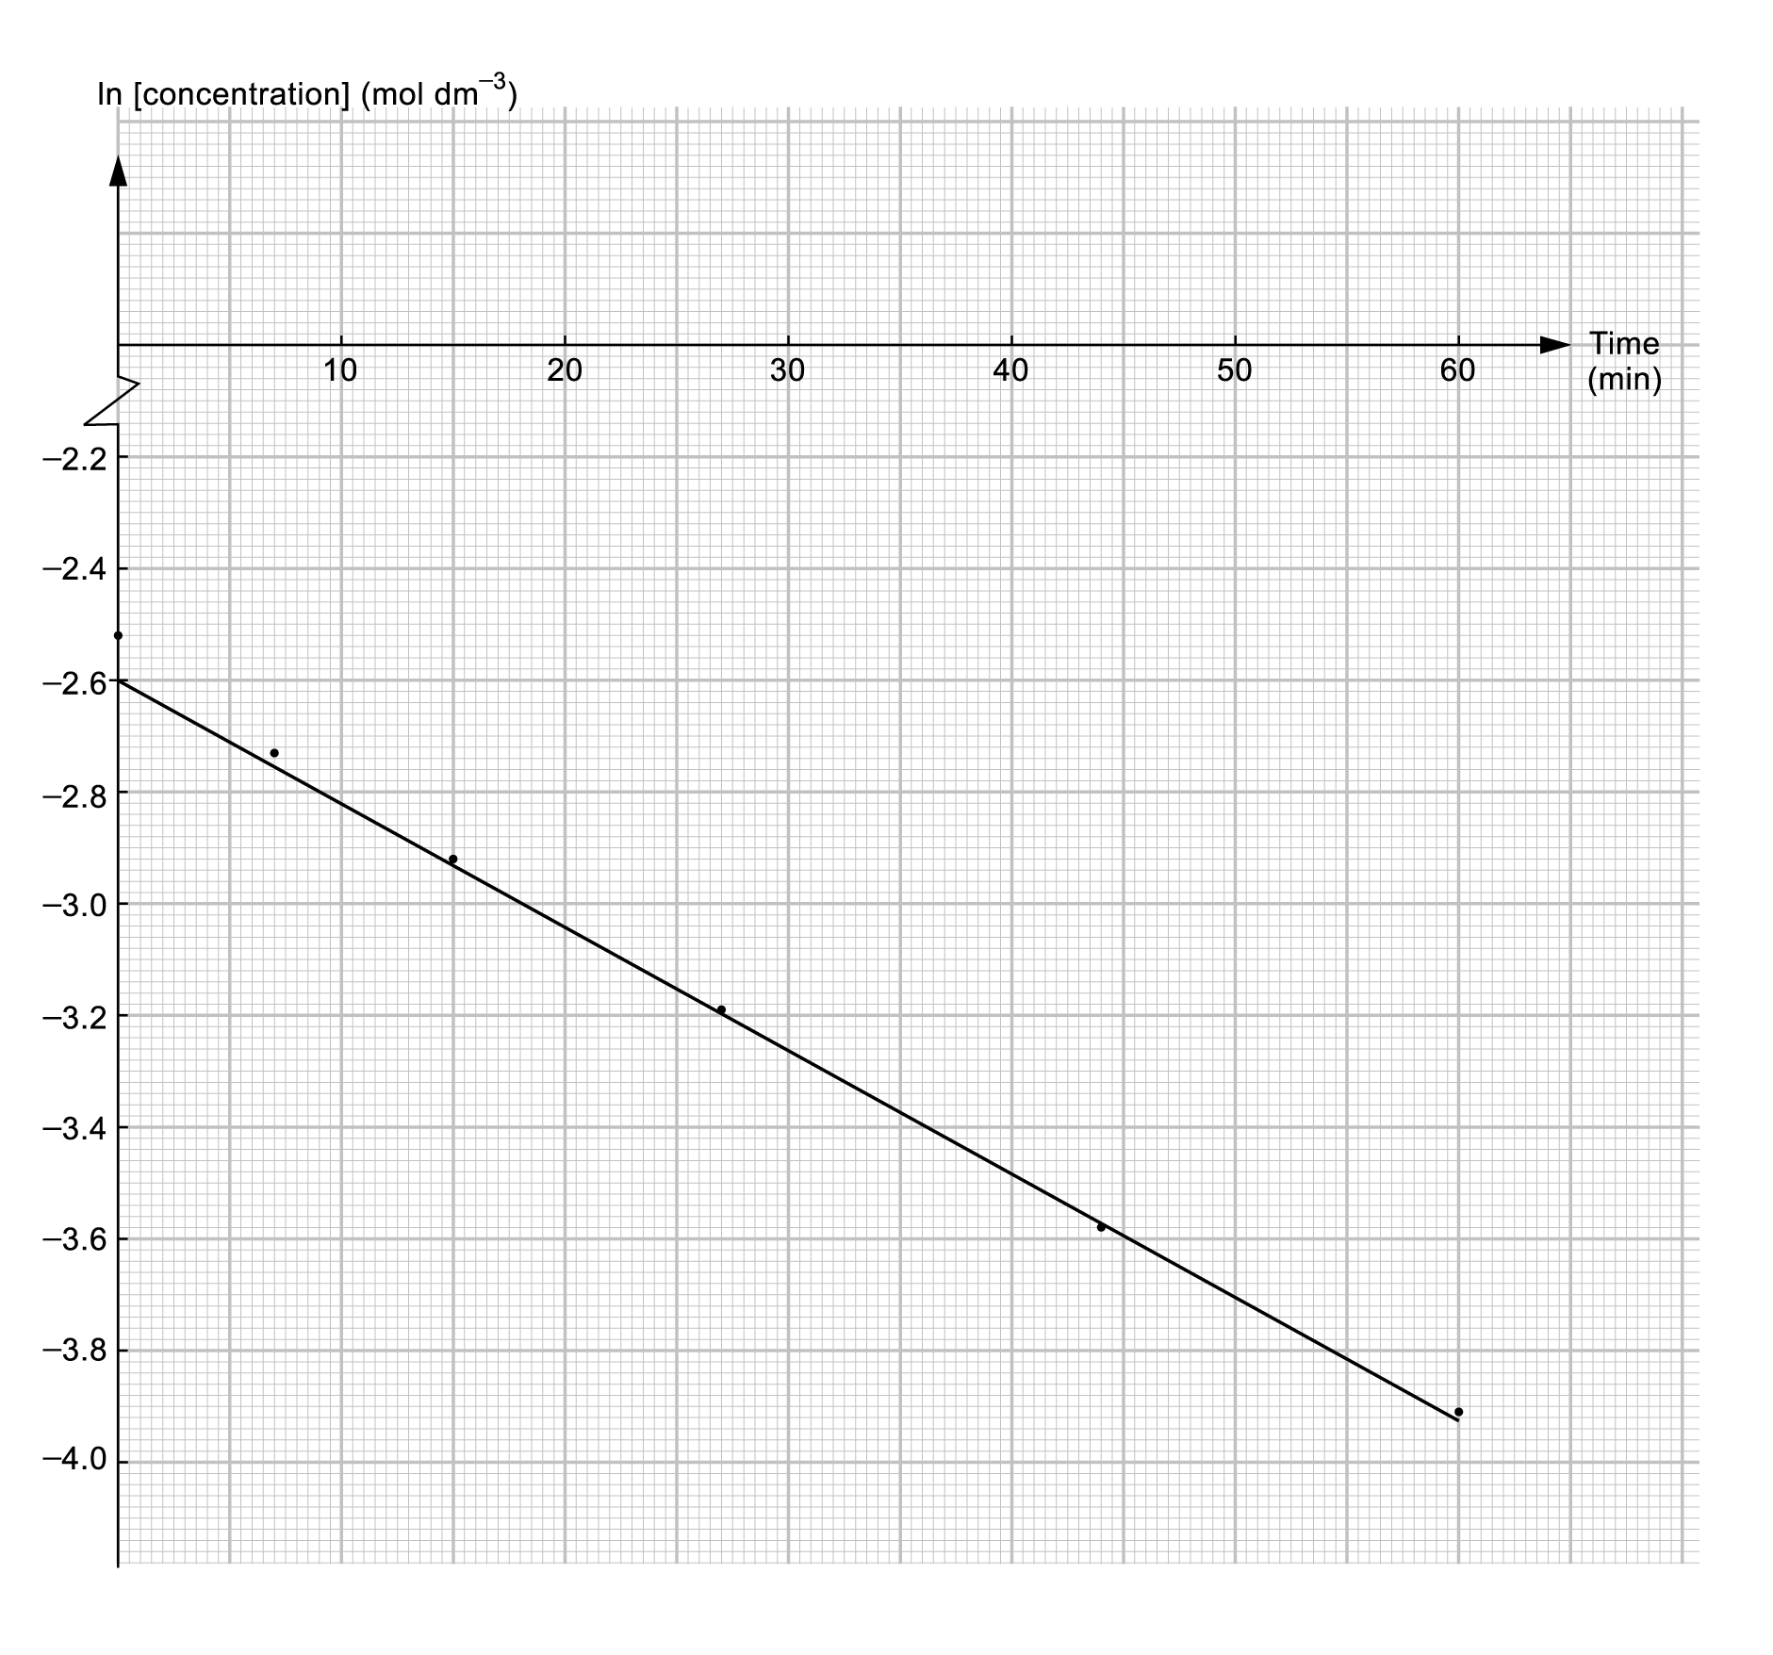

Since a straight line is obtained from the plot of ln[concentration] against time, the reaction is first order.

(b) By carrying out a serial of tests with different initial concentrations of sodium hydroxide (or halogenalkane) but same total volume of reaction mixture. Keeping the other reactant’s concentration constant. Then, measuring the initial rate of the reaction. Finally, plotting a graph of ln[NaOH] against time. For example, if the initial reaction rates are same for all the tests with different initial concentrations of NaOH. The rate law could be rate = k[halogenoalkane]. Otherwise, the rate law could be rate = k[OH–] if the tests show a first order trend.

30. (a) In fact, the rate equation of a reaction can only be determined experimentally. At a fixed temperature, the experimental observations of a reacting system have shown that the rate of the reaction varies with the concentrations of reactants. This means that the concentration of different reactants may affect the rate of the reaction differently.
Therefore, the rate equation cannot be written from the chemical equation.

(b) (i) First order
(ii) Zeroth order
(iii) First order

(c) Since the reaction is zeroth order with respect to iodine, the iodine plays no part in the rate-determining step of the reaction.

(d) rate = k[CH₃COCH₃] [H⁺]

31. (a) (i) & (ii)
Let the order of reaction with respect to ester be x,
the order of reaction with respect to sodium hydroxide by y.
rate = k[ester]^{x}[NaOH]^{y}
Comparing experiment (1) & (2),
6 × 10^{–4} = k[0.1]^{x}[1.0]^{y}
1.2 × 10^{–3} = k [0.1]^{x}[2.0]^{y}
y = 1
Comparing experiment (1) & (3),
6 × 10^{–4} = k[0.1]^{x}[1.0]
2.4 × 10^{–3} = k [0.2]^{x}[2.0]
$\frac{[0\text{.}1]^{x}}{[0\text{.}2]^{x}}$=$\frac{6\text{.}4×{\text{10}}^{−4}}{2\text{.}4×{\text{10}}^{−3}}$ × $\frac{[2\text{.}0]}{[1\text{.}0]}$
x = 1

(b) rate = k[ester][NaOH]
6 × 10^{–4} = k[0.1][1.0]
k = 6 × 10^{–3} mol^{–1} dm³ s^{–1}

