Part 3 Energetics (Book 1, p.182 – p.184)

10. (a) (i) Standard enthalpy change of formation of a compound is the enthalpy change when one mole of compound is formed from the reactants/constituent elements under standard conditions.
(ii) 2C(s) + 3H₂(g) ⎯→ C₂H₆(g)

 | (b) | 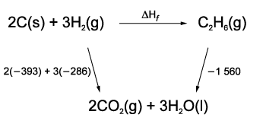

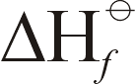 + (–1 560) = 2(–393) + 3(–286)
= –84 kJ mol⁻¹

Alternative method:
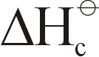(C₂H₆) = Σ (products) – Σ (reactants)
–1560 = [(2(–393) + 3(–286)) – [(C₂H₆)]
= –84 kJ mol⁻¹

11. (a) Standard enthalpy change of formation of a compound is the enthalpy change for making 1 mole of a compound from its constituent elements in their standard states (at 25°C and 1 atm).

(b)
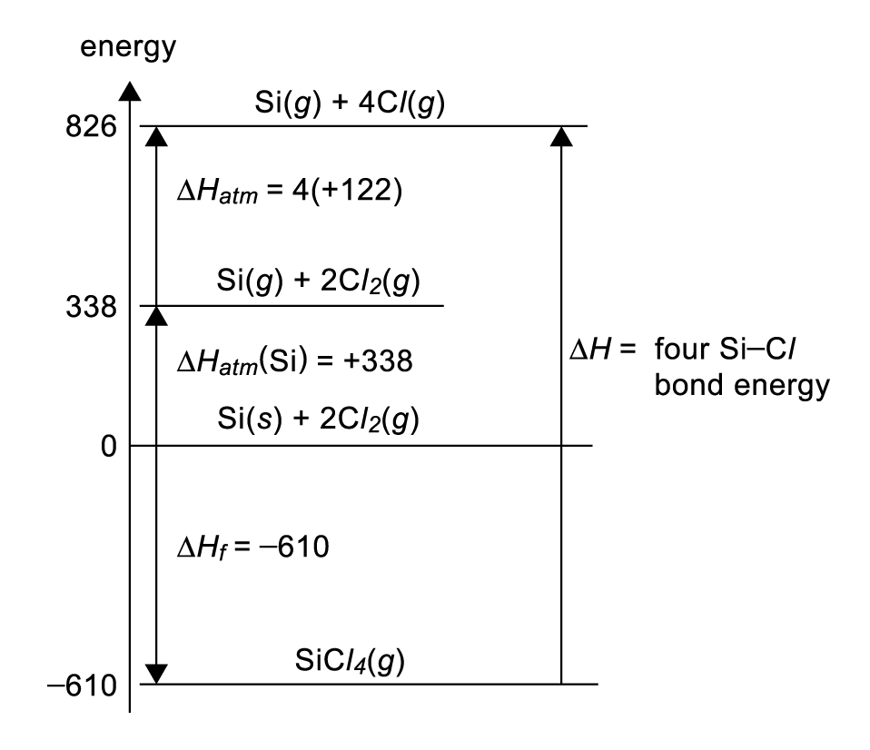

12. = ∑(product) – ∑(reactants)
= 8(–394) + 9(–286) – (–250) – 0
= –5476 kJ mol⁻¹

13. (a) Standard enthalpy change of formation, , of a compound is the enthalpy change when 1 mole of the compound is formed from its elements under standard conditions (at 25°C, 1 atm).

(b) 2H₂O(l) ⎯→ 2H₂(g) + O₂(g)
ΔH = ∑ (product) − ∑ (reactants)
= 0 – 2(−286) kJ mol⁻¹
= +572 kJ mol⁻¹

14. (a) (i) Due to the high temperature of the car engine, energy is provided for the high activation energy needed to break the strong N ≡ N and O = O and also favours the endothermic formation of nitrogen monoxide.
(ii) Reaction I is endothermic because strong N ≡ N and O = O bonds are needed to be broken and this is not compensated by the N = O bonds formed.

(b) (i) Standard enthalpy change of formation of a compound is the energy given out or taken in when one mole of that compound is formed from its elements in their normal states under standard conditions of 298 K and 1 atm.
(ii) N₂(g) +$\frac{5}{2}$O₂(g) ⎯→ N₂O₅(g)
 |  | (iii) | 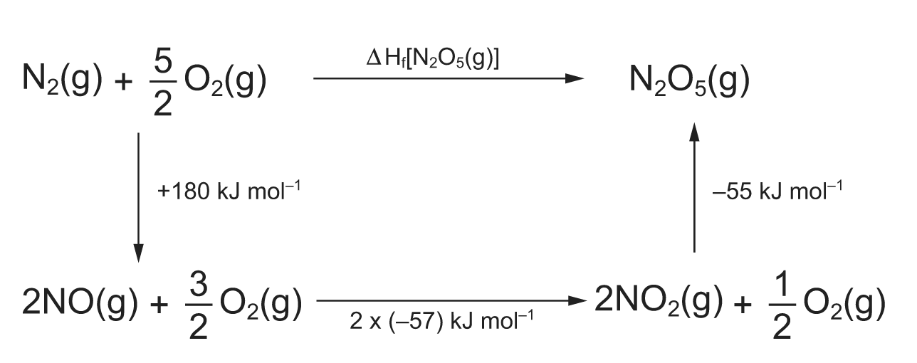
ΔH_{f} [N₂O₅(g)] = +180 + 2 × (−57) − 55
= +11 kJ mol⁻¹

15. (a) (i) CH₄(g) + 2O₂(g) ⎯→ CO₂(g) + 2H₂O(g) ΔH_{c} = −890 kJ mol⁻¹
1 mole of CH₄ produces 890 kJ of heat on combustion.
Number of moles of CH₄ required to produce 1000 kJ of heat =$\frac{\text{1000}}{\text{890}}$
= 1.124 mol
Volume of CH₄ at room temperature and pressure = 1.124 × 24.0 dm³
= 27.0 dm³
(ii) CO(g) + $\frac{1}{2}$O₂(g) ⎯→ CO₂(g) ΔH_{c} = −283 kJ mol⁻¹
H₂(g) + $\frac{1}{2}$O₂(g) ⎯→ H₂O(g) ΔH_{c} = −242 kJ mol⁻¹
1 mole of water gas contains $\frac{1}{2}$ mole of CO and $\frac{1}{2}$ mole of H₂.

Amount of heat energy produced by 1 mole of water gas
= $\frac{1}{2}$× (283) +$\frac{1}{2}$× (242) kJ
= 262.5 kJ
Number of moles of water gas needed to produce 1000 kJ of heat = $\frac{\text{1000}}{\text{262}\text{.}5}$
= 3.810 mol
Volume of water gas at room temperature and pressure = 3.810 × 24.0 dm³
= 91.4 dm³
(iii) One advantage of using natural gas is that it is more economical than water gas. By comparing the volumes of methane and water gas in (a)(i) and (ii), it can be seen that the volume of methane is about 3.3 times lower. Hence, the amount of natural gas required to produce the same amount of heat energy is much lower than that of water gas. Also, natural gas is found naturally in some areas and does not reach much processing to be used while water gas needed to be produced by reacting steam with hot coke. Hence, the production of natural gas is expected to be less expensive than water gas.
Another advantage of natural gas is safety. Water gas contains potentially explosive hydrogen gas and toxic carbon monoxide. Carbon monoxide combines with haemoglobin in the blood strongly and inhibits respiration. The problem is worsened by the fact that it is colourless and odourless. Natural gas on the other hand is less toxic and less potentially explosive.

 | (b) | 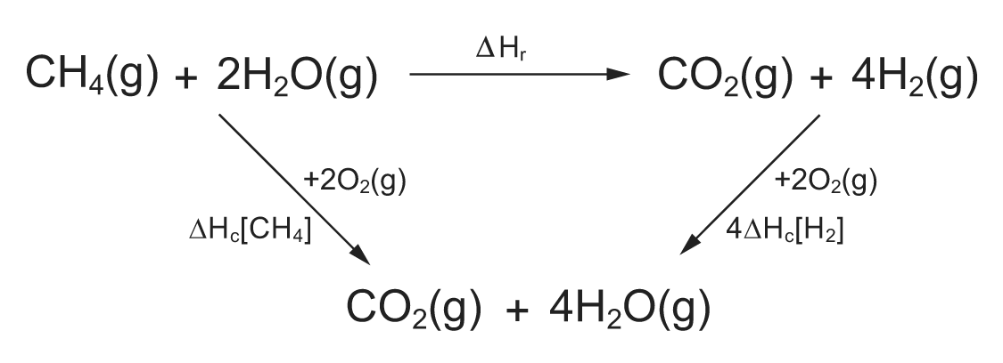
By Hess’s Law,
ΔH_{r} = ΔH_{c}[CH₄] − 4ΔH_{c}[H₂]
= −890 − 4(−242) kJ mol⁻¹
= +78 kJ mol⁻¹

16. | (a) | 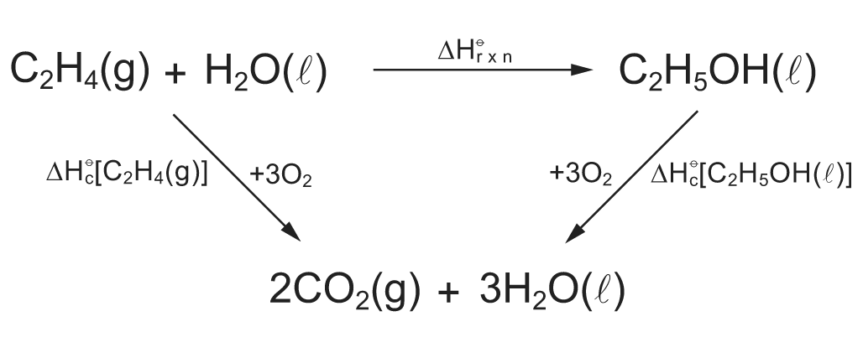
By Hess’s Law,
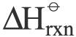 = [C₂H₄(g)] − [C₂H₅OH(l)]
= −1411 − (−1367) kJ mol⁻¹
= −44 kJ mol⁻¹

(b) (i) Standard enthalpy change of combustion is the enthalpy change when one mole of a substance is completely burnt in oxygen at 298 K and 1 atm.
(ii) To apply Hess’s Law to make use of the standard enthalpy changes of combustion given, the initial and final states of the system need to be under standard conditions. Under standard conditions of 298 K and 1 atm, both water and ethanol exist as liquids. Therefore, the state symbols of water and ethanol in (a) have been changed to liquid.
(iii) C₂H₅OH(l) + 3O₂(g) ⎯→ 2CO₂(g) + 3H₂O(l)

17. (a) ΔH = [Mg²⁺(aq)] + 2 [Cl⁻(aq)] − [MgCl₂(s)]
= (−467) + 2(−167) − (−641) kJ mol⁻¹
= −160 kJ mol⁻¹

(b) Since the dissolution of MgCl₂(s) is exothermic, the process is energetically favourable.

18. (a) Standard enthalpy change of neutralization is the heat evolved when 1 mole of water is formed when an acid reacts with a base under standard conditions.

(b) Number of moles of NaHCO₃(aq) = 1.0 × $\frac{\text{40}}{\text{1000}}$
= 0.0400 mol
Number of moles of HCl(aq) = 1.0 × $\frac{\text{40}}{\text{1000}}$
= 0.0400 mol
The same amount of NaHCO₃ and HCl were used.
Number of moles of H₂O(l) = 0.04 mol
Q = 4.2 × (40 + 40) × 0.5 = 168 J absorbed
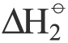 = +$\frac{\text{168}}{0\text{.}\text{04}}$ = +4200 J mol⁻¹ or +4.2 kJ mol⁻¹

(c) (i) = (products) − (reactants)
= [(−285.8) + (−393.5)] − (−692)
= +12.7 kJ mol⁻¹
(ii) Heat absorbed from the surrounding. Otherwise, the temperature drop could be more.

(d) (i) = (H₂O) + (CO₂) − (CO₃²⁻) − 2 × (H⁺)
−2.3 = (−285.8) + (−393.5) − (CO₃²⁻)
(CO₃²⁻) = −677 kJ mol⁻¹
(ii) ΔH = (CO₃²⁻) + (H₂O) + (CO₂) − 2 × (HCO₃⁻)
= (−677) + (−285.8) + (−393.5) − 2 × (−692)
= +27.7 kJ mol⁻¹
Heating will facilitate the decomposition of HCO₃⁻ into CO₃²⁻ and CO₂ since the reaction is endothermic. According to Le Chatelier’s Principle, the equilibrium will shift to the right when heat is supplied so as to remove the “excess” heat.

19. (a) (i) At 500 K: C(s) + O₂(g) ⎯→ CO₂(g)
At 2000 K: 2C(s) + O₂(g) ⎯→ 2CO(g)
In the above two cases, the 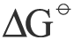 are more negative and hence the reactions take place more readily.
(ii) When the temperature increases, the degree of disorder increases for both sides of the reaction. It is because the gaseous molecules become more energetic and move more randomly and at higher velocities. However, there are more gaseous molecules in the products than there are in the reactants. Hence, a greater disorder is achieved on the product side of the reaction. Hence, the reaction is favoured to the right and becomes more negative.
In reaction 1, there are equal numbers of gaseous molecules on both sides of the equation. The increase in disorder due to an increase in temperature is similar on both sides. Hence, is almost similar.

(b) (i) 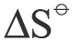 = −$\frac{−\text{560}−(−\text{890})}{\text{2000}−\text{300}}$ = −0.194 kJ mol⁻¹ K⁻¹
(ii) TiO₂(s) + 2C(s) ⎯→ Ti(s) + 2CO(g)
This reaction can take place at temperature higher than about 1950 K where would be negative.
(iii) At about 1950 K, the is only slightly negative. For the reaction to proceed well, a temperature higher than 1950 K is necessary. Such a high temperature would add cost to the production as a lot of energy is required to maintain the high temperature.

