Part 1 Atoms, Molecules and Stoichiometry (Book 1, P. 75 – P. 78)

11. (a) Possible answers are as follows:
m/e Ion

(b) ICl₃
Oxidation number of I = +3
M_{r} of ICl₃ = 127 + 3(35.5) = 233.5
% by mass of I = $\frac{\text{127}}{\text{233}\text{.}5}$ × 100 = 54.4%

(c) (i) ICl₃ + 3I－ ⎯→ 2I₂ + 3Cl－
(ii) 2 mol S₂O₃^{2–} = 1 mol I₂
2 mol I₂ = 1 mol ICl₃
⇒ 4 mol S₂O₃^{2–} = 1 mol ICl₃
$\frac{v×1}{\frac{1}{\text{233}\text{.}5}}$ = (where v = volume of S₂O₃^{2–} in dm³)
v = 0.017 1 dm³ = 17.1 cm³

12. (a)
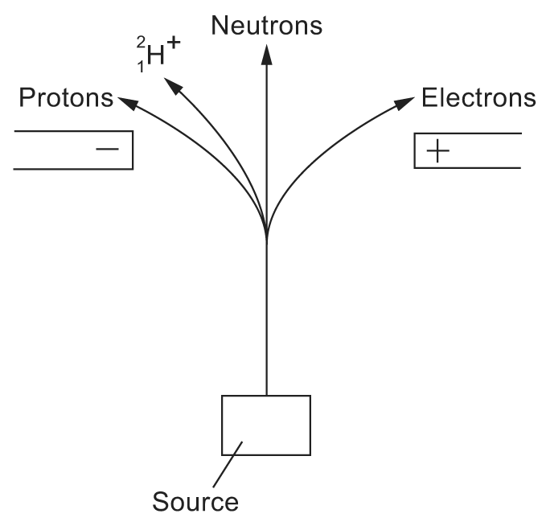

(b) (i) Protons, being positively charged, is deflected towards the negative potential.

(ii) Electrons, being negatively charged, is deflected towards the positive potential. However, being lighter than protons, the electron beam is deflected to a greater extent.

(iii) ${}_{1}^{2}{}H^{+}$, being positively charged, is deflected towards the negative potential. However, carrying the same charge as a proton but being heavier, the deflection is smaller.

13. (a) (i) A – PCl⁺
B – PCl₂⁺
C – PCl₃⁺

(ii) A : intensity of 66 to 88 = 3 : 1
B : intensity of 101 to 103 to 105 = 9 : 6 : 1
C : intensity of 136 to 138 to 140 to 142 = 27 : 27 : 9 : 1

(b) (i) I = CH₂O II = C₂H₆
III = C₃H₆O₂ IV = C₄H₁₀O

I, III : There is only one oxygen atom. With no oxygen atom, there will be too many H atoms.
II : With 2 C atoms, there cannot be any oxygen atoms.
IV : With 4 C atoms, there cannot be any oxygen atoms.
In both II and IV, the presence of an oxygen atom makes the m/e value greater than 30 and 74 respectively.

(ii) I has a higher boiling point. With an oxygen atom, the molecule is likely to be polar while II is a non–polar hydrocarbon. The intermolecular forces between molecules of I are stronger.

14. Number of moles of BaSO₄ = $\frac{2\text{.}\text{047}}{\text{233}\text{.}4}$ = 0.008 77 mol
∴ Number of moles of Al₂(SO₄)₃ = (0.008 77) mol
Mass of Al₂(SO₄)₃ = (0.008 77) × 342.3
= 1.00 g
% = $\frac{1\text{.}\text{00}}{5\text{.}\text{000}}$ × 100 = 20.0%

15. (a) C H O
% by mass 40.0 6.7 53.3
Relative atomic mass 12 1 16
Molar ratio $\frac{\text{40}\text{.}0}{\text{12}}$ : $\frac{6\text{.}7}{1}$ : $\frac{\text{53}\text{.}3}{\text{16}}$
= 3.33 : 6.7 : 3.33
= 1 : 2 : 1

Hence, the empirical formula of the acid is CH₂O.
From the mass spectrum, relative molecular mass = 60.
Let the molecular formula of the acid be (CH₂O)_{n}.
n[12 + 2 × 1 + 16] = 60
n = 2
Hence, the empirical formula of the acid is C₂H₄O₂ or CH₃CO₂H.

(b) m/e Ions
60 CH₃CO₂H⁺
45 CO₂H⁺
43 CH₃CO⁺
15 CH₃⁺

16. (a) (i) Volume = $\frac{0\text{.}\text{05}}{\text{100}}$× 1.0 = 5 × 10^{–4} dm³
Amount = $\frac{5×{\text{10}}^{−4}}{\text{39}}$= 1.28 × 10^{–5} mol

(ii) Volume = $\frac{2\text{.}0+\text{11}\text{.}3}{\text{100}}$× 1.0 = 0.133 dm³
Amount = $\frac{0\text{.}\text{133}}{\text{39}}$= 3.41 × 10^{–3} mol

(iii) Amount of carbon = 3.41 × 10^{–3} mol
Amount of C₈H₁₈ burnt = $\frac{1}{8}$× 3.41 × 10^{–3} = 4.26 × 10^{–4} mol

(iv) Percentage of C₈H₁₈ that remain unburnt
= $\frac{1\text{.}\text{28}×{\text{10}}^{−5}}{1\text{.}\text{28}×{\text{10}}^{−5}+4\text{.}\text{26}×{\text{10}}^{−4}}$× 100% = 2.92%

(v) When the concentrations of O₂ and hydrocarbon are low, mixing becomes poor and rate of combustion becomes slow. The reaction is thus incomplete.

(b) Carbon monoxide is harmful to human beings and carbon dioxide causes global warming (greenhouse effect).

17. (a)
 | Mass | Charge
(i) Neutron | 1 | 0
(ii) Electron | $$\frac{1}{\text{1850}}$$ | –1
(iii) α –particle | 4 | +2

(b) Number of protons = 18 – 3 = 15
Number of neutrons = 31 – 15 = 16

(c) The chemical properties are determined by the electronic configuration, and mainly the valence shell electrons of the atoms. Isotopes have the same electronic configuration and hence identical chemical reactions.

18. NH₃(aq) + HCl(aq) －→ NH₄⁺(aq) + Cl－(aq)
$n_{{\text{NH}}_{3}}$= $n_{\text{HCl}}$= 0.100 × $\frac{\text{10}\text{.}4}{\text{1000}}$= 1.04 × 10^{–3} mol
∴ Amount of NH₄⁺ in 1.00 g of sample = 2 × 1.04 × 10^{–3}
= 2.08 × 10^{–3} mol
$n_{{\text{Fe}}^{3+}}$= $n_{{\text{Fe}}^{2+}}$= 5．$n_{{\text{MnO}}_{4^{−}}}$ = 5 × 0.0100 × $\frac{\text{20}\text{.}8}{\text{1000}}$= 1.04 × 10^{–3}

19. Volume in the greenhouse = 2 × 3 × 4 m³ = 24 000 dm³
Number of moles of gaseous molecules to occupy this volume = $\frac{\text{24000}}{\text{24}}$ = 1 000
Number of moles of SO₂ to give a concentration of 50 ppm = 50 × 10^{–6} × 1 000 = 0.05
Number of moles of S needed = Number of moles of SO₂ = 0.05
Mass of S needed = 0.05 × 32.1 = 1.605 g

20. (a) 2H₂S(g) + 3O₂(g) －→ 2H₂O(g) + 2SO₂(g)
CS₂(g) + 3O₂(g) －→ CO₂(g) + 2SO₂(g)

(b) Let number of moles of CS₂ be y.
Number of moles of H₂S = 5y
Number of moles of SO₂ formed from H₂S = 5y
Number of moles of SO₂ formed from CS₂ = 2y
Number of moles of CO₂ formed from CS₂ = y
Hence ratio of SO₂ to CO₂ = (5y + 2y) : y = 7 : 1

(c) SO₃^{2–} and CO₃^{2–}

21. (a) Isotopes are atoms of the same element containing the same number of protons but different number of neutrons. Hence they have the same proton number but different nucleon number.

(b) (i) Average relative atomic mass
= $\frac{2\text{.}4}{\text{100}}$× 80 + $\frac{\text{11}\text{.}7}{\text{100}}$ × 82 + $\frac{\text{11}\text{.}6}{\text{100}}$ × 83 + $\frac{\text{56}\text{.}9}{\text{100}}$× 84 + $\frac{\text{17}\text{.}4}{\text{100}}$× 86 = 83.9

(ii) For the atom with nucleon number 83:
Number of electrons = 36, number of protons = 36 and number of neutrons = 47
For the atom with nucleon number 86:
Number of electrons = 36, number of protons = 36 and number of neutrons = 50

(c) Assuming ideal behaviour, pV = nRT, where n is the number of moles of Kr present.
n = $\frac{\text{pV}}{\text{RT}}$= $\frac{1\text{.}\text{00}×{\text{10}}^{5}×1\text{.}\text{00}×{\text{10}}^{−3}}{8\text{.}\text{31}×\text{300}}$=0.040 11
Relative atomic mass of Kr in this sample = $\frac{\text{Mass}}{\text{No}\text{.}\text{ of moles}}$=$\frac{3\text{.}\text{32}}{0\text{.}\text{04011}}$= 82.8
It is not likely to have the same isotopic composition as the sample in (c) since the relative atomic masses of the two samples are significantly different.

22. (a) 2Na₂O₂(s) + 2CO₂(g) －→ 2Na₂CO₃(s) + O₂(g)

(b) Assuming room temperature and pressure conditions,
Volume of CO₂ exhaled by the eight submariners = 600 × 8 dm³ = 4 800 dm³
Number of moles of CO₂ = 4 800 ÷ 24 = 200
Number of moles of Na₂O₂ needed to absorb CO₂ = number of moles of CO₂ = 200
Molar mass of Na₂O₂ = 23.0 × 2 + 16.0 × 2 g mol^{–1} = 78 g mol^{–1}
Mass of Na₂O₂ = 200 × 78 g = 15 600 g = 15.6 kg

23. (a) (i) Relative atomic mass = 0.65 × 69 + 0.35 × 71 = 69.7

(ii) Relative atomic mass of an element is the average mass of an atom of the element relative to $\frac{1}{\text{12}}$the mass of a ¹²C atom.

(b) (i) 2Ga + N₂ －→ 2GaN

(ii) $n_{\text{Ga}}$ = $\frac{\text{10}\text{.}0×{\text{10}}^{3}}{\text{69}\text{.}7}$mol
$n_{N_{2}}$ = $\frac{1}{2}$$n_{\text{Ga}}$
$V_{N_{2}}$ = $n_{N_{2}}$× 24.0
= $\frac{1}{2}$×$\frac{\text{10}\text{.}0×{\text{10}}^{3}}{\text{69}\text{.}7}$× 24.0
= 1 722 dm³

