Part 15 Chemistry and Society (Book 4, p. 327 – p.331)

20. (a) BaO(s) + H₂O(l) → Ba(OH)₂ (s)
Both MgO and BaO are ionic oxides.
BaO is soluble in water. Larger Ba²⁺ ion results in smaller lattice energy than MgO.
SO₂(g) + H₂O(l)  H₂SO₃(aq)
sulphuric(IV) acid
SO₂ is a covalent compound which can dissolves in water to form an acid.
(b) (i) SO₂ is a reducing agent. It reacts with oxygen and so prevents oxidation of food and drinks. It also inhibits bacterial growth by providing an acidic medium unfavourable for microbes.
(ii) Sources of sulphur dioxide:
1. Burning of fossil fuels (coal and oil)
2. Roasting of metal-ores (sulphides)
The presence of SO₂ in the atomsphere will lead to the formation of acid rain. It also causes respiratory problems.
The emission of SO₂ can be controlled by:
1. Limitation of sulphur content in fuels
2. Desulphurization of flue gas

21. (a) (i)
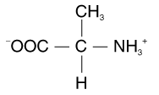
(ii)
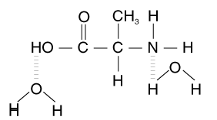
(b) Step A: NaBr and conc. H₂SO₄, reflux
Step B: alcoholic NH₃, heat

22. (a) 6
(b) (i)
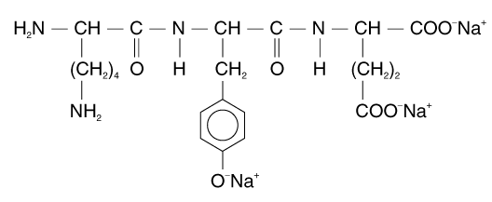
(ii)
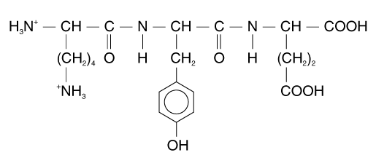
(c) Add universal indicator.
Aq. B has the highest pH, turns indicator blue.
Aq. D has the lowest pH, turns indicator red.
Aq. C has a pH between that of B and D.

23. (a) (i)
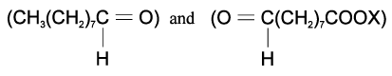
(ii) Add 2,4-dinitrophenylhydrazine
Orange precipitate ⇒ aldehyde or ketone.
(iii) Warm with Tollen’s reagent.
Silver mirror forms ⇒ aldehyde present
(b)
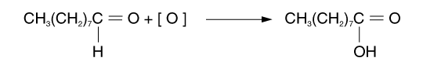
(c) SO₂ is a reducing agent
It prevents oxidation of food and inhibits the bacterial growth.
(d) (i) Aluminium foil
(ii) Nitrogen gas

24. (a) (i) Covalent
(ii) Tetrahedral
(b) Lead and butane
(c) Pb(C₂H₅)₄ + 14O₂ → PbO₂ + 8CO₂ + 10H₂O
(d) (i) PbO₂(s)
(ii) PbBr₂
(iii) PbBr₂ is volatile and discharged into atmosphere. It will poison the catalyst in the catalytic converter. Also lead is toxic, it will cause anaemia and brain damage.
(e) Mass of Pb = 1.0 × 10¹² × $\frac{\text{207}}{\text{323}}×0\text{.}6$= 3.85 × 10¹¹g
= 3.85 × 10⁸ kg

25. (a) Coal (a fossil fuel).
(b) (i) SO₂(g) + H₂O(l) → H₂SO₄(aq)
(ii) H₂SO₃ + CaCO₃ → CaSO₃ + H₂O + CO₂
(c) (i) 2SO₂ + O₂ + 2Mg(OH)₂ → 2MgSO₄ + 2H₂O
(ii) MgSO₄ is soluble in water while CaSO₄ is only sparingly soluble in water.
ΔH_{soln} = ΔH_{hyd} − ΔH_{lattice}
The lattice energy of both MgSO₄ and CaSO₄ is about the same, but ΔH_{hyd} of MgSO₄ is more exothermic because Mg²⁺ ions are smaller in size. Thus, ΔH_{soln} of MgSO₄ is more exothermic and this accounts for its solubility in water.

26. (a) MSG shows optical isomerism. The carbon atom bonded to NH₂ is chiral which is responsible for it.

(b) (i)
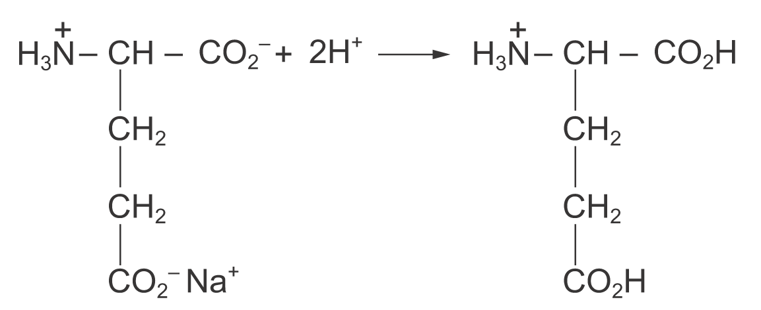
(ii)
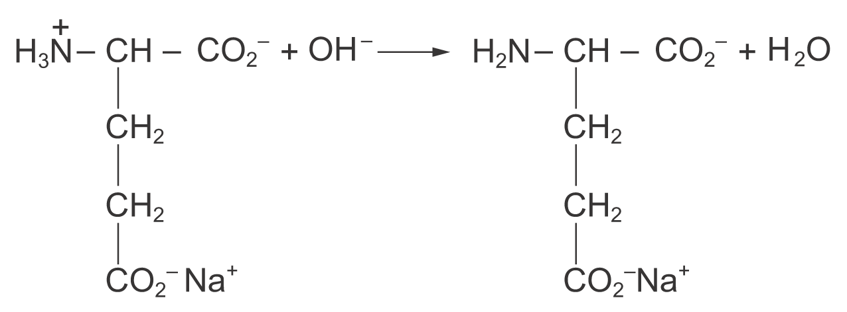
(c) Concentration of MSG = 1.0g dm^{－3}
Mass of MSG in 300 cm³ = $\left(\frac{\text{300}}{\text{1000}}×1\text{.}0\right)$g
= 0.300 g
Molar mass of MSG = 14 + 5 × 12 + 8 × 1 + 23 + 4 × 16
= 169
∴ No. of mole of MSG in 300 cm³ = $\frac{0\text{.}\text{300}}{\text{169}}$
=1.78 × 10^{－3}
(d) An aqueous solution of glutamic acid is likely to have a pH of 5.
(e)
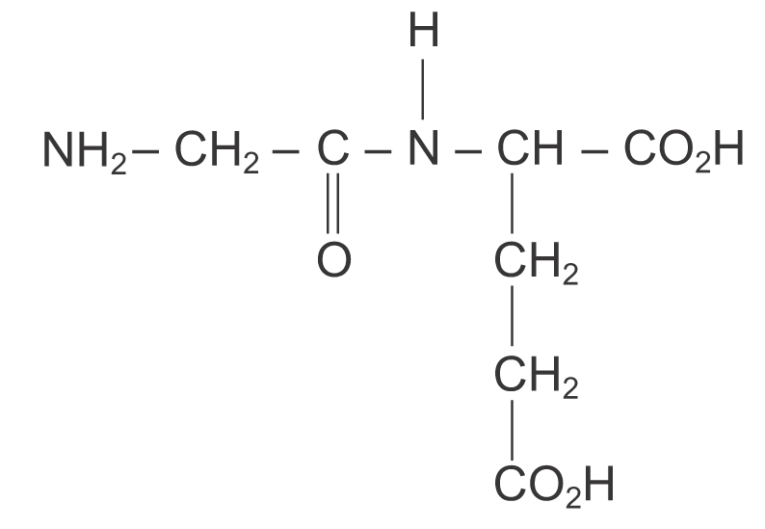
(f) reagents: dilute hydrochloric acid
conditions: heating under reflux

27. (a) (i) Nitrogen monoxide, NO, is formed by the reaction between N₂ and O₂ from the air combining
in the hot carengine, which provides the necessary energy for the endothermic reaction.
(ii) The presence of nitrogen oxides in air is polluting because it would cause acid rain.
It would also lead to the formation of photochemical smog.
(b) 2NO₂ + H₂O → HNO₃ + HNO₂
3NO₂ + H₂O → 2HNO₃ + NO
28. (a) C H Cl
% 66.4 5.5 28.1
No. of moles 5.53 5.5 0.792
Ratio 7 7 1
∴ The empirical formula is C₇H₇Cl.
The relative molecular mass is 126.5
(C₇H₇Cl)_{n} = 126.5
(12 × 7 + 1 × 7 + 35.5)_{n} = 126.5
n = 1
∴ The molecular formulae of X and Y are C₇H₇Cl.

(b) (i) Cl in compound X can be hydrolysed to give Cl⁻. The Cl⁻ ions bonded to Ag⁺ ions to form white precipitate.
Cl in coumpund Y is bonded to the benzene ring () and cannot be hydrolysed under ordinary conditions.
(ii) X: (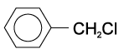) Y: (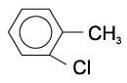)

(c) Toxic to marine life on entry into rivers and lakes because they are non-biodegradable.

(d)
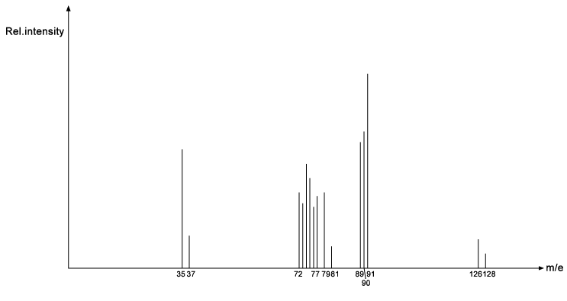
Mass spectrum of X has lines at m/e =79 due to CH₂³⁵Cl⁺ and 81 due to CH₂³⁷Cl⁺ which are absent from spectrum of Y. Lines at m/e = 15 (CH₃⁺), 92 (C₆H₅CH₃⁺), 112 (C₆H₅³⁵Cl⁺), 114 (C₆H₅³⁷Cl⁺) are present in spectrum of Y but absent from X.
29. (a) (i) Ether, alkene, ester

(ii) Add aqueous bromine in 1,1,1-trichloroethane at room temperature under dark condition.
If A is unsaturated, the solution will decolorize..
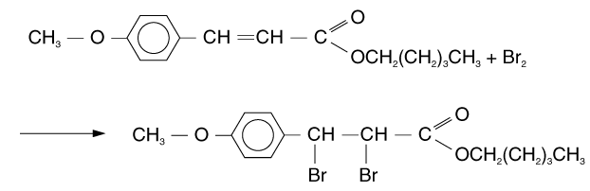

 | (b) | (i) | 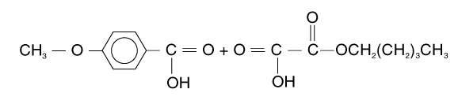
 |  | (ii) | 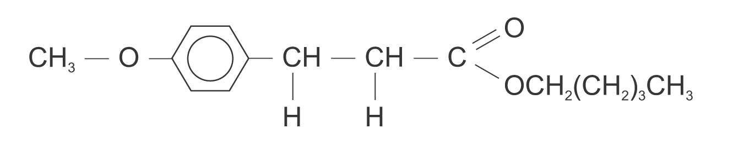
 |  | (iii) | 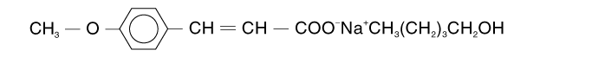

 | (c) | 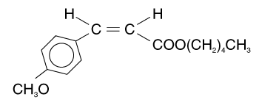  cis | 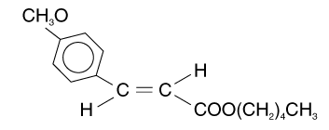  trans

Geometrical isomerism. Geometrical isomerism occurs when compounds have different arrangements of their atoms in space due to restricted rotation of covalent bond.

(d) Ozone depletion by CFCs.
Ozone layer in stratosphere absorbs 99% ultraviolet radiation which is harmful to us. However, during the past few decades the ozone layer has been getting thinner and thinner. This is due to the release of CFCs into atmosphere. CFCs are unreactive. They have a very long lifetime in atmosphere, such as 75 years for CCl₃F. When CFCs reach the stratosphere, they dissociate and release Cl·by absorbing ultraviolet radiation. The Cl·will react with ozone molecules to form O₂. This reaction is much faster than natural depletion of ozone molecules. So the concentration of ozone decreases. The effectiveness of absorbing harmful ultraviolet radiation by ozone decrease, so the use of sun-screen creams increase.

30. (a) (i) Incomplete combustion of petrol in car engine.

(ii) N₂(g) + O₂(g) → 2NO(g)
2NO(g) + O₂(g) → 2NO₂(g)
- Nitrogen gas is a non-polar diatomic molecule. Two nitrogen atoms are held together by very
strong triple covalent bonds. The bond enthalpy of the triple covalent bonds in nitrogen is
944 kJ mol^{－1}, which is extremely high. So the reaction with nitrogen gas requires high temperature to break the bonds.
(b) (i) A catalyst works by providing an alternative pathway for the reaction. Positive catalyst provides a pathway with lower activation energy. So the rate of reaction is increase.
(ii) To increase surface area
(iii) Lead compounds in petrol poisons the catalyst and renders it ineffective.
(iv) Increase rate of reaction.
i.e. reduction of NO and oxidation of CO and unburned hydrocarbons

(c) Increase air supply and contact time in combustion engine so that more complete combustion can occur.
Use of petrol additives to reduce incomplete combustion.

31. (a) (i) 8 tonnes Cu ≡ 16 tonnes SO₂
1 tonne Cu ≡ 2 tonnes SO₂
∴One tonne of copper can produce two tonnes of SO₂.

(ii) Mass of Cu in 200,000 tonnes of rock = × 200 000 tonnes = 1 000 tonnes
Mass of SO₂ formed = 2 × 1 000 tonnes = 2 000 tonnes
Vol. of air contaminated = $\frac{2\text{000}}{3\text{.}7 × {\text{10}}^{−\text{10}}}$ m³ = 5.41 × 10¹² m³
(b) To use up SO₂ to reduce its emission into the atmosphere. Treat exhaust gas by scrubbing with wet limestone-gypsum (e.g. absorbing SO₂ with CaCO₃).

32. (a) (i) To filter off harmful UV radiation from the Sun.

(ii) Ozone causes eye irritation and respiratory problems. Ozone will cause formation of photochemical smog.

(b) (i) By reaction of O₂ gas with oxygen free radicals (formed from different reaction)
O₂(g) $\vec{O}$ O₃(g)
In troposphere, many human activities produce oxygen free radical. For example:
1. Emission from car engines produces intorgen oxides and unburnt hydrocarbons, which react in sunlight to give oxygen free radicals.
2. Electric sparks in car engines, motors and photocopiers also produce free radicals of oxygen from O₂ gas.

In stratosphere, atmospheric oxygen absorbs UV light to form oxygen free radicals,
independent of human activities.
(ii) Chemical reaction is catalysed by light.
e.g. O₂ absorbs UV light to form oxygen free radicals.
O₂ + hν→ O· + O·
When the oxygen molecule absorbs ultraviolet radiation, it undergoes hemolytic dissociation to form 2 oxygen radicals. As this reaction is initiated by ultraviolet radiation, it is called ‘ photochemical reaction’.

(c) (i) They form Cl· easily by absorbing UV light. Chain reaction results in depletion of O₃.
Cl· + O₃ → ClO· + O₂
ClO· + O → Cl· + O₂

(ii) NO_{X} — from car emissions
CFCs — from aerosol sprays, refrigerants

