Part 14 The d-Block Elements (Book 4, p. 212 – p.218)

22. (a) (i) Cr³⁺: 1s²2s²2p⁶3s²3p⁶3d³4s⁰
(ii) d-d transitions is possible in Cr³⁺because of splitting of d-orbitals into two groups of orbitals with slightly different energy levels. It is found that the energy required for the d-d transitions falls within the visible light spectrum.
(b) (i) Cr⁶⁺ does not exist because the ionization energy required to remove six electrons is too great. Instead a covalent ion formed by sharing of electrons is formed.
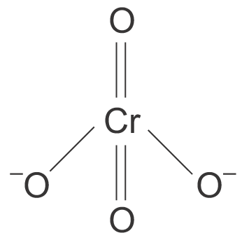
(ii) 2 CrO₄^{2－} + 2H⁺ 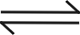 Cr₂O₇^{2－} + H₂O

23. (a) MnO₄－(aq) purple Mn²⁺(aq) light pink
Cr₂O₇^{2－}(aq) orange Cr³⁺(aq) green
(b) (i) MnO₄ + 8H⁺ + 5Fe²⁺ → Mn²⁺ + 5Fe³⁺ + 4H₂O
(ii) Cr₂O₇^{2－} + 14H⁺ + 6Fe²⁺ → 2 Cr³⁺ + 6Fe³⁺ + 7H₂O
(c) No indicator is required in MnO₄－ and Fe²⁺ titration (at equivalence point, one drop of MnO₄－ in excess turns the solution pink).
An indicator required for Cr₂O₇^{2－} titration as end point is not clear.
(d) (i) No. of mole of Fe²⁺ = (4.0 × 10^{－4}) × 5 × 10 = 0.02 mol
(ii) %Fe = $\frac{0\text{.}\text{02}×\text{55}\text{.}6}{1\text{.}\text{40}}×\text{100}$%= 79.4%

24. Four characteristic properties are:
1. Chromium and iron have high densities (i.e. hard and dense metals) while magnesium and aluminium
are much lighter.
2. Chromium and iron show variable oxidation states (e.g. Cr³⁺, Cr²⁺, CrO₄^{2－}, Fe³⁺, Fe²⁺) while magnesium and aluminium do not (they have a fixed oxidation state, Mg²⁺ and Al³⁺).
3. Chromium and iron form coloured compounds (e.g. Cr³⁺ is green, Cr₂O₇^{2－} is orange, Fe³⁺ is yellow, Fe²⁺ is pale green) while magnesium and aluminium form colourless compounds only.
4. Chromium and iron form a vast amount of complexes (e.g. [Fe(SCN)(H₂O)₅]²⁺, [Fe(CN)₆]^{4－}, [Cr(en)₃]³⁺, [Cr(C₂O₄)₃]^{3－} while magnesium and aluminium do not.
Notes: Other properties include melting point of elements and catalytic activities are accepted.

25. (a) The yellow solution of copper(II) chloride in dilute HCl contains [CuCl₄]^{2－}ions.
[Cu(H₂O)₆]²⁺ + 4Cl－ [CuCl₄]^{2－} + 6H₂O
When aqueous NH₃ is added, the yellow solution turns green initially due to the presence of a mixture of the yellow [CuCl₄]^{2－}ions and the blue [Cu(H₂O)₆]²⁺ ions.
Blue [Cu(H₂O)₆]²⁺ ions are formed as NH₃(aq) neutralizes dilute HCl, thus [Cl－] decreases and the above equilibrium shifts to the left.
The green solution then turns pale blue because more [Cu(H₂O)₆]²⁺ ions are formed.
Finally, the pale blue solution forms a pale blue precipitate of Cu(OH)₂ which is soluble in excess NH₃(aq) to give a deep blue solution containing [Cu(NH₃)₄]²⁺ ion.
NH₃ + H₂O NH₄⁺ + OH－
Cu²⁺(aq) + 2OH－(aq) → Cu(OH)₂(s)
Cu(OH)₂ + 4NH₃ [Cu(NH₃)₄]²⁺ + 2OH－

(b) (i) [Co(H₂O)₆]³⁺ + e－ → [Co(H₂O)₆]²⁺ +1.82V
[Co(NH₃)₆]³⁺ + e－ → [Co(NH₃)₆]²⁺ +0.11V
Co³⁺ in aqueous solution is readily reduced to Co²⁺ as shown by the highly positive 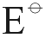 value
(+1.82V). Therefore, Co³⁺(aq) is unstable and is a good oxidizing agent.
[Co(NH₃)₆]³⁺ is more stable than [Co(H₂O)₆]³⁺ because NH₃ is a stronger ligand than water
which can stabilize the Co³⁺ ion more.
(ii) Dilute, acidic solutions of cobalt(II) salts are stable in air because +2 state of Co is more stable
than the +3 state in normal aqueous conditions.
On adding an excess of aqueous NH₃, [Co(NH₃)₆]²⁺ is formed which is readily oxidized to
[Co(NH₃)₆]³⁺ because the +3 state is more stable in complexes.

26. (a) Transition metal complexes are often coloured because they have incompletely filled d-orbitals.
In the presence of ligands, the 3d-orbitals of transition metal become non-degenerate and split into two groups of orbitals with slightly different energy (d-d splitting). When a d-electron from the lower energy group jumps to the higher energy group (d-d transition), radiation in the visible region of the electromagnetic spectrum is absorbed. The light energy not absorbed will be seen as the colour of the complex. The colour of a particular transition metal complex is depended on the nature of the ligand.

(b) (i) The addition of thiocyanate ions to aqueous iron(III) ions produces a deep blood-red solution
due to the formation of [Fe(SCN)(H₂O)₅]²⁺(aq) ion.
[Fe(H₂O)₆]³⁺ + SCN－ → [Fe(SCN)(H₂O)₅]²⁺ + H₂O
blood-red
When aqueous sodium fluoride is added, the colour due to the formation of a stable
complex fluoride, [FeF₆]^{3－}(aq).
(ii) Anhydrous cobalt(II) chloride is blue due to the presence of complex ion, [CoCl₄]^{2－}.
[Co(H₂O)₆]²⁺ + 4Cl－ [CoCl₄]^{2－} + 6H₂O
pink blue
The addition of water shifts the position of equilibrium to the left.
Thus, a pale pink solution is formed.

27. (a) (i) Potassium manganate(VI) is green.
(ii) The manganese-containing ion in the purple solution is MnO₄－.
(iii) 3MnO₄^{2－} + 4H⁺ → 2MnO₄－ + MnO₂ + 2H₂O
(iv) 2MnO₂ + O₂ + 4OH－ → 2MnO₄^{2－} + 2H₂O
(b) (i) MnO₂ + 4H⁺ + 2e－ → Mn²⁺ + 2H₂O +1.23V
To convert MnO₂ to MnSO₄ in acid solution, the reducing agent must possess a value
more negative than +1.23V.
Therefore, Sn²⁺ (or Fe²⁺) would convert MnO₂ to MnSO₄ in acid solution.
(ii) MnO₂ + Sn²⁺ + 4H⁺ → Mn²⁺ + Sn⁴⁺ + 2H₂O
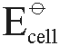 = (+1.23 – (+0.15)) V
= +1.08 V
OR
MnO₂ + 2Fe²⁺ + 4H⁺ → Mn²⁺ + 2Fe³⁺ + 2H₂O
= (+1.23 – (+0.77)) V
=+0.46 V
(iii) When using Sn²⁺ as reducing agent, the final solution is colourless.
When using Fe²⁺ as reducing agent, the final solution is pale yellow in colour.
(c)
 | Mn | O | Cl
% by mass | 34.8 | 20.3 | 45.9
No. of moles  (mol) | $\frac{\text{34}\text{.}8}{\text{54}\text{.}9}$=0.634 | $\frac{\text{20}\text{.}3}{\text{16}\text{.}0}$ = 1.269 | $\frac{\text{45}\text{.}9}{\text{35}\text{.}5}$ = 1.293
Simplest  mole ratio | $\frac{0\text{.}\text{634}}{0\text{.}\text{634}}$= 1 | $\frac{1\text{.}\text{269}}{0\text{.}\text{634}}$= 2 | $\frac{1\text{.}\text{293}}{0\text{.}\text{634}}$= 2

As mole ratio Mn : O : Cl = 1 : 2 : 2
∴ empirical formula is MnO₂Cl₂.

Let the oxidation number of Mn be x.
⇒ x + 2 × (−2) + 2 × (−1) = 0
∴ x = +6
Oxidation number of Mn is +6.
28. (a) (i) The manganese-containing ion in the green solution is MnO₄^{2－}.
The oxidation number of Mn is +6.
(ii) 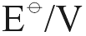
MnO₄－ + e－ → MnO₄^{2－} +0.56
－) O₂ + 2H₂O + 4e－ → 4OH－ +0.40
4MnO₄－ + 4OH－ → 4MnO₄^{2－} + O₂ + 2H₂O
= (+0.56 – 0.40) V = +0.16 V
As > 0, the reaction is feasible. Therefore, the species responsible for the reduction
of the Mn(VII) is OH－.
The balanced equation for the redox reaction:
4MnO₄－ + 4OH－ → 4MnO₄^{2－} + O₂ + 2H₂O
(b) The brown solid is MnO₂ and the purple solution is KMnO₄(aq).
3MnO₄^{2－} + 2H₂O → 2MnO₄－ + MnO₂ + 4OH－
(c) Equation for the reaction between brown MnO₂ and aqueous SO₂:
MnO₂ + SO₂ → Mn²⁺ + SO₄^{2－}
Equation for the reaction between purple MnO₄－ and aqueous SO₂:
2MnO₄－ + 5SO₂ + 2H₂O → 2Mn²⁺ + 5SO₄^{2－} + 4H⁺

29. (a) Transition metal complexes are often coloured because they have incompletely filled d-orbitals.
In the presence of ligands, the 3d-orbitals of transition metal become non-degenerate and split into two groups of orbitals with slightly different energy (d-d splitting). When a d-electron from the lower energy group jumps to the higher energy level(d-d transition), radiation in the visible region of the electromagnetic spectrum is absorbed. The light energy not absorbed will be seen as the colour of the complex.
Compounds of other metals are usually white because they do not have d electrons. Therefore, d-d transition is impossible.
(b) (i) When concentrated HCl is added to blue aqueous CuSO₄, a yellow solution is obtained
because of the formation of [CuCl₄]^{2－} complex ion.
Cu²⁺(aq) + 4Cl－(aq) → [CuCl₄]^{2－}(aq)
Blue yellow
When an excess of water is added, the yellow solution reverts to a light blue.
This is because Cl－ ligands are gradually replaced by H₂O ligands to form the
blue [Cu(H₂O)₆]²⁺ ion.
[CuCl₄]^{2－} + 6H₂O [Cu(H₂O)₆]²⁺ + 4Cl
yellow blue
Adding water shifts the equilibrium to the right hand side.

(ii) When dilute aqueous NH₃ is added to blue aqueous copper(II) sulphate, a blue precipitate of
Cu(OH)₂ is first formed. It is then dissolves in excess aqueous NH₃ to give a deep blue
solution containing [Cu(NH₃)₄]²⁺ ion.
NH₃ + H₂O NH₄⁺ + OH－
Cu²⁺(aq) + 2OH－(aq) → Cu(OH)₂(s)
Cu(OH)₂(s) + 4NH₃ [Cu(NH₃)₄]²⁺ + 2OH－
Aqueous edta forms a more stable complex with Cu²⁺(aq) than aqueous NH₃.
Thus, only a small amount of aqueous edta is required to make the deep blue solution to change
to a paler blue. This is because the more stable [Cu(edta)]^{2－} complex is formed.
[Cu(NH₃)₄]²⁺ + edta^{4－} [Cu(edta)]^{2－} + 4NH₃
deep blue pale blue

30. (b) To prevent overheating, KMnO₄ decomposes under strong heat to give O₂.
(c) Fusing means melt together to form a mixture.
Disproportionation is a chemical change in which oxidation and reduction of the same specices (may be molecules, ions or atoms) take place at the same time.
(d) (i) 3MnO₂ + 6OH－ + ClO₃－ → 3MnO₄^{2－} + 3H₂O + Cl－
(ii) 3MnO₄^{2－} + 4H⁺ → MnO₂ + 2MnO₄－ + 2H₂O
(iii) CO₂ + H₂O 2H⁺ + CO₃^{2－}
To provide an acidic medium so that disproportionation of Mn(VI) and Mn(VII) occurs
quantitatively.
(e) The electronic configuration of manganese is [Ar] 3d⁵ 4s²
By losing two or three electrons, it forms Mn²⁺ ([Ar]3d⁵) and Mn³⁺ ([Ar]3d⁴).
By sharing 4, 6 or 7 electrons from 4s and 3d, manganese can exist in oxidation states of +4
(e.g. MnO₂), +6 (e.g. MnO₄^{2－}) and +7 (MnO₄－).
(f) Mn²⁺ → Mn³⁺
[Ar] 3d⁵ [Ar]3d⁴
Mn²⁺ is more stable than Mn³⁺ because the half-filled d-orbitals of Mn²⁺ gain extra-stability.
Thus, oxidation of Mn²⁺ to Mn³⁺ does not occur readily.
Fe²⁺ → Fe³⁺
[Ar]3d⁶ [Ar]3d⁵
Fe³⁺ is more stable than Fe²⁺ because the half-filled d-orbitals of Fe³⁺ gain extra-stability.
Thus, oxidation of Fe²⁺ to Fe³⁺ occur readily.

31. (a)
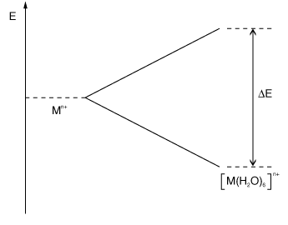
In the presence of a ligand field (H₂O molecules), the d-orbitals split into two groups of orbitals with slightly different energies. The difference in energy ΔE is located at the region of energies of visible radiation.
An d-electron occupying one of the lower energy d-orbitals can undergo d-d transition to a higher energy d-orbital. Light energy equal to ΔE is absorbed. The light transmitted is the complement of the colour absorbed and hence gives the colour of the ion.
(b) (i) Fe
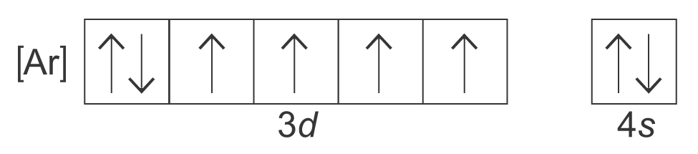
(ii) Fe²⁺
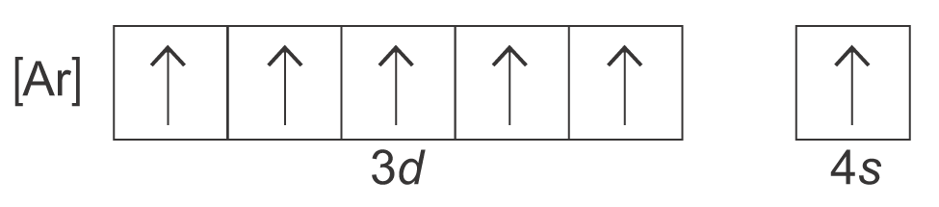
(c) (i) A complex ion is formed when a central metal ion is surrounded by other molecules or ions
which form dative covalent bonds with the central metal ions.
(ii) [Ar]
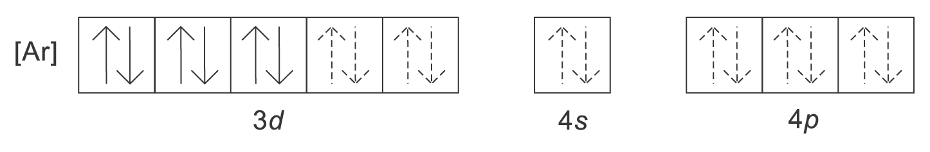
1 electron from ligand CN－
(d) CN－ ions are poisonous but not [Fe(CN)₆]^{4－}
Fe²⁺ forms complexes with CN－
Fe²⁺ + 6 CN－ → [Fe(CN)₆]^{4－}

(e) (i) Reducing agent, precipitating agent
(ii) [Cu(NH₃)₄]⁺, square planar
(iii) Cu⁺ disproportionates to Cu²⁺ and Cu complexes with NH₃ to give [Cu(NH₃)₄]²⁺.
2Cu⁺ → Cu²⁺ + Cu(s)

32. (a) Cr²⁺ → Cr³⁺
[Ar] 3d⁴ [Ar] 3d³
Cr²⁺ easily oxidize to Cr³⁺ because the half-filled d orbital of Cr³⁺ gain extra-stability.
(b) The symbol for the element is Sc.
Sc → Sc³⁺
[Ar]3d¹4s² [Ar]
Sc³⁺ has a stable octet configuration.
(c) MnO₄－ (+7)

33. (a) (i) Cu atom: [Ar] 3d¹⁰ 4s¹
Cu⁺ ion: [Ar] 3d¹⁰ 4s⁰
(ii) Absence of partially filled d-orbitals. No d-d transitions are possible.
(b) (i)
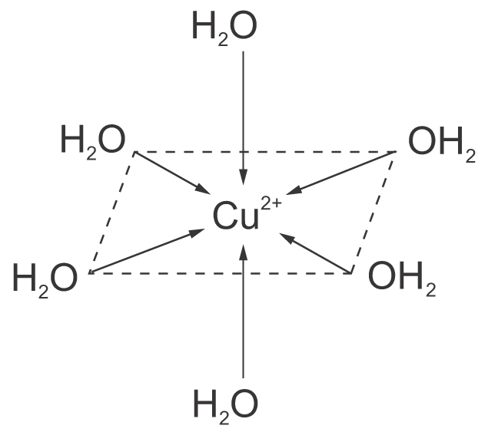
Octahedral
(ii) Warm mixture of copper(II) sulphate, copper and conc. HCl until brown solution is obtained.
Pour product into water. CuCl separates out as white precipitates.
CuSO₄ + 2HCl → CuCl₂ + H₂SO₄
CuCl₂ + Cu 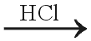 2CuCl

34. (a) Mn: [Ar] 3d⁵ 4s²
Mn²⁺: [Ar] 3d⁵
Mn²⁺ has the most stable electronic configuration (half-filled d-orbitals) among the Mn ions.
(b) (i) The product of reaction acts as the catalyst for the same reaction.
(ii) Exhibit variable oxidation states.

(iii)
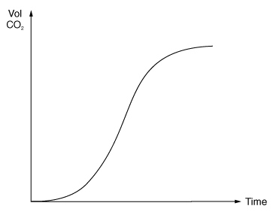
(c) (i) MnO₄－ + 8H⁺ + 5Fe²⁺ → Mn²⁺ + 5Fe³⁺ + 4H₂O
(ii) $\frac{n_{{\text{Fe}}^{2+}}}{n_{{\text{MnO}}_{4^{−}}}}$= $\frac{5}{1}$ = $\frac{n}{\frac{\text{24}\text{.}8}{\text{1000}}×0\text{.}\text{02}}$
n = 2.48 × 10^{－3} mol
mass of Fe = 2.48 × 10^{－3} × 4 × 55.6 = 0.551 6g
% Fe = $\frac{0\text{.}\text{5516}}{2\text{.}8}×\text{100}$% = 19.7 %

35. (a) V³⁺ ion
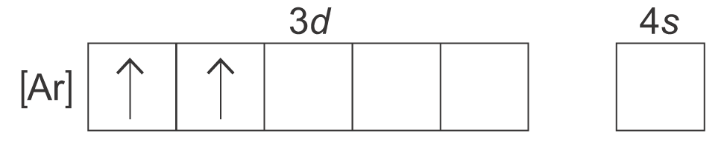
(b) Vanadium can form complex when ligand is present. Vanadium has various oxidation states.
(c) (i) +5
(ii) dioxovanadium(V) ion
(d) (i) Mixture of VO₂⁺(aq) and VO²⁺(aq)
(ii) V³⁺(aq)
(iii) V²⁺(aq)
(e) (i) Reducing agent is a substance which reduces others by oxidizing itself.
The process involves the loss of electrons.
(ii) Zn(s) → Zn²⁺(aq) + 2e－
(f) (i) VO₂⁺(aq) + 2H⁺(aq) + e－ → VO²⁺(aq) + H₂O(l)
(ii) 2VO₂⁺(aq) + 4H⁺(aq) + Zn(s) → 2VO²⁺(aq) + 2H₂O(l) + Zn²⁺(aq)

36. (a) (i) +5 +5
VO₃－(aq) + 2H⁺(aq) → VO₂⁺(aq) + H₂O(l)
The solution formed is yellow in colour.
(ii) Potassium iodide
2VO₂⁺(aq) + 4H⁺(aq) + 2I－(aq) → 2VO²⁺(aq) + 2H₂O(l) + I₂(aq)
(b) (i) the oxidation state of vanadium is +2
The solution formed is violet.
(ii) As V⁵⁺ would be highly charged and very small sized, it binds the coordinating water molecules
strongly. The O－H bond in water molecules are loosened and therefore the ion exists as VO₂⁺.
As V²⁺ has lower charge to volume ratio, so it is stable with water molecules as [V(H₂O)₆]²⁺.
(c) Vanadium(V) oxide is used as heterogeneous catalyst in the Contact Process.

37 (a) (i)
MnO₄－ + e－ MnO₄^{2－} +0.56
−) 4H⁺ + MnO₄^{2－} + 2e－ MnO₂ + 2H₂O +2.26
2MnO₄－ + MnO₂ + 2H₂O → 3MnO₄^{2－} + 4 H⁺ −1.70
The reaction is not feasible under standard condition due to the negative value.
(ii) By increasing the pH, the potential of the reaction MnO₄^{2－} + 2H₂O + 2e－ → MnO₂ + 4OH－
will be lowered. Then the overall reaction potential will be reversed. The reaction becomes
feasible after the increase in pH.
MnO₄－ + e－ MnO₄^{2－} +0.56
−) MnO₄^{2－} + 2H₂O + 2e－ MnO₂ + 4OH－ +0.60
2MnO₄－ + MnO₂ + 4OH－ → 3MnO₄^{2－} + 2H₂O −0.04
(iii)
MnO₄－ + e－ MnO₄^{2－} +0.56
−) 2H₂O + O₂ + 4e－ 4OH－ +0.40
4MnO₄－ + 4OH－ → 4MnO₄^{2－} + 2H₂O + O₂ +0.16
The hydroxide ions are oxidized to oxygen gas as the oxidation number of oxygen atom in
hydroxide ion increase from −2 to 0 in oxygen gas.
(b) As the 3d and 4s electrons are of similar energy levels, manganese can place their electrons in either the 3d orbitals or the 4s orbitals for bond formation. When it reacts to form compounds, it can form ions of roughly the same stability by losing different numbers of electrons. Thus, it can form compounds with a wide variety of oxidation state.
As aluminium does not have 3d electrons, it cannot form different kinds of cations by losing lower energy 3d electrons. It only stabilizes at noble gas configuration by losing all 3 electrons to form Al³⁺.

(c) (i) As aluminium is small size and highly charged, it will distort the electron cloud at the O－H
bond in coordinating water molecules. So the O－H bond is weakened. When another water
molecule attacks, the hydrogen is removed as proton. Thus the aqueous solution of aluminium
salts are acidic.
(ii) [Al(H₂O)₆]³⁺(aq) + OH－(aq) → [Al(OH)(H₂O)₅]²⁺(aq) + H₂O(l)
[Al(OH)(H₂O)₅]²⁺(aq) + OH－(aq) → [Al(OH)₂(H₂O)₄] ⁺(aq) + H₂O(l)
[Al(OH)₂(H₂O)₄] ⁺(aq) + OH－(aq) → [Al(OH)₃(H₂O)₃] (s) + H₂O(l)
white precipitate
[Al(OH)₃(H₂O)₃] (s) + OH－(aq) → [Al(OH)₄(H₂O)₂]－(aq) + H₂O(l)

38. (a) (i)
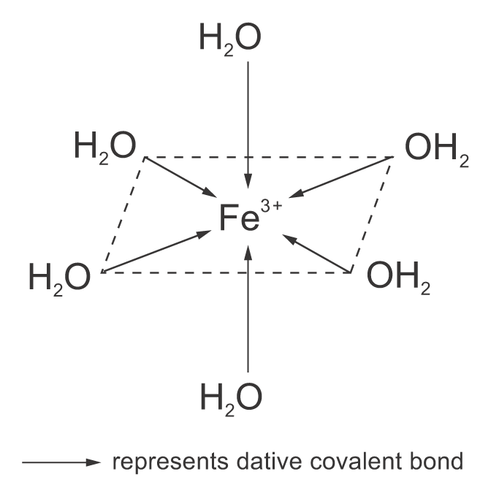
(ii) complex ion

(b) (i) [Fe(H₂O)₆]³⁺(aq) + 6NH₃(aq) [Fe(NH₃)₆]³⁺(aq) + 6 H₂O(l)
red-brown precipitate
(ii) Hexaammineiron(III) ion
(iii) Displacement reaction
(c) (i) [Fe(H₂O)₆]²⁺(aq) + 6CN－(aq) [Fe(CN)₆]^{4－}(aq) + 6H₂O(l)
(ii) Displacement reaction.
(iii) 2[Fe(CN)₆]^{4－}(aq) + Cl₂(aq) → 2[Fe(CN)₆]^{3－}(aq) + 2Cl－(aq)
This is a redox reaction. The iron is oxidized from +2 to +3 while chlorine is reduced
from 0 to −1.

