Part 13 The p-Block Elements (Book 4, p. 157 – p.162)

32. (a) Chloroethene is used in the production of polyvinyl chloride (PVC). Sodium hypochlorite is used in the for production of bleach.
(b) Aq. Cl－ forms white precipitate of AgCl with aq. Ag⁺.
Cl－ + Ag⁺ → AgCl
AgCl dissolves in aq. NH₃ to form soluble complex.
AgCl + 2NH₃ → [Ag(NH₃)₂]⁺ + Cl－
Addition of Br－ forms AgBr precipitate (cream coloured).
[Ag(NH₃)₂]⁺ + Br－ → AgBr + 2NH₃
AgBr has a lower solubility than AgCl.
Hence, AgBr precipitates are formed instead of AgCl.
AgBr dissolves in aq. CN－ to form a soluble complex.
AgBr + 2CN－ → [Ag(CN－)₂]－ + Br－

33. (a) (i) Cl₂ added to drinking water as a germicide to kill bacteria.
(ii) Cl₂ + 2OH－ → Cl－ + OCl－ + H₂O
Smell of Cl₂ disappears as it reacts with OH－ to form salts in aq. solution.
(b) (i) Cl₂ + Mg → MgCl₂
Oxidation no. of Mg increases from 0 to +2 (oxidation).
Oxidation no. of Cl decreases from 0 to －1 (reduction).
(ii) MgCl₂．6H₂O on evaporation decomposes to give Mg(OH)Cl.
MgCl₂．6H₂O → Mg(OH)Cl + HCl + 5H₂O
(iii) On strong heating, Mg(OH)Cl further decomposes to give MgO as residue only. HCl is
driven off.
Mg(OH)Cl → MgO + HCl↑

34. (a) When chlorine reacts with hot NaOH(aq), chlorine undergoes disproportionation to give NaCl and NaClO₃.
3Cl₂ + 6NaOH → 5NaCl + NaClO₃ + H₂O
The greenish-yellow colour (and the smell) of chlorine disappears.
(b) When chlorine reacts with KBr(aq), a redox reaction occurs. Cl₂ oxidizes Br－ to Br₂, with itself being reduced to Cl－.
Cl₂ + 2KBr → Br₂ + 2KCl
The greenish-yellow colour (and the smell) of chlorine disappears and brown fumes of Br₂ are produced.

35. (a) (i) The solid is sodium chloride, NaCl.
NH₄Cl + NaNO₂ → NaCl + N₂ + 2H₂O
(ii) Oxidation no. of N in NH₄Cl = －3
Oxidation no. of N in NaNO₂ = +3
Oxidation no. of N in N₂ = 0
∴ oxidation number of N changes from －3 (in NH₄Cl) to 0 (in N₂), and
from +3 (in NaNO₂) to 0 (in N₂).
(iii) The oxide is N₂O.
NH₄Cl + NaNO₃ → N₂O + NaCl + 2H₂O
Let the oxidation number of N be x.
2x + (－2) = 0
⇒ x = +1

(b) (i) Ammonium sulphate and ammonium nitrate are the two nitrogen compounds used as
agricultural fertilizers.
(ii) This is because microorganisms decompose nitrogen-based fertilizers into gaseous form,
which escape easily from the soil to the air.
(iii) The over-use of nitrogen-based fertilizers results in eutrophication. The excess nutrients encourage the growth of large amounts of algae (‘algae bloom’), cutting out light from bottom-living aquatic plant. When the algae die, oxygen is consumed for decomposing dead algae and the water becomes depleted of dissolved oxygen, thereby killing other aquatic life. Over-use of nitrate fertilizers also results in water toxicity.

36. (a) (i) Nitrogen monoxide, NO, is formed by the reaction between N₂ and O₂ from the air combining
in the hot car engine, which provides the necessary energy for the endothermic reaction.
(ii) The presence of nitrogen oxides in air is polluting because it would cause the formation of
acid rain.
(b) 2NO₂ + H₂O → HNO₃ + HNO₂
3NO₂ + H₂O → 2HNO₃ + NO

37. (a) There are three steps in the manufacture of sulphuric acid by the Contact process.

1. S(s) + O₂(g) 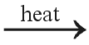 SO₂(g)
2. SO₂(g) + O₂(g) 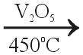 2SO₃(g)
3. SO₃(g) + H₂SO₄(l) → H₂S₂O₇(l) oleum
H₂S₂O₇(l) + H₂O(l) → 2H₂SO₄(l)
(b) Sulphur dioxide is used as preservatives in the food industry, e.g. in preserved fruits and vegetables. It is added to keep food wholesome and to prevent spoilage due to micro-organisms (inhibits growth of bacteria, fungi etc) and thus, prolong the keeping quality of food.
(c) (i) MgO(s) + SO₂(g) → MgSO₃(s)
MgSO₃(s) → MgO(s) + SO₂(g)
(ii) In this method, MgO can be recycled. However, in the alternative method which produces
gypsum, CaSO₄, the limestone used cannot be recycled. In addition, the use of limestone
produces more CO₂ (which leads to global warming) and the gypsum produced also generates a
problem of disposal.
(iii) It is not possible to use the sulphur dioxide in the flue gas to produce sulphuric acid directly
because the other components in the flue gas may poison the V₂O₅ catalyst.
(iv) Mass of S =$\frac{1\text{.}5}{\text{100}}×1×{\text{10}}^{6}$
= 1.50 × 10⁴ tonnes
= (1.50 × 10⁴ × 10³ × 10³)g
No. of mole of S = $\frac{1\text{.}\text{50}×{\text{10}}^{\text{10}}}{\text{32}\text{.}1}$= 4.67 × 10⁸ mol
S + O₂ → SO₂
No. of mole of SO₂ =$\left(\frac{\text{90}}{\text{100}}×4\text{.}\text{67}×{\text{10}}^{8}\right)$= 4.20 × 10⁸ mol
No. of mole of H₂SO₄ = No. of mole of SO₂ = 4.20 × 10⁸ mol
M_{r} of H₂SO₄ = 2 × 1 + 32.1 + 4 ×16 = 98.1
∴ Mass of H₂SO₄ = (4.20 × 10⁸ × 98.1)g
=$\frac{4\text{.}\text{20}×{\text{10}}^{8}×\text{98}\text{.}1}{{\text{10}}^{3}×{\text{10}}^{3}}$tonnes
= 4.12 × 10⁴ tonnes

38. (a) At room temperature, chlorine is a greenish-yellow gas, bromine is a dark brown liquid and iodine is a black solid. Their volatilities decrease down the group due to the increase in the strength of van der Waals’ forces (i.e. instantaneous dipole-induced dipole interaction) between the molecules. As the molecular size increases down the group (i.e. Cl₂ < Br₂ < I₂), the electron clouds of the molecules become larger and more easily polarized. Therefore, the strength of van der Waals’ forces increases, and the volatilities decrease down the group.
(b) Cl－ ion reacts with AgNO₃(aq) to give a white precipitate of AgCl, which dissolves in aqueous NH₃ (both dilute and concentrated) readily to give a colourless solution.
Ag⁺(aq) + Cl－(aq) → AgCl(s)
AgCl(s) + 2NH₃(aq) → [Ag(NH₃)₂]⁺(aq) + Cl－(aq)
Br－ ion reacts with AgNO₃(aq) to give a pale yellow precipitate of AgBr. It dissolves in concentrated NH₃(aq) to give a colourless solution only.
Ag⁺(aq) + Br－(aq) → AgBr(s)
AgBr(s) + 2NH₃(aq) → [Ag(NH₃)₂]⁺(aq) + Br－(aq)
I－ ion reacts with AgNO₃(aq) to give a yellow precipitate of AgI, which does not dissolve in aqueous NH₃ (both dilute and concentrated).
Ag⁺(aq) + I－(aq) → AgI(s)

39. (a) (i) 2P + 3I₂ → 2PI₃
(ii) PI₃ + 3H₂O → HI + H₃PO₃
(b) (i) When hydrogen iodide reacts with aqueous silver nitrate, a yellow precipitate of AgI is
formed which is insoluble in aqueous ammonia.
(ii) When hydrogen iodide is warmed with concentrated H₂SO₄, violet fumes of I₂ are produced.

40. (a) (i) Cl₂ + H₂O 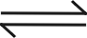 HCl + HOCl
Chlorine is only sparingly soluble in water and hence the reaction is reversible, the solution
smells strongly of chlorine.
(ii) 2OH－(aq) + Cl₂(aq) → Cl－(aq) + OCl－(aq) + H₂O(l)
The aqueous alkali reacts with Cl₂ (aq) to form chloride ions and chlorite(I) ions. And the
reaction is inreversible. Thus, the smell of Cl₂ (aq) is removed.
(iii) Solution B contains OCl－(aq) which is oxidizing.
(b) 3OCl－ → 2Cl－ + ClO₃－
OCl－ disproportionates to give Cl－ and ClO₃－. The reaction is slow. The chloride ions formed react with Ag⁺ to form white precipitate of AgCl.
Ag⁺ + Cl－ → AgCl (white precipitate)

42. (a) Although a low temperature will increase the yield of ammonia, a chemical reaction carried out at low temperature is likely to be slow. That is, the time to reach equilibrium is likely to be long.
(b) Since a large amount of energy is required to produce a higher pressure, it is uneconomic to use pressure higher than 200 atm.
(c) (i)&(ii)
The iron acts as catalyst during the production of ammonia. The iron increases the rate of reaction by providing alternative pathway with lower activation energy. However, since a catalyst does not change the equilibrium position of the reaction, the amount of ammonia in the equilibrium mixture remains unchanged.

(d) The equilibrium mixture is passed into refrigerator. As the boiling point of ammonia is higher than nitrogen and hydrogen, ammonia is liquified and separated from mixture. Unreacted N₂ and H₂ are then recycled.
43. (a) Disproportionation is a chemical change in which oxidation and reduction of the same species (which may be a molecule, atom or ion) takes place at the same time.
+1 +5 −1
(b) 3 OCl－(aq) → ClO₃－(aq) + 2Cl－(aq)
(c) oxidation:
+1 +5
OCl－(aq) + 2H₂O(l) → ClO₃－(aq) + 4H⁺(aq) + 4e－
reduction:
+1 −1
OCl－(aq) + 2H⁺(aq) + 2e－ → Cl－(aq) + H₂O(l)

44. (a) (i) HF(l) + H₂O(l) 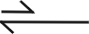 H₃O⁺ + F－(aq)
(ii) As H－F bond is short, the bond dissociation enthalpy of hydrogen fluoride is very high.
Moreover, the extensive intermolecular hydrogen bonds among hydrogen fluoride molecules
make the dissociation process more difficult. The bond dissociation enthalpy of H－F is so great
that the above equilibrium lies essentially to the left. Hence, hydrogen fluoride is a weak acid in
dilute aqueous solution.
(b) (i) When fluorine is bubbled into water, oxygen gas and hydrofluoric acid are formed.
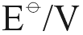
F₂(g) + 2e－ 2F－(aq) +2.87
−) O₂(g) + 4H⁺(aq) + 4e－ 2H₂O(l) +1.23
2F₂(g) + 2H₂O(l) → 4HF(aq) + O₂(g) +1.64

From the reduction potential, fluorine is stronger than oxygen. So fluorine will oxidize water to oxygen. This reaction is feasible because it has relative large positive potential.
(ii)
Cl₂(g) + 2e－ 2Cl－(aq) +1.36
−) O₂(g) + 4H⁺(aq) + 4e－ 2H₂O(l) +1.23
2Cl₂(g) + 2H₂O(l) → 4HCl(aq) + O₂(g) +0.13
(iii) For the above reaction, the potential is just +0.13V. Usually the potential required for a reaction
to occur should be +0.4V or above. Thus this reaction will not occur and disproportionation will
occur instead.
(c) (i)
3 OCl－(aq) 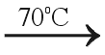 ClO₃－(aq) + 2Cl－(aq)
The conditions necessary for disproportionation of chlorate(I) ion to occur is the presence of hot and concentrated alkalis.
(ii) Disproportionation is a chemical change in which oxidation and reduction of the same species (which may be a molecule, atom or ion) takes place at the same time. From the above equation, chlorate(I) ions are oxidized to chlorate(V) ions and reduced to chloride ions simultaneously.
(d) (i) Potassium bromide, KBr
Ag⁺(aq) + Br－(aq) → AgBr(s)

(ii) KBrO₃(s) KBr(aq) + O₂(g)

45. (a) (i) 2IO₃－(aq) + 12H⁺(aq) + 10e－ → I₂(aq) + 6H₂O(l)
(ii) H₂O₂(aq) → O₂(g) + 2H⁺(aq) +2e－
(b) There are colourless bubbles evoluted and the solution change slowly from colourless to brown.

46. (a) (i) Potassium bromide
(ii) Hydrogen bromide, HBr
(iii) When concentrated sulphuric acid is added into bromide solution, in addition to forming
hydrogen bromide gas, the bromide ion is oxidized to bromine which is brown in colour . This is
because concentrated sulphuric acid is a strong oxidizing agent.
(iv) Starch will react with iodine to form a deep blue complex. The solution turned blue indicates the
presence of iodine.
(v) I₂(aq) + 2S₂O₃^{2－}(aq) → 2I－(aq) + S₄O₆^{2－}(aq)
(vi) Cl₂ > Br₂ > I₂
(b) (i) NaClO₃
(ii) 3OCl－(aq) → ClO₃－(aq) + 2Cl－(aq)
(c) As H－F bond is short, the bond dissociation enthalpy of hydrogen fluoride is high. Moreover, the extensive intermolecular hydrogen bonds among hydrogen fluoride molecules increase the difficulty of dissociation. Thus hydrogen fluoride is a weak acid in aqueous solution.
(d) One large scale use of chlorine is the manufacture of domestic bleaches.

47. (a) Dynamic equilibrium means that the forward reaction is proceeding at the same rate as the backward reaction.
(b) According to Le Chatelier’s principle, the equilibrium position of the system will shift in a way to minimize the effect of raising the temperature. Since the reaction is exothermic, the equilibrium position will shift to backward side and less ammonia is being produced.
(c) It is because the rate of formation of ammonia will be reduced if the temperature is too low. The temperature chosen should be high enough to the reaction to proceed quickly but low enough to have a satisfactory yield of product.
(d) The mixture of gases is passed through a heat exchanger and cooled. The ammonia formed in the process is then absorbed in water and liquefied under pressure.
(e) (i) A catalyst is a substance that can change the rate of a reaction but remains
chemically unchanged at the end of the reaction.
(ii)
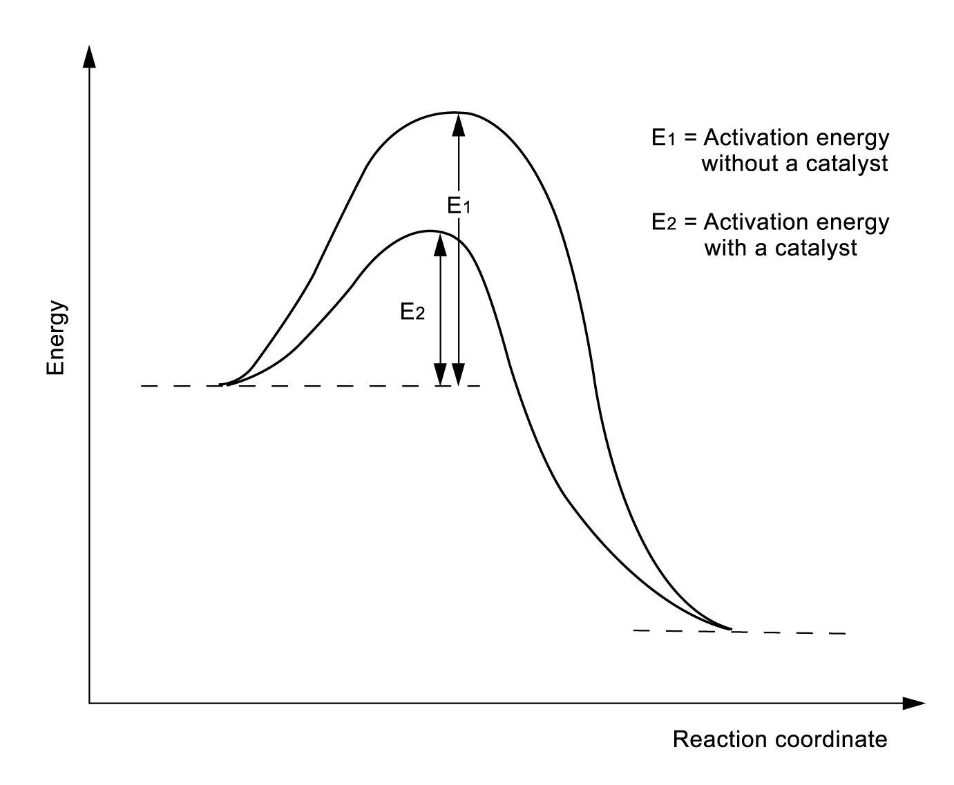

The catalyst increase the rate of attainment of reaction of the equilibrium by providing an alternative pathway with lower activation energy.
(iii) The catalyst is chemically unchanged at the end of the reaction, so it does not change the
position of the equilibrium and the yield of ammonia.
(f) Ammonia is the raw material for making fertilizers.

48. (a) (i) When lithium chloride is treated with concentrated sulphuric acid, chlorides give out
steamy fumes (hydrogen chloride).
(ii) When sodium bromide is treated with concentrated sulphuric acid, it gives out steamy fumes and
pungent smell gas. The solution turns brown.
(iii) When potassium iodide is treated with concentrated sulphuric acid. It gives out steamy violet
fumes and bad egg smell.
(b) LiCl(s) + H₂SO₄(l) → LiHSO₄(s) + HCl(g)

49. (a) (i) Oxidation always involve the loss of electron(s).
(ii) An oxidizing agent is a substance which oxidizes others by undergo reduction.
The reduction involves gain of electron(s).
(iii) Chlorine is a stronger oxidizing agent. As chlorine is a stronger oxidizing agent, it oxidizes bromide ion to bromine from seawater. If bromine is a stronger oxidizing agent, there is no reaction occur when chlorine is pumped into sea water and the manufacture of bromine fail.
(b) (i) 3OCl－(aq) → ClO₃－(aq) + 2Cl－(aq)
(ii) Disproportionation
(c) (i) (1) +4
(2) +6
(ii) SO₂ has been oxidized. Because the oxidation number of sulphur is increased from +4 for SO₂
to +6 for SO₄²⁻. Oxidation involves the increasing of oxidation number.
(iii) Starch solution. If the solution contains iodine, the solution will become deep blue after
adding starch solution. It is because iodine reacts with starch to form a deep blue complex.

50. (a) Dynamic equilibrium means that the forward reaction is proceeding at the same rate as the backward reaction.
(b)
 | Effect on the rate of the reaction | Effect on the position of equilibrium
Increasing the temperature | Increases | Shift to the left
Increasing the pressure | Increases | Shift to the right

(c) (i) The reaction is exothermic, thus a lower temperature will increase the yield of the product. However, the rate to attain equilibrium will be too slow if the temperature is too low. Therefore, the process is operated at the temperature of 450ºC, which would result in the highest percentage of conversion.
(ii) High pressure will increase the yield of the product but under the operating temperature of 450ºC, conversion is already high. A pressure of 2 atm is enough because higher pressure often requires costly equipment.
(iii) A catalyst is used to increase the rate of the reaction.

(d) Vanadium (V) oxide or platinium.
(e) Sulphuric acid is used to make fertilizers.

