Part 12 The s-Block Elements (Book 4, p. 78 – p.80)

14. (a) (i) Group II metals burn in oxygen with a bright flame to form monoxides. For example, Ca
burns with a brick-red flame, Sr burns with a crimson-red flame while Ba burns with an
apple-green flame.
2Mg(s) + O₂(g) → 2MgO(s)
2Ca(s) + O₂(g) → 2CaO(s)
2Sr(s) + O₂(g) → 2SrO(s)
2Ba(s) + O₂(g) → 2BaO(s)
(ii) Group II metals, Mg to Ba, reduces water to H₂(g). The reactivity increases down the group.
Mg reacts with steam only but does not react with cold water. Ca, Sr and Ba react with cold
water vigorously, giving effervescence of H₂(g).
Mg(s) + 2H₂O(g) → Mg(OH)₂(s)+ H₂(g)
Ca(s) + 2H₂O(l) → Ca(OH)₂(s)+ H₂(g)
Sr(s) + 2H₂O(l) → Sr(OH)₂(s)+ H₂(g)
Ba(s) + 2H₂O(l) → Ba(OH)₂(s)+ H₂(g)

(b) (i) Mg₃N₂ is also formed when magnesium burned in air. This is because the reaction between Mg and O₂ is highly exothermic and this provides the necessary energy required to break the
strong N≡N bond. Moreover, Mg₃N₂ has a high lattice energy (therefore it is stable) due to
the small size of Mg²⁺ ion.
(ii) 3Mg + N₂ → Mg₃N₂
Mg₃N₂ + 6H₂O → 3Mg(OH)₂ + 2NH₃
NH₃ + HCl → NH₄⁺Cl－
No. of mole of NH₃ = No. of mole of HCl $=0\text{.}5×\frac{\text{12}\text{.}0}{\text{1000}}$
= 6.0 ×10^{－3}
No. of mole of Mg₃N₂ =$\frac{1}{2}×\text{ No }\text{.}{\text{ of mole of NH}}_{3}$
=$\frac{1}{2}×6\text{.}0×{\text{10}}^{−3}$
=3.0×10^{－3}
M_{r} of Mg₃N₂ = 3 × 24.3 + 2 × 14 = 100.9
Mass of Mg₃N₂ = nM_{r} = (3.0×10^{－3} ×100.9)g
= 0.303g
∴ Percentage of Mg₃N₂ = $\left(\frac{0\text{.}\text{303}}{1\text{.}\text{00}}×\text{100}\right)\text{\%}$ = 30.3 %
15. (a) CaCO₃ → CaO + CO₂
CaO + H₂O → Ca(OH)₂
(b) Lime is used in agriculture to reduce the acidity of soil, making it suitable for cultivation.
(c) Going down the group, the temperature required to decompose the carbonates increases.
This is because going down the group, the increasing cationic size (and decreasing polarizing power of the cation) results in the carbonate anions being less polarized and the compound becomes relatively stable to heat.
(d) (i) As the cations become larger down the group, the lattice energy decreases (becomes less
negative). This leads to decrease in electrostatic forces of attraction between the cation and
O^{2－} anion. Therefore, the melting point decreases down the group.
(ii) MgO is used as a furnace lining because of its high melting point.

16. (a) The symbol for the element is Cs.
2Cs + 2H₂O → 2CsOH + H₂
Cs is the most metallic of all the Groups I and II elements.
(b) The solubilities of the hydroxides of Group II metals increases down the group.

18. (a) Ba(s) + 2H₂O(l) → Ba(OH)₂(aq) + H₂(g)
(b) The reaction of barium with water is more vigorous than the reaction of calcium with water.
Both barium and calcium are Group II elements.The reactivity of Group II metal with water corresponds to the relative ease of the metal to donate the outermost shell electrons. Going down the group, as the atomic size increases, the atoms are easier to donate the outermost shell electrons. Since barium is a lower member of Group II metals than calcium, the electrons are loosely held and they lose more easily to water. So barium react with water more vigorously than calcium.
(c) BaCO₃(s) 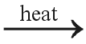 BaO(s) +CO₂(g)
(d) Calcium carbonate would decompose more easily.
This is because calcium has higher polarizing power than barium, it distorts the electron cloud of anion in a greater extent. Thus, it is less stable and decomposes more easily.
(e) As the solubility of barium sulphate in water is less than calcium sulphate, we would distinguish between barium chloride and calcium chloride by adding sodium sulphate solution to form corresponding sulphate compounds.
In the test-tube containing barium chloride, precipitate would appear shortly after adding sodium sulphate solution. On the other hand, precipitate does not appear in the test-tube containing calcium chloride after adding sodium sulphate solution.

19. ΔH_{soln} = ΔH_{hyd} － ΔH_{lattice}
The solubility of compounds depends on both of ΔH_{lattice} and ΔH_{hyd}. For group II sulphate compounds,
the size of are much smaller than the anions. Therefore, going down the group, the increase in size of
cations does not cause a significant change in the ΔH_{lattice}. However, the increase in size of the cations
does cause the ΔH_{hyd} to become less and less negative down the group. As a result, the hydration
energy of cation in MgSO₄ is more negative than that of BaSO₄.Change in ΔH_{hyd} is more significant
than change in ΔH_{lattice}. Therefore, ΔH_{soln} of MgSO₄ is more exothermic, so the solubility of magnesium
sulphate is much higher than barium sulphate.

20. (a) Lithium and calcium
(b) 4Li(s) + O₂(g) → 2Li₂O(s)
2Ca(s) + O₂(g) → 2CaO(s)

21.
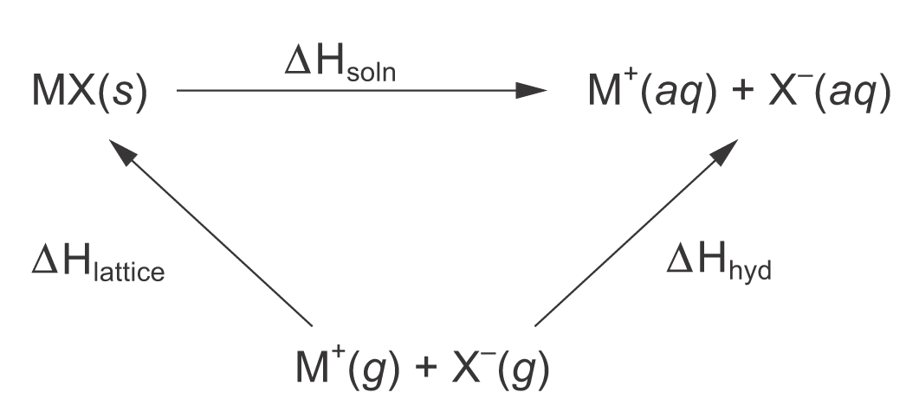
ΔH_{soln} = ΔH_{hyd} － ΔH_{lattice}
For the hydroxides of Group II metals, the sizes of anions and cations are of the same order of
magnitude. From Mg²⁺ to Ba²⁺, less and less energy is required to break the lattice (i.e. from –2843
to –2228 kJ mol⁻¹). However, the change in ΔH_{hyd} is comparatively small (i.e. from –1920 to
−1360 kJ mol⁻¹).
Consequently, the ΔH_{soln} becomes more and more negative, and the solubility of hydroxides
of Group II metals increase down the group.

22. (a) Ca(s) + 2H₂O(l) → Ca(OH)₂(aq) + H₂(g)
(b) The solubility of group II hydroxides increase down the group

23. (a) (i)
Compound | Flame Colour
Lithium chloride | Crimson
Sodium chloride | Golden yellow
Potassium chloride | Lilac

(ii) On heating, the compounds are vapourized. The ion pairs are converted to gaseous atoms.
The outermost shell electron is excited to higher energy levels. When the electron returns to
its ground state, energy is released in form of light corresponding to the initial excitation.
Since the amount of energy is quantized, the flame colour is characteristic property of
each element.

24. (a) Bottle B.
(b) The label is correct.
Magnesium ion is small and highly charged, so it has large polarizing power. As it has large polarizing power, it distorts the electron cloud of carbonate to greater extent. The compound becomes less stable to heat and decompose on heating.
MgCO₃(s) MgO(s) + CO₂(g)
The colourless gas produced is carbon dioxide.
(c) Dissolve the solid in bottle D into water patch by patch. Barium hydroxide is more soluble in water than magnesium hydroxide. If the solid does not dissolve or dissolve slightly in water, it is magnesium hydroxide. If the solid can dissolve in water readily, it is barium hydroxide.

25. The solubility of ionic compounds is depended on the enthalpy of solution. While the enthalpy of solution
depends on enthalpy of hydration and enthalpy of lattice, their relation is shown as follow.
ΔH_{soln} = ΔH_{hyd} － ΔH_{lattice}
For the fluoride of Group I metals, the size of anions and cations are similar. When going down the
group, the lattice enthalpy decreases as the size of cation increases. However, the change in enthalpy of
hydration is not significant. As a result, enthalpy of solution is getting more and more exothermic. Thus,
the solubility of Group I fluorides increase as the Group is descended.

