Part 11 Periodic Properties of the Elements in the Periodic Table (Book 4, p. 37 – p.38)

15. Na₂O + H₂O → 2NaOH
Sodium monoxide (Na₂O) reacts vigorously with water to form sodium hydroxide.
Na₂O₂ + 2H₂O → 2NaOH + H₂O₂
Sodium peroxide(Na₂O₂) gives sodium hydroxide and hydrogen peroxide when reacting with water.

MgO + H₂O → Mg(OH)₂
Magnesium oxide (MgO) reacts with water to form magnesium hydroxide, forming a weakly
alkaline solution.

Aluminium oxide (Al₂O₃) is amphoteric in nature. It is insoluble in water. So, it has no reaction with
water.

Silicon(IV) oxide (SiO₂) does not react with water.

P₄O₆ + 6H₂O→ 4H₃PO₃
Phosphorus(III) oxide (P₄O₆) reacts slowly with cold water to form phosphoric(III) acid.
P₄O₁₀ + 2H₂O → 4HPO₃
Phosphorus(V) oxide (P₄O₁₀) reacts vigorously with cold water to form polyphosphoric(V) acid.
P₄O₁₀ + 6H₂O → 4H₃PO₄
But P₄O₁₀ reacts with warm water to form phosphoric(V) acid.

Sulphur dioxide (SO₂) and sulphur trioxide(SO₃) react with water to form sulphuric(IV) acid and
sulphuric(VI) acid respectively.

16. (a) Oxidation number of Na to P in their chlorides:

Element | Formula | Oxidation number
Na | NaCl | +1
Mg | MgCl₂ | +2
Al | AlCl₃ | +3
Si | SiCl₄ | +4
P | PCl₃ (or PCl₅) | +3 (or +5)

NaCl and MgCl₂ are ionic compounds. NaCl dissolves in water to give a neutral solution
(pH 7) only.
NaCl(s) + aq → Na⁺(aq) + Cl－(aq)
MgCl₂ dissolves in water. Due to the larger polarizing power of Mg²⁺ ions, it slightly hydrolyzes.
MgCl₂(s) + aq → [Mg(H₂O)₆]²⁺(aq) + 2Cl－(aq)
[Mg(H₂O)₆]²⁺ 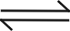 [Mg(H₂O)₅(OH)]⁺ + H⁺
The solution is slightly acidic (pH 6.5).
AlCl₃, SiCl₄ and PCl₃/ PCl₅ are covalent compounds. AlCl₃ dissolves in water with hydrolysis to give an acidic solution (pH ≈ 3).
AlCl₃(s) + aq → [Al(H₂O)₆]³⁺(aq) + 3Cl－(aq)
[Al(H₂O)₆]³⁺ → [Al(H₂O)₅(OH)]²⁺ + H⁺
SiCl₄ and PCl₃ / PCl₅ hydrolyze completely in water to give strongly acidic solution (pH ≈ 2).
SiCl₄(l) + 2H₂O(l) → SiO₂(s) + 4HCl(aq)
PCl₃ + 3H₂O → H₃PO₃ + 3HCl
PCl₅ + 4H₂O → H₃PO₄ + 5HCl

(b) (i) 2S₂Cl₂ + 3H₂O → 3S + H₂SO₃ + 4HCl
The yellow precipitate is sulphur.
No. of mole of S₂Cl₂ = $\frac{\text{100}}{2×\text{32}\text{.}1+2×\text{35}\text{.}5}=\frac{\text{100}}{\text{135}\text{.}2}=7\text{.}\text{40}×{\text{10}}^{−3}$
No. of mole of S precipitate = $\frac{0\text{.}\text{36}}{\text{32}\text{.}1}=0\text{.}\text{0112}$
∴ mole ratio S₂Cl₂ : S = 7.40 × 10^{－3}
= 1 : 1.5
= 2 : 3
(ii) As H₂SO₃ is dibasic and HCl is monobasic,
No. of moleof H⁺ = $\left(\frac{2+4}{2}\right)×\text{ No }\text{.}{\text{of mole of S}}_{2}{\text{Cl}}_{2}$
= 3 ×7.40 × 10^{－3} = 0.0222
Volume of NaOH $=\frac{0\text{.}\text{0222}}{1\text{.}\text{00}}{\text{dm}}^{3}=0\text{.}\text{0222}{\text{ dm}}^{3}$
= 22.2 cm³

17. (a) Na₂O and Al₂O₃ have high melting points because they have the giant ionic structures. Large amount of energy is required to break the strong ionic bonds in the lattice.
However, Al₂O₃ has a higher melting point than Na₂O because of the extra electrostatic attraction by the highly-charged Al³⁺ ions causing the lattice energy, and hence, melting point to be much higher.
SO₃ has very low melting point because it has simple molecular structure. Little energy is required to break the weak van der Waals’ forces between SO₃ molecules.

(b) Na₂O is a basic oxide. It dissolves in water readily to give a strong alkali, pH 13.
Na₂O(s) + H₂O(l) → 2Na⁺(aq) + 2OH－(aq)
Al₂O₃ does not dissolve in water because it has high lattice energy . So, it is difficult to make solution.
SO₃ is an acidic oxide. It dissolves in water readily to give a strong acid, pH 2.
SO₃(g) + H₂O(l) → H₂SO₄(aq)

18. (a) (i) Al₂O₃ + 6NaOH → 2Na₃AlO₃ + 3H₂O
[or Al₂O₃ + 2NaOH + 3H₂O → 2NaAl(OH)₄]
(ii) SO₂ + 2NaOH → Na₂SO₃ + H₂O
[or SO₃ + 2NaOH → Na₂SO₄ + H₂O]
(b) (i) Al₂O₃ + 6HCl → 2AlCl₃ + 3H₂O
(ii) SO₂ (or SO₃) + HCl → no reaction

19. (a) NaCl has a giant ionic structure. It consists of a lattice of Na⁺ and Cl－ions held together by strong electrostatic forces of attraction. A large amount of energy is required to break these strong ionic bonds. Thus, NaCl has a very high melting point.
AlCl₃ has a simple molecular structure consisting of discrete molecules held together by weak van der Waals’ forces in a layered structure. A considerable amount of energy is required to separate the layers. Thus, AlCl₃ has a relatively high melting point (but lower than that of NaCl).
CCl₄ and SiCl₄ have simple molecular structures. They consist of discrete molecules held together by weak van der Waals’ forces. They have low melting points because little energy is needed to overcome the weak intermolecular forces.

(b) NaCl dissolves in water to give a neutral solution (pH 7). It does not further react with water.
NaCl(s) + aq → Na⁺(aq) + Cl－(aq)
AlCl₃ dissolves in water and hydrolyzes to give an acidic solution (pH ≈ 3).
AlCl₃(s) + aq → [Al(H₂O)₆]³⁺(aq) + 3Cl－(aq)
[Al(H₂O)₆]³⁺ → [Al(H₂O)₅(OH)]²⁺ + H⁺
CCl₄ has no reaction with water because C does not have d-orbitals. Therefore it cannot coordinate with water molecules.
SiCl₄ hydrolyzes in water completely to give strongly acidic solutions (pH ≈ 2).
SiCl₄(l) + 2H₂O(l) → SiO₂(s) + 4HCl(aq)

20. (a)
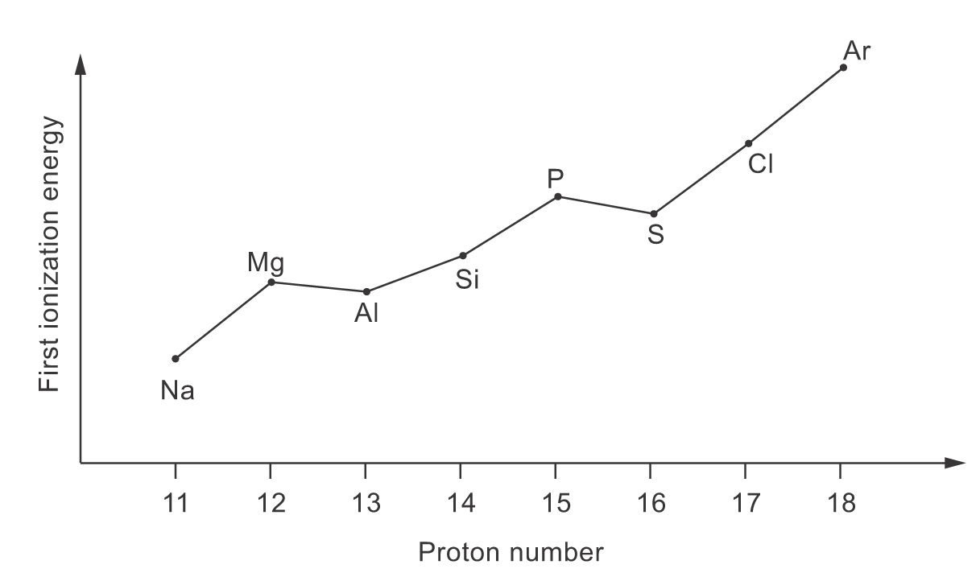
(i) The general increase in first ionization energy from Na to Ar is owing to the increase in
nuclear charge and decrease in atomic radius.
Shielding does not increase very much because the electrons all enter the same shell.
However, the increase in number of protons in the nucleus produces greater electrostatic
attraction
towards the outermost electron.
(ii) Mg [Ne] 3s²
Al [Ne] 3s² 3p¹
P [Ne] 3s² 3p_{x}¹ 3p_{y}¹ 3p_{z}¹
S [Ne] 3s² 3p_{x}² 3p_{y}¹ 3p_{z}¹
The first ionization energy of Al is lower than that of Mg because less energy is required to
remove a 3p electron in Al than a 3s electron in Mg. This is because the 3p electron is further away from the nucleus and it is less shielded when compared with the 3s electrons.
The first ionization energy of S is lower than that of P as less energy is required to remove an electron from the paired 3p electrons in S. This is because electron repulsion arising from two electrons occupying the same orbital.

(b) The ionic radius of Mg²⁺ is smaller than that of Na⁺ because Mg²⁺ has one more proton in the nucleus, but is isoelectronic with Na⁺. The same number of electrons are attracted more strongly in Mg²⁺ dut to larger nuclear charge.
(c) (i)
 | Na⁺ | Mg²⁺ | Al³⁺
Ionic radii/nm: | 0.095 | 0.065 | 0.050

The increasing acidity of the solutions is due to greater hydrolysis arising from the increase
in charge density and thus the polarizing power of the cation from Na⁺ to Al³⁺.
NaCl dissolves in water to give a neutral solution (pH 7). It does not further react with water.
NaCl(s) + aq → Na⁺(aq) + Cl－(aq)
MgCl₂ dissolves in water with slightly hydrolysis due to the larger polarizing power of Mg²⁺
ions.
MgCl₂(s) + aq → [Mg(H₂O)₆]²⁺(aq) + 2Cl－(aq)
[Mg(H₂O)₆]²⁺ [Mg(H₂O)₅(OH)]⁺ + H⁺
The solution is slightly acidic (pH 6).
AlCl₃ dissolves in water and hydrolyzes to give an acidic solution (pH ≈ 3).
AlCl₃(s) + aq → [Al(H₂O)₆]³⁺(aq) + 3Cl－(aq)
[Al(H₂O)₆]³⁺ → [Al(H₂O)₅(OH)]²⁺ + H⁺

(ii)
 | Ca²⁺ | Be²⁺
Ionic radii/nm | 0.099 | 0.031
The pH of 1.0 mol dm^{－3} solution of CaCl₂ is about 6.3.
This is because Ca²⁺ is less polarizing than Mg²⁺ but more polarizing than Na⁺ (since Ca²⁺ is
larger than Mg²⁺ but smaller than Na⁺). Therefore, CaCl₂ is less acidic than MgCl₂ but more
acidic than NaCl.
The pH of 1.0 mol dm^{－3} solution of BeCl₂ is about 3.0.
This is because Be²⁺ is more polarizing than both Mg²⁺ and Na⁺, and it has about the same
polarizing power as Al³⁺. Thus, BeCl₂ has about the same acidity as AlCl₃.
[Accepted pH values: between 6.1 and 7.0 for CaCl₂(aq); between 0 and 5.9 for BeCl₂(aq)]

21. Plots of atomic and ionic radii of Na to Cl
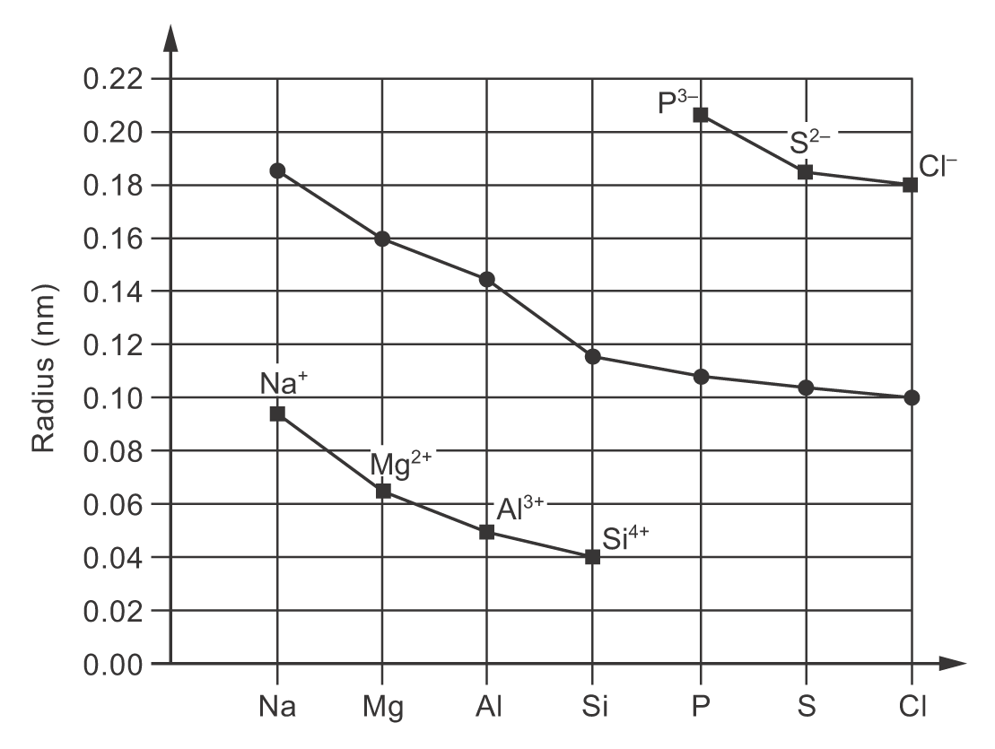
Atomic radii decrease from Na to Cl due to the increase in nuclear charge and nearly same screening
effect as successive electrons are added to same quantum shell. Therefore, the outer electrons are more
strongly held by the nucleus and the screening effect by the inner shells of electrons has little change
only.
The cations of Na⁺ to Si⁴⁺ are smaller than their corresponding atoms because a cation has one
electron shell less than neutral atoms. Therefore, the outer electrons are more strongly held by the
nucleus.The anions of P^{3－} to Cl－ are larger than their corresponding atoms because the number of
electrons in anion is more than protons . Thus, the effective attractive force on the outer electrons is less
than that in the atoms. Hence, the outer electrons are less strongly held by the nucleus.
Anions are larger than cations as anions have one more electron shell. Thus, the outer electrons
are less strongly attracted by the nucleus. The ionic radii decreases along the isoelectronic series
(Na⁺ to Si⁴⁺ and P^{3－} to Cl－) because the same number of electrons are attracted more strongly by the
increasing amount of nuclear charge.

22. (a) With aqueous sodium hydroxide:
(i) Al₂O₃
Al₂O₃ + 2NaOH +3H₂O → 2NaAl(OH)₄
[or Al₂O₃ + 6NaOH → 2Na₃AlO₃ + 3H₂O]
(ii) SO₂
SO₂ + 2NaOH → Na₂SO₃ + H₂O
(b) With concentrated hydrochloric acid:
(i) Al₂O₃
Al₂O₃ + 6HCl → 2AlCl₃ + 3H₂O
(ii) PbO₂
PbO₂ + 4HCl → PbCl₂ + Cl₂ + 2H₂O

23. NCl₃ (l) +3H₂O (l) → NH₃ (aq) + 3HOCl (aq)
PCl₃ (l)+ 3H₂O (l) → H₃PO₃ (aq) + 3HCl (aq)

24. (a) B₂O₃ — acidic
Al₂O₃ — amphoteric
(b)
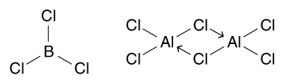

25 (a) (i) The steamy fumes are hydrogen chloride (HCl).
(ii) AlCl₃(s) + 3H₂O(l) → Al(OH)₃(s) + 3HCl(g)
(iii) Because Al³⁺ ion is small and highly charged, it has high polarizing power. It attracts electrons on oxygen causing extra high polarization on O－H bond. Thus, the Al－O bond is strengthened while O－H is weakened. As O－H bond is weakened, another water molecule attracts the hydrogen and remove as proton. The proton formed reacts with Cl－to form HCl.

(b) (i) The bonding in hydrated aluminium chloride is ionic predominant.
(ii) Hydrated aluminium chloride dissolves in water to give [Al(H₂O)₆]³⁺(aq) and chloride ions. [Al(H₂O)₆]³⁺(aq) may undergo further dissociation to give an acidic solution by cation hydrolysis.
[Al(H₂O)₆]³⁺(aq) + H₂O(l) [Al(H₂O)₅(OH)]²⁺(aq) + H₃O⁺(aq)
The solution is acidic due to the presence of protons.

