Part 10 Organic Syntheses and Structural Determination (Book 3B, p. 188 – p.197)

33. (a) Heating bromoethane with excess alcoholic NH₃ in a sealed tube.
CH₃CH₂Br + 2NH₃ ⎯→ CH₃CH₂NH₂ + NH₄Br

(b) Reflux bromethane with alcoholic KCN to give propanenitrile.
CH₃CH₂Br + KCN ⎯→ CH₃CH₂CN + KBr

Reduction of propanenitrile with anhydrous LiAlH₄ in dry ether.
CH₃CH₂CN + [H] ⎯→ CH₃CH₂CH₂NH₂

34. The absorption peak P located around 2200 to 2300 cm^{–1} corresponds to the stretching vibration of the
C ≡ N bond.
The absorption peak Q located at 1700 cm^{–1} corresponds to the stretching vibration of the C = O bond.
The absorption peak R located around 1000 to 1100 cm^{–1} corresponds to the stretching vibration of the C – O bond.
One possible structure of X is:
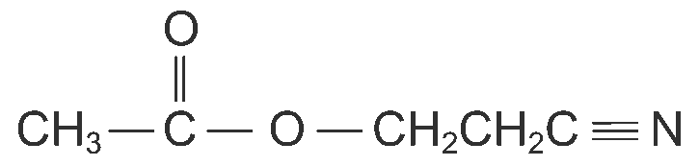

35. Limonene is oxidized to an acid, B, C₉H₁₄O₄, with the cleavage of C = C bonds.
Since H⁺ + OH– ⎯→ H₂O
Number of moles of H⁺ = Number of moles of OH–
= 0.10 × $\frac{5\text{.}4}{\text{1000}}$
= 5.4 × 10^{–4} mol
Molar mass of B = 12.0 x 9 + 1.0 x 14 + 16.0 x 4 = 186 g mol⁻¹
Number of moles of B = $\frac{0\text{.}\text{10}}{\text{186}}$ = 5.4 × 10^{–4} mol
Therefore, B is a monobasic acid.
As B gave precipitates with 2,4-dinitrophenylhydrazine, this shows that B contains a carbonyl group. However, B did not react with Fehling’s solution, therefore B is not an aldehyde.
B gave precipitates with aqueous, alkaline iodine showing the presence of methyl ketone.

Therefore, the structure of B is:
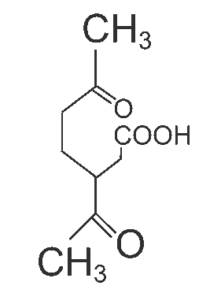

36. (a) (i) Nucleophilic substitution
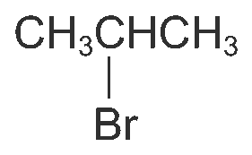
Product:

(ii) Redox reaction
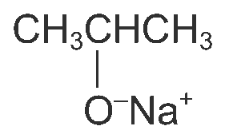
Product:

(iii) Oxidation (triiodomethane test)
Products: CHI₃ and CH₃COO⁻Na⁺

(b) Alcohol B is oxidized by acidified K₂Cr₂O₇ to C. C is a carboxylic acid because it contains two oxygen atoms per molecule. Thus, B is a primary alcohol in order to be oxidized to an acid.
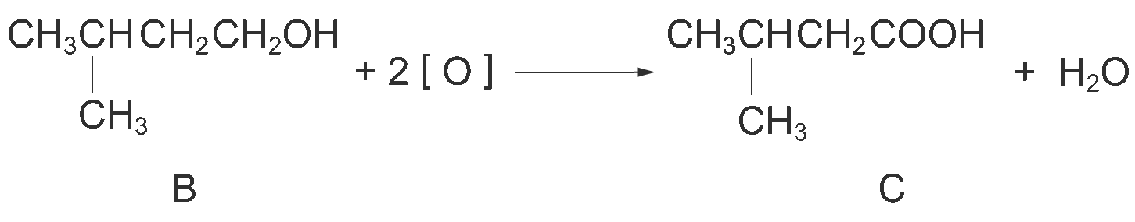

When heated over Al₂O₃, alcohol B undergoes dehydration to give an alkene, D.
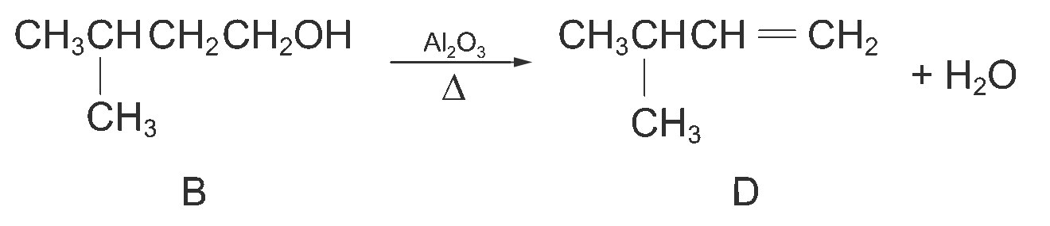

Under vigorous oxidation, D gives 2-methylpropanoic acid. It shows that D is a terminal alkene because one carbon atom is lost when the C = C bond is broken.
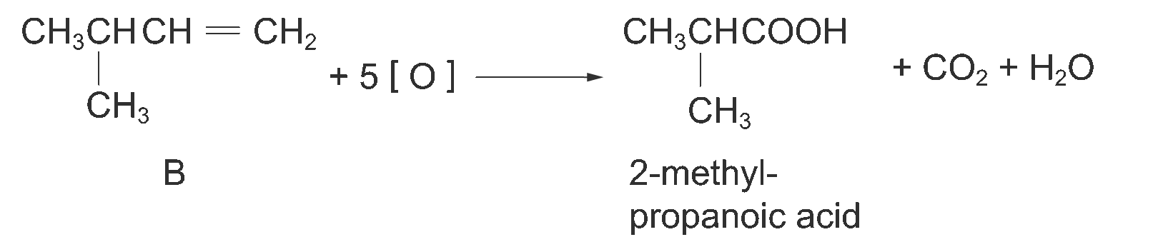

37. (a) Benzocaine is expected to be oil-soluble. The reasone is that it contains the ester group which is hydrophobic and phenylamine which is insoluble in water. Moreover, benzocaine is a large aromatic molecule and is not able to form hydrogen bonds with water molecules. Thus benzocaine is insoluble in water.

(b) (i) Stage I: concentrated HNO₃ and concentrated H₂SO₄; reflux at 55°C
Stage II: acidified KMnO₄; reflux
Stage III: ethanol; reflux in the presence of a small amount of concentrated H₂SO₄
Stage IV: Sn and concentrated HCl; reflux

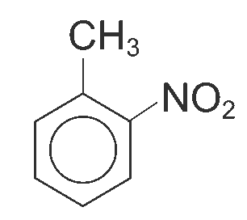
(ii)

38. Let the mass of the salt be 100 g.

 | Carbon | Hydrogen | Oxygen | Nitrogen
Mass (g) | 46.1 | 9.6 | 30.8 | 13.5
Number of moles (mol) | $$\frac{\text{46}\text{.}1}{\text{12}\text{.}0}$$  = 3.84 | $$\frac{9\text{.}6}{1\text{.}0}$$  = 9.6 | $$\frac{\text{30}\text{.}8}{\text{16}\text{.}0}$$  = 1.93 | $$\frac{\text{13}\text{.}5}{\text{14}\text{.}0}$$  = 0.96
Simplest mole ratio | $\frac{3\text{.}\text{84}}{0\text{.}\text{96}}$ = 4 | $\frac{9\text{.}6}{0\text{.}\text{96}}$ = 10 | $\frac{1\text{.}\text{93}}{0\text{.}\text{96}}$ ≈ 2 | $\frac{0\text{.}\text{96}}{0\text{.}\text{96}}$ = 1

∴ The ratio of C : H : O : N is 4 : 10 : 2 : 1.
∴ The empirical formula of the salt is C₄H₁₀O₂N.

As the organic acid is dibasic, 2 moles of propylamine react with 1 mole of the acid to give the neutral salt.
Therefore, the molecular formula of the salt is C₈H₂₀O₄N₂.
The salt is (CH₃CH₂CH₂NH₃⁺)₂(–O₂C – CO₂–).
The organic acid is ethanedioic acid, H₂C₂O₄, and its structure is:
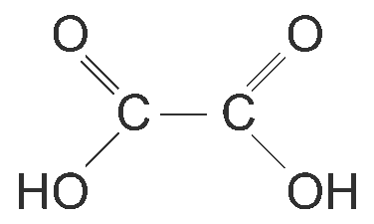

39. (a) Plastics are formed by the polymerization of organic compounds. Organic compounds are formed by linking atoms to each other by covalent bonds. The atoms in the compound are not stationary, but they vibrate continuously. The covalent bonds act as springs. The energy needed for the bond to vibrate is quantized and its amplitude can only have certain values. The energy needed to excite the bonds in a compound making them vibrate more energetically occurs in the infrared region of the electromagnetic spectrum. Therefore, plastics absorb infra-red radiation.

(b) The frequency of vibration of a pair of bonded atoms depends on the masses of the atoms and the strength of the bond. The heavier the atom, the lower the frequency at which it vibrates. The stronger the bonds, the higher frequency at which it vibrates. Different plastics are made of different organic compounds. Different organic compounds are constructed of different atoms and order of bonds. Therefore, they would absorb in different regions of the infra-red spectrum.

(c) Plastic A:
(i) The absorption peak around 2000 cm^{–1}; (ii) the peak corresponds to the stretching vibration of the C ≡ C triple bond.
Plastic B:
(i) The absorption peak around 1650 cm^{–1}; (ii) the peak corresponds to the stretching vibration of the C = C double bond.
Plastic C:
(i) The absorption peak around 1700 cm^{–1}; (ii) the peak corresponds to the stretching vibration of the C = O double bond.

40. (a) Let the mass of A be 100 g.

 | Carbon | Hydrogen | Oxygen
Mass (g) | 40.0 | 6.65 | 53.3
Number of moles (mol) | $\frac{\text{40}\text{.}0}{\text{12}\text{.}0}$ = 3.33 | $\frac{6\text{.}\text{65}}{1\text{.}0}$ = 6.65 | $\frac{\text{53}\text{.}3}{\text{16}\text{.}0}$ = 3.33
Simplest mole ratio | $\frac{3\text{.}\text{33}}{3\text{.}\text{33}}$ = 1 | $\frac{6\text{.}\text{65}}{3\text{.}\text{33}}$ ≈ 2 | $\frac{3\text{.}\text{33}}{3\text{.}\text{33}}$ = 1

Therefore, the empirical formula of A is CH₂O.

(b) (i) A has a chiral centre. This means that there are four different atoms or groups of atoms are attached to one carbon.

(ii) A has a carboxyl group, –COOH.

(iii) A contains a methyl alcohol group (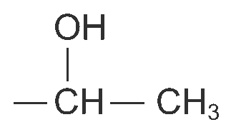) or methyl ketone group
(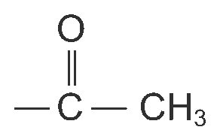).

(c) The displayed formula of A is:
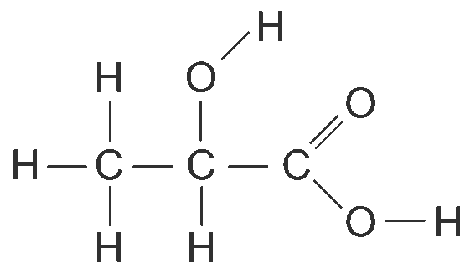

(d) The product is:
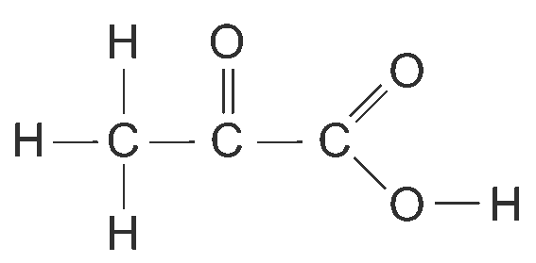

(e) The compound is:
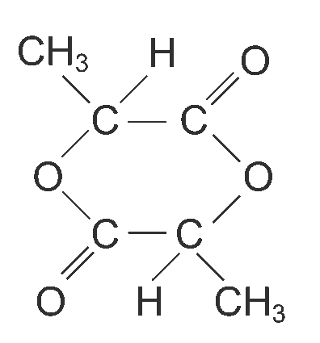
Ester group is present.

41. (a) (i) Reagent: Cl₂
Condition: AlCl₃

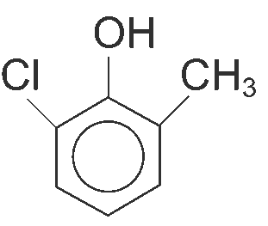
(ii)

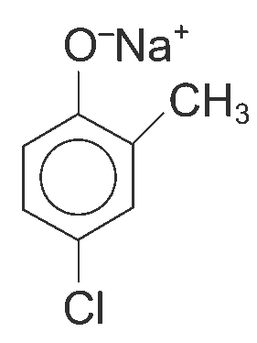
(b)

(c) Reagent: any mineral acid, e.g. dilute H₂SO₄, dilute HCl
Condition: room temperature

42. (a)
Step | Reagent | Condition
1 | Cl₂ | Ultraviolet light
2 | Ethanolic KCN | Heat/ reflux
3 | Dilute H₂SO₄ | Heat/ reflux

(b) (i) Nucleophilic substitution
(ii) Acid hydrolysis
(iii) Reduction

43. (a) (i) Na₂CO₃ is alkaline and reacts with the — SO₃H group to form SO₃–.
i.e. 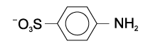
(ii) NaNO₂ and HCl forms HNO₂
HNO₂ reacts with the sodium salt of sulphanilic acid at 0 – 5°C to form benzenediazonium chloride. The benzenediazomium ion is only stable at very low temperatures.
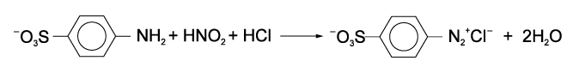

(iii) N,N-dimethylphenylamine is insoluble in water. The reaction with concentrated HCl to form an ion makes N,N-dimethylphenylamine soluble in water. Thus, N,N-dimethylphenylammonium ion becomes soluble in water and is able to react with the benzenediazomium ion in aqueous solution. 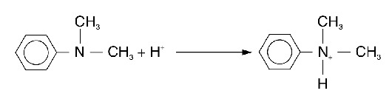
(iv) Coupling reaction to form an azo dye
(v) The function of the sodium hydroxide is to precipitate methyl orange as the sodium salt and to liberate the amine from the amine salt.

(b) Liquid from the mixture is sucked through the filter paper, leaving the solid.
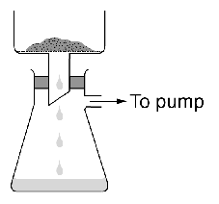

Increasing the suction causes the holes of the filter paper to be clogged by the very fine powder of methyl orange, and hence the rate of filtration decreases.

(c) The crystals are redissolved in a solvent, then the impurities are filtered off and the solution is evaporated to the point of crystallization.

Add crude methyl orange to hot water and stir until some remain undissolved. Filter off the undissolved methyl orange and impurities. Allow the solution to cool in an ice water bath. Filter gently under suction to collect pure methyl orange crystals. Place the crystals on a piece of filter paper and dry them in air.

(d) Place the crude ester in a separating funnel.
Add sodium carbonate solution and shake the funnel. Open the stopper occasionally to release the pressure due to the formation of CO₂. Allow the two layers to separate. Drain off the lower aqueous layer and collect the upper layer of containing the ester. Add anhydrous CaCl₂ to dry the ester. Filter off CaCl₂.

44. | (a) | (i) | 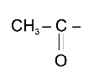 | and | 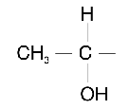

(ii) CHI₃

 | (b) | (i) | 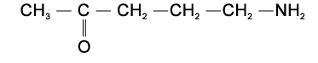
 |  | (ii) | 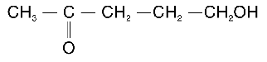
 |  | (iii) | 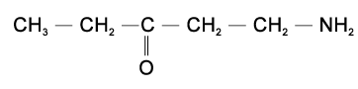

(c) (i) Structural isomerism

 |  | (ii) | 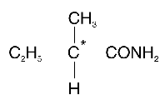

(iii) B could be:
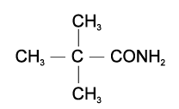
To distinguish B from C, we can put their solutions into a polarimeter respectively. Since C is optically active, it will rotate the plane of polarized light. However, B does not show this behaviour.

(d) (i) Add 2,4-dinitrophenylhydrazine into A. An orange precipitate is formed.

 |  | (ii) | 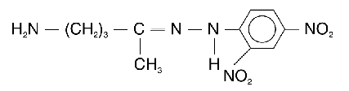

(iii) Determine the melting point of the solid formed and identify the compound A by matching the data with that shown in the data book.

 | (e) | 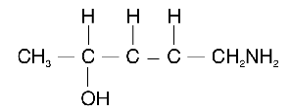

45. Let the mass of X be 100 g.

 | Carbon | Hydrogen | Oxygen
Mass (g) | 54.5 | 9.1 | 36.4
Number of moles (mol) | $\frac{\text{54}\text{.}5}{\text{12}\text{.}0}$ = 4.54 | $\frac{9\text{.}1}{1\text{.}0}$ = 9.1 | $\frac{\text{36}\text{.}4}{\text{16}\text{.}0}$ = 2.28
Simplest mole ratio | $\frac{4\text{.}\text{54}}{2\text{.}\text{28}}$ ≈ 2 | $\frac{9\text{.}1}{2\text{.}\text{28}}$ ≈ 4 | $\frac{2\text{.}\text{28}}{2\text{.}\text{28}}$ = 1

∴ The empirical formula of compound X is C₂H₄O.
Let the molecular formula of compound X be (C₂H₄O)_{n}.
Relative molecular mass of (C₂H₄O)_{n} = 44
n × (12.0 × 2 + 1.0 × 4 + 16.0 × 1) = 44
n = 1
∴ The molecular formula of compound X is C₂H₄O.
X contains a carbonyl group because it forms a yellow precipitate with 2,4-dinitrophenylhydrazine. Therefore, the structure of X is:
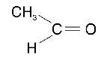

46. (a) (i) Reagent: NaCN in ethanolic solution
Condition: reflux
(ii) Reagent: dilute mineral acid, e.g. H₂SO₄ and HCl
Condition: heating
(iii) Reagent: bromine in sodium hydroxide solution
Condition: heating
(b) C₂H₅COCl

47. (a) (i) Esterification

(ii) Reflux an alcohol and a carboxylic acid (or a carboxylic acid derivative) in the presence of a small amount of concentrated H₂SO₄

(iii) (1) C₁₅H₃₁COCl
(2) NaOH
(b) (i) The solid sample of D could be purified by recrystallization.
Select a solvent which will readily dissolve the solid sample when hot, but only to a small extent when cold. Dissolve the solid sample in hot solvent and give a nearly saturated solution. Filter out any impurities from the hot solution. Cool the solution in a cold water bath and then to room temperature. Collect the crystals of product by suction filtration.

(ii) The purity of the sample can be checked by measuring the melting point of the solid. A pure sample should have a sharp melting point.

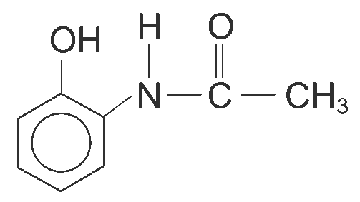
48. (a) (i) A:

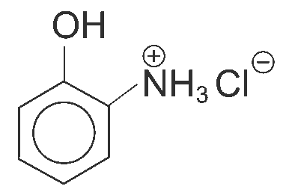
B:

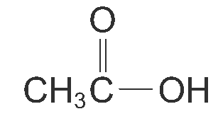
C:

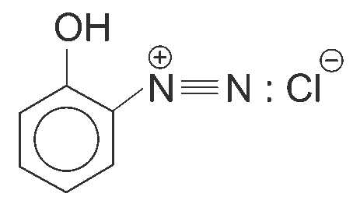
D:

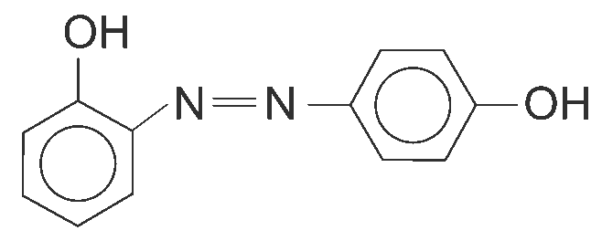
E:

(ii) From the data supplied, the compound A contains four degree of unsaturations. So the structure of A should contain one aromatic ring and one double bond.
We know that A is not a primary aromatic amine because it does not react with the mixture of sodium nitrite and hydrochloric acid at low temperatures. As it is not an amine, it is probably an amide.

When A and excess HCl was heated under reflux, it gave B and C. C is an organic acid because it reacted with sodium carbonate to give CO₂ gas.
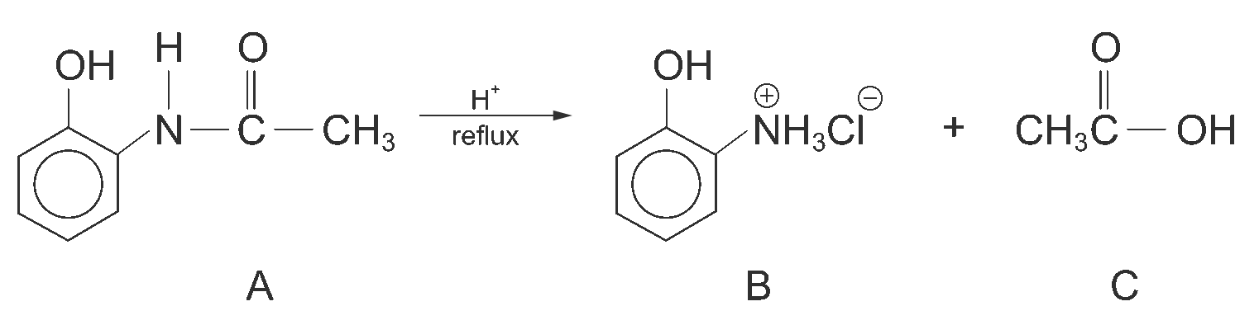

B reacted with sodium nitrite solution at low temperature, but no effervescence of gas is observed. This shows that it is a primary aromatic amine. Therefore, we can confirm that A is an amide as it is hydrolyzed to give an acid and a primary aromatic amine.
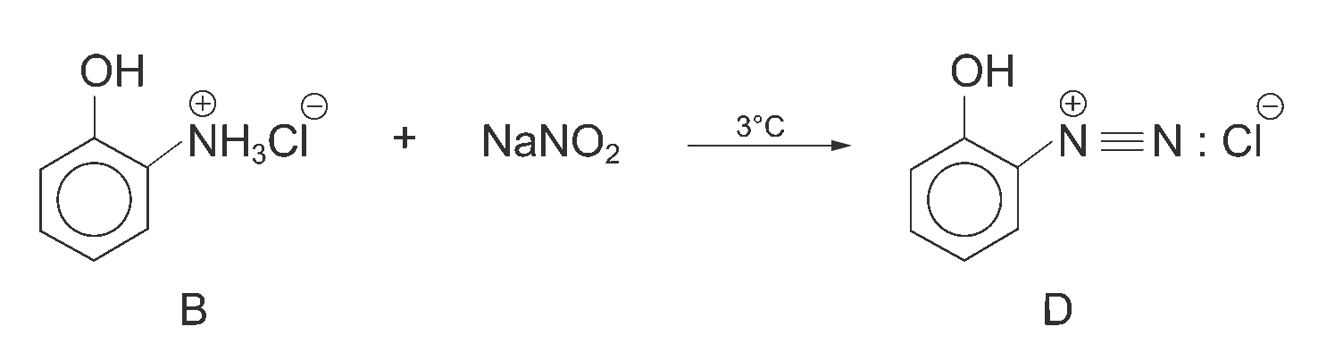

Addition of phenol to the solution gave a coloured precipitate confirmed that D is anbenzenediazomium ion and E is a coloured azo compound.
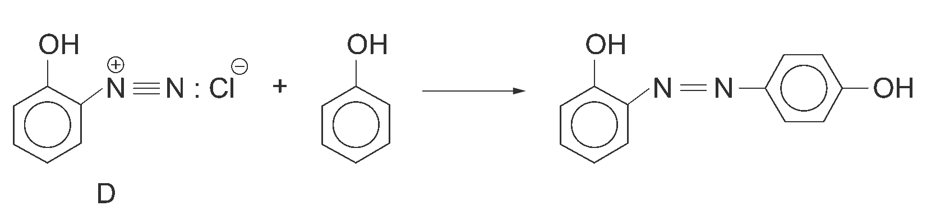

(b) Firstly, bromoethane is heated under reflux with the solution of sodium hydroxide in ethanol to give ethene. Ethene then reacted with bromoethane in 1,1,1-trichloroethane to give bromobutane. Bromobutane is heated under reflux with the solution of sodium hydroxide in ethanol to give but-1-ene. The but-1-ene formed is treated with concentrated sulphuric acid and followed by water to give butan-2-ol.
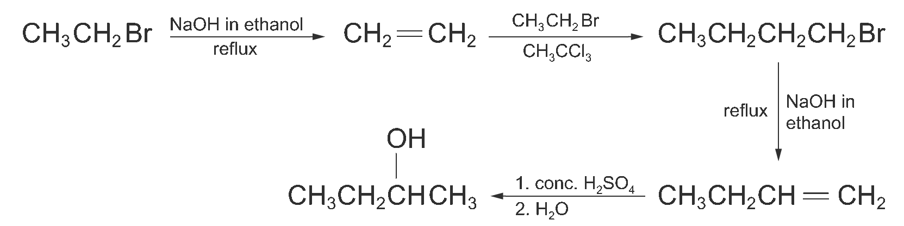
49. (a) Let the mass of compound A be 100 g.

 | Carbon | Hydrogen | Oxygen
Mass (g) | 68.2 | 13.6 | 18.2
Number of moles (mol) | $$\frac{\text{68}\text{.}2}{\text{12}\text{.}0}$$  = 5.68 | $$\frac{\text{13}\text{.}6}{1\text{.}0}$$  = 13.6 | $$\frac{\text{18}\text{.}2}{\text{16}\text{.}0}$$  = 1.14
Simplest mole ratio | $\frac{5\text{.}\text{68}}{1\text{.}\text{14}}$ ≈ 5 | $\frac{\text{13}\text{.}6}{1\text{.}\text{14}}$ ≈ 12 | $\frac{1\text{.}\text{14}}{1\text{.}\text{14}}$= 1

∴ The ratio of C : H : O is 5 : 12 : 1.
The empirical formula of compound A is C₅H₁₂O which is consistent with the information given.

(b) (i) CH₃CH₂CH₂CH₂CH₂OH

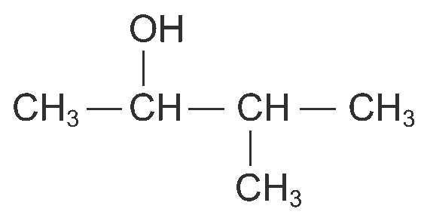
(ii)

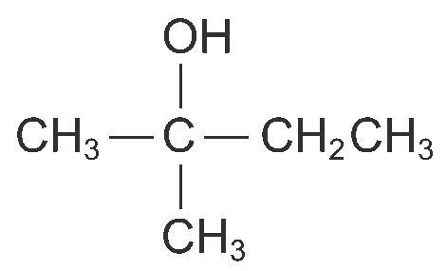
(iii)

(c) (i) CH₃CH₂CH₂CH₂COOH

(ii)

(iii) No product

(d) (i) CH₂ = CHCH(CH₃)CH₃ and CH₃CH = C(CH₃)₂
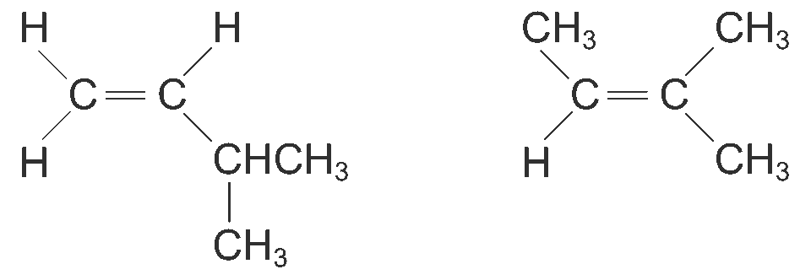

(ii) CH₂ = CHCH(CH₃)CH₃ was being analyzed. During the mass spectrometry, the
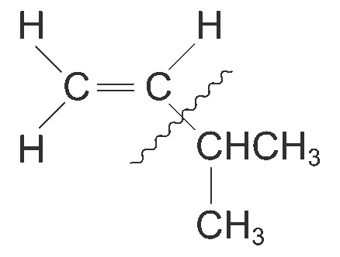

carbon-carbon bond ( ) is broken.

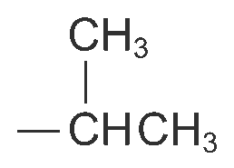
The group left has the m/e ratio of 43.

(e) (i) Reagent: 2-bromo-2-methylbutane and sodium hydroxide in ethanol
Condition: room temperature

(ii) Reagent: 2-methylbut-2-ene, concentrated sulphuric acid and followed by water
Condition: heating when water is added

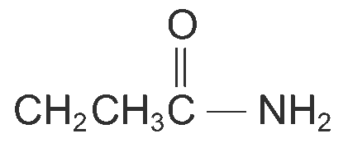
50. (a) B:

C: CH₃CH₂C ≡ N
D and E contain the amino group (─NH₂ group).

(b) (i) Reagent: LiAlH₄ in dry ether and followed by water
Condition: room temperature
(or hydrogen with Ni catalyst, heat up to 140°C)

(ii) Reagent: Bromine in potassium hydroxide solution
Condition: heating
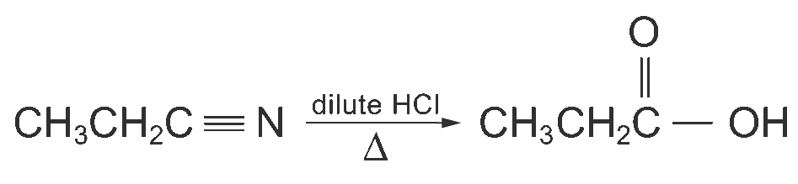
(c) (i)

(ii) Hydrolysis

(d) (i) The ─NH₂ group is basic in nature. This enables it to react with dilut hydrochloric acid.

(ii) CH₃CH₂CH₂NH₂ + HCl ⎯→ CH₃CH₂CH₂NH₃⁺Cl–

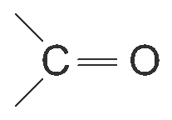
51. (a) (i) carbonyl group ( )

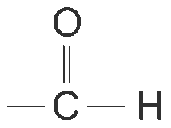
(ii) aldehyde group ( )

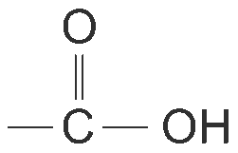
(iii) hydroxy group (─OH) and carboxyl group ( )

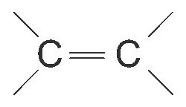
(iv) carbon-carbon double bond ( )

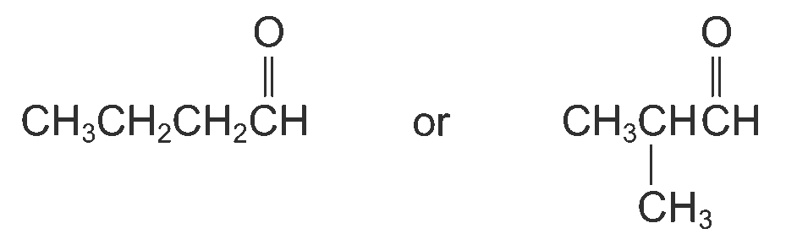
(b) (i)

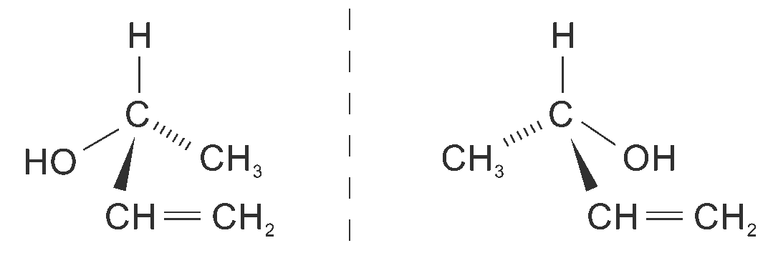
(ii)

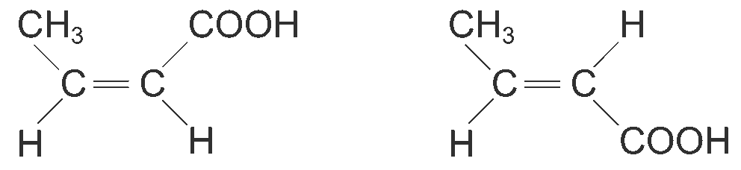
(iii)

52.
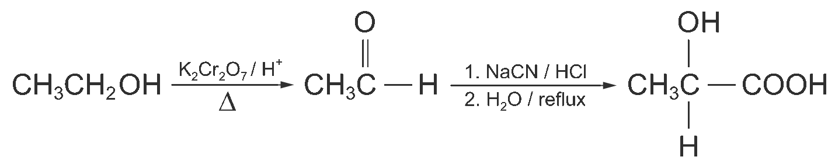

53. (a) (i) The melting point will not be sharp if the sample contains impurities. Therefore, the solid E has to be purified by recrystallization before determination of the melting point.

(ii) Carbon-oxygen double bond (C = O)

(iii) The absorption peak at 3500 cm^{–1} corresponds to the stretching vibration of the O ─ H bond. The peak is appeared as a broad band is due to the vibration of the O ─ H bond is complicated by the hydrogen bonding formed between the molecules.

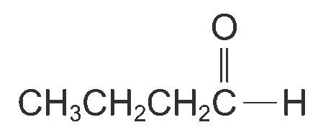

(iv) A: B:

(b) (i) Reagent: sodium hydroxide
Solvent: ethanol

(ii) CH₂ = CHCH₂CH₃

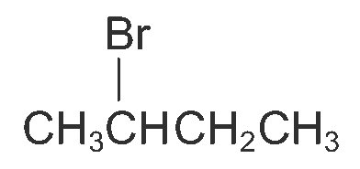
(iii)

(iv) The reaction in (iii) is an electrophilic addition, and the reaction follows Markownikoff’s rule. Markownikoff’s rule states that in the addition of HX to an unsymmetrical alkene, the hydrogen atom adds to the carbon atom of the carbon-carbon double bond that already has the greater number of hydrogen atoms.
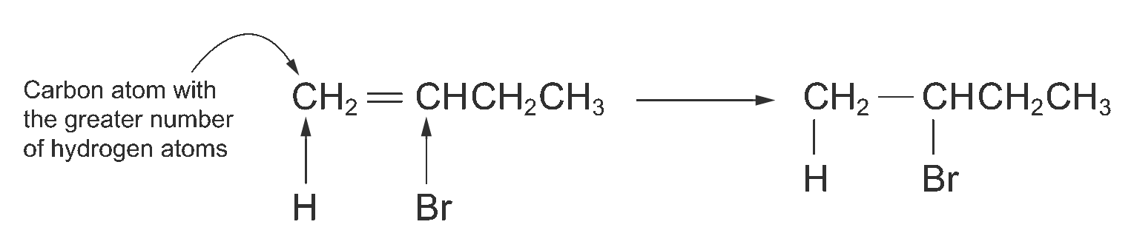
In fact, Markownikoff’s rule is related to the stability of the carbocation intermediates formed in the electrophilic addition reaction. As shown in the above equation, if the hydrogen atom of HBr adds to carbon atom, a secondary carbocation is formed as the intermediate. On the other hand, if the hydrogen atom of HBr adds to another carbon atom, a primary carbocation is formed instead. Since secondary carbocations are more stable than primary carbocations, 2-bromobutane is formed as the major product.
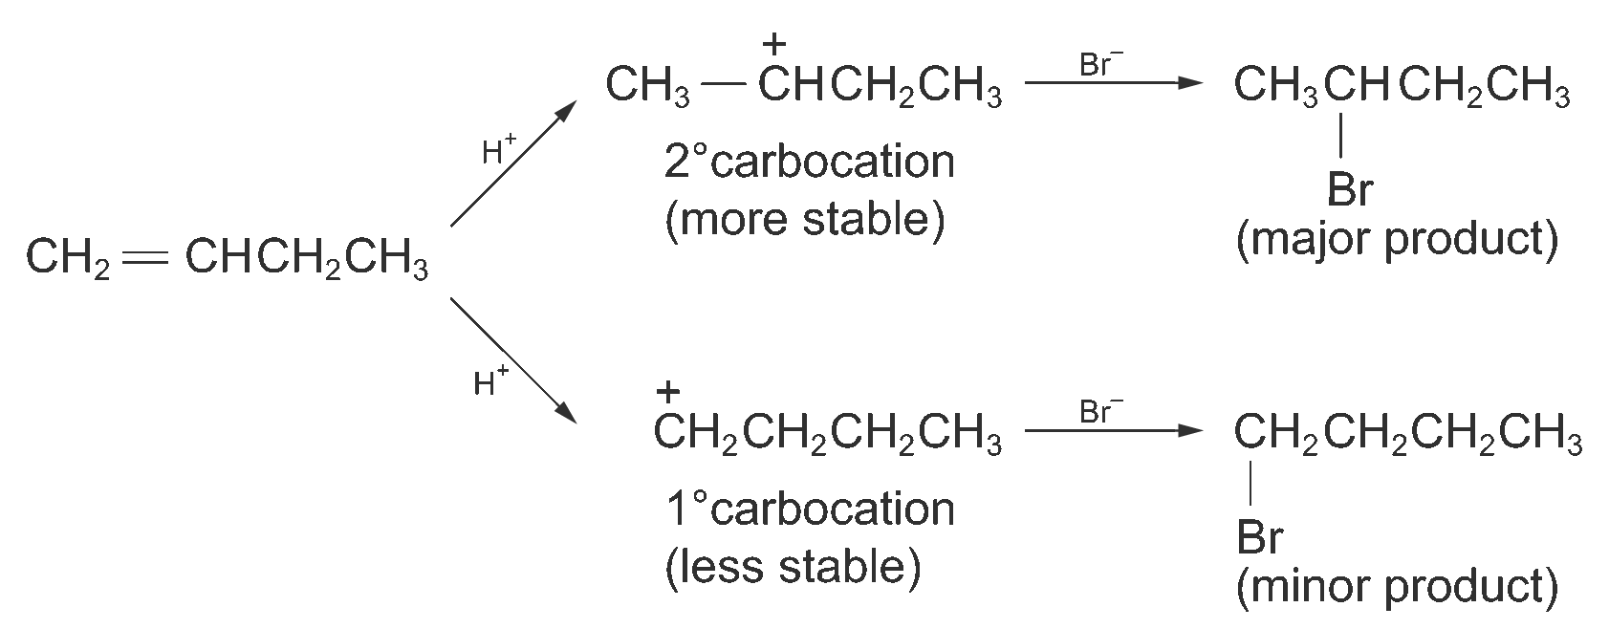

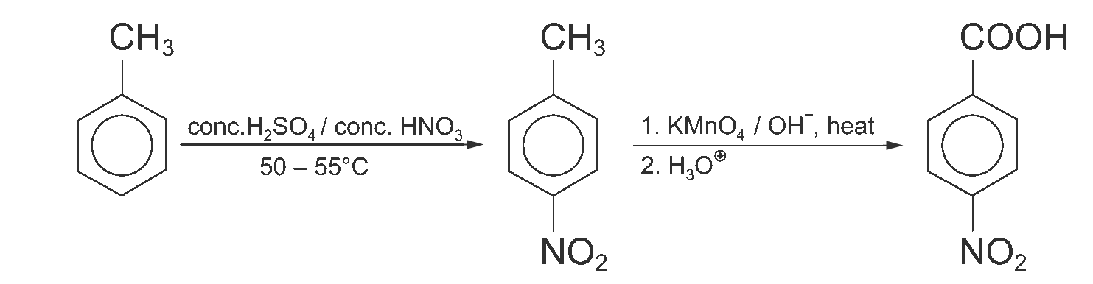
54.

55. (a) Let the mass of compound E be 100 g.

 | Carbon | Hydrogen | Oxygen
Mass (g) | 54.6 | 9.1 | 36.4
Number of moles (mol) | $\frac{\text{54}\text{.}6}{\text{12}\text{.}0}$= 4.55 | $\frac{9\text{.}1}{1\text{.}0}$= 9.1 | $\frac{\text{36}\text{.}4}{\text{16}\text{.}0}$= 2.275
Simplest mole ratio | $\frac{4\text{.}\text{55}}{2\text{.}\text{275}}$= 2 | $\frac{9\text{.}1}{2\text{.}\text{275}}$= 4 | $\frac{2\text{.}\text{275}}{2\text{.}\text{275}}$= 1

∴ The ratio of C : H : O is 2 : 4 : 1.
∴ The empirical formula of compound E is C₂H₄O.

(b) In the mass spectrum, there are three prominent peaks, the highest peak at m/e 29, the second at m/e 44, the third peak at m/e 15. From the empirical formula, the empirical formula mass is 44 which is the same as the peak at m/e 44. Therefore, the molecular mass of compound E is 44 and the molecular formula is C₂H₄O.
From the molecular formula, we know that compound E has one degree of unsaturation.
In the IR spectrum, the sharp peak at 1720 cm^{–1} corresponds to the stretching vibration of the C = O double bond.
According to the above interpretation, we can deduce that compound E is ethanal.

56. (a) CH₃CH₂CH₂CN

(b) (i) Reagent: PBr₃
Condition: heat

(ii) Reagent: KCN in ethanol
Condition: reflux

(c) (i) Nucleophilic substitution
(ii) Hydrolysis

57. (a) Let the mass of compound A be 100 g.

 | Carbon | Hydrogen
Mass (g) | 80.0 | 20.0
Number of moles (mol) | $\frac{\text{80}\text{.}0}{\text{12}\text{.}0}$= 6.67 | $\frac{\text{20}\text{.}0}{1\text{.}0}$= 20
Simplest mole ratio | $\frac{6\text{.}\text{67}}{6\text{.}\text{67}}$= 1 | $\frac{\text{20}}{6\text{.}\text{67}}$= 3

∴ The C : H ratio is 1 : 3.
∴ The empirical formula of compound A is CH₃.

(b) Let the molecular formula of compound A is (CH₃)_{n}
Relative molecular mass of (CH₃)_{n} = 30
(12.0 × 1 + 1.0 × 3)n = 30
15n = 30
n = 2
∴ The molecular formula of compound A is C₂H₆.

