Part 7 Phase Equilibria (Book 2, p.295 – p.298)

20. | (a) | 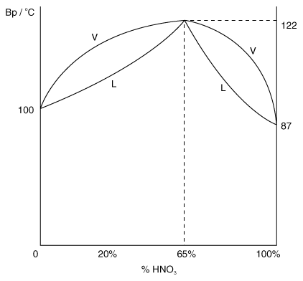

(b) Simple distillation of a 20% HNO₃ – H₂O mixture: The residual mixture becomes more concentrated in HNO₃ until it reaches a maximum constant composition of 65% HNO₃ (i.e. azeotropic mixture).
Temperature of residual mixture increases until it reaches a constant boiling point of 122°C.

(c) (i) Raoult’s law states that the vapour pressure of a component in a mixture at a given temperature is directly proportional to its mole fraction, and is equal to the product of its mole fraction and vapour pressure of the pure component at that temperature.

(ii) Mixture shows negative deviation from Raoult’s Law. The attractions between HNO₃ and H₂O (ion-water dipoles) are stronger than the attractions between molecules in the pure liquids.

21. (a) Chromatography is a method used to separate and analyze mixtures. It is based on the difference in solubility of the solute in the stationary and mobile phases.

22. | (a) | 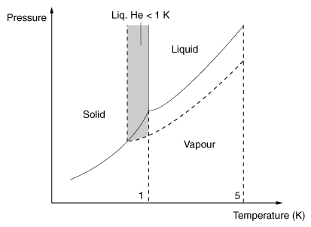

The solid-liquid equilibrium line is vertical since the volume of solid and liquid He is the same for a fixed mass of He, i.e. pressure has no effect on mp.

(b) It can be done by adding a 2nd-component to Helium.

(c) Presence of many other elements increases the boiling point of He. Hence it is possible to have He liquid in the sun even when the temperature is very high.

23. (a) (i) Run 1st chromatogram using one solvent.
Turn the developed chromatogram by 90° and run again using a second solvent.

(ii) 3 components

(b) (i) The injected sample vaporises and the components are carried along by the carrier gas.
The individual components are partitioned between the carrier gas (the more volatile components moves along with the carrier gas faster than the less volatile) and the liquid phase (the more soluble components will be absorbed more strongly to the liquid phase).
The individual components emerges from the column and are detected by the detector as signals.

(ii) A narrow column is to ensure each of the components emerges one at a time from the column.

24. (a) (i) Raoult’s Law states that the partial vapour pressure of a component over a miscible liquid mixture at a given temperature, is equal to the vapour pressure of pure component at the same temperature, multiplied by the mole fraction of it in the liquid mixture.
(ii) Raoult’s law is obeyed when the intermolecular forces between liquid molecules in the mixture are the same as in the pure liquids.

(b) Mixture B is most likely to behave like X and Y. This is because the intermolecular forces of attraction between the liquid molecules in mixture B are weaker than that between the pure liquid due to the intermolecular hydrogen bonding in propan-1-ol and van der Waals’ forces in methylbenzene.
Hence, vapour pressure of the liquid mixture is higher than that predicted by Raoult’s Law as shown by the graph given.

- Mixture B is a minimum boiling point azeotrope. The boiling point/composition curve is shown below:
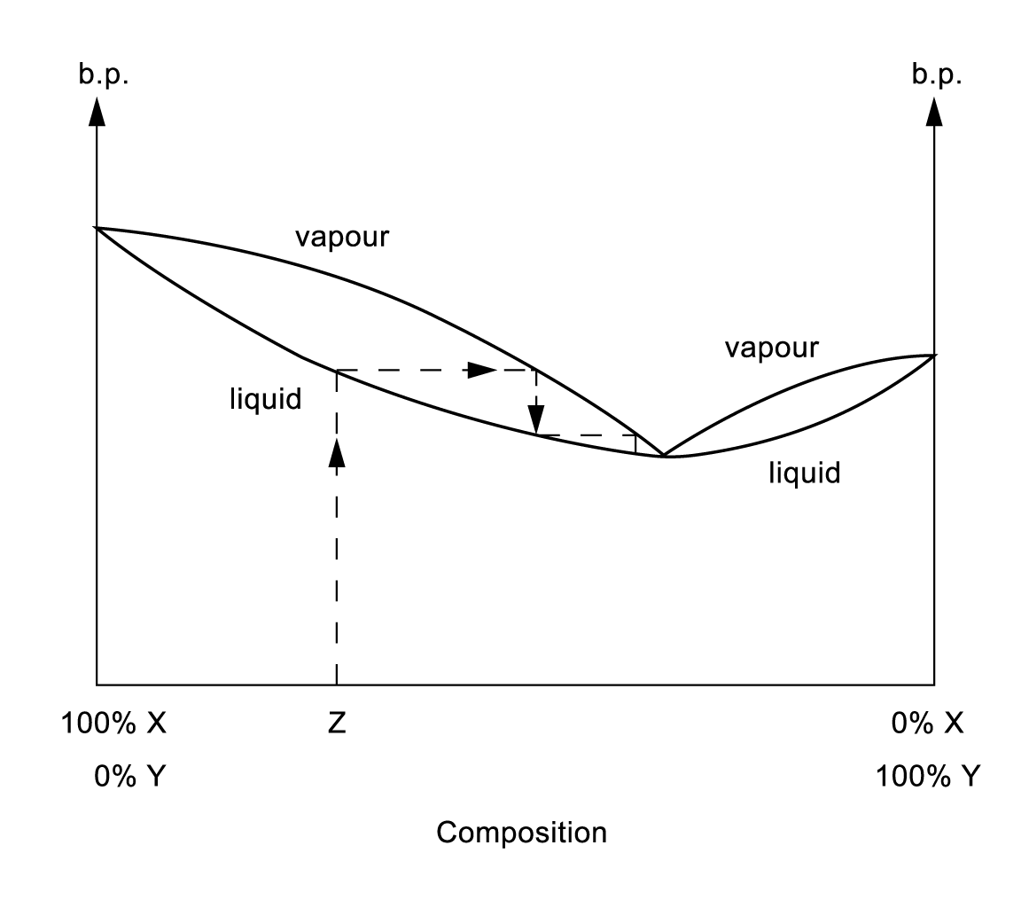

When a liquid sample of composition Z is fractionally distilled, the first distillate is the azeotropic mixture until pure X is left in the flask. As the temperature is raised to the boiling point of X, pure X is distilled as the second distillate.

25. (a) Partition coefficient, K, is defined as the ratio of the concentration of a solute in solvent A to the concentration of the solute in solvent B while A and B are immiscible solvents.
K=$\frac{[\text{solute}]_{\text{solvent A}}}{[\text{solute}]_{\text{solvent B}}}$
K is a constant when the temperature is constant and the solute is in the same molecular form in both solvents.
(b) mass of X extracted = (5.00 – 0.8) g = 4.2g
Partition coeff. = $\frac{[X]_{\text{ether}}}{[X]_{\text{aq}}}$ = $\frac{\frac{4\text{.}2}{\text{100}}}{\frac{0\text{.}\text{80}}{\text{50}}}$
= 2.63

26. The partial pressures of methanol/ethanol are directly proportional to the mole fraction of methanol/ethanol in a mixture of the two liquids.

Intermolecular forces of attraction between methanol molecules are similar to those between ethanol (i.e. H-bonding). Hence similar attractions between methanol and ethanol in the mixture ⇒ Ideal mixture
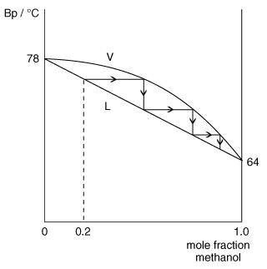

Fractional distillation of a mixture containing 0.2 mole fraction methanol will produce a vapour which is progressively richer in methanol as it ascends the fractionating column through repeated boiling and condensation.
Eventually a distillate containing pure methanol is obtained.

Mole fraction of methanol = $\frac{\frac{\text{64}}{\text{32}}}{\frac{\text{64}}{\text{32}} + \frac{\text{46}}{\text{46}}}$ =
P_{methanol} = × 81 = 54 mm Hg
P_{ethanol} = × 45 = 15 mm Hg
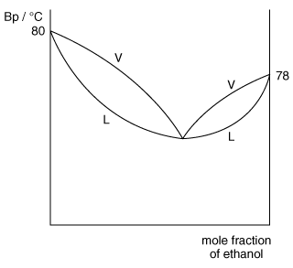

When benzene is added to ethanol, heat is absorbed on mixing. That is, the temperature decreases and the volume of mixture increases.

Mixture shows a positive deviation from Raoult’s Law ⇒ attractions between benzene and ethanol (dipole-induced dipole forces) are weaker than the forces of attractions in the pure liquids (H-bonding in ethanol).

27. (a) Mole fraction of CHCl₃ = $\frac{{\text{moles of CHCl}}_{3}\text{ in mixture}}{{\text{mole of CHCl}}_{3}+\text{ moles of organic liquid}}$

- It is the total vapour pressure of mixture if Raoult’s Law is obeyed.

 | (c) | (i) | 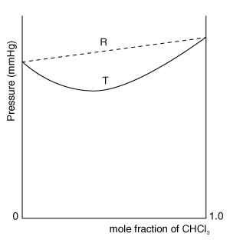
(ii) Negative deviation

(iii) Forces of attraction between CHCl₃ and the organic liquid are stronger than attractions between like molecules in the pure liquids.
⇒ vp of mixture is therefore lower than vp of pure liquids.
(iv) On mixing, temperature increases (i.e. exothermic).
The energy evolved on formation of attraction between CHCl₃ and the organic liquid in the mixture is greater than the energy absorbed to break the attraction between like molecules in the pure liquids.

(d) (i) Benzene and methylbenzene.

(ii) Forces of attraction between benzene molecules are similar to that between methylbenzene molecules (i.e. temporary dipole-induced dipole forces).

28. For a mixture of two liquids A and B forming an ideal solution. The partial pressure of A over a miscible liquid mixture of A and B is equal to the vapour pressure of pure A multiplied by the mole fraction of A at a given temperature.

The liquid mixture is said to be ideal if the intermolecular attraction between the molecules in the mixture is approximately equal to that in pure A and that in pure B.

The liquid mixtures which approximate to ideal behaviour can be separated into their pure components by fractional distillation. The separation is based upon the difference in boiling point of the components. The vapour formed above the liquid mixture is always richer in the more volatile component than the less volatile one. By successive condensation and boiling, the vapour of pure component A is obtained. The composition of the residual liquid becomes gradually richer in B. In petroleum refining, a fractionating tower is used to separate different components of petroleum.

When the average intermolecular attraction between molecules A and B is weaker than that between pure A and pure B, the mixture shows positive deviation from Raoult’s law.

On the other hand, if the average intermolecular attraction molecules A and B is stronger than that between pure A and pure B, the mixture shows negative deviation from Raoult’s law.

Since an azeotropic mixture is formed and the composition of the vapour and that of the liquid in it are the same, it is not possible to obtain pure components in this manner.

29.
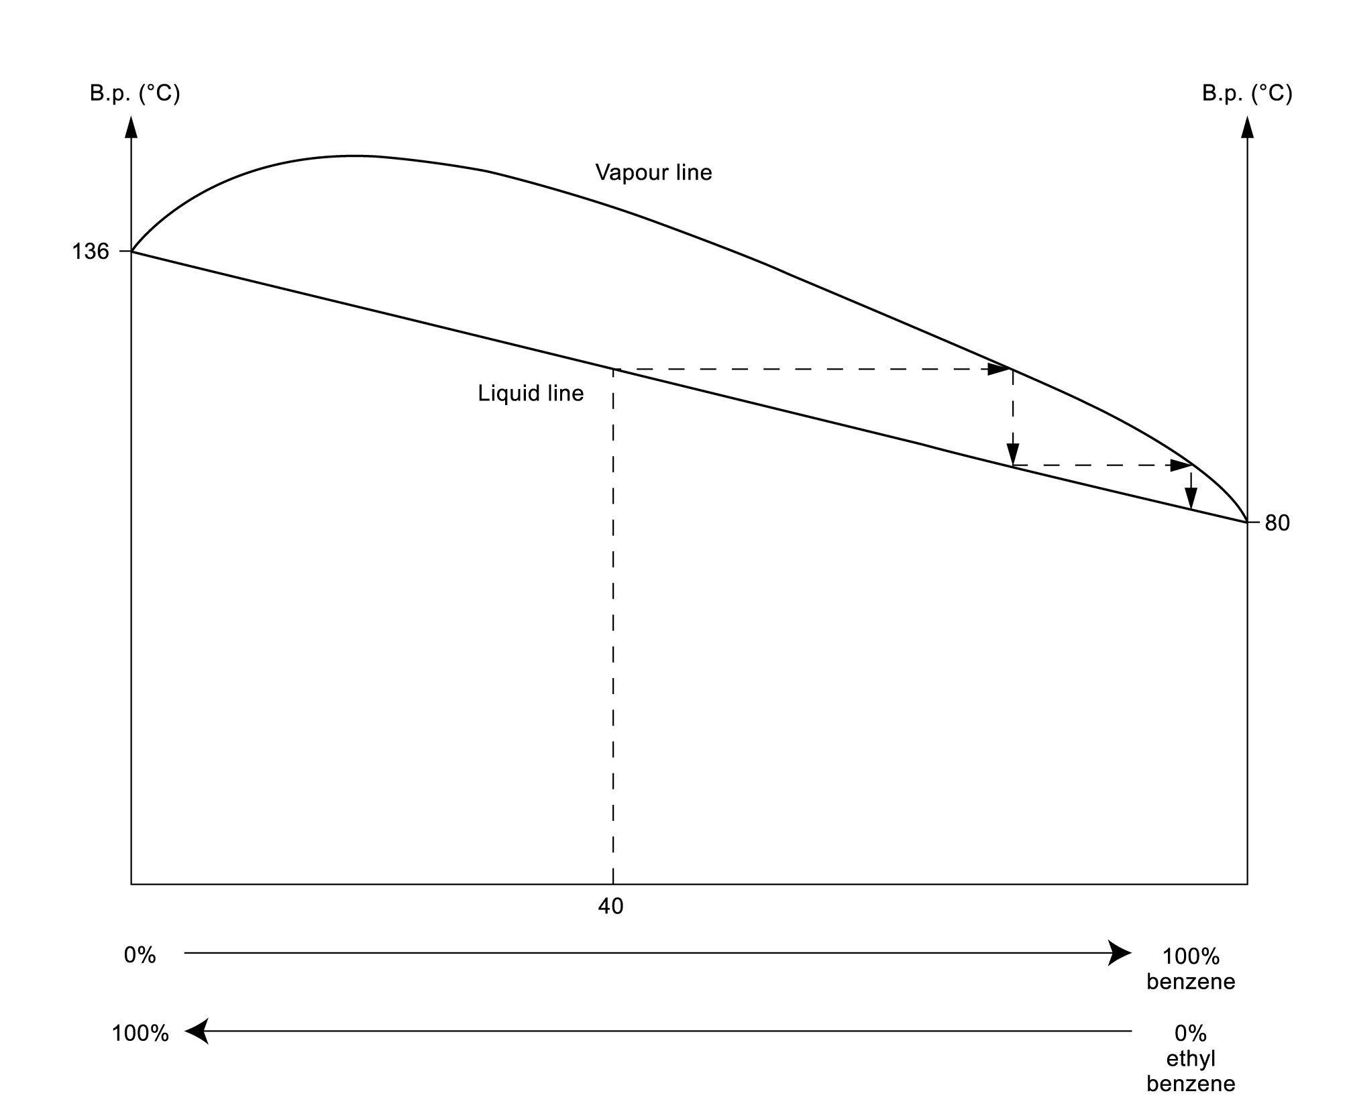

Fractional distillation of a mixture containing 40% benzene and 60% ethylbenzene will produce a vapour which is progressively richer in benzene as it ascends the fractionating column through repeated boiling and condensation. Eventually, a distillate containing pure benzene is obtained.

30. (a) PCl₅(g) + H₂O(l) ⎯→ 2HCl(aq) + POCl₃(aq)

(b)
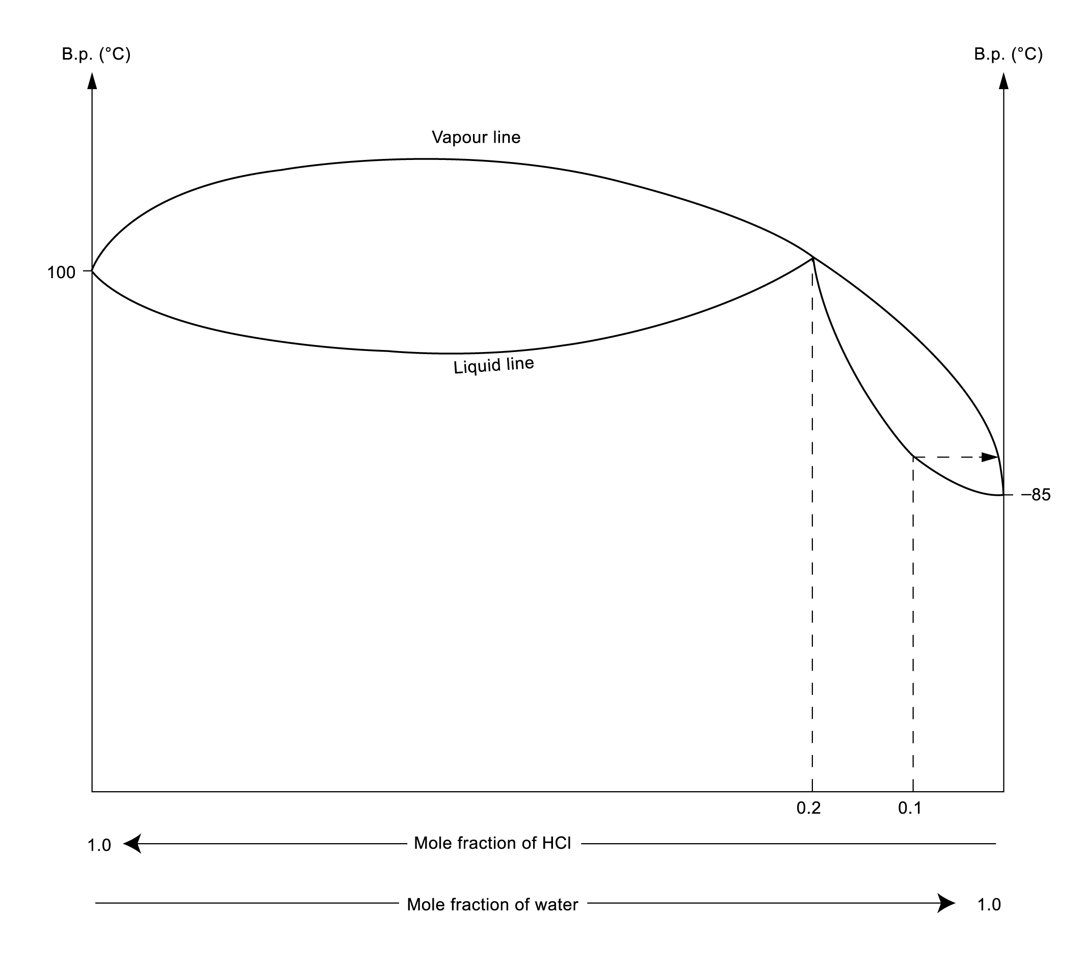
(c) When we choose a liquid contains a mole fraction of HCl of about 0.1, repeated distillation occurs until pure HCl is obtained in the distillate.

