Part 6 Chemical Equilibria (Book 2, p.229 – p.246)

35. (a) (i) pH is defined as the negative logarithm of the concentration of hydroxonium ions in mol dm⁻³ of the solution.
pH= ﹣log[H₃O⁺(aq)]

(ii) pH = 3.5
[H⁺] = 3.16 × 10^{–4} mol dm⁻³

(b) = 1
[acid] = 0.11 mol dm⁻³

(c) (i) It is a weak acid, it undergoes partial dissociation.
∴ [H⁺] « [acid]

(ii)&(iii) K_{a} = =
= 9.08 × 10^{–7} mol dm⁻³

(d) Weak acid – strong base titration
pH at equivalence pt is within pH range of phenolphthalein.

36. (a) CO₃^{2–} remove additional H⁺ from added acid:
CO₃^{2–} + H⁺ HCO₃–
HCO₃– removes additional OH– from added alkali:
HCO₃– + OH– → CO₃^{2–} + H₂O

(b) K = [H⁺]
pH = 10.3 ⇒ [H⁺] = 5.012 × 10^{–11} mol dm⁻³
K = (5.012 × 10^{–11}) × 0.958
= 4.80 × 10^{–11} mol dm⁻³

(c) No. of moles of HCl = $\frac{\text{22}}{1 \text{000}}$ × 0.2 = 0.004 4
Let [HCO₃–] = a mol dm⁻³ ⇒ [CO₃^{2–}] = 0.958a
⇒ [H⁺] = a [H⁺] = 2 × 0.958a
No. of moles of [H⁺] = $\frac{\text{10}}{1 \text{000}}$ × a No. of moles of [H⁺] = $\frac{\text{10}}{1 \text{000}}$ × 2 × 0.958a

Total [H⁺] = $\frac{\text{10}}{1 \text{000}}$a(1 + 2 × 0.958) = 0.004 4
a = [HCO₃–] = 0.151 mol dm⁻³
∴ [CO₃^{2–}] = 0.145 mol dm⁻³

37. (a) Anode: impure copper block
Cathode: ultra pure copper
Electrolyte: aq. copper(II) sulphate

By adjusting voltage, at anode Zn impurities and Cu oxidise, but not Ag and Au.
Zn ⎯→ Zn²⁺ + 2e– E∅ = –0.76 V
Cu ⎯→ Cu²⁺ + 2e– E∅ = +0.34 V
Ag and Au impurities drop off from anode as they are exposed and collected as sludge on bottom of electrolytic bath.

At cathode, Cu²⁺ is reduced to form Cu:
Cu²⁺ + 2 e– ⎯→ Cu
Zn²⁺ remains in aq. solution.

(b) At cathode: Ag⁺ + e– ⎯→ Ag
At anode: 2H₂O ⎯→ O₂ + 4H⁺ + 4e–

4 mole Ag ≡ 4 mole e ≡ 1 mole O₂
i.e. 4 × 108 g Ag ≡ 22.4 dm³ O₂
∴ 0.54 g Ag ≡ × 0.54 dm³ O₂
= 0.028 dm³ O₂ at STP.

38. N₂O₄(g) 2NO₂(g)
(a) In a reversible reaction, a state of dynamic equilibrium is reached when rate of conversion of reactants into products equals rate of conversion of products back into reactants.

K_{p} = (P_{NO2})²/P_{N2O4}

(b) PV = nRT
n =
= 0.0129
n = ⇒ Mr = = 77.3

(c) (i) Increasing the pressure shifts equilibrium to LHS to produce more N₂O₄ (reduction in gas volume).
∴ Average Mr decreases.
(ii) Increasing temperature shifts equilibrium to RHS to produce more NO₂ (forward reaction is endothermic). Therefore, the average Mr decreases.

39. (b) Ag⁺ + e– ⎯→ Ag
Ni²⁺ + 2e– ⎯→ Ni

2 mols Ag ≡ 1 mol Ni
i.e. 2 × 108 g Ag ≡ 58.7 g Ni
Ratio of $\frac{\text{mass Ag}}{\text{mass Ni}}$ = $\frac{\text{2 }×\text{ 108}}{\text{58}\text{.}7}$ = 3.68

(c) (ii) Method described in c(i) cannot be used as it involves the equilibrium between Ca(s) and Ca²⁺(aq). Ca(s) reacts with H₂O.

(d) (i) Hydration of the gaseous ions to form aqueous ions.

(ii) Ca atom is a smaller atom than Ba ⇒ Ca has a much larger ΔH (ionisation energy) due to a larger effective nuclear charge.
Ca²⁺ ion being smaller than Ba²⁺ evolves a larger amount of energy during hydration (exothermic) which compensates for the more endothermic ΔH value of Ca ⇒ E∅ values ~ similar to Ba.

(e) MnO₄–(aq) — purple Cr₂O₇^{2–}(aq) — orange
Mn²⁺(aq) — light pink Cr³⁺(aq) — green

(f) (i) 5Fe²⁺ + MnO₄– + 8H⁺ → 5Fe³⁺ + Mn²⁺ + 4H₂O
(ii) 6Fe²⁺ + Cr₂O₇^{2–} + 14H⁺ → 6Fe³⁺ + 2Cr³⁺ + 7H₂O

(g) KMnO₄ can oxidise Cl– ions impurity in water but not K₂Cr₂O₇.

(h) (i) $n_{{\text{MnO}}_{4}}$ = 4 × 10^{–4} mol
$n_{{\text{Fe}}^{2+}}$ = 5 × 4 × 10^{–4} = 2 × 10^{–3} mol

(ii) $m_{{\text{Fe}}^{2+}}$ in 100 cm³ = 2 × 10^{–3} × 55.8 × 10 = 1.116 g
% Fe in nail = × 100 = 79.7%

40. (a) Discharge:
Cathode: PbO₂ + 4H⁺ + 2e– Pb²⁺ + 2H₂O
Anode: Pb Pb²⁺ + 2e–

Overall: PbO₂ + Pb + 4H⁺ 2Pb²⁺ + 2H₂O …… (I)

$E_{\text{cell}}^{∅}$ = $E_{\text{redn}}^{∅}$ – $E_{\text{oxidn}}^{∅}$ = +1.47 – (–0.13)
= +1.60 V

(b) Pb²⁺ + SO₄^{2–} → PbSO₄
[Pb²⁺] decreases ⇒ Equation in (I) shifts to produce more Pb²⁺
$E_{\text{cell}}^{∅}$ increases (> +1.60 V)

(c) (i) Sn⁴⁺/Sn²⁺ +0.15
H₂O₂/H₂O +1.77

H₂O₂ + 2H⁺ + Sn²⁺ 2H₂O + Sn⁴⁺
Sn²⁺ is oxidised to Sn⁴⁺, H₂O₂ is reduced to H₂O.
$E_{\text{cell}}^{∅}$ = +1.77 – 0.15 = +1.62 V

(ii) Cr₂O₇^{2–}/Cr³⁺ +1.33
S/H₂S +0.14

Cr₂O₇^{2–} + 8H⁺ + 3H₂S 2Cr³⁺ + 7H₂O + 3S
Cr₂O₇^{2–} changes from orange to green as it is reduced. Yellow ppt of S are formed.

41. | (a) | 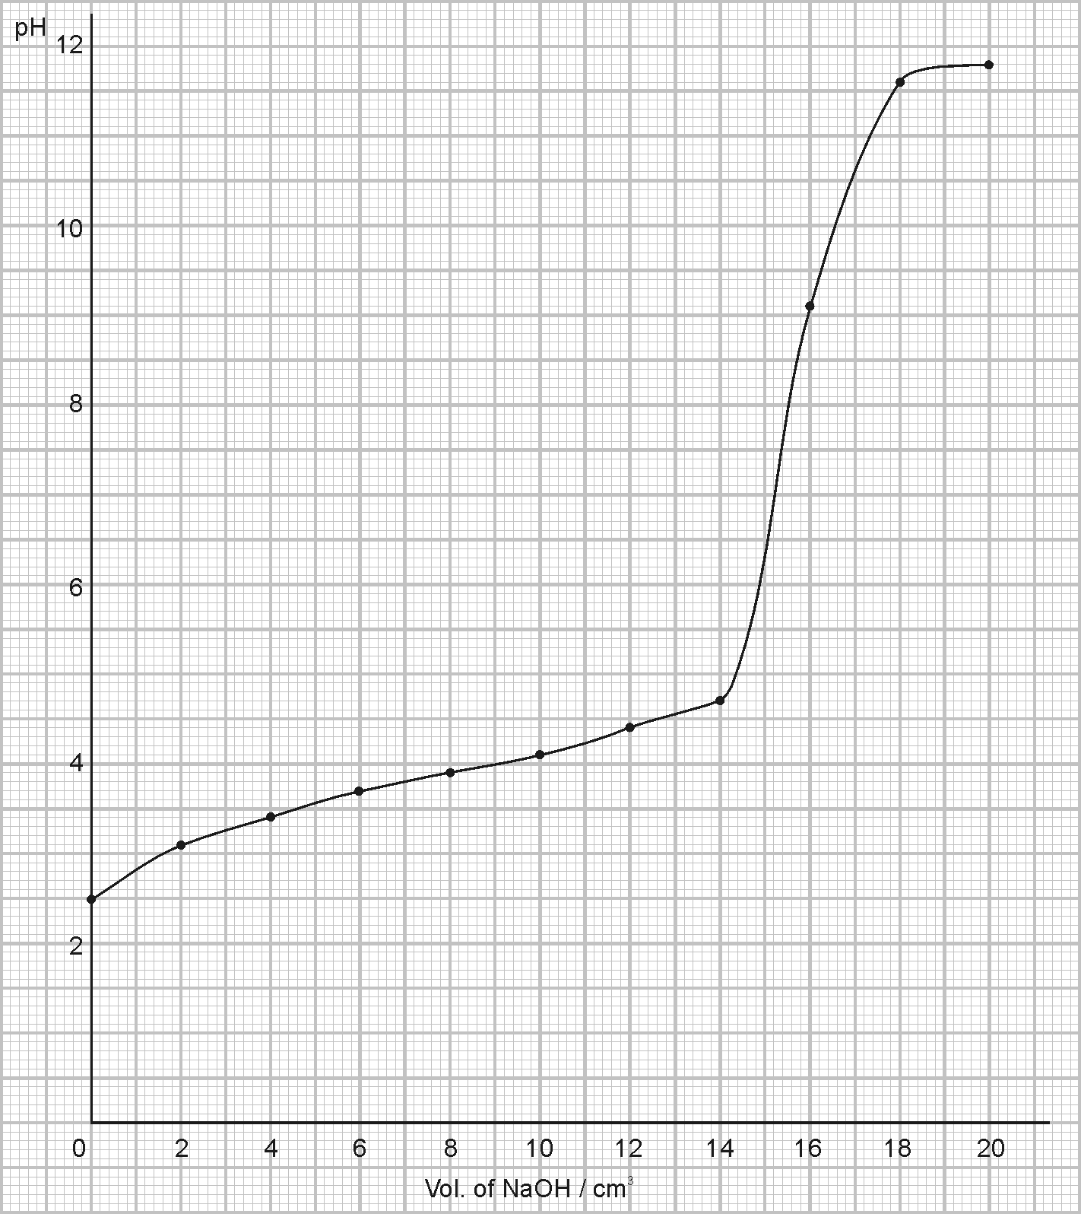

Before neutralisation: pH increases sharply at first, then very gradually (behaving as a buffer solution).
During neutralisation: pH increases very sharply from 5 to 11.
After neutralisation: pH increases gradually.

(b) Phenolphthalein (pH range 8–10) lies within the region of sudden pH increase during neutralisation.

(c) (i) Volume of NaOH required for neutralisation = 16.0 cm³
= c = 0.08 mol dm⁻³

(ii) Mr = 90
Conc. in g/dm³ = 0.08 × 90 = 7.2 g dm⁻³

(d) At mid-pt of neutralisation, i.e. Volume of NaOH added = 8.0 cm³
pH = 3.9 = pK_{a}
K_{a} = 1.26 × 10^{–4} mol dm⁻³

42. (a) (i) Increasing pressure on I shifts equilibrium to LHS to produce more H₂O(g). The change favours reaction that produces fewer gas molecules.

(ii) Increasing temperature on I shifts equilibrium to RHS to produce more H₂ and CO since the forward reaction is endothermic and it uses up the additional heat applied.

(iii) Increase [H⁺] on II shifts equilibrium to RHS to produce more Cr₂O₇^{2–} to use up the additional H⁺.

(b) 2SO₂(g) + O₂(g) 2SO₃(g)
Initial pressure × 3 × 3
= 2 atm = 1 atm –

Equilibrium pressure 2 – 1.9 1 – 1.9 atm
= 0.1 = 0.05

(i) Eqm. $P_{{\text{SO}}_{2}}$ = 0.1 atm
Eqm. $P_{O_{2}}$ = 0.05 atm

New total pressure = 1.9 + 0.1 + 0.05 = 2.05 atm
% conversion = × 100% = 95%

(ii) K_{p} = $\frac{(P_{{\text{SO}}_{3}})^{2}}{(P_{{\text{SO}}_{2}})^{2}(P_{O_{2}})}$ = = 7 220 atm^{–1}

43. (a) Electrolysis of Al₂O₃ (molten Al₂O₃ mixed with cryolite) using carbon electrodes.
Anode: O^{2–} ⎯→ O₂ + 2e–
Carbon anode oxidised by O₂ formed:
C + O₂ → CO ₂
Cathode: Al³⁺ + 3e– ⎯→ Al
Overall equation: 2Al₂O₃ + 3C ⎯→ 4Al + 3CO₂
(b) No. of moles of Al₂O₃ = (500 × 1 × 10^{–3}) × 4 ×
= 0.0196 mol

1 mol Al₂O₃ ≡ 6 mol e ≡ 6F
∴ Q = 0.019 6 × 6 × 96 500 C
= 11 353 C
(c) (i) CrO₄^{2–} oxidises SO₂ to SO₄^{2–} with itself reduced to Cr³⁺.
$E_{\text{cell}}^{∅}$ = +1.33 – 0.17 = 1.16 V

(ii) Reaction is slow, though it is energetically feasible.

(iii) Color changes from yellow to green (Cr³⁺).
Also Pb²⁺ precipitates SO₄^{2–} to form PbSO₄ (white ppt).

44. (a) (i) A buffer solution is a solution which the pH almost remains unchanged when a small amount of acid or alkali is added to it.
(ii) The additional H⁺ ions are removed by the large concentration of NH₃ present in the buffer. Therefore, pH remains almost unchanged.
H⁺ + NH₃ ⎯→ NH₄⁺
The additional OH– ions are removed by the large concentration of NH₄⁺ from the salt. Therefore, pH remains virtually unchanged.
OH– + NH₄⁺ ⎯→ NH₃ + H₂O

(b) (i) NH₄Cl ⎯→ NH₄⁺ + H₂O
no. of mole of NH₄⁺ = no. of mole of NH₄Cl
= $\frac{\text{53}\text{.}5}{\text{14}+(4×1)+\text{35}\text{.}5}=$$\frac{\text{53}\text{.}5}{\text{53}\text{.}5}=$ = 1.0
∴[NH₄⁺(aq)] = 1.0 mol dm⁻³
(ii) no. of mole of NH₃ = 15.0 × $\frac{\text{400}}{1\text{000}}$ = 6.0
∴[NH₃(aq)] = 6.0 mol dm⁻³

(c) (i) NH₄⁺ NH₃ + H⁺
(ii) K_{a} = $\frac{[{\text{NH}}_{3}][H^{+}]}{[{\text{NH}}_{4^{+}}]}$
(iii) [H⁺] = K_{a}$\frac{[{\text{NH}}_{4^{+}}]}{[{\text{NH}}_{3}]}$= 6.00 × 10⁻¹⁰ × $\frac{1\text{.}0}{6\text{.}0}$ = 1.0 × 10⁻¹⁰ mol dm⁻³
∴pH = −log₁₀[H⁺] = −log₁₀(1.0 × 10⁻¹⁰) = 10

45. (a) (i) Cu²⁺ + 2e⁻ ⎯→ Cu E^{ø} = + 0.34V
Fe³⁺ + e⁻ ⎯→ Fe²⁺ E^{ø} = + 0.77V
∴E^{ø} = [+0.77 – (+0.34)]V = +0.43 V

(ii) Reaction occurring in each half cell:
Cu(s) ⎯→ Cu²⁺(aq) + 2e⁻
Fe³⁺(aq) + e⁻ ⎯→ Fe²⁺(aq)
Overall reaction:
Cu(s) + 2Fe³⁺(aq) ⎯→ Cu²⁺(aq) + 2Fe²⁺(aq)

(b) The positive E^{ø} value indicates that the reaction is feasible but it gives no information about the rate. Nevertheless, the activation energy for the reaction in (a)(ii) is likely to be small since it involves simple electron transfer without involving breaking of covalent bonds. Therefore, the reaction will proceed.
(c) To reverse the direction of electron flow in the Fe³⁺(aq), Fe²⁺(aq)│Pt(s) half-cell, the other half-cell must have E^{ø} value more positive than +0.77V.
Therefore, Cu²⁺(aq)│Cu(s) half-cell could be replaced by Ag⁺(aq)│Ag(s) half-cell.
The electrode is silver metal and the reagent is aqueous silver nitrate.

46. (a) The Bronsted-Lowry theory of acids and bases means that acids are protons donors while bases are proton acceptors.
(b) (i) In C, the two acids are H₂O and NH₄⁺ while the two bases are NH₃ and OH⁻.
In D, the two acids are CH₃CO₂H and C₆H₅OH while the two bases are C₆H₅O⁻ and CH₃CO₂⁻.
(ii) The degree of proton exchange is illustrated by the K_{c} value. Since K_{c} value is greater in D, it shows that the position of equilibrium is shifted more to the right in D and shifted more to left in C. Thus, CH₃CO₂H is the stronger acid while OH⁻ is the stronger base.
(c) (i) [H⁺] _{CH3CO2H} : [H⁺]_{HCl} = 10 − 2.4 : 10⁻¹
= 3.98 × 10⁻³ : 0.1
= 1 : 25
(ii) 2CH₃CO₂H + Zn (CH₃CO₂)₂Zn + H₂
2HCl + Zn → ZnCl₂ + H₂
• The ionization equilibrium for ethanoic acid is shifted completely to the right by the excess Zn reacting with the H⁺ formed.
• In each case, 1 mole of H₂ is obtained from 2 moles of acid.
∴ no . of mole of H₂ = $\frac{1}{2}$ × no. of mole of acid
= $\frac{1}{2}$ × 0.1 × $\frac{\text{100}}{1\text{000}}$ = 5.0 × 10⁻³
∴vol. of H₂ = (5.0 × 10⁻³ × 24 × 10³) cm³ = 120 cm³

47. (a) A buffer solution is one that undergoes small changes in pH when small amounts of acid or alkali are added to it.
(b) (i) A⁻ (aq) + H⁺(aq) HA(aq)
(ii) HA(aq) + OH⁻ (aq) A⁻ (aq) + H₂O(l)
(c) (i) For a weak acid like ethanoic acid, HA,
HA(aq) H⁺(aq) + A⁻(aq)
K_{a} = $\frac{[H^{+}][A^{−}]}{[\text{HA}]}$
(ii) pK_{a} = −log₁₀ K_{a}
(iii) pH = −log₁₀(1.8 x 10⁻⁵) – log₁₀(0.04/0.02) = 4.44
(iv) [salt]_{new} = (0.20 + 0.05) mol dm⁻³ = 0.25 mol dm⁻³
[acid]_{new} = (0.40 − 0.05) mol dm⁻³ = 0.35 mol dm⁻³
pH = −log₁₀(1.8 × 10⁻⁵) – log₁₀($\frac{0\text{.}\text{35}}{0\text{.}\text{25}}$) = 4.59
∴change in pH = 4.59 – 4.44 = 0.15

(v) pH of water = 7.0
NaOH ⎯→ Na⁺ + OH⁻ (0.050 mol dm⁻³)
pOH = −log₁₀[OH⁻]
= −log₁₀(0.050)
= 1.30
pH = 14 – pOH = 12.7
∴change in pH = 12.7 – 7.0 = 5.7

(d) A buffer system which helps to control the pH of blood is HCO₃⁻/CO₃²⁻

48. (a) pK_{a} = −log₁₀K_{a}
(b) C₆H₅B(OH)₂ C₆H₅B(OH)O⁻ + H⁺
(c) pK_{a} = −log₁₀K_{a} = 8.86
∴K_{a} = 1.38 × 10⁻⁹ mol dm⁻³
Let α be the degree of dissociation of the acid. Since α is relatively very small,
K_{a} = $\frac{[C_{6}H_{5}B(\text{OH})O^{−}][H^{+}]}{[C_{6}H_{5}B(\text{OH})_{2}]}$= $\frac{[H^{+}]^{{}_{{}^{2}}}}{0\text{.}\text{010}}$
∴[H⁺] = $\sqrt{0\text{.}\text{010}×K_{a}}$ = $\sqrt{0\text{.}\text{010}×1\text{.}\text{38}×{\text{10}}^{−9}}$= 3.72 × 10⁻⁶ mol dm⁻³
pH = −log₁₀[H⁺] = −log₁₀(3.72 × 10⁻⁶) = 5.43
(d) Benzoic acid is the stronger acid because its pK_{a} value is smaller showing that benzoic acid is more dissociated.
- (i)
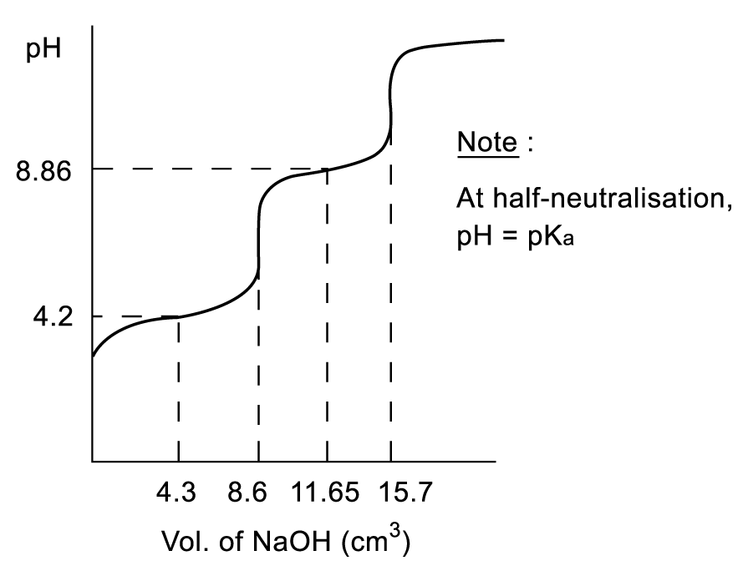

(ii) no. of mole of benzoic acid = no. of mole of NaOH
= 0.050 × $\frac{8\text{.}6}{1\text{000}}$ = 4.30 x 10⁻⁴
[benzoic acid] = $\frac{1\text{000}}{\text{10}\text{.}0}$ × 4.30 × 10⁻⁴ = 0.0430 mol dm⁻³
no. of mole of C₆H₅B(OH)₂ = no. of mole of NaOH
= 0.050 × $\frac{7\text{.}1}{1\text{000}}$ = 3.55 × 10⁻⁴
[C₆H₅B(OH)₂] = $\frac{1\text{000}}{\text{10}\text{.}0}$ × 3.55 × 10⁻⁴ = 0.0355 mol dm⁻³

49. (a) K_{p} = $\frac{p^{2}(H_{2})×p(O_{2})}{p^{2}(H_{2}O)}$
(b) 2H₂O(g) 2H₂(g) + O₂(g)
Initial/mol 2 0 0
equilm.mol 1.6 0.4 0.2
Total no. of mole = 1.6 + 0.4 + 0.2 = 2.2
∴p(H₂O) = ($\frac{1\text{.}6}{2\text{.}2}$ × 1) = 0.727 atm
p(H₂) = ($\frac{0\text{.}4}{2\text{.}2}$ × 1) = 0.182 atm
p(O2) = ($\frac{0\text{.}2}{2\text{.}2}$ × 1) = 0.0909 atm

(c) K_{p} = $\frac{p^{2}(H_{2})×p(O_{2})}{p^{2}(H_{2}O)}$
= $\frac{(0\text{.}\text{182})^{2}(0\text{.}\text{0909})}{(0\text{.}\text{727})^{2}}\text{atm}$= 0.00570 atm
Its unit is atm.

52. (a) Standard electrode potential is the potential difference between the measured half cell
and the standard hydrogen electrode.
(b) (i) Zn(s)⏐Zn²⁺(aq, 1 mol dm⁻³)⏐⏐Ni²⁺(aq, 1 mol dm⁻³)⏐Ni(s)

(ii) KCl(aq) salt bridge

(iii) A high-resistance voltmeter is used.

(iv) Emf = 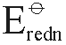 – 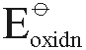
= –0.25 – (–0.76)
= +0.51 V

(c) (i) 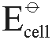 = 0 – (–0.25) = +0.25 V
i.e. Emf of standard Ni—H₂ cell = +0.25 V
[H⁺] = 2 mol/dm³, Emf of Ni—H₂ cell increases (> +0.25 V).
A reaction is expected to occur.

(ii) The reaction between Ni and HCl may be too slow, i.e. kinetically unfeasible for the reaction to occur.

(d) Fe undergoes oxidation more readily than Ni.
= –0.25 – (–0.44)
= +0.19 V
However, since $E_{\text{cell}}^{∅}$ is small, it is not sensible to electroplate Fe with Ni.

(e) (i) Zn(s)⏐Zn²⁺(aq, 1 mol dm⁻³)⏐⏐Fe²⁺(aq, 1 mol dm⁻³)⏐Fe(s)
= –
= 0.44 – (–0.76)
= +0.32 V

(ii) H₂ (g) + O₂(g) ⎯→ H₂O(l)
CH₄(g) + 2O₂(g) ⎯→ CO₂(g) + 2H₂O(l)

(iii) (1) Inert, resistant to corrosion by acid and O₂
(2) To provide H⁺ for reduction of O₂ to H₂O.
O₂ + 4H⁺ + 4e– → 2H₂O
(3) To speed up reactions at the electrodes.

(iv) Predictions are based on the consideration of energetic feasibility and standard conditions. The reaction may not occur because the rate is too slow or the actual reaction conditions are not standard.

(v) 2H⁺ + 2e– ⎯→ H₂
O₂ + 4H⁺ + 4e– ⎯→ 2H₂O

(vi) Increment in pH (from acid to neutral) reduces the tendency for H⁺ to be reduced (lower [H⁺]).

Product at pH 14: Fe(OH)₂
Reduction of O₂ in neutral conditions produces OH–.
O₂ + 2H₂O + 4e– 4OH–

(vii) When Sn coating is cracked, Fe is exposed.
Sn²⁺/Sn 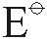 = –0.14 V Fe²⁺/Fe = –0.44 V
i.e. Fe is oxidised instead of Sn. Fe → Fe²⁺ + 2e–
∴ Fe is corroded.

53. (a) Le Chatelier’s principle states that if a system in equilibrium is subjected to a change in concentration, pressure or temperatures, the equilibrium position of the system will shift in a way to minimize the effect of the change.

(b) Haber’s Process: N₂(g) + 3H₂(g) 2NH₃(g)

Manufacture of H₂SO₄ : SO₂(g) + O₂(g) SO₃(g)
SO₃(g) + H₂O(l) → H₂SO₄(l)

(c) (i) Ni(s) + 4CO(g) Ni(CO)₄(g)

(ii) K_{c} =

(iii) [CO] is doubled.
[Ni(CO) ₄] increases by 2⁴ = 16 times.

(iv) At 20 atm, [CO] increases. This shifts equilibrium in the direction of Ni(CO)₄ and increases the yield of Ni(CO)₄.

54. | (a) | When strong acid dissolves in water, almost all the acid molecules are ionized in water, the equilibrium concentration of H₃O⁺(aq) is nearly equal to the initial concentration of the acid. As in the case of hydrochloric acid:  HCl(aq) + H₂O(l) → H₃O⁺ (aq) + Cl⁻(aq)  On the other hand, when a weak acid dissolves in water, most of it still exists in undissociated form at the equilibrium.  As in the case of propanoic acid:  CH₃CH₂COOH(aq) + H₂O(l) H₃O⁺(aq) + CH₃CH₂COO⁻(aq)
 | (b) | (i) | Titration curve for propanoic acid:  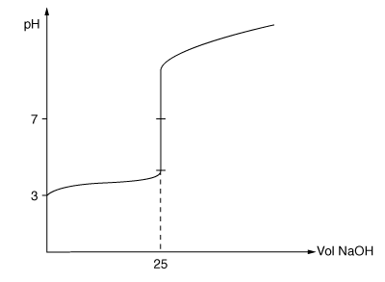
Titration curve for HCl:
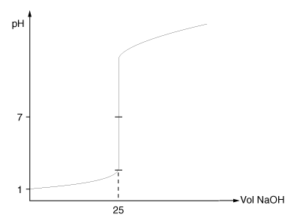

(ii) A suitable indicator must have a pH range (over which color change occurs) within the sharp increase in pH at the equivalence point.
In the propanoic acid—NaOH titration, the sharp increase in pH at equivalence pt occurs between pH 5 to 11.
Hence only some indicators are suitable.

In the HCl—NaOH titration curve, the sharp increase in pH occurs over a very wide range ~3 to 12.
Hence almost any indicator is suitable.

(iii) An acid-base indicator is a substance which changes colour as the pH of the solution in which it is dissolved changes. They are either weak acids or weak bases whose conjugate bases or conjugate acids are of colours different from the indicators themselves. The colour of an indicatior in a solution depends upon the ratio of the acid and the base, which in turn is dependent upon the concentration of hydroxonium ions in the solution.

(c) CH₃CH₂COOH CH₃CH₂COO– + H⁺

(i) K_{a} =

(ii) pK_{a} = –1og K_{a} = –1og (1.35 × 10^{–5})
= 4.87

(d) (i) [H⁺] = $K_{a}\frac{[\text{acid}]}{[\text{salt}]}$ = 1.35 × 10^{–5} ×
= 2.70 × 10^{–5} mol dm⁻³
pH = 4.57

(ii) 1 cm³ HCl (1 mol/dm³) ≡ $\left(\frac{1}{1 \text{000}} × 1\right)$ mol [H⁺]
= 1 × 10^{–3} mol

1 cm³ HCl is added to 1 000 cm³ buffer.
Total vol. = 1 001 cm³
Increase in [H⁺] = $\frac{1 × {\text{10}}^{−3}}{1 \text{001}}$ × 1 000 = 0.000 999 mol dm⁻³

New [salt] = 0.1 – 0.000 999 = 0.099 000
New [acid] = 0.2 + 0.000 999 = 0.200 999

New [H⁺] = K_{a} = (1.35 × 10^{–5}) × $\frac{0\text{.}\text{200} \text{999}}{0\text{.}\text{099} \text{000}}$
= 2.741 × 10^{–5}
pH = 4.56
Charge in pH = 4.57 – 4.56 = 0.01

1 cm³ HCl is added to 1 000 cm³ H₂O.
[H⁺] = 0.000 999 mol dm⁻³
pH = 3.00
Charge in pH = 7.00 – 3.00 = 4.00

(iii) A buffer resists changes in pH with small amounts of acid or alkali added.
∴ pH of propanoic acid and sodium propanoate solution remains fairly constant (change of 0.01 unit of pH) when 1 cm³ HCl is added.
CH₃CH₂COO– + H⁺ CH₃CH₂COOH

56. (a) (i) K_{w} = [H₃O⁺(aq)][OH⁻(aq)]
The unit of K_{w} is mol² dm⁻⁶.
(ii) pH = −log[H₃O⁺(aq)]
pH is the negative logarithm of the concentration of hydroxonium ions in mol dm⁻³ of the solution.

(b) (i) pH at 100°C = –log$\sqrt{\text{51}\text{.}3 × {\text{10}}^{−\text{14}}}$
= 6.145

(ii) Dissociation of H₂O – endothermic.
At higher temperature, more H⁺ are formed.
⇒ lower pH at 100°C than at 25°C.

(c) No. Insoluble catalyst does not dissolve in water.
Also a catalyst does not change the position of equilibrium. That means it does not change the degree of dissociation of water.

(d) 2H⁺ + e– H₂ E∅ = 0.0 V at 25°C, 1 atm. pressure
[H⁺] = 1 mol dm⁻³

Change in pH ⇒ change in [H⁺] ⇒ change in E∅, which can be measured.

57. (a) (i) Zn(s) + 2H⁺(aq) ⎯→ Zn²⁺(aq) + H₂(g)

(ii) + Pole: hydrogen electrode

(iii) Electrons lost in oxidation half-cell are gained in reduction half-cell.

(b) (i) Zn(s)⏐Zn²⁺(aq, 1 mol dm⁻³)⏐⏐H⁺(aq, 1 mol dm⁻³)⏐H₂(g)⏐Pt(s)⏐

(ii) $E_{\text{cell}}^{∅}$ = 0 – (–0.77) = +0.77 V

(c) (i) [H⁺] decrease
Reduction of H⁺ to give H₂(g): 2H⁺(aq) + 2e– → H₂(g)

(ii) K⁺(aq) move in direction of hydrogen half-cell to balance the decrease in [H⁺]
while Cl– move in direction of zinc half-cell to balance the increase in [Zn²⁺].

58. (a) (i) pH = –log [H⁺]
(ii) [Al(H₂O)₆]³⁺ + H₂O → [Al(H₂O) ₅(OH)]²⁺ + H₃O⁺
Increasing in [H₃O⁺] lowers pH of water.

(b) (i) A buffer solution is one that tends to resist changes in pH when a small amount of acid or base is added to it.
(ii) CO₃^{2–} + H₃O⁺ HCO₃– + H₂O
CO₃^{2–} ‘removes’ additional H₃O⁺ from acid.
HCO₃– + OH– ⎯→ CO₃^{2–} + H₂O
HCO₃– ‘removes’ additional OH– from alkali.
Hence pH remains fairly constant with addition of small amounts of acid and alkali.

(c) (i) K_{a} = $\frac{[{\text{CO}}_{3^{2−}}][H_{3}O^{+}]}{[{\text{HCO}}_{3^{−}}]}$
(ii) = 0.003, [H₃O⁺] = $\frac{(4\text{.}8 × {\text{10}}^{−\text{11}})}{0\text{.}\text{003}}$ = 1.6 × 10^{–8}
pH = 7.796
= 0.960, [H₃O⁺] = $\frac{(4\text{.}8 × {\text{10}}^{−\text{11}})}{0\text{.}\text{960}}$ = 5.0 × 10^{–11}
pH = 10.30
(increase)
Charge in pH = 2.504

59. (a) (i) A Bronsted-Lowry acid is a substance which donates hydrogen ions.
(ii) (1) Acid HF / base HNO₃
Acid H₂NO₃⁺ / base F–
(2) Acid HN₃ / base H₂O
Acid H₃O⁺ / base N₃–

(b) (i) K_{a} =

(ii) pK_{a} = –log K_{a}

(iii) pH = 2.86 ⇒ [H₃O⁺] = 0.00 1 38 mol dm⁻³
K_{a} = $\frac{(0\text{.}\text{001}\text{38})^{2}}{0\text{.}1}$ ⇒ pK_{a} = 4.72

(c) Strongest acid: CH₂ClCOOH (largest K_{a})
Weakest acid: CH₃CH₂COOH (smallest K_{a})

Cl – electron-withdrawing, facilitate the removal of H⁺
CH₃ – electron-denoting group makes the removal of H⁺ more difficult when it is compared with CH₃COOH.

60. (a) (i) K_{a} = $\frac{[{\text{RCO}}_{2^{−}}][H_{3}O^{+}]}{[{\text{RCO}}_{2}H]}$
(ii) RCO₂H + H₂O RCO₂⁻ + H₃O⁺
At start: 0.200 0 0
At eqm: (0.200 –x) x x
K_{a} = $\frac{[{\text{RCO}}_{2^{−}}][H_{3}O^{+}]}{[{\text{RCO}}_{2}H]}$
7.4 × 10⁻⁴ = $\frac{x^{2}}{(0\text{.}\text{200}−x)}$
x² + 7.4 × 10⁻⁴ x – 7.4 × 10⁻⁴ = 0
x = 0.0268 or –0.0276 (rejected)
∴[H₃O⁺] = 0.0268
pH = –log[H₃O⁺] = 1.57

(b) (i) The function of a buffer solution is resisting the changes in pH when a small amount of acid or base is added to it.
(ii) Sodium citrate is completely ionized in water but critic acid is only slightly ionized in water.
When a small amount of acid is added to the system, the reaction will shift to left. The additional H₃O⁺ ions are removed mostly by forming partially ionized citric acid.
RCO₂⁻(aq) + H₃O⁺(aq) ⎯→ RCO₂H(aq) + H₂O(l)
Similarly, when a small amount of a base is added to the system, the additional OH⁻(aq) will react with undissociated critic acid molecules to form RCO₂⁻ and water molecules.
OH⁻(aq) + RCO₂H(aq) ⎯→ RCO₂⁻(aq) + H₂O(l)
pH = pK_{a} = log$\frac{[\text{salt}]}{[\text{acid}]}$
= −log (7.4 × 10⁻⁴) + log$\frac{[0\text{.}\text{400}]}{[0\text{.}\text{200}]}$= 3.43

61. (a) Although a low temperature will increase the yield of ammonia, a chemical reaction carried out at low temperature is likely to be slow. That is, the time to reach equilibrium is likely to be long.
(b) Since a large amount of energy is required to produce a higher pressure, it is uneconomic to use pressure higher than 200 atm.
(c) (i)&(ii)
The iron acts as catalyst during the production of ammonia. The iron increases the rate of reaction by providing alternative pathway with lower activation energy. However, since a catalyst does not change the equilibrium position of the reaction, the amount of ammonia in the equilibrium mixture remains unchanged.

62. (a) $\frac{1}{2}$H₂(g) + $\frac{1}{2}$I₂(g) HI(g)
K_{c} = $\frac{[\text{HI}(g)]}{[H_{2}(g)]^{\frac{1}{2}}[I_{2}(g)]^{\frac{1}{2}}}$
(b)
Reactant/ product | Initial no . of moles (mol) | Change in no. of moles (mol) | No. of moles at equilibrium (mol)
H₂ | 1.9 | −1.5 | 0.4
I₂ | 1.9 | −1.5 | 0.4
HI | 0 | 3 | 3

K_{c} = $\frac{[\text{HI}(g)]}{[H_{2}(g)]^{\frac{1}{2}}[I_{2}(g)]^{\frac{1}{2}}}$
K_{c} = $\frac{(\frac{\text{3mol}}{{\text{250cm}}^{3}})}{(\frac{0\text{.}\text{4mol}}{{\text{250cm}}^{3}})^{\frac{1}{2}}(\frac{0\text{.}\text{4mol}}{{\text{250cm}}^{3}})^{\frac{1}{2}}}$ = $\frac{\frac{3}{\text{250}}}{\frac{0\text{.}4}{\text{250}}}$= 7.5

63. (a) K_{p} = $\frac{P({\text{PCl}}_{3})⋅P({\text{Cl}}_{2})}{P({\text{PCl}}_{5})}$
(b) PCl₅(g) PCl₃(g) + Cl₂(g)
At start: 1 0 0
At eqm.: (1−0.39) 0.39 0.39
(i) Mole fraction of PCl₅(g) = $\frac{1−0\text{.}\text{39}}{1−0\text{.}\text{39}+0\text{.}\text{39}+0\text{.}\text{39}}$ = $\frac{0\text{.}\text{61}}{1\text{.}\text{39}}$ = 0.44
Partial pressure of PCl₅(g) = Mole fraction × Total pressure
= 0.44 × 2 atm = 0.88 atm
(ii) Mole fraction of PCl₃(g) = $\frac{0\text{.}\text{39}}{1\text{.}\text{39}}$ = 0.28
Partial pressure of PCl₃(g) = 0.28 × 2atm = 0.56
(c) K_{p} = $\frac{0\text{.}\text{56atm}×0\text{.}\text{56atm}}{0\text{.}\text{88atm}}$= 0.36 atm

64. (a) (i) lead plate
(ii) lead(IV) oxide
(iii) sulphuric acid
(b) Pb(s) + PbO₂(s) + 4H⁺(aq) + 2SO₄²⁻(aq) 2PbSO₄(s) + 2H₂O(l)
(c) e.m.f. of cell = 1.69 – (−0.36) = +2.05V
(d) 2PbSO₄(s) + 2H₂O(l) ⎯→ Pb(s) + PbO₂(s) + 4H⁺(aq) + 2SO₄²⁻(aq)
(e) If the car is not used for a long time, the battery would lose its charge and becomes flat.
(f) (i) Rusting requires the presence of both oxygen and water.
(ii) It is because iron can change into Fe²⁺(aq) ions more easily in deep pitting of the metal surface.
(iii) Magnesium has a higher position in the electrochemical series than iron and it would preferably release electrons. Thus, the magnesium stakes are oxidized first, and iron will not be corroded. However, aluminium is lower than iron in the electrochemical series. It increases the rate of rusting instead of preventing rusting.

65. (a) The hydrogen ion concentration in 0.01 mol dm⁻³ HCl is 0.01 mol dm⁻³
pH = −log([H⁺(aq)])
= −log(0.01) = 2
(b) [H⁺(aq)] = 0.1 mol dm⁻³
(c) pH = pK_{a} + log$\frac{[\text{salt}]}{[\text{acid}]}$
1.57 = −log(0.01) + log $\frac{[H^{+}(\text{aq})]}{[0\text{.}1]}$
1.57 = 2 + log$\frac{[H^{+}(\text{aq})]}{[0\text{.}1]}$
log$\frac{[H^{+}(\text{aq})]}{[0\text{.}1]}$ = −0.43
$\frac{[H^{+}(\text{aq})]}{[0\text{.}1]}$ = antilog(−0.43)
[H⁺(aq)] = 0.037 mol dm⁻³
[H⁺(aq)] in 0.1 mol dm⁻³ H₂SO₄
= 0.1 mol dm⁻³ + 0.037 mol dm⁻³
= 0.137 mol dm⁻³
(d) Since the K_{a} for the reaction I is very large, the reaction will shift to the right hand side. The HSO₄⁻ ions produced in reaction I will push the reaction II to the right hand side, thus the K_{a} in reaction II may be larger than 0.01 mol dm⁻³. The hydrogen ion concentration in 0.1 mol dm⁻³ sulphuric acid thus larger than 0.137 mol dm⁻³, i.e. 0.15 mol dm⁻³.
(e) The reaction is endothermic because an increase in temperature will favour the forward reaction of reaction II.
(f) The increase in temperature will decrease the pH value of the solution.

- (a)
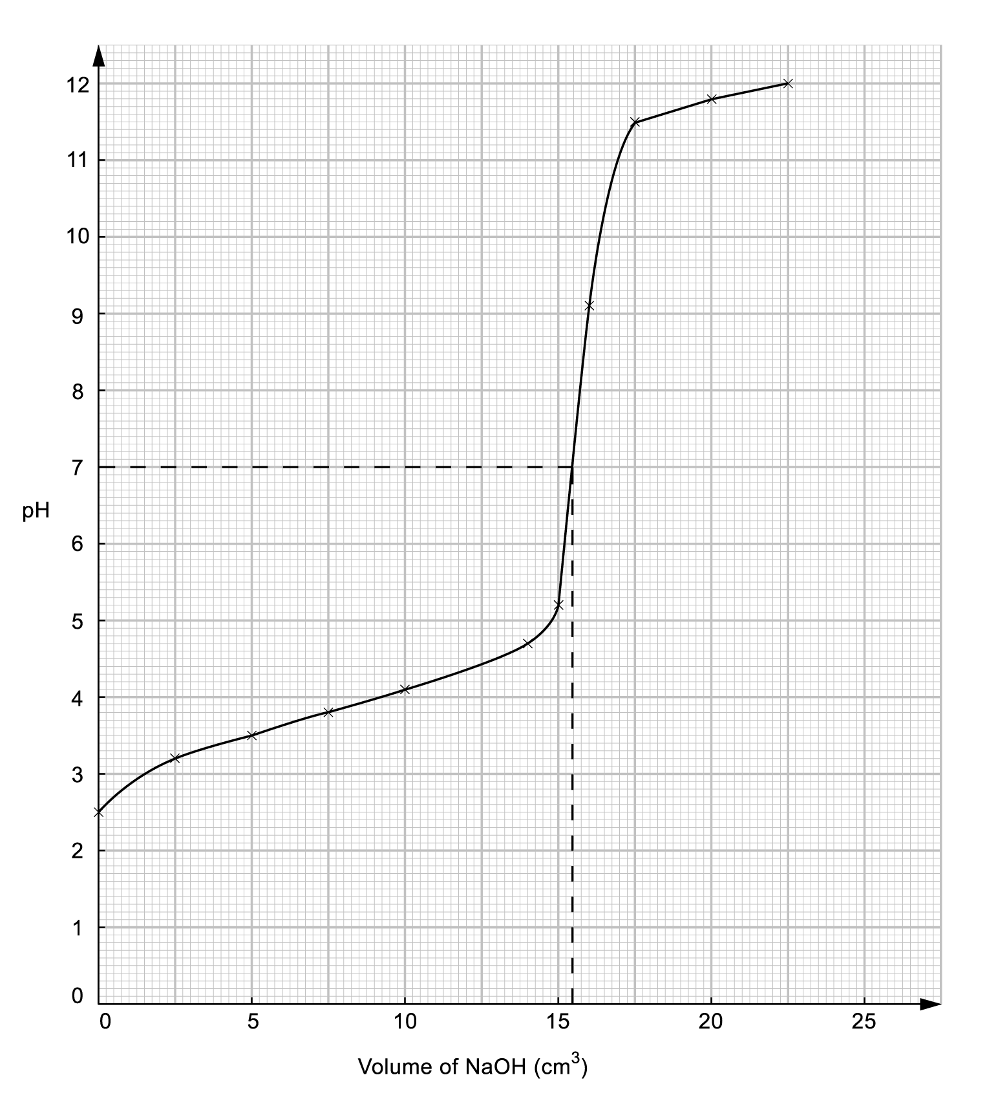
The end point reached when 15.5 cm³ of NaOH was used.

(b) No. of mole of NaOH used = 0.050 mol dm⁻³ × $\frac{\text{15}\text{.}5}{1\text{000}}$ dm³
= 7.75 × 10⁻⁴mol = No. of mole of A
Mass of A= $\frac{7\text{.}\text{20}{\text{ g dm}}^{−3}×\text{10}{\text{ dm}}^{3}}{1\text{000}}$ = 0.072g
Molecular mass of A = $\frac{\text{Mass of A}}{\text{No}\text{.}\text{ of mole of A}}$ = $\frac{0\text{.}\text{072g}}{7\text{.}\text{75}×{\text{10}}^{−4}\text{mol}}$ = 92.9 g mol⁻¹

67. (a) The nature of a dynamic equilibrium is that the forward reaction is proceeding at the same rate as the backward reaction.
(b) K_{c} = $\frac{[{\text{SO}}_{3}(g)]^{2}}{[{\text{SO}}_{2}(g)]^{2}[O_{2}(g)]}$
unit of K_{c} = $\frac{({\text{mol dm}}^{−3})^{2}}{({\text{mol dm}}^{−3})^{2}({\text{mol dm}}^{−3})}$= mol⁻¹ dm³
(c) (i) The equilibrium position will shift to the left hand side since the reaction is exothermic.
(ii) The presence of a catalyst has no effects on the equilibrium position because it affects the rate of reaction instead of changing its equilibrium position.
(d) (i) Since the forward reaction is exothermic, an increase in the temperature unfavoured the reaction and the equilibrium constant decreased. The rate of attainment of equilibrium also decreased.
(ii) The rate of attainment of equilibrium increases in the presence of a catalyst because it provides a pathway with a lower activation energy.

68. K_{p} = $\frac{K_{\text{CO}}(K_{H_{2}})^{3}}{K_{{\text{CH}}_{4}}K_{H_{2}O}}$
unit of K_{p} = $\frac{\text{atm}⋅(\text{atm})^{3}}{\text{atm}⋅\text{atm}}$= atm²

69. (a) Since fluorine is a very strong oxidizing agent, it will oxide water to form hydrogen fluoride and oxygen when it is bubbled in it.
The reaction is shown as following:
2F₂(g) + 2H₂O(l) 4HF(aq) + O₂(g)
(b) As the standard electrode potential of chlorine is higher than water, the expected reaction should be shown as the following equation:
2Cl₂(g) + 2H₂O(l) 4HCl(aq) + O₂(g)
(c) Since the potential difference is 0.13 which is very small, the reaction may not be favourable. Disproportionation is occurred instead of oxidation.

70. (a) (i) H₂O₂(aq) + 2H⁺(aq) + 2e⁻ ⎯→ 2H₂O(l)
(ii) $\frac{1}{2}$I₂(aq) + 3H₂O(l) ⎯→ IO₃⁻(aq) + 6H⁺(aq) +5e⁻
(b) The solution changes from brown to colourless.

71. (a) air
(b) 4Al(s) + 3O₂(g) + 6H₂O(l) ⎯→ 4Al(OH)₃(s)
(c) As the aluminium will be used to produce Al(OH)₃ which is a solid, the efficiency of the cell may be reduced over a period of time.
72. (a) (i) pH = pK_{In} + log$\frac{[{\text{In}}^{−}]}{[\text{HIn}]}$
pH= −log(1 × 10⁻⁴) + log 1 = 4
(ii) When$\frac{[{\text{In}}^{−}]}{[\text{HIn}]}$< $\frac{1}{\text{10}}$
pH < pK_{In} + log$\frac{1}{\text{10}}$
< −log(1 × 10⁻⁴) + log$\frac{1}{\text{10}}$
< 3

When$\frac{[{\text{In}}^{−}]}{[\text{HIn}]}$> 10
pH > pK_{In} + log10
> −log(1x10⁻⁴) + log10
> 5
The approximate range of pH over which indicator changes can be detected at pH value which is lower than 3 or higher than 5.

(b) (i) Since there is a sharp increase in pH of the equivalence points of titrations of a strong alkali against a strong acid, any indicators which show colour change at this range can be used.

For most indicators, the pH range is within ± 1 of the pK_{In} value. When solution with concentration of 1.00 mol dm⁻³ is used, the range of equivalent point is about pH 2 –12. Therefore, the titration can be performed with any indicator. However, the range of equivalent point is about pH 4 −10 if the concentration is 0.01 mol dm⁻³ , only methyl red and bromothymol blue can be used as indicators.

(ii) As the change in pH at the equivalence point does not occur sharply, all indicators will not give a sharp colour change at the equivalence point but will change colour gradually over a large volume of the acid or base added.

(iii) NaOH(aq) + CO₂(g) ⎯→ NaHCO₃(aq)
NaHCO₃ which is a base is formed. It will affect the pH value of the titration mixture.
(c) (i) pH = pK_{a} + log$\frac{[\text{salt}]}{[\text{acid}]}$
When the acid has been half-neutralised, [salt] = [acid]
pH = pK_{a} + log 1 = pK_{a}

(ii) At this pH, there are CH₃COO⁻ ions to react with additional acid and CH₃COOH molecules to react with additional base. It is most effective because there are same amount of CH₃COO⁻ ions and CH₃COOH molecules at this pH.

- (a)
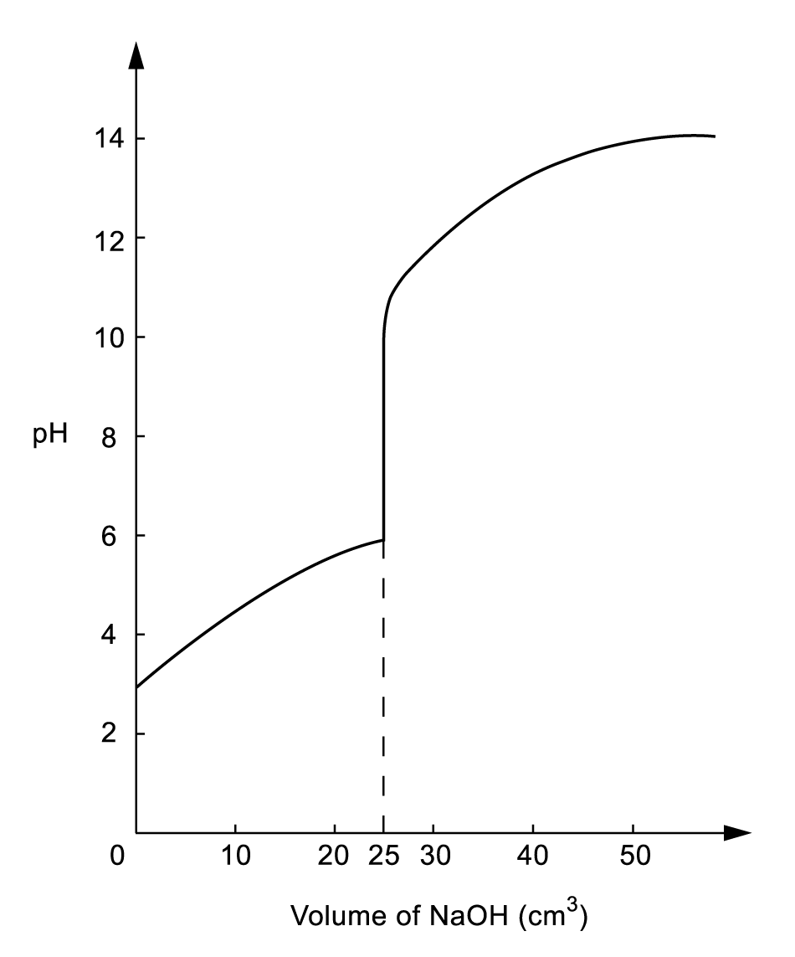

(b) Since the equivalent point occurs at the pH range of about 6-11, thymol blue would be the best for this titration. As thymol blue changes from yellow to blue at the pH range of about 7.9 –9.9.

74. (a) (i) 2 × ($\frac{1}{2}$Cl₂ + e⁻ ⎯→ Cl–) = +1.34 V
–) Fe²⁺ + 2e⁻ ⎯→ F = –0.44 V
Fe + Cl₂ ⎯→ FeCl₂ = +1.80 V
3 × ($\frac{1}{2}$Cl₂ + e⁻ ⎯→ Cl–) = +1.34 V
–) Fe³⁺ + 3 e⁻ ⎯→ Fe = –0.04 V
Fe + $\frac{3}{2}$Cl₂ ⎯→ FeCl₃ = +1.40 V

Although both the formation of iron(II) chloride and iron(III) chloride from iron metal seems to be feasible by considering the electrochemical potentials (E), the formation may not be occurred actually. It is because the positive values of E only imply the reaction is energetically feasible but not necessarily kinetically feasible. The reaction of iron metal with dilute aqueous hydrochloric acid gives iron(II) chloride but not iron(III) chloride, means that the formation of iron(III) chloride is kinetically infeasible.

(ii) 3 × (Co³⁺ + e⁻ ⎯→ Co²⁺) = +1.82 V
–) Fe³⁺ + 3e⁻ ⎯→ Fe = –0.04 V
3Co³⁺ + Fe ⎯→ 3Co²⁺ + Fe³⁺ = +1.86 V
–) 3 × ($\frac{1}{2}$Cl₂ + e⁻ ⎯→ Cl⁻) = +1.34 V

3Co³⁺ + Fe + $\frac{3}{2}$Cl₂ + 3e⁻ ⎯→ FeCl₃ = +1.40 V
By adding an aqueous cobalt(III) solution to the iron metal and aqueous hydrochloric acid, an aqueous solution of iron(III) chloride could be made.

(b) Rusting is an electrochemical process.
At anodic region: Fe ⎯→ Fe²⁺ + 2e⁻
At cathodic region: $\frac{1}{2}$O₂ + H₂O + 2e⁻ ⎯→ 2OH⁻
The Fe²⁺(aq) and OH⁻ (aq) formed react with each other and precipitate as Fe(OH)₂.
= 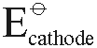 – 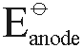 = +0.40V – (–0.44V) = + 0.84V
The Fe(OH)₂ is further oxidized by air to form hydrated iron(III) oxide, i.e. rust.
2Fe(OH)₂ + $\frac{1}{2}$O₂ + (x – 2)H₂O → Fe₂O₃. xH₂0
(c) At anode: Co²⁺ ⎯→ Co³⁺ + e⁻
At cathode: Fe³⁺ + e⁻ ⎯→ Fe²⁺
overall equation: Co²⁺ + Fe³⁺ ⎯→ Co³⁺+ Fe²⁺

75. (a) As the syringe was pushed well rapidly, the concentration of NO₂(g) which is dark brown in colour is increased suddenly. The mixture became momentarily darker.
(b) On standing, the equilibrium position is shift to the side for producing more N₂O₄(g) in order to keep the pressure inside the syringe constant. More N₂O₄(g) is produced which is pale yellow, the mixture turns lighter.
(c) K_{p} = $\frac{(P_{{\text{NO}}_{2}})^{2}}{(P_{N_{2}O_{4}})}$
(d) N₂O₄(g) 2NO₂(g)
K_{p} = $\frac{(P)^{2}}{(P_{N_{2}O_{4}})}$
48 atm =$\frac{(P_{{\text{NO}}_{2}})^{2}}{0\text{.}\text{15atm}}$
P_{NO2} = $\sqrt{\text{48}\text{atm}×0\text{.}\text{15}}$= 2.68 atm

76. (a) ‘Homogeneous equilibrium’ means that the reactants and the products are in the same phase.
(b) K_{p} = $\frac{P_{{\text{PCl}}_{3}}\text{.}P_{{\text{Cl}}_{2}}}{P_{{\text{PCl}}_{5}}}$ unit of K_{p} = atm
(c) PCl₅(g) PCl₃(g) + Cl₂(g)
At state(mol): 1 0 0
At eqm.(mol): 0.67 0.33 0.33
Mole fraction of PCl₅(g) = $\frac{0\text{.}\text{67}}{0\text{.}\text{67}+0\text{.}\text{33}+0\text{.}\text{33}}$= $\frac{0\text{.}\text{67}}{1\text{.}\text{33}}$ = 0.50
Partial pressure of PCl₅(g) = 1.1 × 0.50 = 0.55 atm

Mole fraction of PCl₃(g)
= Mole fraction of Cl₂(g)
= $\frac{0\text{.}\text{33}}{1\text{.}\text{33}}$ = 0.25
Partial pressure of PCl₃(g)
= Partial pressure of Cl₂(g)
= 1.1 × 0.25 = 0.28 atm

(d) ΔH for the forward reaction
= –306 – (–399)
= + 93 kJ mol ^{–1}
(e) The forward reaction is endothermic. The equilibrium position will shift to the right hand side if the temperature to be increased.

77. (a) A buffer system is one that tends to resist changes in pH when a small amount of acid or base is added to it.
RCOOK(aq) ⎯→ RCOO⁻ (aq) + K⁺(aq)
Potassium sorbate is completely ionized in water. Thus, a large amount of RCOO⁻ (aq) ions are produced as the above chemical equation. However, sorbic acid is only slightly ionized in water.
When a small amount of an acid is added to the system, the additional H₃O⁺(aq) ions are removed by the RCOO⁻ (aq). Simiarly, when a small amount of base is added to the system, the OH⁻ (aq) will react with the undissociated sobic acid.
The functioning of the mixture as buffer can be shown as the following chemical equation:
RCOO⁻ (aq) + H₃O⁺(aq) ⎯→ RCOOH(aq) + H₂O(l)
OH⁻ (aq) + RCOOH(aq) ⎯→ RCOO⁻ (aq) + H₂O(l)

78. (a) MnO₂ + 2MnO₄⁻ + 2H₂O ⎯→ 4H⁺ + 3MnO₄²⁻
= + 0.56 – 2.26 = –1.7V
The reaction is infeasible under standard conditions.
(b) Increase the pH of the reaction mixture can make the reaction become feasible. It is because the OH⁻ ions react with the H⁺ ions on the right hand side of the reaction, so the forward reaction can be more favourable.
(c) 4MnO₄⁻ + 4OH⁻ ⎯→ 4MnO₄²⁻ + 2H₂O + O₂
(green)
= +0.56 – 0.04 = + 0.52V
Under alkaline medium, MnO⁴⁻ will oxidize to MnO₄²⁻ which is green in colour. The reaction is feasible because the difference in the standard potential has a positive value.

79. (a) CH₃COOH(aq) + H₂O(l) CH₃COO⁻(aq) + H₃O⁺(aq)
(b) K_{a} = $\frac{[{\text{CH}}_{3}{\text{COO}}^{−}(\text{aq})][HO^{+}(\text{aq})]}{[{\text{CH}}_{3}\text{COOH}(\text{aq})]}$
1.80 × 10⁻⁵ = $\frac{x^{2}}{(2\text{.}\text{00}−x)}$
x² + 1.80 × 10⁻⁵ x – 3.60 × 10⁻⁵ = 0
x = 0.006 or –0.006(rejected)
∴[H₃O⁺(aq)] = 0.006M
pH = –log[H₃O⁺(aq)] = 2.22

80. (a) Dynamic equilibrium means that the forward reaction is proceeding at the same rate as the backward reaction.
(b) According to Le Chatelier’s principle, the equilibrium position of the system will shift in a way to minimize the effect of raising the temperature. Since the reaction is exothermic, the equilibrium position will shift to backward side and less ammonia is being produced.
(c) It is because the rate of formation of ammonia will be reduced if the temperature is too low. The temperature chosen should be high enough to the reaction to proceed quickly but low enough to have a satisfactory yield of product.
(d) The mixture of gases is passed through a heat exchanger and cooled. The ammonia formed in the process is then absorbed in water and liquefied under pressure.
(e) (i) A catalyst is a substance that can change the rate of a reaction but remains
chemically unchanged at the end of the reaction.
(ii)
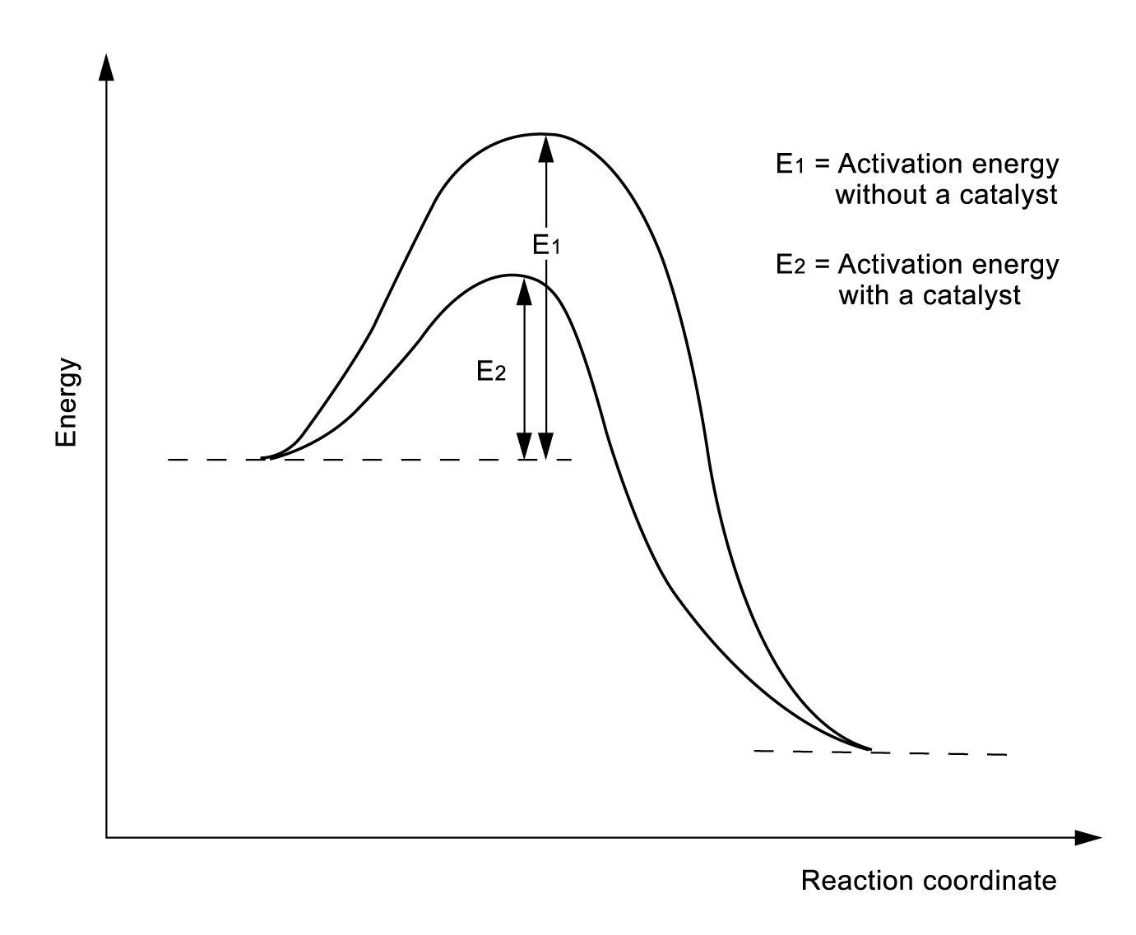

The catalyst increase the rate of attainment of reaction of the equilibrium by providing an alternative pathway with lower activation energy.
(iii) The catalyst is chemically unchanged at the end of the reaction, so it does not change the position of the equilibrium and the yield of ammonia.
81. (a) K_{p} = $\frac{(P_{\text{AlCl}})^{3}}{P_{{\text{AlCl}}_{3}}}$
(b) Mole fraction of AlCl₃ = $\frac{0\text{.}\text{67}}{0\text{.}\text{67}+0\text{.}\text{63}}$= $\frac{0\text{.}\text{67}}{1\text{.}3}$ = 0.52
Mole fraction of AlCl = $\frac{0\text{.}\text{63}}{1\text{.}3}$ = 0.48
P(AlCl₃) = 2 atm × 0.52 = 1.04 atm
P(AlCl) = 2 atm × 0.48 = 0.96 atm
K_{p} = $\frac{(P_{\text{AlCl}})^{3}}{P_{{\text{AlCl}}_{3}}}$ = $\frac{0\text{.}{\text{96}}^{3}{\text{atm}}^{3}}{1\text{.}\text{04}\text{atm}}$= 0.85atm²
(c) The enthalpy change should be positive because the forward reaction is endothermic.
(d) (i) The equilibrium constant remains unchanged because it is related to the temperature of the reaction condition only.
(ii) Also remains unchanged because both left and right hand sides of the chemical reaction contain 3 moles of gases.
(e) We should induce the backward reaction by using lower temperature.

82. (a) (i) Standard electrode potential is the potential difference between the measured half
cell and the standard hydrogen electrode.
(ii) Fluorine
(b) (i) F₂, Cl₂, Br₂ and I₂
(ii) I₂
(iii) We can add iodine solution to the chromium(II) aqueous solution which is sky blue in colour. If the solution shows dark green, that means the predication in part (ii) actually worked in practice.

83. (a) It is because ammonium nitrate is a solid, in considering K_{p}, we only consider the reactants and products which in gaseous state.
(b) Molar mass of NH₄NO₃ = 14.0 × 2 + 1.0 × 4 + 16.0 × 3 = 80 g mol⁻¹
Number of mole of NH₄NO₃ = $\frac{6\text{.}\text{00}\text{ g}}{\text{80}\text{ g}}$ mol⁻¹ = 0.075 mol
For completely dissociation of ammonium nitrate, the pressure in the system
= 0.075 mol × 50 atm × 2 = 7.5 atm
Kp = PNH₃ ⋅ PHNO₃ = 15.7 atm²
PNH₃ = $\sqrt{\text{15}\text{.}7{\text{atm}}^{2}}$= 3.96atm
∴% of ammonium nitrate which has dissociated
= $\frac{3\text{.}\text{96}×2}{7\text{.}5}$ × 100% = 105.6%

84. (a) Oxidation occurs when there is a loss of electron from an atom or ion.
(b) Oxidizing agent is a substance who gains electron by accepting electron from the reducing agent.
(c) Chlorine is the stronger oxidizing agent. During the extraction of bromine from seawater, chlorine acts as an oxidising agent while oxidation is taken place in the bromide ions. Two bromide ions, each transfers one electron, to the chlorine molecule to form a bromine molecule and two chloride ions.

85. (a) Dynamic equilibrium means that the forward reaction is proceeding at the same rate as the backward reaction.
(b)
 | Effect on the rate of the reaction | Effect on the position of equilibrium
Increasing the temperature | Increases | Shift to the left
Increasing the pressure | Increases | Shift to the right

(c) (i) The reaction is exothermic, thus a low temperature will increase the yield of the product. However, the rate to attain equilibrium will be too low if the temperature is too low. Therefore, the process is operated at the temperature of 450ºC, which would result in the highest percentage of conversion.
(ii) High pressure will increase the yield of the product but under the operating temperature of 450ºC, conversion is already high. A pressure of 2 atm is enough because higher pressure often requires costly equipment.
(iii) A catalyst is used to increase the rate of the reaction.
(d) Platinum

