Part 5 Chemical Kinetics (Book 2, p.82 – p.87)

23. (a) Order of reaction: the sum of powers of the concentration of individual reactants in the rate equation.
Half-life: the time taken for half of the reactant to be converted to the product.

(b) (i) Order w.r.t HCl = 1
Order w.r.t. sucrose = 1

Rate = k [HCl][sucrose]
0.024 = k × 0.1 × 0.1
k = 2.4 mol^{–1} dm³ s^{–1}

(ii) t(sucrose) in expt II = t(sucrose) in expt I
= 3.0 sec
Since [HCl] in expt II = [HCl] in expt I
t(sucrose) in expt III = (t in expt I)
= 1.5 sec
Since [HCl] in expt III = 2 × [HCl] in expt I

(c) A catalyst is a substance that can change the rate of a reaction but remains chemically unchanged at the end of the reaction. A positive catalyst is one that speeds up a reaction while a negative catalyst is one that slows down a reaction.
A catalyst works by providing an alternative pathway for the reaction to take place. Positive catalysts make the activation energy lower while negative catalysts make the activation energy higher. As the activation energy is altered, the fraction of molecules with kinetic energies greater in case of positive catalysts (lower in case of negative catalysts) than the activation energy also changed. Hence, the catalyst affects the rate of a chemical reaction.

24. (a) Order of reaction: the sum of powers of the concentration of individual reactants in
the rate equation.

(b) (i) Order w.r.t. NO = 2
Order w.r.t. H₂ = 1

(ii) Rate = k[NO]²[H₂]

(iii) 0.020 = k (0.012)²(0.002)
k = 69 444 mol^{–2} dm⁶ s⁻¹

(c) (i) Increase pressure ⇒ increase in the no. of molecules of reactant per unit volume ⇒ increase in collision rate.

(ii) Increase temperature ⇒ increase in the no. of molecules with collision energies ≧ activation energy ⇒ increase in frequency of effective collisions.

(d) Exothermic
Because N₂ formed evolves a large amount of energy as triple bonds are formed.

(e) (i) They cause acid rain.

(ii) H₂ gas or CO, it reduces NO into N₂ and O₂.

25. (a) Comparing experiments 3 and 4, [O₂] remained constant while [NO] doubled, the initial rate is increased by a factor of 4.
The reaction is second order with respect to NO.
Comparing experiments 1 and 2, [NO] remained constant while [O₂] doubled, the initial rate is also doubled.
The reaction is first order with respect to O₂.
(b) The rate-determining step is
2NO + O₂ ⎯→ 2NO₂

(c) This rate-determining step is unusual because the overall order is three, suggests that three molecules have to collide together.

26. (a) (i) CH₃COCH₃ + I₂ ⎯→ CH₃COCH₂I + HI

(ii) The rate equation is:
rate = k[CH₃COCH₃][H⁺]
overall order = 1 + 1 =2
units of rate constant = $\frac{{\text{moldm}}^{−3}s^{−1}}{({\text{moldm}}^{−3})^{2}}$= dm³ mol⁻¹ s⁻¹

(iii) Mechanism A fits the observed kinetic data. The reason is that the rate equation shows only one molecule of propanone and one molecule of H⁺ are involved in the rate-determining step. However, I₂ is not involved in the rate-determining step.

(iv) I₂ is a reagent while H⁺ is a catalyst.

(v) The rate would be the same. It is because I₂ and Br₂ do not appear in the rate
equation.

(b) Oxides of nitrogen acts as a homogeneous catalyst in the following reactions:
NO₂(g) + SO₂(g) ⎯→ NO(g) + SO₃(g)
NO(g) + $\frac{1}{2}$O₂(g) ⎯→ NO₂(g)

27. (a) (i) Na(s) + C₂H₅OH(l) ⎯→ C₂H₅O⁻Na⁺(l) + $\frac{1}{2}$H₂(g)

(ii) This is because Na is rapidly oxidized by O₂ in air to form a layer of Na₂O in its surface. Moreover, Na reacts with the water vapour present in air.
- (i)
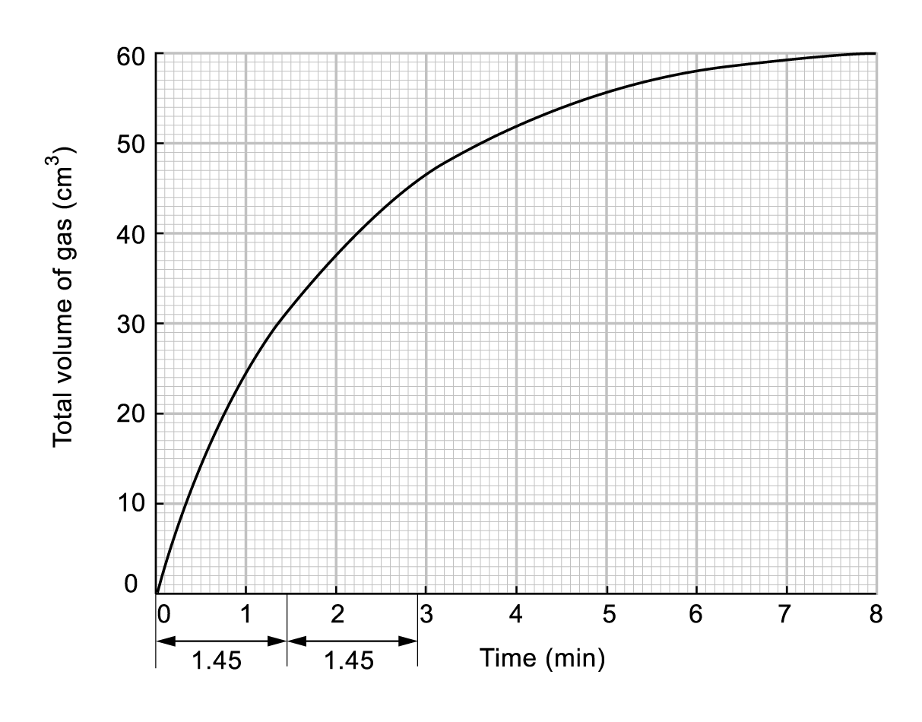

(ii) From the graph, t_{1/2} is constant indicating that the overall kinetics are first order.
(iii) Since ethanol is present in excess amount, the concentration of ethanol does not change throughout the reaction. Hence, rate is independent of the concentration of ethanol; i.e. zero order with respect to ethanol.

(c) (i) Total volume of H₂ = 60 dm³
∴ No. of moles of gas = $\frac{\text{60}}{\text{24}\text{000}}$ = 2.5x10⁻³ mol

(ii) No. of moles of Na = 2 × no.of moles of H₂
= 2 × 2.5 × 10⁻³
= 5.0 × 10⁻³
∴ Mass of Na = (5.0 × 10⁻³ × 23) g
= 0.115 g

(d) (i) This is because water also reacts with sodium.
Na(s) + H₂O(l) ⎯→ NaOH(aq) + $\frac{1}{2}$H₂(g)
(ii) Any organic solvent which has no OH group, e.g. propanone, methylbenzene. and hexane.

29. 2O₃(g) ⎯→ 3O₂(g)
(a) Rate = k[O₃]²
Order of reaction gives exact relationship between variation of rate with concentration of reactant, k is the proportionality constant in rate equation.

(b) (i) Units of rate : mol dm^{–3} s^{–1}

(ii) Rate = k[O₃]²
= 3.38 × 10^{–5} × (2.5 × 10^{–3})²
= 2.11 × 10^{–10} mol dm^{–3} s^{–1}

30. (a) (i) The chemical reaction carried out at an increasing temperature has a higher reaction rate. This can be explained by the increase in kinetic energy of the reactant particles as a result of increasing temperature.
(ii) A positive catalyst increases the rate of a chemical reaction while a negative catalyst decreases the rate of a chemical reaction. For example, the catalyst speeds up a reaction by providing an alternation reaction pathway with a lower activation energy in case of positive catalyst.

(b) (i) The slowest stage in the reaction mechanism is called the rate-determining step.

- Mechanism:
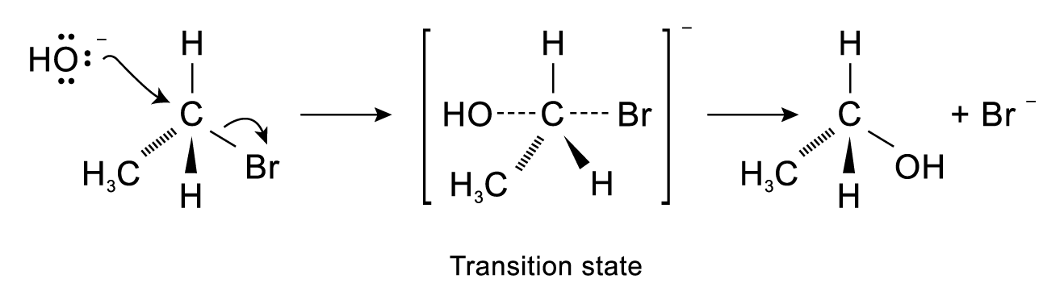

32. (a) Reaction is of zero order.
Since the rate is constant with different concentrations of CH₃Br.
Rate = k[CH₃Br]⁰
k = 8.13 × 10^{–5} mole dm^{–3} s^{–1} at 60°C

(b) ln k = ln A –
At 60°C: ln (8.13 × 10^{–5}) = ln A –
At 80°C: ln (50 × 10^{–3}) = ln A –
Solving the two equations: E_{A} = 3.14 × 10⁵ J mol^{–1}
= 314 kJ mol^{–1}

33. NO(g) + O₂(g) ⎯→ NO₂(g)

(a) (i) Increase in pressure ⇒ increase in concentration of reactants (more molecules per unit volume) ⇒ frequency of molecular collisions increases ⇒ rate increases.

- Increase in temperature ⇒ increase in average kinetic energy of molecule ⇒ collision rate increases.
Moreover, no. of molecules with collision energies equal or greater than activation energy increase greatly. Hence rate increases.

(b) (i) R₁ = 2R₂

(ii) R₁ = R₃

 | (c) |  | A | B | C
 |  | Initial total pressure NO and O₂ | 1.00 | 1.70 | 2.00
 |  | Initial P_{NO} | 0.30 | 0.30 | 0.60
 |  | Initial P_{O2} | 0.7 | 1.40 | 1.40
 |  | Initial rate | 0.8 | 1.60 | 6.40

(i) 1st order w.r.t. O₂
Since rate doubles when P_{O2} doubles (compared with A and B).

2nd order w.r.t. NO
Since rate quadruples when P_{NO} doubles (compared with B and C).

(ii) Rate = k(P_{O2})(P_{NO})²

(iii) Using results from A
0.8 = k(0.7)(0.3)²
k = 12.7 atm^{–2} s^{–1}
(d) (i) O₂(g) + SO₂(g) → SO₃(g)

(ii) NO is a homogeneous catalyst in reaction — participates in being oxidised by O₂ to NO₂ (an intermediate compound), and then reduced by SO₂ back to NO, while SO₂ forms SO₃.

34. (a) (i) 1st order w.r.t. O₂
(ii) Overall order = 2
(iii) The rate doubles.

(b) (i) Rate = k[Hb][O₂]
= (2.1 × 10⁶) × (8 × 10^{–6}) × (1.6 × 10^{–6})
= 2.69 × 10^{–5} mol dm^{–3} s^{–1}
(ii) Rate of formation of HbO₂ = Rate of consumption of O₂
= 2.69 × 10^{–5} mol dm^{–3} s^{–1}

(c) No. of moles of O₂ consumed per hour from 200 ml blood = (2.69 × 10^{–5}) × 60 × 60 ×
= 0.019 4 mol
Volume of O₂ = 0.019 4 × 25 dm³
= 0.484 dm³

(d) (i) Increasing O₂ concentration will increase the rate of oxyhaemoglobin formation. Other means of increasing rate, such as increasing body temperature or addition of catalyst, are unacceptable as it would affect other body functions.

(ii) 1.1 × 10^{–4} = (2.1 × 10⁶) × [O₂] × (8 × 10^{–6})
[O₂] = 6.55 × 10^{–6} mol/dm³
(iii) Increase breathing rate.

35. (a) (i) unit of k: mol^{–2}dm⁶s^{–1}
(ii) The rate of reaction would be also doubled if the concentration of O₂ was doubled while all other factors remaining constant. It is because the reaction is first order with respect to O₂.
(iii) The rate of reaction would be decreased by a factor of 4 if the concentration of NO was halved and all other factors remaining constant. It is because the reaction is second order with respect to NO.

(b) (i) order of reaction = 1 + 2 = 3
∴ It is a third order reaction.
(ii) The collision theory states that reactant molecules must collide with each other in order to react. However, it is very difficult for the three molecules to collide together at the same time. This is why the reaction is unlikely to occur in a single step.

36. (a) The order of the reaction is one with respect to iodine.
(b) Rate = k [H₂][I₂]
1.5 × 10^{–5} mol dm^{–3} = k$(\frac{0\text{.}\text{10}\text{mol}}{0\text{.}5{\text{dm}}^{3}})$$(\frac{0\text{.}\text{10}\text{mol}}{0\text{.}5{\text{dm}}^{3}})$
k = 1.5 × 10^{–5} mol dm⁻³ $(\frac{0\text{.}{\text{5dm}}^{3}}{0\text{.}\text{10mol}})^{2}$
= 3.75 × 10^{–4} mol^{–1} dm³ s^{–1}
The value of k at 200 ºC is 3.75 × 10^{–4} with the unit of mol^{–1} dm³ s^{–1}.

37. (a)
Time (min) | 0 | 7 | 15 | 27 | 44 | 60
ln[Concentration] (mol dm^{–3}) | –2.52 | –2.73 | –2.92 | –3.19 | –3.58 | –3.91
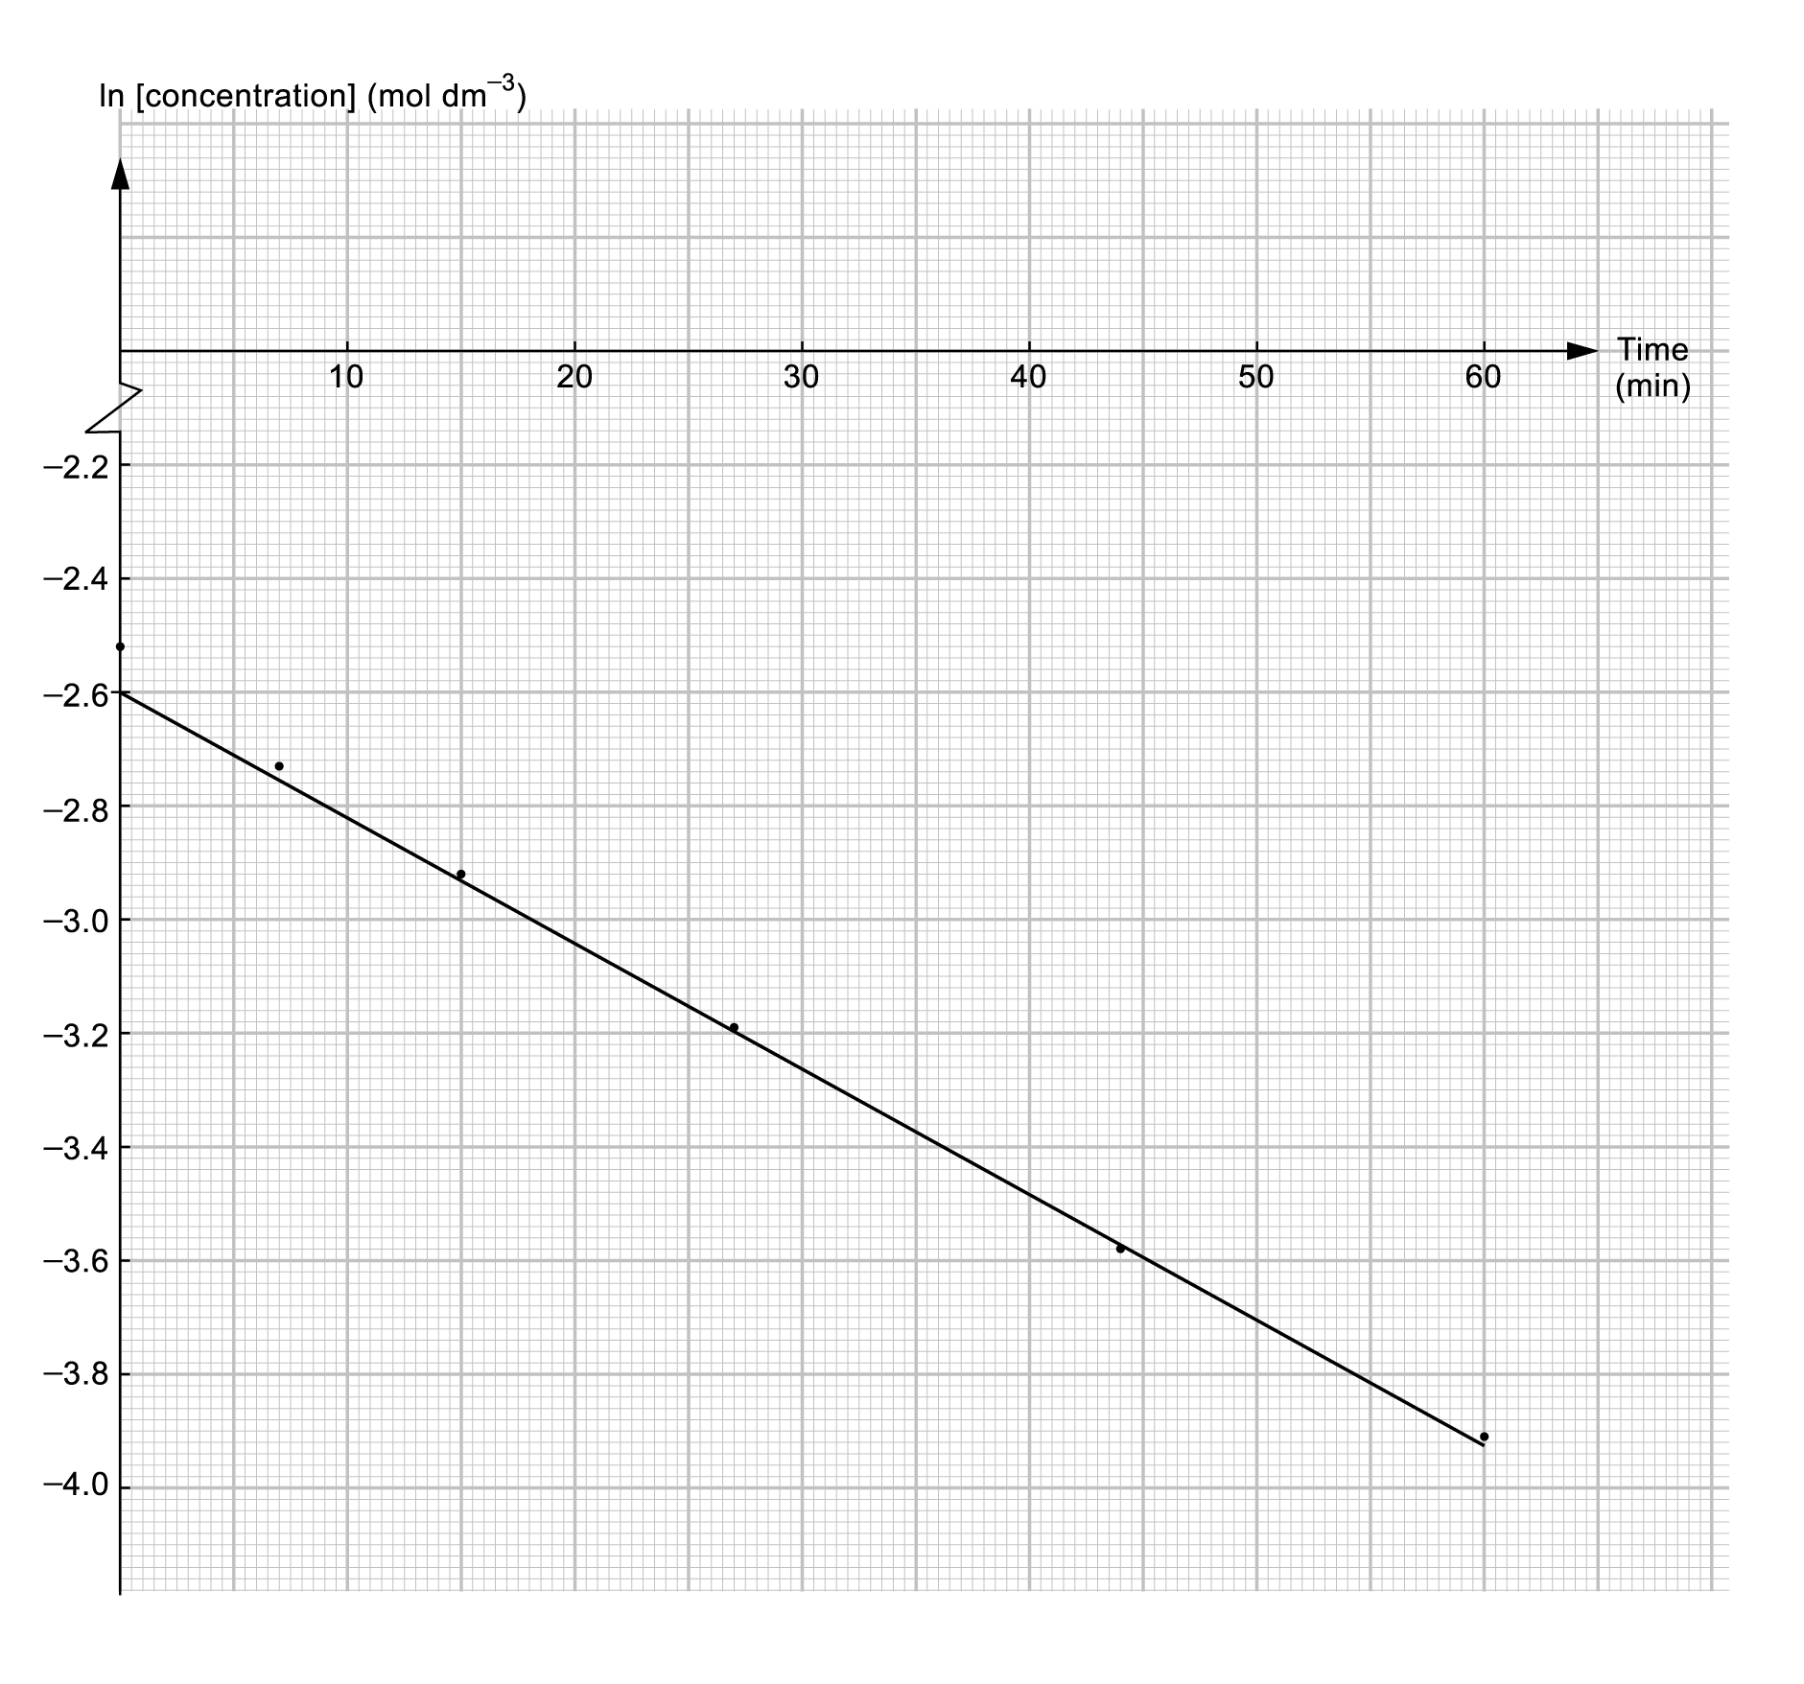

Since the plot of ln[conc.] against time obtained a straight line, the reaction is first order.

(b) By carrying a serial of tests with different initial concentration of sodium hydroxide (or halogenalkane) but same total volume of reaction mixture. While keeping the other reactant’s concentration constant. Then, measuring the initial rate of the reaction. Finally, plotting a graph of ln[NaOH] against time. For example, if the initial reaction rates are same for all the tests with different initial concentrations of NaOH. The rate law could be rate = k[halogenoalkane]. Otherwise, the rate law could be rate = k[OH–] if the tests show a first order trend.

38. (a) In fact, the rate equation of a reaction can only be determined experimentally. At a fixed temperature, the experimental observations of a reacting system have shown that the rate of the reaction varies with concentrations of reactants. This means that the concentration of different reactants may affect the rate of reaction differently.
Therefore, the rate equation cannot be written from the chemical equation.

(b) (i) first order
(ii) zeroth order
(iii) first order

(c) Since the reaction is zeroth order with respect to iodine, the iodine plays no part in the rate-determining step of the reaction.
(d) rate = k[CH₃COCH₃] [H⁺]

39. (a) (i) & (ii)
Let the order of reaction with respect to ester be x,
the order of reaction with respect to sodium hydroxide by y.
rate = k[ester]^{x}[NaOH]^{y}
Comparing experiment (1) & (2),
6 × 10^{–4} = k[0.1]^{x}[1.0]^{y}
1.2 × 10^{–3} = k [0.1]^{x}[2.0]^{y}
y = 1
Comparing experiment (1) & (3),
6 × 10^{–4} = k[0.1]^{x}[1.0]
2.4 × 10^{–3} = k [0.2]^{x}[2.0]
$\frac{[0\text{.}1]^{x}}{[0\text{.}2]^{x}}$=$\frac{6\text{.}4×{\text{10}}^{−4}}{2\text{.}4×{\text{10}}^{−3}}$ × $\frac{[2\text{.}0]}{[1\text{.}0]}$
x = 1

(b) rate = k[ester][NaOH]
6 × 10^{–4} = k[0.1][1.0]
k = 6 × 10^{–3} mol^{–1} dm³ s^{–1}

