Part 4 Bonding and Structure (Book 1, p.292 – p.295)

29. (a) Bond energy—
It is the energy required to break 1 mole of bonds in gaseous molecules to form gaseous atoms under standard conditions.
e.g.
CH₄(g) C(g) + 4H(g)
Bond energy (C—H) = × ΔH.
(b) H and P have similar electronegativities, P—H bond is purely covalent.
⇒ P—H covalent bond length = covalent radius of P + covalent radius of H
= (P—P) bond length + (H—H) bond length.

Since bond energy depends on bond length (inversely),

bond energy (P—H) = BE (P—P) + BE (H—H)
i.e. BE (P—H) = (BE of P—P + BE of H—H)

Cl is more electronegative than H. H—Cl has covalent and ionic character (It is stronger than a pure covalent bond because of the stronger attraction between the 2 atomic nuclei).

⇒ H—Cl bond length < (H—H) bond length + (Cl—Cl) bond length
∴ BE (H—Cl) > [BE (H—H) + BE (Cl—Cl)]

(c) Large amount of energy is required to break triple bonds (N≡N) in N₂ molecules for reaction to occur.
⇒ High activation energy

30. (a) The main features of the electron pair repulsion model for accounting the shapes of molecules are
(1) electron pairs in outermost shell of the central atom in a molecule will stay as far apart as possible to minimize the electrostatic repulsion between electron pairs in the valence shell.
(2) the electrostatic repulsion decreases in order:
lone pair-lone pair > lone pair-bond pair > bond pair-bond pair
(b) F₂O: 2 bp, 2 lp
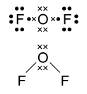
V-shaped or bent

H₃O⁺: 3 bp, 1 lp
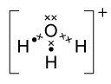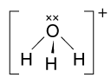
Shape: Triangular pyramid

ClF₄–: 4 bp, 2 lp
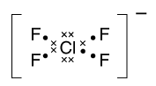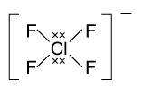
Shape: Square planar

(c) Square based pyramid ⇒ 5 bp + 1 1p
⇒ Total 12 e around Sb
Sb has 5 e (gp V), 5 e from 5F
⇒ n = 2 ⇒ we have SbF₅^{2–}
∴ O.N of Sb = +3

31. (a) F₂(g) ⎯→ 2F(g)
Bonded energy of F—F is the energy required to break 1 mole of F—F bonds in gaseous F₂ molecules to form free gaseous F atoms under standard conditions.
SF₄(g) + F₂(g) → SF₆(g) ΔH = –434 kJ mol⁻¹

Energy required for bond breaking in reactants = 4 × BE (S—F) + BE (F—F)
= 4 × BE (S—F) + 158

Energy evolved in bond formation in products = 6 × BE (S—F)
∴ ΔH = –434 = [4 × BE (S—F) + 158] – [6 × BE (S—F)]
BE (S—F) = + 296 kJ mol⁻¹
Assumption: same BE (S—F) in SF₄ and SF₆

(b) (i) SF₂
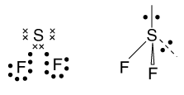
V-shape

SF₆
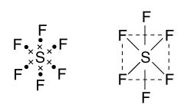
Octahedral

 |  | (ii) | CsF | SF₆
 |  |  | Ionic | covalent
 |  |  | – high mp | – low mp (weak Van der Waal’s force between molecules)
 |  |  | – conducts electricity when melted | – non-conductor
 |  |  | – soluble in water | – soluble in non-polar solvents
 |  |  | insoluble in non-polar solvents | e.g. C₆H₆
 |  |  |  | insoluble in water

32. Ne and Ar — simple ‘molecular structure’ with atoms attracted together by very weak instantaneous dipole-induced dipole forces. Hence both Ne and Ar have very low melting points.
Strength of intermolecular forces increases with no. of electrons.
Ar is a bigger atom and has more electron than Ne.
⇒ Ar has a higher melting point than Ne.

H₂O — polar molecule. Strong H-bonding exists between H₂O molecules.
Ice, simple molecular structure with each H₂O molecule
H-bonded to 4 other H₂O molecules to give an open network structure.
⇒ Ice or H₂O(s) has a low melting point compared with ionic solids or giant covalent compounds. However, because of strong H-bonding, its melting point is higher than other simple molecular substances with similar molecular mass.
NaF — giant ionic structure, Na⁺ and F– held in lattice sites by very strong ionic bonds.
Large amount of energy is required to separate ions for melting to occur ⇒ very high melting point.

Diamond — giant covalent structure with C atoms covalently bonded to each other. Each C atom is strongly bonded to 4 other C atoms to give a giant network of C atoms. Therefore, infinite no. of strong covalent bonds are to be broken in melting ⇒ very high melting point.

33. (a) (i) A: CH₄, non-polar molecule
Discrete molecules held together by weak instantaneous dipole — induced dipoles ⇒ very low boiling point.

D: SiH₄ similar to A
Weak intermolecular force (instantaneous dipole — induced dipoles) ⇒ very low boiling point.
Since SiH₄ has more electrons than CH₄, the strength of intermolecular forces is stronger. ∴ boiling point of it is higher than CH₄.

B: NH₃ — polar molecule with highly electronegative atom N. Strong H-bonding between NH₃ molecules ⇒ boiling point is higher than A and D.

C: H₂O — polar molecule has highly electronegative atom O. H-bonding between H₂O molecules is stronger than NH₃ because O is more electronegative than N.
Hence bp of H₂O is higher than NH₃.

(ii) b.p. of H₂O > b.p. of HF > b.p. of NH₃
(forms more H (F more
bonds than HF) electronegative than N)

bp of GeH₄ > bp of SiH₄
GeH₄ has more electrons.
∴ stronger Van der Waal’s forces.

 | (b) | (i) |  | C₆H₁₂O₆ | H₂O
 |  |  | % by mass | 80 | 20
 |  |  | Mr | 180 | 18
 |  |  | Rel. no. of moles | $$\frac{\text{80}}{\text{180}}$$ | $$\frac{\text{20}}{\text{18}}$$
 |  |  | Ratio | 1 : 2.5

(ii) H-bonds
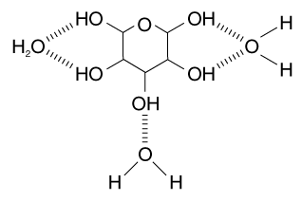

34. NaCl — giant ionic structure with very strong ionic bonds holding Na⁺ and Cl– ions in lattice. A large amount of energy is required to separate ions to melt the solid ⇒ very high melting point.

AlCl₃, CCl₄, SiCl₄ — all non-polar covalent molecules with simple molecular lattices. Discrete molecules are attracted by weak Van der Waal’s force (instantaneous dipole-induced dipoles). Their melting points are generally much lower than that of ionic solids like NaCl.
However AlCl₃ forms dimer Al₂Cl₆ with a large electron cloud with many electrons ⇒ fairly strong van der Waal’s forces
∴ Its melting point is much higher than CCl₄ and SiCl₄

SiCl₄ though having more electrons than CCl₄, it tends to sublime partially and therefore has a lower melting point than CCl₄.

35. (a) (i) A: Enthalpy change of atomisation of sodium
B: First ionisation energy of sodium
C: Enthalpy change of neutralisation

(ii) D: Enthalpy change of hydration of gaseous sodium ion and electron affinity of H⁺(aq).

(b) (i) B: ΔH = +494 kJ mol⁻¹

(ii) –58 – 494 – 107 + ΔH_{E} = –850
ΔH_{E} = –191 kJ mol⁻¹

36. (a) (i) CaCl₂
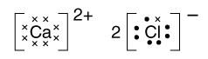
Ionic bonds between Ca²⁺ and Cl– ions
(ii) CH₄
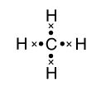
Covalent bonds between C and H atoms.
(iii) Na(s)
Metallic bonding — valence electrons of Na atoms form a delocalised electron cloud. Electrostatic attraction between negatively charged electron cloud and layers of positively charged sodium ions forms metallic bonding.

(b) (i)
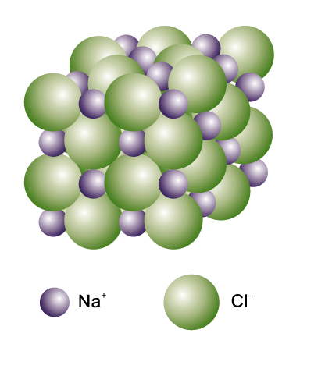

(ii) Face-centred cubic structure

(iii) C.N.(Na⁺) = 6
C.N.(Cl–) = 6

(c) Incorrect statement
Boiling of CCl₄ requires separation of CCl₄ molecules and hence breaking intermolecular attractions between CCl₄, i.e. instantaneous dipole — induced dipole forces, which are weak. Hence ionic bonds are stronger than van der Waal’s forces, but not covalent bonds.

 | (d) | 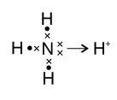

Lone pair of electrons on N in NH₃ is donated to H⁺ to form a dative bond.

(e) Alkali metals form giant metallic lattices with weak metallic bonding. All have body-centred cubic crystal structures.
The other metals have stronger metallic bonding and they can have different crystal structures.

37. PF₃: 3 bp, 1 lp
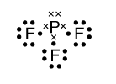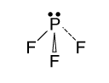
Shape: trigonal pyramid

CS₂: ‘2 bp’ 0 lp
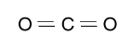
Shape: linear

XeF₄: 4 bp, 2 lp
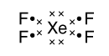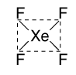
Shape: square planar

PBr₄–: 4 bp, 1 lp
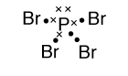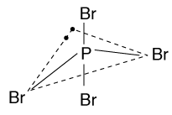
Shape: seesaw

38. (a) (i) Dative covalent bond
A covalent bond is formed by sharing of electrons between 2 atoms, one of which has a lone pair of electrons, which is donated.
 |  |  | e.g. | 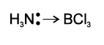

(ii) Ionic bond
An electrostatic attraction exists between oppositely charged ions, which are formed by electron lost by a metal atom and electron gained by a non-metal.
e.g.
Na ⎯→ Na⁺ + e–
Cl + e– ⎯→ Cl–

 |  |  | NaCl | 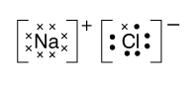

(b) (i) Phase change from solid state to vapour state without passing through the liquid state.
(ii) AlCl₃, a covalent substance hydrolyses in water:
AlCl₃ + 3H₂O ⎯→ Al(OH)₃ + 3HCl
or
AlCl₃(s) + 6H₂O(l) ⎯→ [Al(H₂O)₆]³⁺(aq) + 3Cl–(aq)

The process (hydration of ions) is exothermic, releasing energy to overcome H-bonds between H₂O molecules ⇒ AlCl₃ dissolves readily in water.

I₂ — non-polar molecule forms weak dipole-induced dipole attractions with water. These weak forces are unable to replace the strong H-bonds between H₂O molecules ⇒ I₂ is insoluble in H₂O.

 | (iii) | 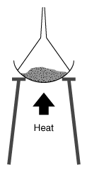 | Invert a filter funnel over an evaporating dish containing mixture of NaCl and I₂. Heat the mixture. I₂ sublimates  Heat mixture. I₂ anand condenses on cool filter funnel above. NaCl(s) remains in dish.

(iv) At 200°C, aluminium chloride exists as a dimer Al₂Cl₆.

 |  | 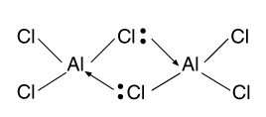 | Covalent and dative covalent bonds

39 | (a) | (i) | 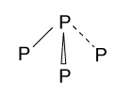 | Trigonal pyramidal

 |  | (ii) | 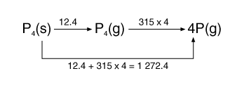
BE (P—P) in P₄(s) = (1 272.4) kJ mol⁻¹ = +318.1 kJ mol⁻¹

(iii) P₄(s) + Cl₂(g) PCl₃(g)

Energy absorbed in bond breaking in reactants
= +318.1 + (242) = 681.1 kJ
681.1 – 3 × BE (P—Cl) = –303
BE (P—Cl) in PCl₃ = 328.0 kJ mol⁻¹

(iv) PCl₃(g) + Cl₂(g) PCl₅(g)
Assuming the 3 P—Cl bonds in PCl₃ remain intact in PCl₅,
BE (Cl—Cl) – 2 × BE (P—Cl) = –93
2 × BE (P—Cl) = 242 + 93
BE (P—Cl) in PCl₅ = 167.5 kJ mol⁻¹

(b) (i) The 2 axial P—Cl bonds are longer than the 3 equatorial P—Cl bonds ⇒ axial P—Cl bonds have smaller bond energies than equatorial P—Cl bonds.
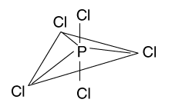
(ii) Average bond energy = [(3 × 328) + (2 × 167.5)]
= 2 63.8 kJ mol⁻¹

(iii) N, a period 2 element, does not have vacant low-lying d-orbitals in its valence shell. Hence N cannot accommodate more than 8 electrons. To form NCl₅, 10e has to occupy its valence shell ⇒ NCl₅ does not form but only NCl₃.
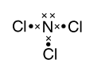

P, period 3 element, has vacant 3d orbitals. Hence P forms PCl₅ as well as PCl₃.

40. (a) K⁺(g) + Br–(g) → KBr(s)
Enthalpy change: Lattice energy of KBr

 | (b) | 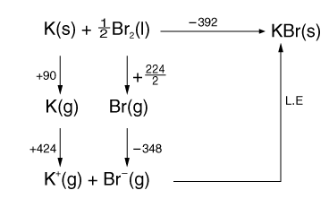

L.E + 90 + 424 + 112 + (–348) = –392
L.E (KBr) = –670 kJ mol⁻¹

(c) Acidic white fume of HBr followed by reddish brown fumes of Br₂ vapour will be observed.
Conc. H₂SO₄ displaces HBr and further oxidises it to Br₂.

(d) Acidify solution with dil. HNO₃, and then add aq. AgNO₃.
If a cream colored ppt which is insoluble in aq. NH₃ is formed ⇒ Br– exists.

