Part 3 Energetics (Book 1, p.176 – p.178)

12. (a) (i) C(s) + O₂ (g) ⎯→ CO(g) 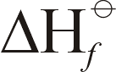 = –110 kJ mol⁻¹
C(s) + O₂ (g) ⎯→ CO₂ (g) = –393 kJ mol⁻¹

(ii) C(s) + CO₂(g) 2CO
ΔH = Σ (products) – Σ (reactants)
= [(2 × (–110)) – [(–393) + 0]
= +173 kJ mol⁻¹

(iii) The reaction is endothermic.
High temperature is necessary for reasonable yield (e.g. heat coke to red hot).

(b) Pass mixture into aq. KOH to remove CO₂.
2OH– + CO₂ ⎯→ CO₃^{2–} + H₂O

(c) (i) *Pb(s) + PbO₂(s) ⎯→ 2PbO  = –157 kJ mol⁻¹
** C(s) + CO₂(g) ⎯→ 2CO = +173 kJ mol⁻¹

ΔH < 0 in * ⇒ +2 oxidation state of Pb is more stable than +4
ΔH > 0 in ** ⇒ +4 oxidation state of C is more stable than +2

“Inert pair” of valence s electrons in Pb are strongly attracted to nucleus and are not readily available for bonding because of ineffective shielding by the more diffuse inner d and f orbitals. As a result, only the 2 valence p electrons are readily available for bonding ⇒ +2 oxidation state.
(ii) CO₂ is an acidic gas while CO is neutral.
Separation using absorption of CO₂ in an alkali is convenient. PbO₂ and PbO are both amphoteric solids, and soluble in acids and alkalis. Hence separation is not so straight-forward.

13. (a) C₄H₁₀(g) + O₂(g) ⎯→ 4CO₂(g) + 5H₂O(g) 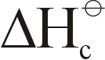 = –3 000 kJ mol⁻¹

(b) Let mass of H₂O = m g
Heat from butane = $\frac{1\text{.}2}{\text{24}}$ × 3 000 kJ = 150 kJ
∴ m × 4.2 × (100 – 20) = 0.8 × 150 × 1 000
m = 357 g

(c) Estimate the mass of container of butane

(d) (i) C₄H₁₀(g) + O₂(g) ⎯→ 4C(s) + 5H₂O(g) = –1 400 kJ mol⁻¹

(ii) Complete combustion of C₄H₁₀ gives CO₂ and evolves more heat. Incomplete combustion gives only C which evolves less heat. Further combustion of C to CO₂ evolves more heat.

(iii) Difference in ΔH = –3 000 – (–1 400) = –1 600 kJ is the enthalpy change for
4C(s) + 4O₂(g) ⎯→ 4CO₂(g)
i.e. ΔH (combustion of C) = (–1 600) = –400 kJ mol⁻¹

14. (a) Standard enthalpy change of combustion is the change in enthalpy for one mole of substance burning completely in oxygen under standard conditions.
(b) C₂H₅OH(l) + 3O₂(g) 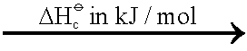 2CO₂(g) + 3H₂O(l)

(c) Q = mcΔθ
= 100 × 4.2 × (65 – 15) = $\left(\frac{1}{\text{46}} × {ΔH}_{c} ×1 \text{000}\right)$ × 0.7
⇒ = –1 380 J mol⁻¹

 | (d) | 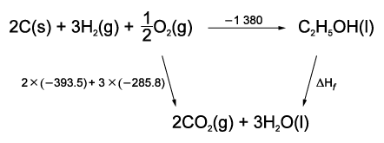

–1 380 + = (2 × –393.5) + (3 × –285.8)
= –264.4 kJ mol⁻¹

Alternative method:
(C(s)) = (CO₂(g)) = –393.5 kJ mol⁻¹
(H₂(g)) = (H₂O(l)) = –285.8 kJ mol⁻¹

(C₂H₅OH(l)) = Σ(prods.) – Σ(reactants)
–1380 = [2(–393.5) + 3(–285.8)] – [(C₂H₅OH)]
(C₂H₅OH(l)) = –264.4 kJ mol⁻¹

(e) Combustion of 1 mole ethanol involves breaking of 1 C—C, 5 C—H, 1 C—O, 1 O—H and 3 O=O bonds and formation of 4 C=O and 6 O—H bonds.

Heat absorbed in bond breaking is less than heat evolved in bond formation ⇒ overall combustion of ethanol is exothermic.

15. (a) (i) Standard enthalpy change of formation of a compound is the enthalpy change when one mole of compound is formed from the reactants/constituent elements under standard conditions.

(ii) 2C(s) + 3H₂(g) ⎯→ C₂H₆(g)

 | (b) | 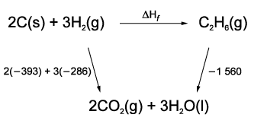

+ (–1 560) = 2(–393) + 3(–286)
= –84 kJ mol⁻¹

Alternative method:
(C₂H₆) = Σ (prods.) – Σ (reactants)
–1560 = [(2(–393) + 3(–286)) – [(C₂H₆)]
= –84 kJ mol⁻¹

16. (a) The standard enthalpy change of formation of a compound is the enthalpy change for making 1 mole of a compound from its constituent elements in their standard states (at 25ºC and 1 atm).
(b)
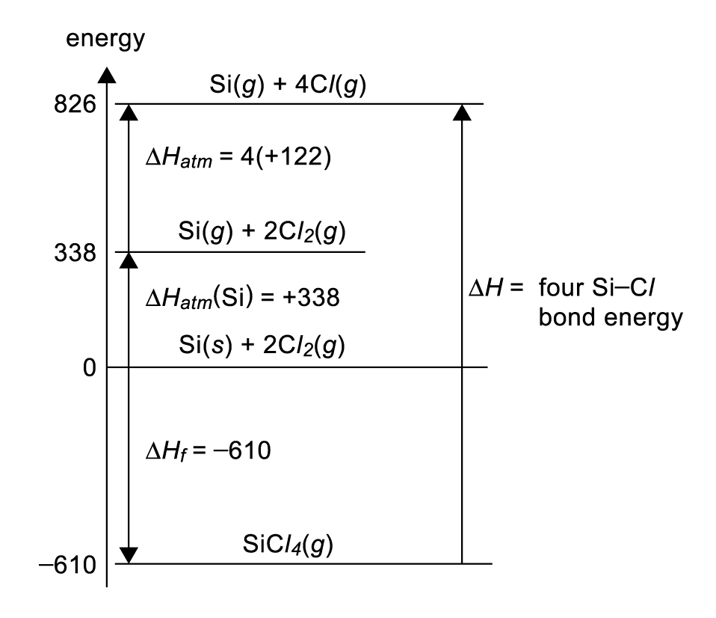

17. = ∑(product) – ∑(reactants)
= 8(–394) + 9(–286) – (–250) – 0
= –5476 kJ mol⁻¹

18. (a) The standard enthalpy change of formation, , of a compound is the enthalpy change when 1 mole of the compound is formed from its elements under standard conditions (at 25ºC, 1 atm).
(b) 2H₂O(l) ⎯→ 2H₂(g) + O₂(g)
ΔH = ∑ (product) − ∑ (reactants)
= 0 – 2(−286) kJ mol⁻¹
= +572 kJ mol⁻¹

- (a) Standard enthalpy of formation is the enthalpy change of reaction when one mole of a
substance is formed from its constituent elements in their standard states under standard conditions.

(b) C₆H₁₀(l) + H₂(g) ⎯→ C₆H₁₂(l)
ΔH = Σ(prods.) – Σ(reactants)
= –156 – (–36)
= –120 kJ mol⁻¹

(c) C₆H₆(l) + 3H₂(g) ⎯→ C₆H₁₂(l)
Assuming C₆H₆ contains 3 C=C,
ΔH (hydrogenation) = –120 × 3
= –360 kJ mol⁻¹
 | (d) | 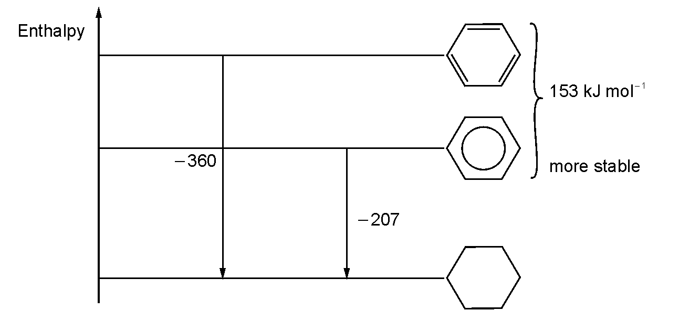

() has a lower enthalpy level than (). Therefore it is more stable.
Stabilisation of () is achieved as a result of delocalisation of π electrons or resonance.

